Functional identification of the C-terminal domain of rhCNB
Ziwei Zhu^{1#}, Li Tong^{1#}, Hongcui Ma¹, Huinan Yang², Jinju Yang²*, Qun Wei¹*

¹Gene Engineering and Biotechnology Beijing Key Laboratory, Department of Biochemistry and Molecular Biology, Beijing Normal University，Beijing, 100875, P. R. of China.
²National Key Laboratory of Biochemical Engineering, Institute of Process Engineering, Chinese Academy of Sciences, Beijing 100190, China;
# Hongcui Ma and Li Tong contributed equally.
*Correspondence should be addressed to:
Professor Qun Wei,
Department of Biochemistry and Molecular Biology
Beijing Normal University
Beijing Key Laboratory, Beijing 100875, People’s Republic of China
Tel & Fax: 86-10-58807365
- mail: weiq@bnu.edu.cn；
Associate Professor Jinju Yang
National Key Laboratory of Biochemical Engineering, Institute of Process Engineering, Chinese Academy of Sciences, Beijing 100190, China;
Tel & Fax: 86-10-82545075
E-mail: yangjinju@ipe.ac.cn

- Supplementary Figures

Figure S1. Identification of mycoplasma contamination in the cell lines used. (A) DAPI fluorescence staining of (ⅰ) positive control cell line, (ⅱ) CT29, (ⅲ) MHCC-97H, (ⅳ) H22, (ⅴ) negative control cell line, (ⅵ) HepG2, and (ⅶ) SMMC-7721. (B) PCR-based identification of mycoplasma in the cell lines. Lane 1: DNA ladder (5000, 3000, 2000, 1500, 750, 500, 250, 100 bp); Lane 2: positive control cell line; Lane 3: negative control cell line; Lanes 4–8: CT29, MHCC-97H, H22, HepG2, and SMMC-7721, respectively.

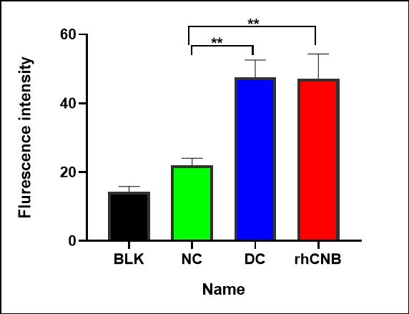

Figure S2. Fluorescence intensity quantification from the images of DC or rhCNB’ cellular uptake. The images were analyzed using ImageJ software. Data are presented as mean ± SD (n=3 independent experiments; **P < 0.01).

- Original Gel and Blot Images

1 2 3 4 5 6 7 8 9 10 11 12

Figure S3. Original uncropped gel for Figure 1c.
Lane1-9 were croped and presented in Figure 1c.
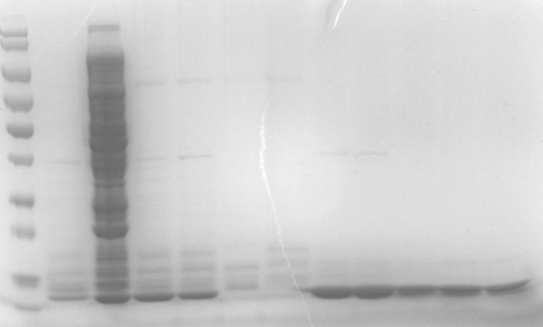
1 2 3 4 5 6 7 8 9 10 11 12

Figure S4. Original uncropped gel for Figure 1f.
Lane1-12 were presented in Figure 1f.
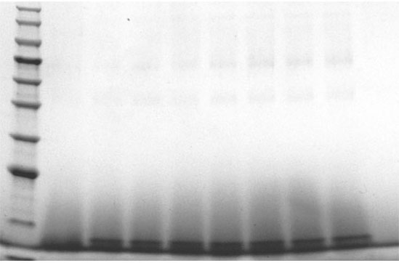
1 2 3 4 5 6 7 8 9 10

Figure S5. Original blot for Figure 1d.
Lane1-9 was presented in Figure 1d.

1 2 3 4 5

Figure S6. Original blot for Figure 1h.
Lane1-2 was presented in Figure 1h.

