ELECTRONIC SUPPLEMENTARY MATERIAL
Enhancing Prediction of Pathological Complete Response to Neoadjuvant Immunotherapy in Non-small cell lung cancer by Whole Lung Radiomics
Supplementary Text 1.
The inclusion criteria were as follows: (1) NSCLC diagnosis confirmed via biopsy pathology without EGFR, ALK, or other driver gene mutations; (2) clinically staged as II-IIIB; (3) administration of at least two cycles of neoadjuvant immunotherapy followed by surgical resection. Patients were excluded if they had a history of any malignancy other than lung cancer, received anti-tumor treatment before baseline CT examination, presented with severe image artifacts quality due to inadequate breath-holding or metallic implants, had a non-measurable primary tumor, or the interval between baseline CT and the initiation of treatment exceeded one month.
Supplementary Text 2.
Complete blood count (CBC) parameters included white blood cell (WBC), neutrophil (N), lymphocyte(L), monocyte (M), and platelet (PLT). Five inflammatory biomarkers derived from CBC results were calculated according to the following formulas: NLR, neutrophil-to-lymphocyte ratio (NLR=N/L); PLR, platelet-to-lymphocyte ratio (PLR=PLT/L); MLR, monocyte-to-lymphocyte ratio (MLR=M/L); dNLR, derived neutrophil-to-lymphocyte ratio (dNLR=N/[WBC-L]); SII, systemic immune inflammatory index (SII= [PLT×N]/L).
Tumor markers included tissue polypeptide specific antigen (TPS), squamous cell carcinoma antigen (SCCA), pro-gastrin-releasing peptide (ProGRP), neuron specific enolase (NSE), carbohydrate antigen 19-9 (CA19-9), carcinoembryonic antigen (CEA) and Cytokeratin 19 fragment (Cyfra21-1).
Supplementary Text 3.
After excluding 243 tumor radiomics features with poor repeatability (intraclass correlation coefficient, ICC < 0.75), feature dimensionality reduction and selection were performed. Following initial univariate statistical filtering, 8, 5, and 13 radiomics features were retained in the primary tumor (PT), whole lung (WL), and combined primary tumor and whole lung (PTWL) feature sets, respectively. Subsequently, Pearson correlation analysis and the Minimum Redundancy Maximum Relevance (MRMR) were applied to remove redundant features and 6, 5, and 11 features were retained in the PT, WL, and PTWL sets. The Least Absolute Shrinkage and Selection Operator (LASSO) was applied to remove irrelevant features and select an optimized subset. Ultimately, 5, 3, and 9 features were retained in the PT, WL, and PTWL sets, respectively.
Supplementary Text 4. The calculation formula of the combined model
log(p) = -5.334 -1.045 * CEA + 11.624* radiomics

Table S1 Univariable and multivariable logistics regression analysis for predicting pCR in rNSCLC after neoadjuvant immunotherapy in the training cohort
Variables | Univariable analysis |  |  | Multivariable analysis
Variables | OR (95% CI) | P value |  | OR (95% CI) | P value
Age | 0.988 (0.947-1.031) | 0.580
Sex
Female | Reference
Male | 1.738 (0.758-3.982) | 0.191
Smoking history
Never | Reference
Current or former smoker | 1.270 (0.631-2.558) | 0.503
Treatment regimen
Immunotherapy | Reference
Chemoimmunotherapy | 2.903 (0.903-9.336) | 0.12
Treatment cycle
2 | Reference
3 | 1.857 (0.790-4.366) | 0.156
4 | 1.345 (0.645-2.805) | 0.430
5 | 0.000 (0.000-none) | 0.999
Pretreatment T stage
T1 | Reference
T2 | 0.589 (0.222-1.566) | 0.289
T3 | 0.669 (0.250-1.788) | 0.423
T4 | 0.706 (0.235-2.123) | 0.535
Pretreatment N stage
N0 | Reference
N1 | 1.103 (0.491-2.482) | 0.812
N2 | 0.845 (0.435-1.642) | 0.620
N3 | 1.576 (0.531-4.683) | 0.413
Pretreatment TNM stage
II | Reference
III | 0.948 (0.535-1.678) | 0.855
WBC | 1.006 (0.888-1.141) | 0.922
N | 0.995 (0.865-1.145) | 0.942
L | 1.052 (0.645-1.716) | 0.840
M | 2.401 (0.590-9.777) | 0.222
PLT | 1.000 (0.997-1.004) | 0.930
NLR | 0.957 (0.804-1.138) | 0.618
PLR | 0.999 (0.995-1.003) | 0.713
MLR | 2.200 (0.235-20.611) | 0.490
dNLR | 0.157 (0.001-26.633) | 0.480
SII | 1.000 (0.999-1.000) | 0.680
TPS
Normal | Reference
Abnormal | 1.416 (0.787-2.549) | 0.246
SCCA
Normal | Reference
Abnormal | 1.773 (0.983-3.197) | 0.057
ProGRP
Normal | Reference
Abnormal | 0.379 (0.142-1.014) | 0.053
NSE
Normal | Reference
Abnormal | 1.291 (0.712-2.344) | 0.400
CA199
Normal | Reference
Abnormal | 0.450 (0.186-1.089) | 0.077
CEA
Normal | Reference
Abnormal | 0.335 (0.167-0.673) | 0.002* |  | 0.447 (0.209-0.956) | 0.038*
Cyfra21-1
Normal | Reference
Abnormal | 0.544 (0.308-0.964) | 0.037* |  | 0.662 (0.360-1.220) | 0.186
Histologic type
ADC | Reference
SCC | 2.741 (1.297-5.795) | 0.008*
Others† | 1.611 (0.470-5.527) | 0.448
RECIST LN
Negative | Reference
Positive | 1.108 (0.595-2.064) | 0.746
Conventional LN
Negative | Reference
Positive | 1.022 (0.563-1.854) | 0.944
Tumor burden | 0.994 (0.883-1.118) | 0.919
Tumor Size | 0.974 (0.847-1.120) | 0.711
pCR = pathological complete response, WBC = white blood cell , N = neutrophil, L = lymphocyte, M = monocyte, PLT = platelet, NLR = neutrophil-to-lymphocyte ratio, PLR= platelet-to-lymphocyte ratio, MLR = monocyte-to-lymphocyte ratio, dNLR = derived neutrophil-to-lymphocyte ratio, SII = systemic immune-inflammation index, TPS = tissue polypeptide specific antigen, SCCA = squamous cell carcinoma antigen, ProGRP = pro-gastrin-releasing peptide, NSE = neuron specific enolase, CA199 = carbohydrate antigen 199, CEA = carcinoma embryonic antigen, Cyfra21-1 = cytokeratin 19 fragment, ADC = adenocarcinoma, SCC = squamous cell carcinoma, RECIST = response evaluation criteria in solid tumors, RECIST LN = short axis of lymph node ≥1.5 cm, Traditional LN = short axis of lymph node ≥1.0 cm, OR = odds ratio, CI = confidence interval
† Includes large cell carcinoma, adenosquamous carcinoma and sarcomatoid carcinoma
* P-value＜0.05
Table S2 Final selected PT radiomics features and their coefficient for the prediction of pCR
Order | VOI | Image type | Feature type | Radiomics features | Coefficients
1 | PT | Wavelet-HHL | GLCM | MCC | 0.064294
2 | PT | log-sigma-1-mm-3D | GLSZM | LargeAreaEmphasis | 0.047165
3 | PT | Wavelet-HLH | GLSZM | ZoneEntropy | -0.047273
4 | PT | Wavelet-LHH | First order | Range | -0.050920
5 | PT | Wavelet-LLH | GLRLM | RunVariance | -0.062290
PT = primary tumor, pCR = pathological complete response, VOI = volum of interest, GLCM = Gray-Level Co-occurrence Matrix, GLSZM = Gray-Level Size Zone Matrix, GLRLM = Gray-Level Run-Length Matrix.

Table S3 Final selected WL radiomics features and their coefficient for the prediction of pCR
Order | VOI | Image type | Feature type | Radiomics features | Coefficients
1 | WL | Wavelet-HHH | First order | Mean | 0.057430
2 | WL | Wavelet-LHH | GLSZM | LowGrayLevelZoneEntropy | -0.053512
3 | WL | log-sigma-1-mm-3D | GLDM | DependenceVariance | -0.074140
WL = whole lung, VOI = volum of interest, pCR = pathological complete response, GLSZM = Gray-Level Size Zone Matrix, GLDM = Gray Level Dependence Matrix.

Table S4 Final selected PTWL radiomics features and their coefficient for the prediction of pCR
Order | VOI | Image type | Feature type | Radiomics features | Coefficients
1 | WL | Wavelet-HHH | First order | Mean | 0.050000
2 | PT | Wavelet-HHL | GLCM | MCC | 0.047962
3 | PT | log-sigma-1-mm-3D | GLSZM | LargeAreaEmphasis | 0.027313
4 | PT | Wavelet-LLH | GLCM | Imc1 | 0.009896
5 | PT | Wavelet-HLH | GLSZM | ZoneEntropy | 0.026956
6 | PT | Wavelet-LHH | First order | Range | -0.033464
7 | PT | Wavelet-LLH | GLRLM | RunVariance | -0.036503
8 | WL | Wavelet-LHH | GLSZM | LowGrayLevelZoneEntropy | -0.051661
9 | WL | log-sigma-1-mm-3D | GLDM | DependenceVariance | -0.062700
PTWL = primary tumor and whole lung, pCR = pathological complete response, VOI = volum of interest, PT = primary tumo, WL = whole lung, GLCM = Gray-Level Co-occurrence Matrix, GLSZM = Gray-Level Size Zone Matrix, GLRLM = Gray-Level Run-Length Matrix, GLDM = Gray Level Dependence Matrix.

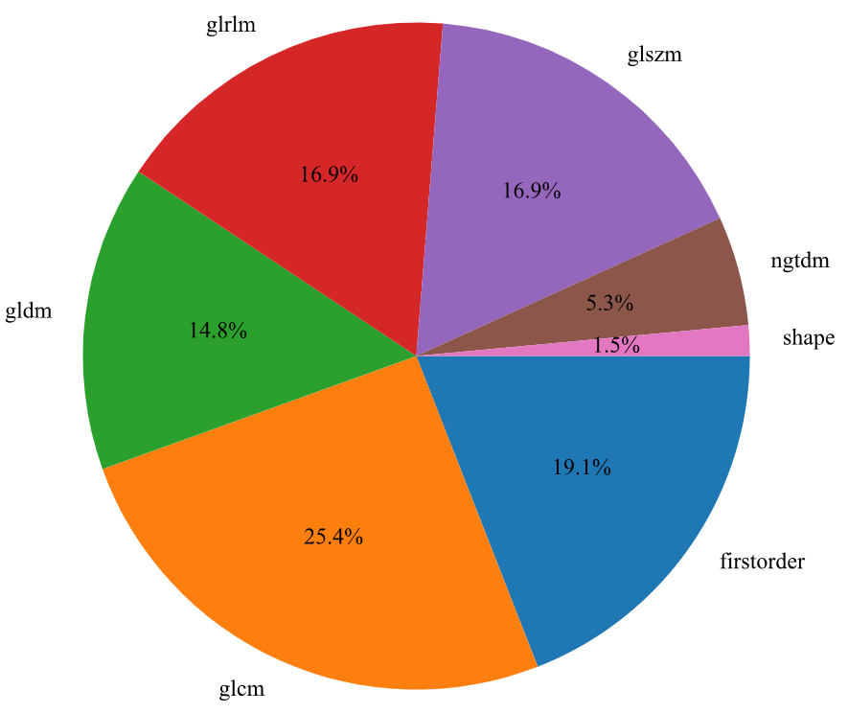
Fig. S1 Extracted radiomics features from each region
GLCM = Gray-Level Co-occurrence Matrix, GLSZM = Gray-Level Size Zone Matrix, GLRLM = Gray-Level Run-Length Matrix, GLDM = Gray Level Dependence Matrix, NGTDM = Neighbouring Gray Tone Difference Matrix.

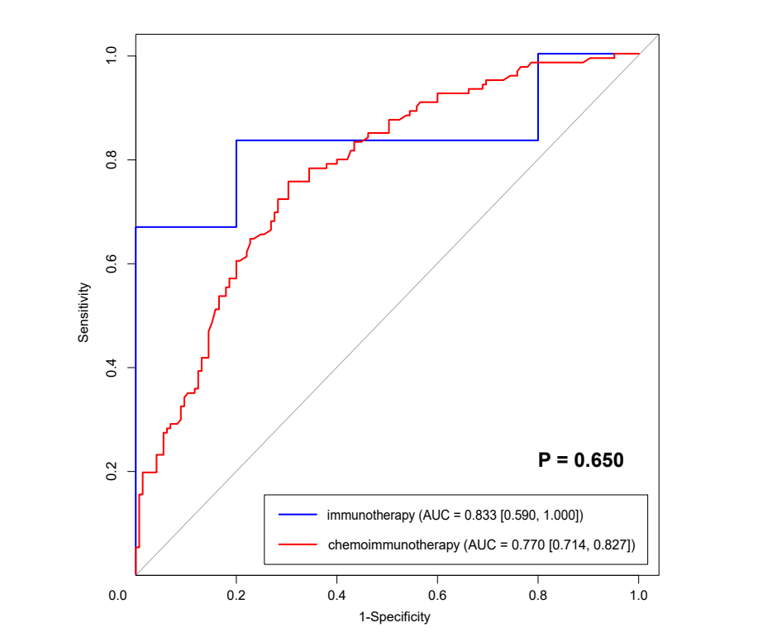
Fig. S2 Receiver operating characteristic (ROC) curves for subgroup analysis of the entire cohort. AUC=area under the curve

