Supplementary figures
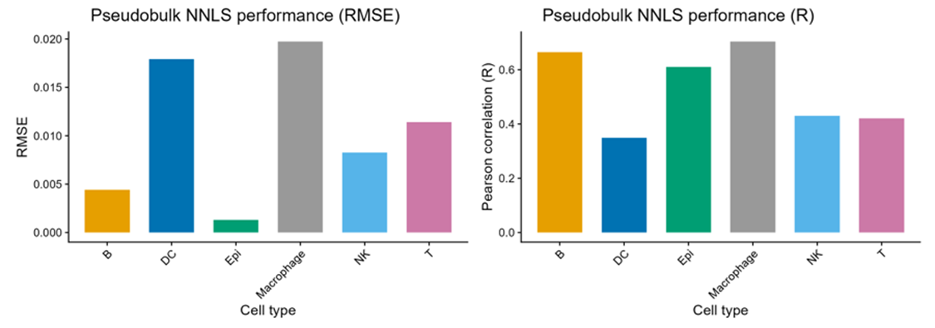
Supplementary Figure S1. Summary performance of SIG6-based pseudobulk NNLS reconstruction.
Left panel: Root mean squared error (RMSE) of estimated cell-type fractions across pseudobulk mixtures generated by multinomial sampling.
Right panel: Pearson correlation coefficient (R) between ground-truth and NNLS-estimated fractions for each cell type.
Pseudobulk mixtures were generated using controlled gradient fractions and reconstructed using non-negative least squares (NNLS). Bars represent aggregate performance across simulation runs for each cell type (B, DC, epithelial, macrophage, NK, T).
RMSE values range from approximately 0.001 to 0.020 across compartments. Pearson correlation coefficients range from approximately 0.35 to 0.70.
Performance metrics are computed on simulated mixtures and reflect relative reconstruction stability of each cell-type component within the SIG6 signature framework.

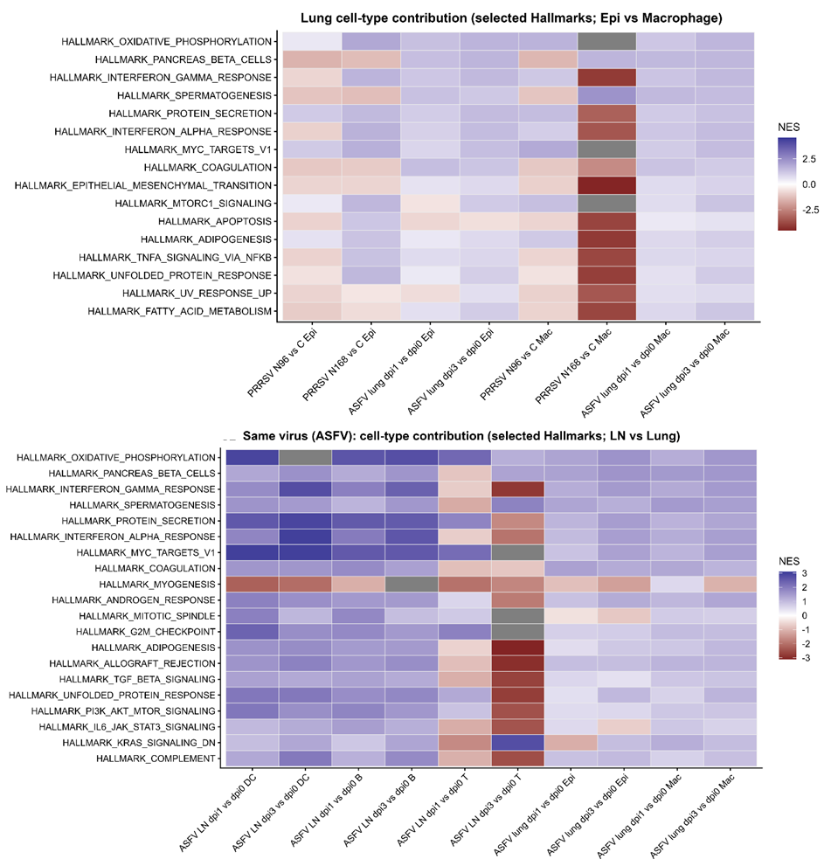
Supplementary Figure S2. Cell-type–specific Hallmark contribution patterns across virus and tissue contexts.
Upper panel: Heatmap of selected Hallmark pathway enrichment scores (NES) comparing epithelial (Epi) and macrophage (Mac) compartments in lung samples across PRRSV and ASFV conditions. Columns represent pairwise contrasts within virus and cell-type contexts (e.g., PRRSV lung sample comparisons and ASFV lung dpi contrasts). Rows represent selected Hallmark gene sets. Color scale indicates normalized enrichment score (NES), ranging approximately from −3 to +3.
Lower panel: Heatmap of selected Hallmark pathway enrichment scores comparing lymph node (LN) and lung compartments within ASFV infection. Columns represent pairwise comparisons across cell types (DC, B, T, Epi, Mac) and tissues. Rows represent selected Hallmark gene sets. NES color scale ranges approximately from −3 to +3.
All enrichment scores were derived from cell-type–resolved transcriptomic attribution prior to comparison. Heatmaps display directionality and magnitude of enrichment differences across specified contrasts.
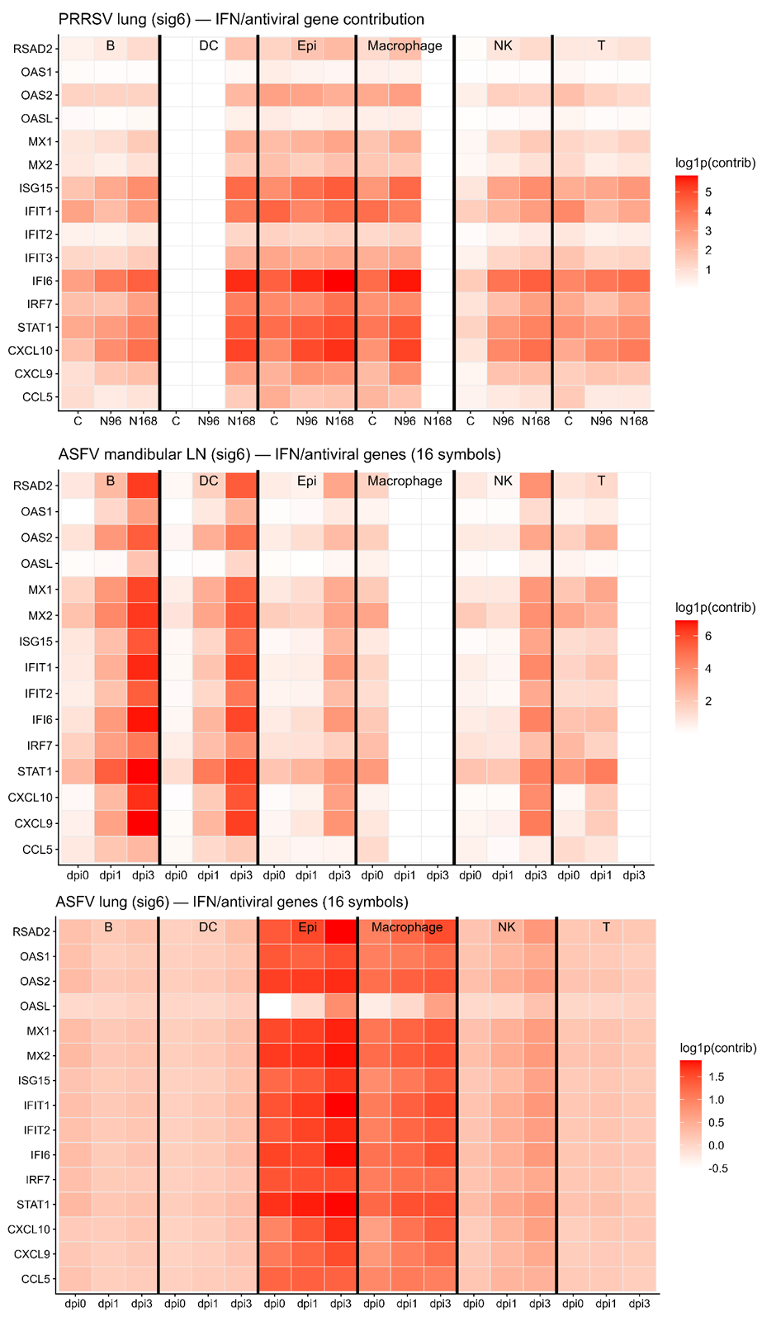

Supplementary Figure S3. Cell-type–resolved IFN/antiviral gene contribution across virus and tissue contexts.
Upper panel: Heatmap of interferon- and antiviral-associated genes in PRRSV lung samples (control, N96, N168). Columns are grouped by cell type (B, DC, epithelial, macrophage, NK, T), and within each group by sample condition. Rows represent 16 IFN/antiviral-related genes (RSAD2, OAS1, OAS2, OASL, MX1, MX2, ISG15, IFIT1, IFIT2, IFIT3, IFI6, IRF7, STAT1, CXCL10, CXCL9, CCL5). Color scale indicates log1p-transformed weighted contribution values.
Middle panel: Heatmap of the same gene set in ASFV mandibular lymph node samples across dpi0, dpi1, and dpi3. Columns are grouped by cell type and time point. Color scale represents log1p(weighted contribution).
Lower panel: Heatmap of the same gene set in ASFV lung samples across dpi0, dpi1, and dpi3. Columns are grouped by cell type and time point. Color scale represents log1p(weighted contribution).
For all panels, vertical separators indicate cell-type boundaries. Color scales differ across panels to reflect dataset-specific dynamic ranges and are displayed on the right of each heatmap.
Weighted contribution values are derived from SIG6-based cell-type attribution and represent relative gene-level contribution within each cell-type–resolved compartment.

