Figure S1. Phenotypic distribution of drought-related traits at the rice seedling stage
DRC; Drought resistance coefficient, RL; Root length, PH; Plant height, LSRI; Leaf senescence resistance index, LW; Leaf wilting score, CDTM; Comprehensive drought tolerance metric

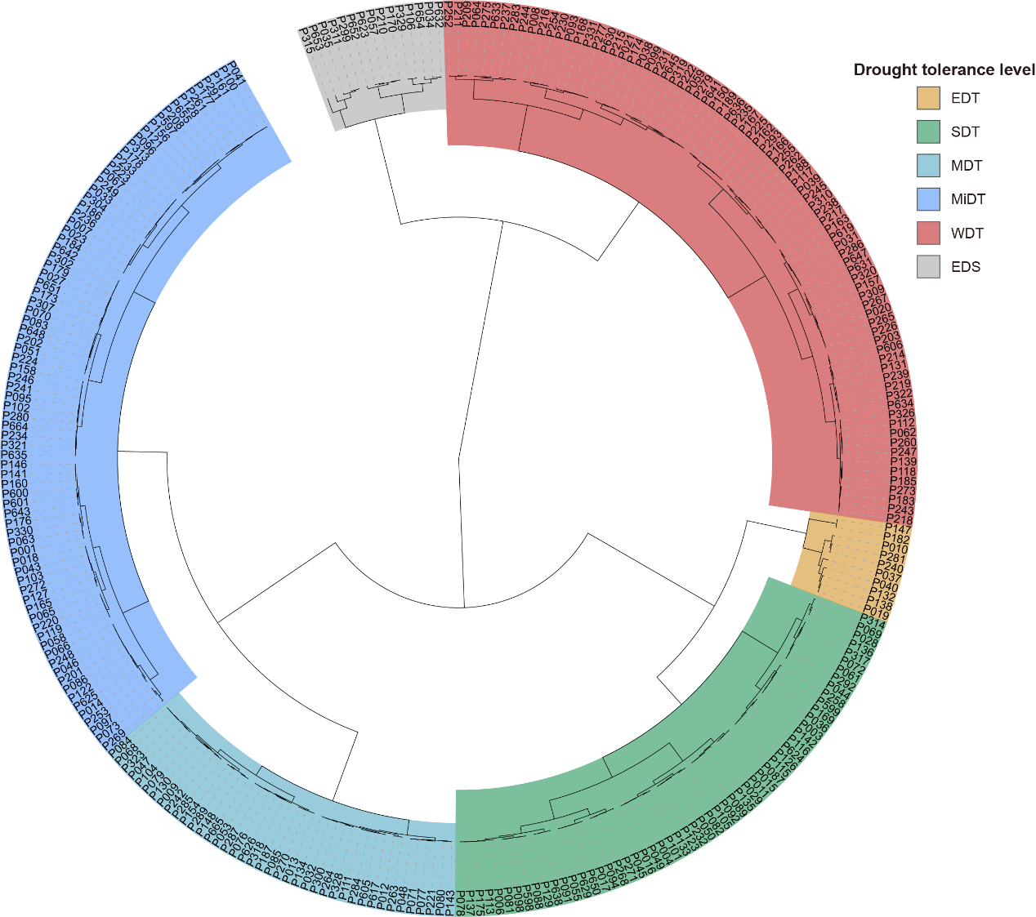
Figure S2. Hierarchical clustering of 283 indica rice accessions based on seedling-stage drought tolerance. The circular dendrogram displays clustering results based on the comprehensive drought tolerance index (CDTM). Accessions were classified into six categories according to drought tolerance levels: extremely drought-tolerant (EDT), strongly drought-tolerant (SDT), moderately drought-tolerant (MDT), mildly drought-tolerant (MiDT), weakly drought-tolerant (WDT), and extremely drought-sensitive (EDS).

Figure S3. Effect of drought stress on SOD activity and H₂O₂ content in two rice varieties. (A) SOD activity. (B) H₂O₂ content. Drought stress was simulated using 20% PEG-6000, and samples were collected at 0 d (control), 3 d, and 7 d after treatment. Data are presented as mean ± SE (n = 3). Different letters indicate significant differences between cultivars at the same time point (Student's t-test, p < 0.05).
DT; Jiangnongzao 1B, DS; TAISEN GLUTINOUS YU 1157, SOD; superoxide dismutase, H₂O₂; Hydrogen peroxide

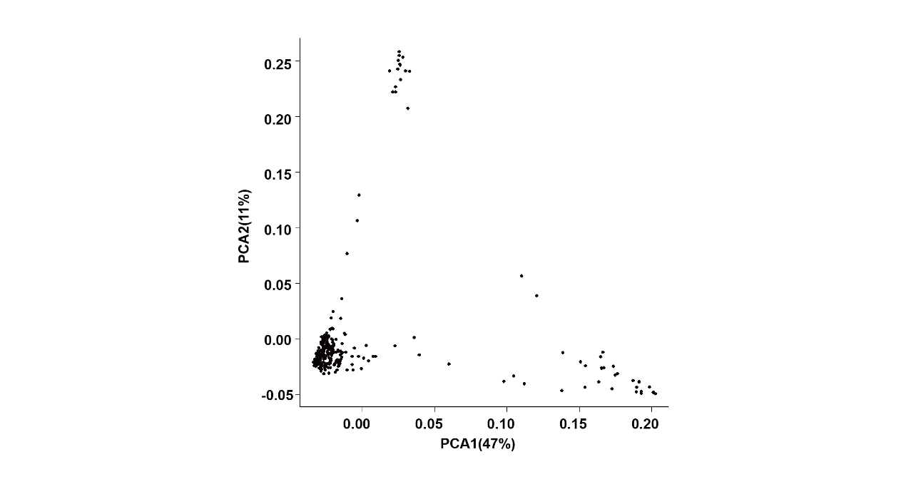
Figure S4. Principal component analysis of 283 rice accessions

Figure S5. Quantile-quantile plots for 5 drought-related traits
RL; Root length, PH; Plant height, LSRI; Leaf senescence resistance index, LW; Leaf wilting score, CDTM; Comprehensive drought tolerance metric

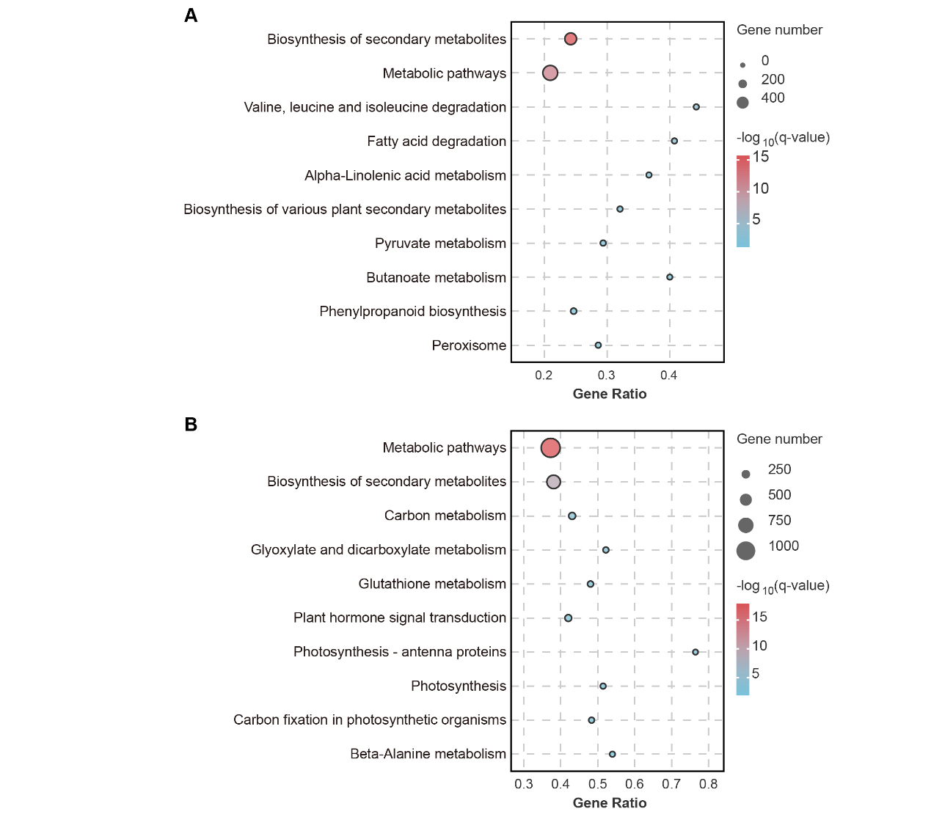
Figure S6. KEGG enrichment analysis of differentially expressed genes in DT and DS. (A) DT. (B) DS. The top 10 significantly enriched pathways are shown.
KEGG; Kyoto encyclopedia of genes and genomes, DT; Jiangnongzao 1B, DS; TAISEN GLUTINOUS YU 1157

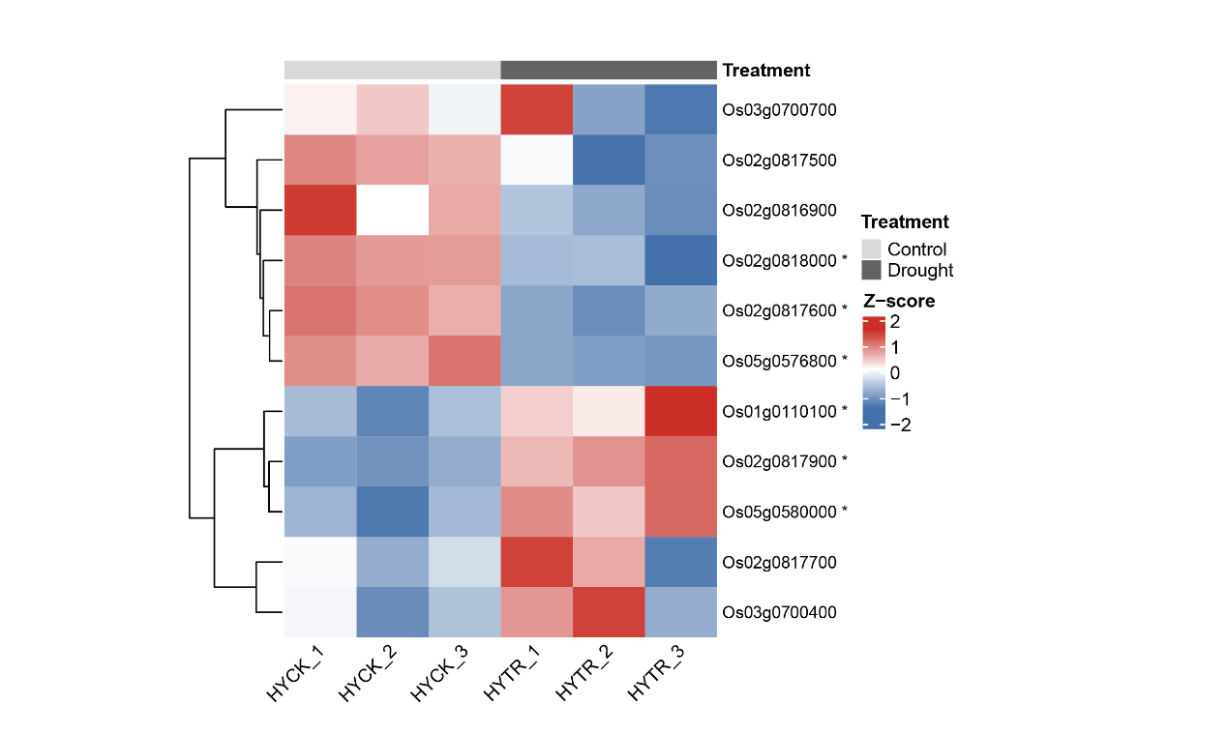
Figure S7. Expression heatmap of 12 candidate genes in Hanyou73. Gene expression values were transformed using VST and Z-score normalized by row.. Asterisks denote significantly differentially expressed genes (adjusted P < 0.05 and |log₂FC| ≥ 1).
VST; Variance-stabilizing transformation, CK; Control check, TR; drought treatment

