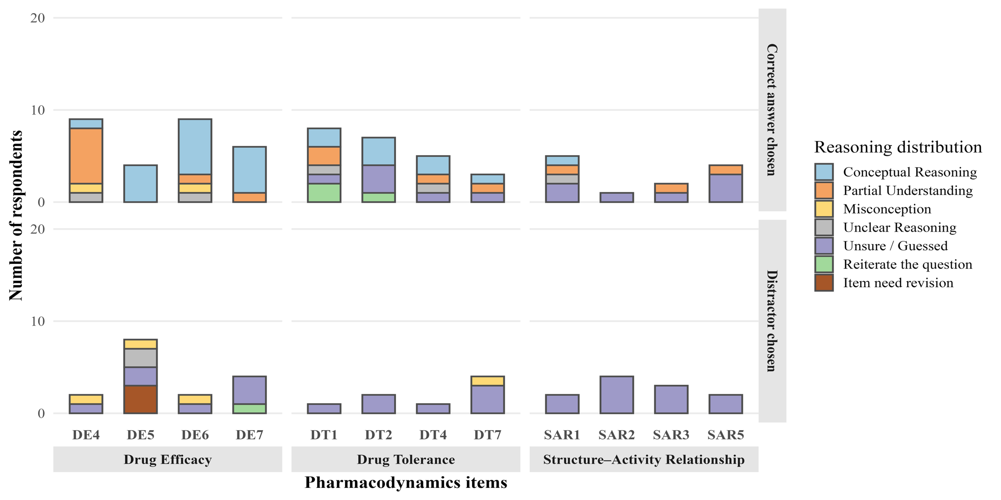
Supplementary file 6 Figure 2: Reasoning distribution across pharmacodynamics PCI items

