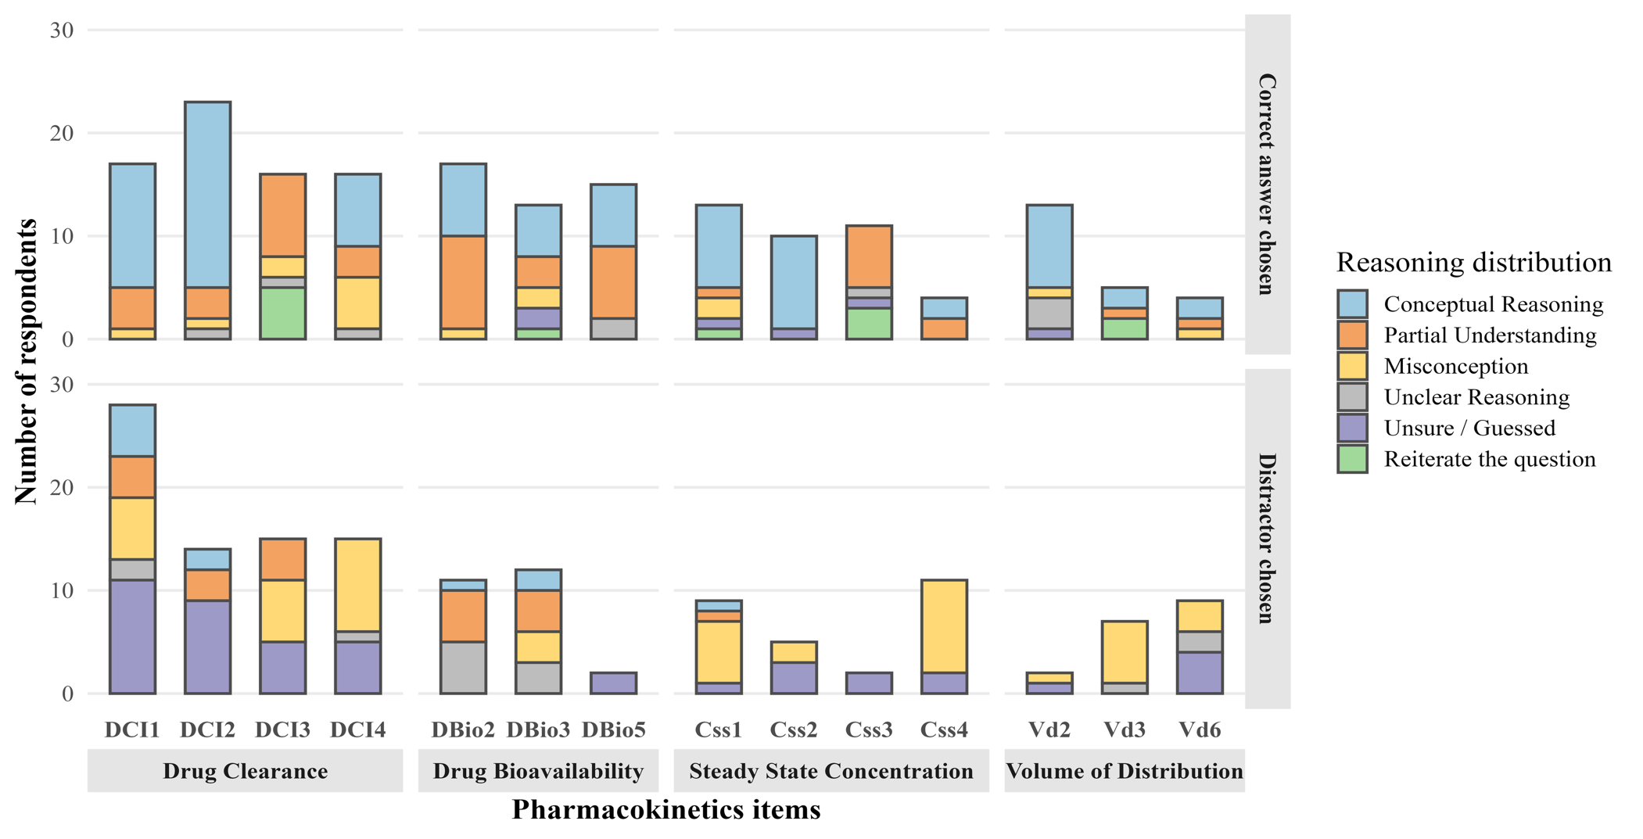
Supplementary file 5 Figure 1: Reasoning distribution across pharmacokinetics PCI items

