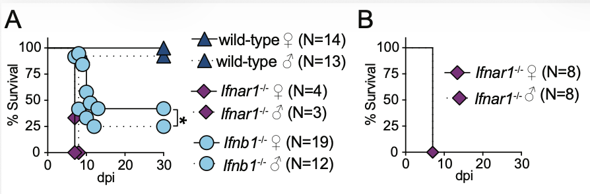
Supplemental Figure 1. IFN-I signaling partially contribute to male-associated increased susceptibility to mousepox. A-B) Survival of the indicated mice infected in the footpad with 3,000 pfu of ECTV. The data correspond to four (A) or two (B) independent experiments combined. P values are compared to wild-type mice or the indicated groups by Log-rank (Mantel-Cox) analysis.

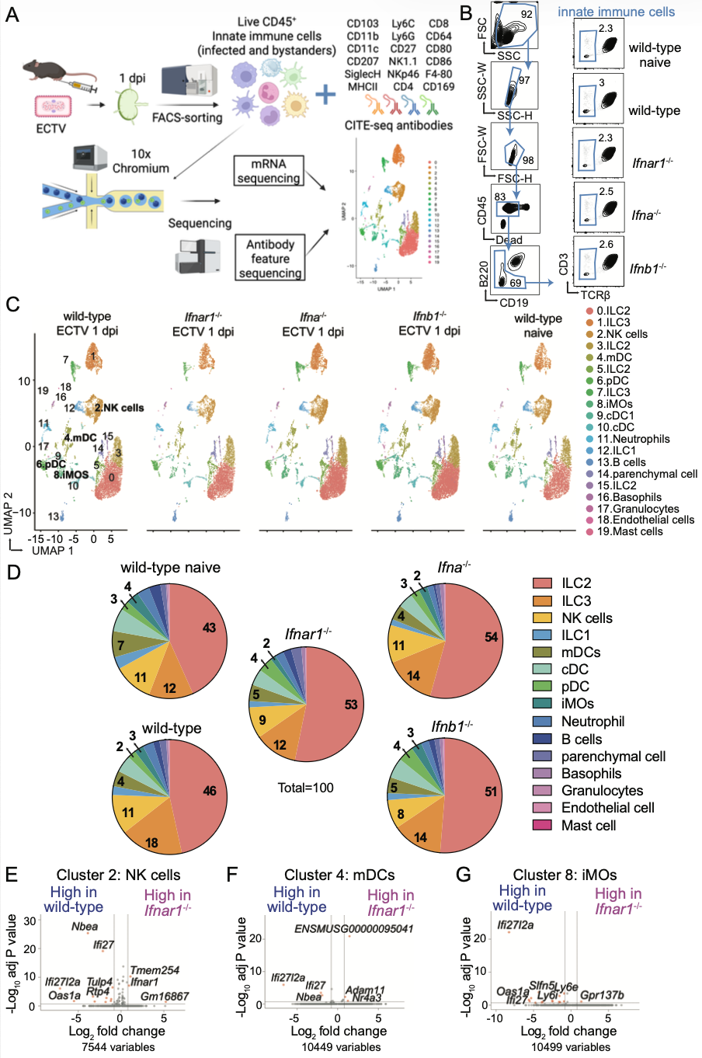
Supplemental Figure 2. IFN-I partially primes innate immune cells in the dLN at one dpi with ECTV. A) CITEseq experimental layout (created with BioRender). B) FACS plots showing the gating strategy for the sorting of live innate immune cells (CD45⁺TCRβ⁻CD3⁻B220⁻CD19⁻) from pooled draining lymph nodes at one dpi from the indicated mice infected with 3,000 pfu of ECTV in both rear footpads or from naïve wild-type controls. C) UMAP clustering and cell annotation based on cell-specific protein markers and transcript expression. D) Percentages of the indicated cell populations of total sequenced cells. E-G) Volcano plots showing differentially expressed genes of clusters annotated as NK cells (E, NK1.1⁺ NKp46⁺Eomes⁺SiglecH⁻MHCII⁻Ly6G⁻CD103⁻), mDCs (F, MHCII^{high}CD11c⁺ CD80⁺ CD86⁺ CD207⁺SiglecH⁻Ly6C⁻CD11b⁻Ly6G⁻NK1.1⁻CD103⁻) or iMOs (G, Ly6C⁺CD11b⁺CD11c⁺CD80⁺SiglecH⁻Ly6G⁻NK1.1⁻CD103⁻) from infected wild-type mice compared to those from infected Ifnar1^{-/-} mice (red dots: Log2 fold change=1, adj P<0.2, gray dots: unchanged).

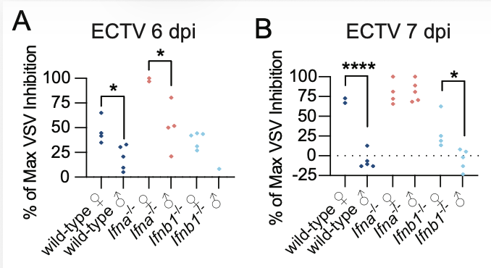

Supplemental Figure 3. Systemic IFN-I signaling is delayed or reduced in male compared to female mice infected with ECTV or WNV. A-B) IFN-I bioactivity in the sera obtained from the indicated mice infected with ECTV at six (A) or seven dpi (B) was quantified by inhibition of VSV replication in mouse L929 cells. The data correspond to two independent experiments combined for A-B. Each symbol depicts an individual mouse, and P values are compared to the indicated groups by t-test with Welch’s correction.

Box1. Material and equipment.
REAGENT or RESOURCE | SOURCE | IDENTIFIER
Antibodies
Mouse monoclonal antibody anti-mouse anti-interferon beta, clone HDβ-4A7 | Leinco  PMC4444312 | I-1182
Armenian hamster monoclonal antibody anti-mouse anti-interferon alpha, clone TIF-3C5 | Leinco  PMC4444312 | I-1183
Mouse monoclonal antibody Buv395 anti-mouse CD45.2, clone 104 | BioLegend | Cat# 564616,  RRID: AB_893350
Rat monoclonal antibody FITC anti-mouse CD3, clone 17A2 | BioLegend | Cat# 100203,  RRID: AB_312660
Armenian hamster monoclonal antibody APC anti-mouse TCRβ, clone H57-597 | BioLegend | Cat# 109211,  RRID: AB_313434
Rat monoclonal antibody PE anti-mouse B220, clone RA3-6B2 | BioLegend | Cat# 103207,  RRID: AB_312992
Rat monoclonal antibody BV605 anti-mouse CD19, clone 6D5 | BioLegend | Cat# 115540,  RRID: AB_2563067
Rat monoclonal antibody PE anti-mouse Ly6C, clone HK1.4 | BioLegend | Cat# 128008, RRID:AB_1186132
Rat monoclonal antibody BUV395 anti-mouse CD11b, clone M1/70 | BD Biosciences | Cat# 565976, RRID:AB_2721166
Armenian hamster monoclonal antibody PE-Cy7 anti-mouse CD11c, clone N418 | BioLegend | Cat# 117318  RRID: AB_493569
Rat monoclonal antibody PerCP/Cy5.5 anti-mouse I-A/I-E, clone M5/114.15.2 | BioLegend | Cat# 107626, RRID:AB_2191071
Rat monoclonal antibody Pacific Blue anti-mouse Ly6C/Ly6G (Gr-1), clone RB6-8C5 | BioLegend | Cat# 108430, RRID:AB_893556
Rat monoclonal antibody BV785 anti-mouse CD19, clone 6D5 | BioLegend | Cat# 115543, RRID:AB_11218994
Rat monoclonal antibody anti-mouse CD16/CD32, clone 93 | BioLegend | Cat#101302
Armenian hamster monoclonal antibody BV605 anti-mouse TCRβ, clone H57-597 | BioLegend | Cat# 109241, RRID:AB_2629563
Mouse monoclonal antibody BV605 anti-mouse NK 1.1, clone PK136 | BioLegend | Cat# 108753,  RRID: AB_2686977
Armenian Hamster monoclonal antibody TTCATTAGCCCGCTG-barcoded anti-mouse CD103, clone 2E7 | BioLegend | Cat# 121445,  RRID: AB_2876437
Rat monoclonal antibody TGAAGGCTCATTTGT-barcoded anti-mouse CD11b, clone M1/70 | BioLegend | Cat# 101273,  RRID: AB_2819781
Armenian Hamster monoclonal antibody  GTTATGGACGCTTGC-barcoded anti-mouse CD11c, clone N418 | BioLegend | Cat# 117359,  RRID: AB_2813987
Mouse monoclonal antibody CGATTTGTATTCCCT-barcoded anti-mouse CD207, clone 4C7 | BioLegend | Cat# 144213,  RRID: AB_2876492
Armenian Hamster monoclonal antibody  CAAGGTATGTCACTG-barcoded anti-mouse CD27, clone LG.3A10 | BioLegend | Cat# 124247,  RRID: AB_2832449
Mouse monoclonal antibody AGCAATTAACGGGAG-barcoded anti-mouse CD64, clone X54-5/7.1 | BioLegend | Cat# 139329,  RRID: AB_2832505
Armenian Hamster monoclonal antibody  GACCCGGTGTCATTT-barcoded anti-mouse CD80, clone 16-10A1 | BioLegend | Cat# 104755,  RRID: AB_2819807
Rat monoclonal antibody CTGGATTTGTGTATC-barcoded anti-mouse CD86, clone GL-1 | BioLegend | Cat# 105057,  RRID: AB_2832345
Rat monoclonal antibody TTAACTTCAGCCCGT-barcoded anti-mouse F4-80, clone BM8 | BioLegend | Cat# 123155,  RRID: AB_2819847
Rat monoclonal antibody AAGTCGTGAGGCATG-barcoded anti-mouse Ly6C, clone HK1.4 | BioLegend | Cat# 128053,  RRID: AB_2832462
Rat monoclonal antibody ACATTGACGCAACTA-barcoded anti-mouse Ly6G, clone 1A8 | BioLegend | Cat# 127659,  RRID: AB_2819864
Rat monoclonal antibody GGTCACCAGTATGAT-barcoded anti-mouse I-A/I-E, clone M5/114.15.2 | BioLegend | Cat# 107657,  RRID: AB_2832367
Mouse monoclonal antibody GTAACATTACTCGTC-barcoded anti-mouse NK1.1, clone PK136 | BioLegend | Cat# 108763,  RRID: AB_2819814
Rat monoclonal antibody CCCTTTCACCTCGAA-barcoded anti-mouse NKp46, clone 29A1.4 | BioLegend | Cat# 137641,  RRID: AB_2860685
Rat monoclonal antibody CCGCACCTACATTAG-barcoded anti-mouse SiglecH, clone 551 | BioLegend | Cat# 129619,  RRID: AB_2922464
Rat monoclonal antibody ATTGACGACAGTCAT-barcoded anti-mouse CD169, clone 3D6.112 | BioLegend | Cat# 142429,  RRID: AB_2876485
Rat monoclonal antibody TACCCGTAATAGCGT-barcoded anti-mouse CD8a, clone 53-6.7 | BioLegend | Cat# 100783,  RRID: AB_2832269
Rat monoclonal antibody AACAAGACCCTTGAG-barcoded anti-mouse CD4, clone RM4-5 | BioLegend | Cat# 100573,  RRID: AB_2813914
Rat monoclonal antibody AAGTCAGGTTCGTTT-barcoded κ isotype control, clone RTK2758 | BioLegend | Cat# 400581,  RRID: AB_3097104
Virus Strains
ECTV Moscow | ATCC | VR-1374
ECTV ΔEVM166 | PMC2292233
ECTV-GFP | PMC2233669
Chemicals, Peptides, and Recombinant Proteins
Zombie Violet Fixable Viability kit | BioLegend | Cat# 423113
Mouse interferon alpha A | PBL Assay Science | Cat# 12100
Mouse interferon alpha 1 | PBL Assay Science | Cat# 12105
Mouse interferon beta | PBL Assay Science | Cat# 12400
DMEM media | CORNING | 10-013-CV
RPMI media | CORNING | 10-040-CV
Penicillin Streptomycin Solution, 100x | CORNING | 30-002-Cl
GlutaMAX 100x | Gibco | 35050-061
Hepes 1M | CORNING | 25-060-Cl
Liberase™ | Roche | 05 401 119 001
Trizol | Invitrogen | Cat# 15596018
Critical Commercial Assays
cDNA synthesis with High Capacity cDNA Reverse Transcription Kit | Applied Biosystems™ Thermo Fisher Scientific | 4368814
iTaq™ Universal SYBR® Green PCR Supermix | BioRad | 172-5124
RNA Clean and Concentrator™-5, DNaseI | Zymo Research | R1014
Dual Index Kit NT Set A, 96 rxn | 10x Genomics | 1000242
Chromium Next GEM Chip G Single Cell Kit, 16 rxns | 10x Genomics | 1000127
Chromium Next GEM Single Cell 3’ Kit v3.1, 16 rxns | 10x Genomics | PN-1000268
3’ Feature Barcode Kit, 16 rxns | 10x Genomics | PN-1000262
Experimental Models: Cell Lines
Monkey C. aethiops epithelial kidney BS-C-1 cells | ATCC | CCL-26
Mouse M. musculus subcutaneous connective tissue L929 | ATCC | CCL-1
Hamster M. auratus fibroblast BHK-21 | ATCC | CCL-10
Mosquito A. albopictus larva C6/36 | ATCC | CRL-1660
Mouse M. musculus hybridoma A9 | ATCC | CRL-1811
Monkey C. aethiops kidney epithelial Vero | ATCC | CCL-81
Experimental Models: Organisms/Strains
Mouse: C57BL/6NCrl | Charles River | 027
Mouse: C57BL/6 Ifnar1^{-/-} mice | Thomas Moran (Mount Sinai School of Medicine, New York, NY)
Mouse: C57BL/6;129P2-Irf7tm1Ttg/TtgRbrc - Irf7^{-/-} | Dr. Tadatsugu Taniguchi, PMID: 15800576
Mouse: C57BL/6.C-Tg(CMV-cre)1Cgn/J - CMV-Cre | Jackson Laboratory | JAX: 006054
Mouse: C57BL/6 Ifnb1^{-/-} | PMC10177031
Mouse: C57BL/6 Ifna4,b1^{-/-} | PMC10177031
Mouse: C57BL/6 Ifna4^{-/-} | PMC10177031
Mouse: C57BL/6 Ifna^{Δ3} | PMC10177031
Mouse: C57BL/6 Ifna^{Δ6} | PMC10177031
Mouse: C57BL/6 Ifna^{-/-} | Present paper | Offspring from crossing of C57BL/6 CMV-Cre and C57BL/6 Ifna^{fl/fl}
Mouse: C57BL/6 Ifna^{fl/fl} | PMC10177031
Mouse: C57BL/6 Ifnb1^{ΔPRDII} | PMC10177031
Mouse: C57BL/6 Ifnb1^{ΔPRDII}Irf7^{-/-} | Present paper | Offspring from crossing of C57BL/6 Ifnb1^{ΔPRDII} and C57BL/6 Irf7^{-/-}
Oligonucleotides
Primer Gapdh forward | IDT | tgtccgtcgtggatctgac
Primer Gapdh reverse | IDT | cctgcttcaccaccttcttg
Primer Ifnb1 forward | IDT | ctggcttccatcatgaacaa
Primer Ifnb1 reverse | IDT | agagggctgtggtggagaa
Primer Ifna4 forward | IDT | tcaagccatccttgtgctaa
Primer Ifna4 reverse | IDT | gtcttttgatgtgaagaggttcaa
Primer Ifna non-a4 forward (II Ifna) | IDT | ARSYtgtStgatgcaRcaggt
Primer Ifna non-a4 reverse (II Ifna) | IDT | ggWacacagtgatcctgtgg
Software and Algorithms
Prism | GraphPad Software | version 10
cellranger | 10x Genomics | version 8.0.1
Seurat package | PMC4430369 | version 5.2.0
RStudio |  | version 4.5.5.1
FlowJo™ | Treestar | version 10
Other
TissueLyzer II | Qiagen | 85300
Thermocycler CFX96 Real-Time System | BioRad
Chromium X | 10x Genomics

