Supplementary Data
Supplementary Figure S1. Schematic illustrating modulation of the sphingolipid rheostat using pathway inhibitors to promote cell death, particularly in IDH1-mutant gliomas.
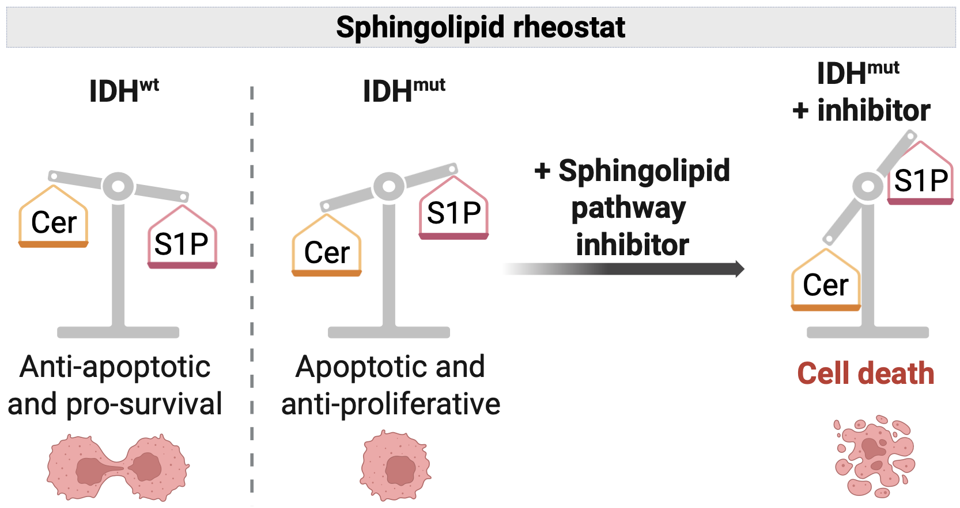

Supplementary Table S1. Values are derived from GEPIA3 DIY analysis and are provided for descriptive purposes.

Supplementary Figure S2. Western blot showing R132H-IDH1 mutation expression in human glioma cell lines. α-tubulin was used as a loading control.
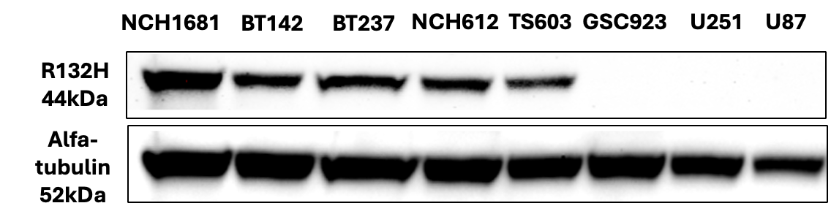

Supplementary Figure S3. Kaplan–Meier survival analysis of glioma patients stratified by ASAH1 expression across independent cohorts and tumor subtypes. Overall survival analyses were performed using data from The Cancer Genome Atlas (TCGA) and the Chinese Glioma Genome Atlas (CGGA). Patients were stratified into high and low ASAH1 expression groups based on tumor expression levels. Kaplan–Meier curves are shown for the major glioma subtypes, including oligodendroglioma, astrocytoma, and glioblastoma. Hazard ratio (HR), log-rank p value, and Wilcoxon p value are indicated in each plot.
TCGA data
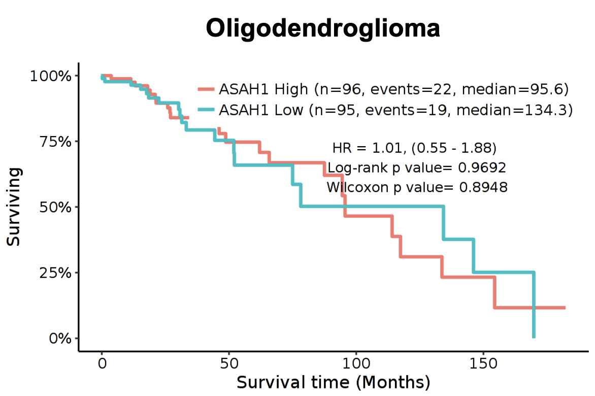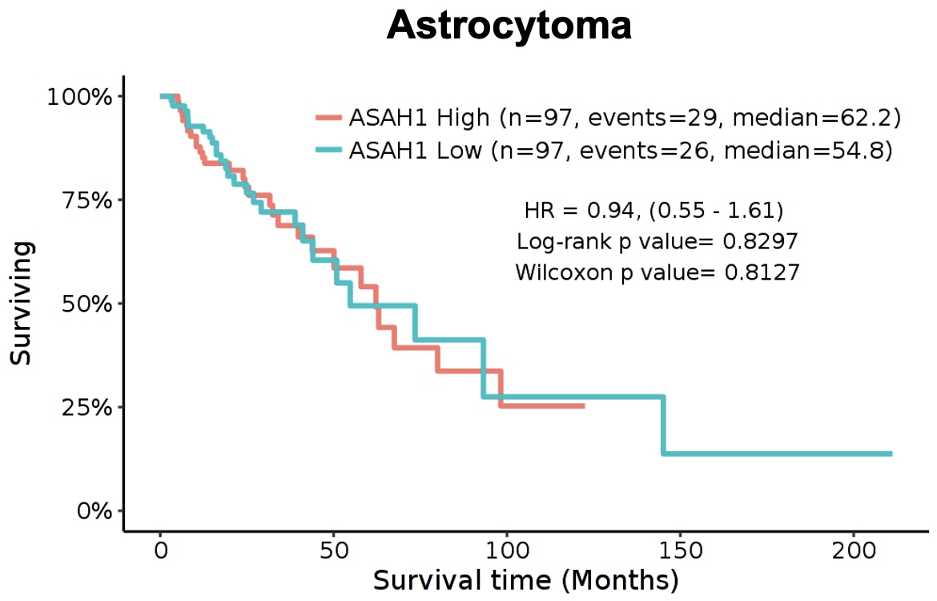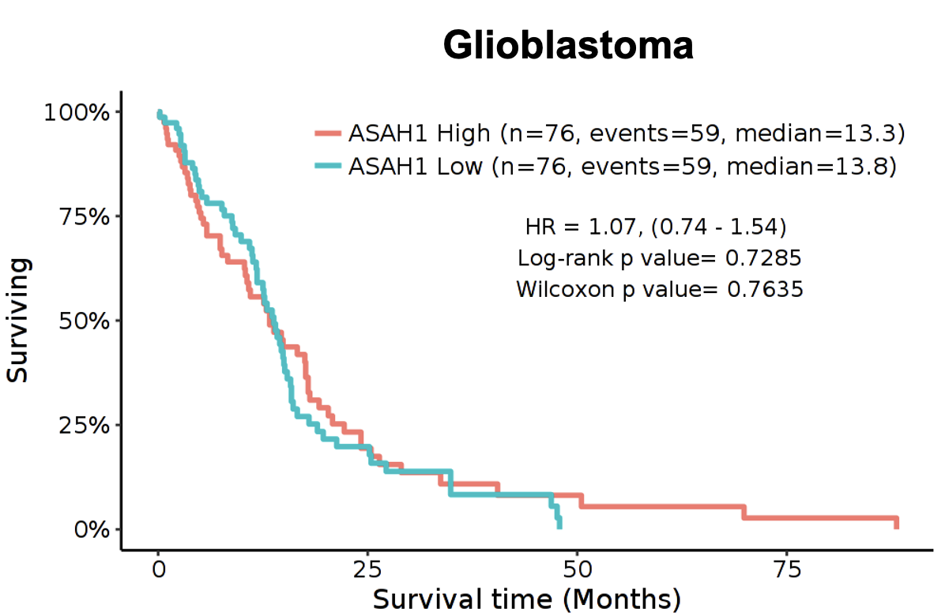

CCGA data
Astrocytoma
Glioblastoma
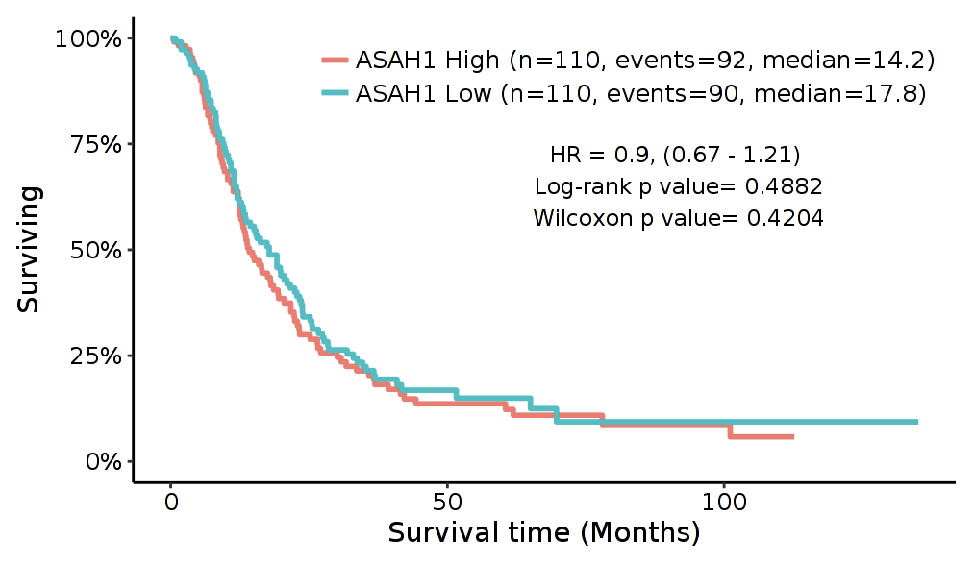
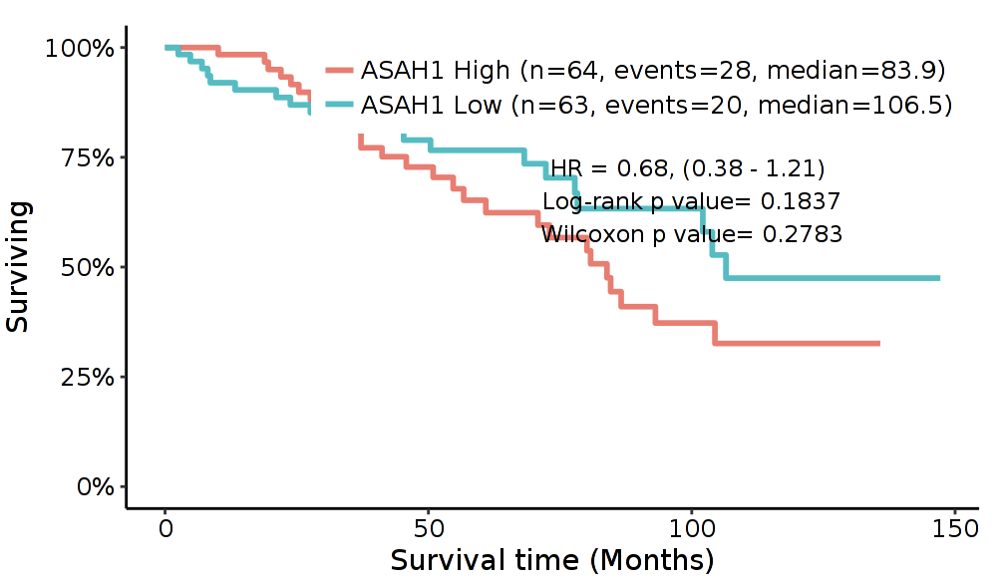

Supplementary Figure S4. Chemical structure of SABRAC drug.
Supplementary Table S2. Nonlinear regression parameters for dose-response analysis. Cell viability was assessed using the Cell Counting Kit-8 assay after 48 h exposure. Summary of four-parameter logistic nonlinear regression fits (concentration-response, variable slope) used to calculate IC₅₀ values for human glioma cell lines treated with SABRAC (0–200 µM). Values were normalized to the mean of untreated controls (0 µM), set to 1. Nonlinear regression was performed using ordinary least squares with strict convergence criteria (maximum 1000 iterations). The top plateau was constrained to 1 and the bottom plateau constrained to 0. Reported parameters include IC₅₀ (µM) with asymmetrical 95% confidence intervals, Hill slope, coefficient of determination (R²), Sy.x (standard error of the estimate), and degrees of freedom (DF). Each replicate from at least three biological independent experiments (≥3 technical replicates per concentration) was included as an individual data point in the regression.

Supplementary Figure S5. Images of TS603 and NCH612 cells after 48 h under vehicle and SABRAC treatment, were acquired using an EVOS™ M5000 Imaging System microscope with a bright field objective of magnification 4×.

Supplementary Figure S6. BT142 cells were treated with different acid ceramidase (AC) inhibitors (SOBRAC, SOCLAC, SACLAC, and SABRAC) at concentrations ranging from 0.0625 to 48 µM for 48 h. Cell viability was measured by Cell Counting Kit-8 assay and normalized to seeding values (time 0 set to 1). Four-parameter logistic nonlinear regression fits (concentration-response, variable slope) was used to calculate IC₅₀ values. Nonlinear regression was performed using ordinary least squares with strict convergence criteria (maximum 1000 iterations). The top plateau was constrained to 1 and the bottom plateau constrained to 0. Reported parameters include IC₅₀ (µM) with asymmetrical 95% confidence intervals, Hill slope, coefficient of determination (R²), Sy.x (standard error of the estimate), and degrees of freedom (DF). Each replicate from at least three biological independent experiments (≥3 technical replicates per concentration) was included in the regression. The upper panel shows the fitted dose-response curves with mean ± SD error bars. SABRAC, which exhibited the lowest IC₅₀, was selected for subsequent experiments.

Supplementary Figure S7. TS603 cells were treated with 0, 5, 10, or 20 µM SABRAC for 48 h followed by lipidomic analysis. Ceramide levels are shown as abundance normalized to internal standards and protein content. Individual points represent biologically independent replicates (n = 4 per group). Boxes indicate the interquartile range with median; whiskers denote minimum-maximum values. Top panel shows normalized ceramide species abundance. Bottom panel represents the identical dataset, expressed as fold change relative to control. Normalized abundance values were log-transformed and analyzed by two-way repeated-measures ANOVA (including interaction) with Geisser–Greenhouse correction. Comparisons were performed versus the corresponding control condition within each ceramide species, with FDR control using the Benjamini–Krieger–Yekutieli method; FDR-adjusted p values are shown.

Supplementary Figure S8. Heatmap depicting fold changes relative to control of ceramide and complex sphingolipid species measured by LC–MS in TS603 cells treated with 0, 5, 10, or 20 µM SABRAC for 48 h.

Supplementary Figure S9. Schematic overview of sphingolipid metabolism and ceramide redistribution. Ceramide occupies a central position in sphingolipid metabolism and can be generated through de novo synthesis or sphingomyelin hydrolysis. Under conditions of ceramide accumulation, excess ceramides may be redistributed into multiple downstream metabolic pathways, including conversion to sphingomyelin, glycosphingolipids, or other ceramide-derived species.
Supplementary Figure S10. Heatmap of Reactome glycosphingolipid metabolism pathway leading-edge gene expression in NCH612 and TS603 cells following SABRAC treatment. Expression values were row-scaled using transformed expression data. Leading-edge genes were defined by preranked Gene set enrichment analysis (GSEA) of the Reactome glycosphingolipid metabolism gene set to highlight transcriptional responses shared across both cell lines. Cells were treated with 7.5 µM SABRAC for 24 h (NCH612) or 6 h (TS603) with n = 4 independent biological replicates per group. Differential expression analysis was performed using DESeq2.

Supplementary Figure S11. Principal component analysis (PCA) plots of RNA-seq data from TS603 cells treated with 7.5 μM of SABRAC for 6 h and NCH612 cells treated with 7.5 μM of SABRAC for 24 h are shown in separate panels. PCA was performed on normalized expression values to visualize global transcriptional differences between treatment conditions.
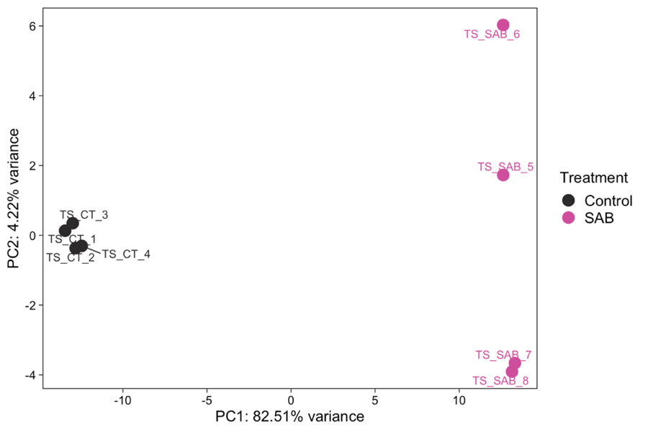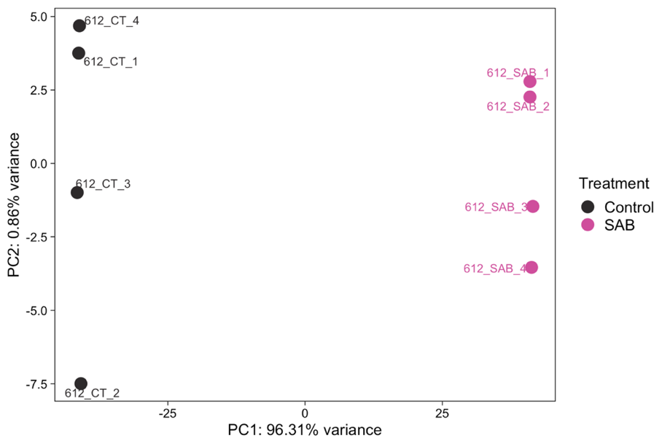

Supplementary Figure S12. TS603 cells were treated with 10 µM SABRAC for the indicated times (0 h, 30 min, 2 h, 4 h) and followed by lipidomic analysis. Ceramide levels are shown as abundance normalized to internal standards and protein content. Individual points represent biologically independent replicates (n = 4 per group). Boxes indicate the interquartile range with median; whiskers denote minimum-maximum values. Top panel shows normalized ceramide species abundance. Bottom panel represents the identical dataset, expressed as fold change relative to control. Normalized abundance values were log-transformed and analyzed by two-way repeated-measures ANOVA (including interaction) with Geisser–Greenhouse correction. Comparisons were performed versus the corresponding control condition within each ceramide species, with FDR control using the Benjamini–Krieger–Yekutieli method; FDR-adjusted p values are shown.

Supplementary Figure S13. Ceramide abundance in AC knockout (KO) and empty vector (EV) TS603 cells measured by lipidomic analysis. Ceramide levels are shown as abundance normalized to internal standards and protein content. Individual points represent biologically independent replicates (n = 4 per group). Boxes indicate the interquartile range with median; whiskers denote minimum-maximum values. Top panel shows normalized ceramide species abundance. Bottom panel represents the identical dataset, expressed as fold change relative to control. Normalized abundance values were log-transformed and analyzed by two-way repeated-measures ANOVA (including interaction) with Geisser–Greenhouse correction. Comparisons were performed versus the corresponding control condition within each ceramide species, with FDR control using the Benjamini–Krieger–Yekutieli method; FDR-adjusted p values are shown. Representative immunoblot images demonstrating the knockout of acid ceramidase (AC) in TS603 cells are shown below. β-actin was used as a loading control.

Supplementary Figure S14. A. Schematic representation of the experimental protocol. B. Graph showing how SABRAC increases C12-NBD Ceramide in the lysosomes in TS603 cells. Ceramide fluorescence intensities were normalized by time 0 and the control values. Results are shown as mean ± SEM from 3 independent experiments performed in 8 replicates. Regression analysis followed by comparison of slopes was applied (n= 24 fields—5 z-stacks and 57 time points for each one—per condition). C. Confocal images from Control- and SABRAC- treated TS603 cells showing the regions of interest (ROI, lysosomes, mitochondria and overlapping surface between lysosomes and mitochondria) that were automatically selected for C12-NBD Ceramide fluorescence quantification. Ceramide increase under SABRAC treatment is highlighted by the presence of merged colors as yellow (ceramide in lysosomes) and cyan (ceramide in the mitochondria).

A.

B.

C.

Supplementary Figure S15. Cytochrome c (Cyt c) release by Raman spectroscopy. Raman spectra of living TS603 oligodendroglioma cells (treated with 10µM SABRAC or vehicle for 5 hours) was obtained with 532nm excitation. Raman spectral profiles were fixed at 1306 and 1317 cm⁻¹. One graph representing how SABRAC increases the mean intensity of cyt c in cell, and another one demonstrating that the increase in area of cyt c in cell under SABRAC treatment is not associated to differences in cell area. Five independent biological experiments were performed, each with at least four technical replicates per condition. Eighteen control cells and nineteen SABRAC-treated cells were analyzed. Individual values are shown with mean ± SEM. Statistical significance was determined using an unpaired two-tailed Student’s t-test after confirmation of normal distribution (Shapiro–Wilk test).

Supplementary Figure S16. Raman spectra of TS603 oligodendroglioma living cells treated with 10 µM SABRAC for 5 hours, obtained with 532nm excitation. The gray square indicates the peak related to cytochrome c.

Supplementary Figure S17. Representative immunoblot images showing apoptotic markers in NCH612 cells treated with SABRAC for 48 h at the indicated concentrations. β-actin was used as a loading control.

Supplementary Figure S18. Representative immunoblot images showing cleavage of Caspase 8 in TS603 cells treated with SABRAC for 48 h at the indicated concentrations. β-actin was used as a loading control.
Supplementary Figure S19. Volcano plot depicting differential gene expression in TS603 cells following SABRAC treatment (7.5 µM, 6 h), generated from DESeq2 analysis. Representative upregulated ER stress- and UPR-associated genes and downregulated genes associated with proliferation and metabolism are highlighted.
Supplementary Figure S20. Gene set enrichment analysis (GSEA) performed in TS603 cells following SABRAC treatment (7.5 µM, 6 h) demonstrating significant enrichment of ER stress- and apoptosis-related transcriptional programs, including the Hallmark UPR gene set, Reactome ATF4-dependent signaling in response to ER stress, and GO Biological Process intrinsic apoptotic signaling pathway in response to ER stress. Enrichment plots are shown for representative gene sets. Enrichment score (ES), normalized enrichment score (NES), nominal p-value, and false discovery rate (FDR q-value) are indicated in the graph.

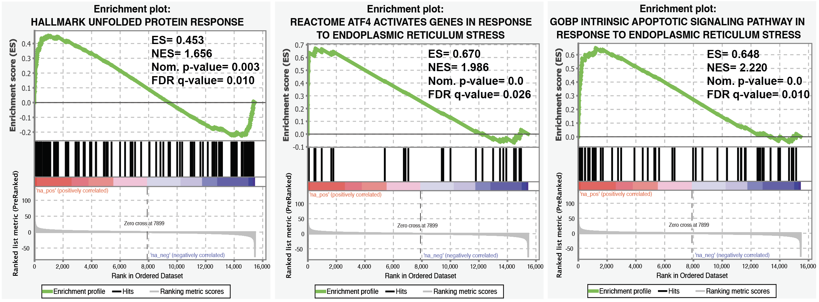

Supplementary Tables 3-10. Transcriptomic pathway enrichment analysis following SABRAC treatment in oligodendroglioma cells. RNA-seq was performed on NCH612 and TS603 oligodendroglioma cells treated with the drug (7.5 µM) for 24 h (NCH612) or 6 h (TS603). Gene set enrichment analysis (GSEA) was conducted using the Hallmark, Reactome, and Gene Ontology Biological Process (GOBP) collections. For each cell line, separate tables list the top 20 significantly enriched upregulated and downregulated pathways. Pathways highlighted in orange correspond to those discussed in the main text and demonstrate consistent modulation across gene set collections and cell lines.

Supplementary Figure S21. Ingenuity Pathway Analysis (IPA) canonical pathway diagram illustrating modulation of the unfolded protein response (UPR) following SABRAC treatment in NCH612 cells. RNA-seq data from NCH612 oligodendroglioma cells treated with SABRAC (7.5 µM) for 24 h were analyzed using IPA. Differentially expressed genes were filtered using an absolute log2 fold change cutoff of ≥1, with adjusted p value ≤ 0.05. The UPR canonical pathway is shown, including key UPR branches (PERK–ATF4–DDIT3, IRE1–XBP1, and ATF6 signaling). Nodes are colored according to IPA’s predicted activation state, as indicated in the accompanying legend. A clear predicted activation of the pathway was observed.

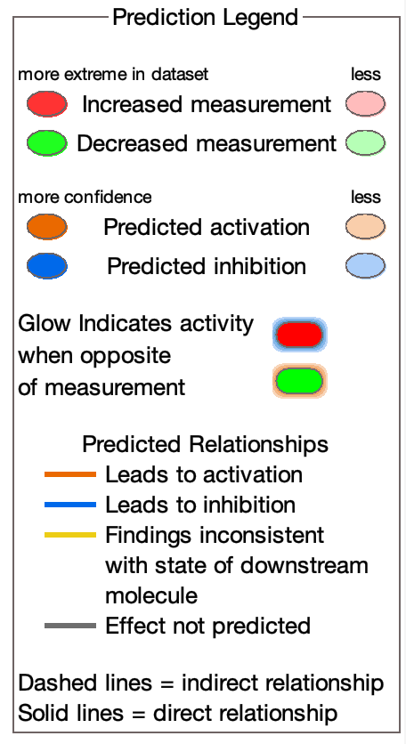

Supplementary Figure S22. Ingenuity Pathway Analysis (IPA) of differentially expressed genes in TS603 SABRAC-treated cells. RNA-seq data from TS603 oligodendroglioma cells treated with SABRAC (7.5 µM) for 6 h were analyzed using IPA. IPA of differentially expressed genes is displayed as a horizontal bar graph with pathways ranked by -log(Benjamini–Hochberg–adjusted p-value), where pathway activation or inhibition is indicated by Z-score (orange, activated; blue, inhibited).

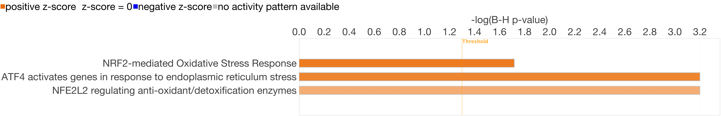

Supplementary Tables 11-12. Ingenuity Pathway Analysis (IPA) upstream regulator analysis following SABRAC treatment in oligodendroglioma cells. IPA upstream regulator analysis was performed on RNA-seq data from NCH612 and TS603 oligodendroglioma cells treated with the drug (7.5 µM) for 24 h or 6 h, respectively. Differentially expressed genes were filtered using an absolute log2 fold change cutoff of ≥1 for NCH612 and ≥0.75 for TS603, with adjusted p value ≤ 0.05. For each cell line, tables display the 5 top transcriptional upstream regulators meeting the following criteria: Benjamini–Hochberg-adjusted p value ≤ 0.05 and absolute activation z-score ≥ 2, ordered by expression log fold change. In both cell lines, the identified regulators were predominantly associated with ER stress and unfolded protein response signaling, including ATF4 and NUPR1, with additional cell line-specific regulators observed.

Supplementary Figure S23. Representative immunoblot images showing increased ATF4 protein expression in TS603 and NCH612 oligodendroglioma cells treated with SABRAC (7.5 µM) for 6 h (TS603) or 24 h (NCH612). β-actin was used as a loading control.

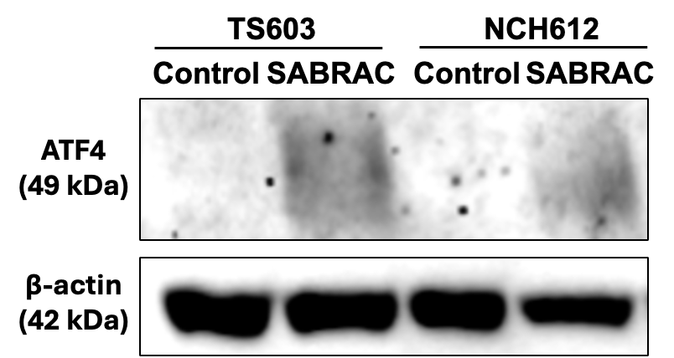

Supplementary Figure S24. Representative immunoblot images showing increased p8 protein expression in TS603 cells treated with SABRAC for 48 h at the indicated concentrations. β-actin was used as a loading control.
Supplementary Figure S25. Mice study for assessment of SABRAC toxicity. Line graph showing lack of toxicity of SABRAC in female SCID mice (n = 4 per group). SABRAC was administered intraperitoneally five times per week. Data normality was assessed using the Shapiro–Wilk test prior to statistical analysis. Two-way ANOVA was applied (ns, p > 0.05).

Supplementary LC–MS data

MSConvert parameters were as follows: peak picking - vendor-specific, MS level, 1-; .mzML output, write index, use TPP compatibility, use zlib compression, use numpress linear compression. MZMine 3 processing was performed per the following steps: mass detection - auto, MS1, level =1, 5.0E2 noise level; mass detection - auto, MSn, level ≥ 2, 1.0E2 noise level; ADAP chromatogram builder - 0.40 - 19.6 min retention time; MS1, level = 1; 4 minimum consecutive scans; 8.0E2 min intensity for consecutive scans, 8.0E2 min absolute height, 0.005 m/z or 20 ppm m/z tolerance; smooting - Savitzky Golay smoothing algorithm, Retention time smoothing = 5; local minimum feature resolver - MS/MS scan pairing (✓), 0.01 m/z or 20 ppm, Use feature edges, 25 % minimum relative feature height, 1 minimum required signal, dimension = retention time, 70 % chromatographic threshold, 0.03 min minimum search range, 8.0E2 minimum absolute height, 1.5 min ratio peak top/edge, 0.05 - 1.51 min peak duration range, 4 minimum scan points; 13C isotope filter - 0.0015 m/z or 3 ppm, 0.04 min retention time tolerance, monotonic shape (✓), most intense representative isotope, never remove feature with MS2 (✓); isotopic peaks grouper - H, C, N, O, S, 0.0015 m/z or 3 ppm m/z tolerance, maximum charge 1, search in scans SINGLE MOST INTENSE; join aligner - 0.004 m/z or 10 ppm m/z tolerance, 3 weight for m/z, 0.1 min retention time tolerance, 1 weight for RT; feature list rows filter - max of 3 samples of 10 % minimum aligned features, keep rows that match all criteria, feature with MS2 scan (✓), never remove feature with MS2 (✓); peak finder (multithreaded) - 20 % intensity tolerance, 0.05 m/z or 20 ppm m/z tolerance, 0.15 retention time tolerance, 1 minimum scan; duplicate peak filter - filter mode NEW AVERAGE, 0.02 m/z or 10 ppm m/z tolerance, 0.05 min RT tolerance; spectral library search - MS level ≥ 2, 0.001 or 5 ppm precursor m/z tolerance, 0.002 m/z or 10 ppm spectral m/z tolerance, 4 minimum matched signals, 0.7 minimum weight cosine similarity, weights = MassBank (Mz^2 * I^0.5); lipid annotation - all lipid classes (✓), 0 - 80 carbon atoms in chains, 0 - 15 number of double bonds in chains, 0.001 m/z or 5 ppm m/z tolerance MS1 level, 0.002 m/z or 10 ppm m/z tolerance MS2 level, 0.6 minimum MS/MS score; correlation grouping (metaCorrelate) - 0.005 min RT tolerance, 0.0E0 minimum feature height, 5.00E2 intensity threshold for correlation, 1 min samples in all, 0 min samples in group 60 % min %-intensity overlap, exclude gap-filled features (✓), feature shape correlation (✓), 5 min data points, 2 min data points on edge, measure = PEARSON, 85 % min feature shape correlation, feature height correlation (✓), 2 minimum samples, measure = PEARSON, 70 % min correlation; ion identity networking - 0.0015 m/z or 3 ppm m/z tolerance, check = ALL FEATURES, 0.0E0 min height, annotation refinement (✓), MS/MS spectral networking, 0.005 m/z or 20 ppm m/z tolerance, only best MS2 scan (✓), 500 max precursor m/z delta, 4 minimum matched signals, 0.7 min cosine similarity.

