Original western blots

Standard Precision Plus Protein Dual Color Standards (1610374 Bio-Rad) From top to bottom (250, 150, 100, 75, 50, 37, 25, 20, 15, 10 kDa)

Figure 1E

Anti-AC (40kDa) Anti-α-tubulin (52kDa)

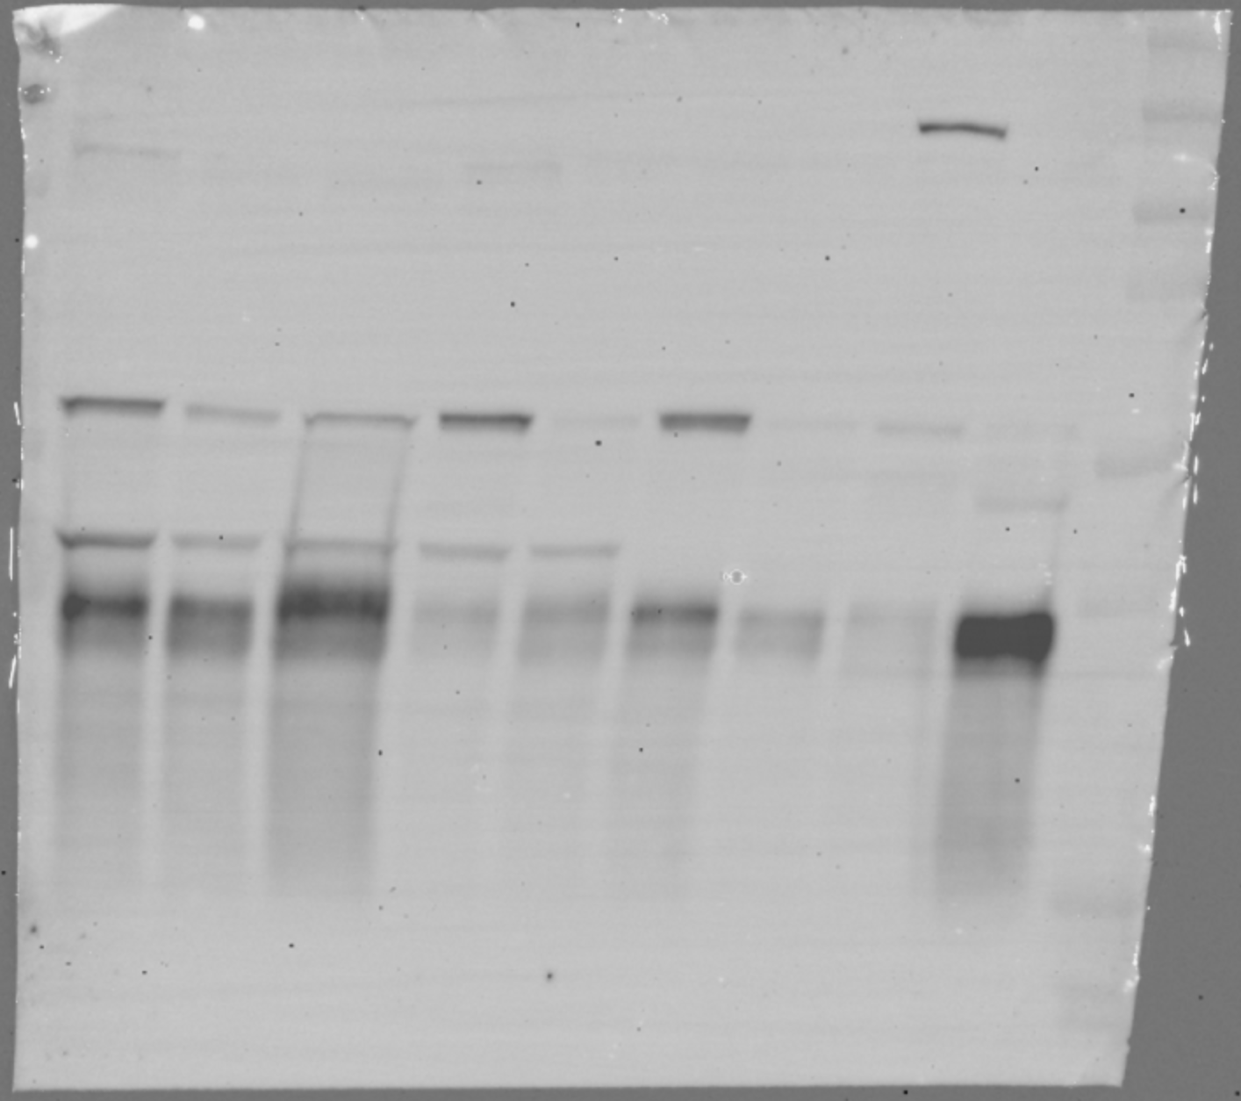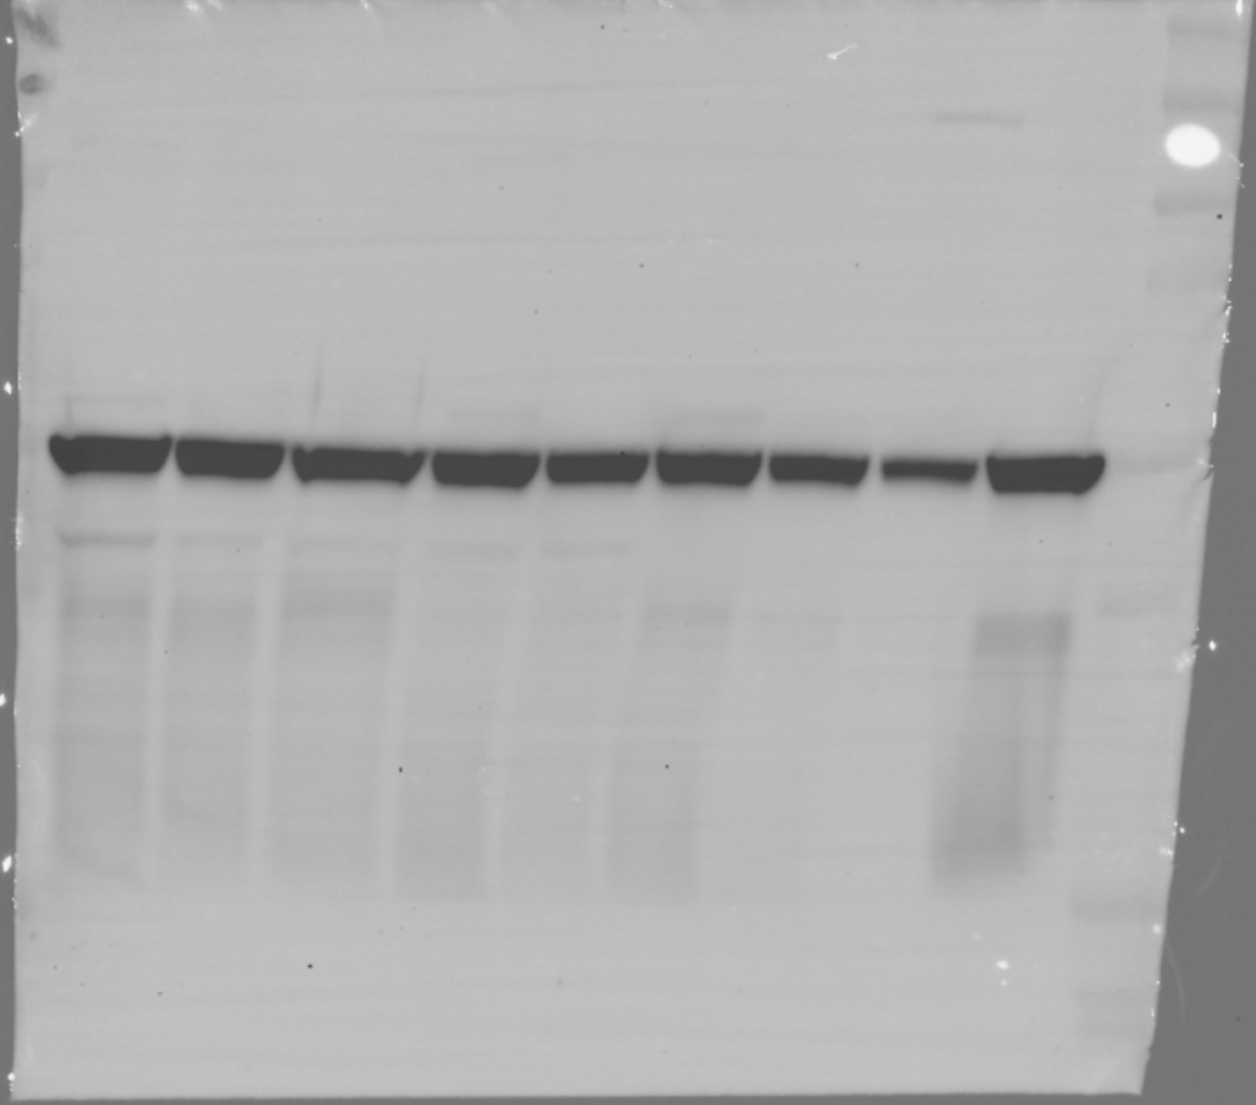

Figure 2E

Anti-AC (40kDa) Anti-β-actin (42kDa)

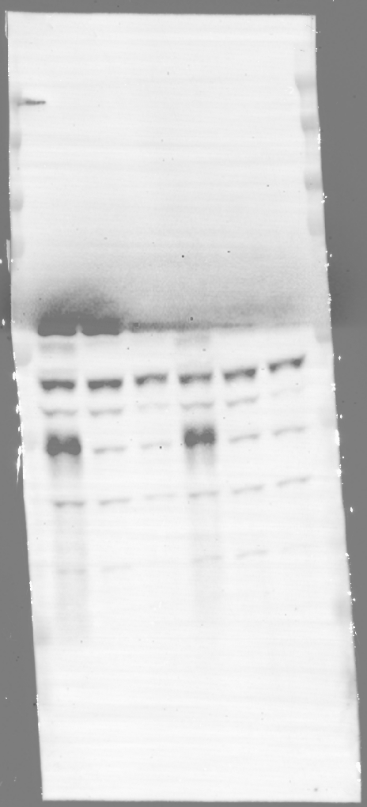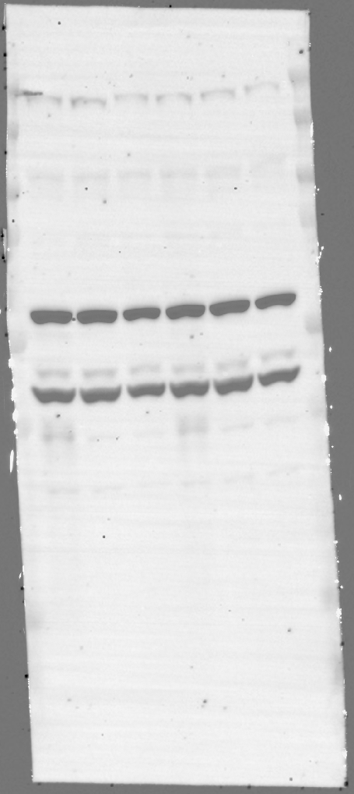

Figure 3C

Anti-Cytochrome c (14kDa) Anti-β-actin (42kDa)

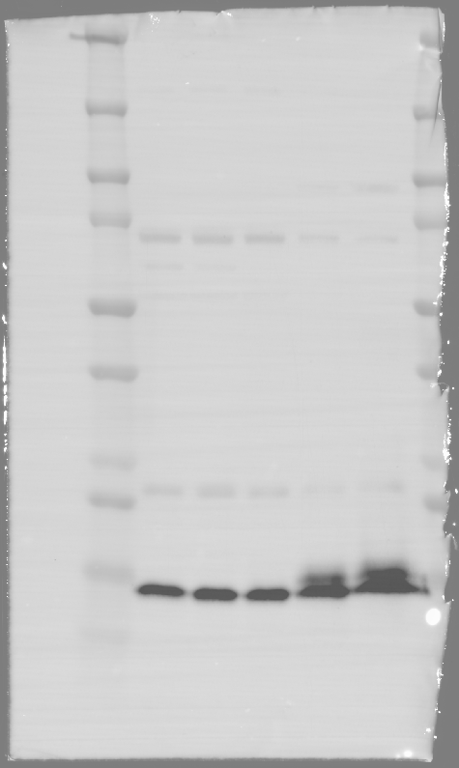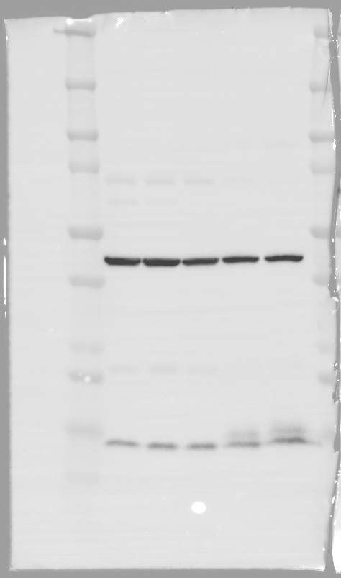

Figure 3D

Anti-BAX and anti-Cleaved-BAX (20-18kDa) Anti-β-actin (42kDa)

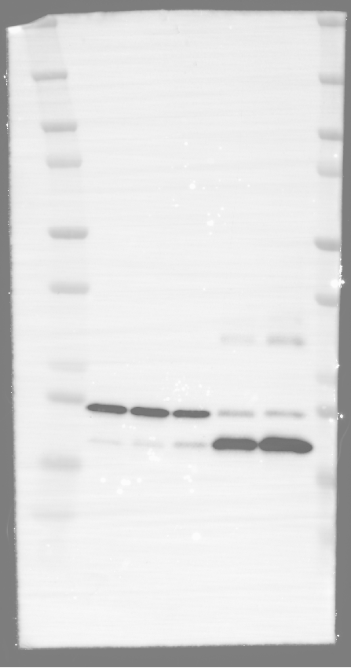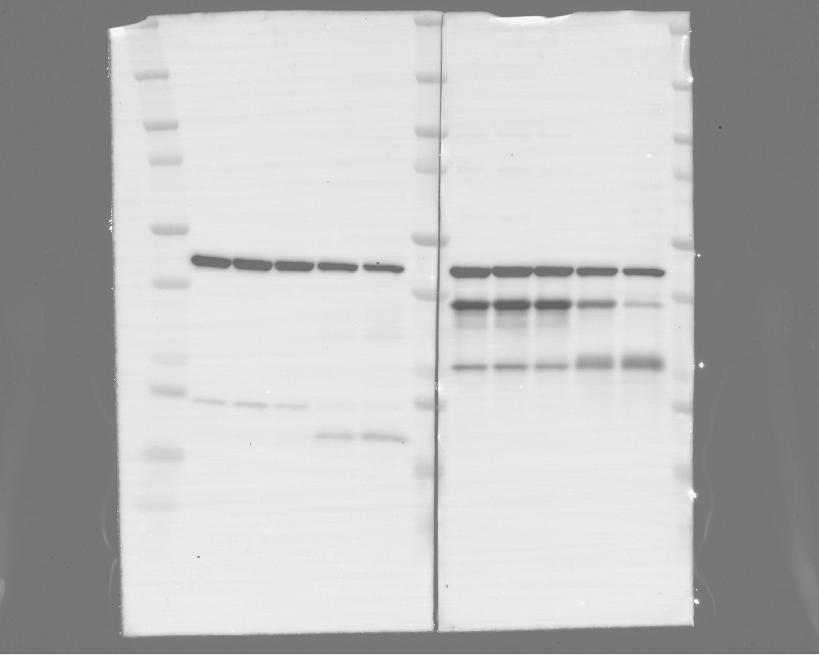
Figure 3D

Anti-BCL-2 (28kDa) Anti-β-actin (42kDa)

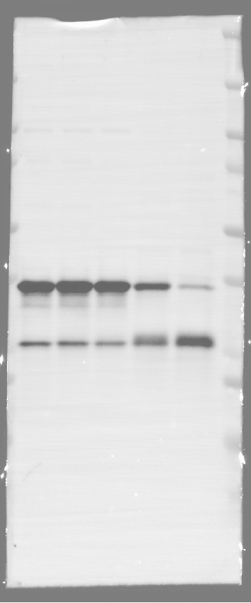

Figure 3E

Anti-Pro-Caspase 3 and anti-Caspase 3 (35-17/19kDa) Anti-β-actin (42kDa)

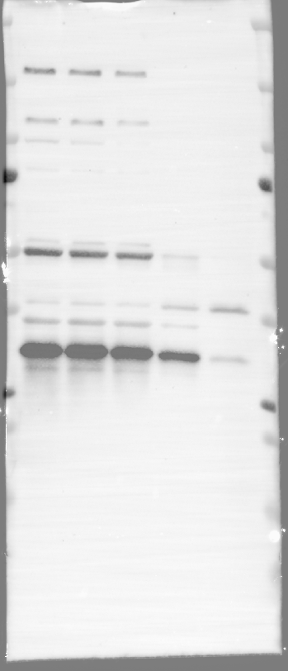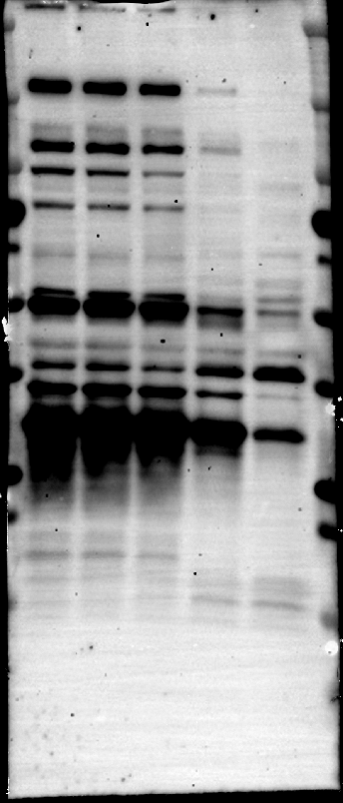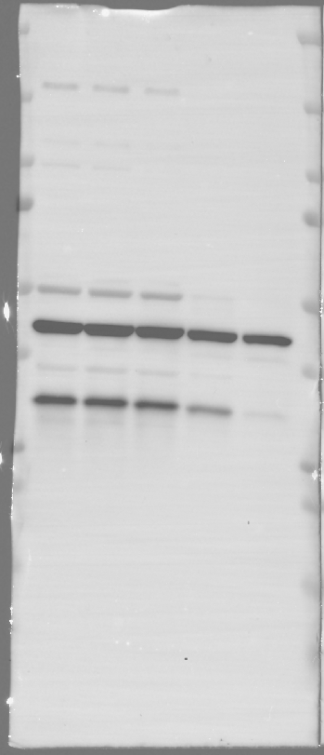
Figure 3E

Anti-Cleaved PARP1 (25kDa) Anti-α-tubulin (52kDa)

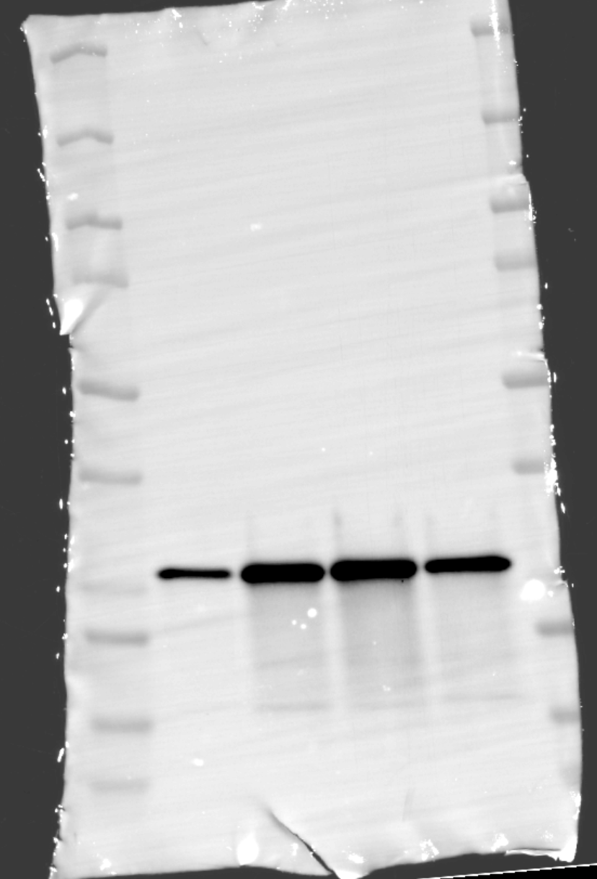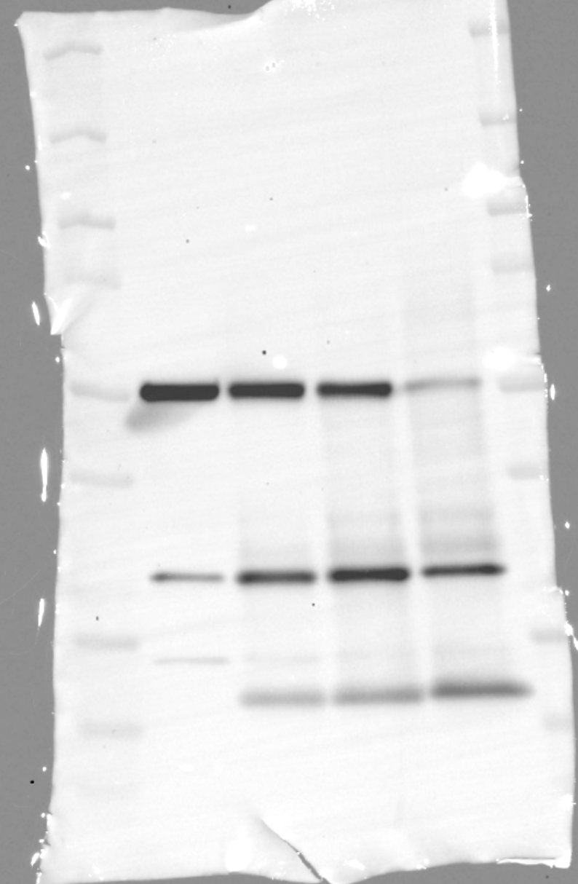

Figure 4E and F

Anti-PERK (140kDa) Anti-CHOP (30kDa) Anti-β-actin (42kDa)

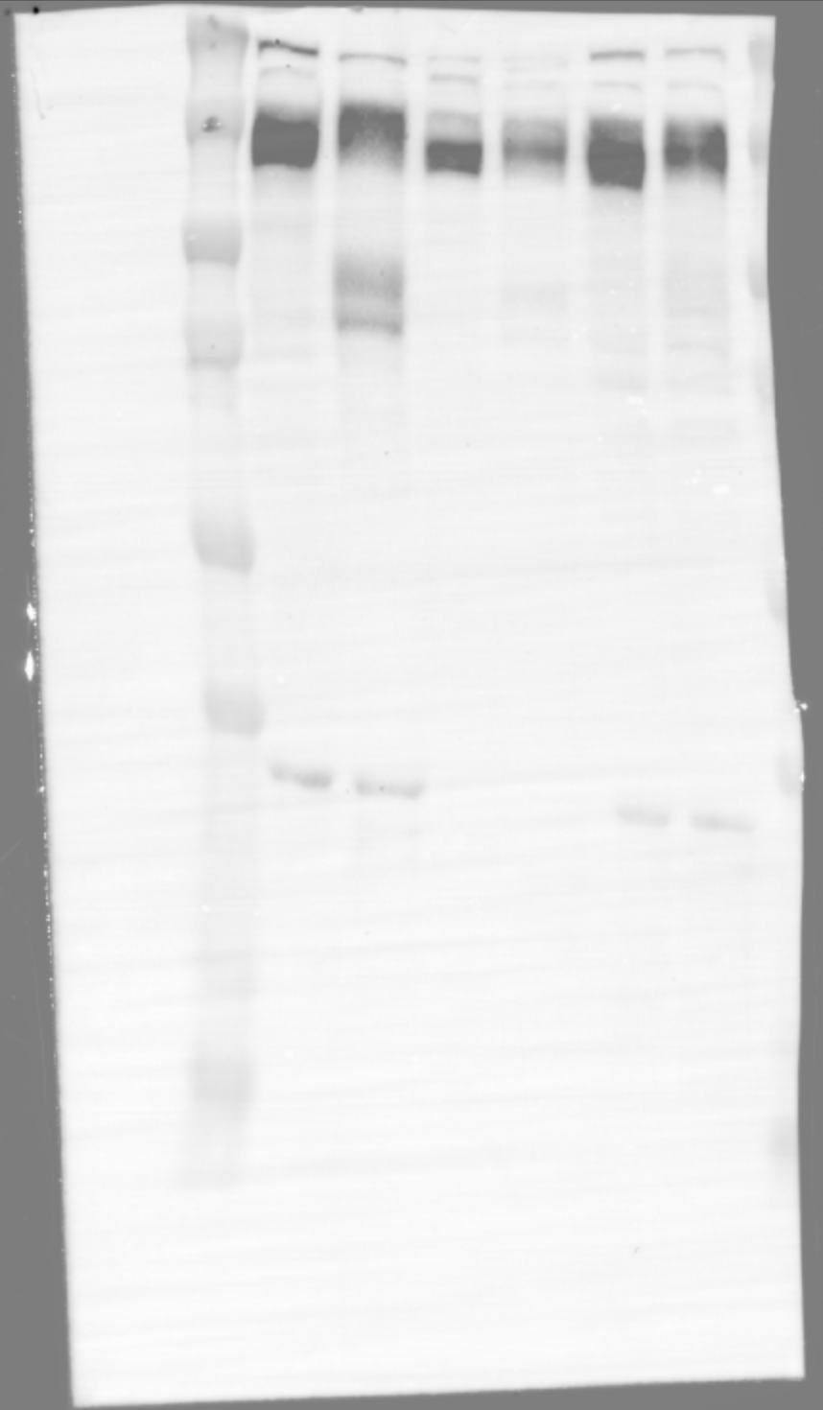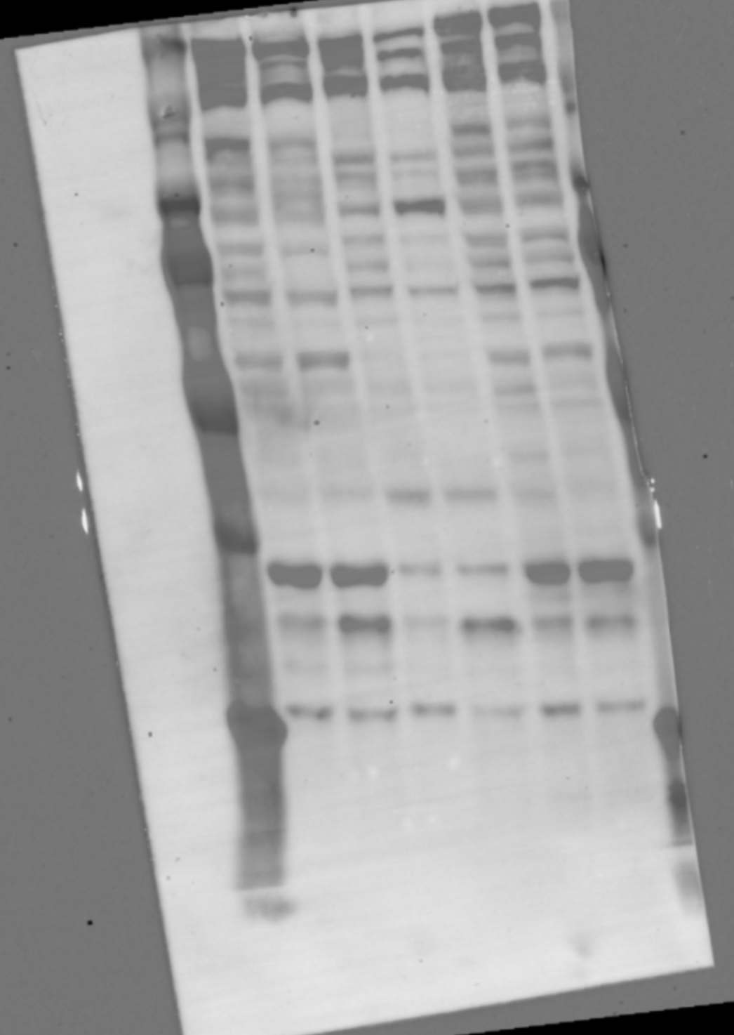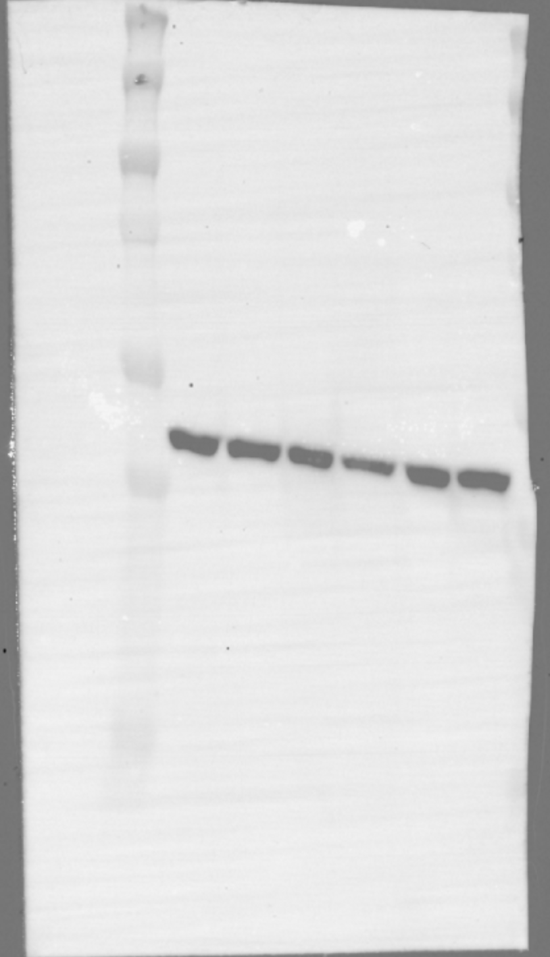

Figure 4F

Anti-ATF-4 (49kDa) Anti-β-actin (42kDa)

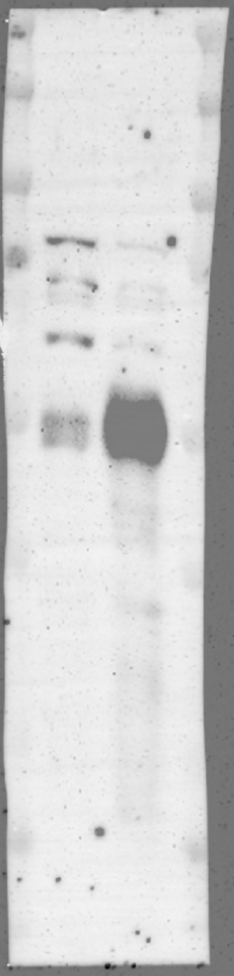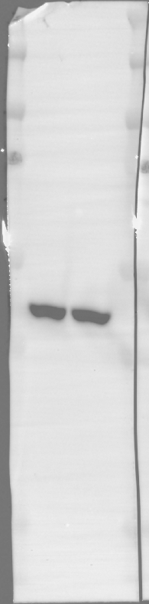

Figure S2

Anti-IDH1 (R132H) (44kDa) Anti-α-tubulin (52kDa)

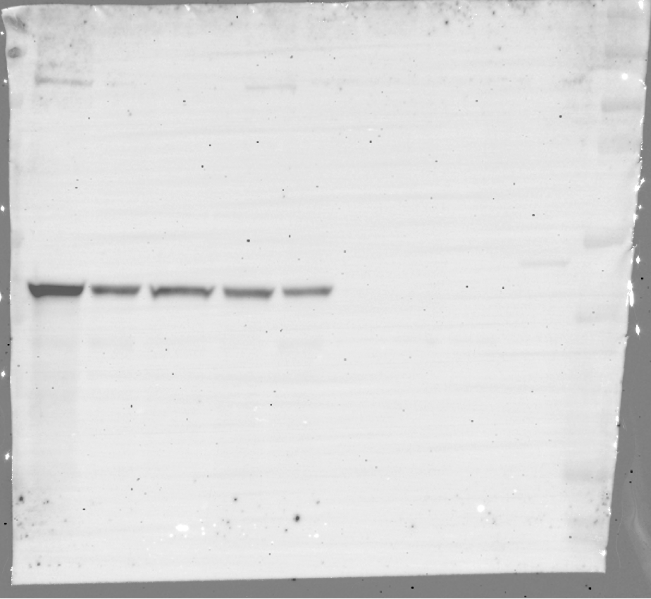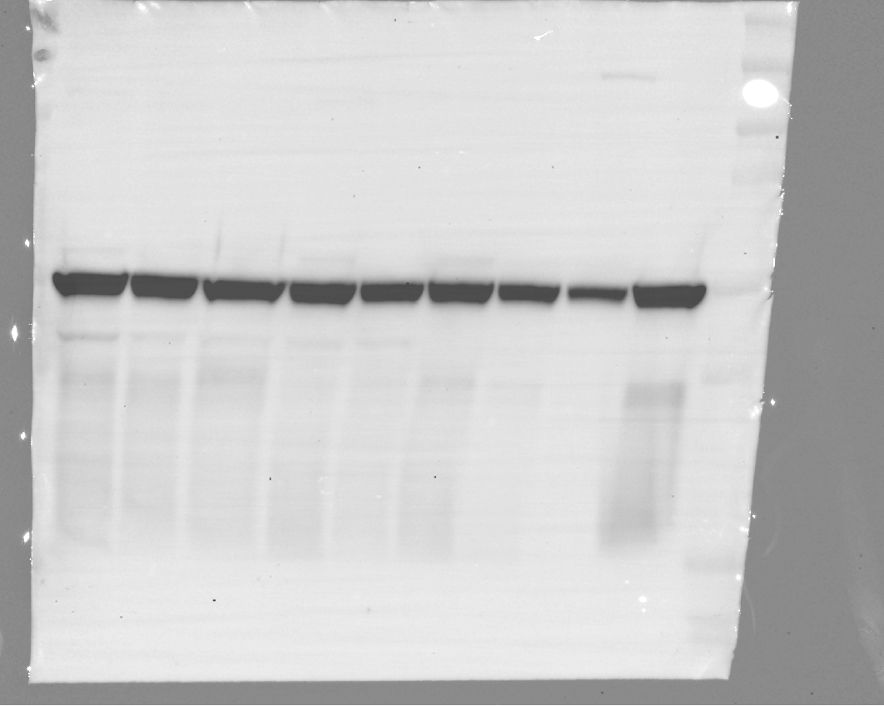

Figure S13

Anti-AC (40kDa) Anti-β-actin (42kDa)

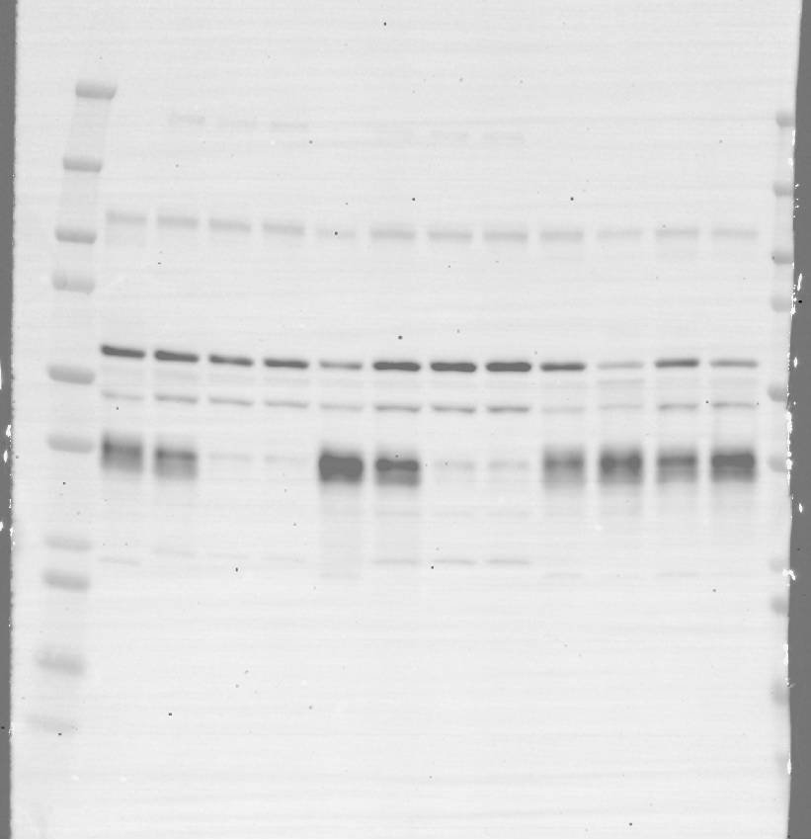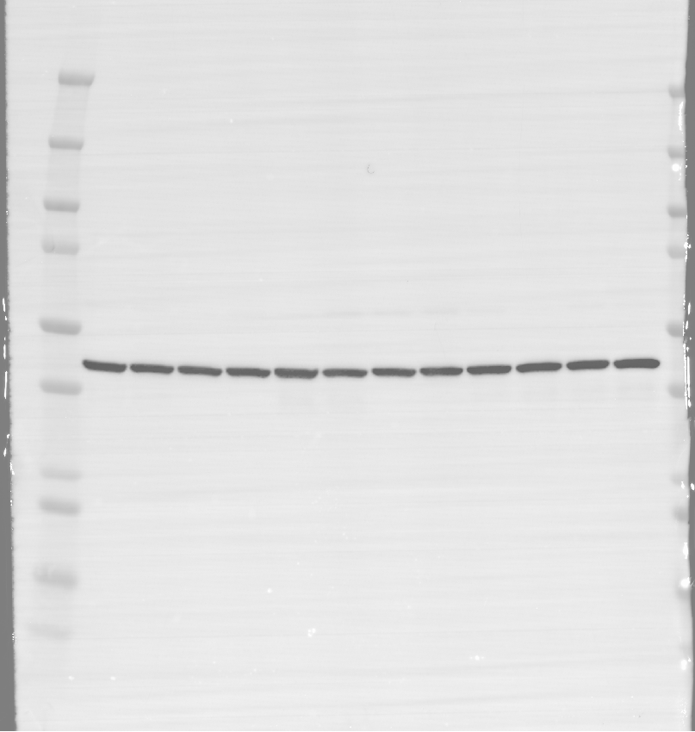

Figure S17

Anti-BAX and anti-Cleaved-BAX (20-18kDa) Anti-β-actin (42kDa)

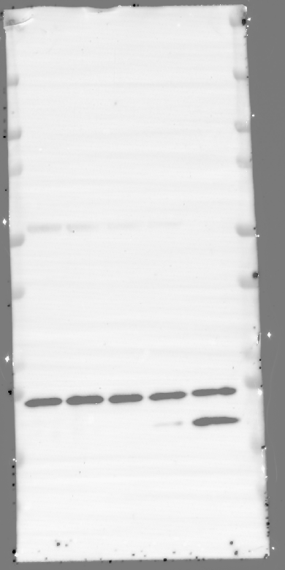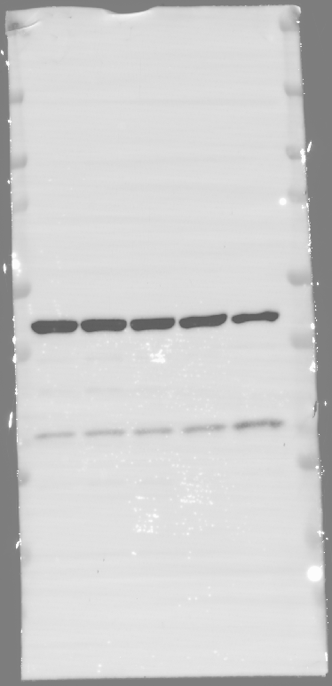

Figure S17

Anti-BCL-2 (28kDa)

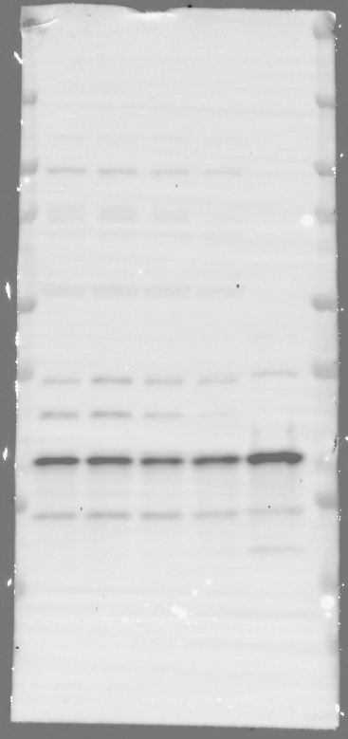

Figure S18

Anti-Pro-Caspase 8 and anti-Caspase 8 (55-18kDa) Anti-β-actin (42kDa)

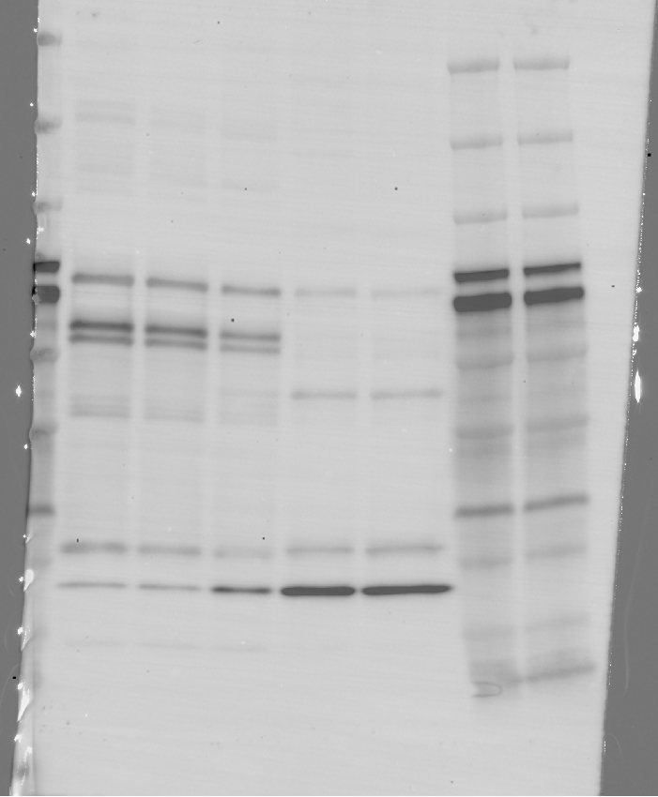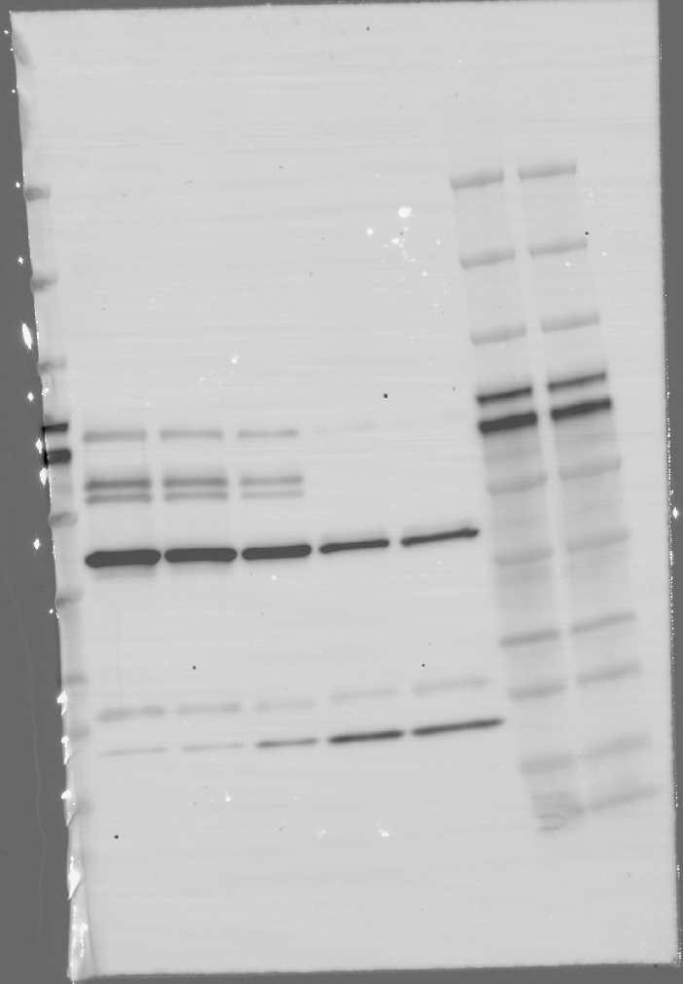

Figure S23

Anti-ATF-4 (30kDa) Anti-β-actin (42kDa)

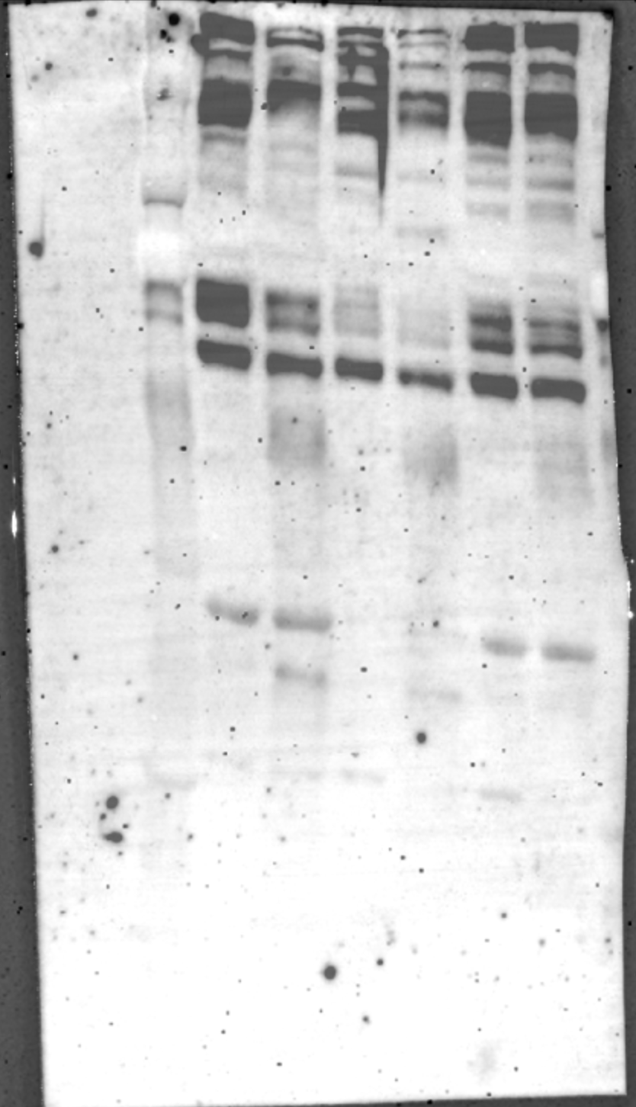

Figure S24

Anti-p8 (11kDa) Anti-β-actin (42kDa)

