Assessment of Geometric Deviations in a Complex Concrete Dome Using UAV Photogrammetry and Integrated Geodetic Techniques
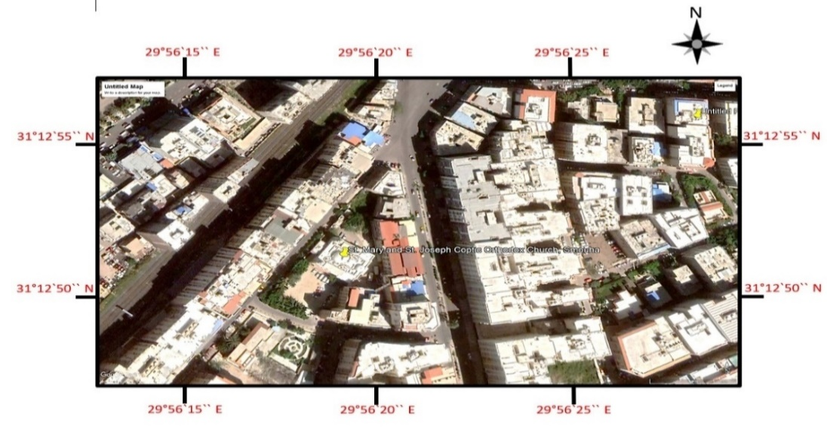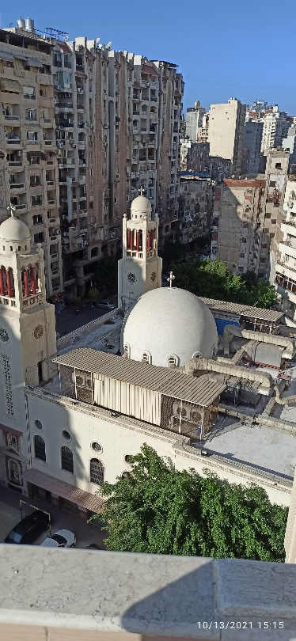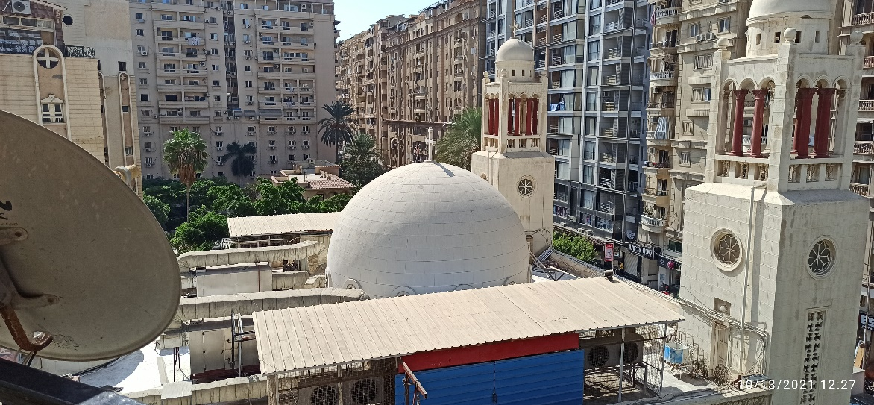
Fig.1 St. Mary& St. Joseph Church in Alexandria, Egypt
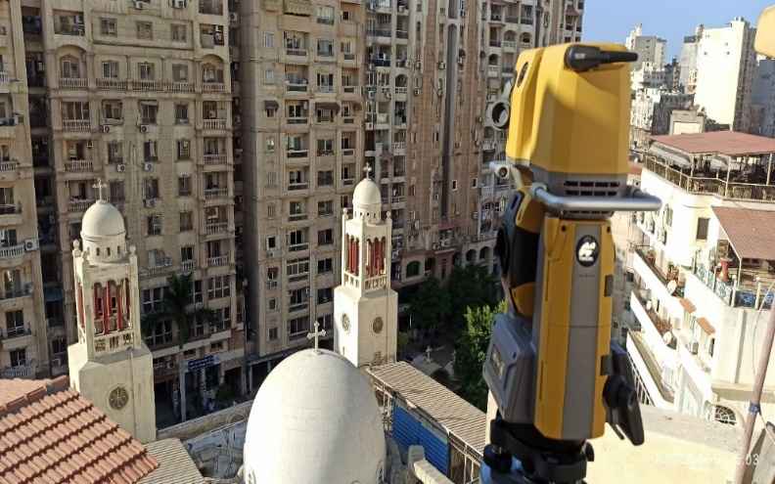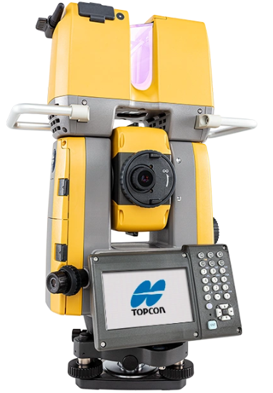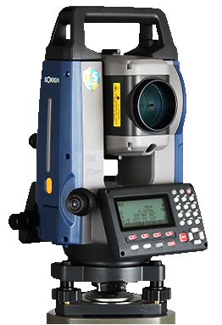

Fig.2 The instruments used (GTL-1003 Robotic Total Station and 3D Laser Scanner)
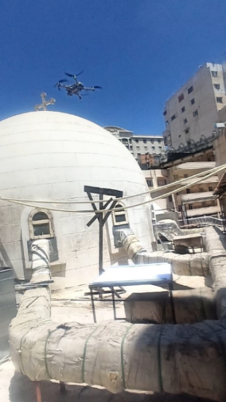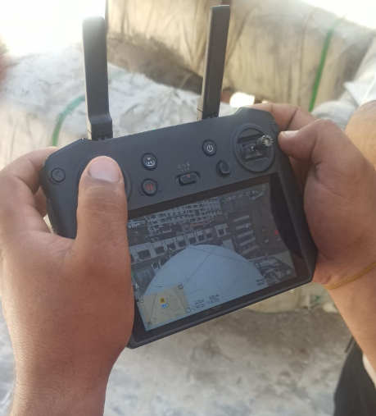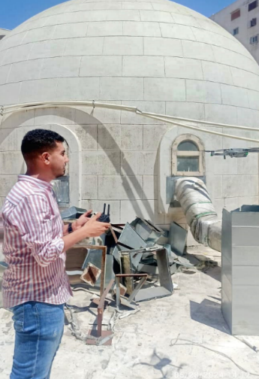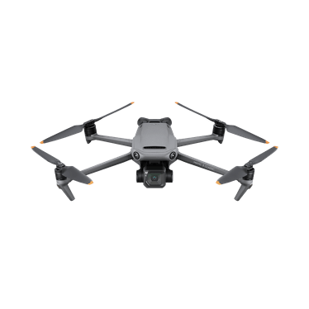

Fig.3 Using the DJI Air 3 Fly for observing the dome structure
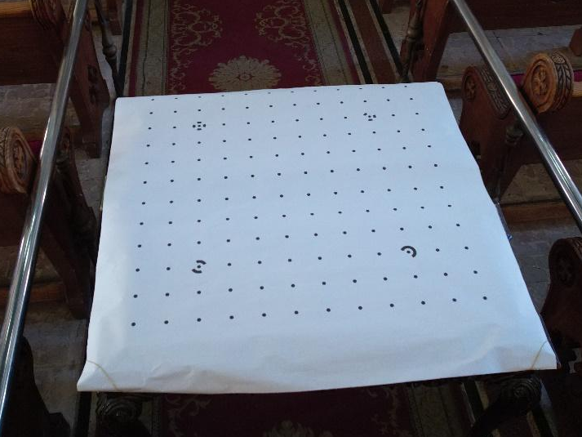
Fig.4 Calibration grid 36 x 36 in² with 4 CPs, 140 dots.
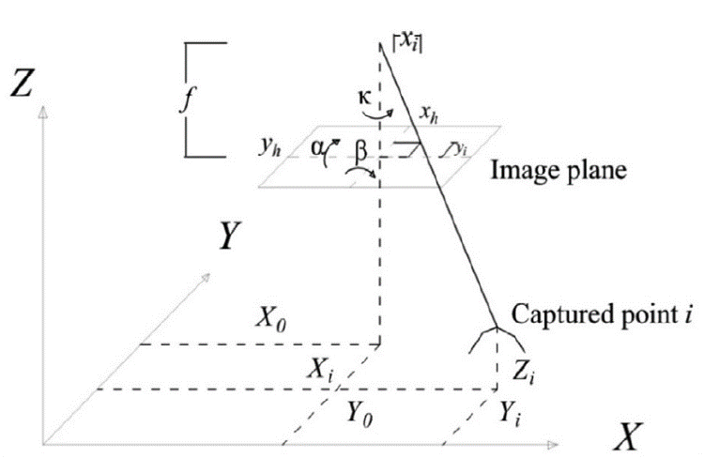
Fig.5 Digital photogrammetry parameters
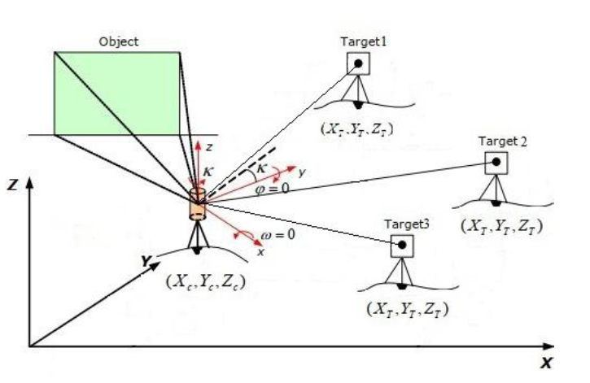
Fig.6 Geometry of resection method in TLS
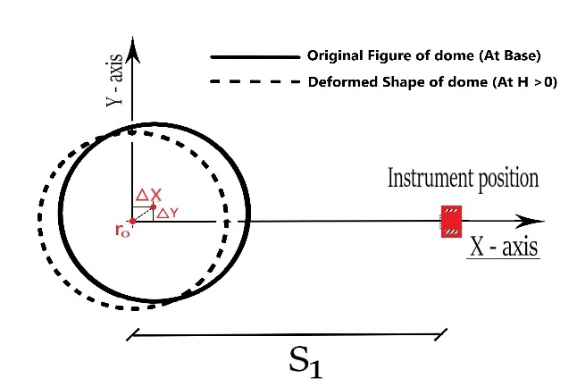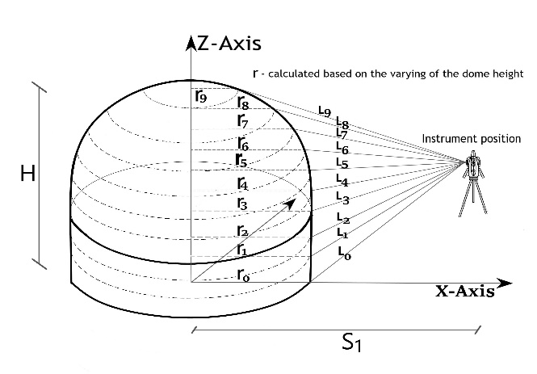

Fig.7 Geometry of determining the inclination of the Dome.
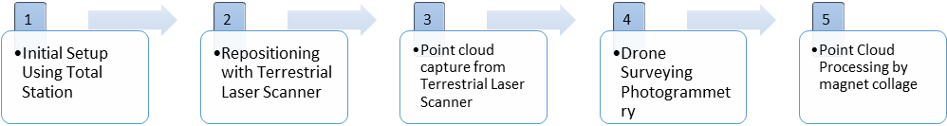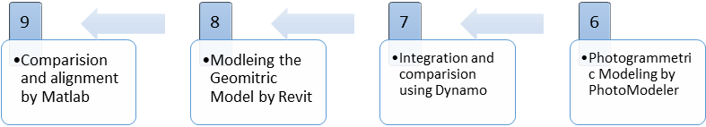
Fig.8 The procedures of the workflow
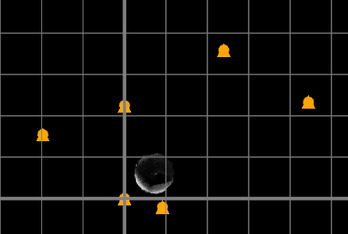
Fig.9 GCPS Layout and benchmark observations for TLS placement and network calibration

Table1: TLS Benchmarks and Target Points Specification
Points |  | type | Observations
 |  | type | X | Y | Z
1 | BM1 | Target | 1000 | 1022.468 | 99.884
2 | BM2 | Target | 1000 | 1000 | 100
3 | BM3 | Target | 1015.64 | 999.765 | 99.939
4 | BM4 | Target | 1007.565 | 971.352 | 115.525
5 | ST2 | GCPs | 1009.165 | 997.901 | 101.721
6 | ST3 | GCPs | 1023.972 | 1035.886 | 119.644
7 | ST4 | GCPs | 980.289 | 1015.438 | 115.892

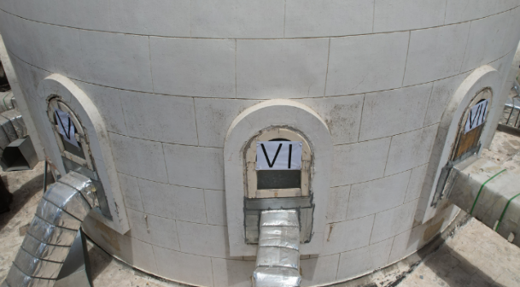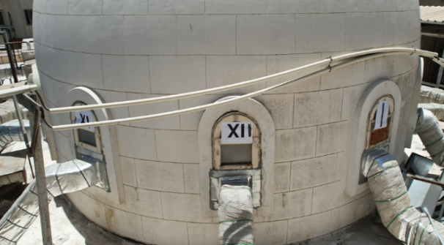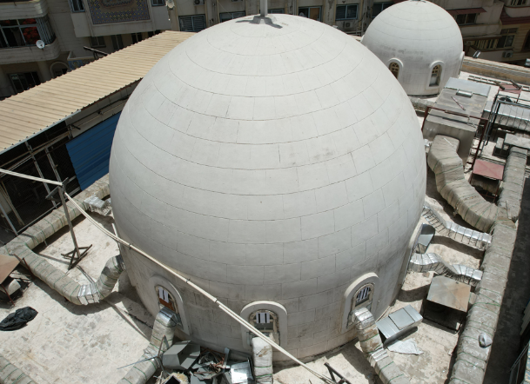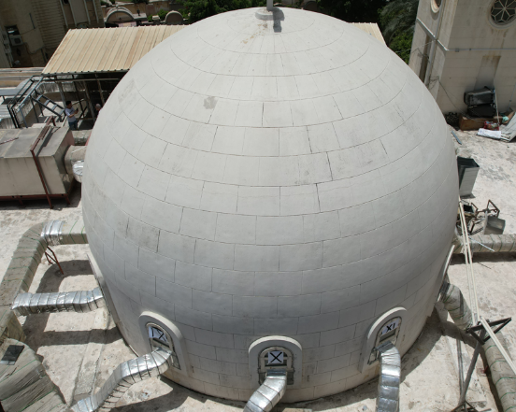

Fig.10Aerial photogrammetry uses dome imagery with various perspectives and numbered window
targets
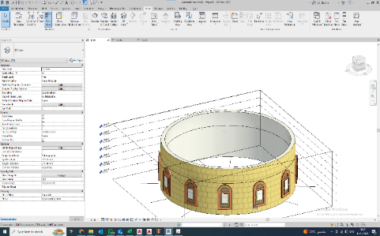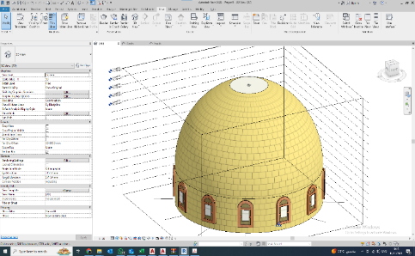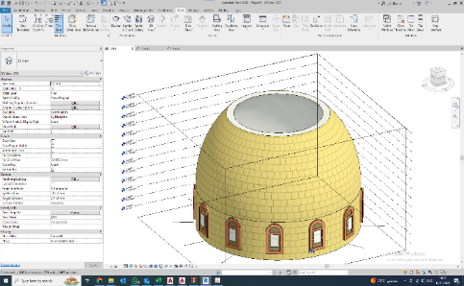

Fig.11Shows Sectional comparison between the ideal dome model and observed structure using
Revit + Dynamo.
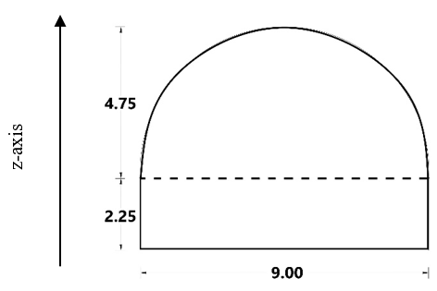
Fig.12 shows the geometric dimensions of the studied Dome outcoming resulting from geodetic
observations.
Table 2 Geometrical dimensions based on the best-fit dome shape
Base Diameter (m) | Constant height  (m) | Dome height  (m)
9 (m) | 2.25 (m) | 4.75 (m)
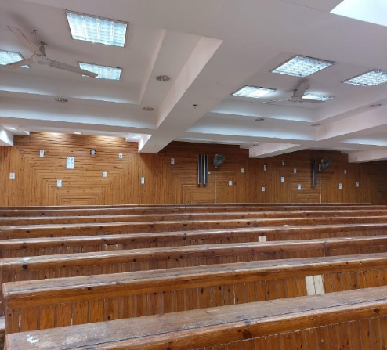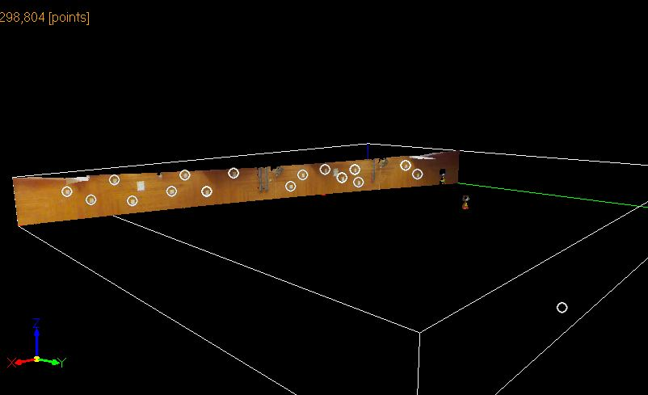

Fig.13 A photo of the site's geometric point presents the location and the counting of the observed points.
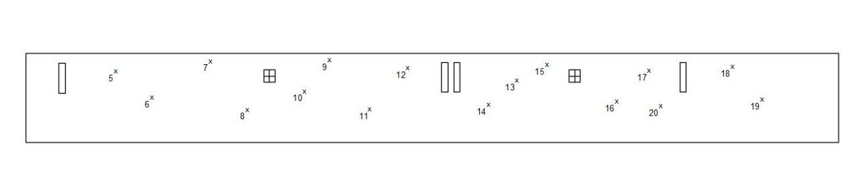
Fig.14TLS setup and points registration

Table 3The TS Reference Observation
Z | Y | X | Points
2.231 | 13.264 | -0.668 | 1
2.161 | 13.95 | -2.67 | 2
1.829 | 13.751 | -2.064 | 3
2.44 | 13.516 | -1.348 | 4
1.698 | 13.368 | -0.893 | 5
2.426 | 12.799 | 0.797 | 6
1.904 | 12.96 | 0.317 | 7
1.797 | 12.575 | 1.482 | 8
2.374 | 12.26 | 2.427 | 9
2.126 | 11.388 | 5.042 | 10
1.726 | 11.559 | 4.539 | 11
2.28 | 11.081 | 5.972 | 12
1.905 | 10.844 | 6.689 | 13
2.173 | 10.655 | 7.266 | 14
2.201 | 9.862 | 9.67 | 15
1.808 | 9.645 | 10.299 | 16
1.675 | 10.602 | 7.424 | 17

Fig.15 The differences between the accuracy and their distance from the actual point

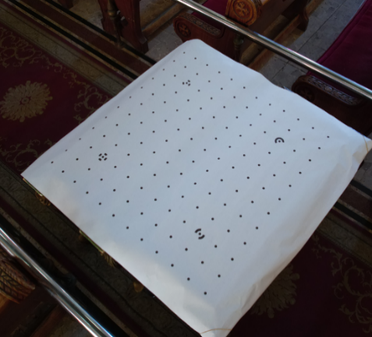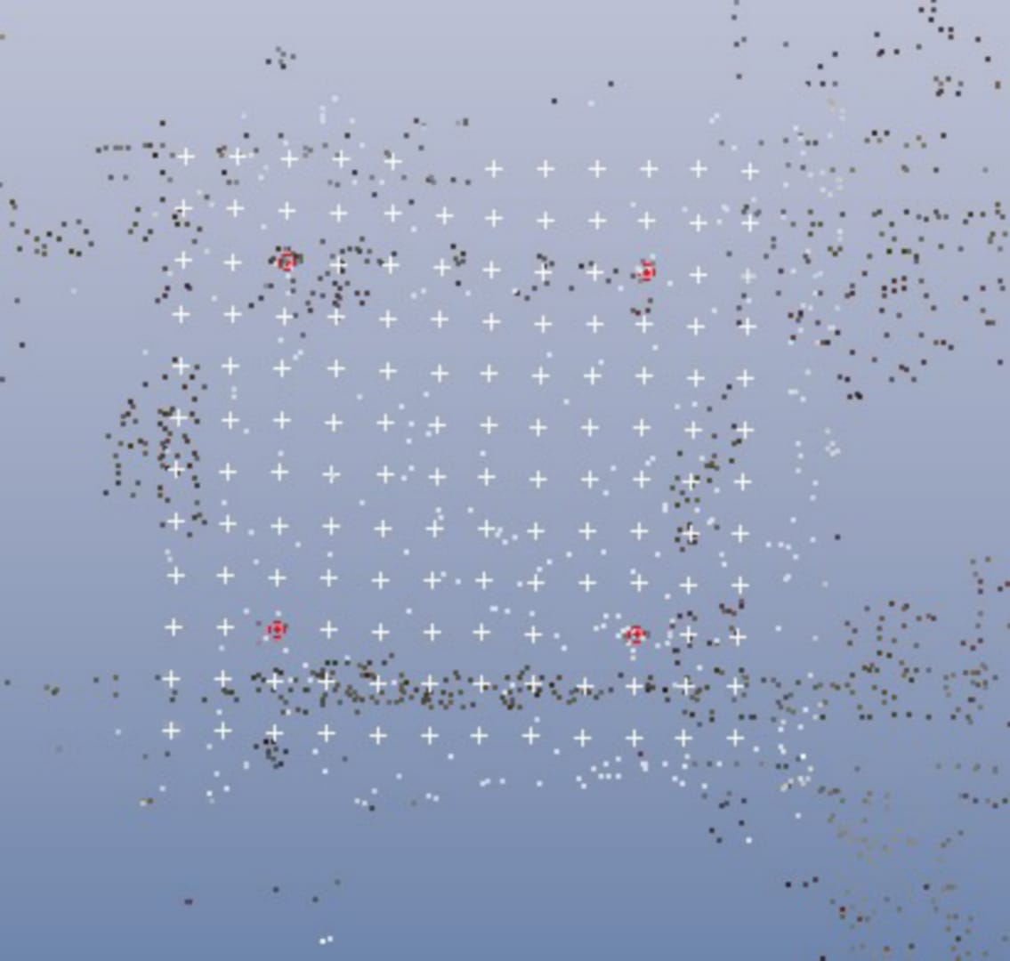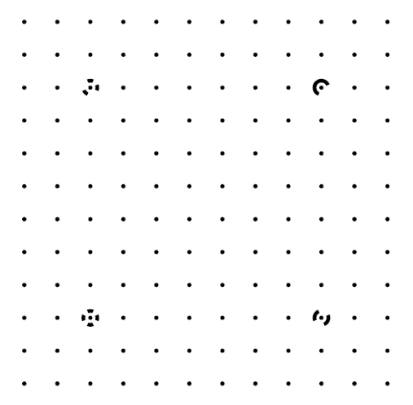

Fig.16 shows the experimental setup, identified CPs, and calibration target (A0 sheet) for the DJI
Air 2S camera
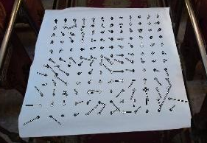
Fig.17 Residual vector of each point (magnified 400 times in idealized calibration image)
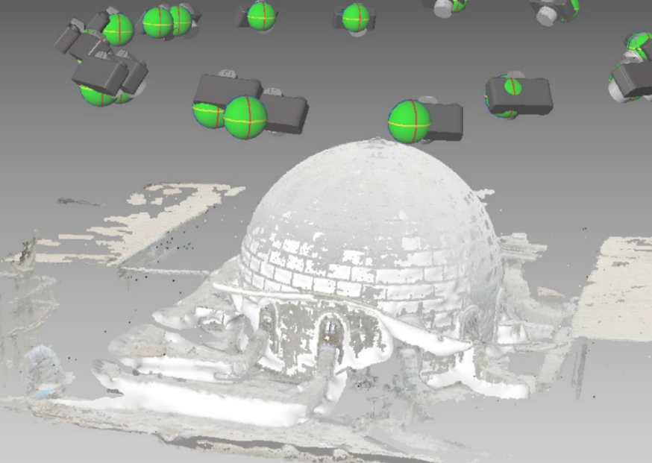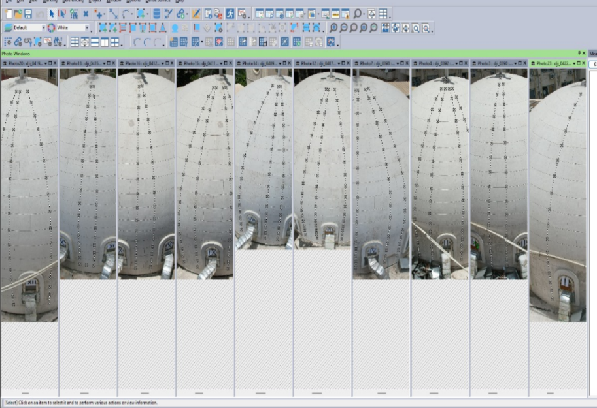

Fig.18PhotoModeler DSM project creation.
Table 4 Digital camera DJI Air 3 Fly calibration results
Image No. | α in degrees | β in degrees | κ in degrees | Max. and Overall  Residual error |  | Max. image distortion in  pixels after camera idealization
01 | 4.660729 | 27.546381 | 32.026672 | MRE: 1.036  ORE: 0.472 < 2.00 accepted |  | Y direction 5 Pixels  X direction 5 Pixels
02 | -21.960231 | 43.422341 | 76.683424
03 | -36.585044 | 43.986309 | 97.782567
04 | -63.474967 | 31.757878 | 140.525044
05 | -73.254089 | 13.625651 | 165.924165
06 | -62.416762 | -8.452096 | -165.928634
07 | -56.134359 | -20.834926 | -140.237398
08 | -45.660703 | -28.807402 | -118.093895
09 | -29.947907 | -31.965004 | -87.757676
10 | -7.672763 | -21.390097 | -40.996142
11 | 0.541911 | 0.478618 | -0.388213
12 | 0.184936 | 5.345525 | 7.652968
Camera calibration parameters |  | Literatures of previous invstigations
 |  | FWZY[32] | Mark2020 | Current | [32] | Mark2020 | Current
Focal length ƒ |  | 3.708025 mm | 3.579417 mm | 8.73389 mm | 0.006 mm | 5.4e 04 mm | 0.006 mm
Xp - image principle point Co.X |  | 2.253131 mm | 2.264516 mm | 6.93081 mm | 0.003 mm | 3.5e 04 mm | 0.001 mm
Yp - image principal point Co.Y |  | 1.276118 mm | 1.285145 mm | 4.57091 mm | 0.001 mm | 3.0e 04 mm | 0.00
Fx - format width |  | 4.544863 mm | 4.540593 mm | 13.7023 mm | 0.001 mm | 1.6e 04 mm | 0.003 mm
Fy - format height |  | 2.552578 mm | 2.552578 mm | 9.14182 mm | 0.00 | 0.00 | 0.00
k1 - radial distortion 1 |  | 8.453e-003 | 1.044e-002 | 6.044e-004 | 3.1e-004 | 5.6e-005 | 3.6e-006
k2 - radial distortion 2 |  | 1.785e-003 | 1.619e-003 | 0.00 | 6.7e-005 | 1.0e-005 | 0.00
k2 - radial distortion 3 |  | 0.00 | 0.00 | 0.00 | 0.00 | 0.00 | 0.00
P1 - tangential distortion 1 |  | 5.130e-004 | 7.526e-005 | 0.00 | 8.6e-005 | 1.1e-05 | 0.00
P1 - tangential distortion 2 |  | 0.00 | 1.468e-004 | 0.00 | 0.00 | 9.7e-06 | 0.00

Table 5: Detailed Results of TLS and Total Station Comparative Setups
 | TLS with 3.1 mm resolution |  |  | TLS with 6.3 mm resolution |  |  | TLS with 12.5 mm resolution
No. | 5.246 m | 10.311 m | 13.066 m | 5.246 m | 10.311 m | 13.066 m | 5.246 m | 10.311 m | 13.066 m
1 | 0.030 | 0.066 | 0.064 | 0.127 | 0.149 | 0.127 | 0.126 | 0.193 | 0.194
2 | 0.035 | 0.072 | 0.158 | 0.137 | 0.181 | 0.116 | 0.130 | 0.226 | 0.239
3 | 0.030 | 0.077 | 0.125 | 0.125 | 0.215 | 0.115 | 0.130 | 0.227 | 0.229
4 | 0.027 | 0.036 | 0.098 | 0.128 | 0.205 | 0.117 | 0.125 | 0.236 | 0.241
5 | 0.022 | 0.026 | 0.029 | 0.023 | 0.085 | 0.120 | 0.123 | 0.171 | 0.185
6 | 0.034 | 0.087 | 0.055 | 0.135 | 0.162 | 0.117 | 0.132 | 0.228 | 0.231
7 | 0.036 | 0.077 | 0.065 | 0.135 | 0.179 | 0.138 | 0.131 | 0.220 | 0.254
8 | 0.035 | 0.044 | 0.079 | 0.137 | 0.180 | 0.126 | 0.133 | 0.221 | 0.239
9 | 0.033 | 0.043 | 0.067 | 0.135 | 0.153 | 0.110 | 0.132 | 0.214 | 0.228
10 | 0.038 | 0.047 | 0.047 | 0.156 | 0.122 | 0.120 | 0.155 | 0.204 | 0.211
11 | 0.025 | 0.030 | 0.052 | 0.140 | 0.136 | 0.130 | 0.136 | 0.203 | 0.204
12 | 0.049 | 0.062 | 0.070 | 0.174 | 0.220 | 0.107 | 0.174 | 0.183 | 0.242
13 | 0.052 | 0.065 | 0.049 | 0.146 | 0.158 | 0.114 | 0.144 | 0.161 | 0.211
14 | 0.038 | 0.063 | 0.056 | 0.184 | 0.121 | 0.106 | 0.181 | 0.175 | 0.216
15 | 0.023 | 0.033 | 0.065 | 0.198 | 0.080 | 0.104 | 0.199 | 0.221 | 0.261
16 | 0.033 | 0.035 | 0.081 | 0.188 | 0.114 | 0.098 | 0.169 | 0.181 | 0.312
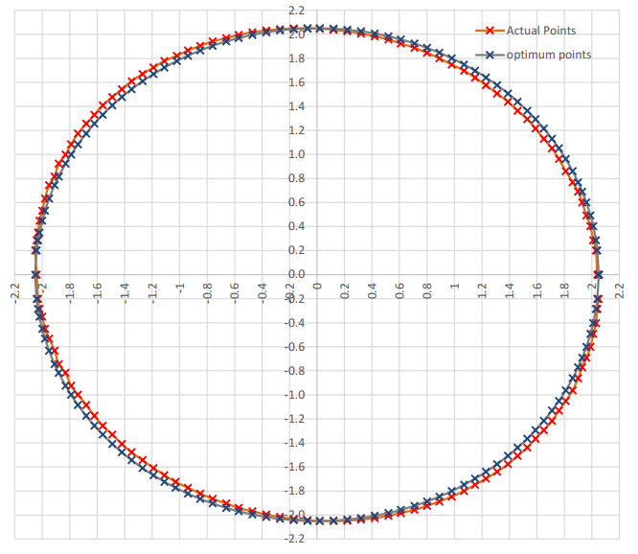
Fig.20 Results of the dome at 2.25 meters using the DCRP approach

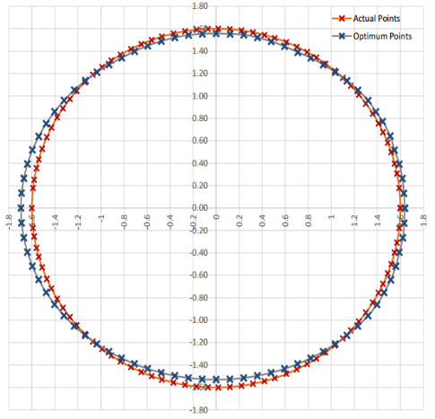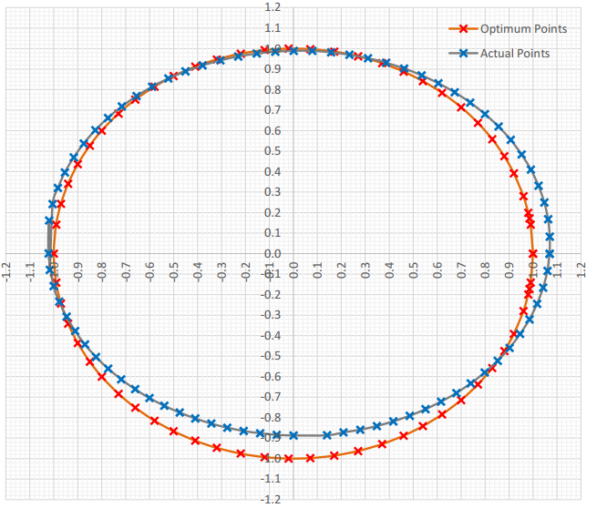
Fig.21 The dome's 3.50 and 4.50 m DCRP technique results
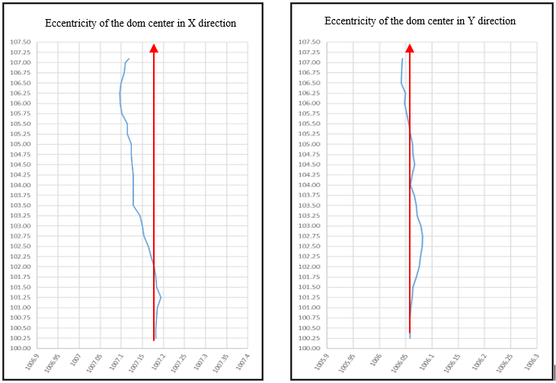
Fig. 22 The center of the dome-cross section deviation
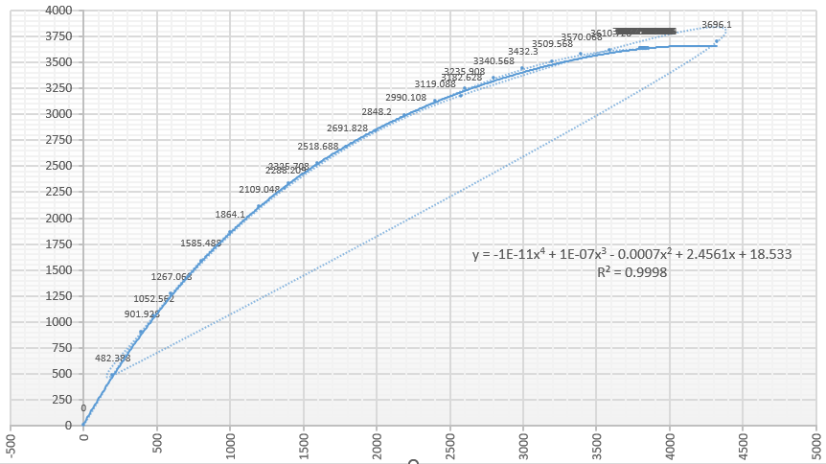
Fig.23 Curvature analysis of the vertical sector division of the dome.

Table 6 Structure deviation details
Dome cross-section | Radius and its accuracy |  | Center coordinates and its accuracy
Dome cross-section | r_{act.}, m | σ_{r}, mm | X, m | σ_{X}, mm | Y, m | σ_{Y}, mm
At height = 0.25 m | 4.5754 | 2.3 | 7.2397 | 2.5 | 19.6818 | 3.3
At height = 0.50 m | 4.5751 | 2.2 | 7.2389 | 2.7 | 19.6798 | 2.6
At height = 0.75 m | 4.5745 | 2.9 | 7.2372 | 2.8 | 19.6786 | 2.9
At height = 1.00 m | 4.5685 | 2.2 | 7.2368 | 2.0 | 19.6779 | 3.3
At height = 1.25 m | 4.5645 | 2.0 | 7.2332 | 2.7 | 19.6735 | 3.4
At height = 1.50 m | 4.5745 | 1.6 | 7.2351 | 3.3 | 19.676 | 2.0
At height = 1.75 m | 4.5482 | 1.7 | 7.236 | 2.7 | 19.6771 | 2.9
At height = 2.00 m | 4.5414 | 2.0 | 7.2382 | 2.8 | 19.6793 | 3.0
At height = 2.25 m | 4.5390 | 2.2 | 7.2427 | 2.6 | 19.6777 | 3.3
At height = 2.50 m | 4.5313 | 2.4 | 7.246 | 2.0 | 19.6736 | 3.7
At height = 2.75 m | 4.5085 | 2.5 | 7.2449 | 3.2 | 19.6749 | 2.9
At height = 3.00 m | 4.4935 | 1.6 | 7.2491 | 2.8 | 19.6937 | 4.0
At height = 3.25 m | 4.4130 | 1.5 | 7.2506 | 1.6 | 19.6964 | 2.8
At height = 3.50 m | 4.4265 | 1.3 | 7.2522 | 3.4 | 19.6977 | 2.0
At height = 3.75 m | 4.3435 | 2.0 | 7.2493 | 3.3 | 19.6937 | 3.3
At height = 4.00 m | 4.2744 | 2.4 | 7.253 | 2.3 | 19.699 | 3.6
At height = 4.25 m | 4.1946 | 2.5 | 7.2611 | 2.4 | 19.7096 | 2.0
At height = 4.50 m | 4.0761 | 1.8 | 7.2521 | 2.0 | 19.6977 | 2.6
At height = 4.75 m | 3.9535 | 1.7 | 7.2492 | 2.6 | 19.6937 | 2.9
At height = 5.00 m | 3.7995 | 1.9 | 7.2459 | 3.6 | 19.6898 | 3.8
At height = 5.25 m | 3.6142 | 0.9 | 7.2486 | 3.3 | 19.6937 | 2.2
At height = 5.50 m | 3.4105 | 1.9 | 7.2478 | 2.9 | 19.6924 | 4.2
At height = 5.75 m | 3.1873 | 2.0 | 7.2457 | 3.0 | 19.6898 | 2.0
At height = 6.00 m | 2.8282 | 2.2 | 7.2449 | 3.3 | 19.6884 | 3.4
At height = 6.25 m | 2.5917 | 2.5 | 7.238 | 1.7 | 19.6852 | 2.7
At height = 6.50 m | 2.1895 | 1.8 | 7.2332 | 1.9 | 19.6936 | 2.9
At height = 6.75 m | 1.6905 | 2.3 | 7.2324 | 2.3 | 19.6953 | 2.7
At height = 7.00 m | 0.9605 | 2.2 | 7.2341 | 2.8 | 19.6919 | 3.0
At height = 7.25 m | 0.5725 | 2.3 | 7.2371 | 2.8 | 19.6818 | 2.8
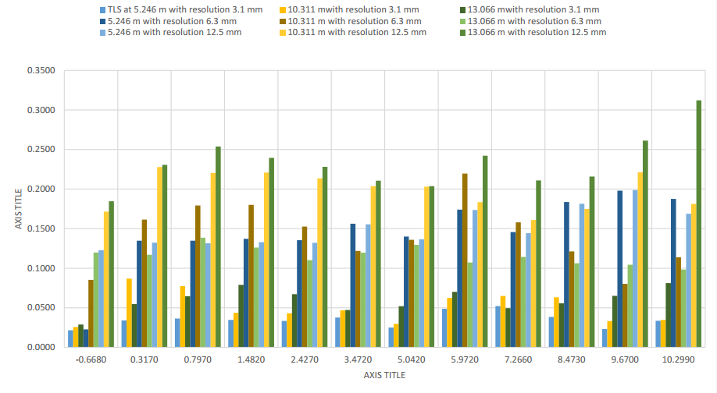
Fig.19 TLS comparisons of the observed results of the experimental points

