Supplementary information
Table S1 Concentrations of rare earth elements (REEs) and actinides (U and Th) in nearshore sediments from the Kifissos River discharge zone (samples designated as “KIF”) in Athens, Greece, and the harbor area (samples designated as “FJR”) in Fujairah, UAE. Total REE content (ΣREE and also ΣREE+Y+Sc), as well as Ce/Ce* and Eu/Eu* anomaly values, are also presented.
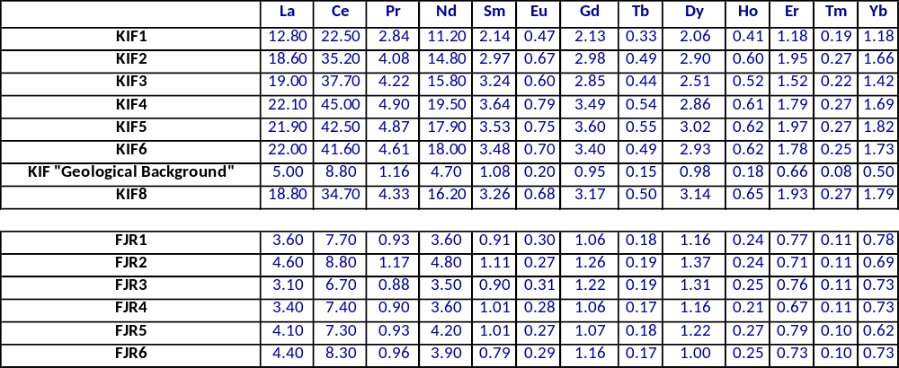
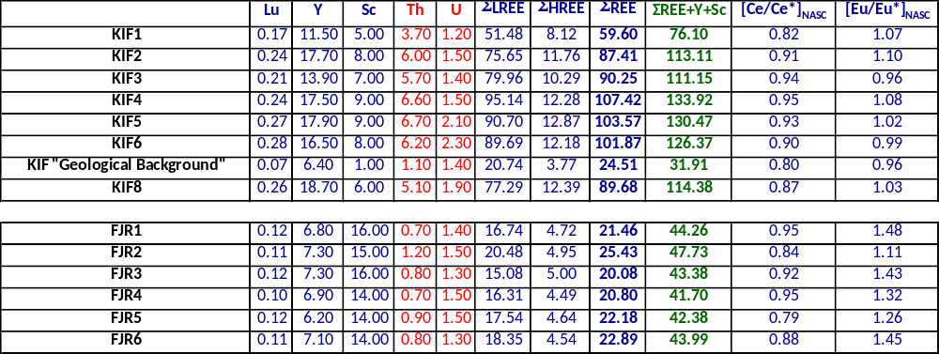

Table S2 Gamma-ray spectroscopy results for nearshore sediments from the Kifissos River discharge zone in Athens, Greece (samples designated as “KIF”).
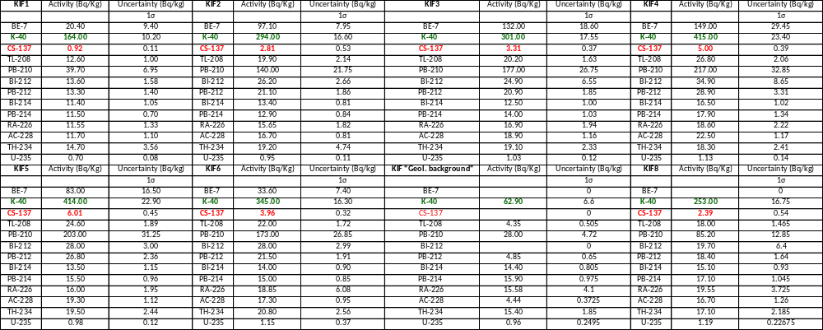

Table S3 Gamma-ray spectroscopy results for nearshore sediments from the harbor area in Fujairah, UAE (samples designated as “FJR”).
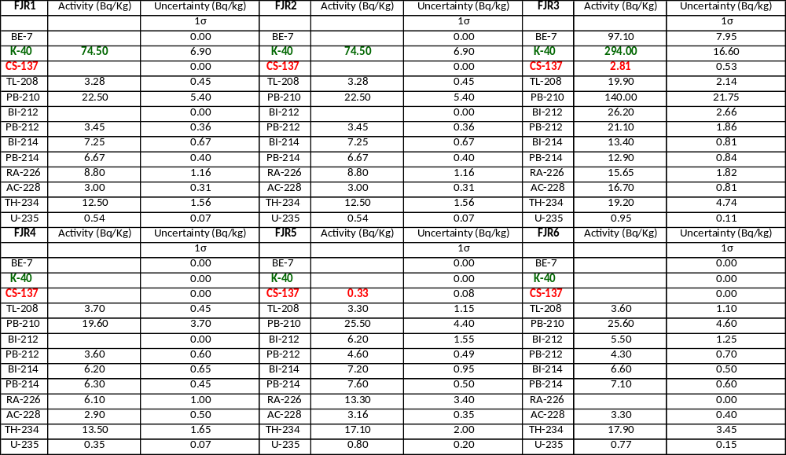

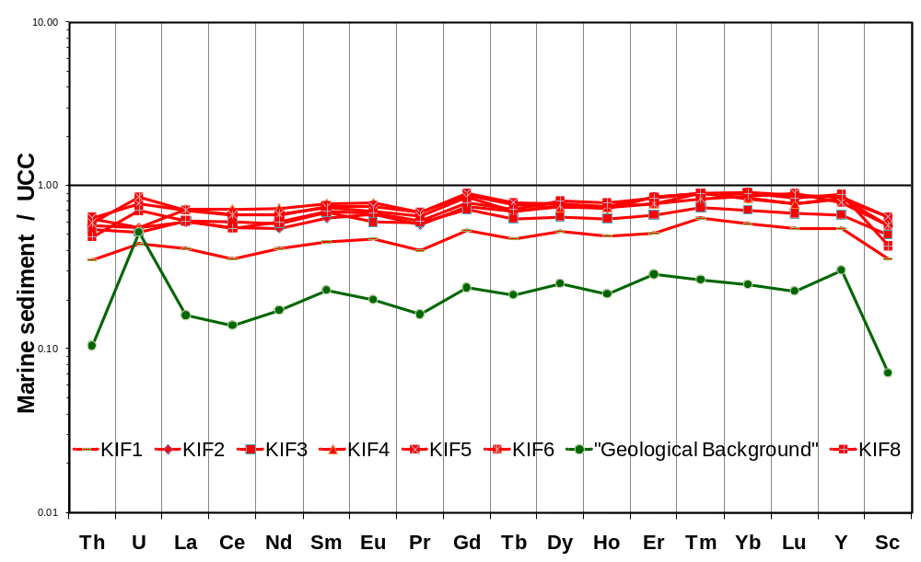
Fig. S1 Multi-element spider diagram illustrating geochemical anomalies of rare earth elements (REEs) and actinides in nearshore surface sediments from the Kifissos urban river discharge zone into the Saronikos Gulf (Athens, Greece), normalized to Upper Continental Crust (UCC) composition [14].

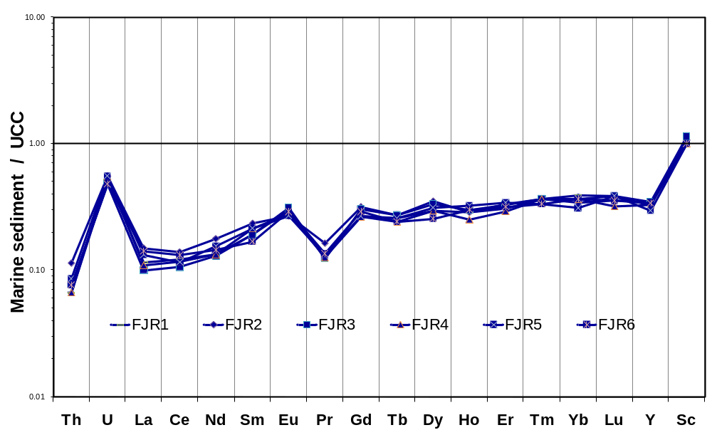
Fig. S2 Multi-element spider diagram illustrating geochemical anomalies of rare earth elements (REEs) and actinides in nearshore surface sediments from the Fujairah harbor area (UAE), normalized to Upper Continental Crust (UCC) composition [14].

