Supplementary file 2: Sensitivity analysis
A deterministic sensitivity analysis was conducted to assess the impact of varying catastrophic cost thresholds. Additionally, the prevalence of catastrophic health expenditure was calculated using the SDG benchmark for financial protection only the total direct costs as a proportion of the household with a 10% threshold (30).

Using the 10% threshold, more households incurred catastrophic costs (68%), and this was reversed at 40% thresholds (5%). Similar trends were observed when using the output approach to estimate catastrophic costs. About 49% of households incurred catastrophic health expenditures due to TB, using a threshold of 10%.
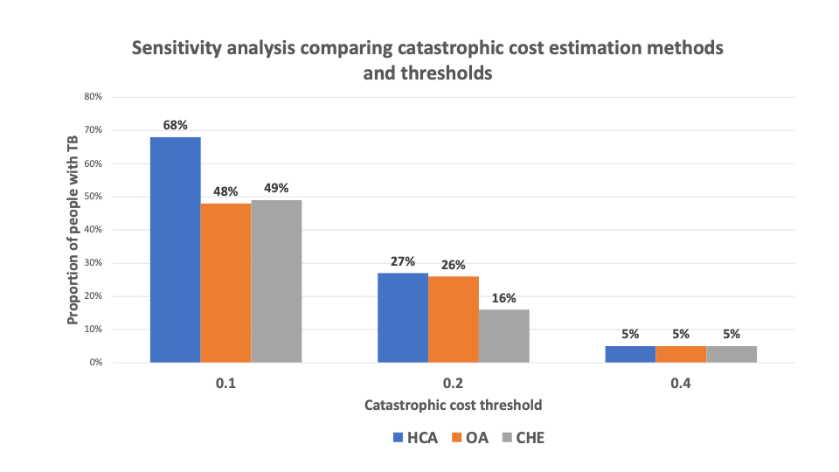
*HCA represents the human capital approach method for estimating indirect costs; OA represents the output approach for estimating indirect costs; CHE represents catastrophic health expenditure calculation calculated as direct costs/household income threshold at 10%.
** Base case is estimated as costs/household expenditure with 20% threshold using the human capital approach

We applied the WHO-recommended 20% household income threshold for catastrophic cost assessment (41,59), verifying robustness through sensitivity analyses at 10% and 40%, which confirmed expected trends. Additionally, using the SDG benchmark for financial protection (30), we found that 49% of households faced catastrophic health expenditures, surpassing the 33% reported for Africa (60).

We used the human capital approach to estimate the income loss due to the low levels of formal employment. Although this approach captures all time off work, it does not consider household mitigation efforts to compensate for lost income leading to an over-estimation of the productivity losses. To counter this, we ran a parallel estimation using the output approach and using reported lost income. The indirect costs with the HCA method were higher than the output approach, giving a lower estimation of TB costs at USD 106. Still the indirect costs only contributed 17% of the total costs which is lower than 47% in the national cost estimate and in other national estimates (20).

