Table 1. Hormonal profile of the patient, including evaluation of cortisol secretion, renin–aldosterone axis parameters, and plasma metanephrines obtained during the diagnostic workup 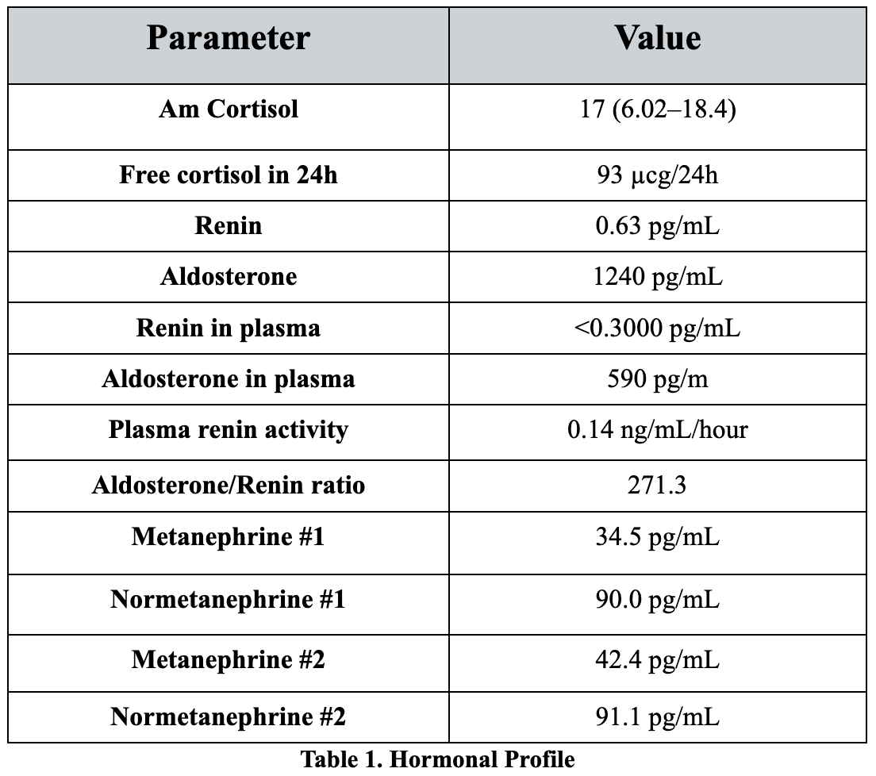

Table 2. Biochemical Study of Adrenal Venous sampling
