Supplementary Material
This table provides descriptive clinical information to document the context in which care journeys unfolded. Data are reported as documented in medical records and patient-reported sources and were not used for comparative or inferential analyses. The table is intended to support interpretation of organizational and care pathway data presented in the main text.

Supplementary Figure S1 — COOP/WONCA Charts
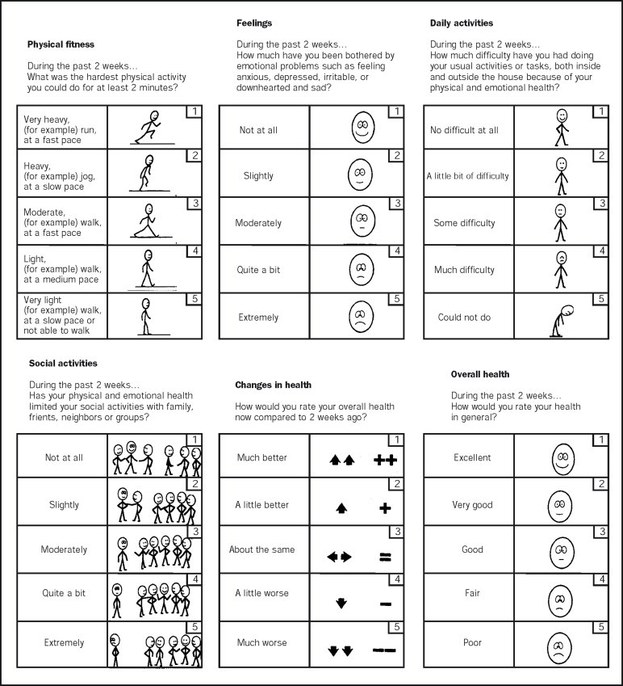

Figure S1: COOP/WONCA Charts for Functional Health Assessment. The COOP charts were originally developed by the Trustees of the Dartmouth COOP (Primary Care Cooperative Infor- mation Project) and subsequently endorsed and disseminated by WONCA through the work of the WONCA International Classification Committee [40, 70]. The charts are a patient-reported outcome measure of functional health status. Scores range from 6 (very good health) to 30 (ex- tremely severe impairment). The French-language version was used in this study [71].

Supplementary Material S1 — Long COVID Clinical Questionnaire (English translation)
Foreword. The patient-facing version of this questionnaire is administered online in French via Google Forms as part of routine clinical care. The present English version is provided for transparency and methodological documentation. The content and structure correspond exactly to the instrument used in practice.
The questionnaire serves two purposes: (1) systematic symptom documentation to support clinical evaluation, and (2) structured data capture for phenotypic encoding using the Human Phenotype Ontology (HPO) within the reconstruction framework described in the Methods section. Responses are recorded under a pseudonymized alphanumeric identifier.
Dear patient,
You have requested my opinion regarding your current health status. The evaluation of an emerging disease requires collecting detailed and structured information. With your consent, I will consult your medical record through the Réseau Santé Wallon. Please answer the questions below and use the identifier sent to you by email.

General information
Identifier: MGA.xxx Date of first contact:
Age: Sex:
Occupation (including retired):
Primary care physician:
Regular specialist(s):
Long COVID care pathway: □ No □ Yes Start date:

Pre-existing health status
Significant health problems prior to COVID-19:

COVID-19 vaccination
Vaccinated: □ No □ Yes
Post-vaccination reaction: □ No □ Yes Type: □ Local □ Systemic (fever, malaise, etc.) Brief description:

Acute COVID-19
Date of first infection:
PCR confirmation: □ No □ Yes Date:
Multiple infections (dates and type of PCR/antigen tests):
Major acute symptoms:
Workplace exposure: □ No □ Yes
Duration of work leave:
Currently on work leave: □ No □ Yes

Long COVID
Diagnoses considered before Long COVID:
Who suggested Long COVID and when:
Main long COVID symptoms (brief description):
Specific treatments already undertaken (e.g., hyperbaric therapy, vagus nerve stimulation):

Symptoms (COMPaRe questionnaire, AP–HP)
Instructions: Tick the symptoms experienced. Underline those that are still present. See the original questionnaire at COMPaRe Long COVID (AP–HP).

Neurological □ Headache
- Brain fog / concentration difficulties
- Dizziness
- Paresthesia
- Memory impairment
- Loss or change of smell
- Loss or change of taste
- Word-finding difficulty
- Reduced sensitivity
- Tremor
- Balance disturbance
- None
General □ Fatigue
- Chills (with or without fever)
- Sleep disturbance
- Mood changes / irritability / low mood
- Muscle aches
- Weight loss
- Loss of appetite
- Sweating
- Drowsiness
- Sensitivity to heat or cold
- Hot flashes
- None

Chest □ Shortness of breath
- Palpitations / arrhythmia
- Chest pain or burning
- Cough
- Chest tightness
- None

Musculoskeletal □ Muscle pain
- Joint pain
- Back or neck pain
- Heavy legs / edema
- None

Digestive □ Abdominal discomfort
- Diarrhea
- Nausea / vomiting
- None

ENT □ Sore throat / difficulty swallowing
- Tinnitus
- Nasal congestion
- Ear pain
- Hearing impairment

Free comments
Symptoms or information not captured above:

- None
Skin and hair □ Hair loss
- Rash
- Dry skin
- Discoloration of fingers/toes
- None
Eyes □ Dryness / irritation
- Blurred vision
- Photophobia
- None

Vascular / lymphatic □ Circulatory distur- bances
- Spontaneous bruising
- Blood pressure abnormalities
- Swollen lymph nodes
- None
Genitourinary □ Gynecological symptoms
- Urinary symptoms
- None

Figure S2: Healthcare utilization patterns by case: institutions, medical specialties, and laboratories.
28
Laboratories
Medical specialties
Case 318 Case 407 Case 458
Patient Care Journeys in Long COVID
Institutions
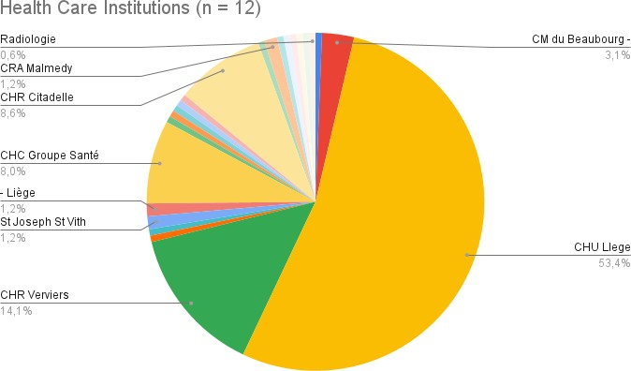
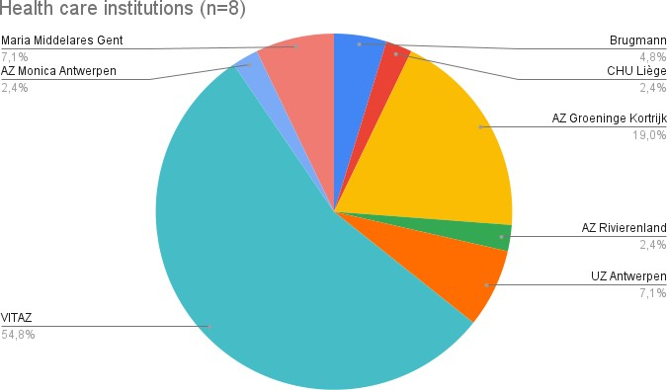
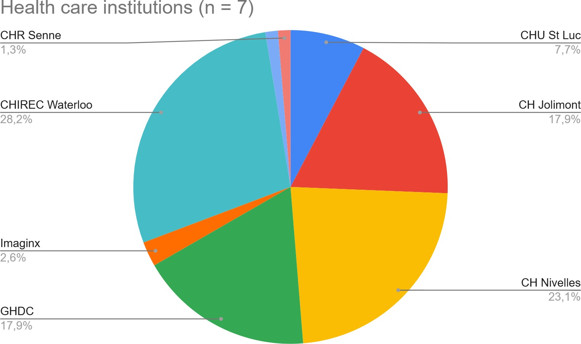

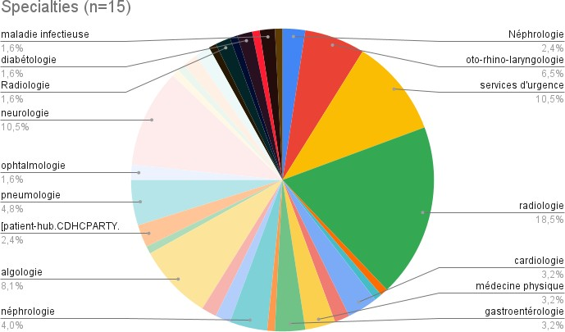
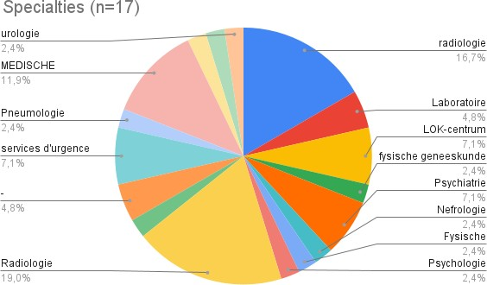
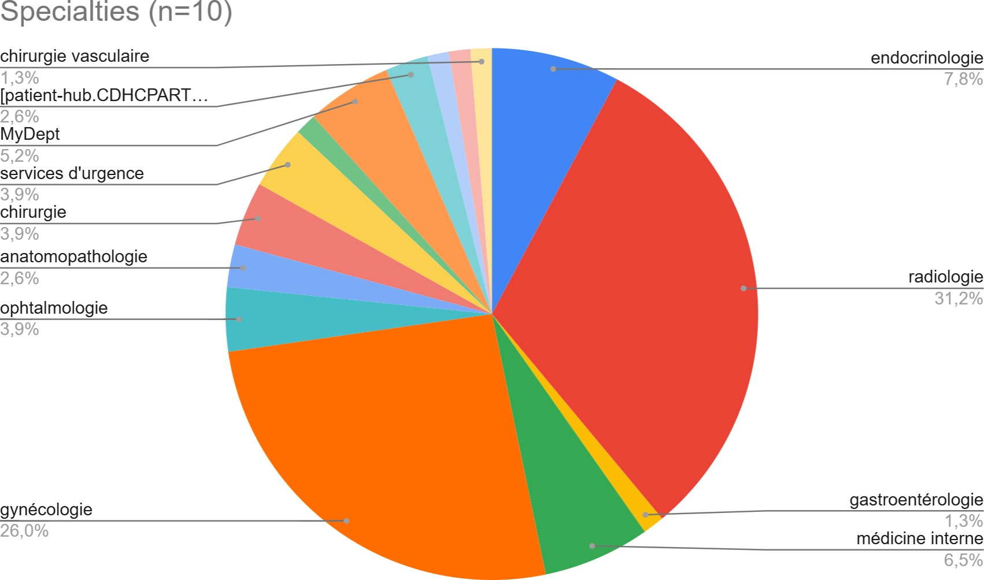

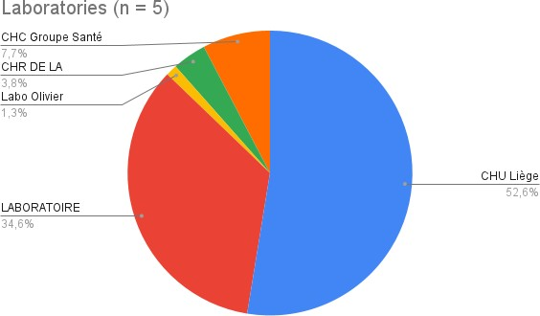
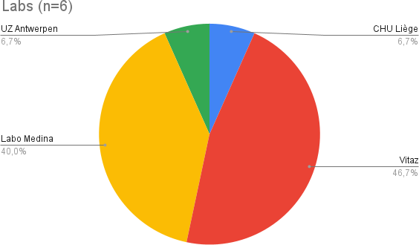
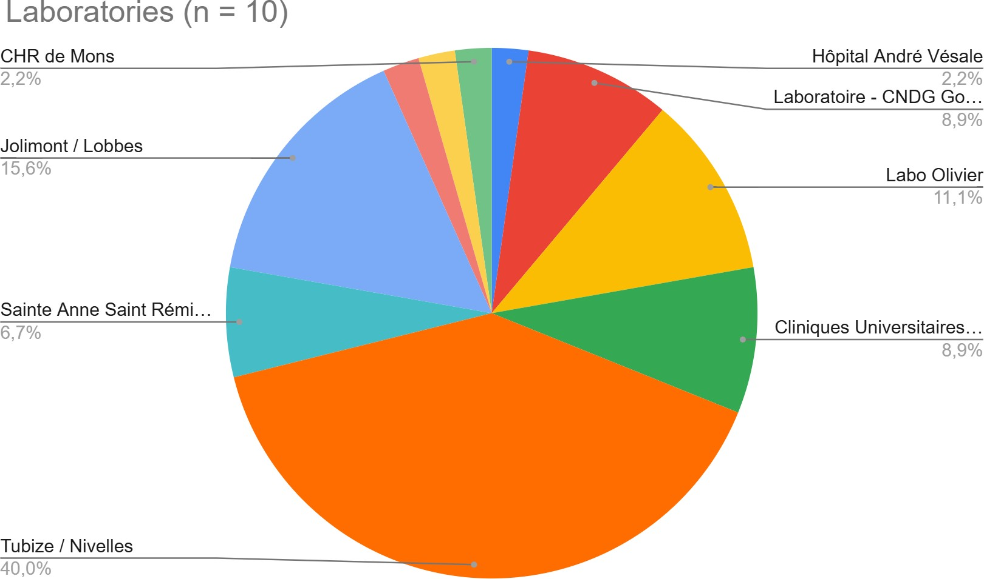

Table S1: Detailed clinical characteristics of three illustrative cases
Clinical data Case 318 Case 407 Case 458

Sex Male Female Female

Age at first COVID-19
episode (years)
48 27 35

Occupational status
Complete work cessation for 5 years
Work interruption denied by insurance fund; appeal ongoing
Part-time employment

Diagnostic labels found in medical reports
Major burnout; chronic fatigue Fibromyalgia Burnout

BMI 29.3 27.3 48.1

DUSOI severity index1
4 4 3

Technetium brain scintigraphy
Ongoing Areas of poorly systematized hypofixation, notably frontal and bilateral parietal regions, and the lateral aspect of the anterior pole of the right temporal lobe
Heterogeneous cortical uptake across the cortex, particularly in the left frontal region; microangiovascular involvement reported

Notable biological findings

COOP/WONCA
score (PROM)2

Index diagnosis (ICPC)3

HPO phenotypes (terms)4
Low-titer speckled antinuclear antibodies; creatinine 1.3 mg/dL
27/30 (04 Mar 2025): poor perceived health, limited to light efforts, severe emotional impact, unable to perform usual activities, impaired social life; health status unchanged

L99 Cervical intervertebral foraminal stenosis (03/2015) U99 Mild renal insufficiency (03/2017)
K86 Hypertension (03/2017) A77 COVID–19 (10/2020) A77 Long COVID–19 (08/2025)

Chronic fatigue; Cognitive impairment; Impaired concentration; Memory impairment; Brain fog; Dizziness; Tremor; Ataxia; Paresthesia | Insomnia; Non-restorative sleep; Nightmares; Decreased endurance; Post-exertional malaise | Anxiety; Panic attacks; Increased stress sensitivity | Hypoacusis; Tinnitus | Dyspnea; Tachycardia; Palpitations; Chest tightness | Nausea;
Abdominal discomfort; Weight loss; Anorexia | Myalgia; Arthralgia; Bone pain | Hyperhidrosis; Cold intolerance
| Ear fullness | Alopecia; Xerosis; Visual blur
B-cell and NK-cell lymphopenia with preserved CD4/CD8 ratio

24/30 (02 Sep 2025): fairly poor perceived health, limited to light efforts, moderate emotional impact, major difficulty with usual activities, moderately impaired social life; slightly worsened health

A80 Accident injury (02/2004) P29 Autistic traits (11/2020) U85 Horseshoe kidney (02/2021)
A85 Vaccination adverse effect (12/2021)
A77 COVID–19 (07/2022) A77 COVID–19 (07/2025) A77 Long COVID–19 (09/2025)
N71 Encephalitis (11/2025)
Impaired concentration; Short-term memory impairment; Memory impairment; Word-finding difficulties; Unsteady gait; Orthostatic dizziness; Falls | Fatigue; Unrefreshing sleep;
Excessive daytime sleepiness | Migraine; Visual blur; Hearing impairment | Palpitations; Tachycardia | Arthralgia; Myalgia; Back pain; Foot pain; Generalized pain | Abdominal pain; Abdominal distention; Diarrhea; Constipation; Lactose intolerance | Eczema | Menstrual irregularity
Euglobulin lysis time: 1111 min (reference range 100-174)

19/30 (14 Nov 2025): good perceived health, able to perform very light efforts, moderate emotional impact, some difficulty with usual activities, moderately impaired social life; health status unchanged
T82 Obesity, bypass (11/2010) A75 Mononucleosis (12/2014) A77 COVID–19 (03/2020) A77 COVID–19 (09/2020) A77 COVID–19 (11/2020) A77 COVID–19 (07/2022) A77 COVID–19 (12/2023)
K86 Hypertension (11/2024) A77 Long COVID–19 (11/2025)
N71 Encephalitis (01/2026) Cognitive impairment; Memory impairment; Aphasia; Vertigo |
Fatigue; Hypersomnia | Depression | Hyposmia; Phantosmia; Hyperacusis; Blurred vision | Palpitations; Dyspnea | Myalgia | Menorrhagia; Urinary frequency; Recurrent urinary tract infections | Decreased libido; Lactose intolerance

1 DUSOI: clinician-rated measure of overall illness severity (score range 0–4; higher scores indicate greater severity).
2 COOP/WONCA: Patient-reported outcome measure assessing perceived health status, functional capacity, emotional well-being, daily activities, social functioning, and perceived change in health (score range 6–30; higher scores indicate poorer health).
3 ICPC, as routinely used in Belgian primary care; diagnoses are reported as documented in medical reports, with dates indicating first
documentation.
4 HPO: Human Phenotype Ontology terms describing the main reported phenotypic features, extracted from patients’ narratives, clinical
anamnesis, and medical reports using a large language model; terms are listed descriptively for readability.

