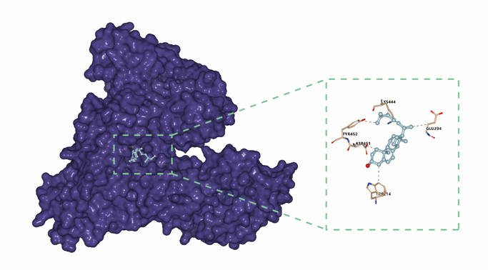
Ergosterol

5,6-Dihydroergosterol
Ganoderic Acid Am1
Ganoderic Acid C1
Ganoderiol
Lucidenic
Lucidone

