Supplementary Methods and Materials:

Sensitivity-variant network reconstruction. To assess robustness of multimodal network inferences to time handling and repeated-measures dependence, we generated multiple sensitivity variants from the same early-fusion latent space and rebuilt networks for each group (Cases; Controls). For each variant, we rebuilt edge lists for three complementary network inference strategies: (i) loading-cosine similarity, (ii) k-nearest neighbor graph with Louvain community detection (kNN–Louvain), and (iii) shared-signal correlation based on reconstruction of shared latent signals back into feature space.

Variants retained for the supplement. We generated six variants initially, but only three were retained for the manuscript supplement because they produced non-empty networks across groups and methods: (1) baseline; (2) removal of time/timepoint-related serology features prior to network construction; and (3) subject-collapsed shared-signal reconstruction (Supplementary Table S6; Supplementary Figures S6–S7). All predefined sensitivity variants were executed. Some configurations produced extremely sparse graphs after thresholding and multiple-testing correction, and therefore are not visualized but are reported in summary outputs.

Shared-signal reconstruction and correlation inference.For shared-signal correlation networks, shared scores (first three axes) were projected back into feature space using the corresponding view loadings, producing a reconstructed shared-signal matrix per modality. Features were standardized prior to correlation testing. Edges were retained using combined effect-size and multiple-testing criteria (|r| threshold and Benjamini–Hochberg q threshold) with the minimum sample requirement enforced per group.

Subject-collapsed shared-signal sensitivity.To reduce dependence from repeated measures, we collapsed shared scores by subject prior to shared-signal reconstruction by averaging shared-score vectors within subject (and using the median time when needed). Networks were then reconstructed identically from the collapsed representation.

Removal of time/timepoint serology features sensitivity. To ensure time variables embedded within a low-dimensional view (serology) did not spuriously contribute to cross-modal wiring, we removed rows with time/timepoint aliases from the serology loadings prior to network construction and recomputed all networks.

LOSO stability: As an additional robustness check, we performed leave-one-subject-out (LOSO) stability analyses comparing each fold’s networks to the full network using edge-set Jaccard similarity and bridge-set Jaccard similarity. Because loading-cosine and kNN–Louvain networks depend only on loadings (and not on the shared scores), LOSO is expected to have minimal effect for these methods; shared-signal correlation networks are score-dependent and therefore provide the most sensitive LOSO diagnostic.

Supplementary Table 1: Network Topology: Baseline tri-modal matched dataset

Group | Network | Nodes | Edges | Density | Avg. Degree | Global Mean  Clustering Path  Coeffecient. length |  | Cross Modal Edges | Fraction Cross Modal Edges
Case | Loading Cosine | 976.00 | 169,819 | 0.36 | 347.99 | 0.71 | 0.59 | 49,421 | 0.29
Control | Loading Cosine | 973.00 | 283,270 | 0.60 | 582.26 | 0.79 | 0.57 | 70,341 | 0.25
Case | Shared Signal | 976.00 | 7,882 | 0.02 | 16.15 | 0.20 | 2.91 | 986 | 0.13
Control | Shared Signal | 973.00 | 7,986 | 0.02 | 16.42 | 0.17 | 3.20 | 1,306 | 0.16
Case | KNN + Louvain | 976.00 | 10,914 | 0.02 | 22.36 | 0.20 | 2.22 | 1,644 | 0.15
Control | KNN + Louvain | 973.00 | 11,185 | 0.02 | 22.99 | 0.15 | 3.42 | 2,005 | 0.18

Density computed as edges / [nodes×(nodes−1)/2] for undirected graphs. Cross-modal edges are edges linking nodes assigned to different modalities.

Supplementary Table 2: Taxonomic Partners of consensus serologic bridge candidates
Group | Bridge Candidate | Median Modalities Touched | Median Degree | Top Partner Genus | Partner Support*
Case | CBir1 Fla. Pos. | 3 | 39 | Intestinibacter; Acidaminococcus | 3m | w=0.888; 2m | w=0.780
Case | OmpC EU | 2 | 42 | Lachnospira; Aggregatibacter | 3m | w=0.867; 3m | w=0.658
Case | IgA ASCA Pos. | 3 | — | Peptoniphilus | 3m | w=0.822
Case | ANCA Pos. | 3 | — | Megasphaera | 3m | w=0.888
Control | CBir1 Fla. Pos. | 3 | 37 | Uncultured Ruminococcaceae | 3m | w=0.895
Control | OmpC EU | 3 | 37 | Ruminiclostridium 6; Flavonifractor | 3m | w=0.881; 3m | w=0.831
Control | IgA ASCA EU | 3 | 42 | Flavonifractor | 3m | w=0.905
Control | ANCA EU | 2 | 46 | protEC-only partners | 3m | w=0.986; 3m | w=0.949
* All candidates were identified as bridge features common across three modeling approaches (kNN–Louvain clustering, loading-cosine similarity, and shared-signal integration). “m” denotes the number of models supporting the specific partner association; “w” indicates median edge weight across supporting models. Median degree reflects network connectivity within the integrated graph. “—” indicates degree not estimable under sparsity constraints. protEC-only partners denote associations confined to the proteomic EC layer.

Supplementary Table 3: Functional protEC partners of consensus serologic bridge candidates
Group | Bridge Candidate | Median Modalities Touched | Median Degree | Top protEC Partner (EC: Enzyme) | protEC Partner Support*
Case | CBir1 Fla. Pos. | 3 | 39 | 3.6.1.3: Adenosinetriphosphatase; Transaldolase | 3m | w=0.907
Case | OmpC EU | 2 | 42 | 3.5.1.87: N-carbamoyl-L-amino-acid hydrolase | 3m | w=0.862
Case | IgA ASCA Pos. | 3 | — | 1.3.1.98: UDP-N-acetylmuramate dehydrogenase | 3m | w=1.000
Case | ANCA Pos. | 3 | — | 2.3.1.29: Glycine C-acetyltransferase | 3m | w=0.867
Control | CBir1 Fla. Pos. | 3 | 37 | 4.1.1.18: Lysine decarboxylase | 3m | w=1.000
Control | OmpC EU | 3 | 37 | 3.6.3.4: Cu(2+)-exporting ATPase | 3m | w=0.970
Control | IgA ASCA EU | 3 | 42 | 1.6.5.3: NADH:ubiquinone reductase (H(+)-translocating) | 3m | w=0.962
Control | ANCA EU | 2 | 46 | 2.3.1.222: Phosphate propanoyltransferase; 6.2.1.1: Acetate–CoA ligase | 3m | w=0.986; 3m | w=0.949
* All candidates were identified as bridge features common across three modeling approaches (kNN–Louvain clustering, loading-cosine similarity, and shared-signal integration). “m” denotes the number of models supporting the specific partner association; “w” indicates median edge weight across supporting models. Median degree reflects network connectivity within the integrated graph. “—” indicates degree not estimable under sparsity constraints.

Supplementary Table 4: Convergence summary across network inference strategies (edge/hub/module/adjacency)
Convergence target |  | Cases | Controls | Interpretation
  Metric
Edge-set agreement (all edges) | Pairwise Jaccard range | 0.132–0.411 | 0.127–0.296 | Exact edge identity differs by method (expected due to different sparsification rules).
Edge-set agreement (cross-modal edges) | Pairwise Jaccard range | 0.150–0.535 | 0.155–0.495 | Cross-modal edges show comparable or slightly higher agreement than the full edge set.
Hub agreement (degree hubs) | Top 25 Jaccard range | 0.064–0.724 | 0.190–0.471 | High-degree hubs show moderate agreement across methods.
Hub agreement (betweenness hubs) | Top 25 Jaccard range | 0.042–0.136 | 0.111–0.429 | Betweenness hubs are more method-sensitive than degree hubs.
Community agreement | ARI range |  | 0.247–0.504 | Community structure shows moderate agreement across methods.
  0.272–0.507
Community agreement | NMI range | 0.485–0.667 | 0.456–0.641 | Modular organization converges more strongly than individual edges.
Weighted adjacency similarity | Spearman range | 0.191–0.471 | 0.147–0.490 | Even with differing edge sets, global weighted structure is concordant.

Supplementary Table 5: Convergence summary for consensus edges and bridge/boundary organization
Convergence target |  | Cases | Controls | Interpretation
  Metric
Consensus edge set (≥2 methods) | # edges retained | 19,355 |  | Core reproducible associations across inference strategies.
  20,163
Consensus edge set (all 3 methods) | # edges retained | 7,287 | 6,602 | High-confidence subset supported by all constructions.
Bridge-set overlap (≥2 modalities) | Jaccard range across methods | 0.689–0.893 | 0.710–0.855 | Cross-modal boundary organization is highly stable across methods.
Bridge-set overlap (all 3 modalities) | Jaccard range across methods | 0.248–0.578 |  | Tri-modal bridges show moderate stability.
  0.246–0.508

Figure S6. Baseline multimodal networks from block-scaled early-fusion PCA (cases vs controls) across three inference strategies.
(loading-cosine, shared-signal correlation, and kNN–Louvain; pruned for readability; node modality inferred from fusion loadings when prefixes are absent).

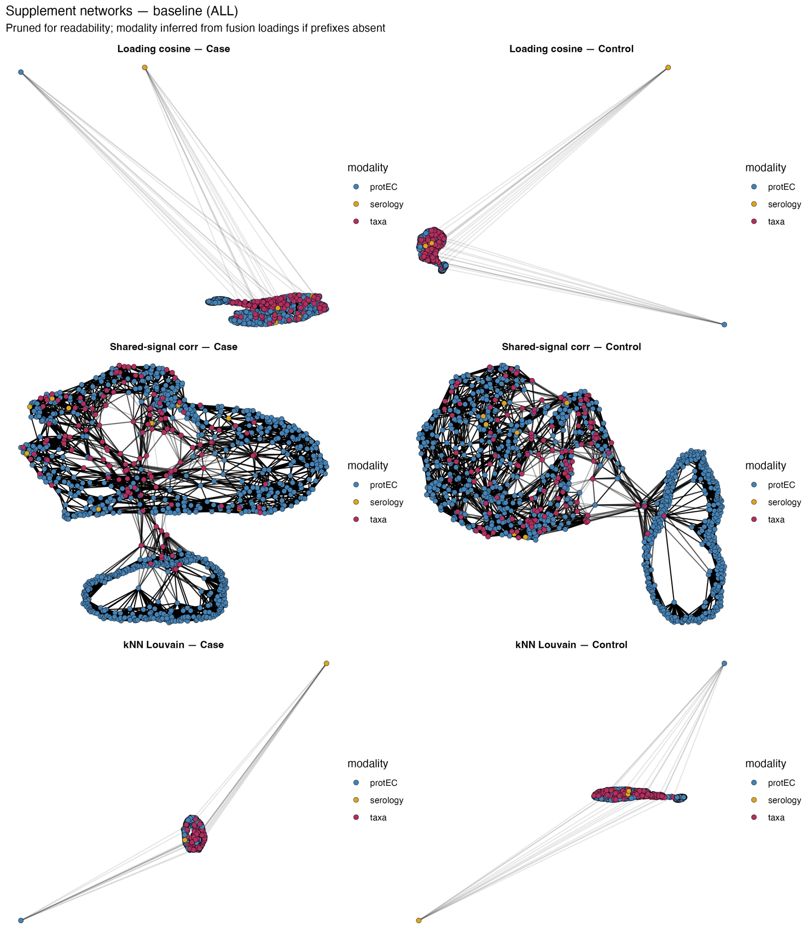

Figure S7. Sensitivity analysis: multimodal networks after removing time/timepoint-derived serology features, showing preserved serology anchoring and stable nstwork structure.
(same three inference strategies and visualization settings as baseline; cases vs controls; pruned for readability).

