Tables and Images page

Table(1): The primers, their sequences, annealing temperatures, and the amplicons used in this study.
Primer-Names | Sequences (5` - 3`) | Annealing-Tem. | Amplicon
Cas1 | GTAGAAAAYCATTACTTTGTTACYG  CRAATCCATGWAWAGCTARYTC | 53°C | 370
Cas4 | CTAAAYTWGAACGTMRRRTBGC  GYTTWGGTTCTTTKYKSACARC | 54°C | 255
Cas6 | TTTAGGAAGTRTTTTACATGGYGTG  CCWGAAAATTCRCCAAACTTYA | 55°C | 630
Cas9 | GGKAAAATTATMTATCGRAGTRRYG  CWGTRTAYAAAAGATTTGCTCGTGY | 52°C | 883
Spa | AGACGATCCTTCGGTGAGC  GCTTTTGCAATGTCATTTACTG

St. au.
Figure(1): Prevalence of Staphylococcus aureus 20% and Other Bacteria25% while 55% negative bacterial culture in SSTI Samples(N=100).

Table2:Distribution of Cases by Sex and Age Groups.
Age Group | Female | Male | Total | P-Value
 |  |  |  | a | b | c
G1 (1–5) | 2 (10%) | 1 (5%) | 3 (15%) | 0.383 | 0.865 | 0.439
G2 (6–10) | 2 (10%) | 3 (15%) | 5 (25%) | 0.383 | 0.865 | 0.439
G3 (11–15) | 0(0%) | 3 (15%) | 3 (15%) | 0.383 | 0.865 | 0.439
G4 (16–20) | 2 (10%) | 7 (35%) | 9 (45%) | 0.383 | 0.865 | 0.439
Total | 6 (30%) | 14(70%) | 20 (100%) | 0.383 | 0.865 | 0.439

Table (3): Percentage of Antibiotics Sensitive and Resistance by S. aureus clinical isolates. Against 13 types of Antibiotics by Vitek2 Compact According to CLSI (2025)(n=20).
Isolate N. | Benzyl pencillin | Oxacillin | Gentamicin | Ciprofloxacin | Erythromycin | Clindamycin | Linezolid | Teicoplanin | Vancomycin | Teteacycline | Tigecycline | Rifampicin | Trimethoprim / sulfamethoxazole
S1 | R | R | S | R | R | R | S | S | S | R | S | S | S
S2 | R | R | S | S | S | R | S | S | S | R | S | S | S
S3 | R | R | R | R | R | S | S | S | S | S | S | S | S
S4 | R | R | S | S | S | S | S | S | S | S | S | S | S
S5 | S | R | S | R | R | R | S | S | S | R | R | S | S
S6 | R | R | R | R | R | R | S | S | S | R | S | S | S
S7 | R | R | S | S | S | S | S | R | S | R | S | S | S
S8 | R | R | S | I | R | S | S | S | S | R | S | S | S
S9 | R | R | S | S | S | S | S | S | S | S | S | S | S
S10 | R | R | S | I | R | R | S | S | S | R | S | S | S
S11 | R | R | S | R | R | R | S | S | S | S | S | S | S
S12 | R | R | R | R | R | R | R | R | I | R | S | R | R
S13 | R | R | R | R | R | R | S | S | S | R | S | S | S
S14 | R | R | S | I | R | R | R | R | R | R | S | R | S
S15 | R | R | R | R | R | S | S | R | I | S | S | S | S
S16 | R | R | R | R | R | S | S | R | R | R | S | S | R
S17 | R | R | R | R | R | S | S | R | R | R | S | R | S
S18 | R | R | R | R | R | S | S | S | R | R | R | S | S
S19 | R | R | R | R | R | S | S | S | R | R | S | R | S
S20 | R | R | R | R | R | S | S | S | R | R | S | S | R
R% | 93.3 | 100 | 33.3 | 53.3 | 73.3 | 60 | 13.3 | 26.7 | 6.7 | 66.7 | 6.7 | 13.3 | 6.7
S% | 6.7 | 0 | 66.7 | 26.7 | 26.7 | 40 | 86.7 | 73.7 | 80 | 33.3 | 93.3 | 86.7 | 93.3
I% | 0 | 0 | 0 | 20 | 0 | 0 | 0 | 0 | 13.3 | 0 | 0 | 0 | 0
P value | 0.01* | 1.0 | 0.197 | 0.247 | 0.071 | 0.439 | 0.005* | 0.071 | 0.001* | 0.197 | 0.001* | 0.005* | 0.001*
* represents a significant difference at p<0.05. R, resistant; S, sensitive; I, intermediate.

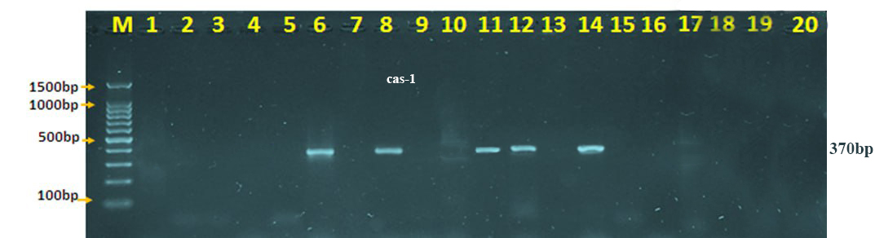

Fig(2).:- Gel electrophoresis for the PCR product of (Cas-1 gene) shows a 370bp band, which was performed at 60 volts for 2 hr. (100-1500bp ladder). Lanes (6,8,11,12,14) of S. aureus isolates show positive results.

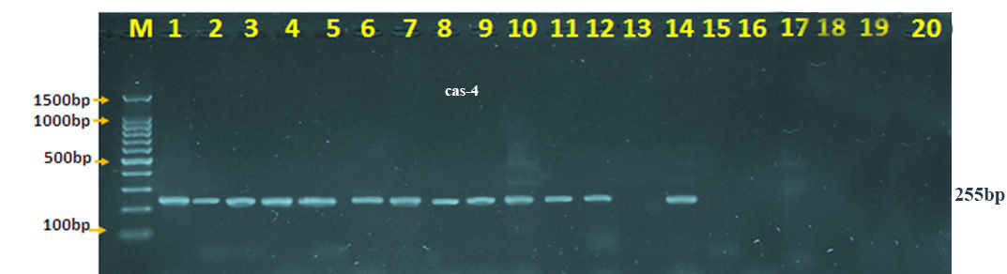
Fig(3).:- Gel electrophoresis for the PCR product of (Cas-4 gene) shows a 255bp band, which was performed at 60 volts for 2 hr. (100-1500bp ladder). Lanes (1-12,14) of S. aureus isolates show positive results.
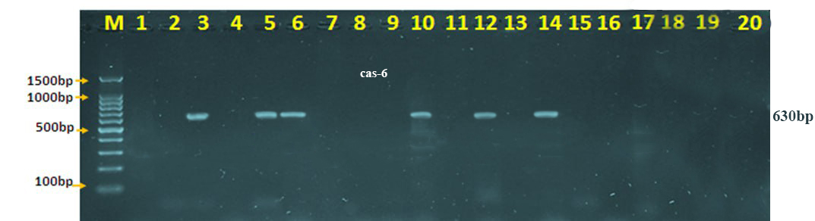
Fig(4).:- Gel electrophoresis for the PCR product of (Cas-6 gene) shows a 630bp band, which was performed at 60 volts for 2 hr. (100-1500bp ladder). Lanes (3,5,6.10,12,14) of S. aureus isolates show positive results.

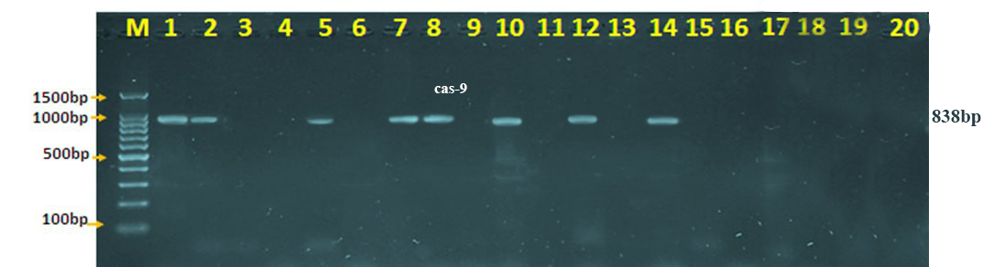

Fig(5).:- Gel electrophoresis for the PCR product of (Cas-9 gene) shows a 838bp band, which was performed at 60 volts for 2 hr. (100-1500bp ladder). Lanes (1,2,5,7,8,10,12,14) of S. aureus isolates show positive results.

Table (4): Correlation between antimicrobial susceptibility of S. aureus isolates and the presence of CRISPR/Cas Types.
CRISPR-Cas subtypes | Benzyl pencillin |  | Oxacillin |  |  | Gentamicin |  |  | Ciprofloxacin |  |  |  | Erythromycin |  |  | Clindamycin |  |  | Linezolid |  |  | Teicoplanin |  |  | Vancomycin |  |  |  | Teteacycline |  |  | Tigecycline |  |  | Rifampicin |  |  | Trimethoprim / sulfamethoxazole
(N) | R | S |  | R | S |  | R | S |  | R | S | I |  | R | S |  | R | S |  | R | S |  | R | S |  | R | S | I |  | R | S |  | R | S |  | R | S |  | R | S
Cas1 (5) p | 5 | 0 |  | 5 | 0 |  | 1 | 4 |  | 2 | 2 | 1 |  | 3 | 2 |  | 3 | 2 |  | 0 | 5 |  | 1 | 4 |  | 0 | 5 | 0 |  | 4 | 1 |  | 0 | 5 |  | 0 | 5 |  | 0 | 5
Cas4  (13) p | 12 | 1 |  | 13 | 0 |  | 3 | 10 |  | 6 | 4 | 3 |  | 9 | 4 |  | 8 | 5 |  | 2 | 11 |  | 3 | 10 |  | 1 | 11 | 1 |  | 9 | 4 |  | 1 | 12 |  | 2 | 11 |  | 1 | 12
Cas6 (6) p | 5 | 1 |  | 6 | 0 |  | 2 | 4 |  | 3 | 2 | 1 |  | 4 | 2 |  | 4 | 2 |  | 0 | 6 |  | 1 | 5 |  | 0 | 6 | 0 |  | 5 | 1 |  | 1 | 5 |  | 0 | 6 |  | 0 | 6
Cas90 (8) p | 7 | 1 |  | 8 | 0 |  | 1 | 7 |  | 3 | 2 | 3 |  | 6 | 2 |  | 6 | 2 |  | 2 | 6 |  | 3 | 5 |  | 1 | 6 | 1 |  | 8 | 0 |  | 1 | 7 |  | 2 | 6 |  | 1 | 7
P value ª  ^{b}  ^{c}  ^{d} | 0.464 |  | 1 |  |  | 0.439 |  |  | 0.687 |  |  |  | 0.409 |  |  | 1 |  |  | 0.283 |  |  | 0.680 |  |  | 0.392 |  |  |  | 0.439 |  |  | 0.464 |  |  | 0.283 |  |  | 0.464
P value ª  ^{b}  ^{c}  ^{d} | 0.685 |  | 1 |  |  | 0.032* |  |  | 0.364 |  |  |  | 0.360 |  |  | 0.756 |  |  | 0.551 |  |  | 0.423 |  |  | 0.254 |  |  |  | 0.591 |  |  | 0.685 |  |  | 0.551 |  |  | 0.685
P value ª  ^{b}  ^{c}  ^{d} | 0.205 |  | 1 |  |  | 1 |  |  | 0.886 |  |  |  | 0.634 |  |  | 0.667 |  |  | 0.215 |  |  | 0.475 |  |  | 0.287 |  |  |  | 0.264 |  |  | 0.205 |  |  | 0.215 |  |  | 0.398
P value ª  ^{b}  ^{c}  ^{d} | 0.333 |  | 1 |  |  | 0.067 |  |  | 0.178 |  |  |  | 0.876 |  |  | 0.205 |  |  | 0.155 |  |  | 0.310 |  |  | 0.626 |  |  |  | 0.003* |  |  | 0.333 |  |  | 0.155 |  |  | 0.333
* represent the significant difference at p <0.05. Lettters a, b and c represent type of statistical analysis; where a= comparison antibiotic type with Cas1 results, b= comparison antibiotic type with Cas2 results, c= comparison antibiotic type with Cas6 results, d= comparison antibiotic type with Cas10 results.

Table (5): Distribution of Cas Genes among pathogenic S. aureus isolates

Cas- genes | PCR Product | Positive (N, %) | Negative (N, %) | Total | P value
Cas1 | 370bp | 5 (25%) | 15 (75%) | 20 | 0.197
Cas4 | 255 bp | 13 (65%) | 7 (35%) | 20 | 0.005
Cas6 | 630 bp | 6 (30%) | 14 (70%) | 20 | 0.439
Cas9 | 883 bp | 8 (40%) | 12 (60%) | 20 | 0.796

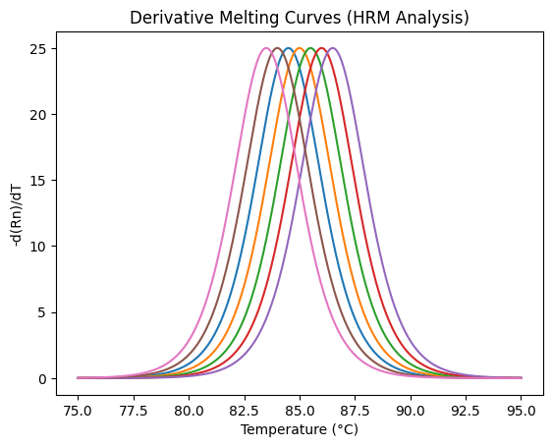
Fig. (6): Normalised melting curves of spa-–dRn/dT typing among the 20 Staphylococcus aureus isolates by using –dRn/dT v0.0.2. Numbers (1-7) represent the clonal complexes (CC).

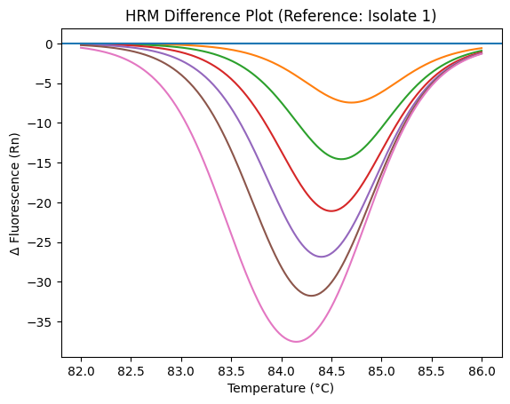
Fig (7): Raw melting curves of spa-–dRn/dT typing among the 20 studied Staphylococcus aureus isolates. Numbers (1-7) represent the clonal complexes (CC).

Table (6) : (–dRn/dT)spa typing results of 20 Staphylococcus aureus clinical isolates.
Isolate N. | CC group | HRM Tm (°C) | Product size pb | Spa type | Repeat of spa types
S.A1 | CC7 | 82.041 | 278 | t304 | 11-10-21-17-34-24-34-22-25
S.A2 | CC6 | 82.420 | 278 | t078 | 04-21-12-41-20-17-12-12-17
S.A3 | CC2 | 85.210 | 223 | t037 | 15-12-16-02-25-17-24
S.A4 | CC7 | 82.044 | 278 | t304 | 11-10-21-17-34-24-34-22-25
S.A5 | CC7 | 82.040 | 278 | t304 | 11-10-21-17-34-24-34-22-25
S.A6 | CC5 | 83.430 | 326 | t491 | 26-23-12-34-34-12-12-23-02-12-23
S.A7 | CC7 | 82.043 | 278 | t304 | 11-10-21-17-34-24-34-22-25
S.A8 | CC6 | 82.410 | 278 | t078 | 04-21-12-41-20-17-12-12-17
S.A9 | CC4 | 83.950 | 158 | t14870 | 11-10-13-25
S.A10 | CC5 | 83.441 | 326 | t491 | 26-23-12-34-34-12-12-23-02-12-23
S.A11 | CC3 | 84.501 | 134 | t059 | 11-19-25
S.A12 | CC5 | 83.440 | 326 | t491 | 26-23-12-34-34-12-12-23-02-12-23
S.A13 | CC6 | 82.421 | 278 | t078 | 04-21-12-41-20-17-12-12-17
S.A14 | CC3 | 84.503 | 134 | t059 | 11-19-25
S.A15 | CC1 | 86.201 | 206 | t030 | 15-12-16-02-24-24
S.A16 | CC3 | 84.501 | 134 | t059 | 11-19-25
S.A17 | CC5 | 83.440 | 326 | t491 | 26-23-12-34-34-12-12-23-02-12-23
S.A18 | CC6 | 82.421 | 278 | t078 | 04-21-12-41-20-17-12-12-17
S.A19 | CC3 | 84.503 | 134 | t059 | 11-19-25
S.A20 | CC1 | 86.201 | 206 | t030 | 15-12-16-02-24-24
CC= clonal complex
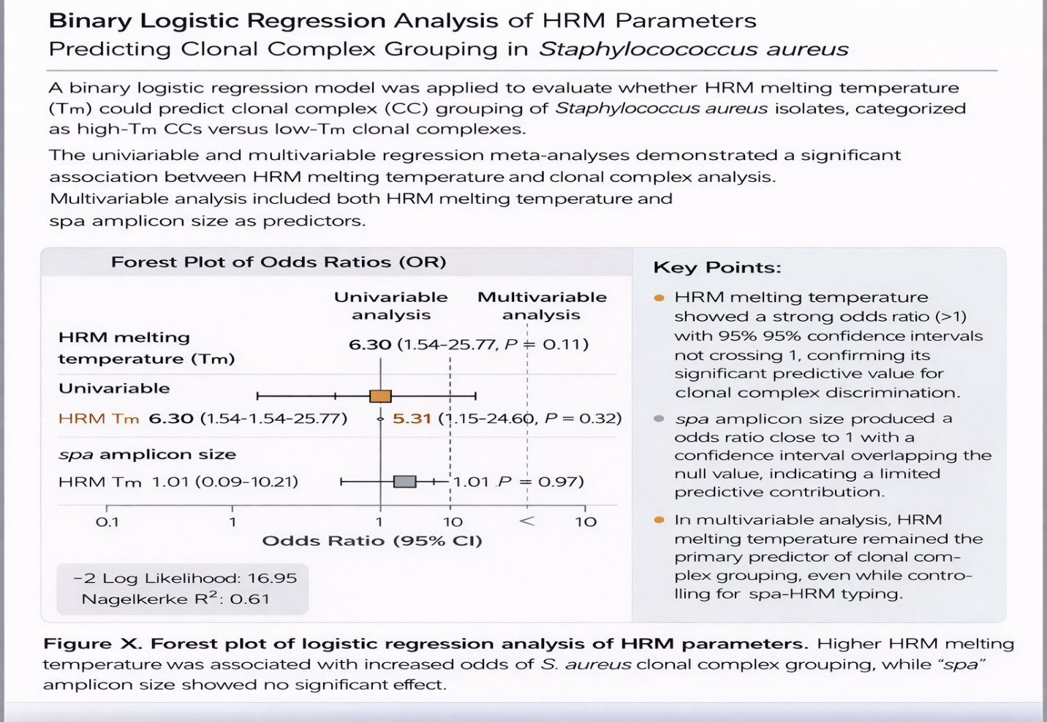
Fig(8): Forest plot of logistic regression analysis for HRM parameter.

References
References
[1].Asadollahi, P., Farahani, N.N., Mirzaii, M., Khoramrooz, S.S., van Belkum, A., Asadollahi, K. and Dadashi, M. (2018) ‘Distribution of the most prevalent spa types among clinical isolates of methicillin-resistant and -susceptible Staphylococcus aureus around the world: a review’, Frontiers in Microbiology, 9, Article 163.
[2].Balasubramanian, D., Harper, L., Shopsin, B. and Torres, V.J. (2017) ‘Staphylococcus aureus pathogenesis in diverse host environments’, Pathogens and Disease, 75(1), ftx005.
[3].Chow, A., Htun, H.L., Hon, P.Y., Ang, B., Kanagasabai, K., Koh, J. and Hsu, L.Y. (2021) ‘Comparative epidemiology and factors associated with major healthcare-associated methicillin-resistant Staphylococcus aureus clones among interconnected healthcare facilities in Singapore’, Clinical Microbiology and Infection, 27(5), pp. 785.e1–785.e9.
[4].Crisóstomo, M.I., Westh, H., Tomasz, A., Chung, M., Oliveira, D.C. and de Lencastre, H. (2001) ‘The evolution of methicillin resistance in Staphylococcus aureus’, Proceedings of the National Academy of Sciences, 98(17), pp. 9865–9870.
[5].David, M.Z. and Daum, R.S. (2017) ‘Community-associated methicillin-resistant Staphylococcus aureus: epidemiology and clinical consequences of an emerging epidemic’, Clinical Microbiology Reviews, 30(1), pp. 3–56.
[6].de Lencastre, H., Chung, M. and Westh, H. (2000) ‘Archaic strains of methicillin-resistant Staphylococcus aureus: molecular and microbiological properties of isolates from the 1960s in Denmark’, Microbial Drug Resistance, 6(1), pp. 1–10.
[7].Eriksen, K.R. and Erichsen, I. (1964) ‘Resistance to methicillin, isoxazolyl penicillins, and cephalothin in Staphylococcus aureus’, Acta Pathologica et Microbiologica Scandinavica, 62, pp. 255–275.
[8].Hille, F., Richter, H., Wong, S.P., Bratovic, M., Ressel, S. and Charpentier, E. (2018) ‘The biology of CRISPR–Cas: backward and forward’, Cell, 172(6), pp. 1239–1259.
[9].Hong, F., Salmon, S., Ong, X.Y., Liew, K., Koh, Y., Young, A. and Fisher, D. (2021) ‘Routine antiseptic baths and MRSA decolonisation: diverse approaches across Singapore’s acute-care hospitals’, Journal of Hospital Infection, 112, pp. 87–91.
[10].Klein, E.Y., Mojica, N., Jiang, W., Cosgrove, S.E. and Septimus, E. (2022) ‘Trends in invasive Staphylococcus aureus infections by age and sex’, The Lancet Infectious Diseases, 22(4), pp. 567–576.
[11].Klein, S., Morath, B., Weitz, D., Schweizer, P.A., Sähr, A., Heeg, K. and Nurjadi, D. (2022) ‘Comparative genomics reveals clonal heterogeneity in persistent Staphylococcus aureus infection’, Frontiers in Cellular and Infection Microbiology, 12, 817841.
[12].Kluytmans-VandenBergh, M.F.Q. and Kluytmans, J.A.J.W. (2006) ‘Community-acquired methicillin-resistant Staphylococcus aureus: current perspectives’, Clinical Microbiology and Infection, 12(Suppl. 1), pp. 9–15.
[13].Kluytmans-Vandenbergh, M.F.Q. and Kluytmans, J.A.J.W. (2006) ‘Community-acquired Staphylococcus aureus carriage: determinants and implications’, Clinical Microbiology Reviews, 19(3), pp. 469–493.
[14].Koonin, E.V. and Makarova, K.S. (2023) ‘Evolutionary and functional classification of CRISPR–Cas systems’, Annual Review of Microbiology, 77, pp. 1–25.
[15].Makarova, K.S., Wolf, Y.I., Iranzo, J., Shmakov, S.A. and Koonin, E.V. (2020) ‘Evolutionary classification of CRISPR–Cas systems: a burst of class 2 and derived variants’, Nature Reviews Microbiology, 18(2), pp. 67–83.
[15].Makarova, K.S., Wolf, Y.I. and Koonin, E.V. (2023) ‘In silico approaches for prediction of anti-CRISPR proteins’, Journal of Molecular Biology, 435(7), 168036.
[16].Montoya-Urrego, D., Vanegas, J.M., Jiménez, J.N. and González-Gómez, D. (2025) ‘Analysis of the dynamics of transition from non-colonization to colonization and Staphylococcus aureus bacteremia in hemodialysis patients using Markov models’, F1000Research, 13, 837.
[17].Nyman, J.A., Lees, C.H., Bockstedt, L.A., Filice, G.A., Lexau, C., Lesher, L.J. and Lynfield, R. (2011) ‘Cost of screening intensive care unit patients for methicillin-resistant Staphylococcus aureus’, American Journal of Infection Control, 39(1), pp. 27–34.
[18].Pinilla-Redondo, R., Russel, J., Mayo-Muñoz, D., Shah, S.A., Garrett, R.A. and Sørensen, S.J. (2022) ‘CRISPR–Cas systems are widespread accessory elements across bacterial and archaeal plasmids’, Nucleic Acids Research, 50(8), pp. 4315–4328.
[19].Pinilla-Redondo, R., Mayo-Muñoz, D., Russel, J. and Shah, S.A. (2022) ‘Diversity and evolution of CRISPR–Cas systems in bacterial pathogens’, Trends in Microbiology, 30(4), pp. 364–378.
[20].Pinilla-Redondo, R., Russel, J., Mayo-Muñoz, D., Shah, S.A., Sørensen, S.J. and Garrett, R.A. (2022) ‘Type IV CRISPR–Cas systems are highly diverse and involved in competition between plasmids’, Molecular Ecology, 31(5), pp. 1595–1608.
[21].Rahi, A.A. and Al-Hasnawy, H.H. (2024) ‘Expression of genes associated with efflux pumps and porins in Acinetobacter baumannii isolates recovered from different clinical specimens’, Biomedical and Biotechnology Research Journal, 8(4), pp. 464–473.
[22].Salmanov, A.G., Shchehlov, D.V., Mamonova, M., Shcheholkov, Y.E., Litus, V.I., Burakov, O.V. and Brodskaya, A. (2025) ‘Healthcare-associated infections in patients with combat wounds and antimicrobial resistance of the responsible pathogens in Ukraine’, Wiadomości Lekarskie, 8, pp. 1624–1634.
[23].Tong, S.Y.C., Davis, J.S., Eichenberger, E., Holland, T.L. and Fowler, V.G. (2015) ‘Staphylococcus aureus infections: epidemiology, pathophysiology, clinical manifestations, and management’, Clinical Microbiology Reviews, 28(3), pp. 603–661.
[24].Turner, N.A., Sharma-Kuinkel, B.K., Maskarinec, S.A., Eichenberger, E.M., Shah, P.P., Carugati, M., Holland, T.L. and Fowler, V.G. (2019) ‘Methicillin-resistant Staphylococcus aureus: an overview of basic and clinical research’, Nature Reviews Microbiology, 17(4), pp. 203–218.
[25].Watson, D.W., Iglesias, S.L., Vasarhelyi, E.M. and Heinrichs, D.E. (2021) ‘GraXRS-dependent resistance of Staphylococcus aureus to human osteoarthritic synovial fluid’, mSphere, 6(2), e01128-20.

