Supplementary Materials for
Atomically Dispersed CoN₃C₁-TeN₁C₃ Diatomic Sites Anchored in N-doped Carbon as Efficient Bifunctional Catalyst for Synergistic Electrocatalytic Hydrogen Evolution and Oxygen Reduction
Minmin Wang^{1,+}, Xiuhui Zheng^{1,+}, Min Li¹, Kaian Sun², Chuhao Liu², Weng-Chon Cheong², Zhi Liu¹, Yanju Chen¹, Shoujie Liu², Bin Wang³, Yanpeng Li¹, Yunqi Liu^{1*}, Chenguang Liu¹, Xiang Feng^{1*}, Chaohe Yang¹, Yuan Pan^{1*}, Chen Chen^{2*}
¹State Key Laboratory of Heavy Oil Processing, China University of Petroleum (East China), Qingdao 266580 (China)
²Department of Chemistry, Tsinghua University, Beijing 100084, China
³School of Chemistry and Chemical Engineering, Shaanxi Normal University, Xi’an 710119 (China)
#These authors contributed equally.
*Correspondence to: liuyq@upc.edu.cn (Y. Liu); xiangfeng@upc.edu.cn (X Feng); panyuan@upc.edu.cn (Y. Pan); cchen@mail.tsinghua.edu.cn (C. Chen)

Fig. S1 Schematic illustration of the synthesis process of Co SASs/N-C.

Fig. S2 Schematic illustration of the synthesis process of Te SASs/N-C.

Fig. S3 XRD pattern of Co-Te DASs/N-C, Co SASs/N-C, Te SASs/N-C, CN.

Fig. S4 Raman spectrum of Co-Te DASs/N-C, Co SASs/N-C, Te SASs/N-C, CN.

a
b
c
Fig. S5 (a) N₂ adsorption-desorption isotherms, (b) micropore size distribution, and (c) mesoporous size distribution curves of Co SASs/N-C.
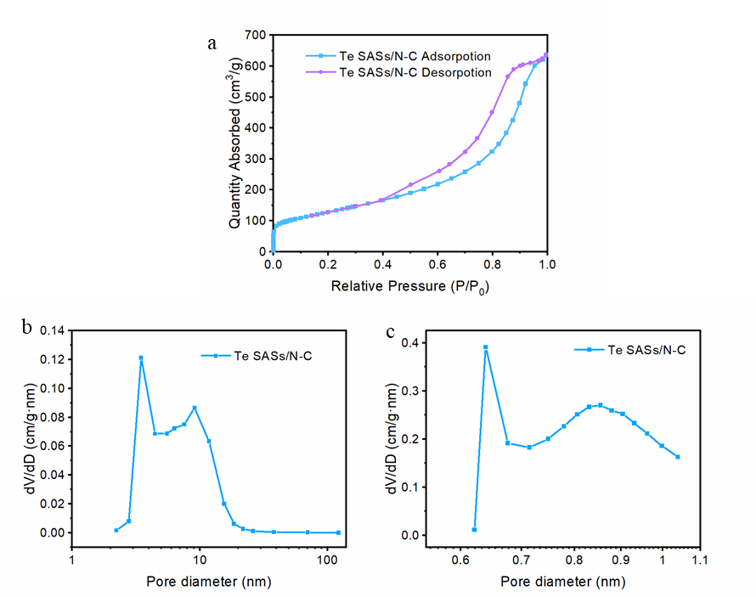
Fig. S6 (a) N₂ adsorption-desorption isotherms, (b) micropore size distribution, and (c) mesoporous size distribution curves of Te SASs/N-C.

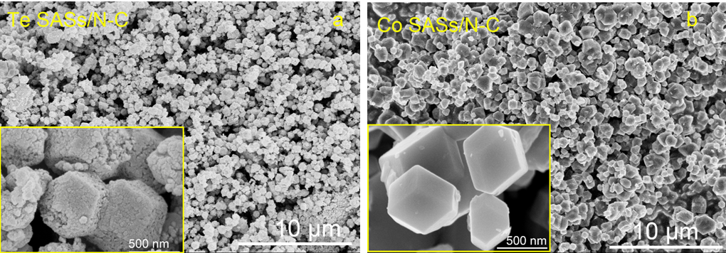
Fig. S7 SEM images of (a) Te SASs/N-C, (b) Co SASs/N-C.

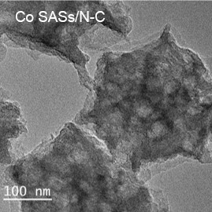
Fig. S8 TEM images of Co SASs/N-C.

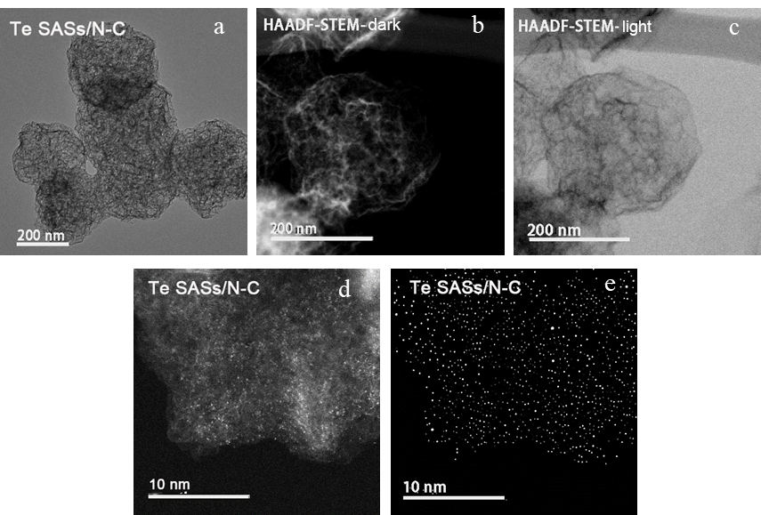Fig. S9 (a) TEM, (b, c) HAADF-STEM, (d) AC-HAADF-STEM, (e) Atom detecct image of Te SASs/N-C.

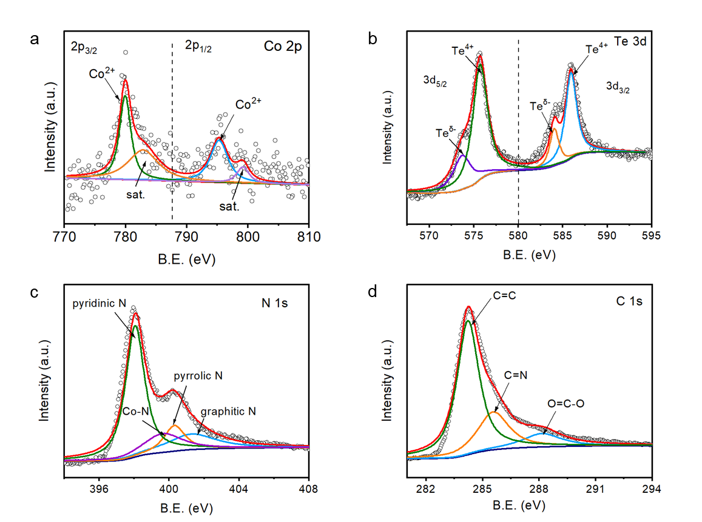
Fig. S10 XPS spectrum of Co SASs/N-C (a) Co 2p, (b) Te 3d, (c) N 1s, (d) C 1s.

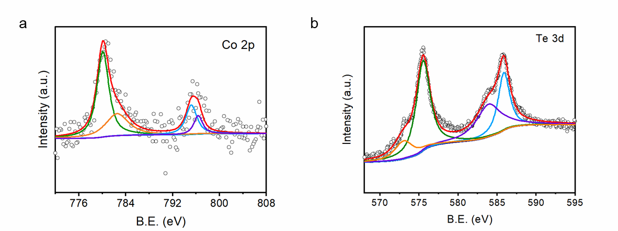
Fig. S11 (a) Co 2p XPS spectrum of Co SASs/N-C, (b) Te 3d XPS spectrum of Te SASs/N-C.

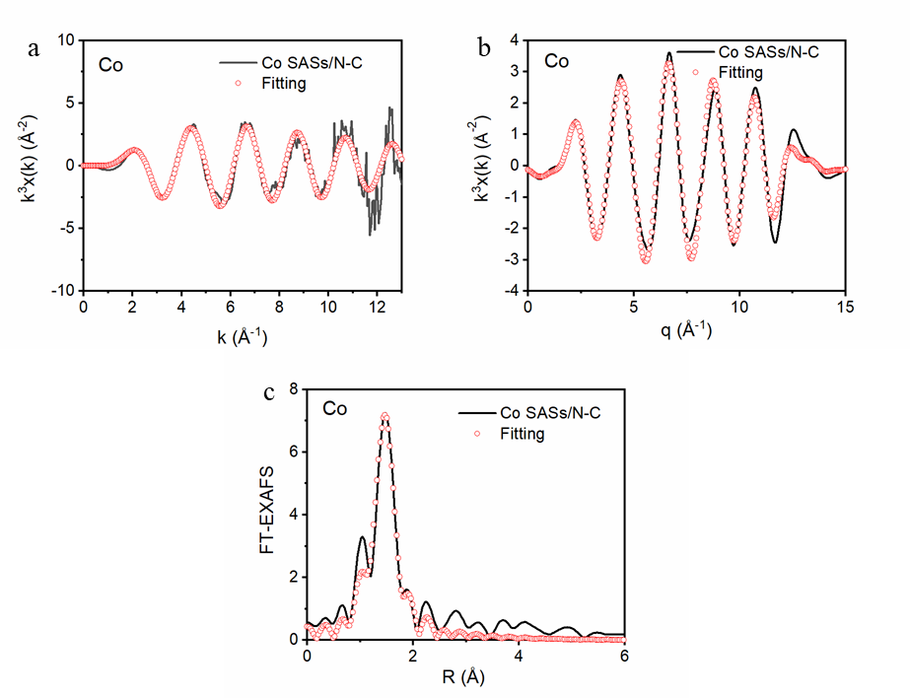
Fig. S12 EXAFS fitting in (a) q space, (b) R space, and (c) k space of Co SASs/N-C.

Fig. S13 EXAFS fitting in k space of Co-Te DASs/N-C.

Fig. S14 EXAFS in k space of Co-Te DASs/N-C, Co SASs/N-C, Co₃O₄, CoO and Co foil.

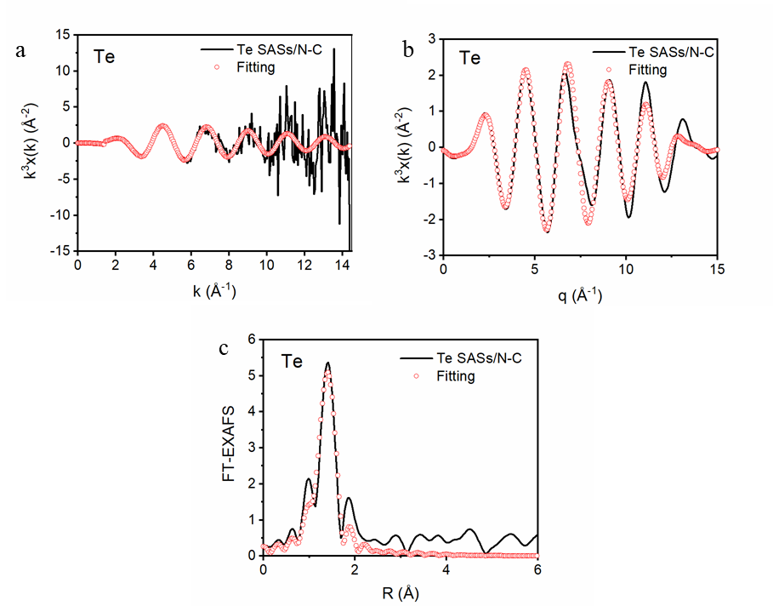
Fig. S15 EXAFS fitting (a) q space, (b) R space, and (c) k space of Te SASs/N-C.

Fig. S16 EXAFS fitting in k spaces of Co-Te DASs/N-C.

Fig. S17 EXAFS in k space of Co-Te DASs/N-C, Te SASs/N-C, TeO₂ and Te foil.

Fig. S18 C K-edge spectrum of Co-Te DASs/N-C.

Fig. S19 C K-edge spectrum of Co SASs/N-C.

Fig. S20 LSV curves of Co-Te DASs/N-C with different Co/Te ratios in 0.5 M H₂SO₄.

Fig. S21 LSV curves of Co-Te DASs/N-C with different Co/Te ratios in 1 M KOH.

a
b
Fig. S22 (a) Tafel slope curves in 0.5 M H₂SO₄, (b) Tafel slope curves in 1 M KOH.

b
a
Fig. S23 (a) EIS curves (0.5 V vs. Ag/AgCl) in 0.5 M H₂SO₄, (b) EIS curves (1.6 V vs. SCE) in 1 M KOH.

a
b
Fig. S24 (a) TOF curves in 0.5 M H₂SO₄, (b) TOF curves in 1 M KOH.

a
b
Fig. S25 (a) C_{dl} curves of Co-Te DASs/N-C, Co SASs/N-C, Te SASs/N-C and CN in 0.5 M H₂SO₄, (b) C_{dl} curves of Co-Te DASs/N-C, Co SASs/N-C, Te SASs/N-C and CN in 1 M KOH.

Fig. S26 LSV curves of Co-Te DASs/N-C, Co SASs/N-C, Te SASs/N-C, CN and Pt/C in PBS.

Fig. S27 i-t curves of Co-Te DASs/N-C in PBS.

Fig. S28 CV curves of Co-Te DASs/N-C, Co SASs/N-C, Te SASs/N-C and CN in PBS.

a
b
Fig. S29 LSV curves of Co SASs/N-C and Te SASs/N-C at different rotation speeds (insets shows the corresponding K-L plots).

Fig. S30 CV curves of Co-Te DASs/N-C, Co SASs/N-C and Te SASs/N-C.

Fig. S31 Tafel slope curve for ORR.

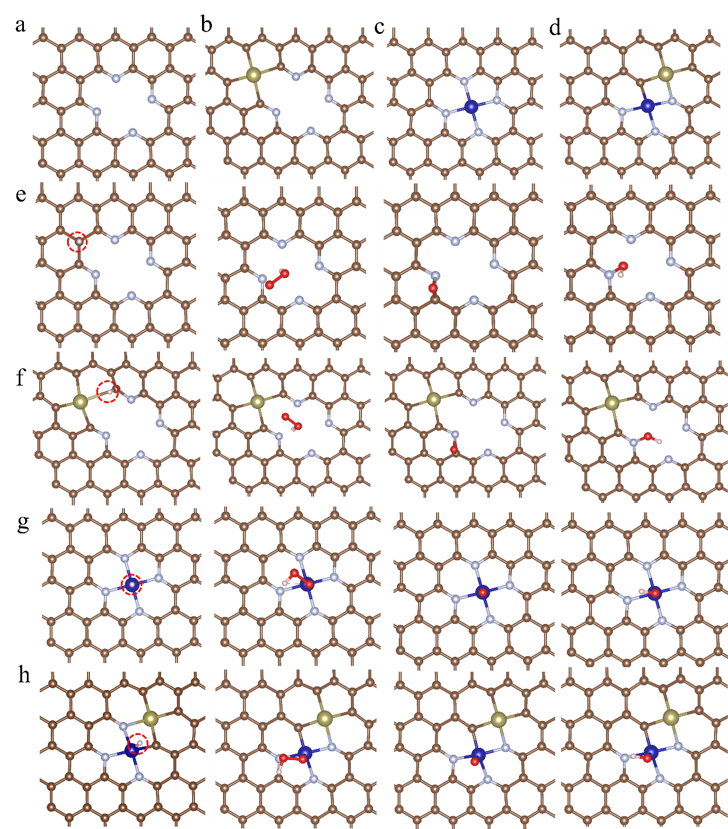
Fig. S32 The optimized configurations of different catalyst models: (a) CN, (b) Te SASs/N-C, (c) Co SASs/N-C, (d) Co-Te SASs/N-C. The adsorption intermediate configurations of HER (H is marked in red circles) and ORR of each structure: (e) CN, (f) Te-SACs/N-C, (g) Co SASs/N-C, (h) Co-Te DASs/N-C.
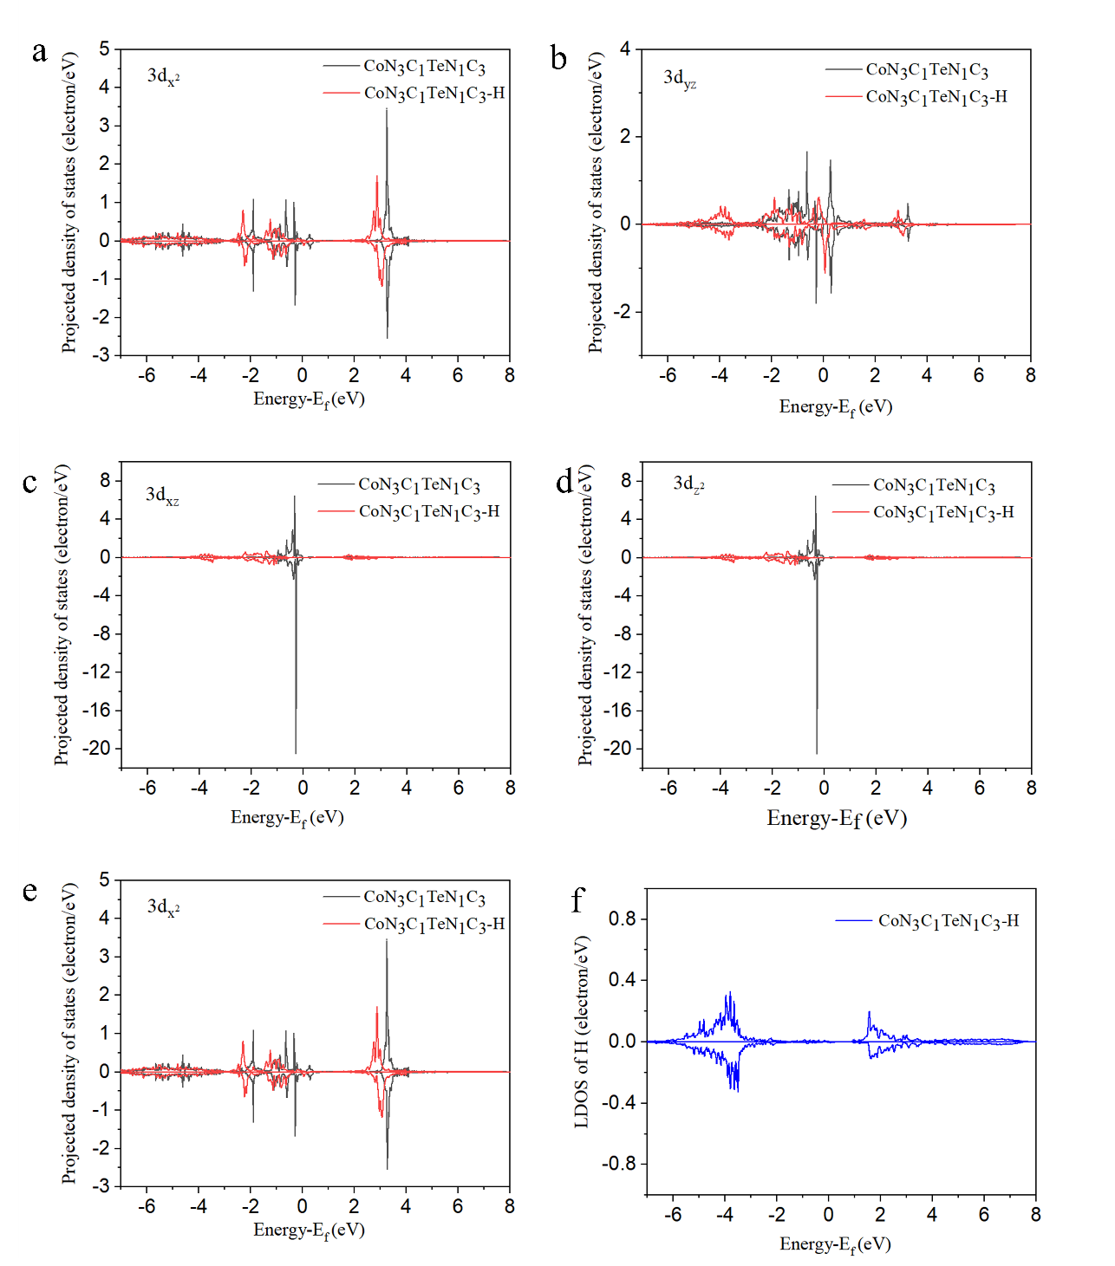
Fig. S33 The projected density of states (PDOS) of individual Co 3d orbitals of CoN₃C₁TeN₁C₃ (Co-Te DASs/NC) before and after H adsorption and the local density of states (LDOS) of H after adsorption: (a) 3d_{xy},$3d_{xy}$ (b) 3d_{yz}$3d_{yz}$, (c) 3d_{xz}$3d_{xz}$, (d) 3d_{z}²$3d_{z^{2}}$, (e) 3d_{x}²$3d_{x^{2}}$, (f) H atom state.
After H adsorption on Co-Te DASs/NC, there are broadenings with different levels in the individual Co 3d orbitals from 3d_{xy}$3d_{xy}$ to 3d_{x}²$3d_{x^{2}}$. Among them, the broadenings of 3d_{yz}$3d_{yz}$, 3d_{xz}$3d_{xz}$, and 3d_{z}² $3d_{z^{2}}$orbitals are more obvious, indicating that there are strong hybridizations between these orbitals and H atom state, which further cause the delocalization of the H atom state, the negative shift of the bonding orbital, and the positive shift of the anti-bonding orbital. In contrast, according to the study by Hossain et al., only 3d_{z}²$3d_{z^{2}}$ orbitals of Co atom effectively participate in orbital hybridization in CoN₄ (Co SASs/N-C). Therefore, CoN₃C₁TeN₁C₃ has more active surface states involved in orbital hybridization, thus enhancing H atom adsorption.
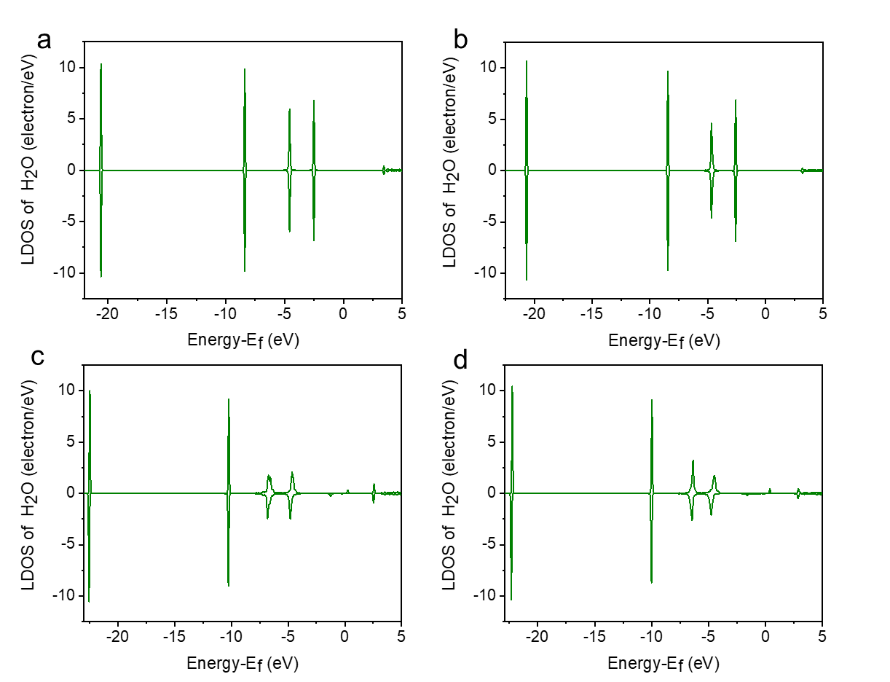
Fig. S34 The LDOS of adsorbed H₂O molecule in (a) CN, (b) Te SASs/N-C, (c) Co SASs/N-C, and (d) Co-Te DASs/N-C.

a
b
Fig. S35 (a) Discharge/charge cycling curves of two-electrode rechargeable Zn-air batteries at a current density of 2 mA·cm⁻², (b) specific capacities of the batteries at a current density of 20 mA cm⁻².

Table S1 Single-atom(s) adsorption energy and Bader charge population of different catalysts
 | ªE_{b}(eV) | ^{b}Charge density(|e|)
 |  | Co | Te
Te SASs/N-C | 3.77 | - | 1.220
Co SASs/N-C | 7.64 | 0.834 | -
Co-Te DASs/N-C | 9.24 | 0.819 | 1.335
The cohesion energies per atom are 4.39 eV (Co) and 2.19 eV (Te) with the sum of them being equal to 6.58 eV, which are smaller than the corresponding binding energies E_{b}, indicating the stability of these three single-atom or dual-atom catalysts (Table S1). Co atom in Co-Te DASs/N-C has a lower positive charge than that in Co SASs/N-C, while Te atom in Co-Te DASs/N-C has a higher positive charge than that in Te SASs/N-C. This is consistent with the XAS results, as shown in Fig. 2o.

Table S2. ICP results
Sample | Test element | Element content (wt%)
Co-Te DASs/N-C | Co | 0.37
Co SASs/N-C | Co | 0.23

Table S3. Structural parameters extracted from the EXAFS fitting. (S₀²=0.85)
Sample | Scattering pair | CN | R(Å) | σ²(10⁻³Å²) | ΔE₀(eV) | R factor
Co SASs/N-C | Co-N | 4.0 | 1.92 | 4.3 | -3.7 | 0.02
Co-Te DASs/N-C | Co-C | 1.0 | 1.92 | 4.8 | -3.7 | 0.02
Co-Te DASs/N-C | Co-N | 2.9 | 1.93 | 4.9 | -3.7 | 0.02
Te SASs/N-C | Te-C | 4.1 | 1.92 | 4.4 | -3.5 | 0.02
Co-Te DASs/N-C | Te-C | 3.0 | 1.92 | 4.8 | -3.5 | 0.02
Co-Te DASs/N-C | Te-N | 1.1 | 1.93 | 4.9 | -3.5 | 0.02
S₀² is the amplitude reduction factor; CN is the coordination number; R is interatomic distance (the bond length between Fu central atoms and surrounding coordination atoms); σ² is Debye-Waller factor (a measure of thermal and static disorder in absorber-scatterer distances); ΔE₀ is edge-energy shift (the difference between the zero kinetic energy value of the sample and that of the theoretical model). R factor is used to value the goodness of the fitting.

