Extended Data

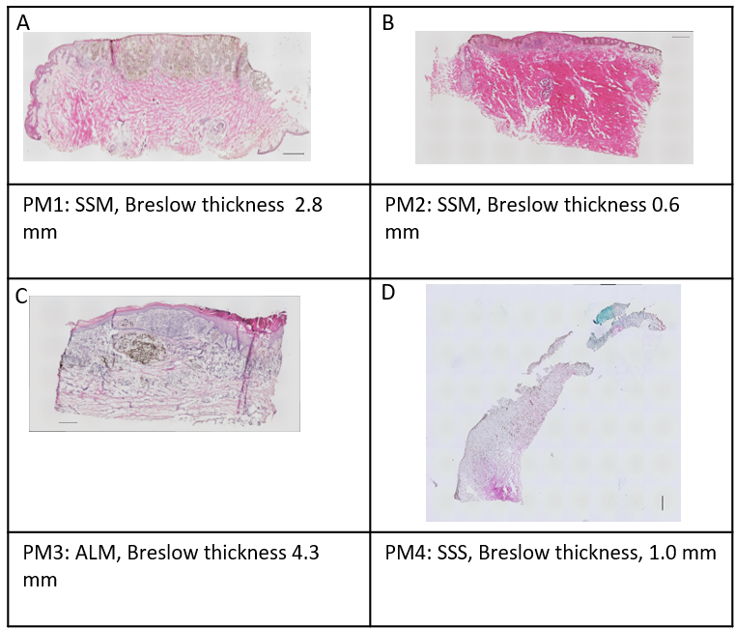
Extended Data Figure 1: Melanoma subtype, histopathological picture and Breslow thicknesses of four primary melanomas analyzed by spatial transcriptomics using the 10x Genomics Visium technology. (A) SSM of 2.8 mm Breslow thickness (PM1). (B) SSM of 0.6 mm Breslow thickness (PM2). (C) ALM of 4.3 mm Breslow thickness. (D) SSM of 1.0 mm Breslow thickness. H&E staining; scale bars, 500 μM. Abbreviations: SSM, superficial spreading melanoma; ALM, acrolentiginous melanoma.

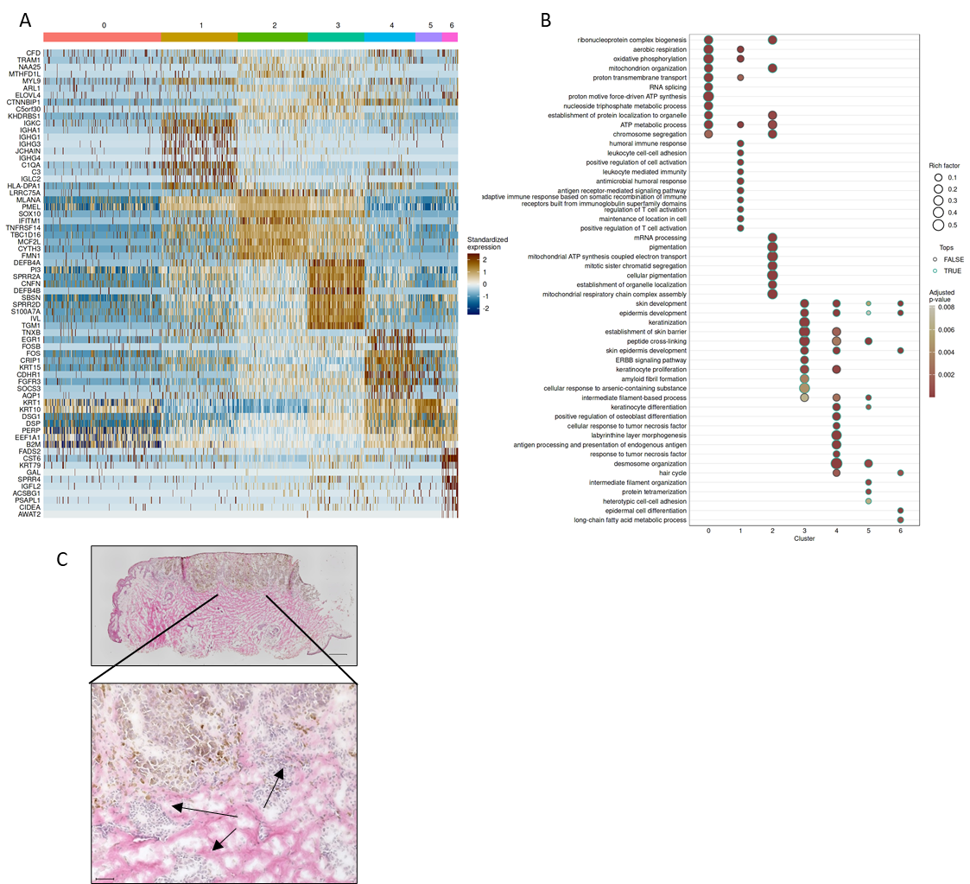
Extended Data Figure 2: Characteristics of melanoma sample PM1. (A) Spatial transcriptomics data from PM1 were analyzed and gene expression patterns of different clusters as shown in Figure 1, are presented as heatmap. (B) Gene expression patterns of different clusters of PM1 were subjected to analysis for gene ontology categories. Dot plot shows enriched GO terms in different transcriptomic clusters. (C) H&E staining of a serial sections of PM1 from paraffin-embedded tissue (upper picture). Higher power view of the H&E-stained section (lower picture). Arrows in lower picture indicate inflammatory infiltrate. Scale bars in (C); upper picture, 500 µm; lower picture, 50 µm.

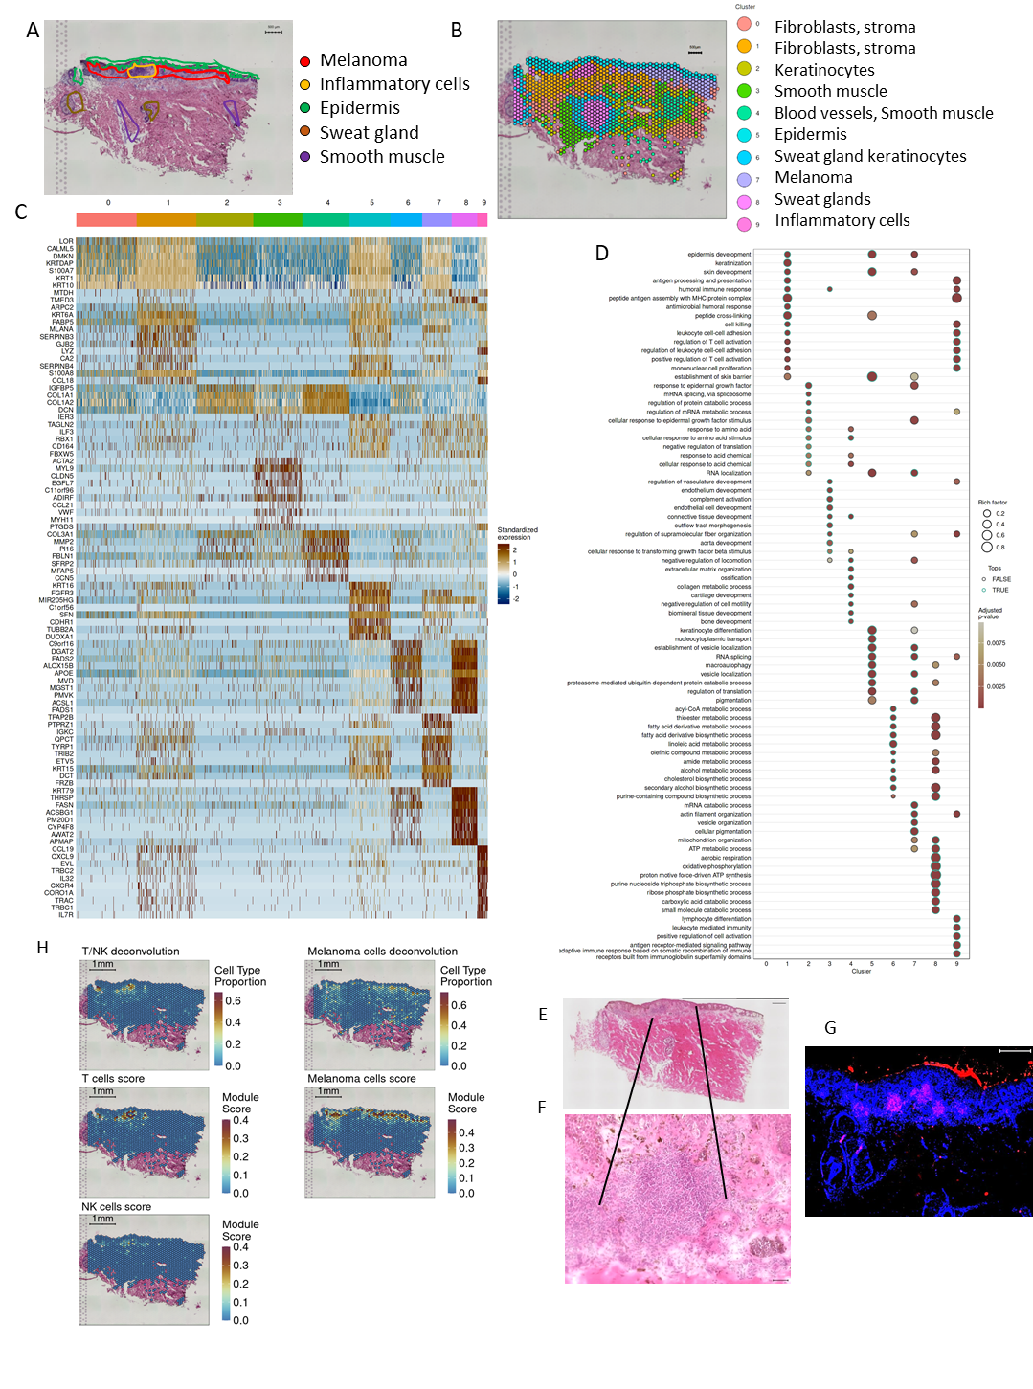
Extended Data Figure 3: Spatial transcriptomics of a superficial spreading melanoma (PM2) of 0.6 mm Breslow tumor thickness. A melanoma sample of a superficial spreading melanoma, Breslow thickness 0.6 mm, was analyzed by spatial transcriptomics using the 10x Genomics Visium technology. (A) H&E staining of the cryosection of the Visium slide with expert annotation of histopathological areas. (B) Spatial transcriptomics-based clustering results. (C) Cluster marker heatmap. (D) Gene expression patterns of different clusters of PM2 were subjected to analysis for gene ontology categories. Dot plot shows enriched GO terms in different transcriptomic clusters. (E) H&E staining of a serial sections of PM2 from paraffin-embedded tissue (upper picture). (F) Higher power view of the H&E-stained section (lower picture). (G) Immunofluorescence staining for CD3 expression. (H) Spatial distribution of deconvolved melanoma and T/NK cell content and spatial distribution of cell type specific module scores for melanoma, T and NK cells calculated using log-transformed counts of custom gene panels.. Scale bars in (E), upper picture, 500 µm, lower picture, 50 µm; in (F), 500 µm; or as indicated in the Figure.

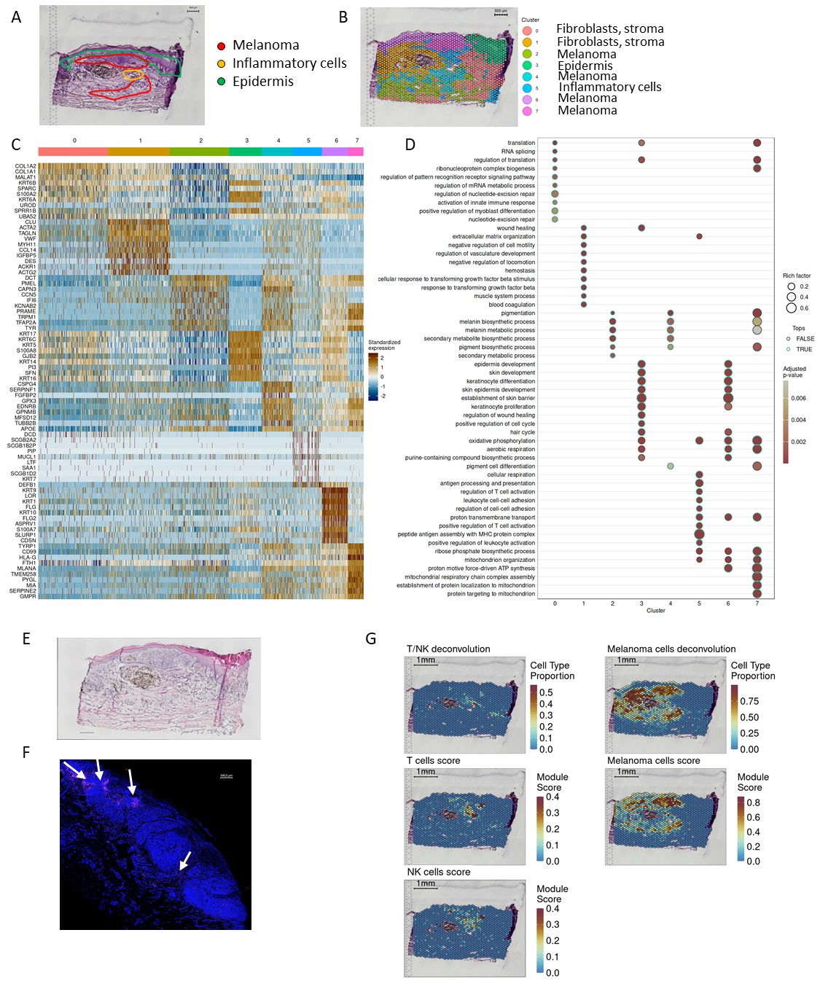
Extended Data Figure 4: Spatial transcriptomics of an acrolentiginous melanoma (PM3) of 4.3 mm Breslow thickness (PM3). An acrolentiginous melanoma (ALM) of 4.3 mm Breslow tumor thickness (PM3) was analyzed by spatial transcriptomics using the 10x Genomics Visium technology. (A) H&E staining of the cryosection of the Visium slide with expert annotation of histopathological areas. (B) Spatial transcriptomics-based clustering results. (C) Cluster marker heatmap. (D) Gene expression patterns of different clusters of PM3 were subjected to analysis for gene ontology categories. Dot plot shows enriched GO terms in different transcriptomic clusters. (E) H&E staining of a serial sections of PM3 from archival paraffin-embedded tissue. Area shown in (F) framed. (F) Immunofluorescence staining for CD3 expression. Arrows indicate immune cell infiltration. (G) Spatial distribution of deconvolved melanoma and T/NK cell content and spatial distribution of cell type specific module scores for melanoma, T and NK cells calculated using log-transformed counts of custom gene panels. Scale bars in (E), 500 µm; (F), 500 µm; or as indicated in the Figure.

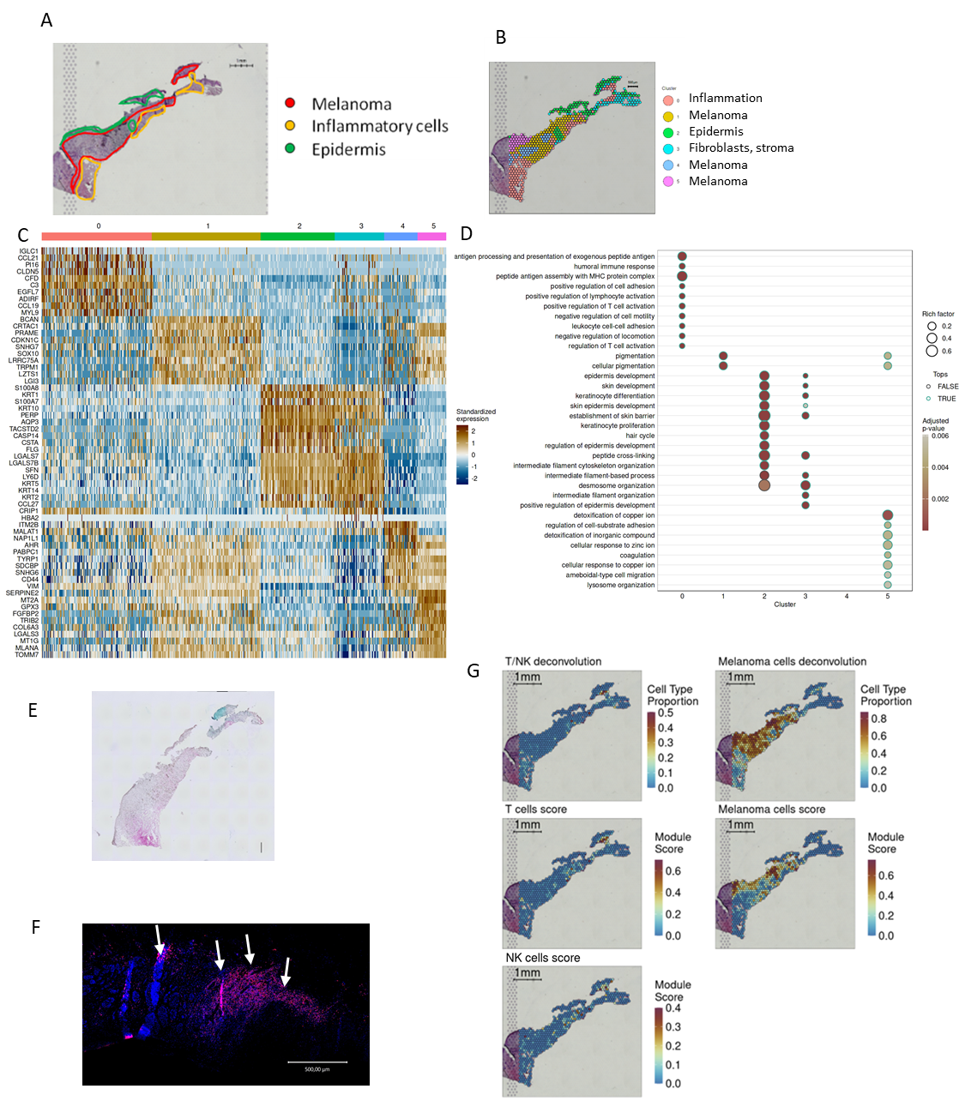
Extended Data Figure 5: Spatial transcriptomics of a superficial spreading melanoma (PM4) of 1.0 mm tumor thickness. (A) A melanoma sample of a superficial spreading melanoma, Breslow thickness 1.0 mm, was analyzed by spatial transcriptomics using the 10x Genomics Visium technology. H&E staining of the cryosection of the Visium slide with expert annotation of histopathological areas. (B) Spatial transcriptomics-based clustering results. (C) Cluster marker heatmap. (D) Gene expression patterns of different clusters of PM4 were subjected to analysis for gene ontology categories. Dot plot shows enriched GO terms in different transcriptomic clusters. (E) H&E staining of a serial sections of PM4 from paraffin-embedded tissue. Area shown in (F) framed. (F) Immunofluorescence staining for CD3 expression. Arrows indicate immune cell infiltrates. (G) Spatial distribution of deconvolved melanoma and T/NK cell content and spatial distribution of cell type specific module scores for melanoma, T and NK cells calculated using log-transformed counts of custom gene panels. Scale bars in (E), 500 µm; (F), 500 µm; or as indicated in the Figure.

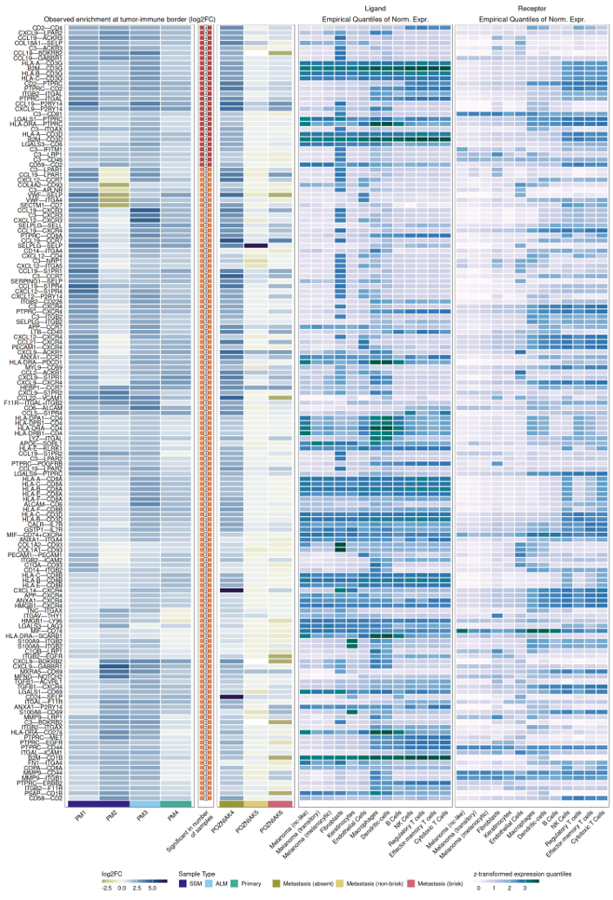
Extended Data Figure 6: Overview of ligand-receptor interactions in melanoma samples. Based on 10 x Visium spatial transcriptomics data, ligand-receptor (LR) interactions between melanoma cells and lymphocytes in close proximity at the inflammatory border were analyzed by use of the NICHES framework and permutation-based enrichment tests. LR interactions shown were significantly enriched in at least 3 out of 4 primary melanomas in the tumor-immune border region compared to tumor and T/NK cell positive spots outside the border region.

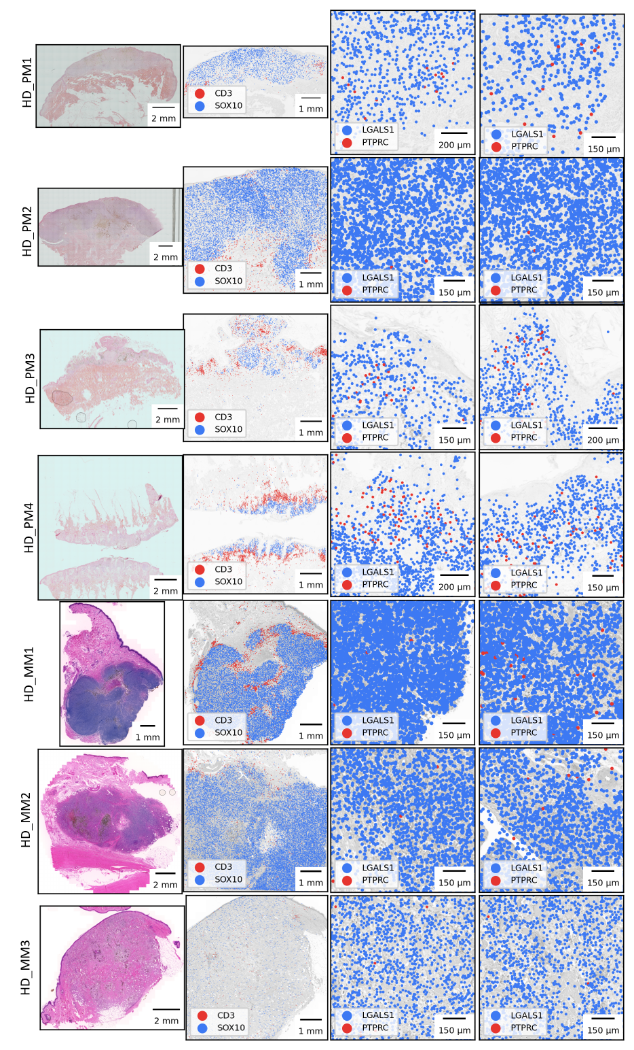
Extended Data Figure 7: Spatial transcriptomics of a second set of primary melanomas and cutaneous melanoma metastases. An additional set of 4 primary melanomas and three metastases was analyzed using the 10x Genomics Visium HD (high definition) technology. An overview of H&E-stained paraffin-embedded sections of indicated samples is shown (first column). Expression of SOX10 (melanoma cell marker) and CD3 (T cell receptor marker), respectively, in spatial transcriptomics data are shown, indicated by blue (SOX10) or red (CD3) color (second column). Third and fourth column shows microscopic higher power views of sections in the second column. Images show cells expressing LGALS1 (blue) and PTPRC (red).

