Supplementary Information

Multi-Scale Genesis Pathway for the Formation of the Near-Equatorial Tropical Cyclone Senyar

Marzuki Marzuki¹*, Michał Brennek², Ravidho Ramadhan¹, Nadya Rezky Ananda¹, Fredolin Tangang³, Carl J. Schreck III⁴, Dariusz B. Baranowski²*

¹ Department of Physics, Universitas Andalas, Padang 25163, Indonesia
² Department of Atmospheric Physics, Institute of Geophysics, Polish Academy of Sciences,
64 Ksiecia Janusza Street, Warsaw, 01-452, Poland
³ Department of Earth Sciences and Environment, Faculty of Science and Technology, Universiti Kebangsaan Malaysia, 43500 Bangi, Malaysia
⁴ North Carolina Institute for Climate Studies (NCICS), North Carolina State University,
151 Patton Ave. Asheville, NC 28801, USA

* Correspondence to: Marzuki Marzuki (marzuki@sci.unand.ac.id) and Dariusz B. Baranowski (dbaranowski@igf.edu.pl)

Supplementary Text

NETC Climatology
Figure S1 presents climatology (1980 – 2024) of near-equatorial tropical cyclones (NETC) – defined by their genesis latitude (first data point in IBTrACS database^{1,2}) within 6° latitude of the equator. The NETCs which formed over the Maritime Continent (MC, shown in red) are exceptionally rare, accounting for only 14 systems since 1980 (0.31% of all basin TCs; 5.38% of all NETCs).
The predominant trajectory for NETCs is westward with poleward recurvature. The rare NETC within MC behave similarly as they tend to transect Sumatra and recurve northward over Indian Ocean. TC Senyar exhibited anomalous motion (Fig. 1), initially tracking southward before turning eastward - a rare departure from the climatological poleward recurvature. This unusual trajectory reflects the atypical steering flow configuration during Senyar's genesis (transient northerlies induced by a Mixed-Rossby-Gravity wave), and likely a Fujiwara Effect^{3,4} (transition to eastward movement) due to double TC interaction with TC Koto (Fig. 1).

Pre-Senyar disturbance track
The pre-Senyar trajectory (Fig.1, Fig. 2) is based on 850 hPa relative vorticity from ERA5. Here sensitivity to pressure level selection is tested (Fig. S2). Tracking performed in the range of pressure levels between 950 and 250 hPa yields qualitatively the same result, while tracking at levels above 250 hPa, shows different pattern. Hence, pre-Senyar disturbance was a coherent feature across most of the troposphere. It should be noted that some discrepancy can be observed between the pre-Senyar track in the main text and the 850 hPa track here. However, it is attributable to different temporal resolution of input data (1 hourly in the main text vs 6 hourly here) for the same tracking algorithm (see Methods section).

Maps of temporally decomposed dynamical fields at 850 hPa
Figure S3 shows temporally decomposed wind and vorticity fields (maps) for selected 3 days in TCG period of November 2025. Animation of the decomposed fields is available for November 2025 at 6 hourly time step: DOI.org/10.6084/m9.figshare.31424309. These data were spatially averaged over Westerly Wind Burst, NE Monsoon, and Strait of Malacca regions (Fig. 1) and presented in Fig. 3.
Background (periods longer than 20 days) 850 hPa flow shows NE flow across South China Sea and Southeast Asia, and westerly flow over eastern equatorial Indian Ocean and Karimata Strait throughout preTCG and TCG, leading to cyclonic vorticity at around 5°N, and especially in the Strait of Malacca. Sub-intraseasonal (5-20 days) flow variability is dominated by the westward propagation of NE monsoon winds at around 10°N and westward propagation of equatorial westerlies related to the first convectively coupled Kelvin wave and equatorial Rossby wave (Fig. 6). It results in a strong and persistent cyclonic circulation over the Strait of Malacca. The arrival of tropical storm Koto near Philippines pushed NE monsoon flow southward leading to enhanced convergence in that region.
The transient (shorter than 5 days) variability shows significant variance in the Strait of Malacca after 20 November, related to an arrival of preSenyar disturbance, and intense, coherent and narrow westerlies associated with positive relative vorticity on 25 November, related to the second convectively coupled Kelvin wave (Fig. 6).

Comparison of ERA5 and soundings profiles during TC Senyar formation
TC Senyar formation occurred over Strait of Malacca (Fig. 1) and vertical profiles were analyzed based on ERA5 data (Fig. 5). To validate this data source, radiosonde observations from Kuala Lumpur (WMO 48650; 3.13°N, 101.69°E), the nearest available upper-air station to the genesis region, were used and compared to the nearest ERA5 grid point data (Fig. S4). Comparison was performed for the preTCG (November 19–22; Fig. S3 - top row) and TCG (November 23–26; Fig. S4 - bottom row) periods using 00UTC profiles (8 and 6 soundings, respectively). Specific humidity profiles (Fig. S4 left column) show good agreement between ERA5 and observations throughout the troposphere, with differences typically less than 1 g/kg at all levels (e.g., at 925 hPa: 15.85 vs 14.91 g/kg during preTCG; 15.98 vs 15.71 g/kg during TCG). More importantly the ERA5 day – to – day tendencies agree with upper soundings observations and show gradual moistening of lower and middle troposphere, reiterating development of favorable conditions for TCG across the broader region (Fig. 5b). Wind direction (Fig. S4 middle column) also demonstrates reasonable agreement in both periods, with ERA5 capturing the predominantly westerly flow in the lower-to-middle troposphere at that location and the transition to easterly flow above 300 hPa.
Systematic differences were identified in wind speed magnitudes (Fig. S4, right column), with radiosonde observations consistently exceeding ERA5 values by a factor of 2–3 throughout the troposphere (e.g., at 700 hPa: 21.4 m/s observed vs 8.9 m/s ERA5 during preTCG; 24.3 vs 11.1 m/s during TCG). These discrepancies are attributable to the processing applied to radiosonde wind data obtained via the Global Telecommunications System (GTS) through the University of Wyoming archive. Similar magnitude differences have been documented based on comparison of ERA5, radiosondes, and Equatorial Atmosphere Radar (EAR) observations over West Sumatra⁵ and found that EAR-derived winds were more consistent with ERA5 than with GTS-processed soundings. The corrections applied during GTS data processing cannot be reverse-engineered from the available dataset⁶, precluding direct adjustment of the radiosonde values. Despite the biases the day-to-day tendencies in ERA5 and upper soundings are in agreement.
Identified biases in assessment of horizontal winds in sounding – based observations, and successful formation of TC Senyar imply that ERA5 derived wind shear (Fig. 5e) well depicts the evolution of environmental conditions during preTCG and TCG. We acknowledge the limitation that available radiosonde observations are confined to land-based stations outside the Strait of Malacca, and direct validation over the maritime genesis region is not possible.

Equatorial waves filtering
Figures S5-7 show filtered wind and vorticity field anomalies (maps) for selected 3 days in TCG period of November 2025. Animation of the decomposed fields is available for November 2025 at 6 hourly time step: DOI.org/10.6084/m9.figshare.31408212. The evolution of 850 hPa relative vorticity as well as equatorial wave activity is shown in Fig. 7 and vorticity budget analysis over the Strait of Malacca on Fig. 8.
The equatorial waves became phase-aligned over the Maritime Continent, leading to a constructive amplification of the vorticity. Convectively coupled Kelvin waves exhibit narrow meridional band trapping and were displaced to N due to the position of ITCZ. This is particularly true for the second wave arriving in Strait of Malacca on 25 November. The main equatorial Rossby wave, active during preTCG and TCG in the Strait of Malacca (Fig. 6) was also narrower than typical (notice typical structure can be observed after Senyar TCG during TC Koto formation near Philippines), with it’s north gyre positioned between 1 -6°N. Hence, the Eq-10°N meridional band well depicts tropical waves activity relevant to the TC Senyar genesis in Strait of Malacca.
Both regimes exhibit typical movement with narrower meridional trapping, allowing for the interaction between CCKWs increased westerly winds and sustained cyclonic vorticity of ER, which, in turn, allowed for the isolation of preTC Senyar vorticity environment, forming a protective pouch. The mixed Rossby gravity waves contributed to modulation of meridional steering flow and also increased flow convergence (a visible coexistence of Kelvin wave westerlies and mixed Rossby-gravity wave north-easterlies on 24 November 2025) over the Strait of Malacca. The arrival of second CCKW allowed for final transition of TC Senyar into self-sustaining system contributing cyclonic vorticity on its northern edge and also amplifying westerly flow (in already favorable conditions - due to MJO westerlies) south of the TC Senyar center.

Supplementary bibliography
1. Knapp, K. R., Kruk, M. C., Levinson, D. H., Diamond, H. J. & Neumann, C. J. The International Best Track Archive for Climate Stewardship (IBTrACS): Unifying Tropical Cyclone Data. Bull. Am. Meteorol. Soc. 91, 363–376 (2010).
2. Information (NCEI), N. C. for E. International Best Track Archive for Climate Stewardship (IBTrACS) Project, Version 4.01. https://www.ncei.noaa.gov/access/metadata/landing-page/bin/iso?id=gov.noaa.ncdc:C01552.
3. Latos, B. et al. The role of tropical waves in the genesis of Tropical Cyclone Seroja in the Maritime Continent. Nat. Commun. 14, 856 (2023).
4. Fujiwhara, S. The natural tendency towards symmetry of motion and its application as a principle in meteorology. Q. J. R. Meteorol. Soc. 47, 287–292 (1921).
5. Szkolka, W. et al. Tropospheric winds over West Sumatra—a comparison between ERA-5 reanalysis and equatorial atmosphere radar. Clim. Dyn. 63, 88 (2025).
6. Ciesielski, P. E. et al. Quality-Controlled Upper-Air Sounding Dataset for DYNAMO/CINDY/AMIE: Development and Corrections. J. Atmospheric Ocean. Technol. 31, 741–764 (2014).

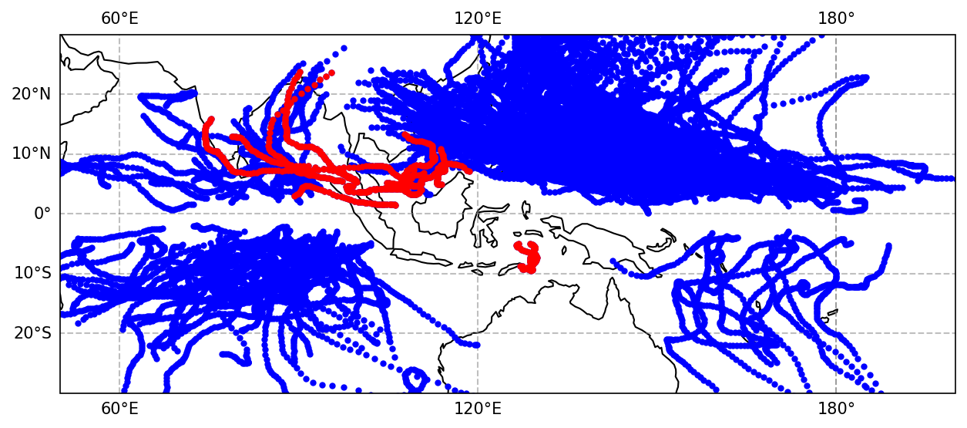
Fig. S1 Global distribution of near equatorial Tropical Cyclone (NETC) tracks (1980–2024) defined by their genesis location within +/-6° latitude. Red lines indicate any NETC initiated within MC; Blue lines all other NETC.

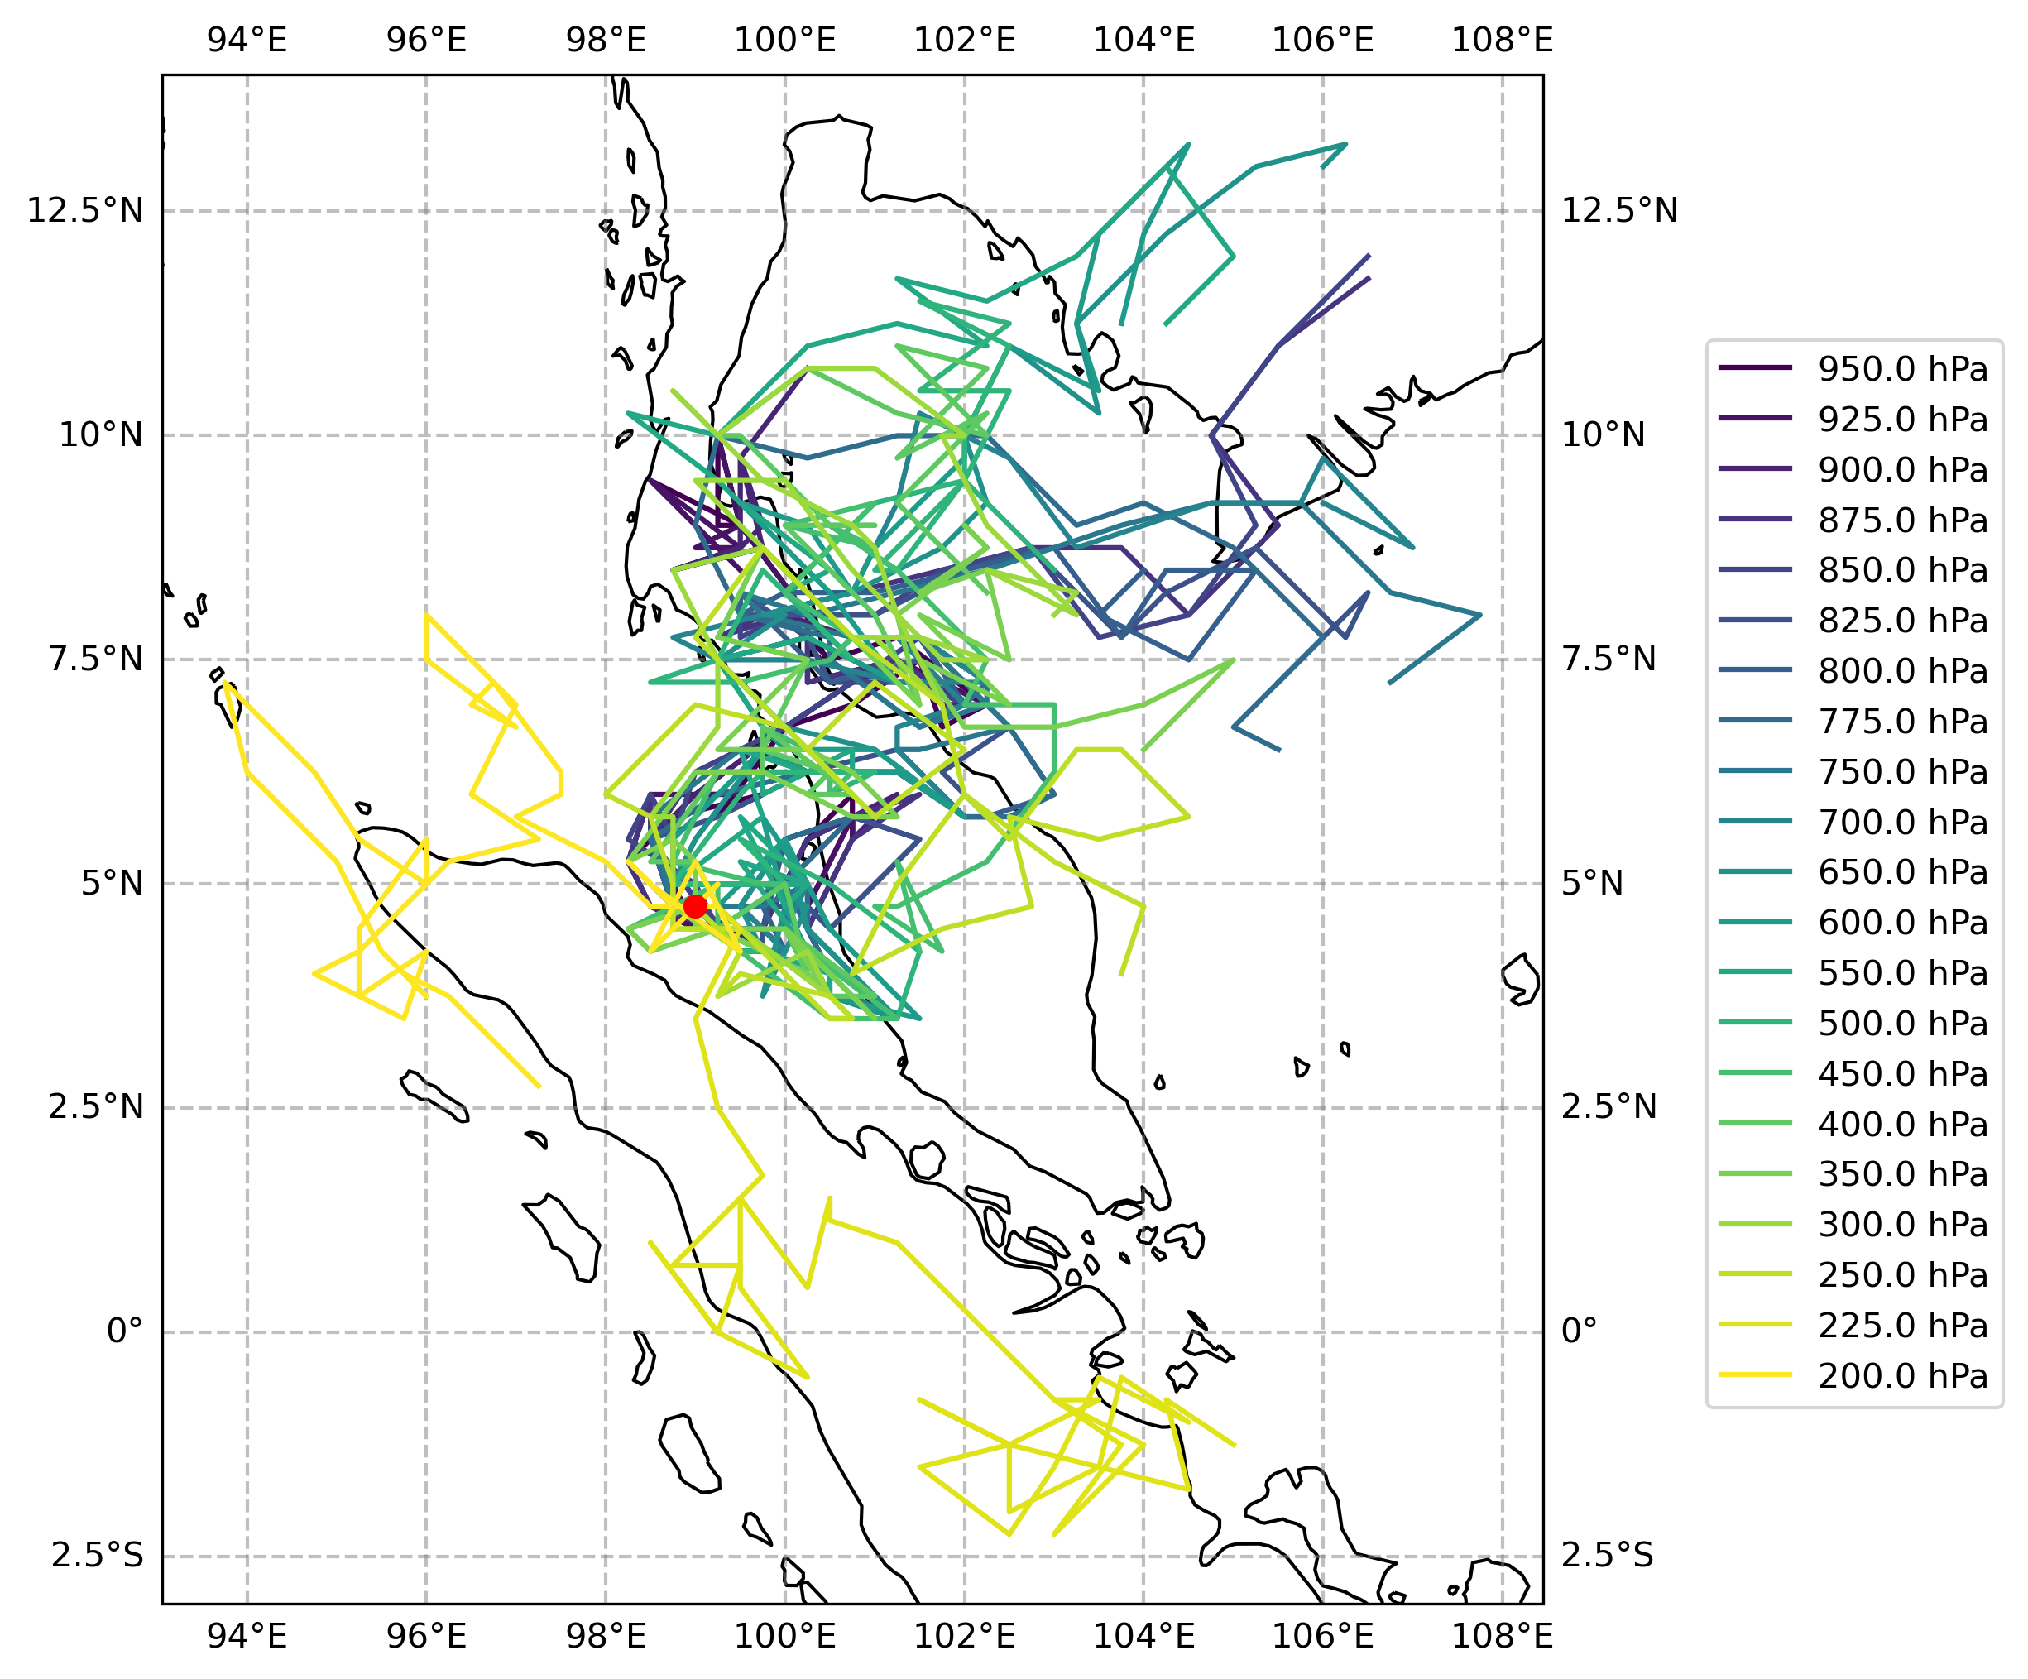
Fig. S2 Track of pre-Senyar vortex based on vorticity maxima at different pressure levels derived from ERA5 relative vorticity with 6-hourly resolution. Each trajectory is 10 days long. Pressure levels are color coded (see legend).

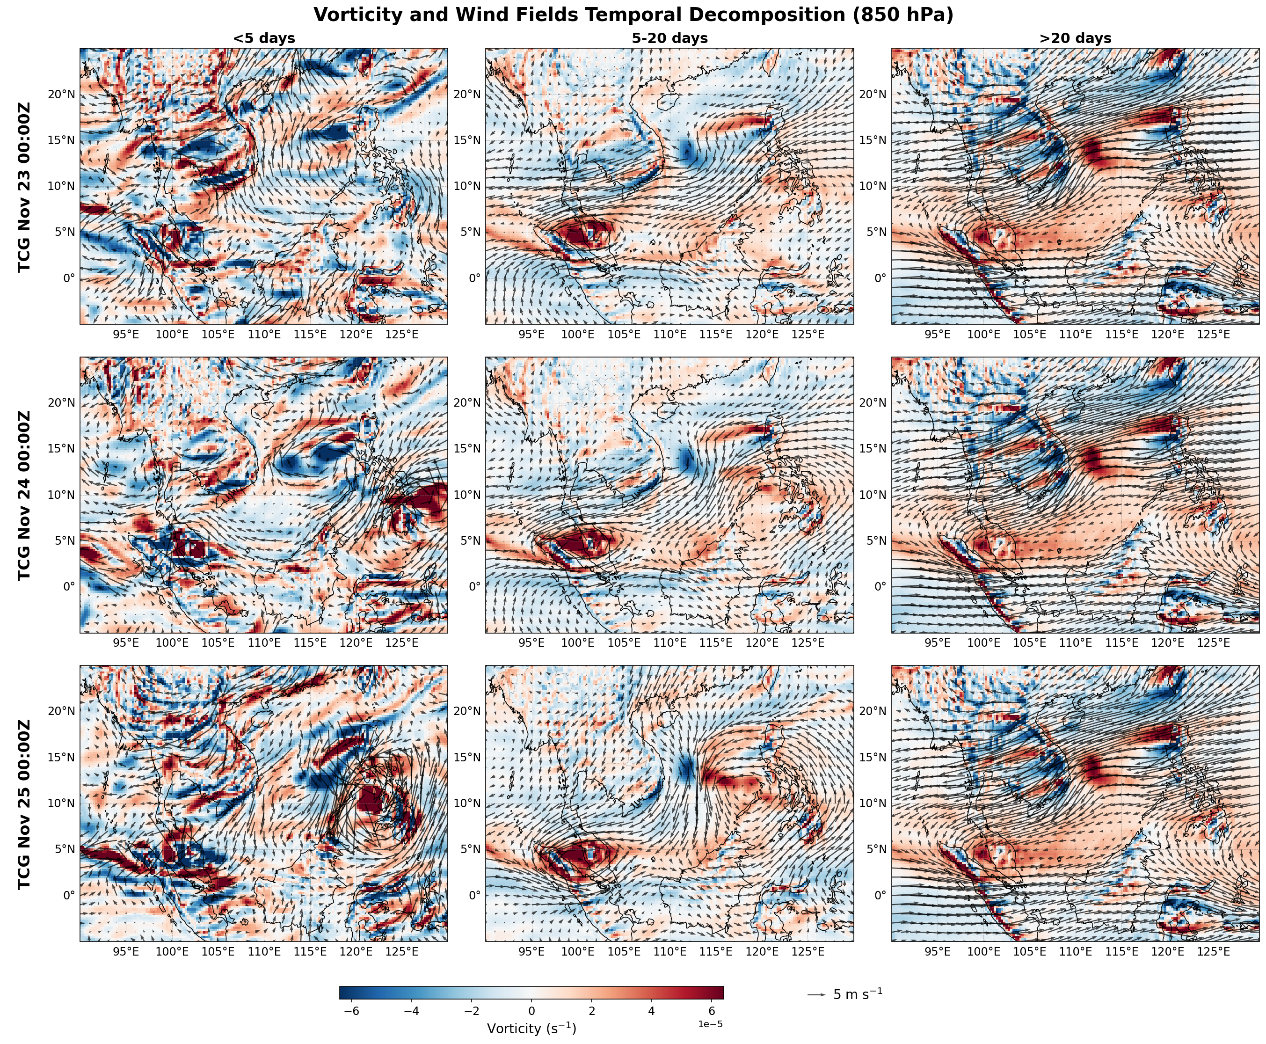
Fig. S3 Temporal decomposition of 850 hPa wind and relative vorticity fields into transient (left), sub-intraseasonal (middle), and background (right) variability. Instantaneous values at 00UTC are shown. The temporal evolution of these fields can be found in Supplementarty Movie 1 DOI.org/10.6084/m9.figshare.31424309

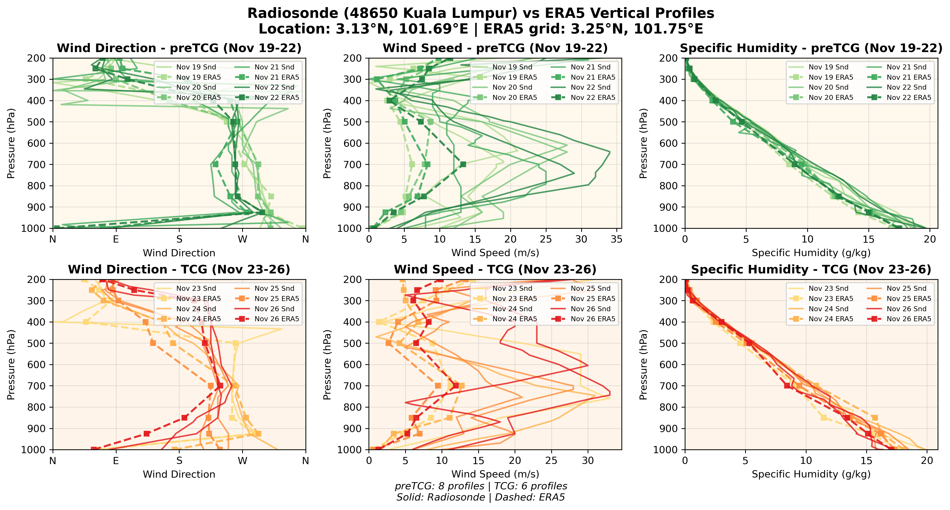
Fig. S4 Validation of ERA5 reanalysis vertical profiles with radiosonde observations from Kuala Lumpur (WMO ID48650). ERA5 data (solid lines) are compared with soundings – dashed. Left column: wind direction; middle column: wind speed (m/s); right column: specific humidity (g/kg). Top row is preTCG period, bottom row is TCG period.

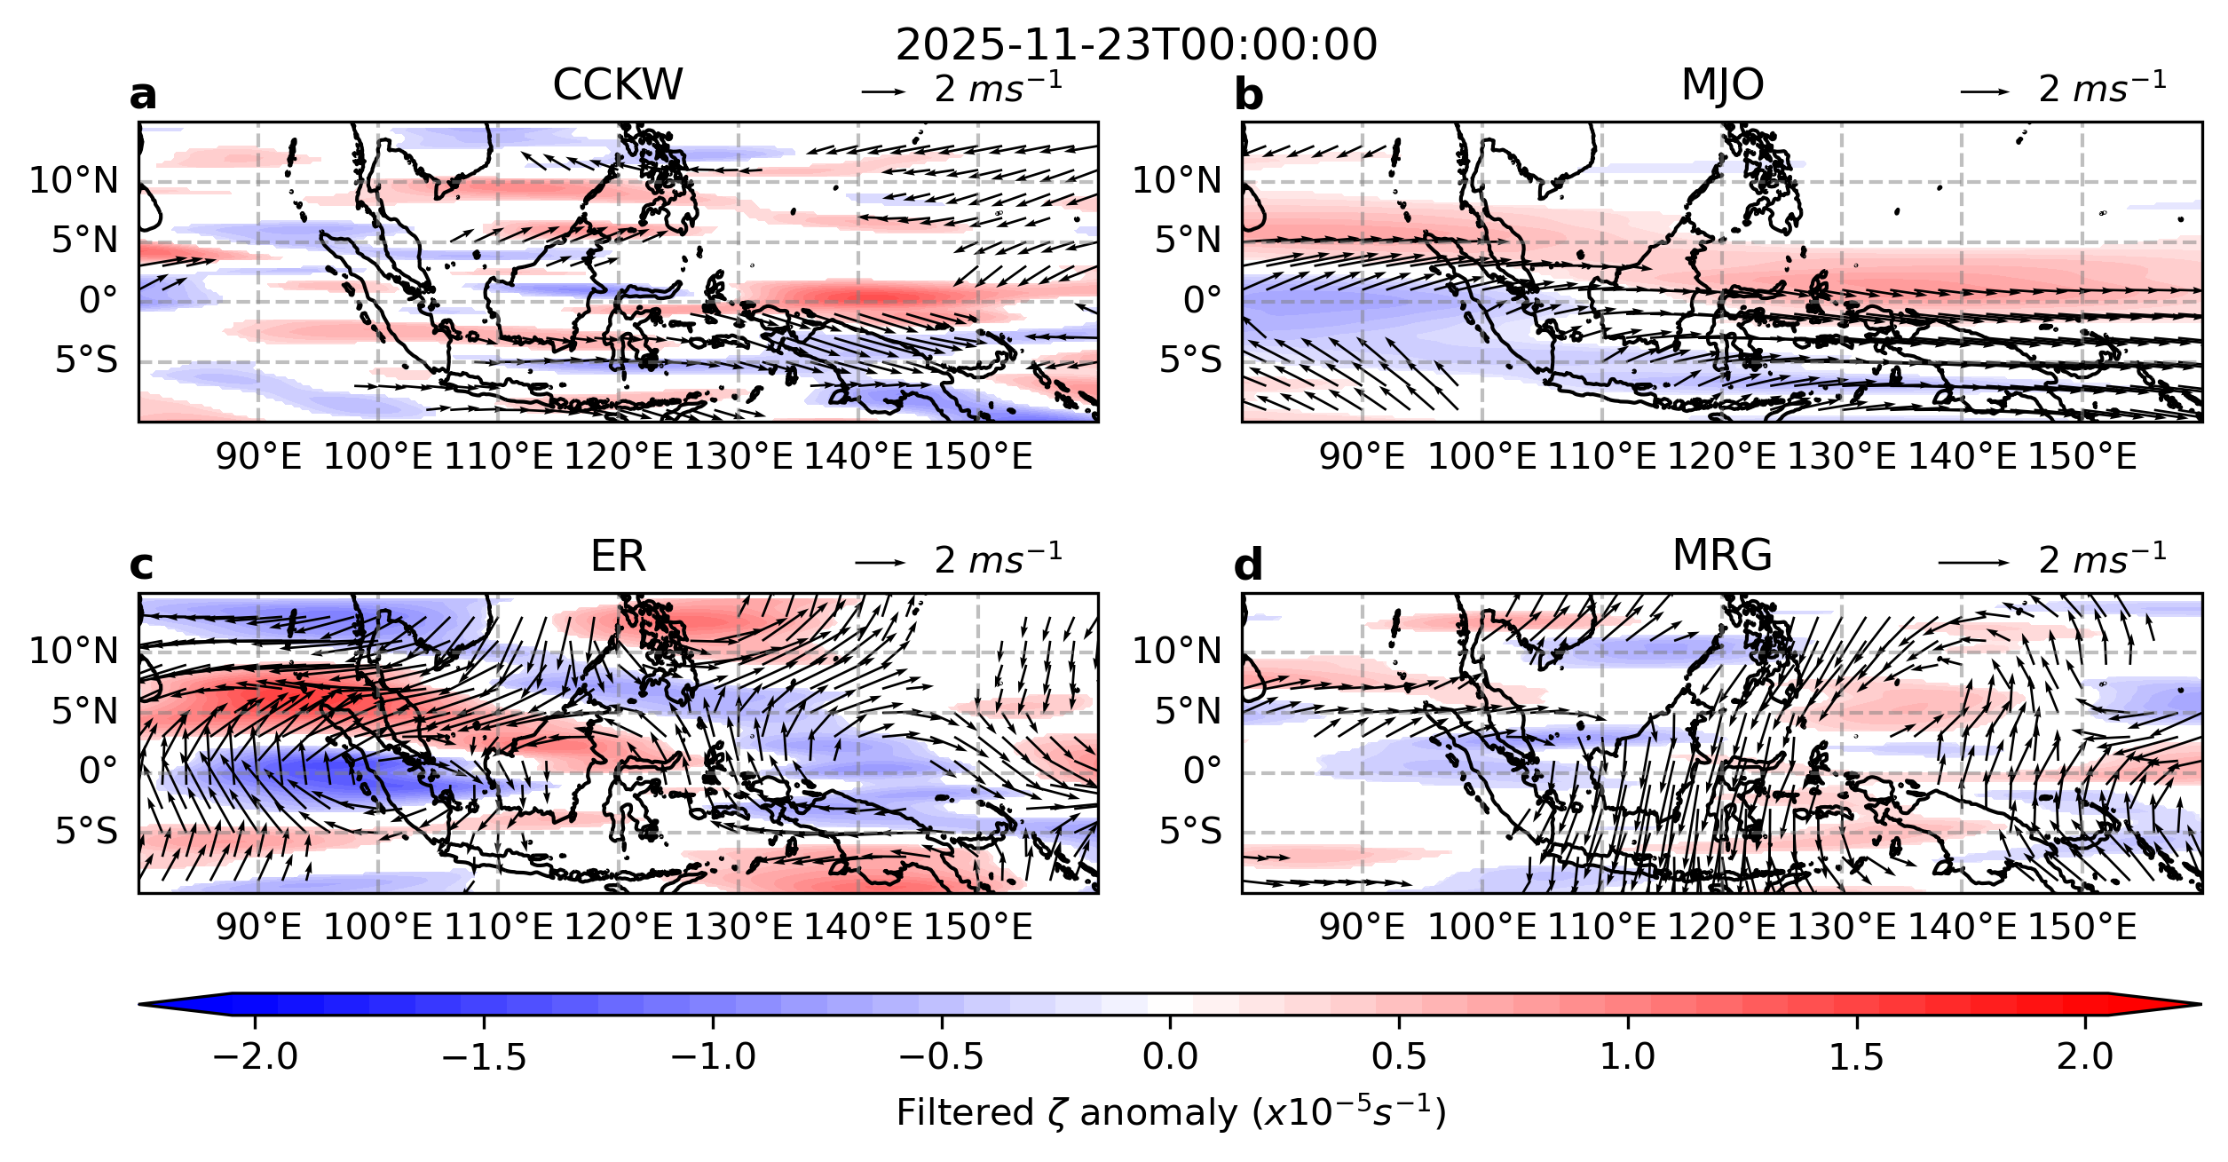
Fig. S5 Filtered wind field anomaly and relative vorticity anomaly for 23 November 2025: a Convectively coupled Kelvin waves, b Madden – Julian Oscillation, c Equatorial Rosby waves, d Mixed Rossby – gravity waves. Animation can be found in Supplementary Movie 2: DOI.org/10.6084/m9.figshare.31408212

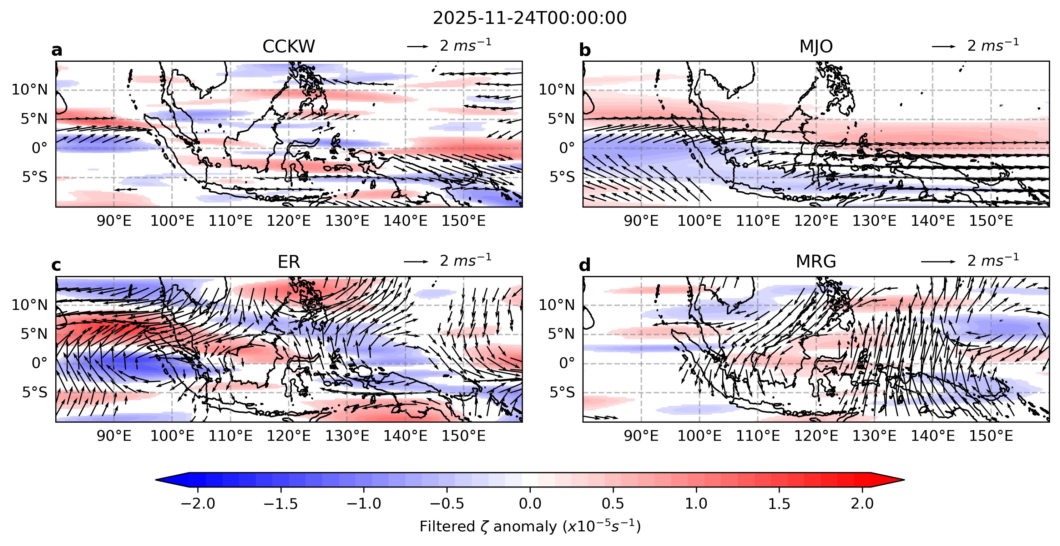
Fig. S6 Filtered wind field anomaly and vorticity field anomaly for 24 November 2025: a Convectively coupled Kelvin waves, b Madden – Julian Oscillation, c Equatorial Rosby waves, d Mixed Rossby – gravity waves. Animation can be found in Supplementary Movie 2: DOI.org/10.6084/m9.figshare.31408212

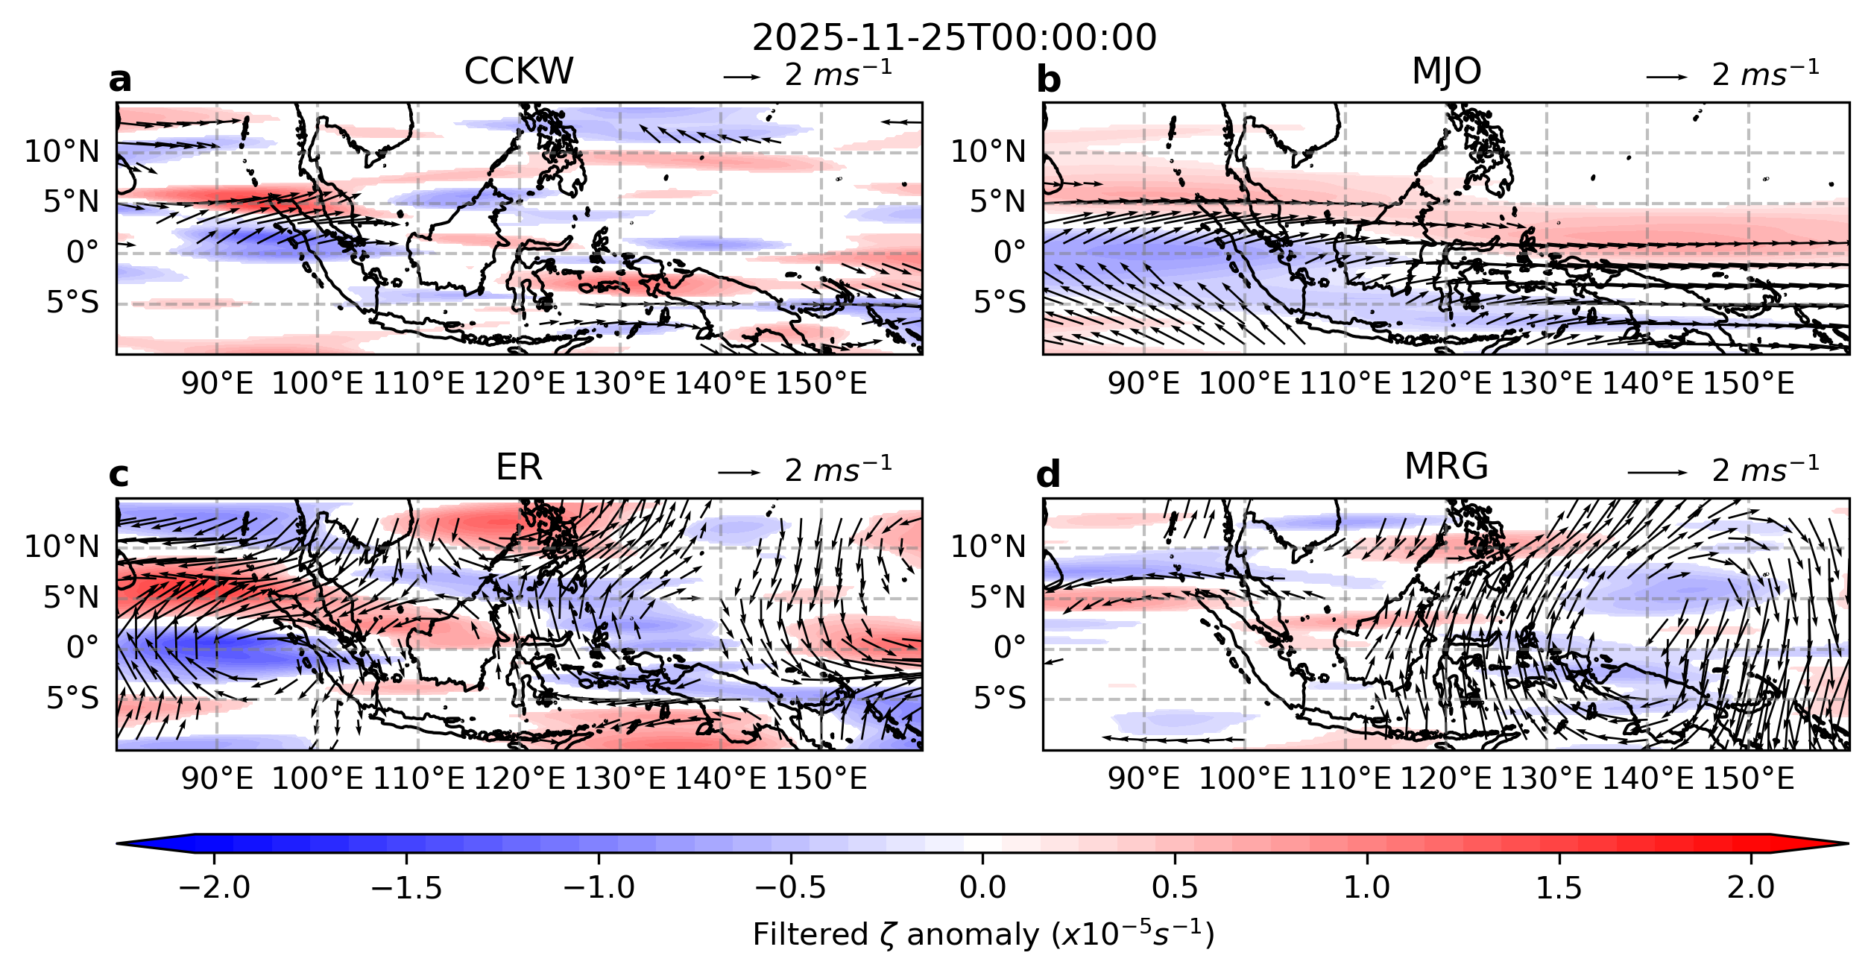
Fig. S7 Filtered wind field anomaly and vorticity field anomaly for 25 November 2025: a Convectively coupled Kelvin waves, b Madden – Julian Oscillation, c Equatorial Rosby waves, d Mixed Rossby – gravity waves. Animation can be found in Supplementary Movie 2: DOI.org/10.6084/m9.figshare.31408212

