SUPPLEMENTARY

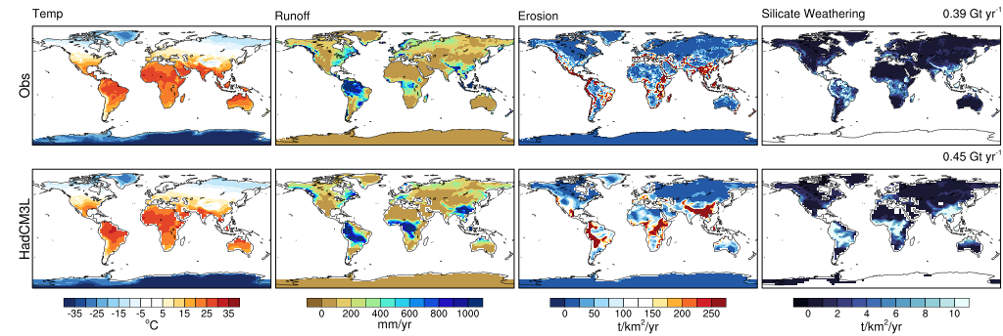
S1. Comparison of observed and HadCM3L derived fields of the modern mean annual temperature and terrestrial runoff and subsequent silicate weathering model output. Mean Annual Temperature (2m) derived from ECMWF Reanalysis v5 (ERA5) reanalysis data (Hersbach et al., 2020) averaged over the period 1981-2010. Runoff observations are taken from the long-term annual runoff from the GRUN data product averaged over the same period (Ghiggi et al., 2020).

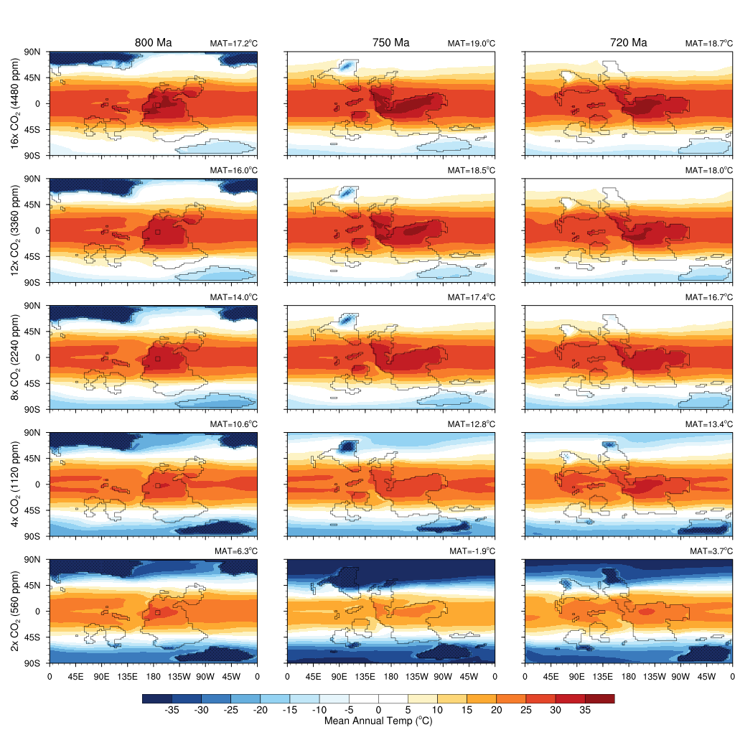
S2. Temperature sensitivity as a function of Time (Ma) and atmospheric CO₂. HadCM3L predicted Mean Annual Temperature (MAT; ºC) for the three palaeogeographies under all atmospheric pCO₂ forcings. Also indicated is the globally integrated MAT.

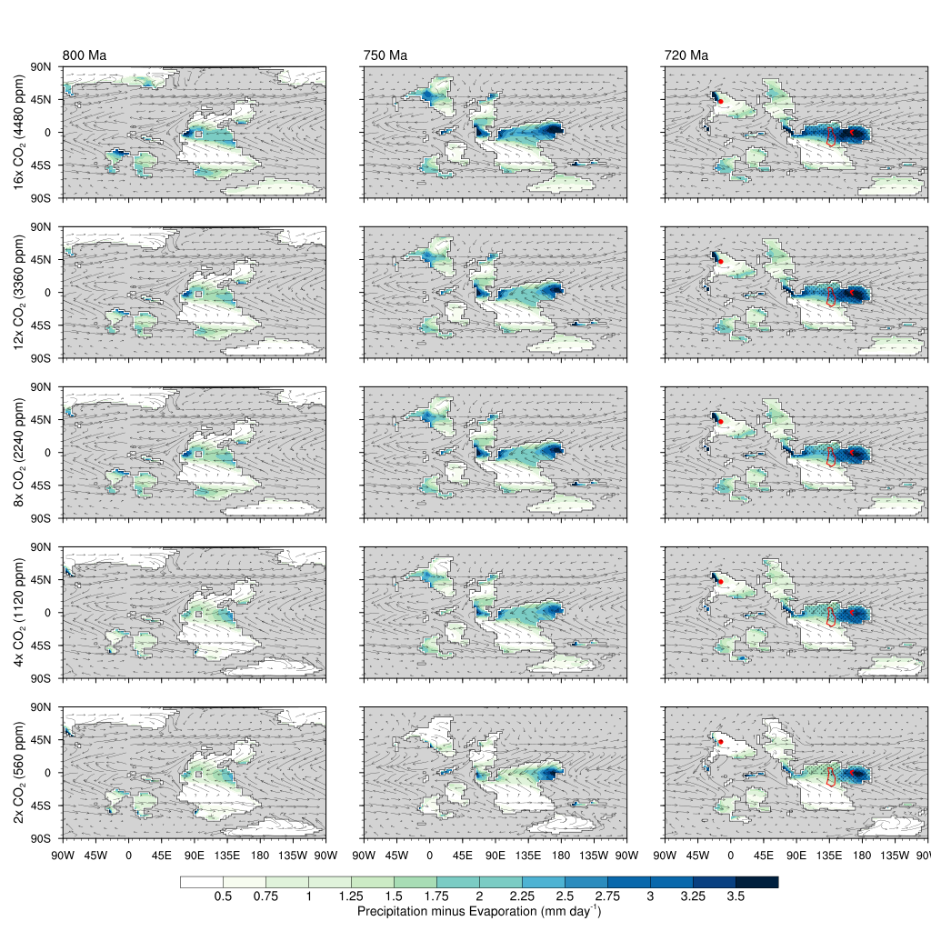
S3. Land surface moisture balance and wind fields across the ensemble in Time (Ma) and atmospheric CO₂. Shown are positive component of the Mean Precipitation-Evaporation (P-E; mm day⁻¹) for the three palaeogeographies under all atmospheric pCO₂ forcings. For 720 Ma the red polygons indicate the Franklin-Irkutsk LIP volcanic terrane (Northern Canada, NW Greenland and southern Siberia), the red dot indicates the Hubei–Shaanxi Magmatic Province (South China), and dotted infill indicates the envelope of the Inter Tropical Convergence Zone. Also shown in grey streamlines are corresponding mean annual wind field.

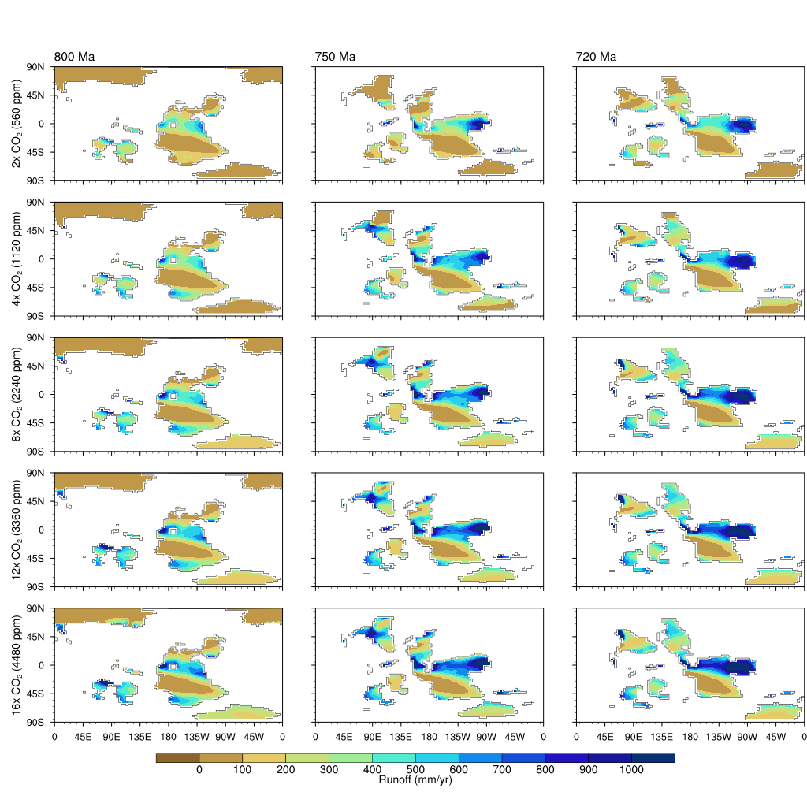S4. Terrestrial runoff across the ensemble in Time (Ma) and atmospheric CO₂. Shown are the combined surface and subsurface terrestrial runoff (mm/yr) as predicted by HadCM3L.
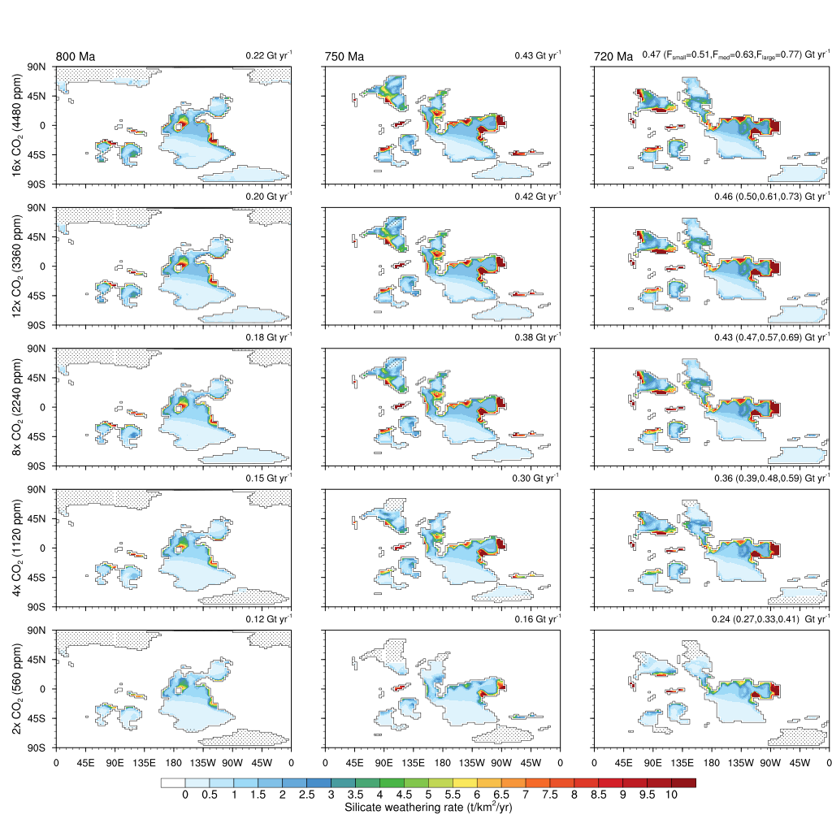
S5. Global Silicate Weathering. Shown are the silicate weathering rates for non-LIP configurations (according to the boundary conditions within the HadCM3L climate model). Global means are indicated in top right of each subfigure, those in parenthesis for 720 Ma are for different Franklin LIP configurations, F_{small} , F_{med}, and F_{large}. Dotted areas indicate extent of continental-scale ice sheets within the GCM.

