Supplementary Fig. S1 Bacterial shannon curve based on V3-V4 regions of the 16S rRNA for high-throughput sequencing analysis

Supplementary Fig. S2 Fungal shannon curve based on 1-2 regions of ITS for high-throughput sequencing analysis

Supplementary Fig. S3 Bacterial richness (abundance-based coverage estimator, ACE) in rhizosphere soil

Supplementary Fig. S4 Bacterial chao index in rhizosphere soil

Supplementary Fig. S5 Fungal richness (abundance-based coverage estimator, ACE) in rhizosphere soil

Supplementary Fig. S6 Fungal chao index in rhizosphere soil

Supplementary Fig. S7 Bar diagram of the linear discriminant analysis (LDA) distribution (LDA score threshold: ≥2) with soil bacterial communities

Supplementary Fig. S8 Bar diagram of the linear discriminant analysis (LDA) distribution (LDA score threshold: ≥2) with soil fungal communities

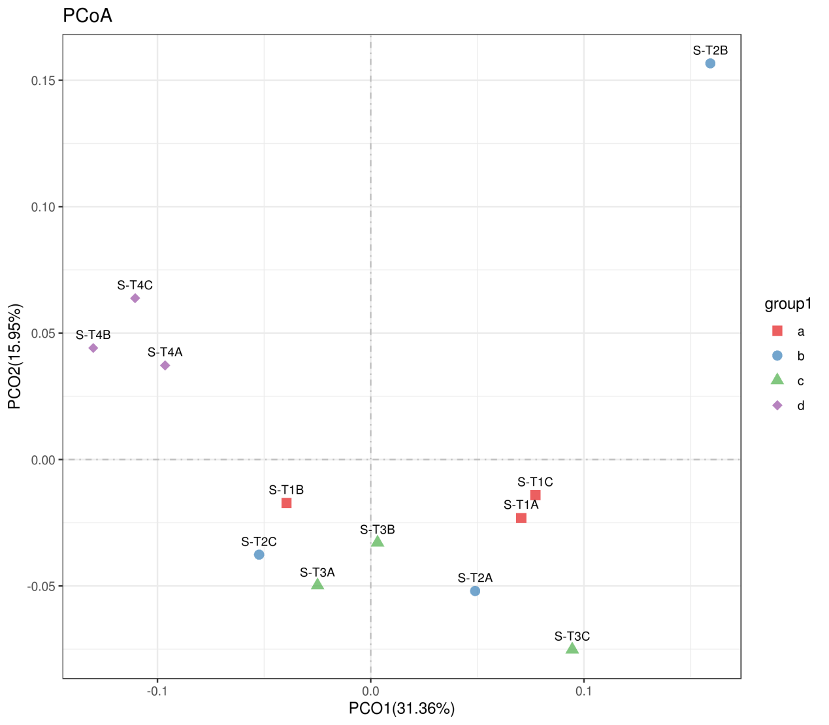
Supplementary Fig. S9 Principal coordinates analyses (PCoA) were performed based on the soil bacterial OTU distributions using Bray-Curtis distance（a: T1; b: T2; c:T3; d: T4）

Supplementary Fig. S10 Principal coordinates analyses (PCoA) were performed based on the soil fungus OTU distributions using Bray-Curtis distance

