Supplementary File:
Annual agricultural land-use maps of Germany from 1990 to 2023 derived from satellite imagery
Gideon Okpoti Tetteh ^{1,*}, Vu-Dong Pham ^{3,4}, Marcel Schwieder ^{1,2}, Lukas Blickensdörfer ^{1,2}, Alexander Gocht ^{1,5}, Sebastian van der Linden ^{3,4}, Stefan Erasmi ¹
¹ Thünen Institute of Farm Economics, Bundesallee 63, 38116 Braunschweig, Germany
² Geography Department, Humboldt University of Berlin, Unter den Linden 6, 10099 Berlin, Germany
³ Earth Observation and Geoinformation Science Lab, Institute of Geography and Geology, University of Greifswald, Friedrich-Ludwig-Jahn-Str. 16, 17489 Greifswald, Germany
⁴ Interdisciplinary Centre for Baltic Sea Region Research (IFZO), University of Greifswald, 17489 Greifswald, Germany
⁵ Agricultural Development and Trade Group, Department of Agricultural Economics, Humboldt University of Berlin, Unter den Linden 6, 10099 Berlin, Germany
* Corresponding author. Email address: gideon.tetteh@thuenen.de

Table S1. Overview of the number of clear-sky observations and the corresponding sensors per year.
Year | Minimum | Maximum | Mean | Median | Sensors
1990 | 1 | 25 | 9.460 | 9 | Landsat 5
1991 | 1 | 20 | 8.602 | 9 | Landsat 5
1992 | 1 | 22 | 8.741 | 9 | Landsat 5
1993 | 1 | 20 | 6.358 | 6 | Landsat 5
1994 | 1 | 19 | 7.824 | 8 | Landsat 5
1995 | 1 | 17 | 7.232 | 7 | Landsat 5
1996 | 1 | 18 | 6.548 | 6 | Landsat 5
1997 | 1 | 17 | 7.475 | 7 | Landsat 5
1998 | 1 | 19 | 6.058 | 6 | Landsat 5
1999 | 1 | 28 | 12.376 | 13 | Landsat 5, Landsat 7
2000 | 1 | 27 | 11.439 | 11 | Landsat 5, Landsat 7
2001 | 1 | 26 | 10.787 | 11 | Landsat 5, Landsat 7
2002 | 1 | 29 | 10.340 | 10 | Landsat 5, Landsat 7
2003 | 1 | 28 | 12.219 | 12 | Landsat 5, Landsat 7
2004 | 1 | 26 | 11.201 | 11 | Landsat 5, Landsat 7
2005 | 1 | 36 | 14.356 | 14 | Landsat 5, Landsat 7
2006 | 1 | 29 | 14.115 | 14 | Landsat 5, Landsat 7
2007 | 1 | 27 | 8.754 | 9 | Landsat 5, Landsat 7
2008 | 1 | 23 | 8.757 | 9 | Landsat 5, Landsat 7
2009 | 1 | 31 | 11.758 | 11 | Landsat 5, Landsat 7
2010 | 1 | 25 | 10.089 | 10 | Landsat 5, Landsat 7
2011 | 1 | 36 | 15.299 | 15 | Landsat 5, Landsat 7
2012 | 1 | 20 | 5.730 | 6 | Landsat 7
2013 | 1 | 30 | 10.609 | 11 | Landsat 7, Landsat 8
2014 | 1 | 34 | 14.709 | 15 | Landsat 7, Landsat 8
2015 | 1 | 51 | 21.159 | 20 | Landsat 7, Landsat 8, Sentinel-2A
2016 | 1 | 59 | 27.523 | 28 | Landsat 7, Landsat 8, Sentinel-2A
2017 | 1 | 68 | 27.598 | 27 | Landsat 7, Landsat 8, Sentinel-2A, Sentinel-2B
2018 | 1 | 97 | 51.032 | 52 | Landsat 7, Landsat 8, Sentinel-2A, Sentinel-2B
2019 | 1 | 88 | 44.870 | 45 | Landsat 7, Landsat 8, Sentinel-2A, Sentinel-2B
2020 | 1 | 100 | 50.057 | 51 | Landsat 7, Landsat 8, Sentinel-2A, Sentinel-2B
2021 | 1 | 80 | 36.258 | 36 | Landsat 7, Landsat 8, Sentinel-2A, Sentinel-2B
2022 | 1 | 112 | 57.487 | 59 | Landsat 7, Landsat 8, Landsat 9, Sentinel-2A, Sentinel-2B
2023 | 1 | 88 | 46.201 | 47 | Landsat 7, Landsat 8, Landsat 9, Sentinel-2A, Sentinel-2B

Table S2. Translation of classes from the Geo-spatial Application (GSA) to our classes.
Class code | Class name | GSA class and code
110 | Winter cereals | Winter durum wheat (112), winter common wheat (115), spelt (120, 114), winter rye (121), winter barley (125,131), winter triticale (156)
120 | Summer cereals | Summer barley (132), summer oats (143)
130 | Maize | Grain maize (171), maize for biogas (172), silage maize (411)
200 | Grassland | Meadows (451), mowing pastures (452), pastures (453), all other grassland uses (459), grassland reseeding (441), pasture reseeding (443), alpine pastures and meadows (455), vetches (221, 291), mixed legumes (250), forage grass (424), alfalfa (423), clovers (421, 422, 425, 426, 427), alfalfa-grass (433)
1401 | Potato | Various potatoes (601, 602, 606, 614, 640, 641, 642, 643)
1402 | Sugar beet | Sugar beet (603)
1501 | Rapeseed | Winter rapeseed (311)
1502 | Sunflower | Sunflowers (320)
1601 | Legumes | Peas (210, 211, 212, 240), Broad bean (220), Lupin (230), Soybeans (330), lentils (292)
1603 | Horticultural crops | Strawberries (707), asparagus (860), onion (633), pumpkin (630), carrot (634), garden bean (635), vegetables (610), cabbage (613), chicory (621), lettuce (637), spinach (638), other vegetables (632), carrot (183), cabbage (414), field vegetables (710), cauliflower (712), strawberries (723)
3003 | Fallow land | Fallow lands (62, 66, 65, 560, 581, 582, 593, 594, 595, 590, 599)
4001 | Vineyards | Vineyards (842, 843, 844, 847, 850, 851)
4002 | Hops | Hops (750,856)
4003 | Plantation | Pome and stone fruits, and fruit orchards (811, 814, 815, 816, 819, 824, 825, 826, 821, 829)

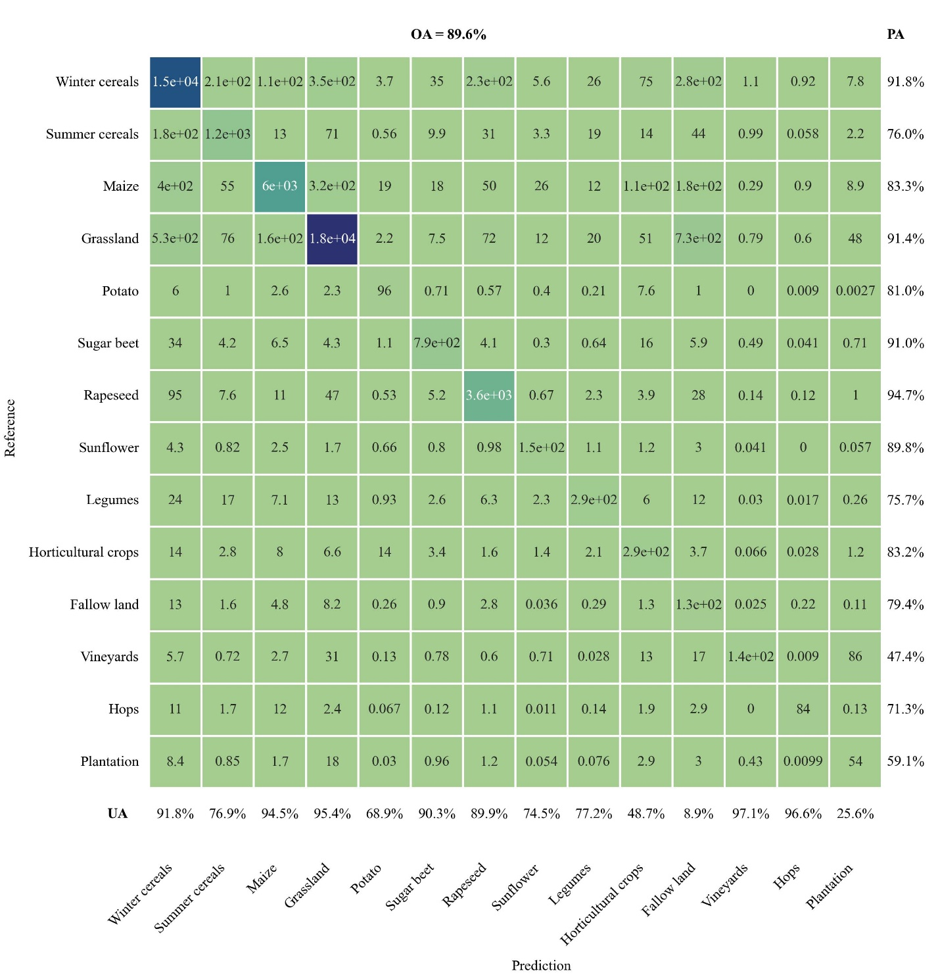
Fig. S1. Confusion matrix for 2010. The values in this, and all subsequent confusion matrices, are areas (km²). In all confusion matrices, OA = overall accuracy, UA = user’s accuracy, and PA = producer’s accuracy.

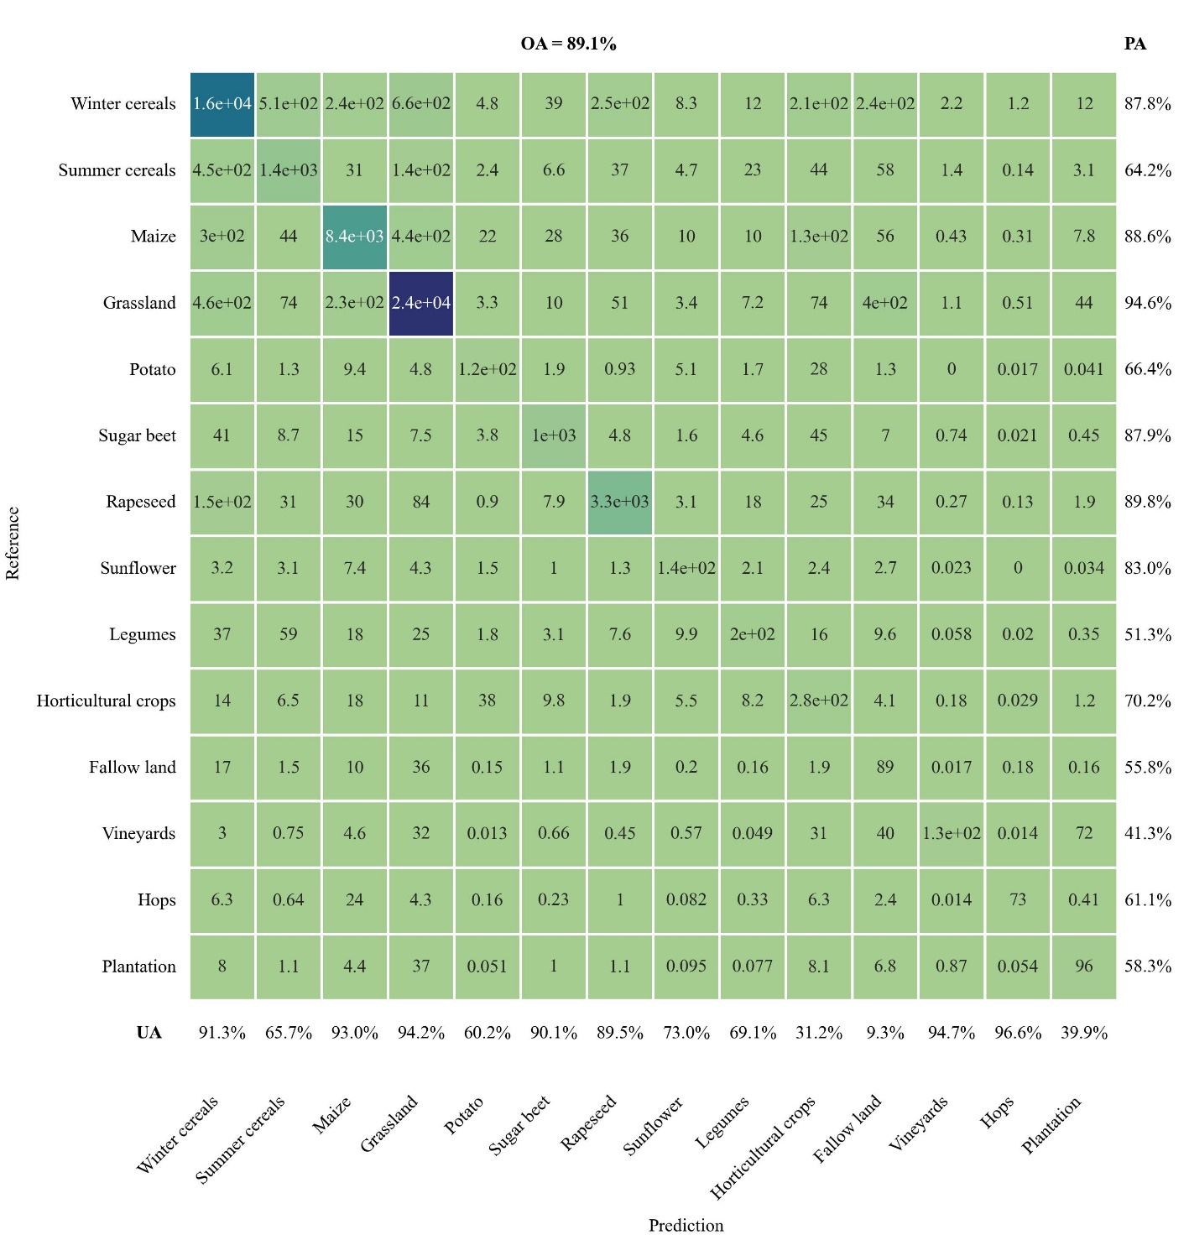
Fig. S2. Confusion matrix for 2011.

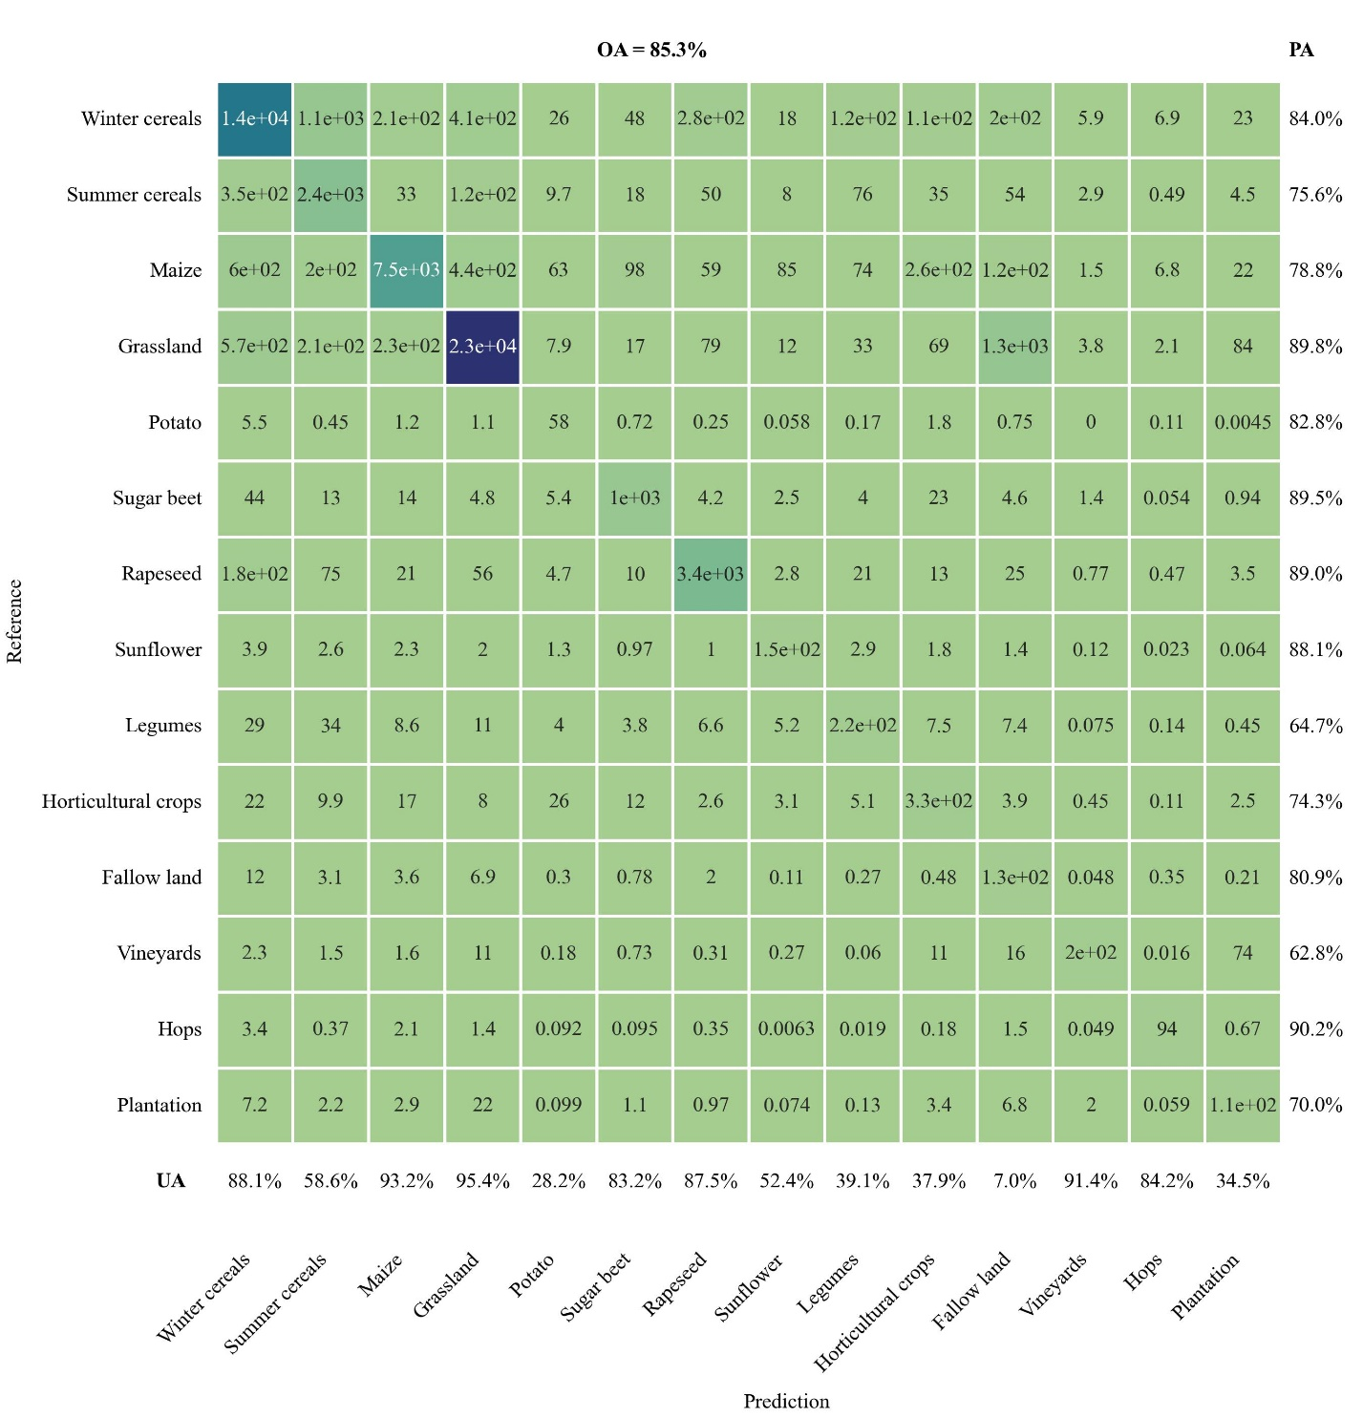
Fig. S3. Confusion matrix for 2012.

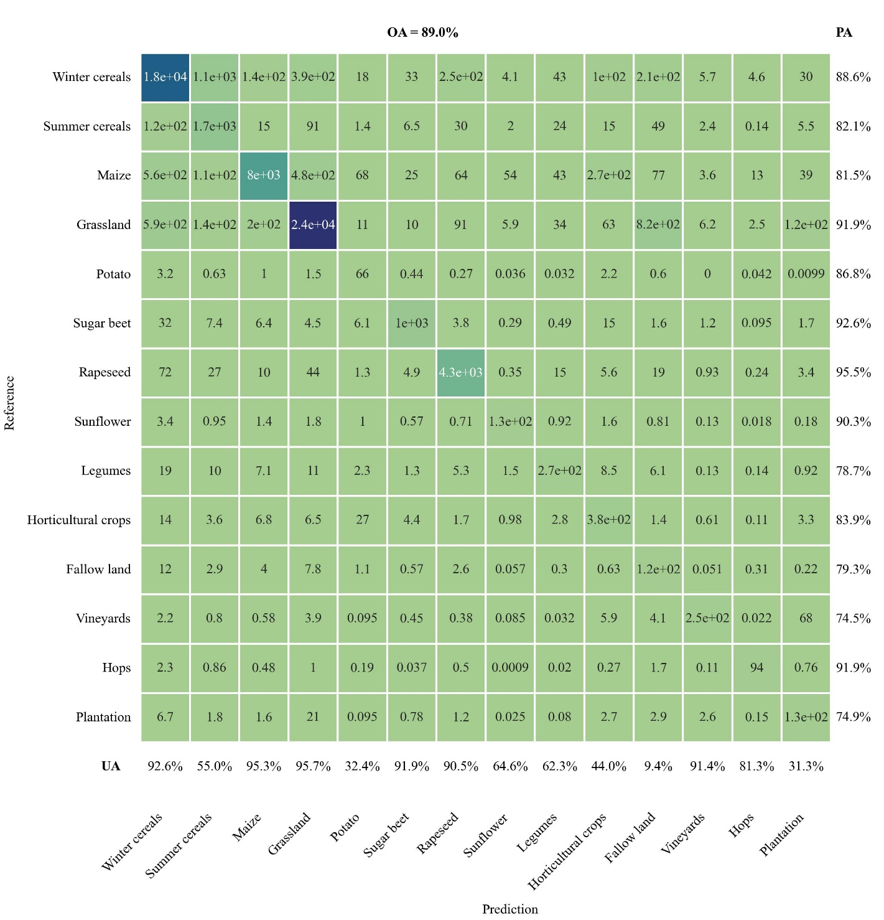
Fig. S4. Confusion matrix for 2013.

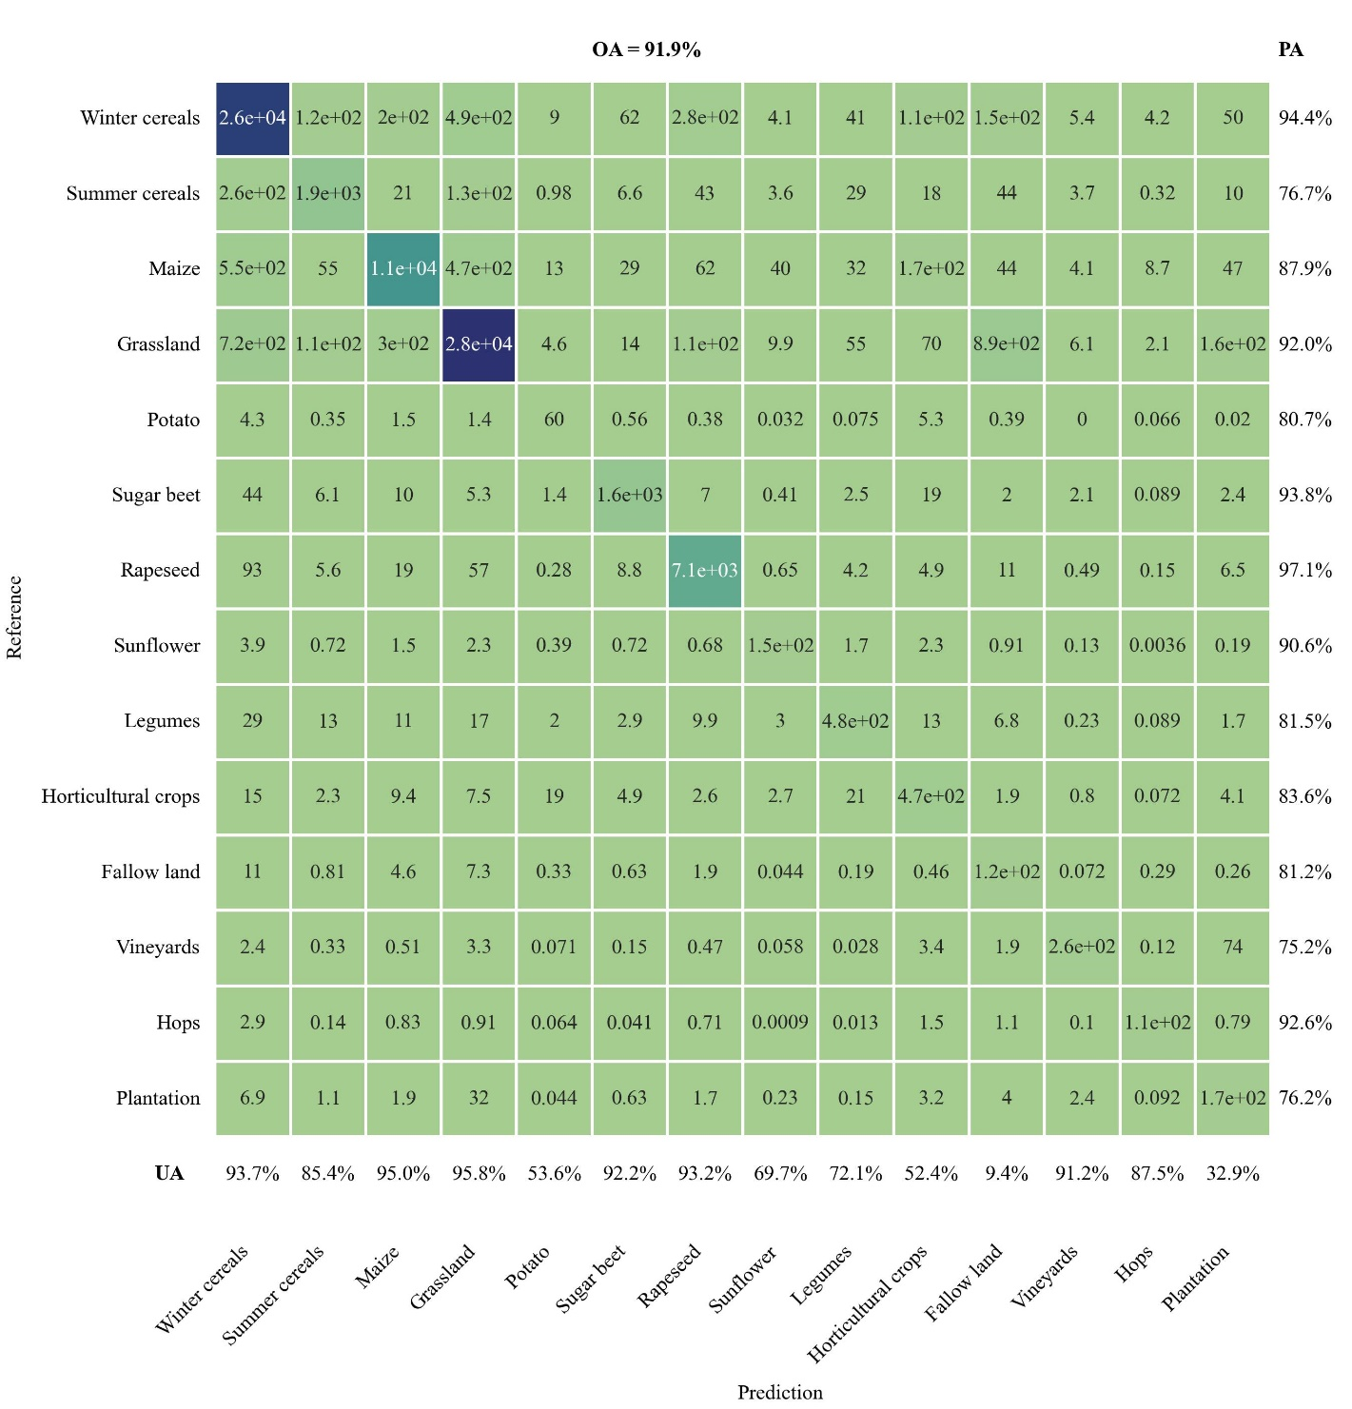
Fig. S5. Confusion matrix for 2014.

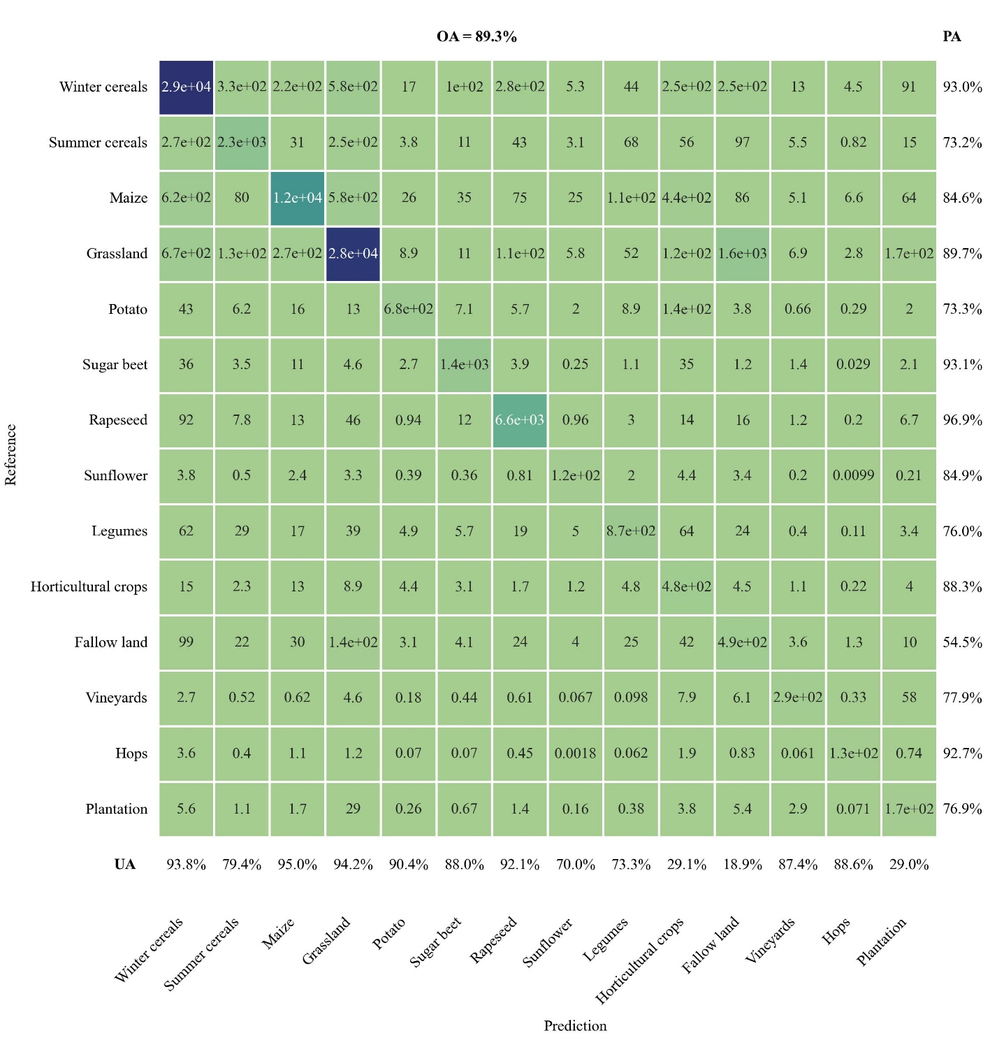
Fig. S6. Confusion matrix for 2015.

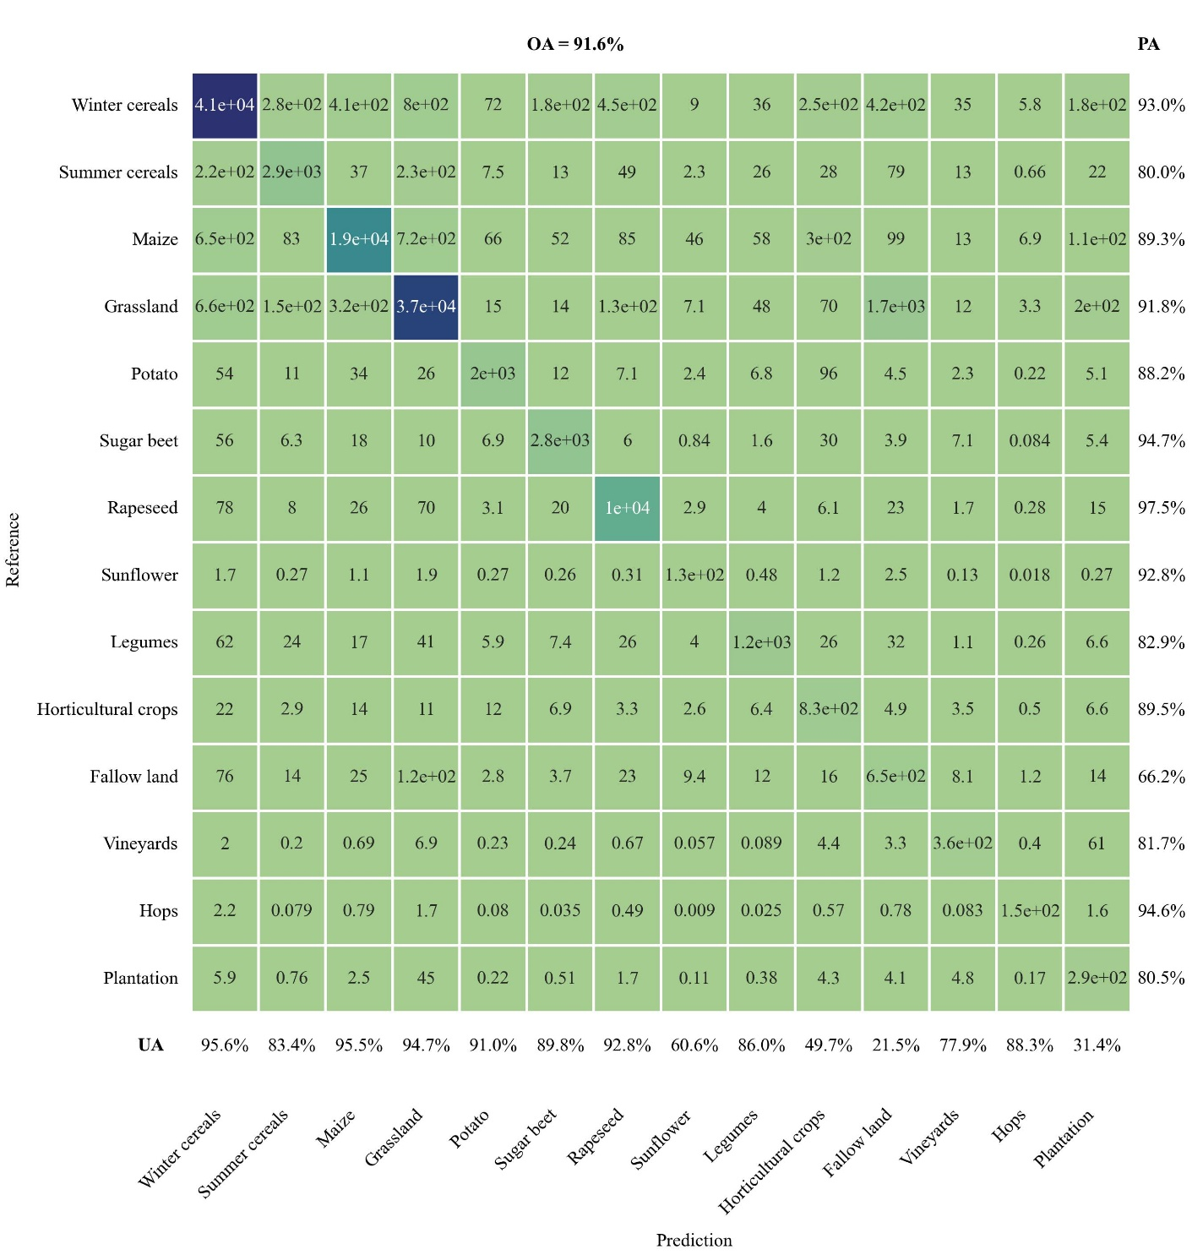
Fig. S7. Confusion matrix for 2016.

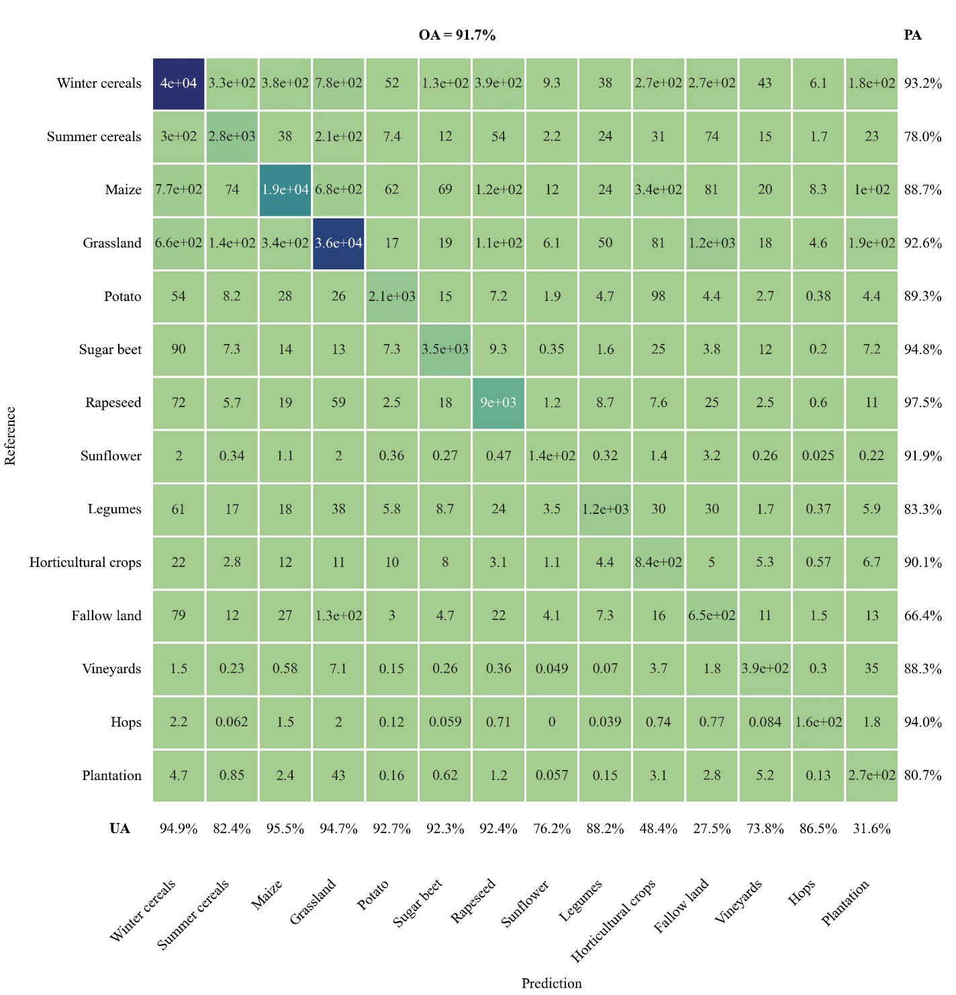
Fig. S8. Confusion matrix for 2017.

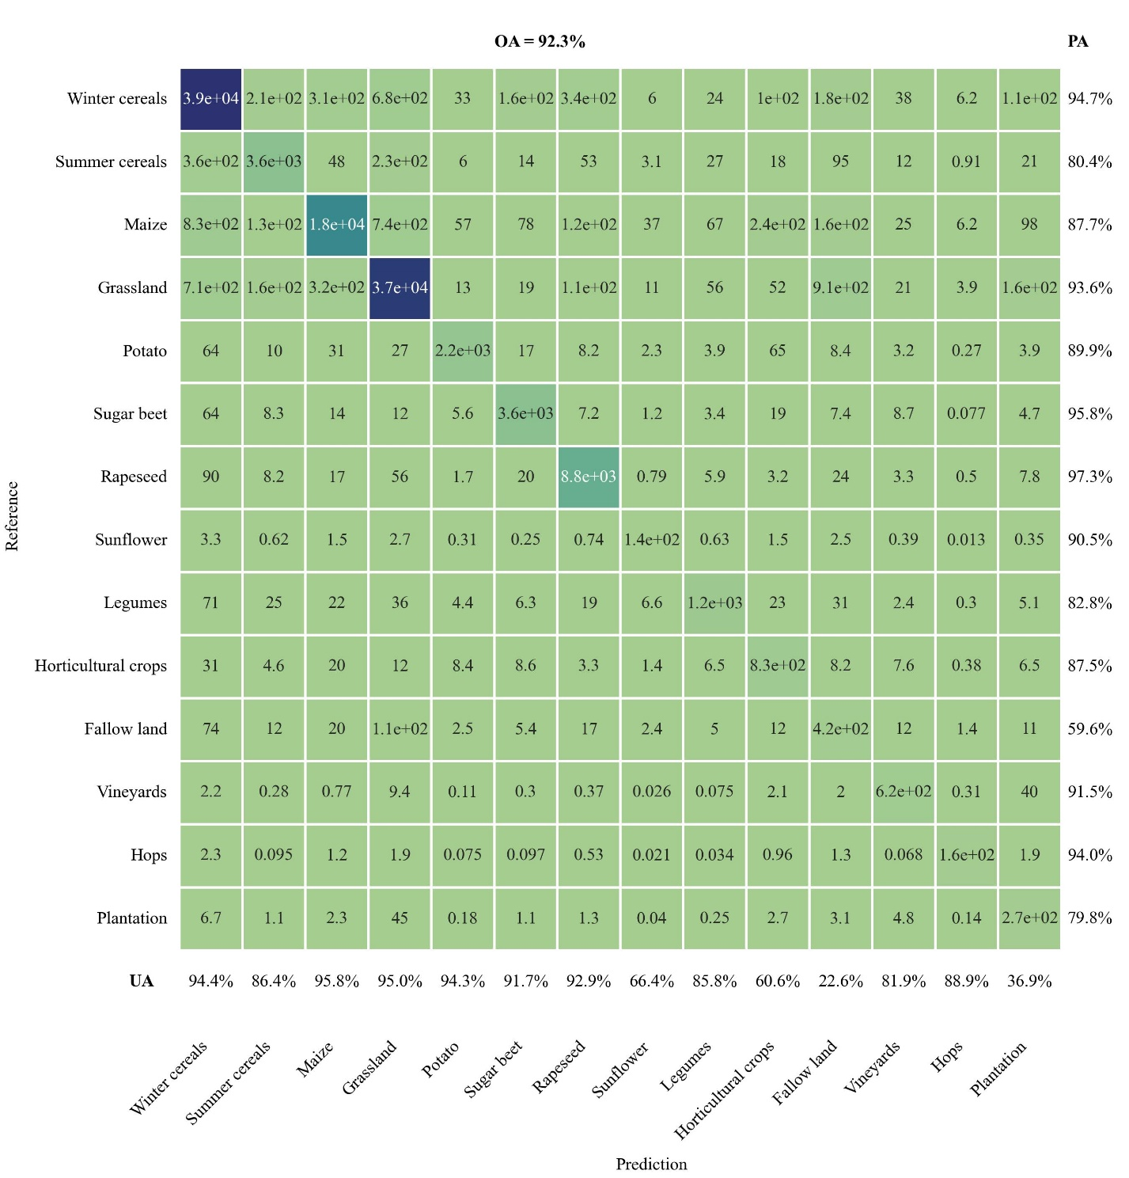
Fig. S9. Confusion matrix for 2018.

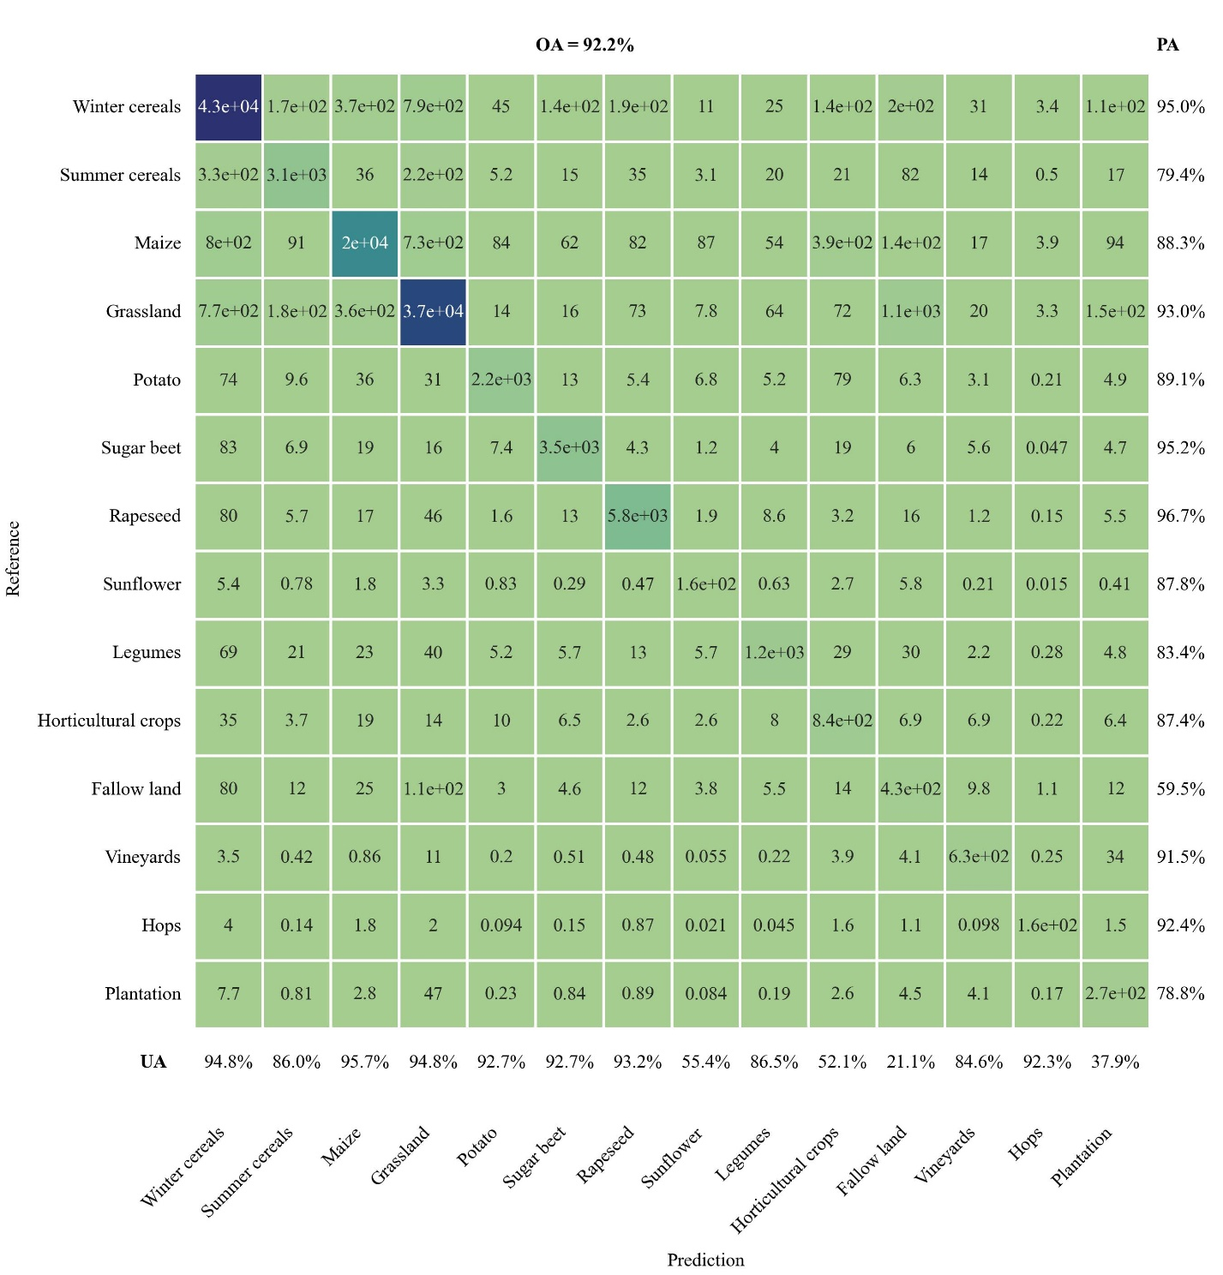
Fig. S10. Confusion matrix for 2019.

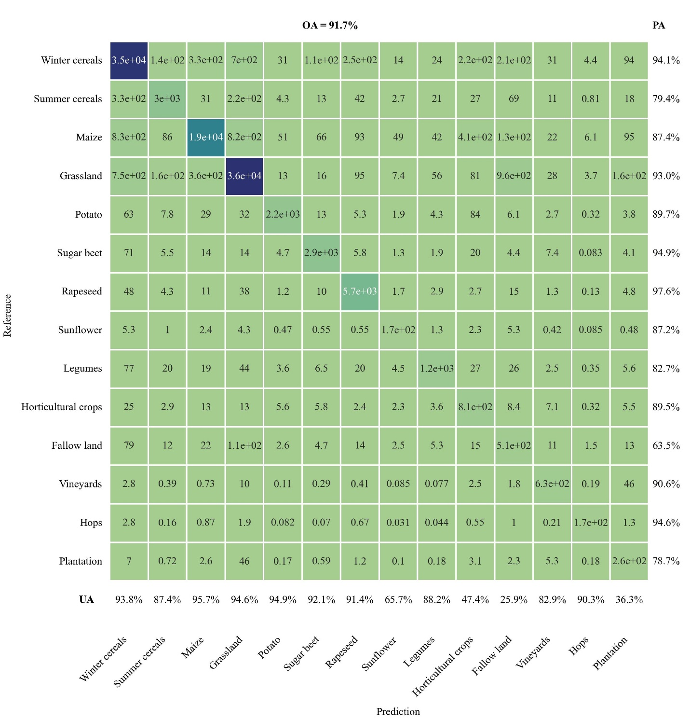
Fig. S11. Confusion matrix for 2020.

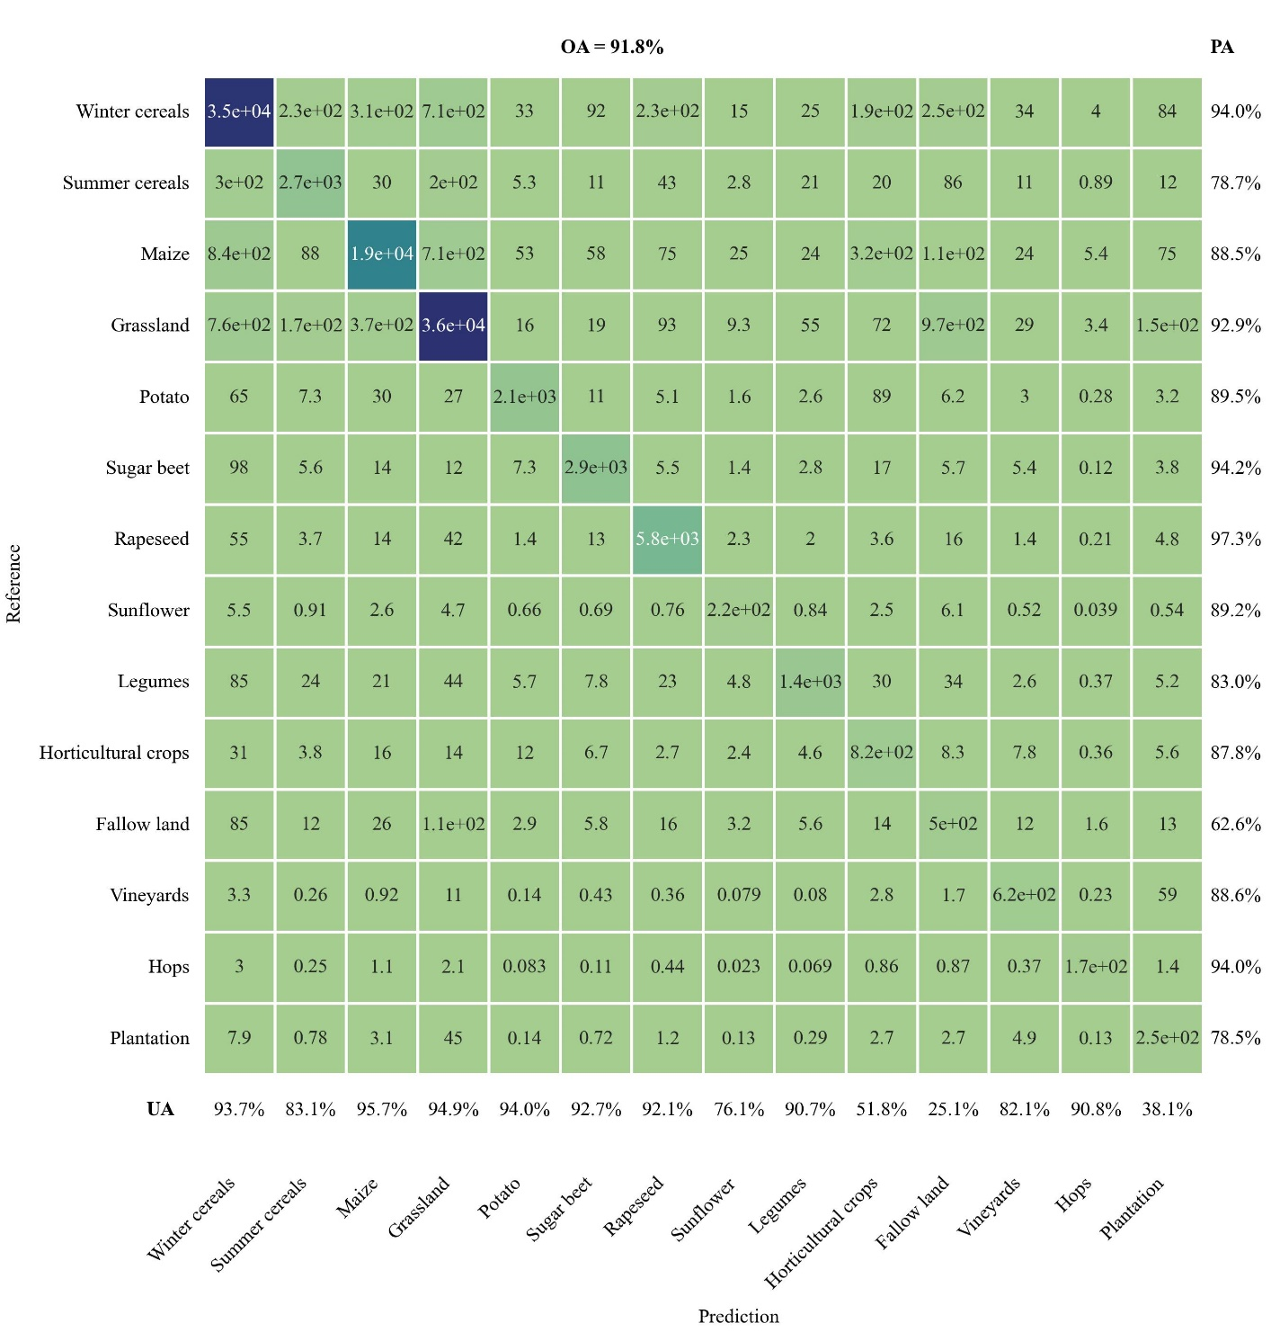
Fig. S12. Confusion matrix for 2021.

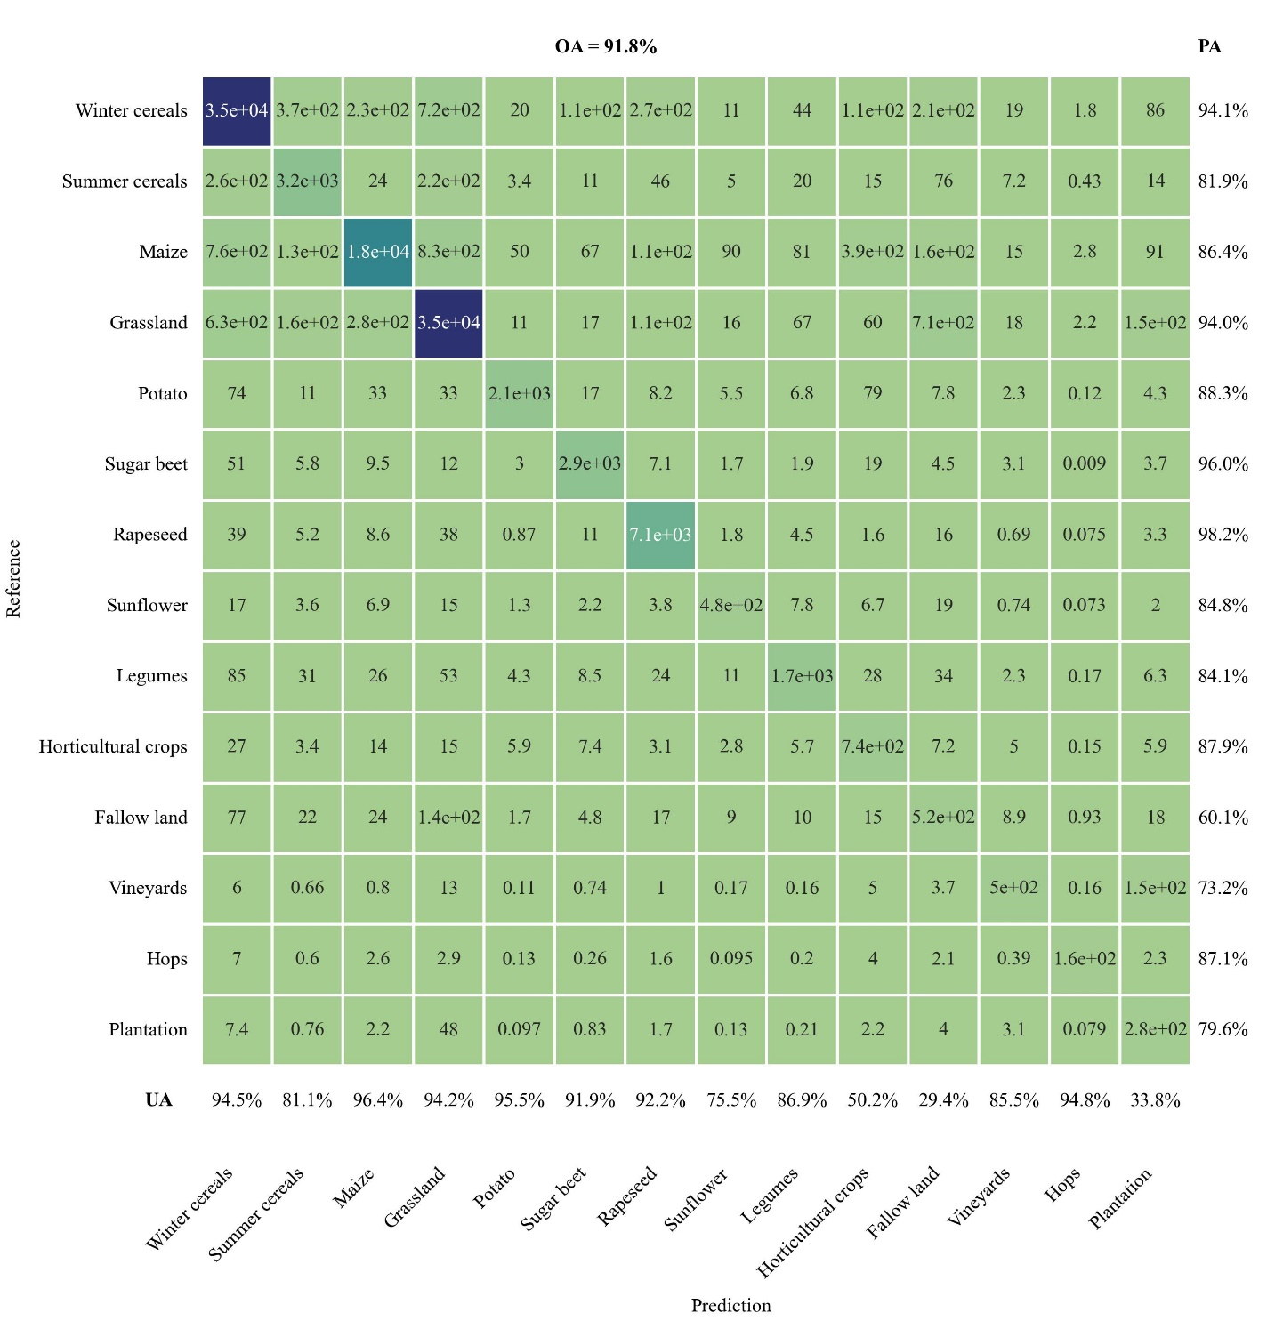
Fig. S13. Confusion matrix for 2022.

Table S3. Translation of classes from our map to those of Tetteh et al.^{1,2}.
Class code | Class name | Name and code in Tetteh et al.^{1,2}
110 | Winter cereals | Winter wheat (1101), Winter barley (1102), Winter rye (1103)
120 | Summer cereals | Spring barley (1201), Spring oat (1202)
130 | Maize | Maize (1300)
200 | Grassland | Permanent grassland (200), Cultivated grassland (1602)
1401 | Potato | Potato (1401)
1402 | Sugar beet | Sugar beet (1402)
1501 | Rapeseed | Winter rapeseed (1501)
1502 | Sunflower | Sunflower (1502)
1601 | Legumes | Peas (1611), Broad bean (1612), Lupin (1613), Soy (1614)
1603 | Horticultural crops | Vegetables (1603)
3003 | Fallow land | Fallow land (3003)
4001 | Vineyards | Grapevine (4001)
4002 | Hops | Hops (4002)
4003 | Plantation | Orchard (4003)

References
1. Tetteh, G. O., Schwieder, M., Blickensdörfer, L., Gocht, A. & Erasmi, S. Agricultural land use (raster): National-scale crop type maps for Germany from combined time series of Sentinel-2 and Landsat data (2024). Zenodo https://doi.org/10.5281/zenodo.17197830 (2025).
2. Tetteh, G. O., Schwieder, M., Blickensdörfer, L., Gocht, A. & Erasmi, S. Agricultural land use (raster): National-scale crop type maps for Germany from combined time series of Sentinel-2 and Landsat data (2025). Zenodo https://doi.org/10.5281/zenodo.17197871 (2025).

