(1) Supplementary experiment of GM12878 cell line
①Analysis Of Overlapping Degree Of Prediction Results By Different Tools
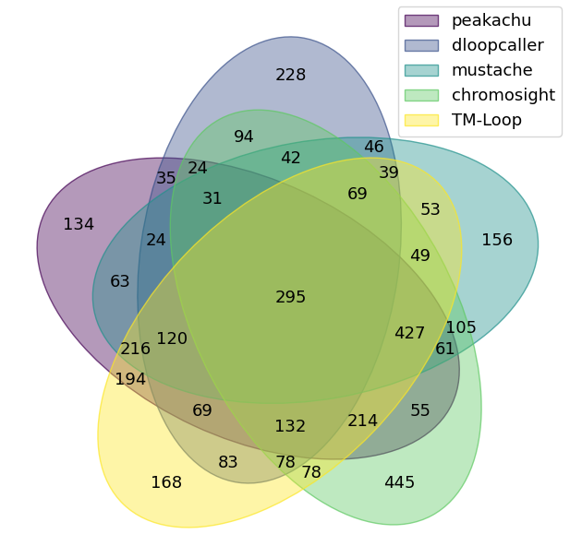
Fig.1 Different methods for predicting the number of chromatin overlapping loops of chr15, chr16 and chr17 in GM12878 cells.
Different prediction tools not only have some common characteristics in the task of chromatin loop recognition, but also show obvious methodological differences. In this study, we systematically analyzed the overlapping characteristics of chromatin loops predicted by TM-Loop, Chromosight, Dloopcaller, Mustache and Peakachu on chromosome 15, 16 and 17 of GM12878 cell line.
It can be seen from the results of Wayne diagram that TM-Loop and other tools have a high degree of prediction overlap in many regions: for example, TM-Loop and Chromosight have 427 common prediction loops, share 214 loops with Dloopcaller, overlap 49 loops with Mustache, and overlap 194 loops with Peakachu, reflecting the strong prediction consistency between TM-Loop and other tools. At the same time, each tool also shows unique prediction characteristics. For example, TM-Loop independently predicted 168 chromatin loops, Chromosight independently predicted 445 loops, and Peakachu independently predicted 134 loops. This result reflects the differences in the focus and technical advantages of different methods in chromatin loop detection tasks. It also suggests that a single tool is difficult to cover all real chromatin loops, and multi tool joint analysis can more comprehensively capture the three-dimensional conformation information of chromatin.
②Visual Verification Of Spatial Distribution Of Chromatin Loops
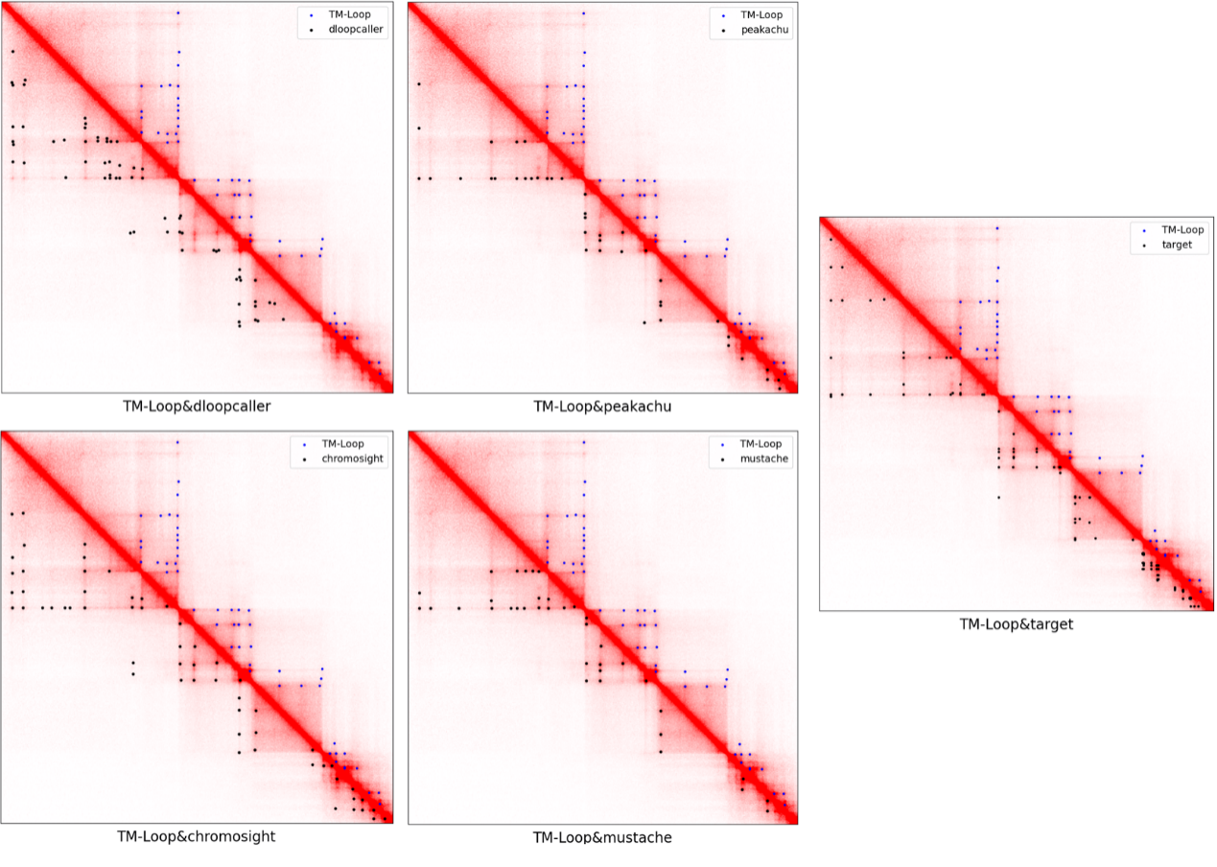
Fig.2 Specific chromatin loops in specific regions predicted by different tools.
In order to intuitively evaluate the spatial consistency of the prediction results of different tools, we selected the specific genomic region of chromosome 17 of GM12878 cell line, and visually mapped the chromatin loop predicted by TM-Loop, Peakachu, Mustache, Chromosight, Dloopcaller and other tools. We map the predicted loops of each tool and the target loop (Target) identified by the experiment to the Hi-C contact heat map, in which the blue dot represents the prediction result of TM-Loop, and the black dot represents the position of other tools or target loops. Each coordinate corresponds to a pair of genome sites of chromatin interaction fragments.
From the visualization results, it can be seen that the spatial distribution of the chromatin loop (blue dot) predicted by TM-Loop is highly coincident with that predicted by other tools (black dot), especially with the mapping position of the experimental target loop. This result directly verified the reliability of TM-Loop prediction results, and the predicted spatial distribution of chromatin loop on the genome had a good correspondence with the predicted results of target loop and other tools, which further supported the effectiveness of the tool in the task of chromatin loop detection.
③Distance Accumulation Distribution Of Chromatin Loops Predicted By Different Tools
In order to evaluate the ability of different tools to capture chromatin loops with different spans, we analyzed the distance cumulative distribution characteristics of each tool prediction loop. From the distance accumulation curve, it can be seen that the curve of TM-Loop is in the front position as a whole, and it can reach a high accumulation ratio in a small distance range (such as<500 KB), reflecting its efficient ability to capture medium and short distance chromatin loops. In contrast, Dloopcaller's curve starts late, and almost no loop is predicted when the distance is less than 100 kb. This phenomenon is related to the high-density background noise in the diagonal region of the Hi-C interaction matrix - the signal of the small distance loop is easily covered by the background noise, which makes it difficult for tools relying on large-scale aggregation matrix to effectively distinguish local peaks from background signals.
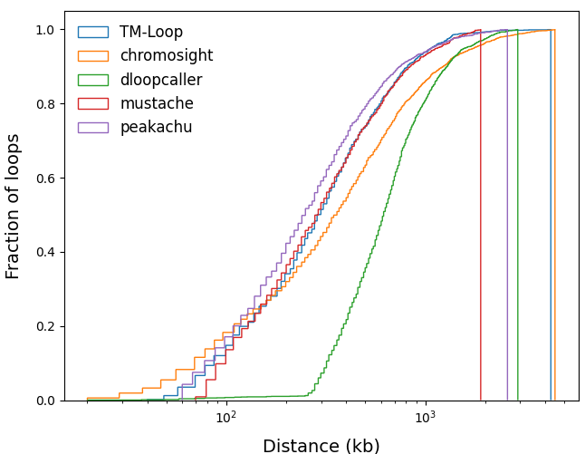
Fig.3 Loop radius statistics.
④Different Tools To Predict The Distribution Ratio Of Chromatin Loop Distance Interval
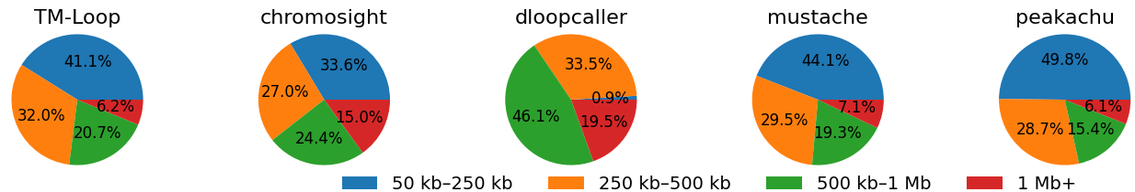
Fig.4 Distance distribution ratio of loops.
We further divided the chromatin loop into four intervals: 50 KB – 250 KB, 250 KB – 500 KB, 500 KB – 1 MB and 1 MB+according to the distance, and analyzed the proportion of each tool in different intervals. From the pie chart results, it can be seen that among the loops predicted by TM-Loop, the proportion of loops in the range of 50 KB–250 KB is 41.1%, which is significantly higher than that of Chromosight (33.6%), Mustache (44.1%) and Peakachu (49.8%), but it is still lower than the proportion of small distance loops captured by some tools. This result is consistent with the inherent characteristics of Hi-C data: the dense background noise in the diagonal region will interfere with the signal recognition of the small distance loop, so even the better performing tool has a relatively limited proportion of the prediction of the<250 KB loop, avoiding the false positive prediction caused by the background noise.
⑤Different Tools For Predicting The Cumulative Distribution Of Chromatin Loop Radius
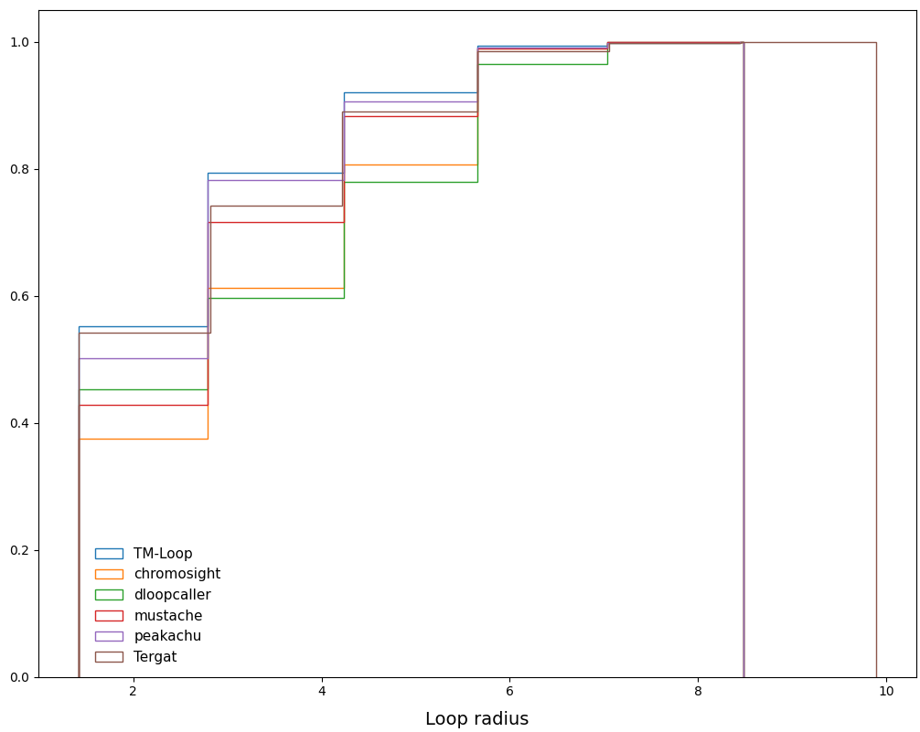
Fig.5 Distance distribution difference of loops.
In order to evaluate the prediction characteristics of tools from the dimension of loop radius, we analyzed the cumulative radius distribution of each tool's prediction loop. From the accumulation curve, it can be seen that the TM-Loop curve can reach a higher accumulation ratio in a small radius range (such as radius<4), reflecting its capture efficiency of the small radius chromatin loop. In contrast, the curves of some tools (such as Peakachu) still rise significantly in the large radius range, indicating their preference for large radius loops. The core reason for this difference is the background noise interference of Hi-C data: the signal of small radius loop is usually located near the diagonal line, which is easy to be covered by dense background noise, so it is easier for tools relying on local signal recognition to capture large radius loop, while TM-Loop balances the recognition efficiency of small radius loop and the interference of background noise to a certain extent by optimizing the signal filtering strategy.
⑥Functional Analysis Of CTCF Motif Orientation
CTCF is a core zinc finger protein that regulates the three-dimensional conformation of chromatin. It is highly evolutionarily conservative and can recognize and bind the non palindromic asymmetric motif (5'-CCACNAGGTGGCAG-3') on the genome. This property gives each CTCF binding site a specific DNA strand orientation. During the formation of the chromatin loop, there are four typical orientation patterns for a pair of CTCF binding sites on the same chromosome: Convergent (the motifs of the two sites are opposite to each other), Divergent (the motifs are opposite to each other), Tandem (the motifs are arranged in the same direction along the same chain), and Singleton or None with a single anchor containing a motif. Previous studies have confirmed that the formation of functional chromatin loops is highly dependent on CTCF site pairs with convergent orientation, which is the key structural basis of CTCF mediated loop assembly.
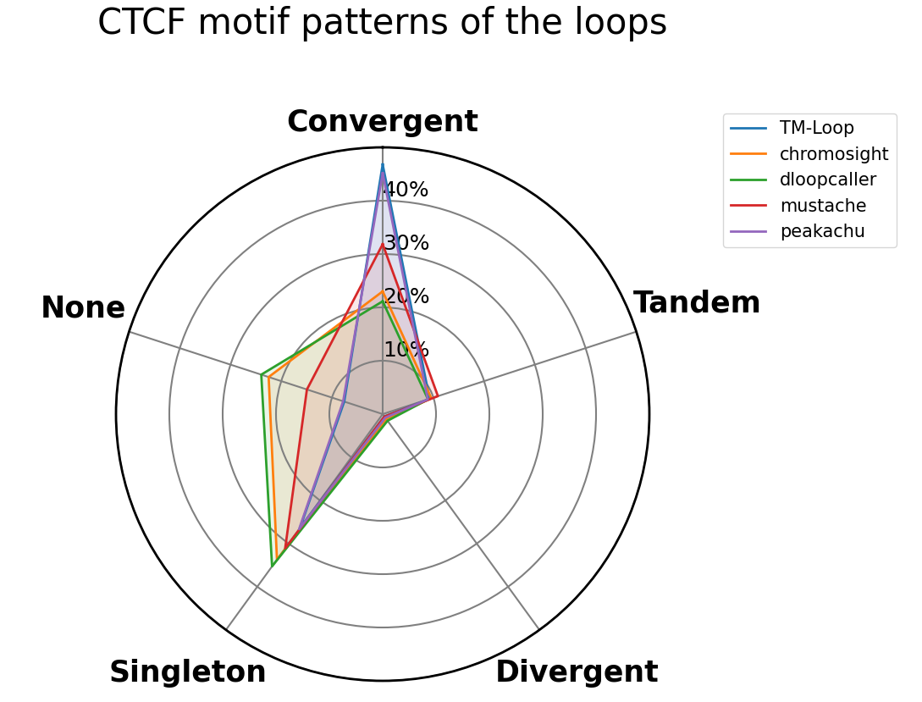
Fig.6 CTCF binding site orientation configuration detection analysis.
From the radar map of CTCF motif orientation, it can be seen that the proportion of CTCF motif pairs with Convergent orientation is the highest in the chromatin loop predicted by TM-Loop, which is close to 40%, significantly higher than that of Chromosight, Dloopcaller and Mustache; At the same time, the proportion of anchors without CTCF motif (none) or single anchor with motif (singleton) in TM-Loop prediction loop is also at a low level. These results indicate that TM-Loop has higher reliability in recognizing CTCF mediated functional chromatin loops, and its predicted loop structure is more in line with the biological rules of CTCF motif orientation.
(2) Supplementary experiment of K562 cell line
①Enrichment evaluation of interaction hot spot signals (APA analysis)
In order to quantitatively characterize the signal enrichment intensity in the central region of the prediction loop, we use Aggregation Peak Analysis (APA) to evaluate the capture accuracy of various methods for spatial interaction hotspots. APA objectively reflects the consistency between the predicted results and the real chromatin interaction peaks by calculating the signal intensity ratio between the central quadrant of the interaction matrix and the background region.
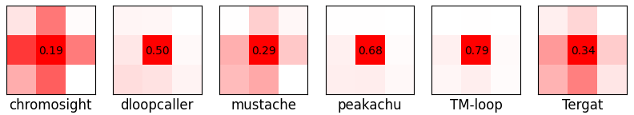
Fig.7 Local significance analysis of the loop.
The signal contrast under local resolution (local thermal map) shows that TM-loop shows excellent signal sharpness in the center of the loop anchor point, and the contrast between the central pixel and the adjacent background is 0.79, significantly exceeding Chromosight（0.19）、Dloopcaller（0.50）、Mustache（0.29）、Peakachu（0.68）and Tergat (0.34). This difference reveals that TM-loop can effectively penetrate the high background noise interference of Hi-C matrix and accurately locate the core peak area of the interaction signal.
In the global APA evaluation of the 11 × 11 matrix, TM-loop obtained a signal enrichment score of 1.43, which was significantly superior to Dloopcaller (1.25) and Mustache (1.30), and showed stronger central aggregation characteristics than Chromosight (1.16), Peakachu (1.29) and Tergat (1.13). This result confirmed that TM-loop could stably recognize the chromatin loop with significant spatial aggregation characteristics even under the heterogeneous epigenetic background of myeloid leukemia.
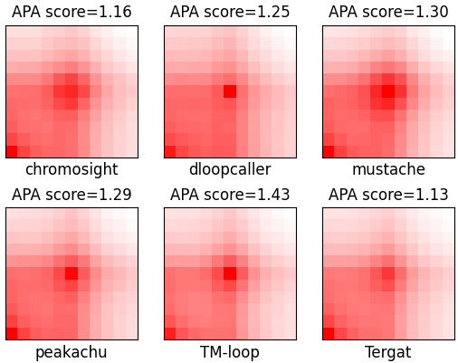
Fig.8 Summary of aggregate peak analysis.
②Correlation verification of hematopoietic lineage specific regulatory elements
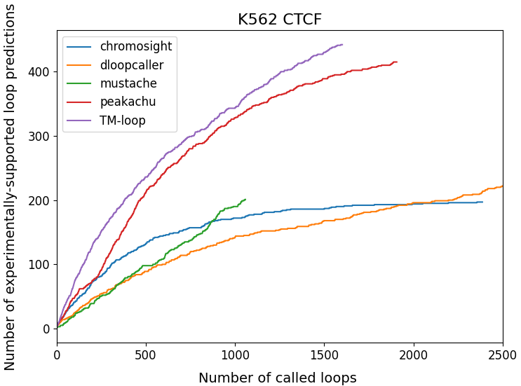
Fig.9 Enrichment factor analysis of structural proteins integrated from CTCF ChIA-PET.
In K562 cells, BCR-ABL fusion oncogene driven transformation is accompanied by extensive remodeling of chromatin topology. We used the CTCF ChIA-PET data unique to the cell line (rather than the multi factor validation mentioned in the template) to evaluate the sensitivity of each method for the recognition of leukemia related chromatin loops. As an insulator binding protein, CTCF plays a key role in maintaining the enhancer promoter interaction related to the abnormal proliferation of K562 cells.
The verification curve shows (K562 CTCF diagram). With the relaxation of the prediction threshold (the number of prediction loops increases from 0 to 2500), the number of experimental verification loops obtained by TM-loop continues to be ahead of other algorithms. When 2500 loops are predicted, the number of CTCF support loops of TM-loop is more than 450, showing significant advantages over Peakachu (about 420), Chromosight (about 200) and Dloopcaller (about 220). This trend indicates that TM-loop has higher accuracy in capturing CTCF mediated abnormal chromatin interactions in leukemia cells.
③Resolution difference analysis of genome distance dimension
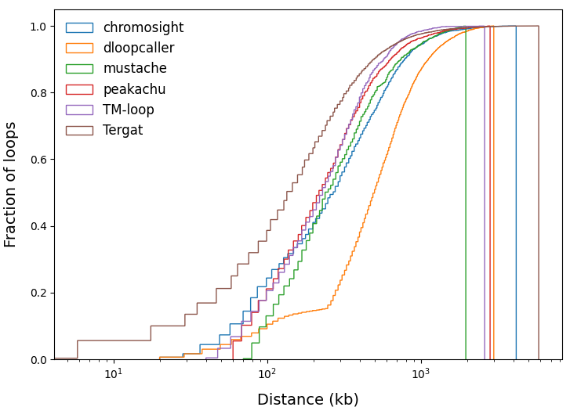
Fig.10 Loop radius statistics.
Different algorithms show significant preference differences in the linear span detection of chromatin loops. The cumulative distribution curve revealed that TM-loop accumulated rapidly in the short-range interaction (<500 KB), and more than 50% of the prediction loops were concentrated in this range, reflecting its sensitivity to the local chromatin microenvironment. In contrast, the detection curve of Dloopcaller has a significant delay near 100 kb, suggesting that there is a blind spot in the identification of short-range interaction, which may be due to the excessive correction of its diagonal background noise.
④The heterogeneity and consensus of algorithm prediction space
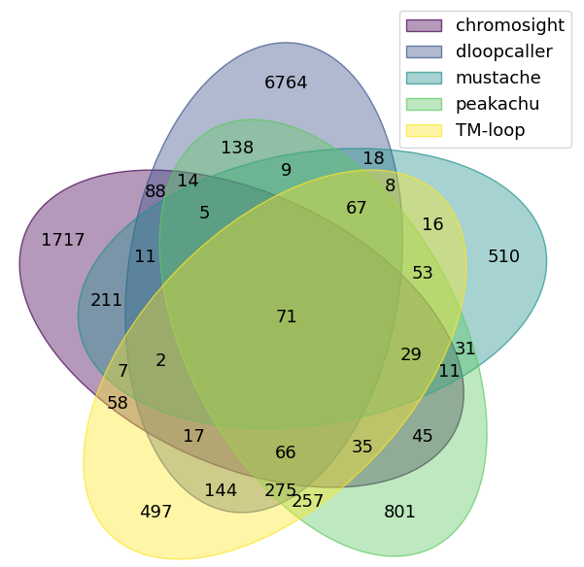
Fig.11 Number of overlapping chromatin loops predicted by different methods on chr15, chr16, and chr17 in the K562 cell.
By analyzing the overlapping pattern of prediction results with five dimensional Wayne diagram, we found that each algorithm not only has a core consensus set in K562 cells, but also retains the unique prediction space of methodology. TM-loop shares 194 loops with Peakachu, 211 loops with Chromosight, and 214 loops with Dloopcaller, reflecting the recognition consistency on the core interaction sites. However, TM-loop independently predicted 497 unique loops, and these K562 specific predictions may represent the unique chromatin microstructure of myeloid cells, providing a unique resource for mining leukemia specific regulatory interactions.

(3)Change of cluster number of chromatin rings
Table 1 Change of cluster number of chromatin rings
cell/tissue type | Chromosome name | Prediction loops | Clustering parameters（Threshold） | Candidate loops | Clustered reads
 | chr15 | 2953624 |  | 58370 | 591
GM12878 | chr16 | 2707521 | 0.985 | 54322 | 343
 | chr17 | 2766755 |  | 52965 | 689
 | chr15 | 2162914 |  | 33324 | 515
K562 | chr16 | 2080751 | 0.98 | 38515 | 417
 | chr17 | 1977508 |  | 32287 | 670

(4)Number of training sets
Table 2 Number of training sets
Chromosome | Positive Samples | Negative Samples |  | Chromosome Total Samples
chr1 | 6862 |  | 20586 | 27448
chr2 | 5249 |  | 15747 | 20996
chr3 | 4449 |  | 13347 | 17796
chr4 | 3195 |  | 9585 | 12780
chr5 | 3747 |  | 11241 | 14988
chr6 | 4390 |  | 13170 | 17560
chr7 | 3529 |  | 10587 | 14116
chr8 | 3074 |  | 9222 | 12296
chr9 | 2716 |  | 8148 | 10864
chr10 | 3190 |  | 9570 | 12760
chr11 | 4004 |  | 12012 | 16016
chr12 | 3855 |  | 11565 | 15420
chr13 | 1552 |  | 4656 | 6208
chr14 | 2607 |  | 7821 | 10428
chr15 | 2330 |  | 6990 | 9320
chr16 | 2262 |  | 6786 | 9048
chr17 | 3432 |  | 10296 | 13728
chr18 | 1444 |  | 4332 | 5776
chr19 | 2580 |  | 7740 | 10320
chr20 | 1959 |  | 5877 | 7836
chr21 | 657 |  | 1971 | 2628
chr22 | 1428 |  | 4284 | 5712
chrX | 2059 |  | 6177 | 8236
GM12878 Total Samples:282280

(5) data sources
Table 3 TM-Loop data sources
Cell line | Data type | Data source
GM12878 | Hi-C | https://drive.google.com/file/d/  1rfkdHSfmn5GK7qdzSwVlrSHpJVPPn5R3/  view?usp=sharing
K562 | Hi-C | GSE63525 (GEO)
GM12878 | CTCF ChIA-PET
GM12878 | Rad21 ChIA-PET
GM12878 | SMC1 HiChIP | https://github.com/tariks/peakachu/tree/master/trainingsets
GM12878 | H3K27ac HiChIP
K562 | CTCF ChIA-PET
GM12878 | CTCF narrowPeak | ENCFF833FTF (ENCODE)
K562 | CTCF narrowPeak | ENCFF085HTY (ENCODE)
GM12878 | Promoters And enhancers | https://github.com/tariks/peakachu/tree/master/analysis/annotations
K562 | Promoters And enhancers
GM12878 | CTCF motif | https://github.com/Yin-Shen/CharID/tree/main/signal
GM12878 | ATAC-seq(BigWig) | ENCFF816ZFB (ENCODE)
GM12878 | CTCF CHIP-seq(BigWig) | ENCFF797LSC (ENCODE)
K562 | ATAC-seq(BigWig) | ENCFF888RNH (ENCODE)
K562 | CTCF CHIP-seq(BigWig) | ENCFF910QVN (ENCODE)

