Supplementary Information

Covalent stabilization of mutant p53 suppresses aggregation and restores apoptotic signaling

Giulia D. S. Ferretti¹, Ruan C. B. Ribeiro², Mariana M. da Paz^{1,3,4}, Raissa E. dos Santos⁴, Francisca H. Guedes da Silva^{1,3}, Gileno S. de Sousa¹, Michelle F. Mota¹, Julia Quarti¹, Danilo Predes⁵, Beatriz Iandra⁶, Otacilio da Cruz Moreira⁶, Fernando C. da Silva³, Vitor F. Ferreira⁷, Luciana P. Rangel⁴, Jerson L. Silva^{1,3}
¹ Institute of Medical Biochemistry Leopoldo de Meis, National Institute of Science and Technology for Structural Biology and Bioimaging (INBEB), National Center for Structural Biology and Bioimaging (CENABIO) , Federal University of Rio de Janeiro, Rio de Janeiro, RJ. 21941-902, Brazil.
² Federal Fluminense University, Institute of Chemistry, Department of Organic Chemistry, Valonguinho Campus, Niterói, RJ, Brazil.
³ D’Or Institute for Research and Education (IDOR), Rio de Janeiro, Brazil, 22281-100.
⁴Faculty of Pharmacy, FF/UFRJ, RJ, Brazil;
⁵Institute of Biomedical Sciences/ UFRJ, RJ, Brazil;
⁶Oswaldo Cruz Institute, IOC/FIOCRUZ, RJ, Brazil;

⁷Federal Fluminense University, School of Pharmacy, LabIQTF, Niterói, RJ, Brazil.

Supplementary Table S1. Chemical synthesis and characterization of RCT-13 and RCT-14

Parameter | RCT-13 | RCT-14
Compound name | 2-(azidomethyl)-3-methyl-1,4-naphthoquinone | 2-(((5H-[1,2,4]triazino[5,6-b]indol-3-yl)thio)methyl)-3-methyl-1,4-naphthoquinone
Molecular formula | C₁₂H₉N₃O₂ | C₂₁H₁₅N₄O₂S
Molecular weight (g mol−1) | 227.22 | 387.46
Synthetic approach | Azide nucleophilic substitution of chloromethyl-naphthoquinone | Thiol nucleophilic substitution of chloromethyl-naphthoquinone
Yield (%) | 76 | 63
Physical appearance | Orange solid | Brown solid
Melting point (°C) | 84–85 | 215–217
IR νmax (cm⁻¹) | 2174, 2092, 1659, 1624, 1591, 1443, 1381, 1331, 1290 | 1291, 1319, 1335, 1375, 1420, 1459, 1500, 1524, 1594, 1619, 1656, 2797, 2920, 3059
¹H NMR (500 MHz, DMSO-d6) δ (ppm) | 8.04–7.96 (m, 2H), 7.88–7.81 (m, 2H), 4.42 (s, 2H), 2.18 (s, 3H) | 12.59 (s, 1H), 8.30 (d, J = 7.6 Hz, 1H), 8.05–7.98 (m, 2H), 7.88–7.80 (m, 2H), 7.69 (t, J = 7.6 Hz, 1H), 7.59 (d, J = 8.2 Hz, 1H), 7.43 (t, J = 7.5 Hz, 1H), 4.59 (s, 2H), 2.36 (s, 3H)
¹³C NMR (125 MHz, DMSO-d6) δ (ppm) | 184.5, 184.3, 146.3, 138.8, 134.0, 131.6, 131.0, 125.9, 125.8, 44.9, 12.6 | 184.1, 183.1, 166.2, 146.4, 144.8, 141.5, 141.1, 140.3, 133.9, 133.8, 131.5, 131.3, 130.7, 125.9, 125.8, 122.3, 121.3, 117.5, 112.6, 25.9, 13.1
HRMS (ESI+) m/z | [M + Na]+ 250.0589 (calcd for C12H9N3NaO2+ 250.0586) | [M + Na]+ 387.0927 (calcd for C21H15N4O2SNa+ 387.0910)
Structural confirmation | ¹H NMR, ¹³C NMR, IR, HRMS | ¹H NMR, ¹³C NMR (APT), IR, HRMS

Supplementary Table S1. Synthetic yields and spectroscopic characterization of RCT-13 and RCT-14. Detailed experimental procedures and representative spectra are provided in the Methods and Supplementary Figure 1.

Supplementary Figure 1

Supplementary Figure 1. Details of the reaction conditions for the preparation of RCP 13 and RCP 14.

Supplementary Figure 2

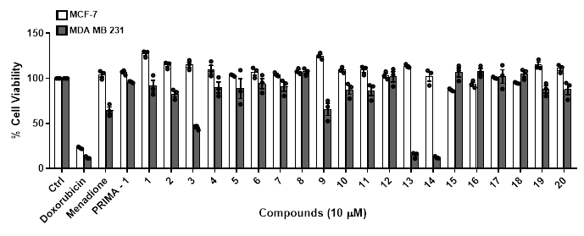

Supplementary Figure 2: Viability screening of RCT compounds in breast cancer and control cell lines. MTT cell-viability assay performed after 72 h treatment with the full panel of synthesized naphthoquinone derivatives (20 compounds) in MDA-MB-231 (MT-p53 R280K) and MCF-7 (WT-p53) cells. Viability is expressed relative to the DMSO control. The screening identifies RCT-13 and RCT-14 as the most potent molecules, with selective reduction of viability in MDA-MB-231 cells. Data are mean ± s.e.m.; n = 3 independent experiments; statistical significance assessed by Student’s t-test (p ≤ 0.05).

Supplementary Figure 3

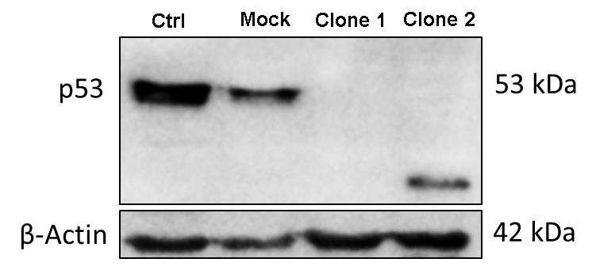

Supplementary Figure 3: Validation of TP53 knockout in MDA-MB-231 cells. Western blot analysis of p53 expression in mock control cells and two independent TP53-knockout clones generated by CRISPR–Cas9. Clone 1 show complete loss of p53 protein compared with mock control and other clones. β-actin served as loading control. Data confirm successful gene editing for use in the functional assays.

Supplementary Figure 4

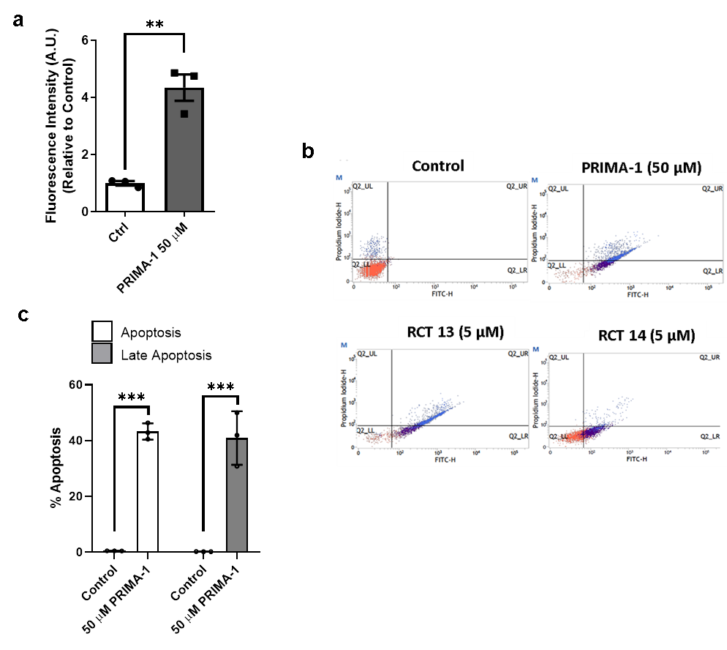

Supplementary Figure 4: PRIMA-1 restores wild-type conformation and induces apoptosis in MDA-MB-231 cells. a, Quantification using the conformational antibody pAb1620 after 24 h treatment with PRIMA-1 b, Representative dot plots from annexin V–FITC/PI staining of MDA-MB-231 cells treated with 5 µM RCT-13, 5 µM RCT-14, 50 µM PRIMA-1 (positive control), or DMSO for 18 h. c, Quantification of apoptotic populations (early + late apoptosis). RCT-13 induces apoptosis at levels comparable to PRIMA-1, whereas RCT-14 causes only a mild increase in early apoptotic cells. Data are mean ± s.e.m.; Student’s t-test; p ≤ 0.05; n = 3 independent experiments.

Supplementary Figure 5

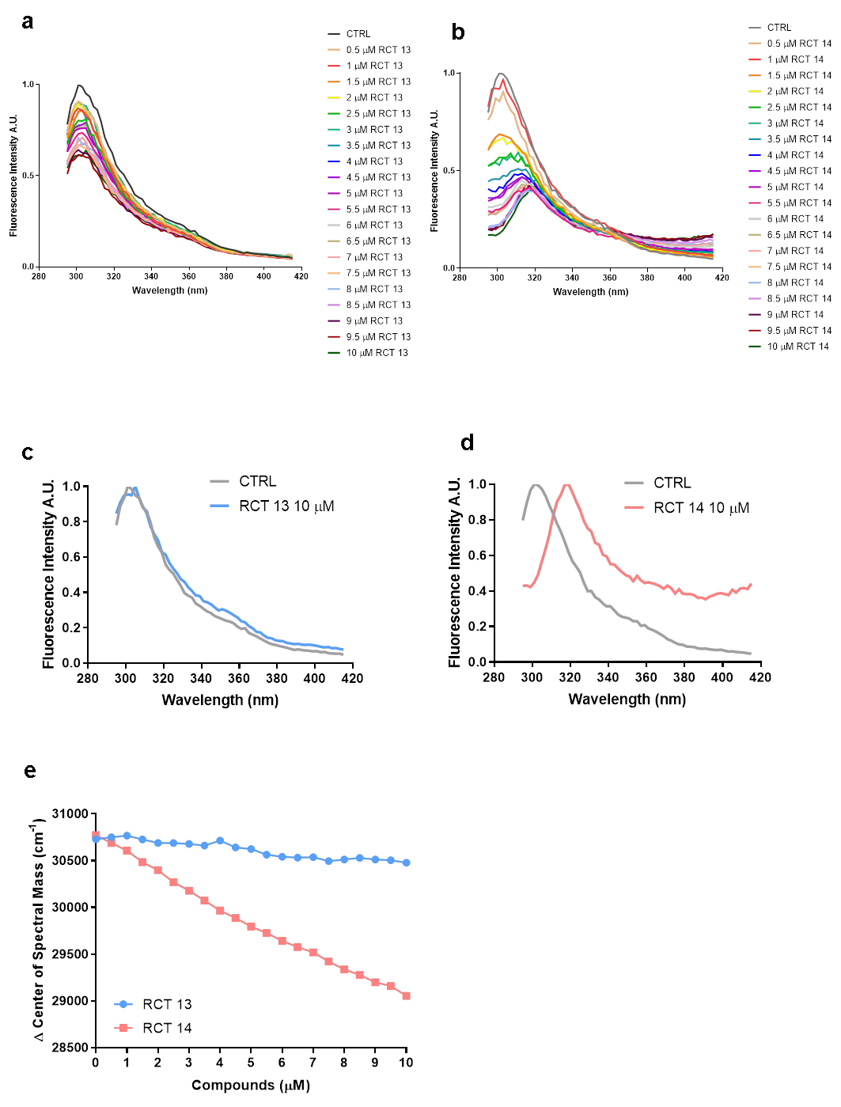

Supplementary Figure 5: Fluorescence spectroscopy analysis of RCT-13 and RCT-14 interactions with p53 R280K DBD. a-b, Intrinsic fluorescence emission spectra of purified p53 R280K DNA-binding domain (DBD) in the absence or presence of RCT-13 or RCT-14 using different concentrations. RCT-13 induces intensity quenching without spectral shift, indicating direct interaction with minimal structural destabilization. c-e, Fluorescence emission spectra and center-of-mass analysis of the DBD upon incubation with RCT-14, showing red shifts and decreased spectral stability consistent with partial unfolding and destabilization of the protein. These profiles contrast with RCT-13 and could explain the divergent cellular outcomes. All spectra represent the average of n = 3 independent experiments.

