Imaging-based biological age estimation predicts competing mortality risk in lung cancer screening:

Supplementary Materials

Daryl O. Cheng ^{1,2, ‡}
John McCabe ^{1,2}
Tanya Patrick ²
Robert Chapman ¹
Shanshan Wang ¹
Tianqi Yang ¹
Adam Szmul ¹
Mehran Azimbagirad ¹
Shahab Aslani ^{1,3}
Monica L. Mullin ⁴
Sindhu Bhaarrati Naidu ²
Chuen Ryan Khaw ²
Alfred CP So ¹
SUMMIT consortium *
Neal Navani ¹
Arjun Nair ⁵
John R Hurst ³
Andre Altmann ⁶
Adam Pennycuick ²
Daniel C. Alexander ¹
Neil Oxtoby ¹
Alexandra Young ¹
Matthew Sperrin ⁷
Sam M. Janes ^{2,†}
Joseph Jacob ^{1,†}
1: UCL Hawkes Institute and Department of Computer Science, University College London, UK
2: Lungs for Living Research Centre, University College London, UK
3: UCL Respiratory, University College London, UK
4: Division of Respiratory Medicine, Cumming School of Medicine, University of Calgary, Canada
5: Department of Radiology, University College London Hospitals NHS Trust, UK
6: UCL Hawkes Institute and Department of Medical Physics and Biomedical Engineering, University College London, UK
7: Division of Informatics, Imaging & Data Sciences, University of Manchester, UK
*: listed in acknowledgements
†: represents joint senior authorship
‡: Corresponding author: daryl.cheng@ucl.ac.uk

Table of Contents
Definition of non-lung cancer related death 8
Characteristics of participants with unknown vital status 9
Imaging feature extraction 11
Segmentation quality control for trabecular bone density 11
Disease course mapping 13
Internal-external Cross Validation 14
Sample size calculation 16
Clinical characteristics and associations with age gap 18
Evaluation of model discrimination & calibration 21
Comparison with established risk prediction tools 34
Subgroup analysis by ethnicity and socioeconomic deprivation 39
Decision curve analysis 41
Comparison with aortic calcification 46
References 49

List of Tables
Supplementary Table 1. Cumulative incidence of lung cancer diagnoses and non-lung cancer deaths. 8
Supplementary Table 2. Baseline characteristics of participants with unknown vital status compared with the remainder of the cohort. 9
Supplementary Table 3. Disease course mapping model residual noise parameters across internal-external cross-validation clusters. 13
Supplementary Table 4. Number of participants in each International Territorial Level and grouping into groups for IECV clusters. 15
Supplementary Table 5. Minimum required sample size for the combined clinical and age gap model, by competing-risk endpoint. 17
Supplementary Table 6. Multivariable linear regression of age offset and clinical characteristics. 20
Supplementary Table 7. Calibration slope and intercept for LC diagnosis in IECV clusters and pooled estimate in random effects meta-analysis, 5-year time horizon. 21
Supplementary Table 8. Calibration slope and intercept for non-LC-related death in IECV clusters and pooled estimate in random effects meta-analysis, 5-year time horizon. 22
Supplementary Table 9. Calibration slope and intercept for LC diagnosis in IECV clusters and pooled estimate in random effects meta-analysis, 2-year time horizon. 22
Supplementary Table 10. Calibration slope and intercept for non-LC-related death in IECV clusters and pooled estimate in random effects meta-analysis, 2-year time horizon. 23
Supplementary Table 11. Complete case sensitivity analysis, calibration slope and intercept for LC diagnosis in IECV clusters and pooled estimate in random effects meta-analysis, 5-year time horizon. 23
Supplementary Table 12. Complete case sensitivity analysis, calibration slope and intercept for non-LC-related death in IECV clusters and pooled estimate in random effects meta-analysis, 5-year time horizon. 24
Supplementary Table 13. Calibration slope and intercept for non-LC-related death, comparing established risk tools (PLCO-ci, LYFS-CT) with the Base and Base + Age gap models, in IECV clusters and pooled estimate in random effects meta-analysis, 5-year time horizon. 35
Supplementary Table 14. Calibration slope and intercept for non-LC-related death, comparing established risk tools (PLCO-ci, LYFS-CT) with the Base and Base + Age gap models, in IECV clusters and pooled estimate in random effects meta-analysis, 2-year time horizon. 36
Supplementary Table 15. Discrimination and calibration of the combined clinical and age gap model for non-lung cancer death at 5 years, by IMD quintile. 39
Supplementary Table 16. Discrimination and calibration of the combined clinical and age gap model for non-lung cancer death at 5 years, by ethnicity (White vs. non-white). 40
Supplementary Table 17. Discrimination (C-index) for non-lung cancer death for the Base, Base + Aortic calcification, and Base + Age gap models, pooled estimate in random effects meta-analysis, 5- and 2-year time horizons. 46

List of Figures
Supplementary Figure 1. Associations between clinical characteristics and age gap. 19
Supplementary Figure 2. Forest plot of competing risks model concordance at 5 years by IECV clusters and random effects meta-analyzed estimates. 25
Supplementary Figure 3. Forest plot of competing risks model concordance at 2 years by IECV clusters and random effects meta-analyzed estimates. 26
Supplementary Figure 4. Forest plot of competing risks model concordance at 2 years by IECV clusters and random effects meta-analyzed estimates. 27
Supplementary Figure 5. Forest plot of competing risks model concordance by IECV clusters and random effects meta-analyzed estimates, complete case sensitivity analysis. 28
Supplementary Figure 6. Forest plot of competing risks model concordance by IECV clusters and random effects meta-analyzed estimates, complete case sensitivity analysis. 29
Supplementary Figure 7. Calibration plots for non-lung cancer related death at 5 years across IECV clusters. 30
Supplementary Figure 8. Calibration plots for lung cancer diagnosis at 5 years across IECV clusters. 31
Supplementary Figure 9. Calibration plots for non-lung cancer death at 5 years across IECV clusters, complete case sensitivity analysis. 32
Supplementary Figure 10. Calibration plots for lung cancer diagnosis at 5 years across IECV clusters, complete case sensitivity analysis. 33
Supplementary Figure 11. Forest plot of competing risks model concordance for non-lung cancer death at 5 years, comparing established risk tools (PLCO-ci, LYFS-CT) with the Base and Base + Age gap models, by IECV clusters and random effects meta-analyzed estimates. 37
Supplementary Figure 12. Forest plot of competing risks model concordance for non-lung cancer death at 2 years, comparing established risk tools (PLCO-ci, LYFS-CT) with the Base and Base + Age gap models, by IECV clusters and random effects meta-analyzed estimates. 38
Supplementary Figure 13. Decision curve analysis for non-lung cancer death at 5 years. 42
Supplementary Figure 14. Decision curve analysis for non-lung cancer death at 2 years. 43
Supplementary Figure 15. Decision curve analysis for lung cancer diagnosis at 5 years. 44
Supplementary Figure 16. Decision curve analysis for lung cancer diagnosis at 2 years. 45
Supplementary Figure 17. Forest plot of competing risks model concordance for non-lung cancer death at 5 years, comparing aortic calcification alone with the Base and Base + Age gap models, by IECV clusters and random effects meta-analyzed estimates. 47
Supplementary Figure 18. Forest plot of competing risks model concordance for non-lung cancer death at 2 years, comparing aortic calcification alone with the Base and Base + Age gap models, by IECV clusters and random effects meta-analyzed estimates. 48

Definition of non-lung cancer related death
Non-lung cancer related death was defined using death certificate data from the National Cancer Registration and Analysis Service, where International Classification of Disease-10 (ICD-10) codes for lung cancer related terms did not appear in part 1a, 1b or 1c. Part 1a is: disease or condition leading directly to death; 1b: other disease or condition, if any, leading to 1a; and 1c: other disease or condition, if any, leading to 1b. Lung cancer ICD-10 codes were taken as any code beginning with ‘C34 – Malignant neoplasm of bronchus or lung’.
Age gap quartile | Cumulative incidence (95% CI) | N at risk | N of events
Lung cancer diagnosis
1 | 4.5% (3.8%–5.3%) | 1520 | 136
2 | 4.4% (3.7%–5.2%) | 1443 | 132
3 | 4.8% (4.0%–5.6%) | 1401 | 137
4 | 5.7% (4.9%–6.6%) | 1338 | 168
Non-lung cancer death
1 | 3.8% (3.2%–4.6%) | 1520 | 112
2 | 5.0% (4.2%–5.8%) | 1443 | 146
3 | 7.3% (6.4%–8.3%) | 1401 | 214
4 | 10.0% (8.9%–11.1%) | 1338 | 292

Supplementary Table 1. Cumulative incidence of lung cancer diagnoses and non-lung cancer deaths.
CI: Confidence Interval

Characteristics of participants with unknown vital status
Vital status (alive/dead) and date of death or censor for SUMMIT participants are obtained via linkage to national mortality registration records. Of the full cohort, 178 participants (1.4%) could not be matched to these records and have unknown vital status. Of these, 176 also lacked a last-known-status date and were consequently excluded from complete-case competing-risks analyses. The remaining 2 participants had a usable follow-up date and were retained as censored. To assess whether this exclusion could introduce bias, baseline characteristics of participants with unknown vital status were compared with the remainder of the cohort. Given the small numbers of participants which were not of White ethnicity, they were combined for analysis.
Characteristic | Unknown vital status (N=178) | Known vital status | p-value
Age at baseline, years | 65.1 | 65.4 | 0.53
BMI, kg/m² | 28.0 | 28.0 | 0.91
Smoking amount, pack-years | 19.7 | 21.2 | 0.034
Total smoking duration, years | 43.7 | 44.1 | 0.47
Female sex, % | 43.3 | 42.6 | 0.85
COPD/bronchitis/emphysema, % | 25.8 | 29.4 | 0.29
Current smoker (any tobacco), % | 48.3 | 48.8 | 0.90
Any prior cancer, % | 10.1 | 13.6 | 0.13
Non-white ethnicity, % | 29.8 | 15.4 | <0.001
IMD quintile (1-5), mean | 2.11 | 2.31 | 0.036

Supplementary Table 2. Baseline characteristics of participants with unknown vital status compared with the remainder of the cohort.
BMI: body mass index; COPD: chronic obstructive pulmonary disease; IMD: Index of Multiple Deprivation (1=most deprived, 5=least deprived). Continuous variables compared using a t-test; categorical variables using a chi-squared test.

Participants with unknown vital status did not differ from the rest of the cohort in age, sex, BMI, COPD status, or smoking status. However, they were disproportionately of non-white ethnicity (29.8% vs. 15.4%, p<0.001) and modestly more socioeconomically deprived (mean IMD quintile 2.11 vs. 2.31, p=0.04). Given the small proportion of the cohort affected (1.4%), this exclusion is unlikely to have a large effect on the overall point estimates reported, but it is noted here as a limitation, and as a further, data-completeness-related instance of the same equity consideration discussed elsewhere in relation to age gap, ethnicity and socioeconomic deprivation.

Imaging feature extraction
The relevant segmentations of vertebral bodies, erector spinae muscles, pericardial fat, and aorta were produced using an in-house deep learning segmentation algorithm, adapted from existing nnU-Net based methods ¹. Erector spinae mass was calculated as the product of volume and density. Trabecular density was calculated by erosion of the cortex from the vertebral segmentation, and calculation of mean density. Aortic calcification was defined as the percentage of volume of aorta segmentation above 130 Hounsfield units (HU). Features were normalized from 0 to 1 using an empirical cumulative distribution function, and where appropriate, the direction was reversed for features expected to decrease with age. Mass of pericardial fat was estimated by multiplying the volume of the fat segmentation with the mean attenuation. Scans which had been manually identified by the reporting radiologist as containing a vertebral fracture were removed from the analysis.
Features which were expected to decrease in value with age (muscle density, trabecular density) had the sign reversed. All features were scaled to between 0 and 1, using an empirical cumulative distribution function, stratified by sex, before being collated for disease progression modelling.

Segmentation quality control for trabecular bone density
CT attenuation-derived density biomarkers in this pipeline (erector spinae muscle, pericardial fat, vertebral trabecular bone) are expressed in approximate g/cm³ units via density (1 + HU/1000, where HU is the raw Hounsfield unit value). A value of 0 HU (water) therefore corresponds to 1.0. Erector spinae density and pericardial fat density were constrained to anatomically plausible ranges prior to biomarker derivation (0.94-1.2 g/cm³ and 0.85-0.975 g/cm³ respectively); values outside these ranges were treated as missing. Trabecular bone density was constrained analogously, to 0-300 HU (density 1.0-1.3): the lower bound excludes non-physiological negative-HU readings, and the upper bound reflects that values above 300 HU are implausible for vertebral trabecular bone in this cohort’s age range. This upper threshold was set with reference to normative CT-based trabecular attenuation data (mean L1 attenuation 226 ± 44 HU under age 30, declining approximately 2.5 HU per year to 89 ± 38 HU at age 90 or older) ²: extrapolated to this cohort’s age range (55-80 years), expected mean attenuation is approximately 108-164 HU, well below the 300 HU threshold applied here. 96 of 11,818 non-missing trabecular density readings (0.81%) exceeded this threshold, most likely reflecting partial-volume artifacts of cortical bone at the segmentation boundary rather than true trabecular signal. These measurements were set to missing for this analysis.

Disease course mapping
The mixed-effects framework naturally accommodates missing biomarker data by estimating individual trajectories using all available observations for each subject, without requiring imputation or complete-case analysis. The Monte Carlo Markov Chain-Stochastic Approximation Expectation Maximization algorithm integrates over uncertainty in unobserved values during parameter estimation. The final fitted progression is then mapped onto individual data to estimate the parameter of time-shift, 𝜏_{i.} for each participant, which estimates the age of onset of biomarker evolution.
Disease course mapping models achieved good fit across IECV folds (negative log-likelihood: -25,203, -25,177, and -28,244 for folds 0-2). Model noise parameters were highly consistent across folds, with residual standard deviations ranging from 0.045-0.082 across biomarkers (Supplementary Table 3).
Cluster | Erector Spinae Muscle Density | Aortic Calcification | Pericardial Fat Mass | Trabecular Bone Density
1 | 8.19% | 4.84% | 6.09% | 4.90%
2 | 8.07% | 4.52% | 5.94% | 4.91%
3 | 8.18% | 4.74% | 6.01% | 4.85%

Supplementary Table 3. Disease course mapping model residual noise parameters across internal-external cross-validation clusters.
Residual standard deviations for each biomarker under a Gaussian diagonal noise model (independent, normally distributed errors per feature). Values indicate measurement variability unexplained by the fitted aging trajectories. Consistency across clusters demonstrates stable model performance across geographic sites.

Internal-external Cross Validation
The Internal-External Cross Validation (IECV) workflow applied to both disease course mapping, as well as competing risks survival analysis. Model development steps were performed for 2 regions and evaluated on the region held out for evaluation. Similarly, for disease course mapping, all data were used for model development on 2 regions, but only baseline data were used for inference on the third held out region.
The geographical regions used for this purpose were modelled using the geocode standards of International Territorial Level (ITL) from the Office for National Statistics (ONS), the statistical classification framework equivalent to the European Statistical System’s Nomenclature of Territorial Units for Statistics (NUTS).
Since SUMMIT recruited in London using primary care records from practices in north-central and northeast London, the geographical distribution of participants mirrors this ³. The numbers of participants from each territorial unit, as well as the IECV cluster assignment, are presented in Supplementary Table 4. Cluster 1 had 4,650 participants (11,030 scans); cluster 2 had 4,714 participants (11,140 scans); and cluster 3 had 3,116 participants (7,575 scans). The clusters correspond to East Inner London (Cluster 1); East and North East Outer London (Cluster 2); and West Inner London, East of England, South, West and North West Outer London, the South East and South West (Cluster 3).

 | International Territorial Level | IECV Group | No. of participants
East of England | Basildon | 3 | 2
East of England | Brentwood | 3 | 3
East of England | Broxbourne | 3 | 5
East of England | Castle Point | 3 | 1
East of England | Chelmsford | 3 | 1
East of England | East Hertfordshire | 3 | 1
East of England | Epping Forest | 3 | 18
East of England | Hertsmere | 3 | 2
East of England | Rochford | 3 | 1
East of England | South Cambridgeshire | 3 | 1
East of England | Southend-on-Sea | 3 | 1
East of England | Tendring | 3 | 1
East of England | Thurrock | 3 | 6
East of England | Watford | 3 | 2
East of England | Welwyn Hatfield | 3 | 4
Inner London - East | Hackney | 1 | 825
Inner London - East | Haringey | 1 | 985
Inner London - East | Islington | 1 | 1,036
Inner London - East | Newham | 1 | 865
Inner London - East | Tower Hamlets | 1 | 1,157
Inner London - West | Camden | 3 | 537
Inner London - West | City of London | 3 | 38
Inner London - West | Westminster | 3 | 1
Outer London - East and North East | Barking and Dagenham | 2 | 835
Outer London - East and North East | Bexley | 2 | 3
Outer London - East and North East | Enfield | 2 | 1,219
Outer London - East and North East | Havering | 2 | 1,616
Outer London - East and North East | Redbridge | 2 | 792
Outer London - East and North East | Waltham Forest | 2 | 467
Outer London - South | Bromley | 3 | 1
Outer London - South | Croydon | 3 | 2
Outer London - West and North West | Barnet | 3 | 2,516
Outer London - West and North West | Brent | 3 | 16
Outer London - West and North West | Harrow | 3 | 70
Outer London - West and North West | Hillingdon | 3 | 1
South East | Buckinghamshire | 3 | 1
South East | Maidstone | 3 | 1
South East | South Oxfordshire | 3 | 1
South West | Bournemouth, Christchurch and Poole | 3 | 1

Supplementary Table 4. Number of participants in each International Territorial Level and grouping into groups for IECV clusters.
IECV: Internal-external Cross Validation.

Sample size calculation
Minimum required sample size for the combined clinical and age gap model was calculated separately for each competing-risk endpoint, using the pmsampsize approach for developing a prediction model for a survival (time-to-event) outcome, which targets a shrinkage factor of 0.9, small optimism in the model’s apparent R², and precise estimation of the overall risk at the chosen time point. This requires an anticipated Cox-Snell R², which was back-calculated from an anticipated C-statistic and outcome proportion following the same simulation-based approach used internally by pmsampsize for other outcome types^{4,5}. For each endpoint, the anticipated C-statistic was taken as the model’s own achieved 5-year pooled internal-external cross-validation C-statistic for the combined clinical and age gap model, since no comparable prior model exists for this novel imaging biomarker from which to take an anticipated R², as is standard practice for a retrospective sample size justification of an already-completed analysis, rather than a prospectively pre-registered target. Twelve candidate predictor parameters were specified for both endpoints, corresponding to the 11 base clinical variables plus age gap, none of which required more than one parameter. Event rate and 5-year cumulative incidence were calculated directly from the complete-case cohort used for the main analysis, using the Aalen-Johansen estimator for cumulative incidence to correctly account for the competing event.
Both endpoints exceeded their minimum required sample size (Supplementary Table 5). Lung cancer diagnosis, the rarer and lower-discrimination of the two endpoints, was the more binding constraint, but the achieved cohort still exceeded its requirement by approximately two-fold, and exceeded the non-lung cancer death requirement by approximately five-fold.
Outcome | Anticipated C-statistic | Event rate (per person-year) | 5-year cumulative incidence | Mean follow-up (years) | Minimum required N (events) | Cohort N (events by 5 years)
Non-lung cancer death | 0.73 | 1.37% | 6.5% | 4.6 | 2,484 (158) | 12,300 (763)
Lung cancer diagnosis | 0.67 | 1.05% | 4.9% | 4.6 | 6,307 (308) | 12,300 (573)
Supplementary Table 5. Minimum required sample size for the combined clinical and age gap model, by competing-risk endpoint.
Calculated using the pmsampsize approach for time-to-event, targeting a shrinkage factor of 0.9. Twelve candidate predictor parameters were specified for both endpoints (11 base clinical variables plus age gap). Event rate and cumulative incidence were derived from the complete-case cohort used in the main analysis.

Clinical characteristics and associations with age gap
Individuals currently smoking comprised 6,089 participants (49%), with 6,389 (51%) having quit smoking. The median smoking duration was 44 years (IQR: 40–48), with a median smoking history of 20 pack-year equivalents (IQR: 15–22). 3,661 (29%) participants had an existing diagnosis of COPD, bronchitis, or emphysema.
Multivariable linear regression examined associations between clinical characteristics and age gap (Supplementary Figure 1, Supplementary Table 6). Higher BMI was associated with a positive age gap (β=0.4 years per unit BMI, 95% CI: 0.42–0.46, p<0.001), as was a diagnosis of COPD, bronchitis or emphysema at baseline (β=1.4, 95% CI: 1.1–1.6, p<0.001), lower educational attainment (β=-0.3, 95% CI: -0.4– -0.2, p<0.001) and higher socioeconomic deprivation (β=-0.1, 95% CI: -0.2– -0.02, p=0.02).
Current smoking status was not associated with age gap (95% CI: -0.6–0.05, p= 0.1) compared to former smokers. Higher smoking amount was associated with higher age gap (β=0.9 per 10 pack-years, PY, 95% CI: 0.73–0.98, p<0.001), whilst longer time since stopping all tobacco was associated with a lower age gap (β=-1.2 per 10 years, 95% CI: -1.5–-0.9, p<0.001). Only time since stopping all tobacco had a significant interaction with sex, which was negative (β=-0.4, 95% CI: -0.78–-0.01, p=0.05), suggesting that female sex attenuated the effect of time since stopping all tobacco on decreasing age gap.

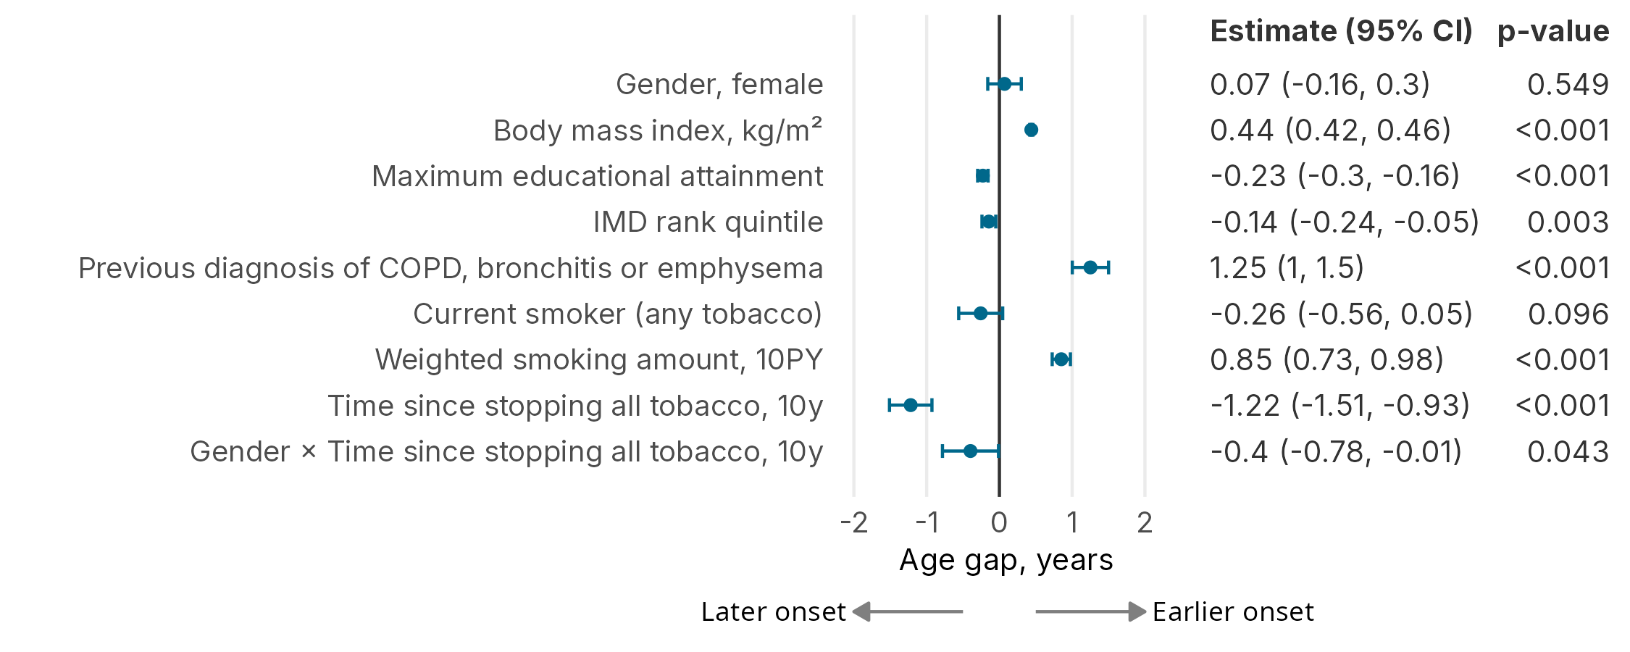
Supplementary Figure 1. Associations between clinical characteristics and age gap.
Multivariable linear regression coefficients with 95% confidence intervals (CI) for predictors of age gap. Positive age gap indicates earlier onset of age-related processes; negative values indicate later onset. IMD: Indices of Multiple Deprivation; COPD: Chronic Obstructive Pulmonary Disease.

Characteristic | Beta | 95% CI | p-value | VIF
Sex, female | 0.07 | -0.16, 0.30 | 0.5 | 1.0
Body mass index, kg/m² | 0.44 | 0.42, 0.46 | <0.001 | 1.1
Maximum educational attainment | -0.23 | -0.30, -0.16 | <0.001 | 1.0
IMD rank quintile | -0.14 | -0.24, -0.05 | 0.003 | 1.0
COPD, bronchitis or emphysema diagnosis | 1.3 | 1.0, 1.5 | <0.001 | 1.0
Current smoker (any tobacco) | -0.26 | -0.56, 0.05 | 0.10 | 1.8
Weighted smoking amount, 10PY | 0.85 | 0.73, 0.98 | <0.001 | 1.1
Time since stopping all tobacco, 10y | -1.2 | -1.5, -0.93 | <0.001 | 2.4
Sex, female * Time since stopping all tobacco, 10y | -0.40 | -0.78, -0.01 | 0.043 | 1.7

Supplementary Table 6. Multivariable linear regression of age offset and clinical characteristics.
Total smoking duration and years since stopping all tobacco are expressed in 10 year units and are centered on 44 years and 21 years respectively. Weighted smoking amount is expressed in 10 pack-year equivalents, and is centered on 4 pack-years. CI: Confidence Interval; VIF: Variance Inflation Factor; IMD: Indices of Multiple Deprivation; COPD: Chronic Obstructive Pulmonary Disease; PY: Pack-years.

Evaluation of model discrimination & calibration
Model discrimination was assessed by concordance (C-index) at 5 years of follow-up, estimated using inverse probability of censoring weighting. C-indices between models were compared using the independent and identically distributed-representation-based comparison test, which accounts for the paired nature of measurements on the same individuals and adjusts for multiple testing across time points⁶.
We tested differences in concordance indices between models using cluster-aware bootstrap resampling (1,000 iterations) that preserved the IECV structure. For each iteration, we resampled clusters with replacement and meta-analyzed cluster-specific concordance indices using random-effects models. Two-sided p-values and 95% confidence intervals were calculated from the bootstrap distribution of differences.

 |  | n | Calibration Slope (95% CI) | Intercept (95% CI)
Base | 1 | 4581 | 0.93 (0.68–1.18) | 0.04 (−0.11–0.20)
Base | 2 | 4642 | 0.65 (0.43–0.86) | −0.15 (−0.30–0.01)
Base | 3 | 3079 | 0.85 (0.53–1.18) | −0.10 (−0.29–0.09)
Base | Pooled | 12302 | 0.79 (0.61–0.98) | −0.07 (−0.19–0.05)
Base + Age gap | 1 | 4581 | 0.90 (0.66–1.14) | 0.05 (−0.11–0.21)
Base + Age gap | 2 | 4642 | 0.66 (0.45–0.86) | −0.14 (−0.30–0.01)
Base + Age gap | 3 | 3079 | 0.79 (0.50–1.08) | −0.14 (−0.33–0.06)
Base + Age gap | Pooled | 12302 | 0.77 (0.61–0.93) | −0.07 (−0.20–0.06)

Supplementary Table 7. Calibration slope and intercept for LC diagnosis in IECV clusters and pooled estimate in random effects meta-analysis, 5-year time horizon.
CI: Confidence Interval; LC: Lung cancer; IECV: Internal-external cross validation.

 |  | n | Calibration Slope (95% CI) | Intercept (95% CI)
Base | 1 | 4581 | 0.79 (0.62–0.97) | 0.04 (−0.10–0.17)
Base | 2 | 4642 | 0.90 (0.69–1.12) | −0.10 (−0.23–0.04)
Base | 3 | 3079 | 1.04 (0.77–1.32) | −0.04 (−0.21–0.12)
Base | Pooled | 12302 | 0.88 (0.75–1.02) | −0.03 (−0.12–0.05)
Base + Age gap | 1 | 4581 | 0.82 (0.65–0.99) | 0.04 (−0.10–0.17)
Base + Age gap | 2 | 4642 | 0.88 (0.70–1.06) | −0.08 (−0.21–0.06)
Base + Age gap | 3 | 3079 | 1.08 (0.83–1.34) | −0.05 (−0.22–0.11)
Base + Age gap | Pooled | 12302 | 0.90 (0.78–1.02) | −0.03 (−0.11–0.05)

Supplementary Table 8. Calibration slope and intercept for non-LC-related death in IECV clusters and pooled estimate in random effects meta-analysis, 5-year time horizon.
CI: Confidence Interval; LC: Lung cancer; IECV: Internal-external cross validation.

 |  | n | Calibration Slope (95% CI) | Intercept (95% CI)
Base | 1 | 4581 | 0.68 (0.35–1.00) | −0.12 (−0.34–0.09)
Base | 2 | 4642 | 0.51 (0.25–0.76) | −0.22 (−0.43–−0.02)
Base | 3 | 3079 | 1.08 (0.59–1.57) | 0.04 (−0.21–0.29)
Base | Pooled | 12302 | 0.69 (0.41–0.98) | −0.12 (−0.26–0.03)
Base + Age gap | 1 | 4581 | 0.68 (0.35–1.00) | −0.12 (−0.34–0.10)
Base + Age gap | 2 | 4642 | 0.54 (0.28–0.80) | −0.22 (−0.43–−0.01)
Base + Age gap | 3 | 3079 | 0.89 (0.50–1.28) | −0.02 (−0.28–0.24)
Base + Age gap | Pooled | 12302 | 0.66 (0.47–0.85) | −0.13 (−0.26–0.00)

Supplementary Table 9. Calibration slope and intercept for LC diagnosis in IECV clusters and pooled estimate in random effects meta-analysis, 2-year time horizon.
CI: Confidence Interval; LC: Lung cancer; IECV: Internal-external cross validation.

 |  | n | Calibration Slope (95% CI) | Intercept (95% CI)
Base | 1 | 4581 | 0.85 (0.49–1.22) | 0.12 (−0.13–0.37)
Base | 2 | 4642 | 0.87 (0.45–1.29) | −0.20 (−0.45–0.05)
Base | 3 | 3079 | 1.62 (0.76–2.47) | 0.06 (−0.25–0.37)
Base | Pooled | 12302 | 0.93 (0.67–1.19) | −0.01 (−0.22–0.19)
Base + Age gap | 1 | 4581 | 0.86 (0.53–1.20) | 0.13 (−0.12–0.39)
Base + Age gap | 2 | 4642 | 0.73 (0.40–1.07) | −0.26 (−0.52–0.00)
Base + Age gap | 3 | 3079 | 1.40 (0.71–2.09) | 0.03 (−0.28–0.34)
Base + Age gap | Pooled | 12302 | 0.86 (0.64–1.08) | −0.03 (−0.28–0.21)

Supplementary Table 10. Calibration slope and intercept for non-LC-related death in IECV clusters and pooled estimate in random effects meta-analysis, 2-year time horizon.
CI: Confidence Interval; LC: Lung cancer; IECV: Internal-external cross validation.

 |  | n | Calibration Slope (95% CI) | Intercept (95% CI)
Base | 1 | 4014 | 0.88 (0.62–1.14) | 0.02 (−0.14–0.19)
Base | 2 | 4063 | 0.66 (0.43–0.89) | −0.15 (−0.31–0.00)
Base | 3 | 2705 | 0.94 (0.60–1.28) | −0.04 (−0.24–0.15)
Base | Pooled | 10782 | 0.80 (0.62–0.98) | −0.06 (−0.17–0.05)
Base + Age gap | 1 | 4014 | 0.86 (0.62–1.11) | 0.03 (−0.13–0.20)
Base + Age gap | 2 | 4063 | 0.67 (0.45–0.89) | −0.15 (−0.31–0.00)
Base + Age gap | 3 | 2705 | 0.85 (0.55–1.15) | −0.09 (−0.28–0.11)
Base + Age gap | Pooled | 10782 | 0.78 (0.63–0.92) | −0.07 (−0.19–0.05)
Base + Raw Biomarkers | 1 | 4014 | 0.82 (0.57–1.07) | 0.01 (−0.15–0.18)
Base + Raw Biomarkers | 2 | 4063 | 0.66 (0.44–0.87) | −0.17 (−0.33–−0.01)
Base + Raw Biomarkers | 3 | 2705 | 0.90 (0.58–1.21) | −0.06 (−0.26–0.13)
Base + Raw Biomarkers | Pooled | 10782 | 0.76 (0.62–0.91) | −0.07 (−0.19–0.04)

Supplementary Table 11. Complete case sensitivity analysis, calibration slope and intercept for LC diagnosis in IECV clusters and pooled estimate in random effects meta-analysis, 5-year time horizon.
CI: Confidence Interval; LC: Lung cancer; IECV: Internal-external cross validation.

 |  | n | Calibration Slope (95% CI) | Intercept (95% CI)
Base | 1 | 4014 | 0.83 (0.63–1.02) | 0.05 (−0.09–0.19)
Base | 2 | 4063 | 0.84 (0.62–1.06) | −0.11 (−0.25–0.04)
Base | 3 | 2705 | 0.90 (0.63–1.16) | −0.07 (−0.25–0.10)
Base | Pooled | 10782 | 0.85 (0.72–0.98) | −0.04 (−0.14–0.06)
Base + Age gap | 1 | 4014 | 0.80 (0.63–0.98) | 0.03 (−0.12–0.17)
Base + Age gap | 2 | 4063 | 0.84 (0.66–1.02) | −0.09 (−0.23–0.06)
Base + Age gap | 3 | 2705 | 0.98 (0.73–1.23) | −0.06 (−0.24–0.11)
Base + Age gap | Pooled | 10782 | 0.85 (0.74–0.97) | −0.04 (−0.13–0.05)
Base + Raw Biomarkers | 1 | 4014 | 0.80 (0.63–0.97) | 0.00 (−0.15–0.15)
Base + Raw Biomarkers | 2 | 4063 | 0.83 (0.64–1.01) | −0.06 (−0.22–0.09)
Base + Raw Biomarkers | 3 | 2705 | 0.91 (0.67–1.14) | −0.06 (−0.25–0.13)
Base + Raw Biomarkers | Pooled | 10782 | 0.83 (0.72–0.95) | −0.04 (−0.13–0.05)

Supplementary Table 12. Complete case sensitivity analysis, calibration slope and intercept for non-LC-related death in IECV clusters and pooled estimate in random effects meta-analysis, 5-year time horizon.
CI: Confidence Interval; LC: Lung cancer; IECV: Internal-external cross validation.

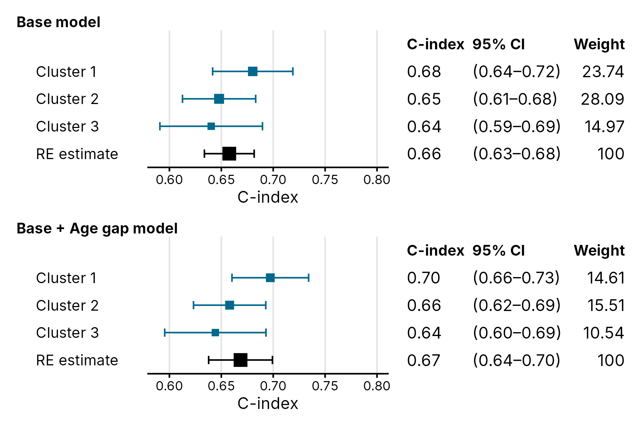
Supplementary Figure 2. Forest plot of competing risks model concordance at 5 years by IECV clusters and random effects meta-analyzed estimates.
Outcome is lung cancer diagnosis. C-index: Concordance index; CI: confidence interval.

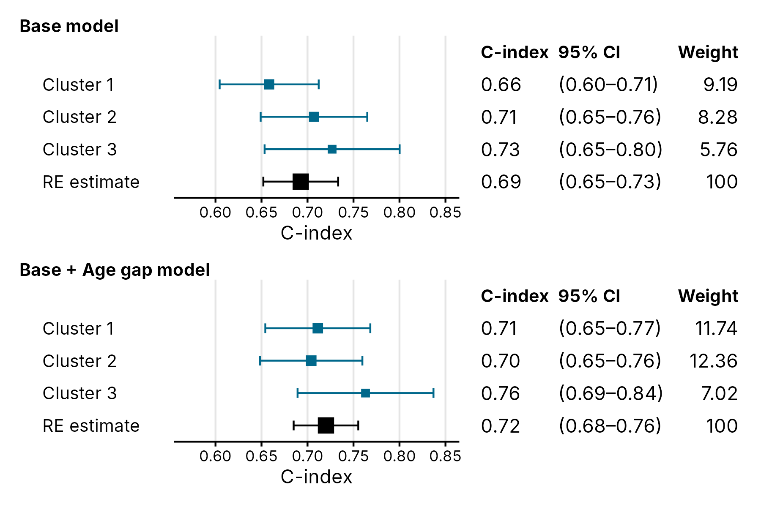
Supplementary Figure 3. Forest plot of competing risks model concordance at 2 years by IECV clusters and random effects meta-analyzed estimates.
Outcome is non-lung cancer related death. C-index: Concordance index; CI: confidence interval.

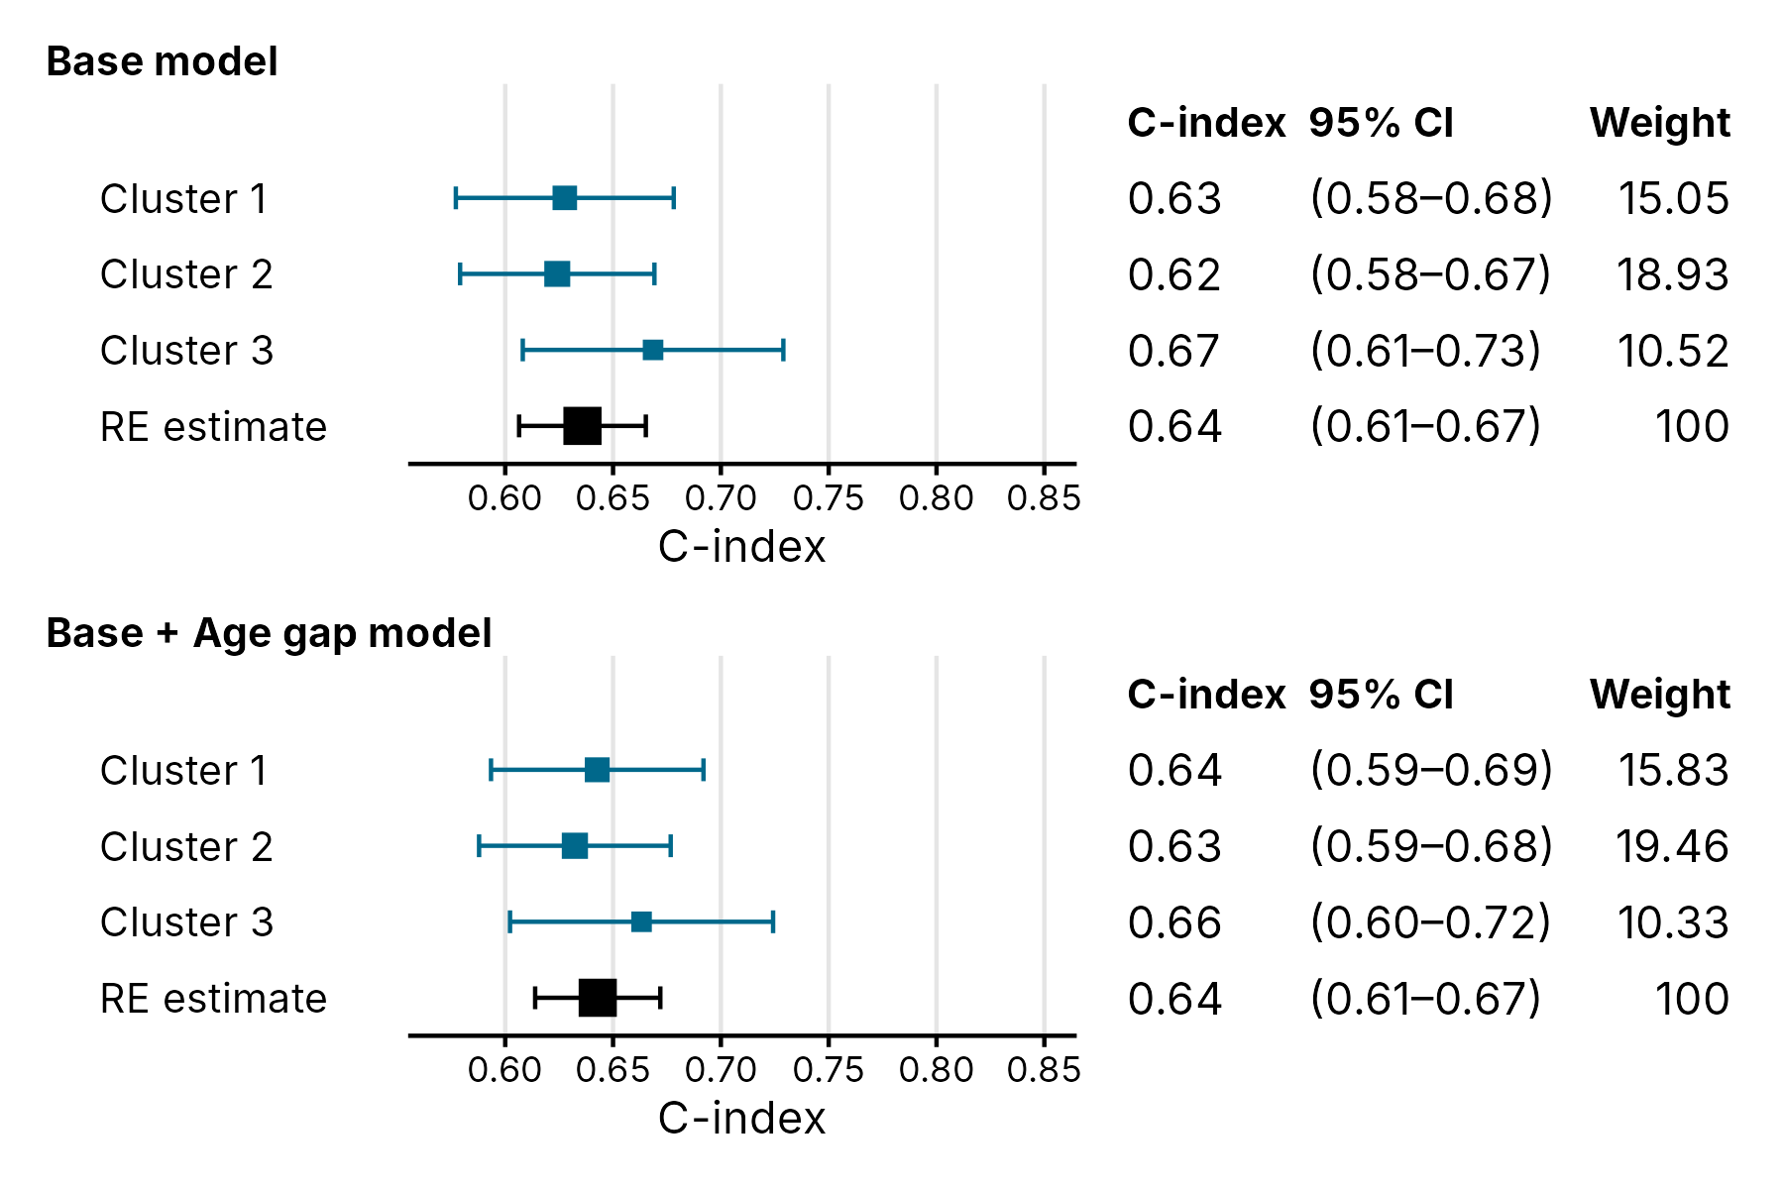
Supplementary Figure 4. Forest plot of competing risks model concordance at 2 years by IECV clusters and random effects meta-analyzed estimates.
Outcome is lung cancer diagnosis. C-index: Concordance index; CI: confidence interval.

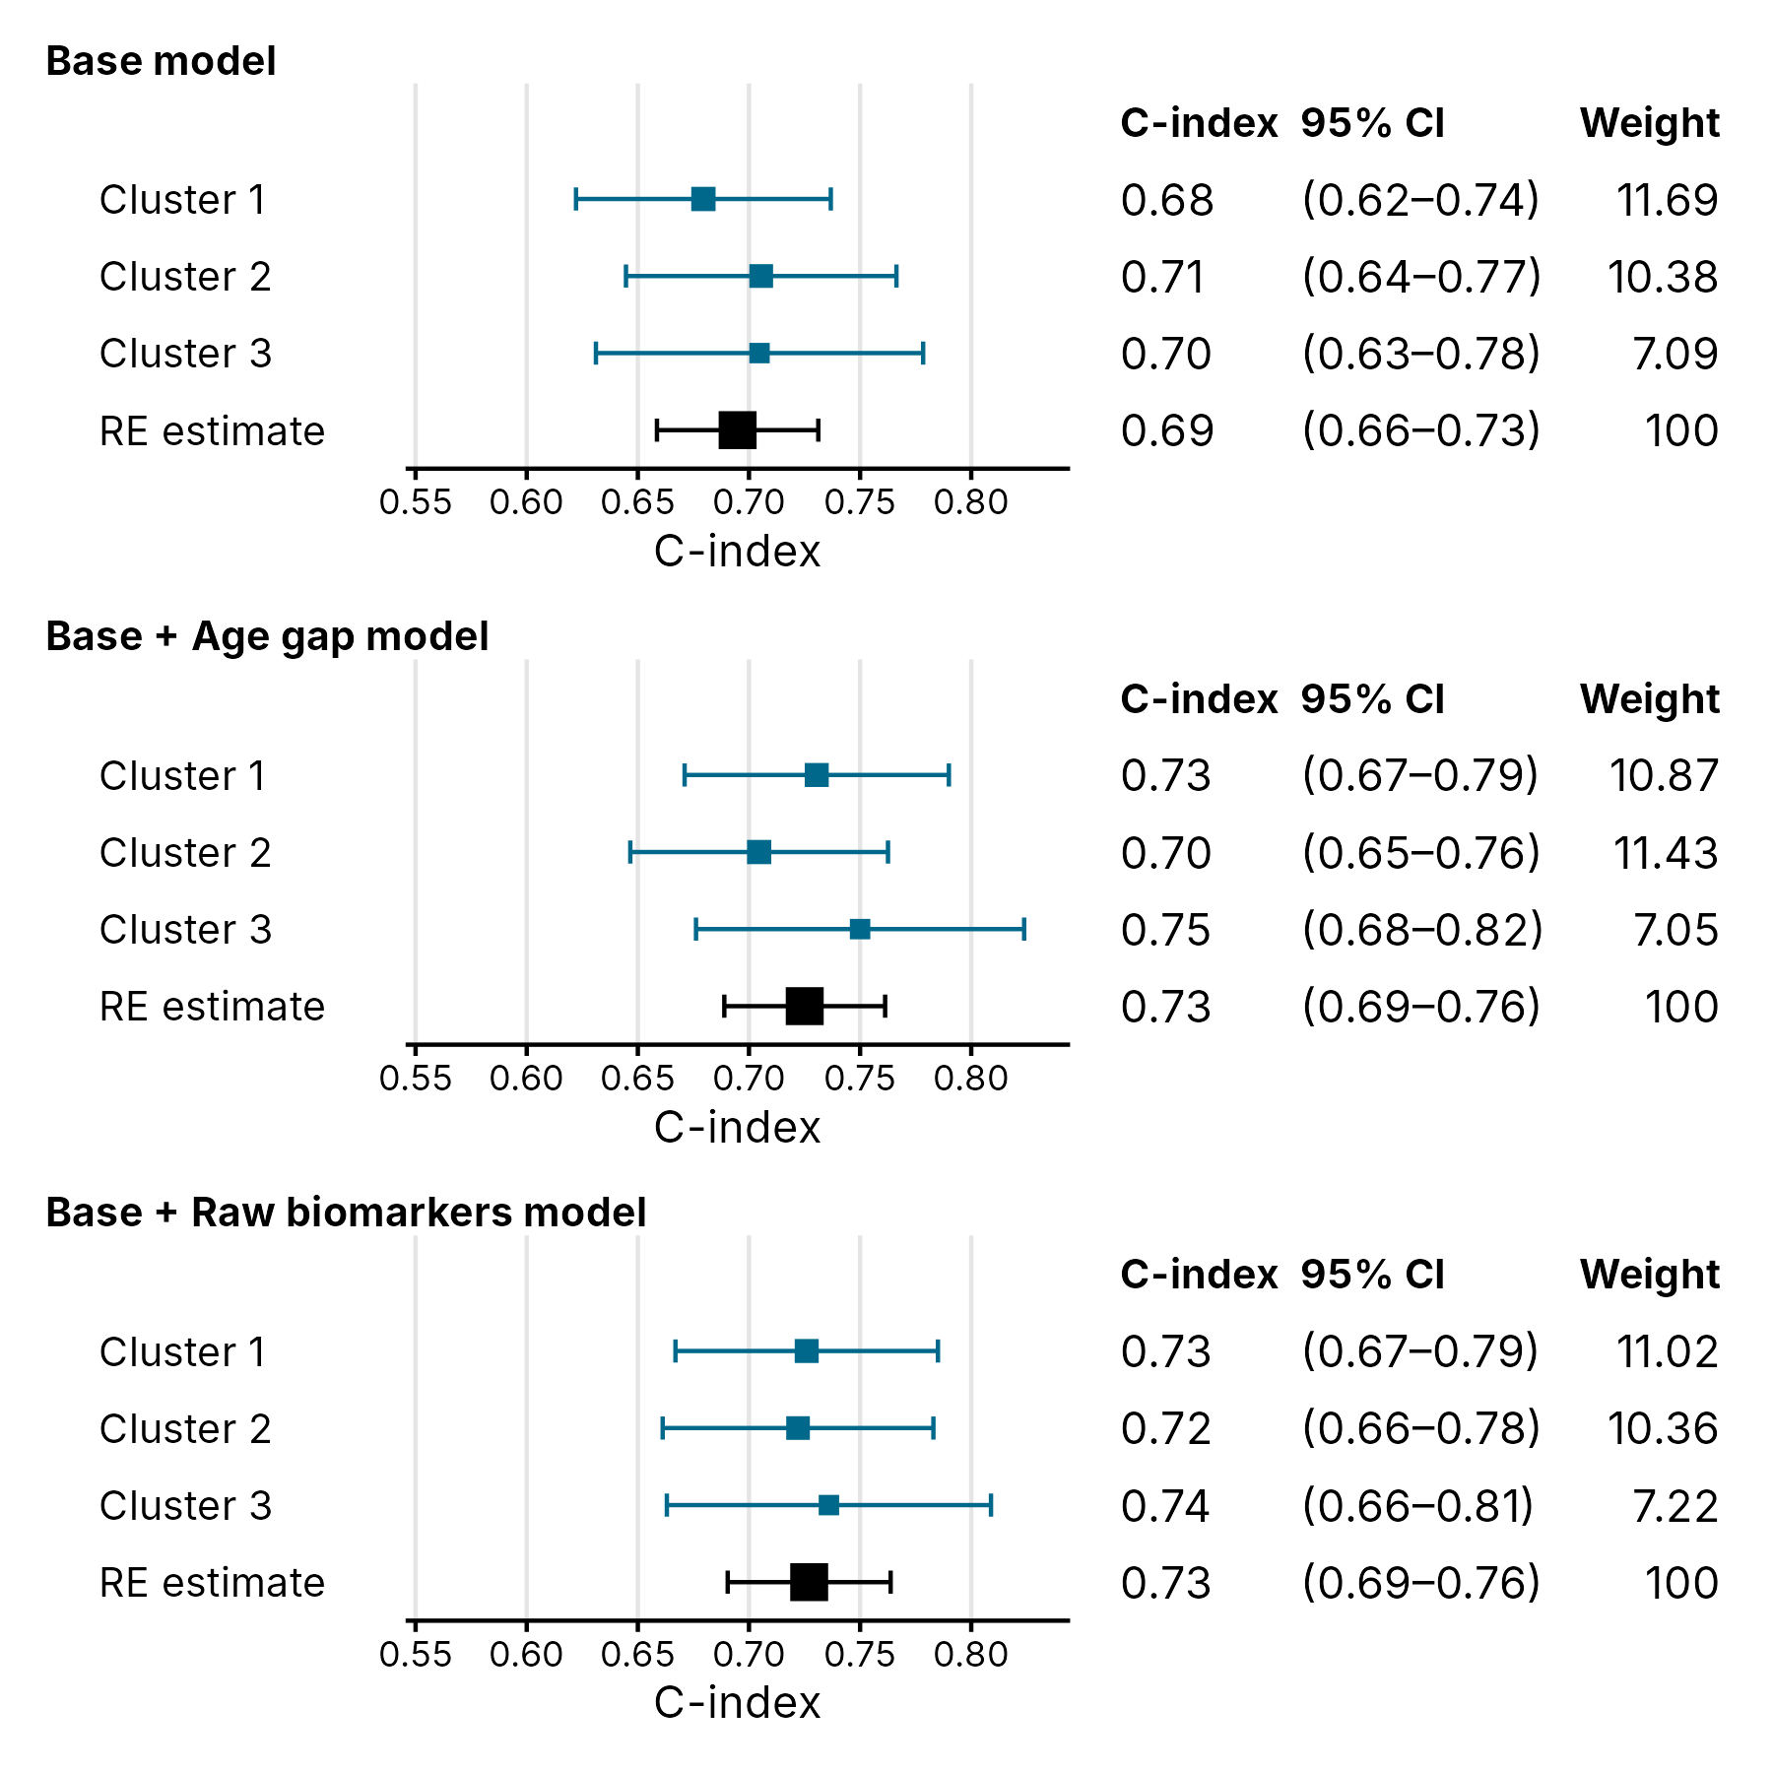

Supplementary Figure 5. Forest plot of competing risks model concordance by IECV clusters and random effects meta-analyzed estimates, complete case sensitivity analysis.
Outcome of non-lung cancer death. IECV: internal-external cross validation; LC: lung cancer; C-index: Concordance index; CI: confidence interval.

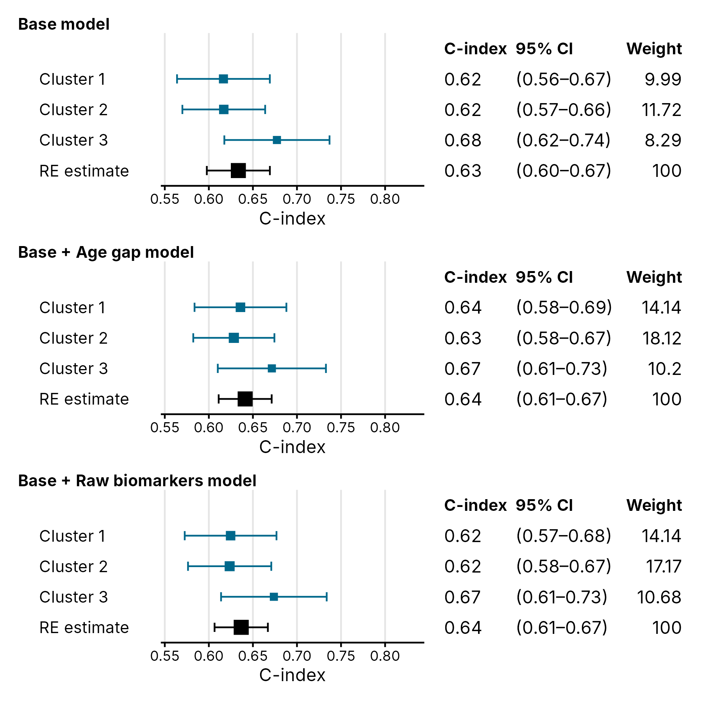
Supplementary Figure 6. Forest plot of competing risks model concordance by IECV clusters and random effects meta-analyzed estimates, complete case sensitivity analysis.
Outcome of lung cancer diagnosis. IECV: internal-external cross validation; LC: lung cancer; C-index: Concordance index; CI: confidence interval.
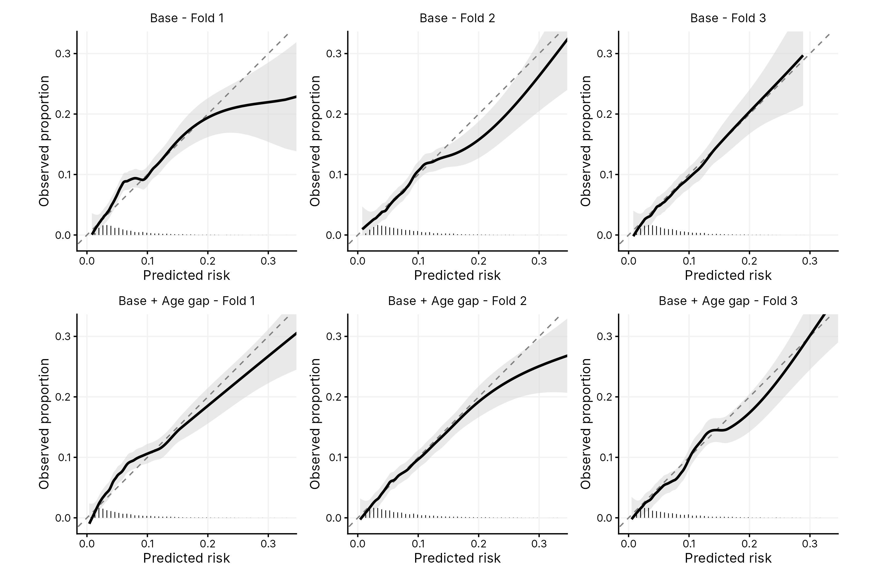
Supplementary Figure 7. Calibration plots for non-lung cancer related death at 5 years across IECV clusters.
Each column shows a different validation cluster; the top row are models with clinical variables only, and the bottom row are models with the addition of the single age gap metric. Fit lines are LOESS-smoothed calibration curves with 95% confidence bands. The diagonal dashed line represents perfect calibration. Histograms show the distribution of predicted risks.

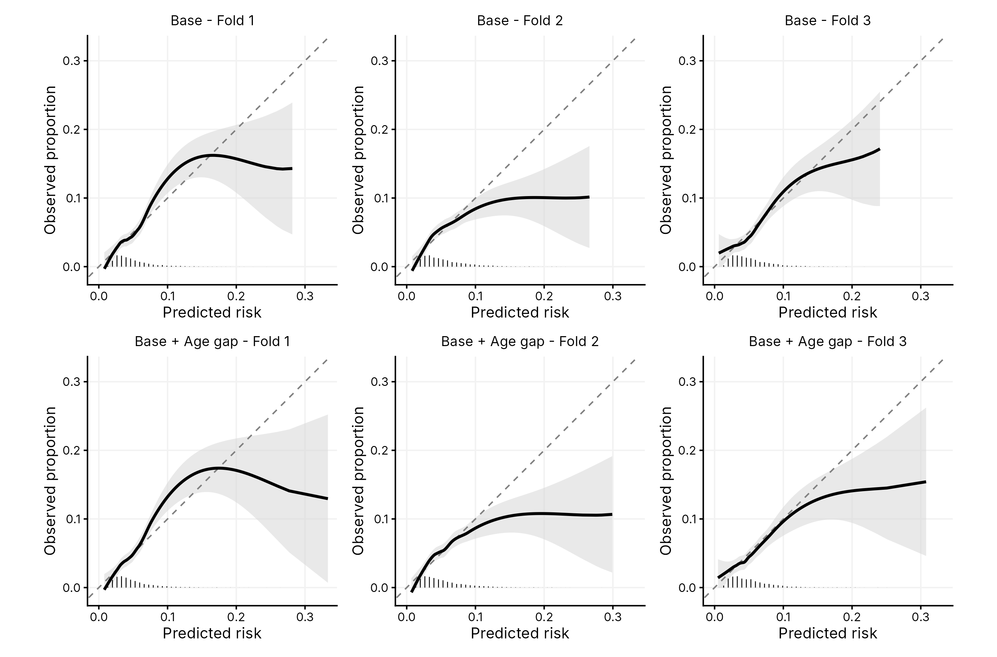
Supplementary Figure 8. Calibration plots for lung cancer diagnosis at 5 years across IECV clusters.
Each column shows a different validation cluster; the top row represent models with clinical variables only, and the bottom row represent models with the addition of the single age gap metric. Fit lines are LOESS-smoothed calibration curves with 95% confidence bands. The diagonal dashed line represents perfect calibration. Histograms show the distribution of predicted risks.

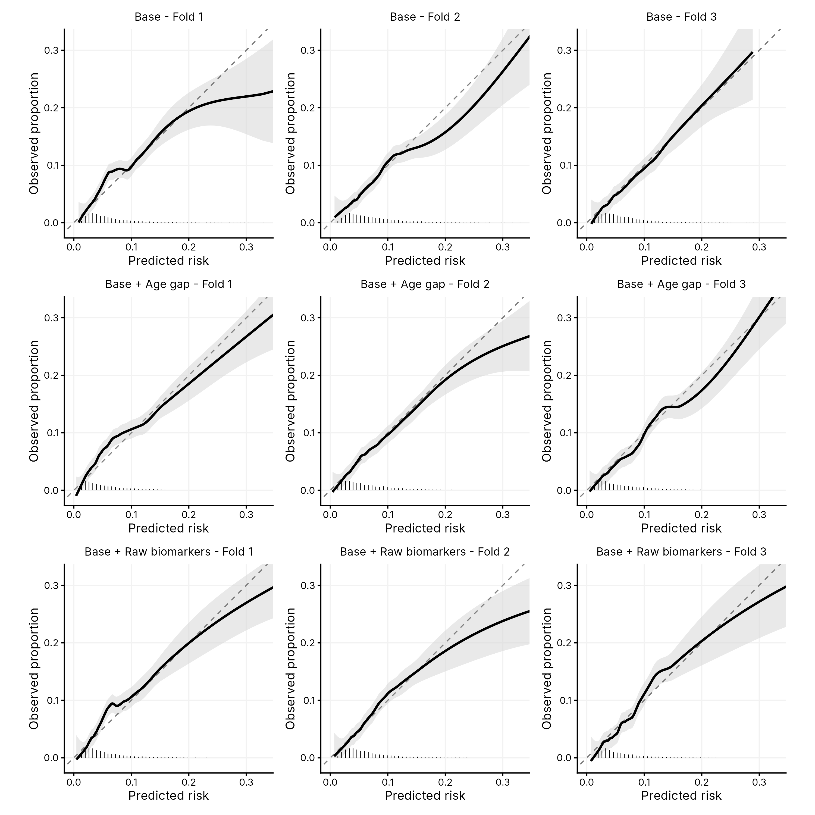
Supplementary Figure 9. Calibration plots for non-lung cancer death at 5 years across IECV clusters, complete case sensitivity analysis.
Each column shows a different validation cluster; each row shows a different model (base clinical variables, base + age gap, base + raw biomarkers). Fit lines are LOESS-smoothed calibration curves with 95% confidence bands. The diagonal dashed line represents perfect calibration. Histograms show the distribution of predicted risks.

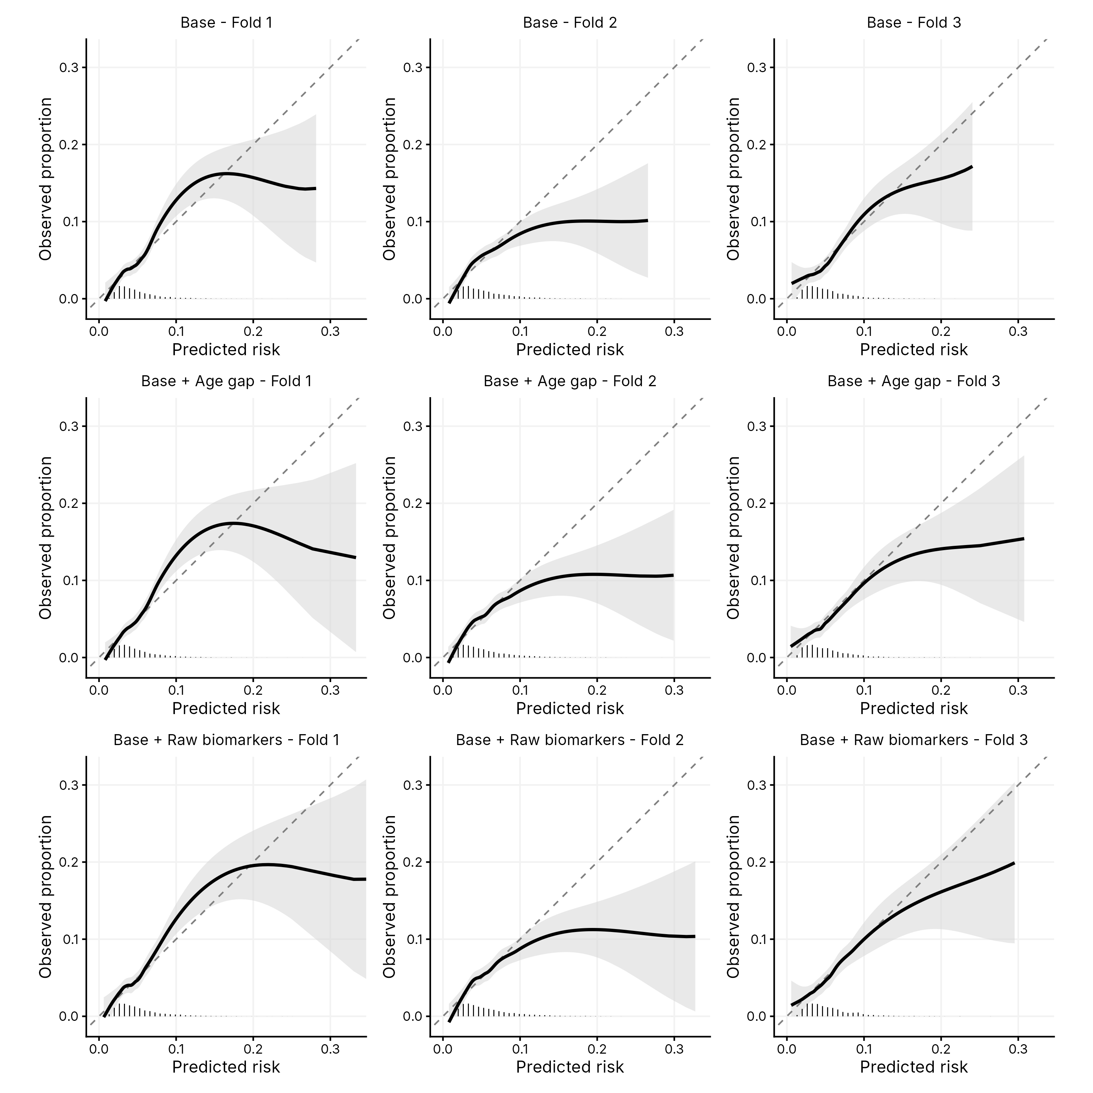
Supplementary Figure 10. Calibration plots for lung cancer diagnosis at 5 years across IECV clusters, complete case sensitivity analysis.
Each column shows a different validation cluster; each row shows a different model (base clinical variables, base + age gap, base + raw biomarkers). Fit lines are LOESS-smoothed calibration curves with 95% confidence bands. The diagonal dashed line represents perfect calibration. Histograms show the distribution of predicted risks.

Comparison with established risk prediction tools
To benchmark age gap against previously published, externally-derived competing-mortality risk tools, we compared model discrimination and calibration for non-lung cancer death against two standalone tools: the PLCO comorbidity index (PLCO-ci)⁷, and a non-lung-cancer-death risk derived from the LYFS-CT model’s own internal competing-risk term⁸, obtained from the National Cancer Institute’s lcrisks reference implementation. Both tools combine age, sex, smoking history and comorbidity diagnoses (hypertension, cardiovascular disease, stroke, COPD, diabetes, and personal cancer history) into a single composite score; comorbidity diagnoses were derived from linked primary care records, and published model coefficients were applied directly, without refitting. Each tool was evaluated as a standalone predictor rather than as an addition to the base clinical variables, since both tools already incorporate age, sex, smoking and comorbidities within their own composite score; combining them additively with the base model would evaluate a largely redundant set of covariates and understate each tool’s genuine standalone performance. The clinical-only (Base) and combined clinical and age gap (Base + Age gap) models are repeated here as reference points, using the same out-of-fold internal-external cross-validation predictions reported throughout.
Both established tools performed comparably to the clinical-only model when used standalone (PLCO-ci: C-index 0.69, 95% CI 0.66–0.71 at 5 years; LYFS-CT: 0.70, 95% CI 0.67–0.73 at 5 years; Supplementary Figure 11), and were reasonably calibrated (Supplementary Table 13 and Supplementary Table 14). The combined clinical and age gap model significantly outperformed both established tools at 5 years (vs. PLCO-ci alone: difference 0.039, 95% CI 0.019–0.085, p<0.001; vs. LYFS-CT alone: difference 0.029, 95% CI 0.019–0.046, p<0.001); the direction of this difference was consistent, but not statistically significant, at 2 years.

 |  | n | Calibration Slope (95% CI) | Intercept (95% CI)
Base | 1 | 4580 | 0.79 (0.62–0.97) | 0.04 (−0.10–0.17)
Base | 2 | 4642 | 0.90 (0.69–1.12) | -0.09 (−0.23–0.04)
Base | 3 | 3078 | 1.05 (0.77–1.33) | -0.05 (−0.21–0.12)
Base | Pooled | 12300 | 0.88 (0.75–1.02) | -0.03 (−0.12–0.05)
Base + Age gap | 1 | 4580 | 0.81 (0.64–0.98) | 0.03 (−0.11–0.17)
Base + Age gap | 2 | 4642 | 0.89 (0.71–1.07) | -0.07 (−0.21–0.06)
Base + Age gap | 3 | 3078 | 1.09 (0.83–1.35) | -0.06 (−0.22–0.11)
Base + Age gap | Pooled | 12300 | 0.90 (0.76–1.04) | -0.03 (−0.11–0.05)
LYFS-CT alone | 1 | 4574 | 0.88 (0.62–1.13) | 0.11 (−0.02–0.25)
LYFS-CT alone | 2 | 4641 | 0.90 (0.66–1.15) | 0.06 (−0.07–0.20)
LYFS-CT alone | 3 | 2978 | 1.15 (0.77–1.53) | -0.04 (−0.20–0.13)
LYFS-CT alone | Pooled | 12193 | 0.94 (0.78–1.10) | 0.06 (−0.02–0.14)
PLCO-ci alone | 1 | 4579 | 0.82 (0.63–1.01) | 0.05 (−0.08–0.18)
PLCO-ci alone | 2 | 4641 | 0.95 (0.74–1.16) | 0.01 (−0.12–0.14)
PLCO-ci alone | 3 | 3077 | 0.65 (0.42–0.88) | -0.16 (−0.33–0.00)
PLCO-ci alone | Pooled | 12297 | 0.81 (0.65–0.97) | -0.02 (−0.14–0.09)
Supplementary Table 13. Calibration slope and intercept for non-LC-related death, comparing established risk tools (PLCO-ci, LYFS-CT) with the Base and Base + Age gap models, in IECV clusters and pooled estimate in random effects meta-analysis, 5-year time horizon.
CI: Confidence Interval; IECV: Internal-external cross validation; PLCO-ci: PLCO comorbidity index; LYFS-CT: non-lung-cancer-death risk derived from the LYFS-CT model.

 |  | n | Calibration Slope (95% CI) | Intercept (95% CI)
Base | 1 | 4580 | 0.85 (0.49–1.22) | 0.12 (−0.13–0.37)
Base | 2 | 4642 | 0.87 (0.45–1.28) | -0.20 (−0.45–0.05)
Base | 3 | 3078 | 1.62 (0.76–2.47) | 0.06 (−0.25–0.37)
Base | Pooled | 12300 | 0.93 (0.67–1.19) | -0.01 (−0.22–0.19)
Base + Age gap | 1 | 4580 | 0.86 (0.53–1.18) | 0.12 (−0.13–0.38)
Base + Age gap | 2 | 4642 | 0.74 (0.40–1.08) | -0.25 (−0.51–0.00)
Base + Age gap | 3 | 3078 | 1.44 (0.74–2.15) | 0.04 (−0.28–0.35)
Base + Age gap | Pooled | 12300 | 0.86 (0.64–1.09) | -0.03 (−0.27–0.20)
LYFS-CT alone | 1 | 4574 | 0.56 (0.17–0.95) | 0.05 (−0.23–0.33)
LYFS-CT alone | 2 | 4641 | 0.63 (0.27–1.00) | -0.18 (−0.47–0.12)
LYFS-CT alone | 3 | 2978 | 0.79 (0.11–1.46) | -0.08 (−0.49–0.33)
LYFS-CT alone | Pooled | 12193 | 0.62 (0.38–0.87) | -0.06 (−0.24–0.12)
PLCO-ci alone | 1 | 4579 | 0.90 (0.55–1.25) | 0.16 (−0.08–0.39)
PLCO-ci alone | 2 | 4641 | 0.97 (0.54–1.40) | -0.10 (−0.34–0.14)
PLCO-ci alone | 3 | 3077 | 0.54 (0.19–0.89) | -0.23 (−0.53–0.07)
PLCO-ci alone | Pooled | 12297 | 0.79 (0.52–1.06) | -0.04 (−0.26–0.18)
Supplementary Table 14. Calibration slope and intercept for non-LC-related death, comparing established risk tools (PLCO-ci, LYFS-CT) with the Base and Base + Age gap models, in IECV clusters and pooled estimate in random effects meta-analysis, 2-year time horizon.
CI: Confidence Interval; IECV: Internal-external cross validation; PLCO-ci: PLCO comorbidity index; LYFS-CT: non-lung-cancer-death risk derived from the LYFS-CT model.
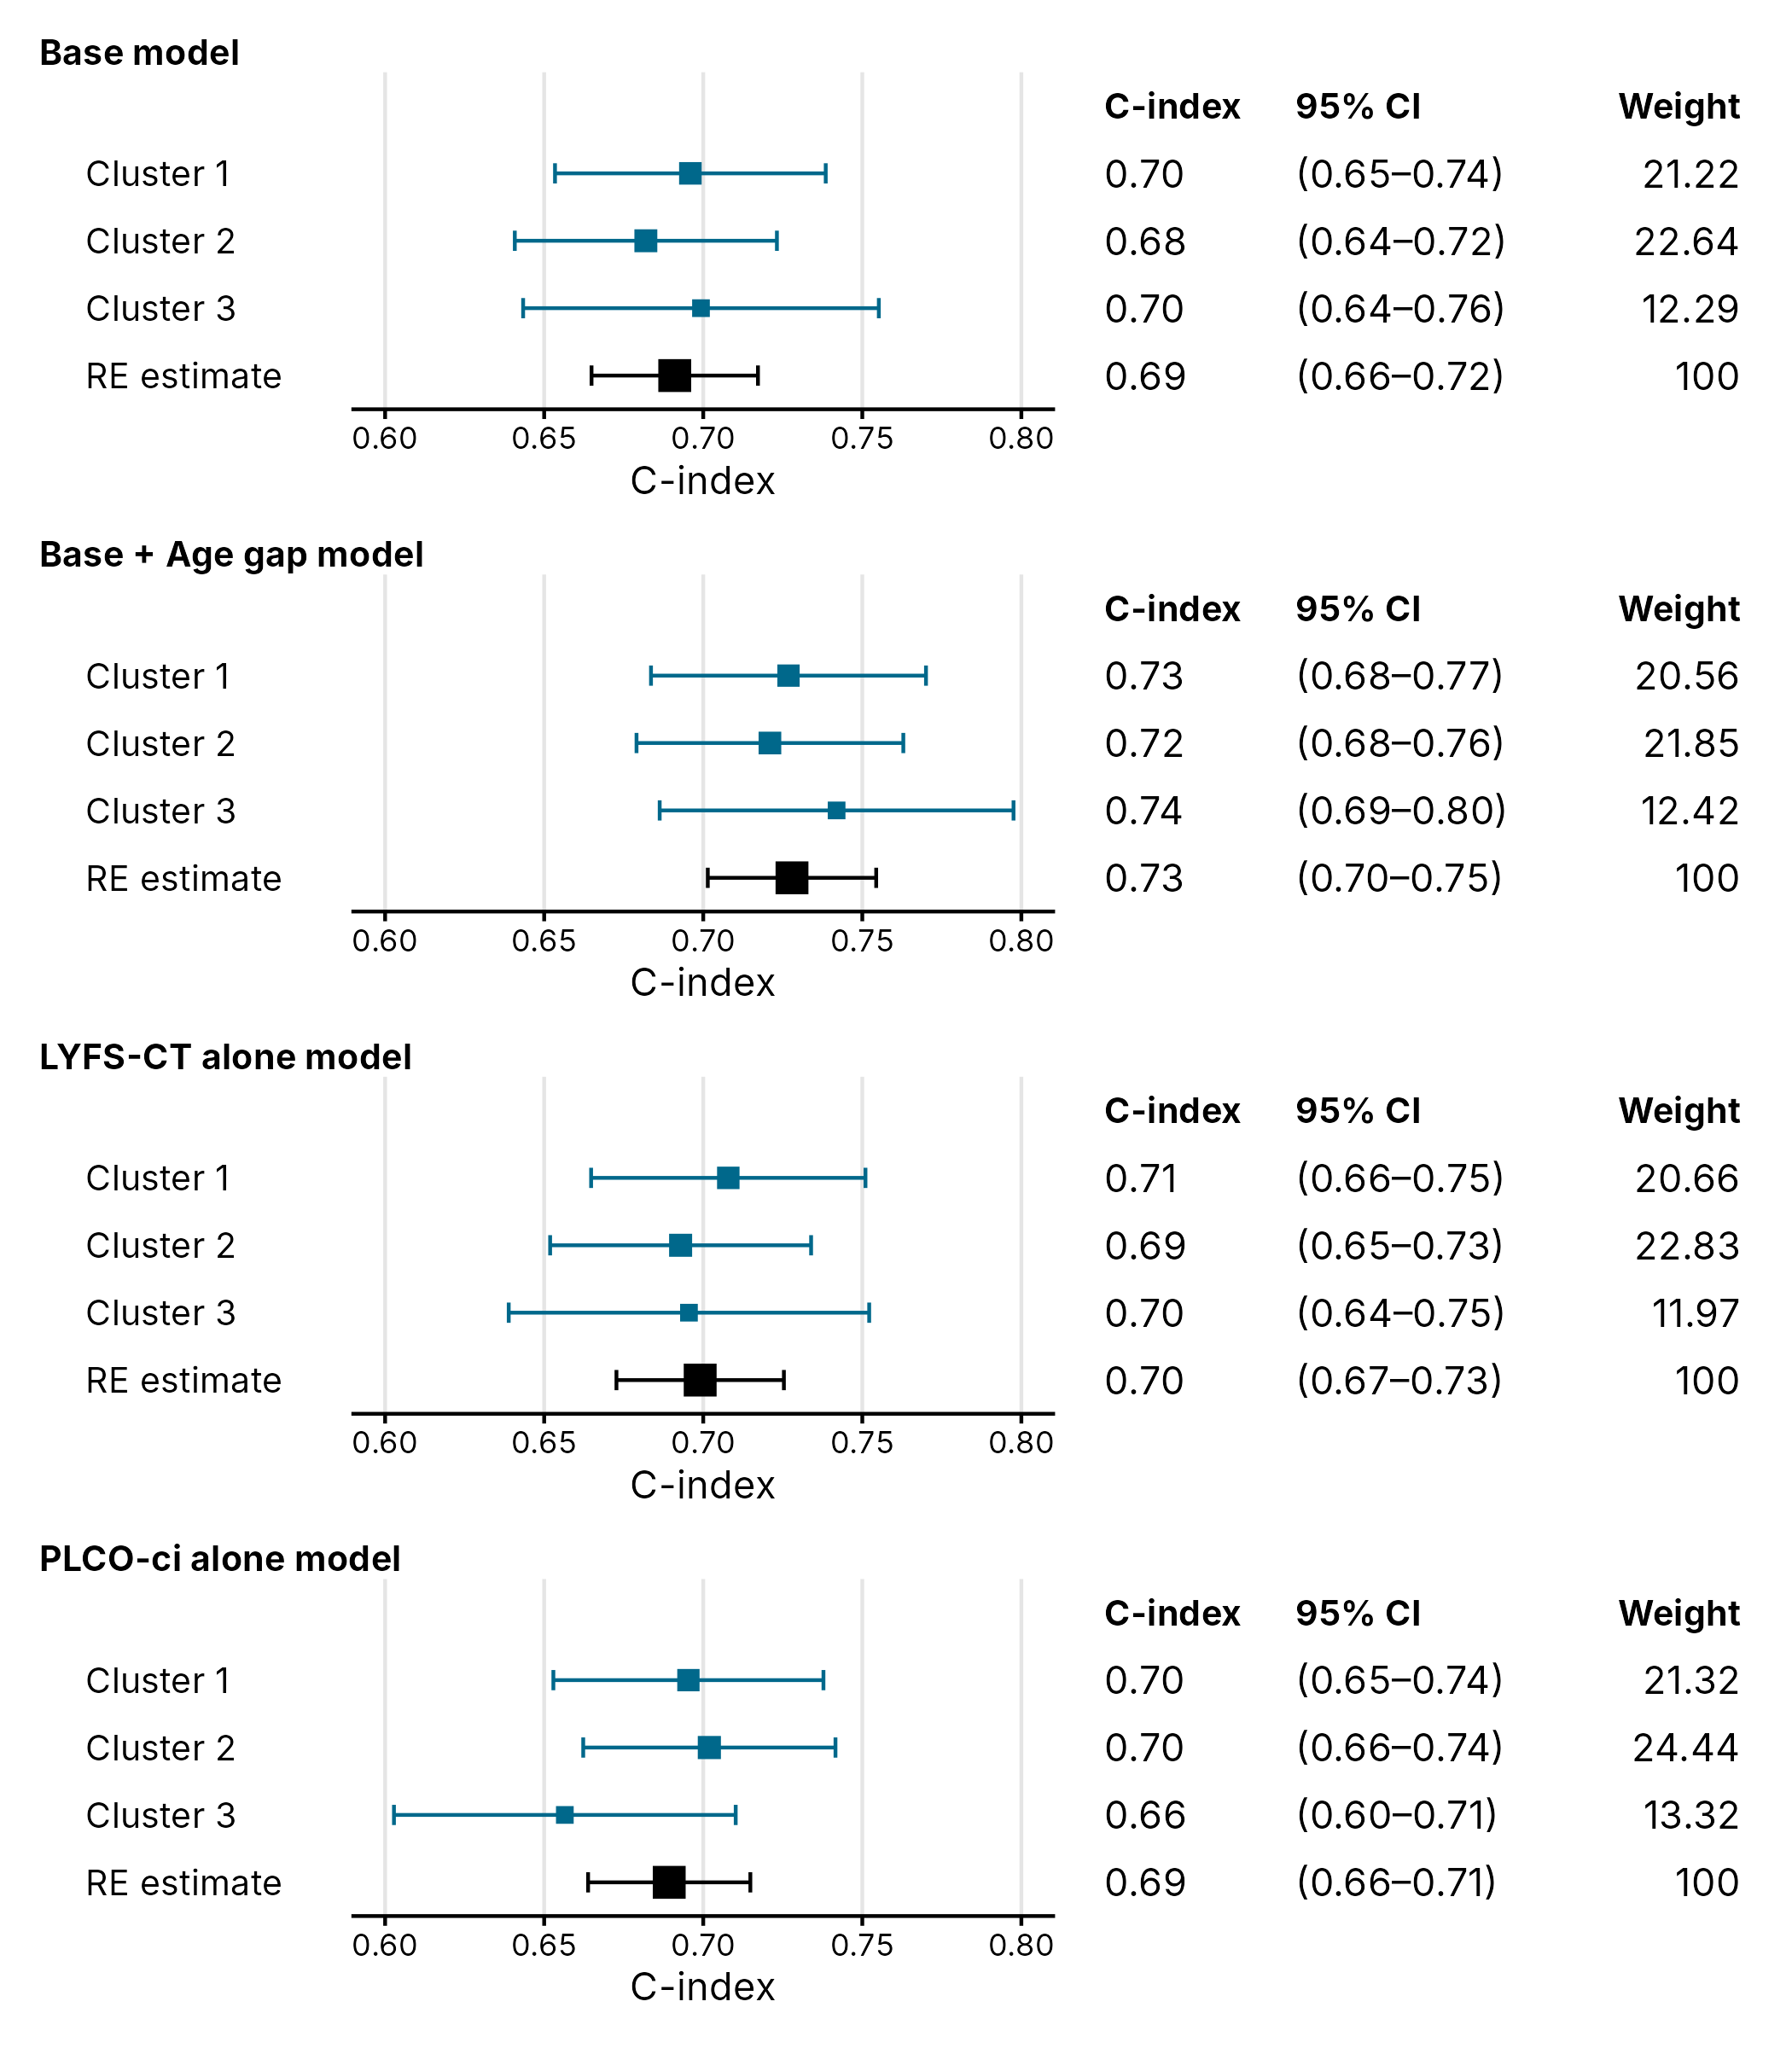
Supplementary Figure 11. Forest plot of competing risks model concordance for non-lung cancer death at 5 years, comparing established risk tools (PLCO-ci, LYFS-CT) with the Base and Base + Age gap models, by IECV clusters and random effects meta-analyzed estimates.
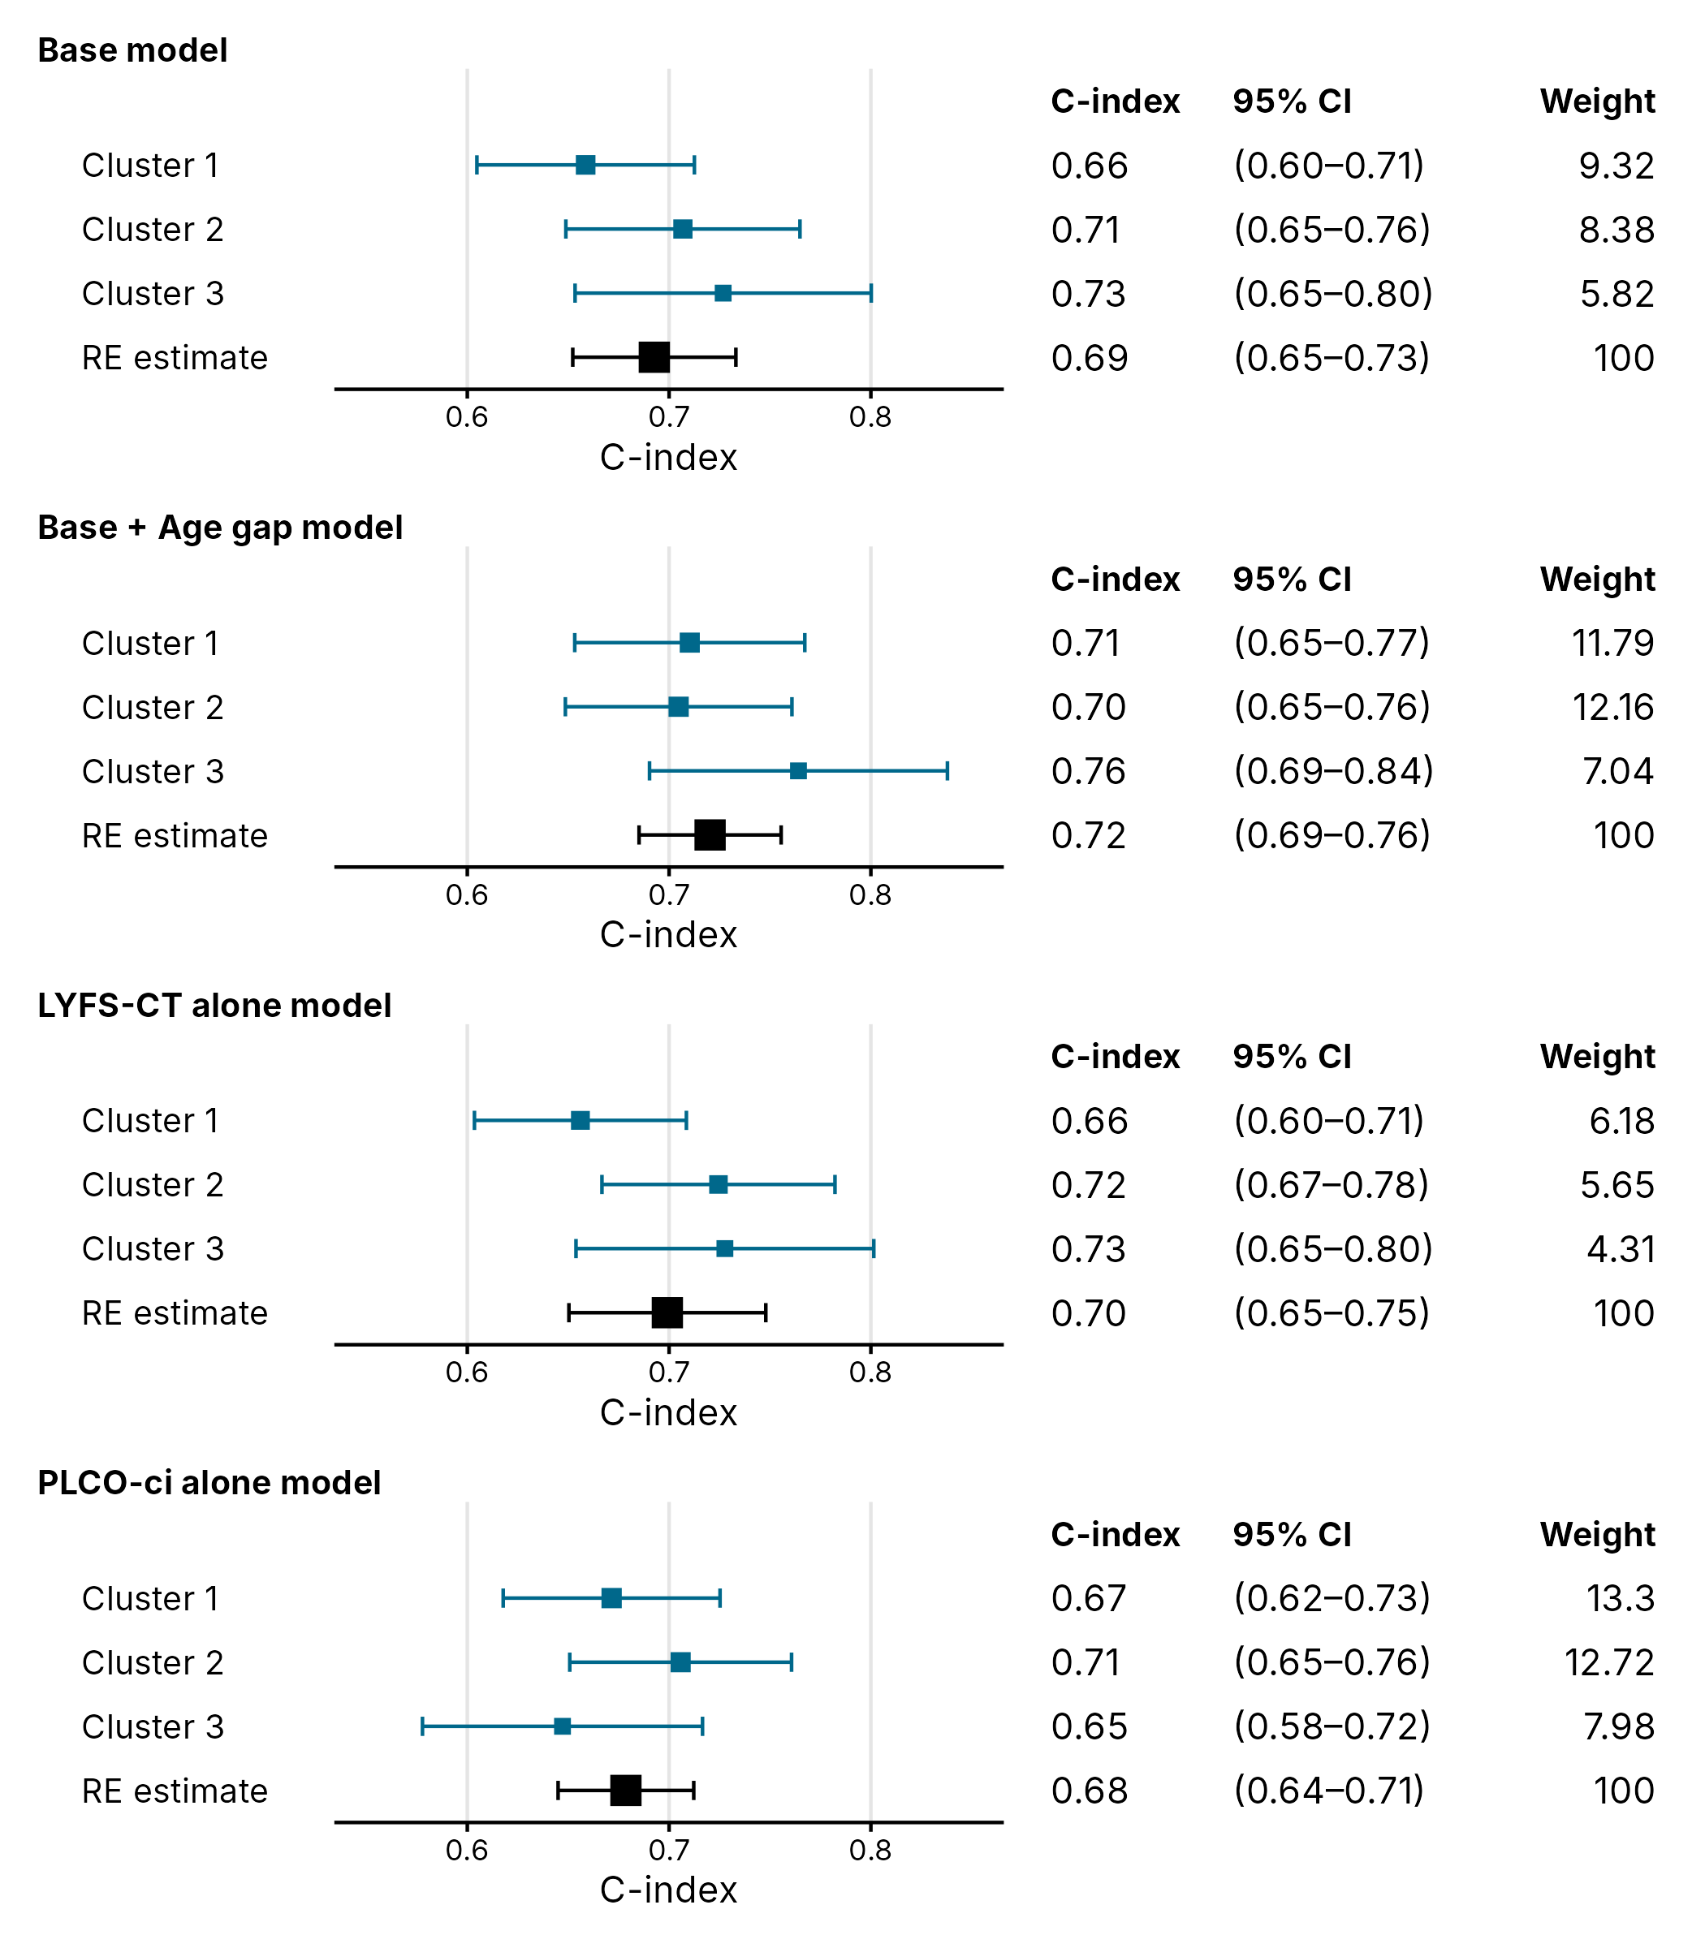
Supplementary Figure 12. Forest plot of competing risks model concordance for non-lung cancer death at 2 years, comparing established risk tools (PLCO-ci, LYFS-CT) with the Base and Base + Age gap models, by IECV clusters and random effects meta-analyzed estimates.

Subgroup analysis by ethnicity and socioeconomic deprivation
To assess whether the combined clinical and age gap model performs differently for participants from more deprived backgrounds or from minority ethnic groups, discrimination and calibration for non-lung cancer death at 5 years were re-assessed within subgroups defined by socioeconomic deprivation (IMD quintile) and by ethnicity. Out-of-fold predicted risks from the internal-external cross-validation (IECV) framework used throughout the main analysis were used directly, rather than re-fitting the model separately within each subgroup, so that every participant’s risk estimate still came from a model that had not been trained on them, while avoiding unstable model fits in smaller subgroups. Ethnicity was collapsed to a binary White/non-white grouping, since the individual ethnicity categories recorded (each 2.2-7.3% of the cohort) were considered too small to support a reliable stratified analysis on their own. Within each subgroup, discrimination was assessed by time-dependent C-index at 5 years, and calibration by the ratio of the observed 5-year cumulative incidence (Aalen-Johansen estimator) to the mean model-predicted risk (observed:expected ratio, O:E); an O:E ratio above 1 indicates the model under-predicted risk for that subgroup, and a ratio below 1 indicates over-prediction.

IMD quintile | N | Events (5yr) | Observed CIF, % | Mean predicted risk, % | O:E | C-index
1 (most deprived) | 3913 | 277 | 7.4 | 6.4 | 1.16 | 0.66
2 | 3648 | 232 | 6.7 | 6.5 | 1.02 | 0.63
3 | 2163 | 126 | 6.2 | 6.9 | 0.90 | 0.61
4 | 1828 | 92 | 5.2 | 6.5 | 0.80 | 0.65
5 (least deprived) | 617 | 32 | 5.4 | 6.2 | 0.88 | 0.70

Supplementary Table 15. Discrimination and calibration of the combined clinical and age gap model for non-lung cancer death at 5 years, by IMD quintile.
IMD: Index of Multiple Deprivation; CIF: cumulative incidence function. Observed:Expected, O:E ratio >1 indicates the model under-predicted risk for that subgroup; <1 indicates over-prediction. Predictions are out-of-fold estimates from the internal-external cross-validation used throughout the main analysis.

Ethnicity | N | Events (5yr) | Observed CIF, % | Mean predicted risk, % | O:E | C-index
Non-white | 1895 | 109 | 5.9 | 5.2 | 1.13 | 0.65
White | 10405 | 654 | 6.6 | 6.7 | 0.98 | 0.63

Supplementary Table 16. Discrimination and calibration of the combined clinical and age gap model for non-lung cancer death at 5 years, by ethnicity (White vs. non-white).
CIF: cumulative incidence function. O:E ratio >1 indicates the model under-predicted risk for that subgroup; <1 indicates over-prediction. Predictions are out-of-fold estimates from the internal-external cross-validation used throughout the main analysis.

Discrimination did not differ materially by deprivation (C-index 0.61-0.70 across IMD quintiles) or by ethnicity (C-index 0.65 for non-white participants vs. 0.63 for White participants); subgroup sample sizes are smaller than the full-cohort analysis, particularly for IMD quintile 5 (N=617, 32 events) and for the non-white group (N=1,895, 109 events), so these estimates should be interpreted with appropriately wide confidence intervals in mind. Calibration showed a gradient across IMD quintiles, with the model under-predicting risk for the most deprived quintile (O:E 1.16) and over-predicting for less deprived quintiles (O:E 0.80-0.90); a similar pattern of under-prediction was seen for non-white participants (O:E 1.13) relative to White participants (O:E 0.98). In both cases the direction of miscalibration is that the model somewhat underestimates rather than overestimates competing-mortality risk for more deprived and non-white participants, which does not support a mechanism by which the fitted, calibrated model would inflate risk estimates and disproportionately recommend reduced screening intensity for these groups specifically. This finding does not, however, remove the separate observation that age gap itself, as a raw predictor independent of the fitted model, remains associated with greater deprivation and lower educational attainment in this cohort (Supplementary Table 6); any future clinical application of age gap for screening triage should be accompanied by ongoing monitoring for differential impact by deprivation and ethnicity.

Decision curve analysis
To assess the clinical utility of adding age gap to clinical risk factors, decision curve analysis (DCA) was performed for both competing risk endpoints (non-lung cancer death and lung cancer diagnosis) at 5 and 2 years, comparing the clinical-only (“Base”) model against the combined clinical and age gap (“Base + Age gap”) model. As for the discrimination and calibration analyses above, out-of-fold predicted risks from the internal-external cross-validation were used, so that net benefit is assessed on risk estimates from a model that had not been trained on the individual being scored, consistent with the rest of the analysis. Threshold probabilities from 0-20% were evaluated, spanning a range of plausible thresholds for a screening-continuation decision. Net benefit was calculated using the dcurves R package; for the time-to-event setting used here, this treats the competing event (e.g. lung cancer diagnosis, when non-lung cancer death is the outcome of interest) in the same way as administrative censoring when estimating the observed side of net benefit, since no competing-risks-native net benefit implementation is available in the package used. The predicted risks themselves are unaffected by this and are correctly based on the cause-specific cumulative incidence function; only the observed-outcome weighting used internally to translate this into net benefit carries this simplification, with a modest expected tendency to overestimate net benefit when the competing event’s incidence is non-trivial relative to the event of interest.
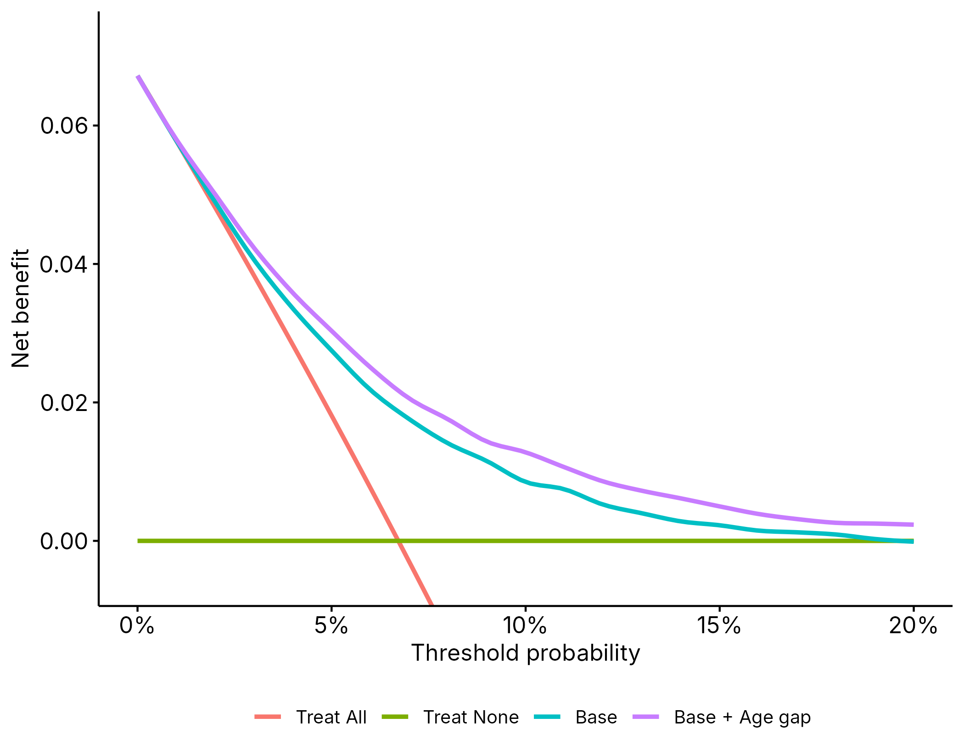
Supplementary Figure 13. Decision curve analysis for non-lung cancer death at 5 years.
Comparing the clinical-only (Base) and combined clinical and age gap (Base + Age gap) models, alongside the ‘treat all’ and ‘treat none’ reference strategies.
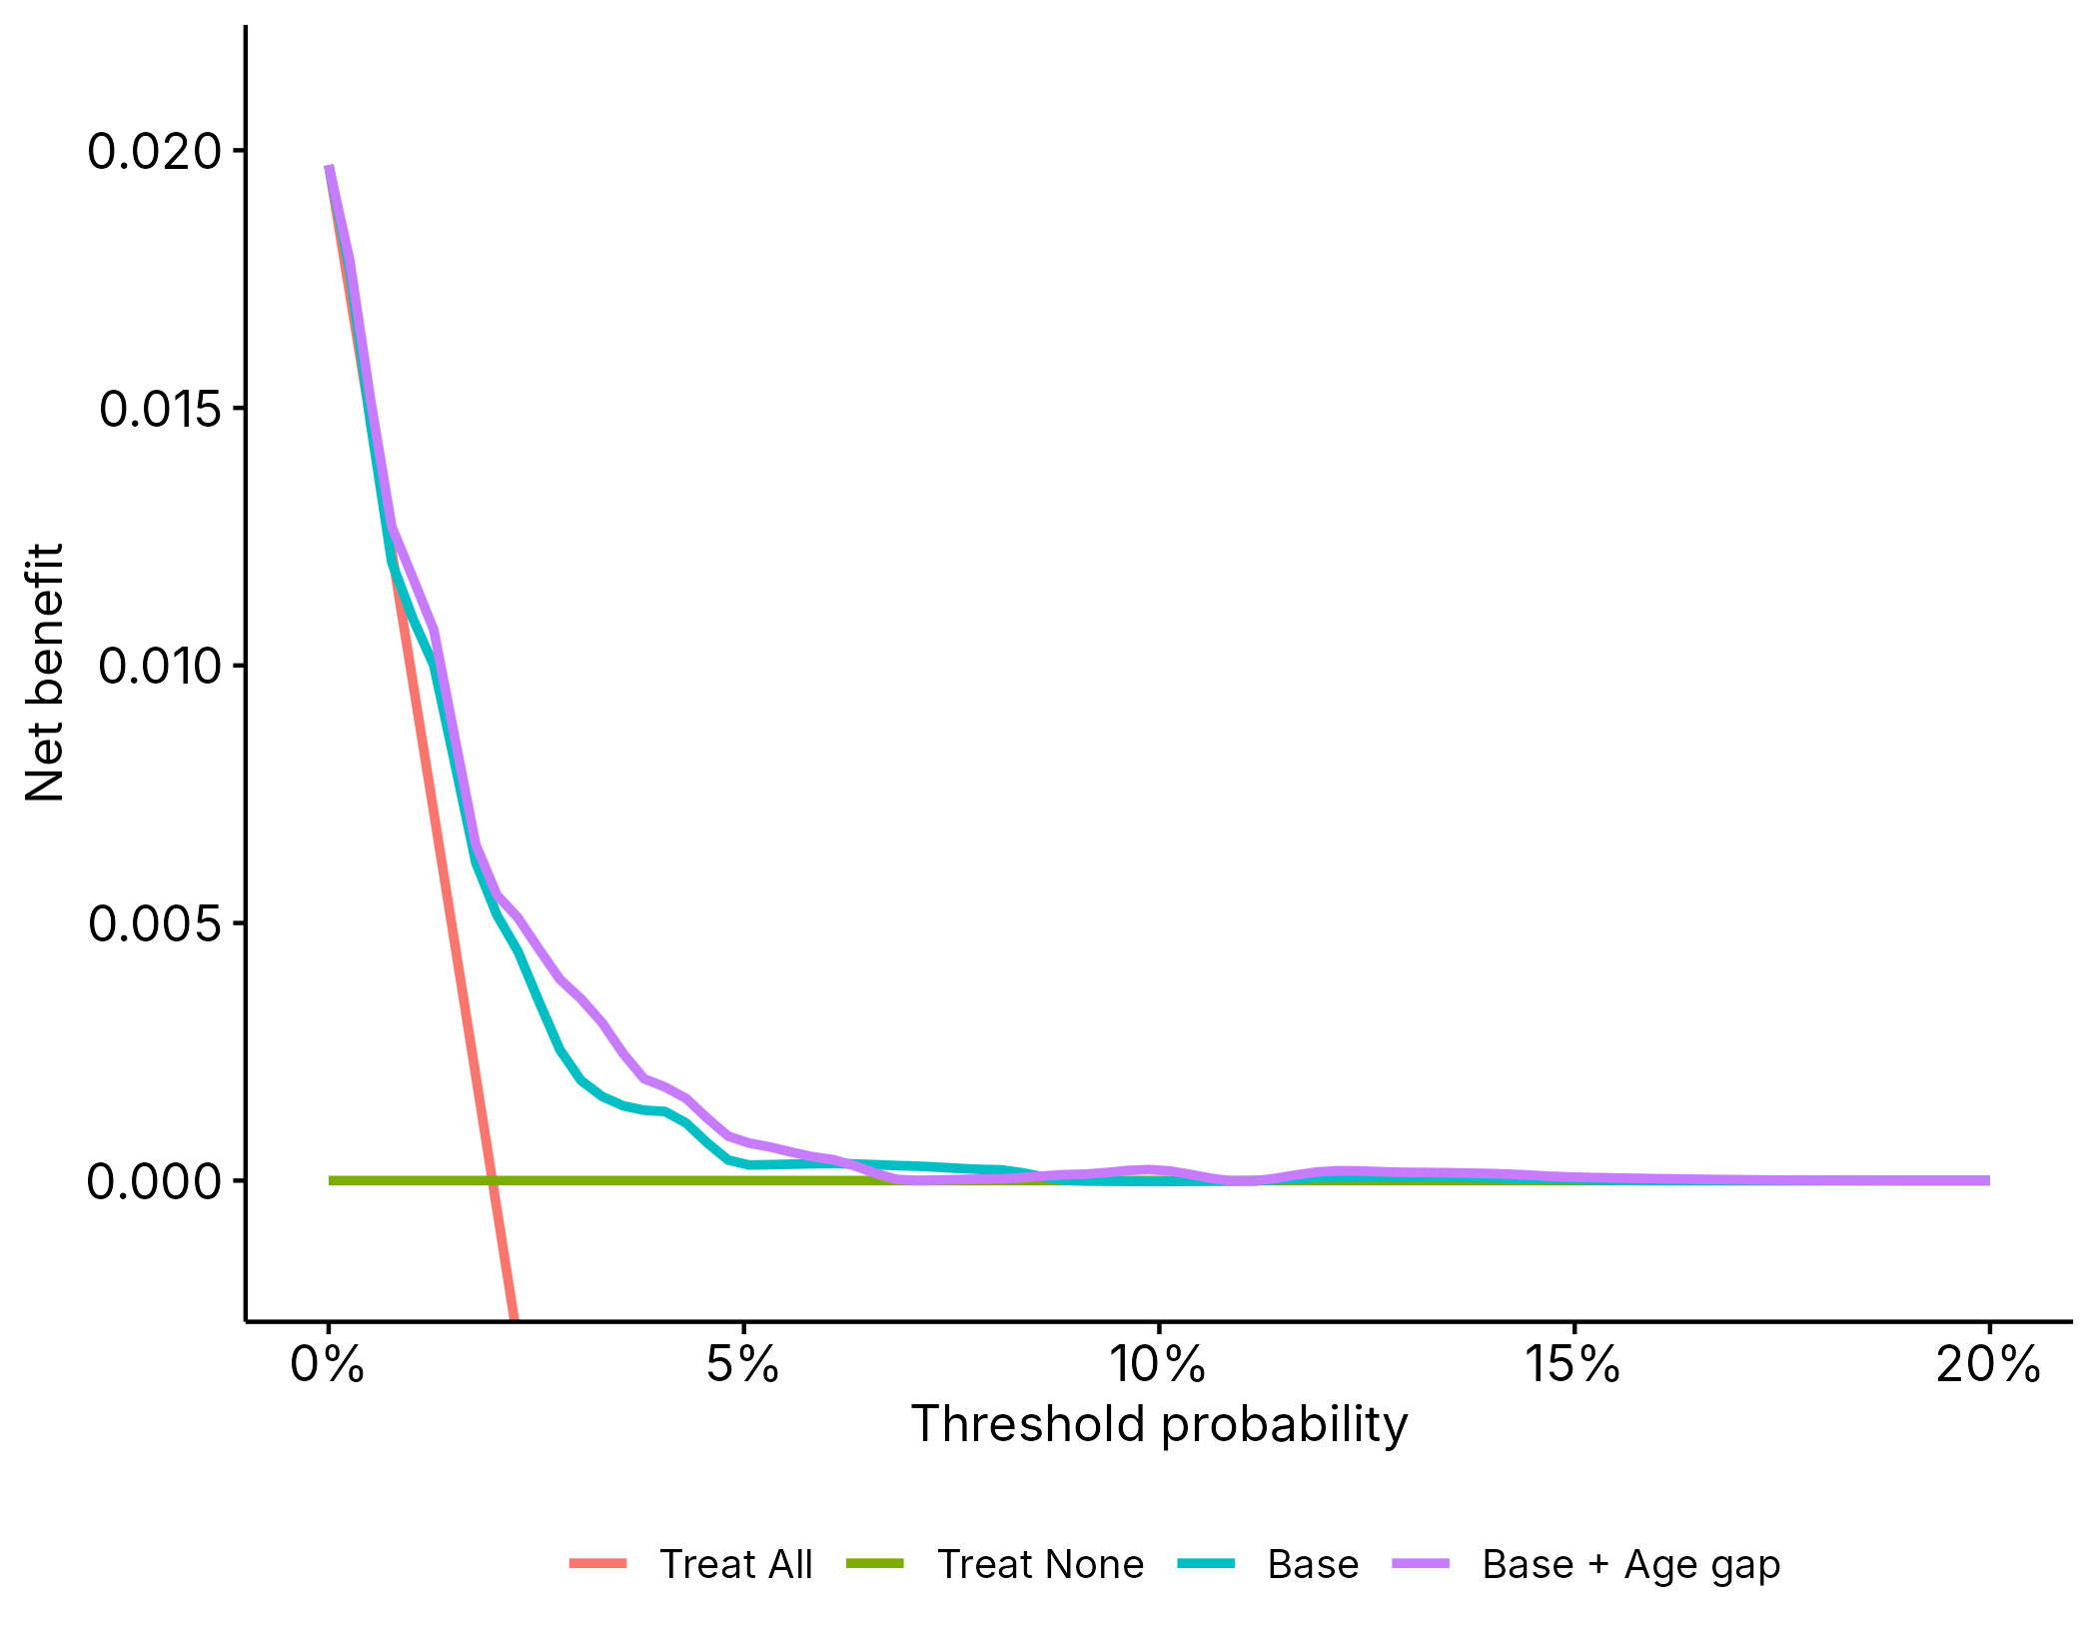
Supplementary Figure 14. Decision curve analysis for non-lung cancer death at 2 years.
For non-lung cancer death at 5 years, the combined model showed higher net benefit than the clinical-only model across the full range of threshold probabilities evaluated (1-20%; difference in net benefit +0.0002 to +0.004, equivalent to approximately 2-4 additional net true positives identified per 1,000 people screened at each threshold, at no additional false-positive cost). Both models exceeded the “treat all” strategy from a threshold of approximately 2%, and the “treat none” strategy up to approximately 19%, a wide range encompassing plausible thresholds for a screening-continuation decision. At 2 years, the advantage of the combined model was smaller and crossed zero at several thresholds, consistent with the smaller and non-significant discrimination gain observed at this shorter horizon (Supplementary Table [X-1]).
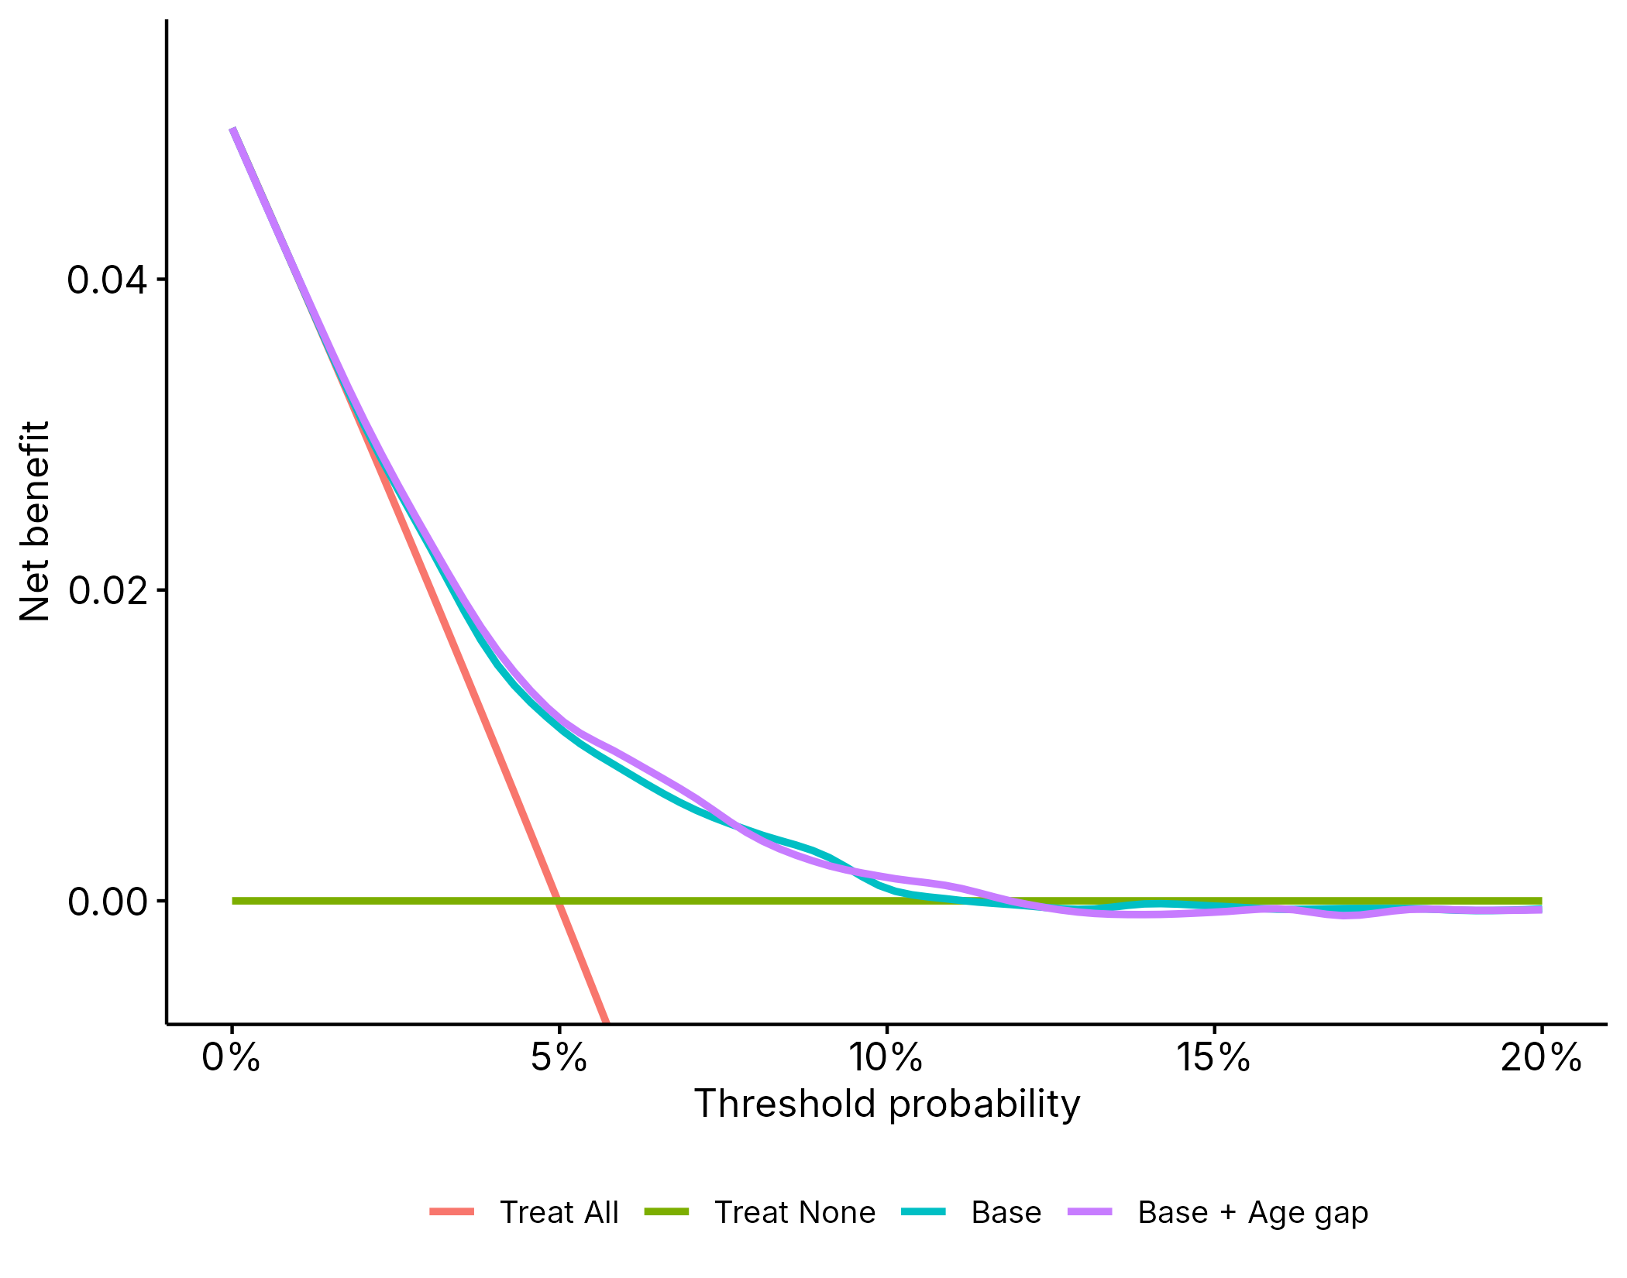
Supplementary Figure 15. Decision curve analysis for lung cancer diagnosis at 5 years.
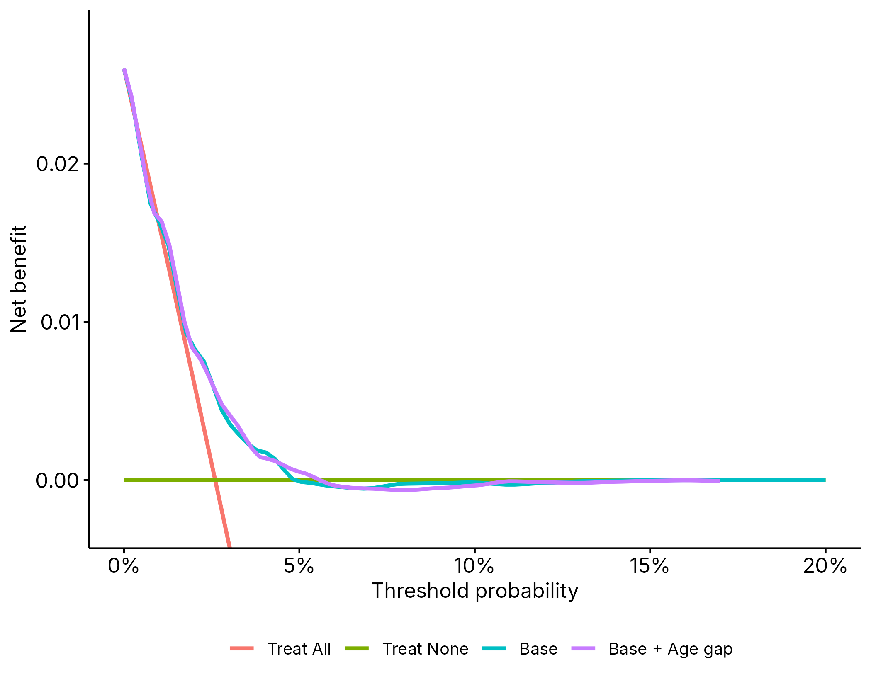
Supplementary Figure 16. Decision curve analysis for lung cancer diagnosis at 2 years.
For lung cancer diagnosis, a similar, smaller pattern was seen at 5 years (the combined model ahead of the clinical-only model by up to +0.0007 across thresholds of 1-10%, converging toward no difference above approximately 10%). At 2 years, differences between the two models were small and inconsistent in direction, consistent with the limited number of lung cancer diagnosis events available within this shorter follow-up window.

Comparison with aortic calcification
To test whether disease course mapping provides added value over the single most directly comparable, already-established imaging biomarker, rather than only over the four raw biomarkers combined, we additionally compared discrimination for non-lung cancer death when the base clinical model was combined with aortic calcification alone. Discrimination for the Base, Base + Aortic calcification, and Base + Age gap models was assessed for non-lung cancer death at 5- and 2-year horizons using the same out-of-fold internal-external cross-validation predictions.
Aortic calcification alone significantly improved discrimination for non-lung cancer death over the clinical-only model (5-year C-index difference +0.020, 95% CI 0.015–0.027, p<0.001; Supplementary Table 17). However, the combined clinical and age gap model significantly outperformed the model using aortic calcification alone at 5 years (C-index 0.730, 95% CI 0.703–0.757, vs. 0.711, 95% CI 0.684–0.739; difference 0.019, 95% CI 0.012–0.025, p<0.001; Supplementary Figure 17). The direction of this difference was consistent at 2 years (difference 0.010, 95% CI −0.001–0.021, p=0.054; Supplementary Figure 18).

 | 5-year C-index (95% CI) | 2-year C-index (95% CI)
Base | 0.69 (0.66–0.72) | 0.69 (0.66–0.73)
Base + Aortic calcification | 0.71 (0.68–0.74) | 0.71 (0.67–0.75)
Base + Age gap | 0.73 (0.70–0.76) | 0.72 (0.68–0.76)
Supplementary Table 17. Discrimination (C-index) for non-lung cancer death for the Base, Base + Aortic calcification, and Base + Age gap models, pooled estimate in random effects meta-analysis, 5- and 2-year time horizons.
CI: Confidence Interval.

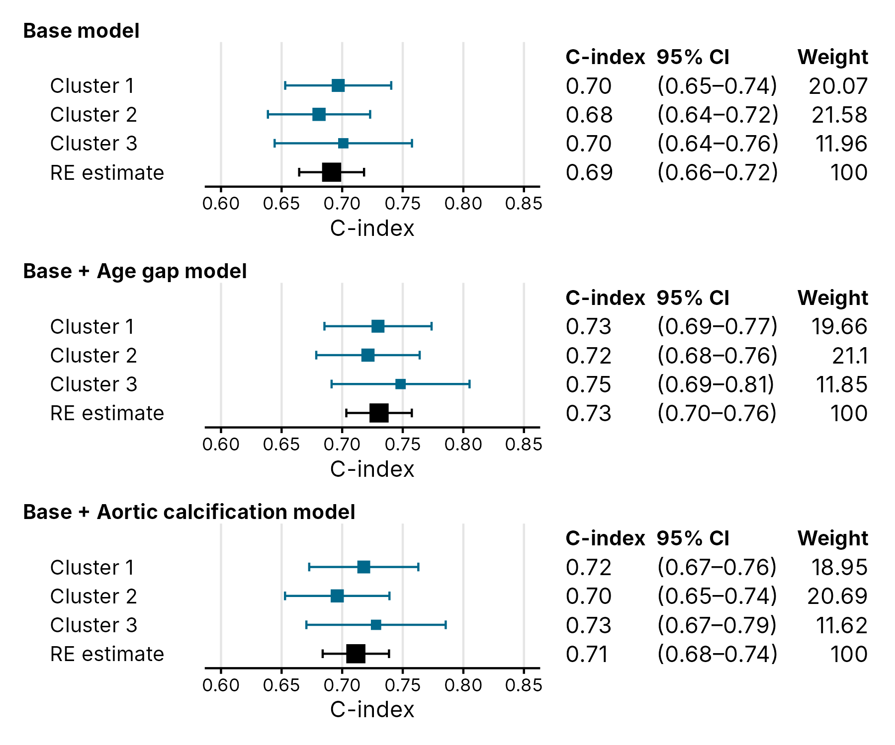
Supplementary Figure 17. Forest plot of competing risks model concordance for non-lung cancer death at 5 years, comparing aortic calcification alone with the Base and Base + Age gap models, by IECV clusters and random effects meta-analyzed estimates.

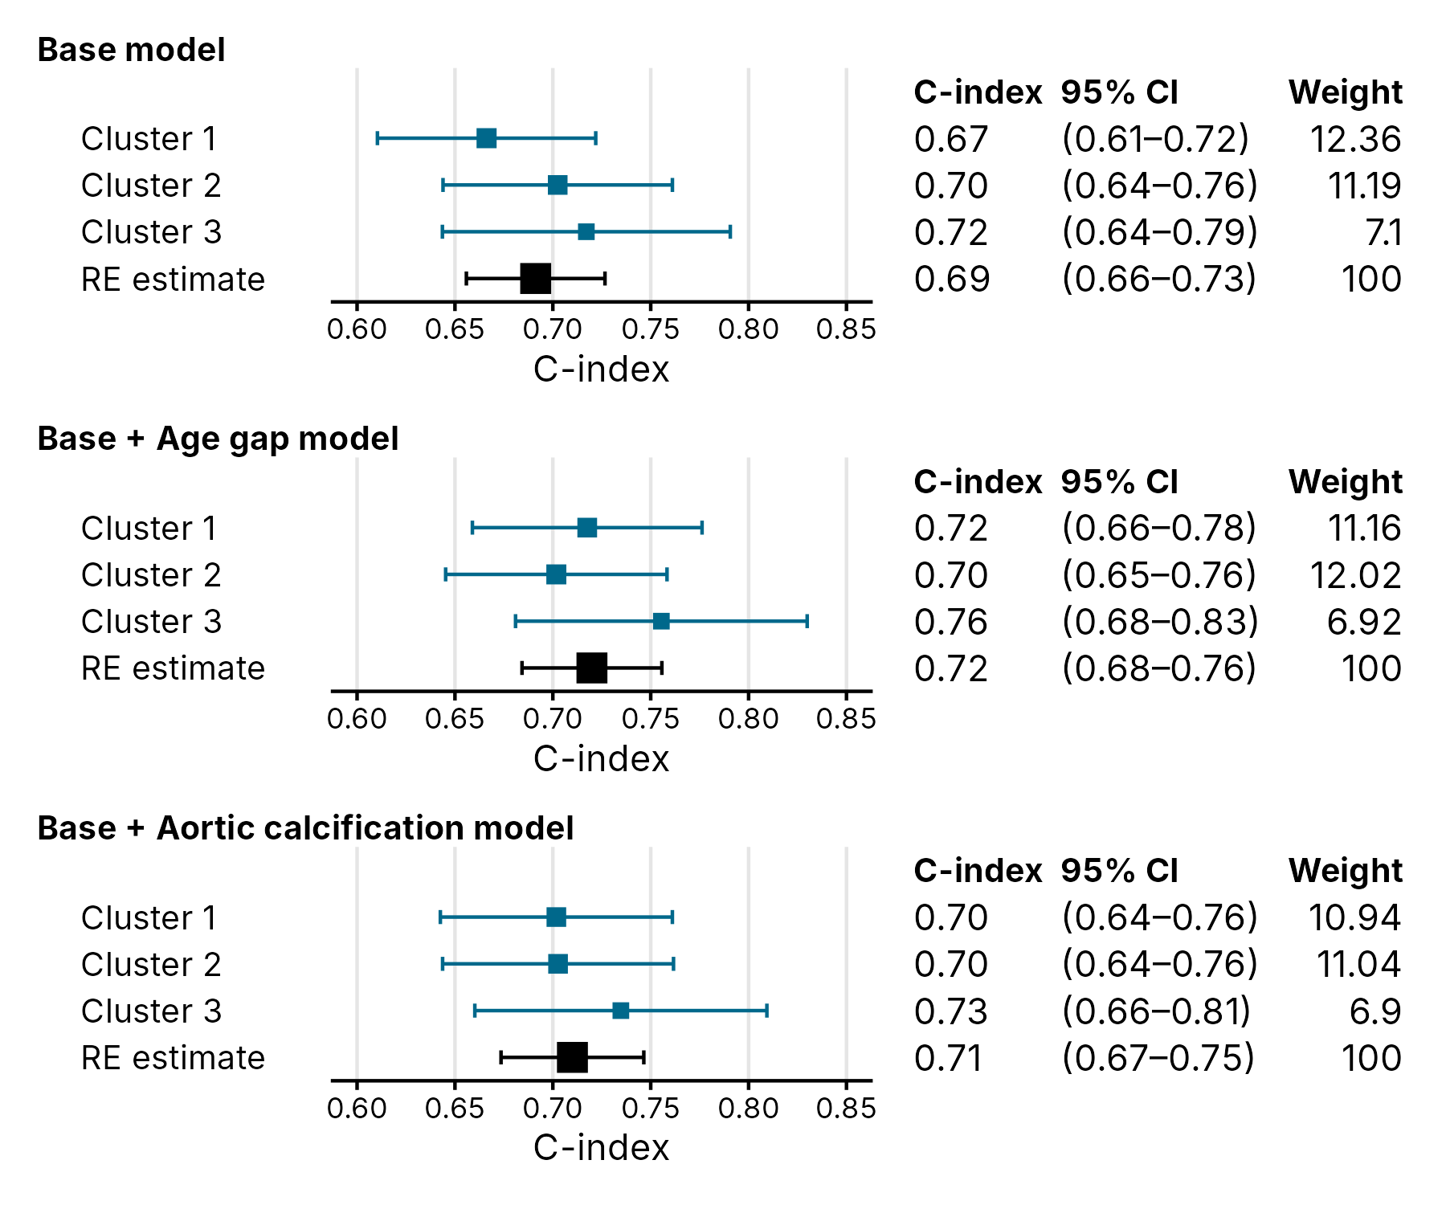
Supplementary Figure 18. Forest plot of competing risks model concordance for non-lung cancer death at 2 years, comparing aortic calcification alone with the Base and Base + Age gap models, by IECV clusters and random effects meta-analyzed estimates.

References
1. Wasserthal, J. et al. TotalSegmentator: Robust Segmentation of 104 Anatomic Structures in CT Images. https://doi.org/10.1148/ryai.230024 5, (2023).
2. Jang, S. et al. Opportunistic Osteoporosis Screening at Routine Abdominal and Thoracic CT: Normative L1 Trabecular Attenuation Values in More than 20 000 Adults. https://doi.org/10.1148/radiol.2019181648 291, 360–367 (2019).
3. Dickson, J. L. et al. Uptake of invitations to a lung health check offering low-dose CT lung cancer screening among an ethnically and socioeconomically diverse population at risk of lung cancer in the UK (SUMMIT): a prospective, longitudinal cohort study. Lancet Public Health 8, e130–e140 (2023).
4. Riley, R. D., Van Calster, B. & Collins, G. S. A note on estimating the Cox-Snell R2 from a reported C statistic (AUROC) to inform sample size calculations for developing a prediction model with a binary outcome. Stat. Med. 40, 859–864 (2021).
5. Riley, R. D. et al. Calculating the sample size required for developing a clinical prediction model. BMJ 368, (2020).
6. Blanche, P., Dartigues, J. F. & Jacqmin-Gadda, H. Estimating and comparing time-dependent areas under receiver operating characteristic curves for censored event times with competing risks. Stat. Med. 32, 5381–5397 (2013).
7. Gendarme, S. et al. Impact of Comorbidities on the Mortality Benefits of Lung Cancer Screening: A Post-Hoc Analysis of the PLCO and NLST Trials. Journal of Thoracic Oncology 20, 565–576 (2025).
8. Cheung, L. C., Berg, C. D., Castle, P. E., Katki, H. A. & Chaturvedi, A. K. Life-Gained–Based Versus Risk-Based Selection of Smokers for Lung Cancer Screening. https://doi.org/10.7326/M19-1263 171, 623–632 (2019).

