Supplemantary
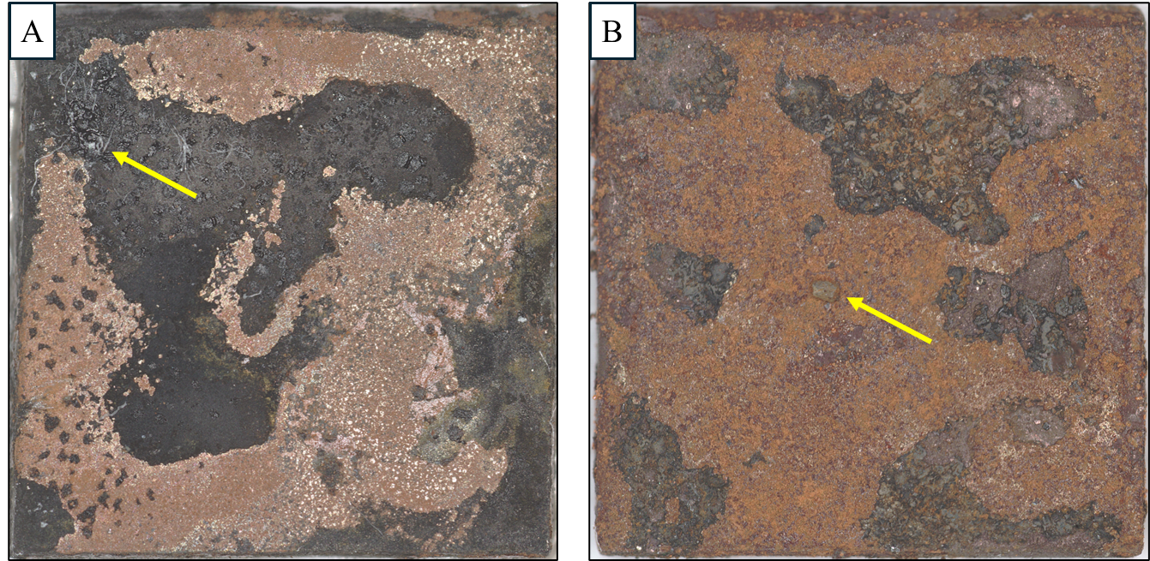
Figure 1S. Representative surface images of carbon steel coupons exposed under (A) static-sediment and (B) low-flow-sediment conditions. Locally elevated thickness values observed in both treatments are attributed to adherent sand particles rather than intrinsic corrosion product or biofilm growth. As indicated by the yellow arrows, several sand grains were firmly embedded within the surface layer and could not be removed without disrupting the underlying corrosion film.

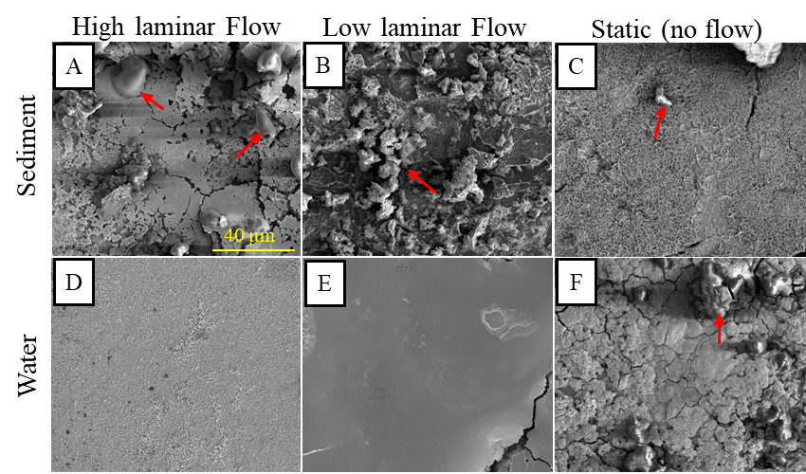
Figure 2S. Scanning electron microscopy (SEM) images of coupons exposed to different hydrodynamic conditions. Red arrows indicate vertically oriented microchimney structures. (D) The biofilm is very thin, and such structures are not formed. (F) The biofilm is very thick, and the surface is covered by a continuous, coherent layer.

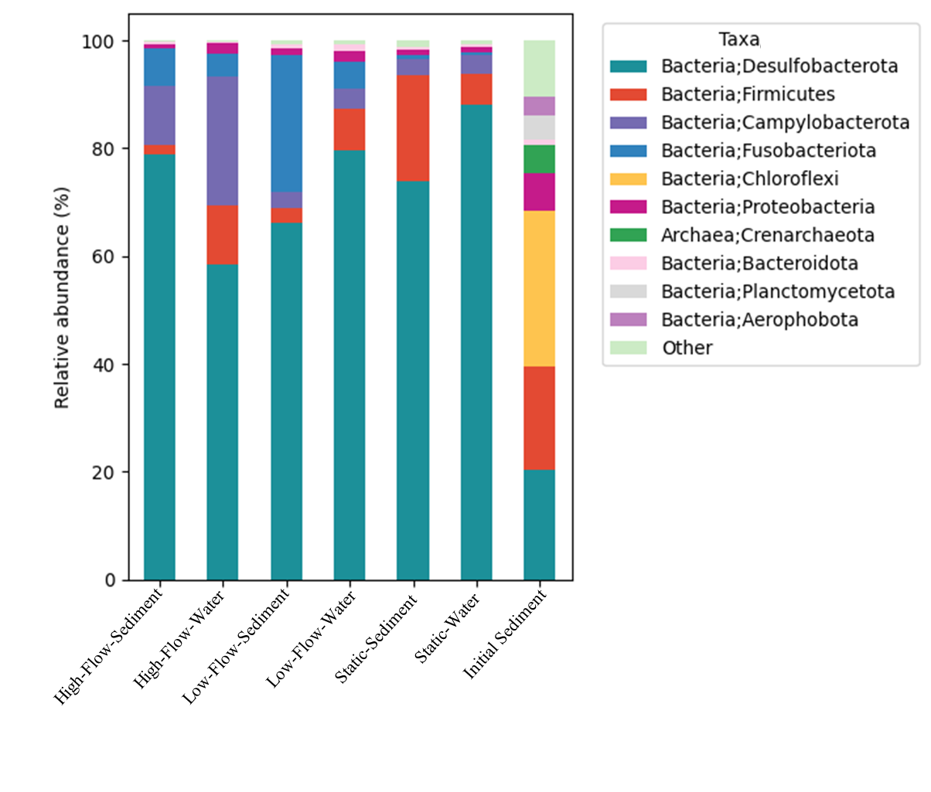
Figure 3S. Top ten most abundant Taxa by Treatment

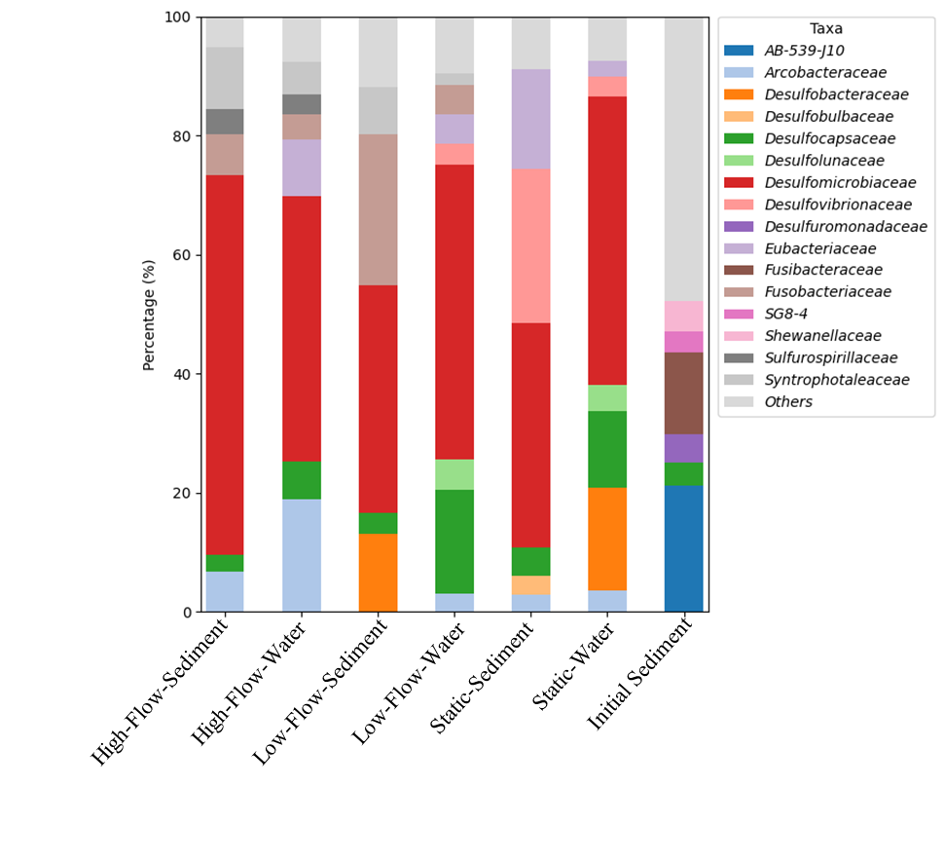

Figure 4S: Stachbar plot showing the relative abundance of ASVs summarized on the taxonomic level of families. 'Taxa (%) by treatment — ≥2% shown

