Table 1. Details of PFOS, PFHxS and TPs identified after PFOS degradation by CAP.
PFOS and intermediates | Chemical structure | Chemical formula | Molecular weight (g/mol)
Perfluorooctane sulfonic acid (PFOS) | 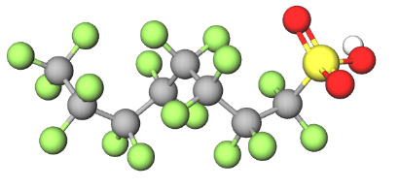 | C₈​HF₁₇​O₃​S | 500.11
Perfluorooctanoic acid (PFOA) | 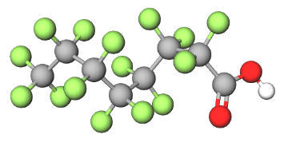 | C₈​HF₁₅​O₂ | 414.06
Perfluoroheptanoic acid (PFHpA) | 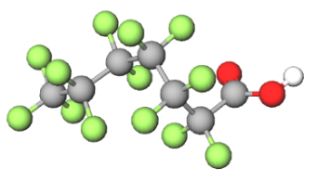 | C₇​HF₁₃​O₂ | 364.05
Perfluorohexane sulfonic acid (PFHxS) | 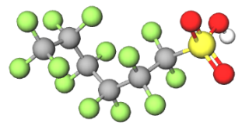 | C₆​HF₁₃​O_{3​}S | 400.10
Perfluorohexanoic acid (PFHxA) | 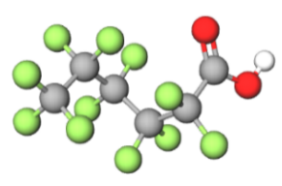 | C₆​HF₁₁​O₂ | 314.05
Perfluoropentanoic acid (PFPeA) | 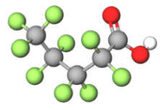 | C₅​HF₉​O₂ | 264.04
Perfluorobutanoic acid (PFBA) | 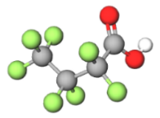 | C₄​HF₇​O₂ | 214.03

