Extended Data:
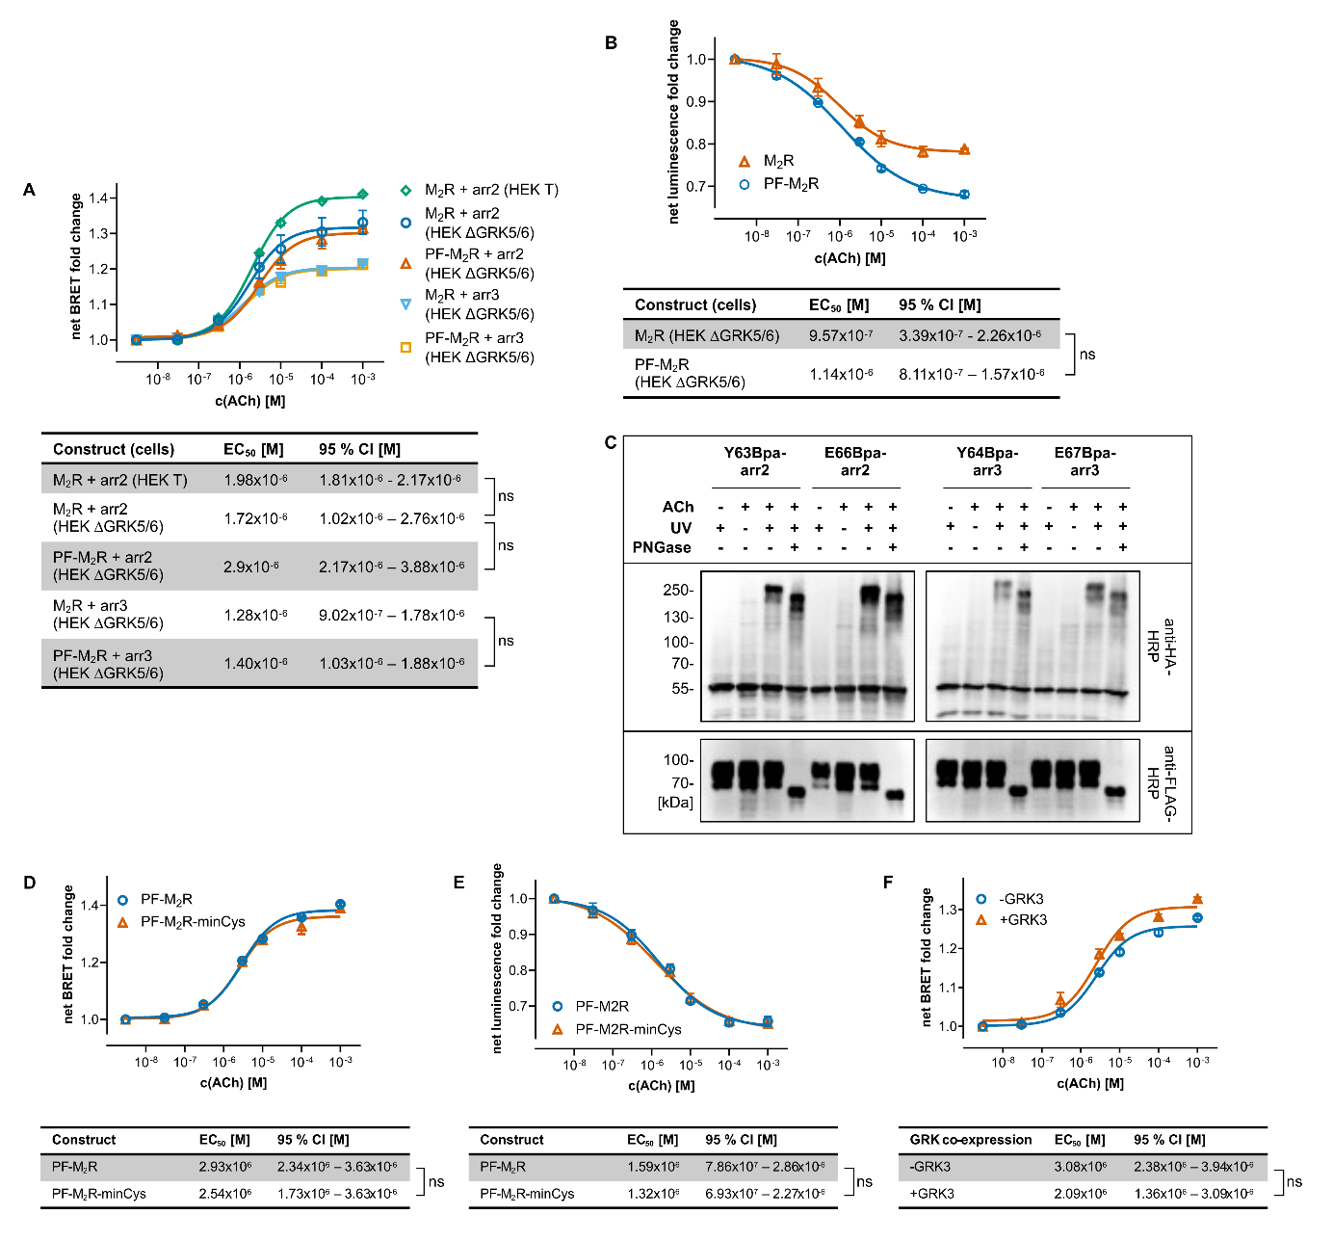
Extended Data Fig. 1: A Arrestin recruitment to the M₂R in HEK T and HEK ∆GRK5/6 as well as to PF-M₂R in HEK ∆GRK5/6. EC50 values for the recruitment of arrestin to the M₂R in HEK293 ∆GRK5/6 cells is comparable to the value in HEK293 T cells. EC50 values for the recruitment of arrestin are comparable between the M₂R and the PF-M₂R too. BRET-based assay using receptor-NanoLuc and Venus-arr2/Venus-arr3 constructs. Three independent biological replicates, error bars show the SEM. The table shows associated EC50 values and 95 % CI, significance is calculated via extra-sum-of-squares F test (p ≤ 0.05). B G protein dissociation at the M₂R and PF-M₂R, measured via NanoBiT complementation assay using Gαi-LgBiT and SmBiT-Gγ. EC50 values are comparable between the receptor constructs. Three independent biological replicates, error bars show the SEM. The table shows associated EC50 values and 95 % CI, significance is calculated via extra-sum-of-squares F test (p ≤ 0.05). C Western blots of the photo-crosslinking between the PF-M₂R and Bpa-arr2 as well as Bpa-arr3 mutants. The experiment is performed without prior stimulation with ACh, without UV irradiation, following stimulation and irradiation, and with additional treatment of the sample with PNGase F. PNGase F deglycosylates the receptor, causing a shift of receptor and crosslinking bands to a lower molecular weight. Detection with HRP-coupled anti-HA and anti-FLAG antibodies. D Arrestin recruitment to the PF-M₂R and PF-M₂R construct depleted of intracellular cysteine residues (PF-M₂R-minCys) in HEK ∆GRK5/6. In the PF-M2R-minCys construct, C124 is mutated to S, C274 to A, C324 to A, C337 to A, C439 to S, C443 to S, C457 is not mutated due to palmitoylation. BRET-based assay using receptor-NanoLuc and Venus-arr2 constructs. Three independent biological replicates, error bars show the SEM. The table shows associated EC50 values and 95 % CI, significance is calculated via extra-sum-of-squares F test (p ≤ 0.05). E G protein dissociation at the PF-M₂R and PF-M₂R construct depleted of intracellular cysteine residues (PF-M₂R-minCys), measured via NanoBiT complementation assay using Gαi-LgBiT and SmBiT-Gγ. Three independent biological replicates, error bars show the SEM. The table shows associated EC50 values and 95 % CI, significance is calculated via extra-sum-of-squares F test (p ≤ 0.05). F Arrestin recruitment to the PF-M₂R in HEK ∆GRK5/6 with and without co-expression of GRK3. BRET-based assay using receptor-NanoLuc and Venus-arrestin constructs. Three independent biological replicates, error bars show the SEM. The table shows associated EC50 values and 95 % CI, significance is calculated via extra-sum-of-squares F test (p ≤ 0.05).
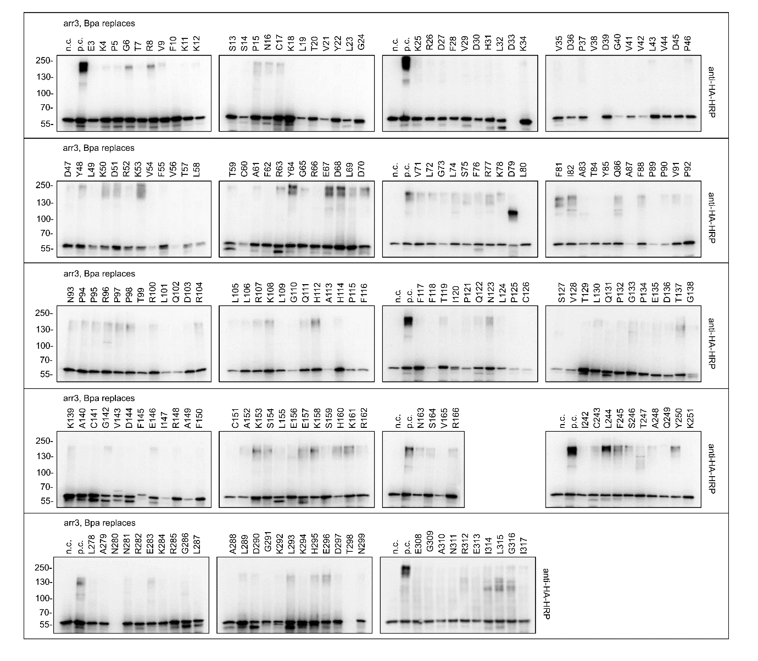
Extended Data Fig. 2: Western blots of the photo-crosslink between Bpa-arr3 mutants and the PF-M₂R. After stimulation with ACh stimulation, UV irradiation and cell lysis, lysates were resolved on SDS-PAGE and immunoblotted. Detection with HRP-coupled anti-HA antibody. Arr3 runs at an apparent molecular weight of ~60 kDa, the crosslinked PF-M₂R-arr3 at ~200-250 kDa.

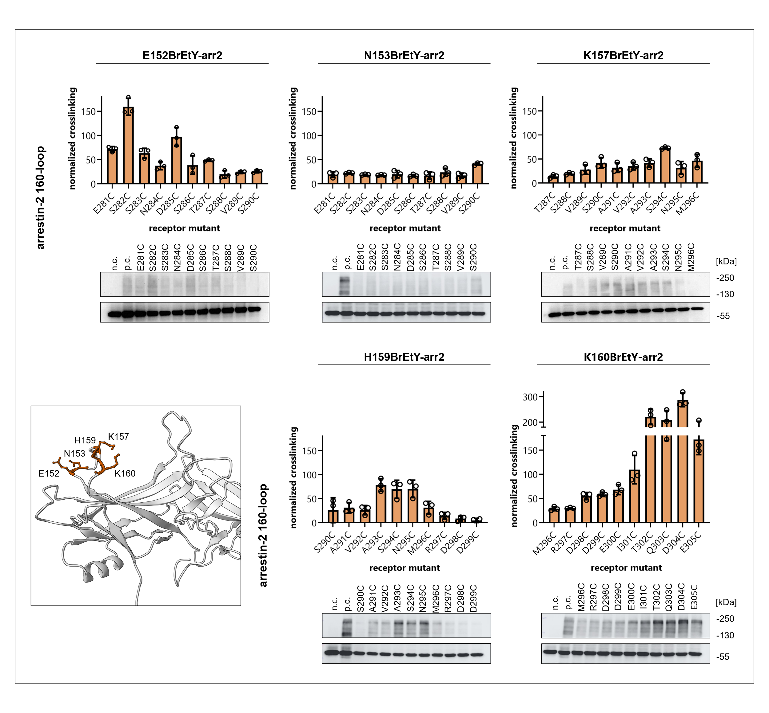
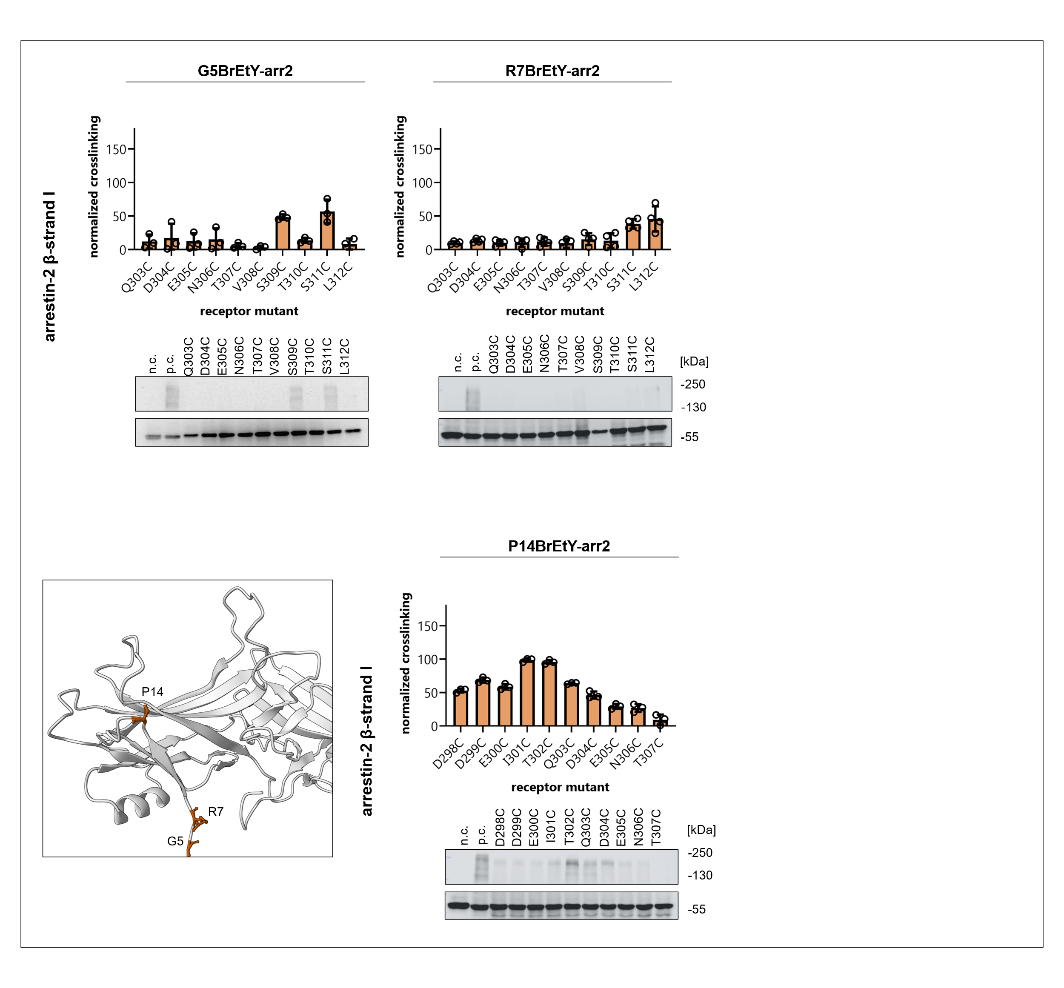
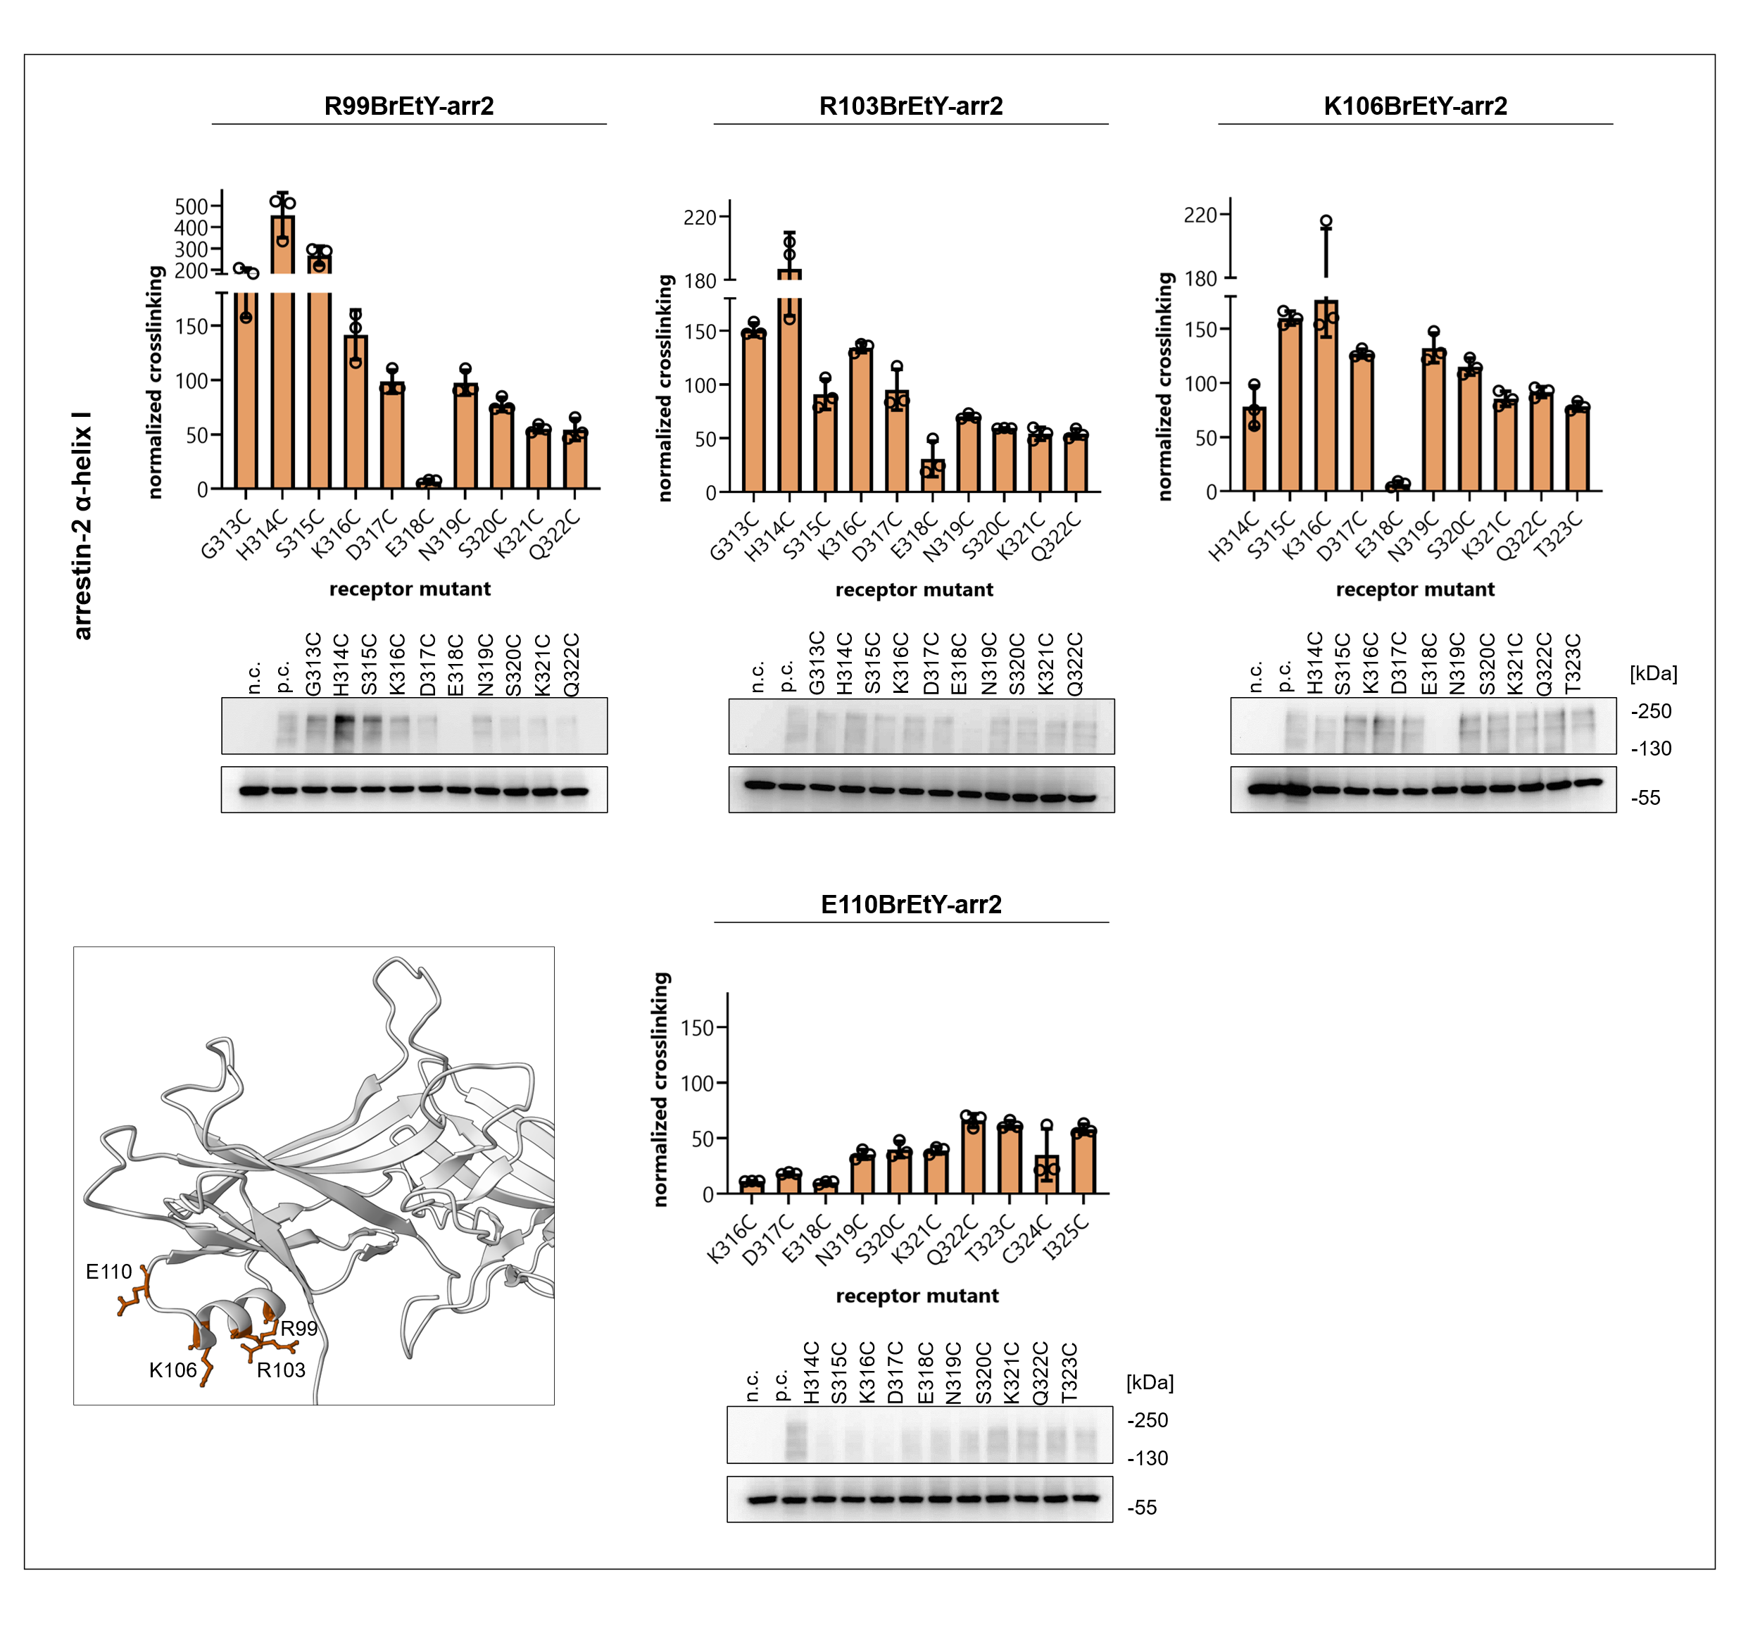
Extended Data Fig. 3: Pairwise crosslinking between arr2-3xHA BrEtY mutants and Cys-PF-M₂R mutants. Crosslinking intensity plotted as bar charts, measured via XL-ELISA in three independent biological replicates and normalized to the positive control (E152BrEtY-arr2 + D285C-PF-M₂R). Arrestin mutants are indicated above, receptor mutants on the x-axis. Error bars represent SD. Corresponding western blots are detected with HRP-coupled anti-HA antibodies and include positive control (p.c.) and negative control (n.c., wt-arr2 + PF-M₂R-minCys). Receptor mutants are indicated above lanes. Tested residues are visualized in orange in active arrestin-2.

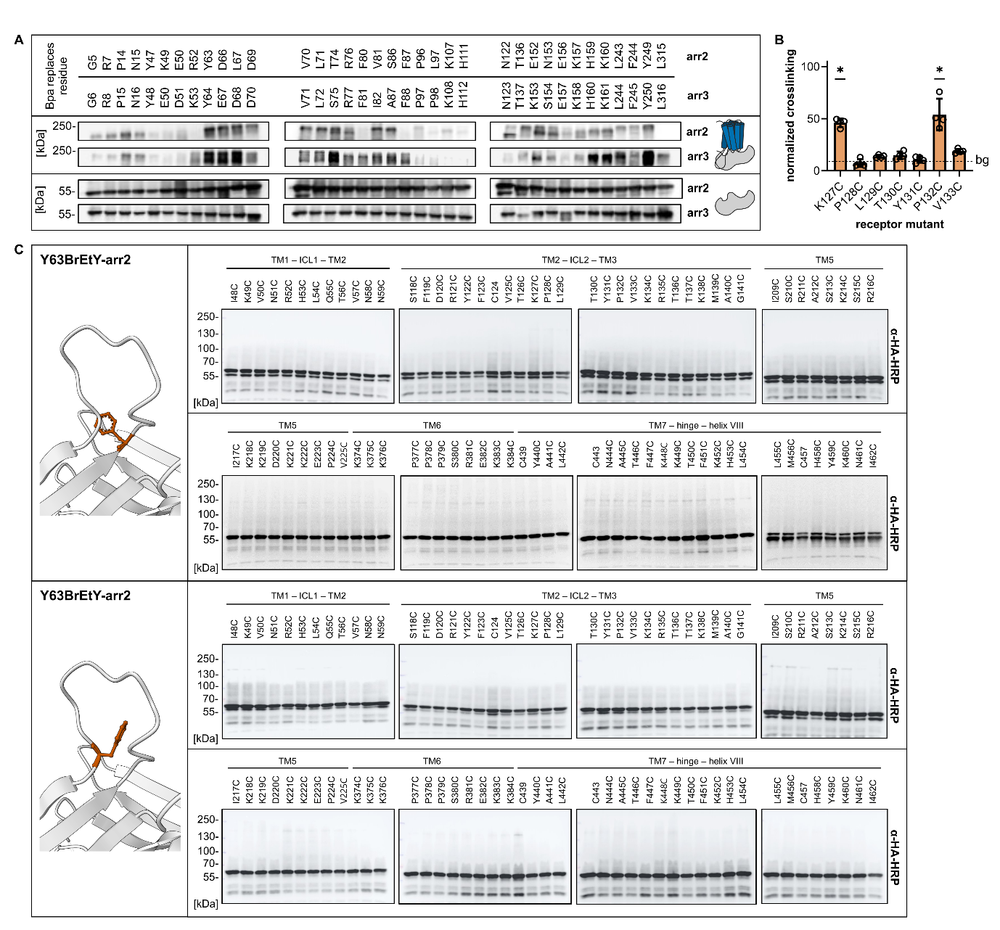
Extended Data Fig. 4: A Subset of crosslinking hits of both Bpa-arr2-3xHA and Bpa-arr3-3xHA with the PF-M₂R. Immunoblots of whole cell lysates stained with a HRP-coupled anti-HA antibody. Bpa-arr-3xHA mutants run at an apparent MW ~60 kDa, crosslinking products at ~200-250 kDa, B XL-ELISA of the pairwise crosslinking between C140S-G286BrEtY-arr2 and Cys-PF-M₂R mutants of the ICL2. Four independent biological replicates, error bars represent the SD. Stars indicate significance (unpaired t-test, p ≤ 0.02) above background (bg, dashed line). C Western blots of the pairwise crosslinking between Y63BrEtY-arr2 and F75BrEtY-arr2 mutants and Cys-PF-M2R mutants of residues in the transmembrane helices, ICL1, ICL2, beginning and end of the ICL3, hinge region, and helix VIII. Detection with HRP-coupled anti-HA antibodies.
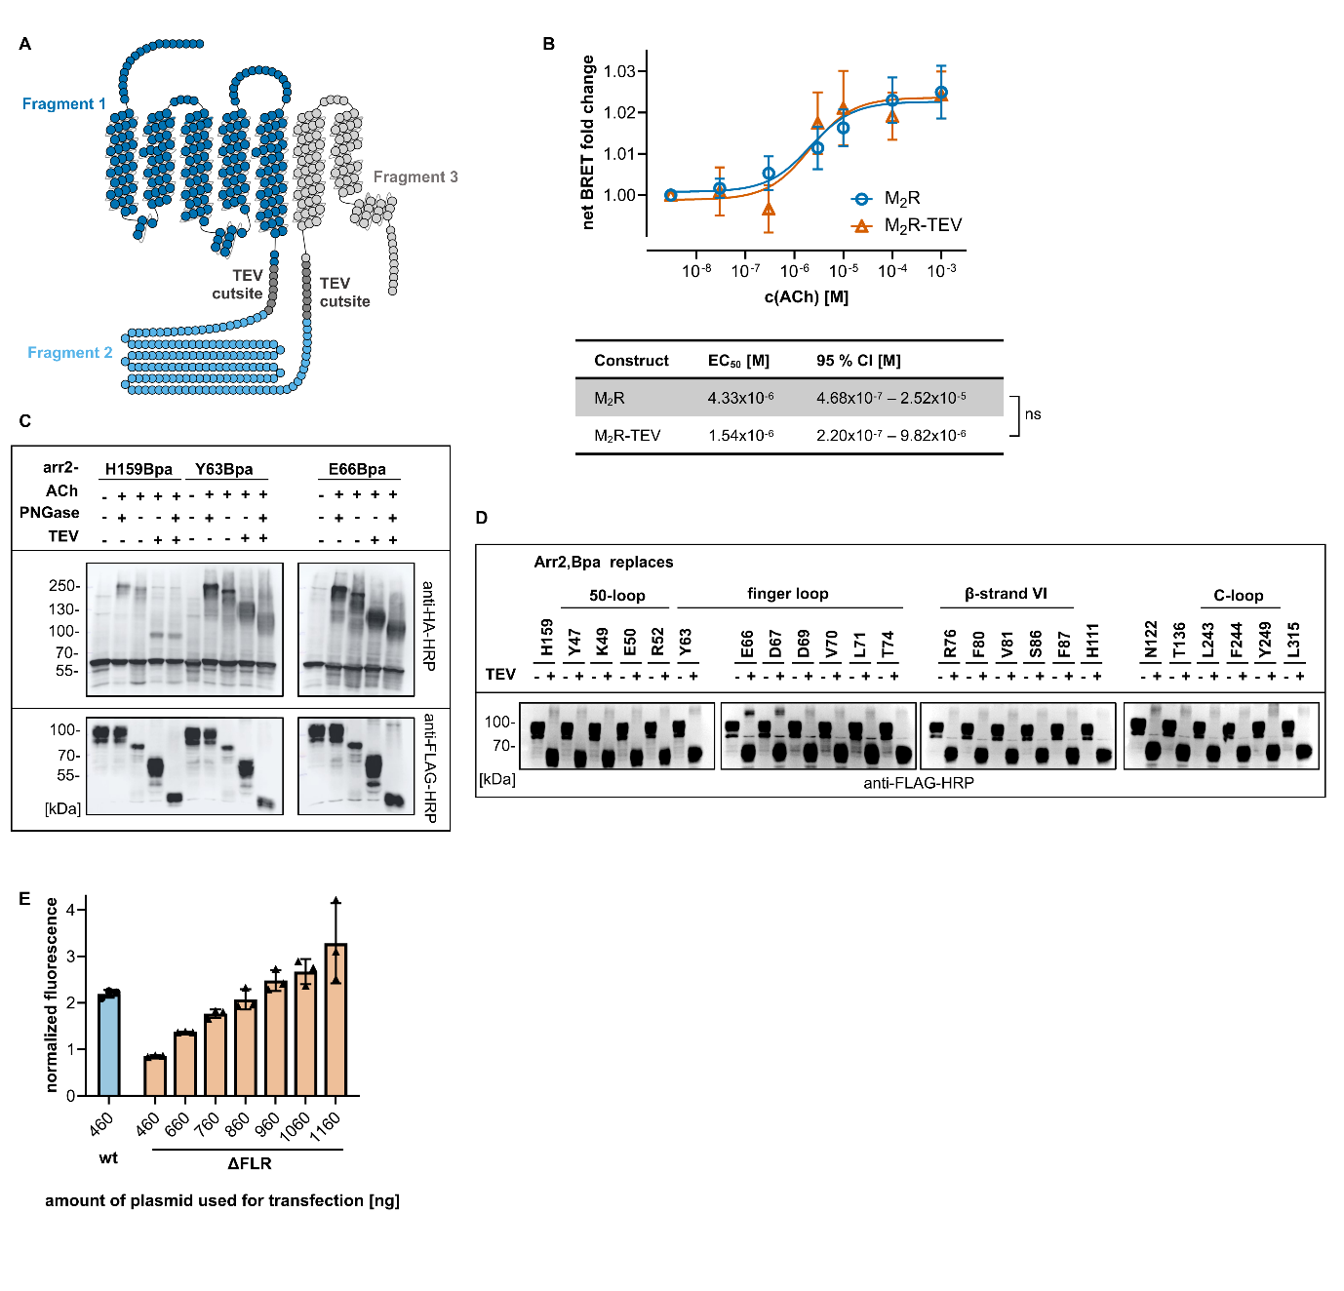
Extended Data Fig. 5: A Snake plot of the TEV-cleavable M₂R construct. TEV cutsites are highlighted in dark grey, resulting fragments following cleavage are highlighted in dark blue, light blue and light grey, respectively. B Arrestin recruitment to the PF-M₂R and PF-M₂R-TEV construct in HEK ∆GRK5/6. Bystander-BRET-based assay using unmodified receptor and nLuc-arr2 constructs as well as eYFP fused to the plasma membrane marker CAAX. Three independent biological replicates, error bars show the SEM. The table shows associated EC50 values and 95 % CI, significance is calculated via extra-sum-of-squares F test (p ≤ 0.05). C Western blots of the photo-crosslinking with subsequent TEV cleavage between the PF-M₂R-TEV construct and H159Bpa-arr2, Y63Bpa-arr2 as well as E66Bpa-arr2. Detection with HRP-coupled anti-HA and anti-FLAG antibodies. Y63 and E66 are both situated in the finger loop of arr2. Upon TEV cleavage, the crosslinking bands run at an apparent molecular weight of approximately ~130 kDa, and shift to lower molecular weights upon declycosylation with PNGase. This definitely demonstrates that these positions crosslink to the N-terminal portion of the receptor core. In contrast, TEV cleavage of the photo-crosslinking product with arrestin-2-H159Bpa, of which we know from pairwise crosslinking data that it is in contact with the ICL3, leads to a shift to an apparent molecular weight of circa 100 kDa and treatment with PNGase F does not cause a further shift. D Western blots of the photo-crosslinking between Bpa-arr2 mutants and the PF-M₂R equipped with TEV cutsites, following stimulation with ACh and cleavage with TEV protease, detected with HRP-coupled anti-FLAG antibodies. Upon TEV cleavage, the apparent molecular weight of the PF-M₂R-TEV shifts from ~90 kDa to ~60 kDa. E Expression level measured via the fluorescence of Venus-arr2 and Venus-∆FL-arr2, normalized to the fluorescence of co-expressed CFP. Increasing amounts of Venus-∆FL-arr2 plasmid used for transfection are compared to wild-type Venus-arr2. Comparable expression levels were achieved between transfection with 460 ng Venus-arr2 plasmid and 860-960 ng Venus-∆FL-arr2 plasmid.

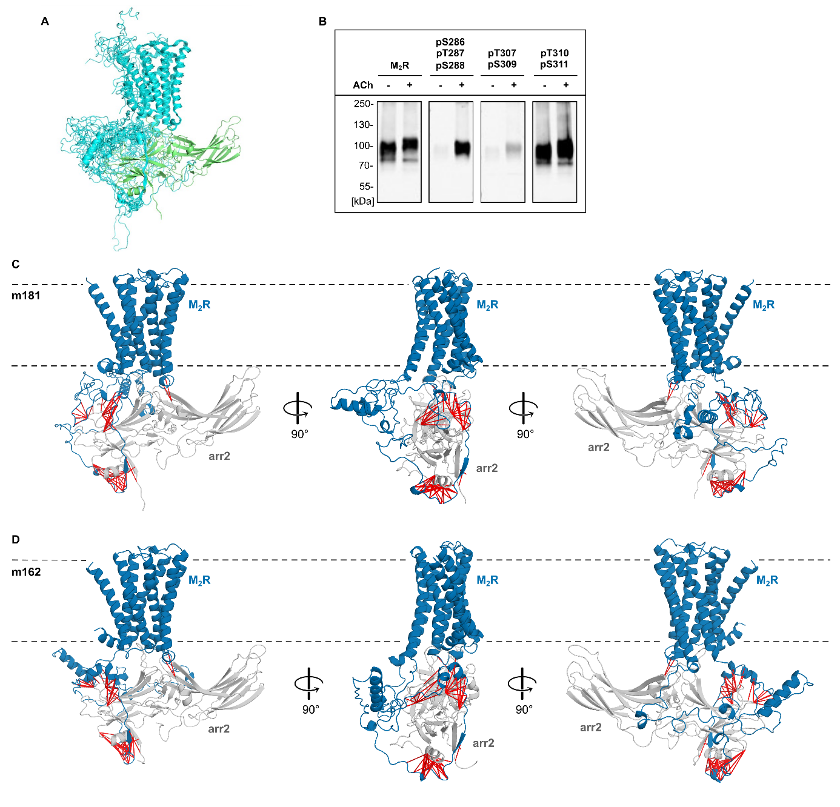
Extended Data Fig. 6: A Superimposition of the ten M₂R-arr2 starting complexes obtained by Robetta (M₂R cyan, arr2 green). B Phosphorylation-specific immunoblotting of the PF-M₂R without receptor stimulation and after stimulation with ACh. Detection using anti-M₂R, anti-pS286/pT287/pS288-M₂R, anti-pT307/pS309-M₂R and anti-pT310/pS311-M₂R antibodies. C and D Crosslinking-guided optimized static models m181 (C) and m162 (D) of the M₂R-arr complex. The M₂R is shown in blue, arr2 in grey. Crosslinking pairs are shown as red lines.

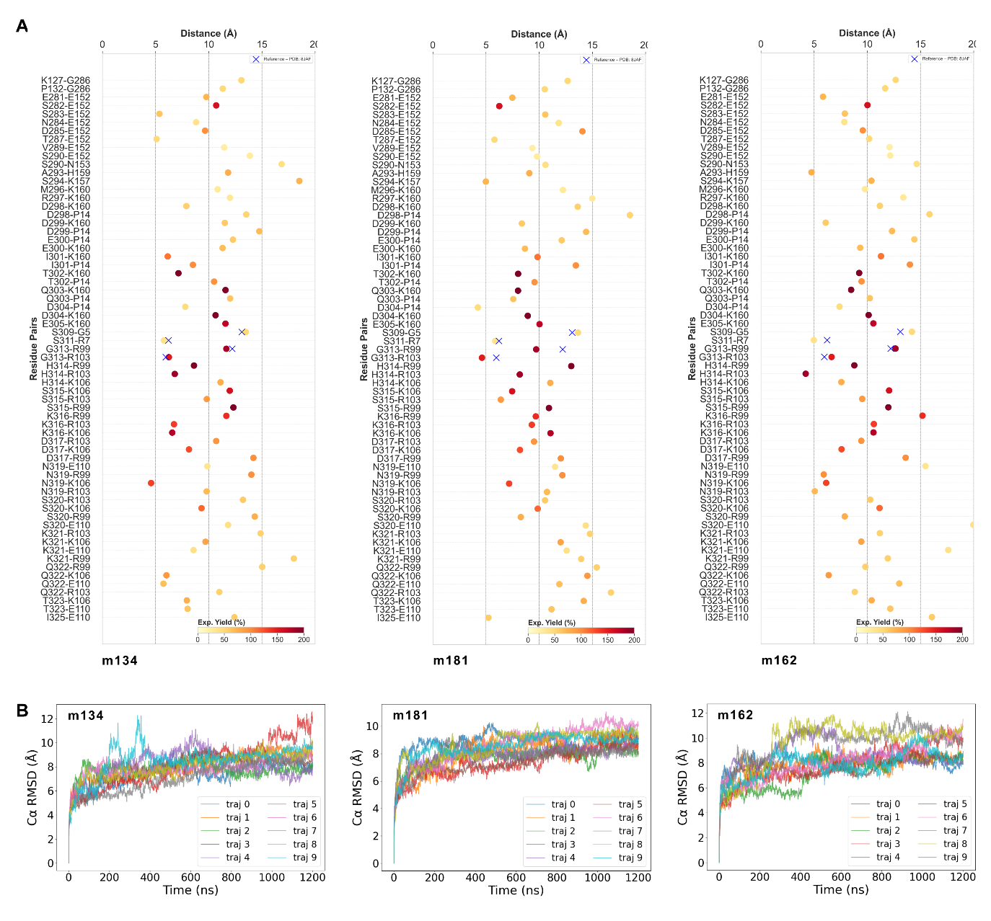
Extended Data Fig. 7: A Distance of the crosslinking pairs in the static models m134, m181, and m162. Crosslinking strength is indicated as a color gradient from light yellow (weak crosslink) to dark red (strong crosslink). Reference distances from PDB ID 8JAF are marked as blue crosses. B M₂R-arr2 complex RMSD of m134, m181 and m162 in ten independent replicates over 1.2 µs simulation time.

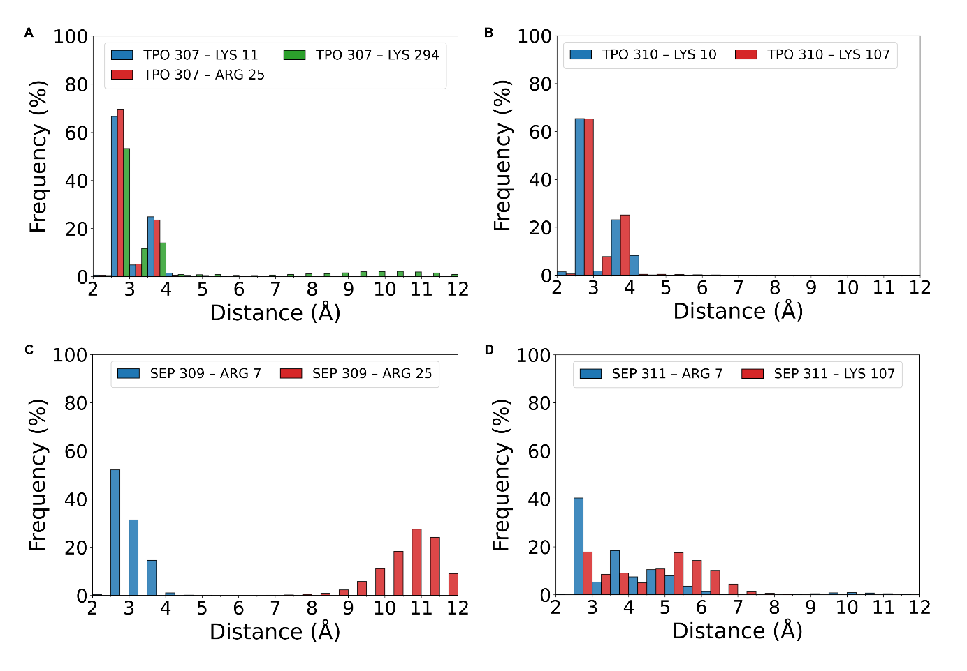
Extended Data Fig. 8: Cumulative histograms of the distance between phosphorylated residues in the M₂R and positively charged residues in arr2. 36 µs aggregate simulation time of m134, m181 and m162. A Distance between pT307-M₂R and K11-, R25-, K294-arr2. B Distance between pT310-M₂R and K10-, K107-arr2. C Distance between pS309-M₂R and R7-, R25-arr2. D Distance between pS311-M₂R and R7-, K107-arr2.

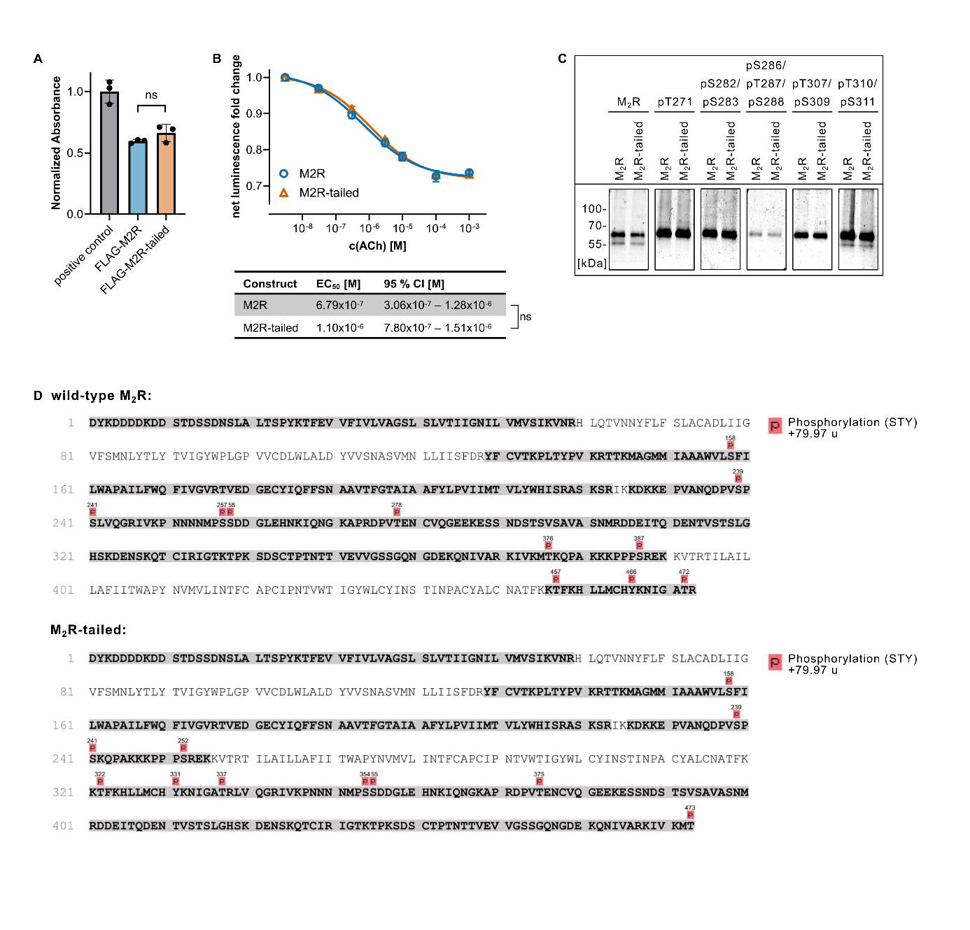
Extended Data Fig. 9: A Expression of FLAG-M₂R and FLAG-M₂R-tailed measured via surface ELISA. Membrane expression of the receptors is measured via a colorimetric reaction following incubation with HRP-coupled anti-FLAG antibody. Absorbance is normalized to the positive control (FLAG-PTH1R). Three independent biological replicates, error bars show the SD. Significance is determined using an unpaired t-test (p ≤ 0.05). No significant difference was observed between the surface expression of the FLAG-M₂R and FLAG-M₂R-tailed constructs. B G protein dissociation at the M₂R and M₂R-tailed, measured via NanoBiT complementation assay using Gαi-LgBiT and SmBiT-Gγ. Three independent biological replicates, error bars show the SEM. The table shows associated EC50 values and 95 % CI, significance is calculated via extra-sum-of-squares F test (p ≤ 0.05). C Phosphorylation-specific immunoblotting of the M₂R and M₂R-tailed following stimulation with ACh. Detection using anti-M₂R, anti-pT271-M₂R, anti-pS282/pS283-M₂R, anti-pS286/pT287/pS288-M₂R, anti-pT307/pS309-M₂R and anti-pT310/pS311-M₂R-antibodies. D Phosphorylation patterns of wt-M2R and M2R-tailed were determined by mass spectrometry in three biological replicates. Detected peptides are highlighted in bold and grey, phosphorylation sites are highlighted in red.

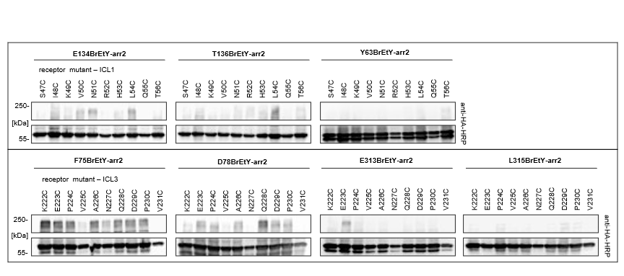
Extended Data Fig. 10: Western blots of the pairwise crosslinking between BrEtY-arr2 mutants and Cys-PF-M₂R-tailed mutants. Residues in the middle loop and finger loop of arr2 are combined with residues in the ICL1 of the M₂R-tailed. Residues in the finger loop, β-strand VI and back loop of arr2 are combined with residues in the ICL3 of the M₂R-tailed. Detection with HRP-coupled anti-HA antibodies.

