Figure 1C. Anti-His tag (right)
Figure 1C. Anti-L-ASNase (right)
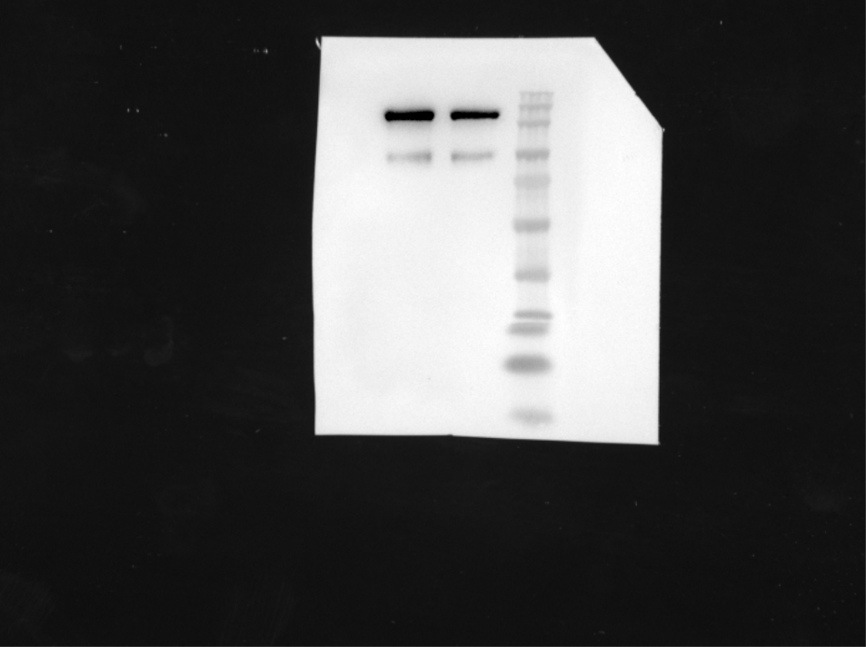
Figure 1C. Anti-FlaB (right)
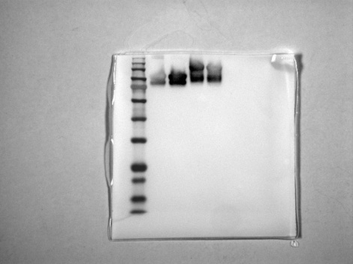
Figure 1C. Anti-His tag (left)

