Appendix: 1
Supplementary Methodological Notes:

1.1 KDQoL-36 Survey: Description and Scoring
The Kidney Disease Quality of Life-36 (KDQoL-36) is a 36-item instrument that includes the SF-12 Health Survey (12 items) and 24 kidney disease-targeted items grouped into three domains: Burden of Kidney Disease, Symptoms/Problems, and Effects of Kidney Disease. The SF-12 is scored to produce Physical and Mental Health Composite scores (PHC and MHC) according to standard SF-12/KDQoL-36 scoring procedures. Kidney disease-targeted domain scores are computed from their respective items and are typically transformed to a 0-100 scale, with higher scores indicating better health-related quality of life (i.e., lower burden, fewer symptoms/problems, and less impact of kidney disease) (Hays et al., 1994; Peipert et al., 2018). The KDQoL-36 has been validated in diverse CKD and dialysis populations, including English and Spanish versions, supporting its use across different clinical settings and patient groups (Ricardo et al., 2013; Yang et al., 2013).
Table A1 provides an overview of the KDQoL-36 structure and scoring, summarizing each component/domain, what it measures, example item content, and the interpretation of higher scores.

Table A1.1. Structure and scoring overview of the KDQoL-36.
Component | Domain / score | What it measures | Example content | Score interpretation
Generic HRQoL (SF-12) | PHC (Physical Health Composite score) | Overall physical health status and functioning | Physical functioning/limitations, general health, bodily pain, vitality | Higher = better physical HRQoL
Generic HRQoL (SF-12) | MHC (Mental Health Composite score) | Overall mental health and emotional well-being | Emotional well-being, role limitations due to emotional problems, social functioning | Higher = better mental HRQoL
Kidney disease–targeted | Burden of Kidney Disease (BKD) (n items=4) | Perceived burden and intrusiveness of kidney disease | Feeling “burdened” by kidney disease; interference with life | Higher = lower burden/ better Kidney Disease-targeted HRQoL
Kidney disease–targeted | Symptoms/Problems (SKD) (n items=12) | Frequency/severity of kidney disease–related symptoms and problems | Itching, cramps, sleep problems, appetite, access issues (examples), others | Higher = fewer/less severe symptoms/better Kidney Disease-targeted HRQoL
Kidney disease–targeted | Effects of Kidney Disease (EKD) (n items=8) | Impact of kidney disease on daily life and activities | Ability to travel/work; dependence; time spent managing kidney disease, others | Higher = less impact/better Kidney Disease-targeted HRQoL

To avoid confusion with the original PHC and MHC scores derived using classical test theory (CTT) weights, we refer to the IRT-based recalculated physical and mental health composite scores as PHC_{IRT} and MHC_{IRT}, respectively. These scores are conceptually aligned with SF12_{PHC} and SF12_{MHC} but derived from domain-specific theta estimates using IRT-based scoring procedures. For the kidney disease-specific domains of the questionnaire, we adopt the labels BKD (Burden of Kidney Disease), SKD (Symptoms of Kidney Disease), and EKD (Effect of Kidney Disease) to denote the IRT-based scores calculated for each respective construct. In the classical scoring framework, these kidney-related domains correspond to: KDQoL-Burden, KDQoL-Symptoms/Problems, and KDQoL-Effects, respectively based on the original scoring approach from the KDQoL-36 instrument.

1.2 Psychometric Evaluation
For completeness, Table A1.2 defines major measurement terms (COSMIN/ISOQOL) and summarizes how each psychometric property was assessed in this study.

Table A1.2 Summary of measurement properties and corresponding analyses (COSMIN/ISOQOL framework)
Property | COSMIN-style definition | How tested here | Metric / rule
Item-level targeting (descriptive/interpretability) | Distributional issues affecting usefulness (e.g., floor/ceiling) | Floor/ceiling effects | % at min/max
Structural validity | Degree to which scores reflect dimensionality of the construct | Confirmatory IRT-based factor analysis and models fit (SF12; KDQoL-36 disease-specific) | RMSEA/SRMR/CFI/TLI; AIC/BIC/SABIC; bifactor ECV, ωH, PUC, TIF
Internal consistency/reliability | Interrelatedness of items within a scale | Item-total/inter-item + Cronbach’s α (and ω where used) | α/ω reported + item-total correlations
Construct validity – convergent/divergent | Degree to which scores behave as expected based on hypotheses | MTMM; within-factor vs cross-factor correlations | Convergent: r ≥ 0.30; Divergent: r < 0.30
Construct validity - Score comparability: Classical Test Theory (CTT) scores vs IRT/CAT scores | Agreement/relationship between alternative scoring approaches | Mapping regressions between IRT-based, CAT-based, and CTT scores | R², slope/intercept, error; report calibration/fit
Construct validity - known-groups | Ability to discriminate between groups expected to differ | HRQoL vs hospitalization risk quintiles; a priori hypotheses (SF12G stronger than KDSG, etc.) | Pearson r / regression; hypothesis confirmation
Intra Correlation Coefficient (ICC) | Degree of agreement between alternative scoring approaches (absolute agreement) | Two-way absolute-agreement, average-measure ICC across CTT-, IRT-, and CAT-derived scores (ICCagreement) | ICCagreement (higher = better agreement; interpreted as concordance across methods)
Smallest detectable change (SDC) | Smallest detectable change beyond measurement error | SEM-based SDC derived from ICCagreement using pooled SD across methods | SDCagreement = 1.96·√2·SEMagreement, where SEMagreement = SDpooled·√(1−ICCagreement):
*SDpooled is the pooled standard deviation (SD) across CTT, IRT and CAT score computation methods.

1.2.1 Structural validity: SF12 Domains
To evaluate the measurement structure of the SF12, four IRT-based models were developed and compared to determine their ability to capture patients’ responses. Model fit indices were used to identify the structure offering the best measurement precision for the SF12_{PHC} and SF12_{MHC} scores.
Model 1a (see Appendix 2) served as the baseline, reflecting a two-dimensional uncorrelated structure. All items were allowed to load on both dimensions, except item 9, which loading on SF12_{PHC} was set to nil. This model was based on the structure showing the best fit in Forero et al. (2013) (Forero et al., 2013).
Model 2a (see Appendix 2) retains the two-dimensional structure of Model 1a (see Appendix 1), where all items load on both dimensions except item 9, which does not load on the SF12_{PHC} dimension. The key difference is that Model 2 allows the two latent dimensions to correlate freely, relaxing the assumption of independence imposed in the baseline model.
Model 3a (see Appendix 2) further modified the two-factor correlated structure, aligning more closely with a second model proposed by Forero et al. (2013) (Forero et al., 2013). In this configuration, items 1, 2, 3, 4, 5, and 8 loaded onto SF12_{PHC}, while items 6, 7, 9, 10, 11, and 12 loaded onto SF12_{MHC}.
Model 4a (see Appendix 2) employed a Bifactor structure (Chen et al., 2006; Reise et al., 2007), incorporating an orthogonal general health factor (SF12_{G}) alongside two orthogonal specific subscale factors (SF12_{PHC} and SF12_{MHC}). Item loadings for SF12_{PHC} and SF12_{MHC} matched those used in Model 3a.
1.2.2 Structural validity: Kidney Disease-Specific Domains
To assess the factor structure of patients’ response patterns to the kidney disease-specific domains of the KDQoL-36, three alternative models were contrasted by comparing model fit indexes:
Model 1b (see Appendix 2): Knowing which items are used to calculate each score in this section of the questionnaire, each item was loaded onto its respective factor. The first tested model was a three-factor model with not-intercorrelated factors.
Model 2b (see Appendix 2): A three-factor model with a structure similar to Model 1b, but with intercorrelated factors, was fitted to the data.
Model 3b (see Appendix 2): A Bifactor-Model was considered, assuming that the three subscale scores provide unique information beyond the general factor (General Kidney Disease Scale KDS_{G}) – representing the overall impact of Kidney Disease on patient’s life.
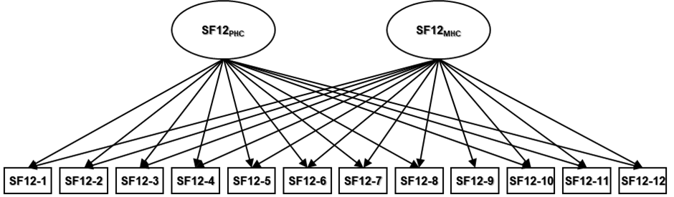
1.2.3 Models structures and diagrams
In this paragraph the structure of the models used in structural validity analysis is shown together with loadings, proportion of variance and factor correlation (Figure 1-Figure 7). Moreover at the end of the appendix the Test Information Curve (TICs) of the bifactor models are shown.
Figure A1.1 Graphic representation of the Model 1a-Uncorrelated two-factor model of the SF12 questionnaire.
Model 1a: Uncorrelated Two-Factor Model

Table A1.3 Factor loadings, communalities (h²), variance explained, and factor correlations for the Model 1a-Uncorrelated two-factor model of the SF12 questionnaire.
 | Loadings |  |  |  |  | Variance
 | SF12_{PHC} | SF12_{MHC} | h2 |  |  | SF12_{PHC} |  | SF12_{MHC}
SF12-1 | 0.29 | 0.49 | 0.33 |  | SS loadings | 2.75 |  | 3.43
SF12-2 | 0.65 | 0.36 | 0.55 |  | Proportion variation | 0.23 |  | 0.29
SF12-3 | 0.65 | 0.34 | 0.54
SF12-4 | 0.71 | 0.44 | 0.70 |  | Factor correlations | SF12_{PHC} |  | SF12_{MHC}
SF12-5 | 0.76 | 0.45 | 0.78 |  | SF12_{PHC} | 1 |  | 0
SF12-6 | 0.47 | 0.60 | 0.57 |  | SF12_{MHC} | 0 |  | 1
SF12-7 | 0.43 | 0.34 | 0.30
SF12-8 | 0.41 | 0.56 | 0.48
SF12-9 |  | 0.73 | 0.53
SF12-10 | 0.28 | 0.56 | 0.39
SF12-11 | 0.09 | 0.74 | 0.55
SF12-12 | 0.28 | 0.62 | 0.46
SF12_{PHC}: SF12 Physical Health Composite; SF12_{MHC}: SF12 Mental Health Composite; h2: Communalities (Communalities of an item in IRT and factor analysis represents the proportion of variance in that item which is explained by the latent traits (factors or dimensions) estimated in the model).

Figure A1.2 Graphic representation of the Model 2a-Correlated two-factor model of the SF12 questionnaire.
Model 2a -Correlated Two-Factor Model
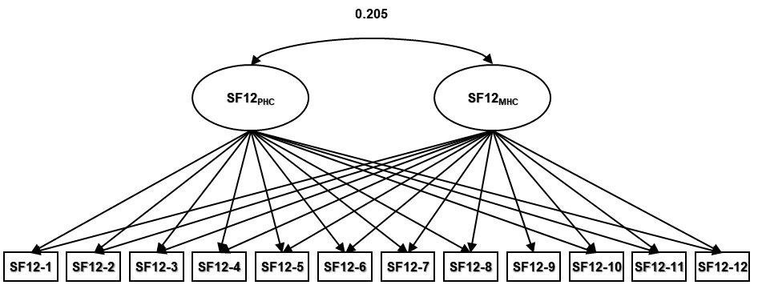
Table A1.4 Factor loadings, communalities (h²), variance explained, and factor correlations for the Model 2a-Correlated two-factor model of the SF12 questionnaire.
 | Loadings |  |  |  |  | Variance
 | SF12_{PHC} | SF12_{MHC} | h2 |  |  | SF12_{PHC} |  | SF12_{MHC}
SF12-1 | 0.30 | 0.45 | 0.30 |  | SS loadings | 3.01 |  | 2.83
SF12-2 | 0.68 | 0.25 | 0.51 |  | Proportion variation | 0.25 |  | 0.24
SF12-3 | 0.67 | 0.23 | 0.51
SF12-4 | 0.76 | 0.32 | 0.68 |  | Factor correlations | SF12_{PHC} |  | SF12_{MHC}
SF12-5 | 0.81 | 0.32 | 0.76 |  | SF12_{PHC} | 1 |  | 0.205
SF12-6 | 0.49 | 0.54 | 0.53 |  | SF12_{MHC} | 0.205 |  | 1
SF12-7 | 0.44 | 0.27 | 0.27
SF12-8 | 0.42 | 0.51 | 0.41
SF12-9 |  | 0.72 | 0.52
SF12-10 | 0.28 | 0.53 | 0.36
SF12-11 | 0.08 | 0.73 | 0.55
SF12-12 | 0.28 | 0.59 | 0.43
SF12_{PHC}: SF12 Physical Health Composite; SF12_{MHC}: SF12 Mental Health Composite; h2: Communalities (Communalities of an item in IRT and factor analysis represents the proportion of variance in that item which is explained by the latent traits (factors or dimensions) estimated in the model).
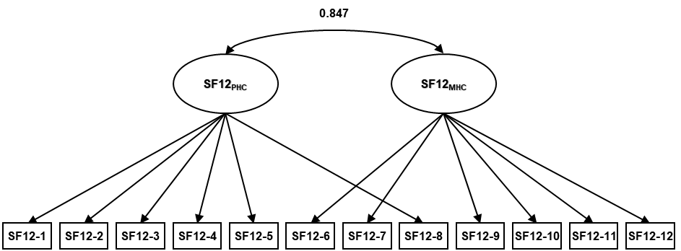
Figure A1.3 Graphic representation of the Model 3a-Alternative Correlated two-factor model of the SF12 questionnaire.
Model 3a -Alternative Correlated Two-Factor Model

Table A1.5 Factor loadings, communalities (h²), variance explained, and factor correlations for the Model 3a-Alternative Correlated two-factor model of the SF12 questionnaire.
 | Loadings |  |  |  |  | Variance
 | SF12_{PHC} | SF12_{MHC} | h2 |  |  | SF12_{PHC} |  | SF12_{MHC}
SF12-1 | 0.57 |  | 0.32 |  | SS loadings | 3.28 |  | 2.60
SF12-2 | 0.74 |  | 0.54 |  | Proportion variation | 0.27 |  | 0.22
SF12-3 | 0.72 |  | 0.52
SF12-4 | 0.82 |  | 0.67 |  | Factor correlations | SF12_{PHC} |  | SF12_{MHC}
SF12-5 | 0.88 |  | 0.73 |  | SF12_{PHC} | 1 |  | 0.847
SF12-6 |  | 0.79 | 0.63 |  | SF12_{MHC} | 0.847 |  | 1
SF12-7 |  | 0.54 | 0.30
SF12-8 | 0.70 |  | 0.49
SF12-9 |  | 0.60 | 0.36
SF12-10 |  | 0.60 | 0.37
SF12-11 |  | 0.69 | 0.48
SF12-12 |  | 0.69 | 0.48
SF12_{G}: SF12 General Factor, SF12_{PHC}: SF12 Physical Health Composite; SF12_{MHC}: SF12 Mental Health Composite; h2: Communalities (Communalities of an item in IRT and factor analysis represents the proportion of variance in that item which is explained by the latent traits (factors or dimensions) estimated in the model).
Figure A1.4 Graphic representation of the Model 4a-Bi-factor model of the SF12 questionnaire.
Model 4a Bi-Factor Model
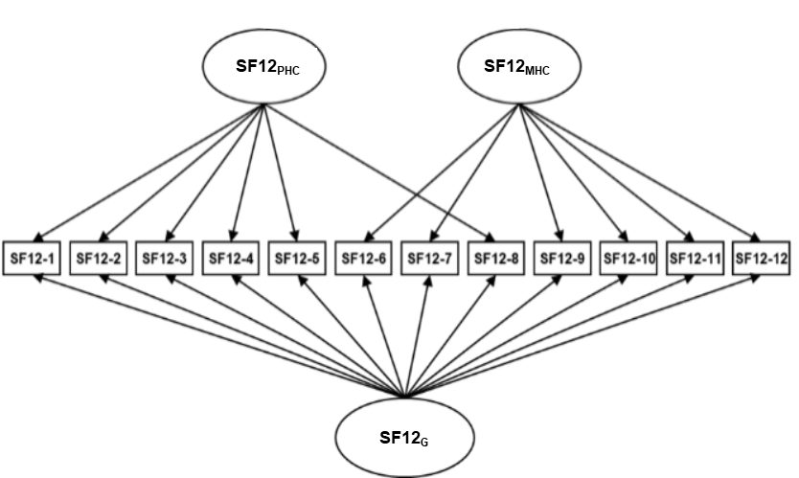
Table A1.6 Factor loadings, communalities (h²), variance explained, and factor correlations for the Model 4a-Bi-factor model of the SF12 questionnaire.
 |  | Loadings |  |  |  |  |  | Variance
 | SF12_{G} | SF12_{PHC} | SF12_{MHC} | h2 |  |  | SF12_{G} | SF12_{PHC} | SF12_{MHC}
SF12-1 | 0.54 | 0.11 |  | 0.31 |  | SS loadings | 5.14 | 0.62 | 0.93
SF12-2 | 0.66 | 0.54 |  | 0.73 |  | Proportion variation | 0.43 | 0.05 | 0.08
SF12-3 | 0.65 | 0.55 |  | 0.72
SF12-4 | 0.85 | -0.04 |  | 0.73 |  | Factor correlations | SF12_{G} | SF12_{PHC} | SF12_{MHC}
SF12-5 | 0.90 | -0.03 |  | 0.80 |  | SF12_{G} | 1 | 0 | 0
SF12-6 | 0.75 |  | 0.27 | 0.63 |  | SF12_{PHC} | 0 | 1 | 0
SF12-7 | 0.56 |  | 0.04 | 0.32 |  | SF12_{MHC} | 0 | 0 | 1
SF12-8 | 0.67 | 0.11 |  | 0.47
SF12-9 | 0.47 |  | 0.39 | 0.37
SF12-10 | 0.57 |  | 0.13 | 0.35
SF12-11 | 0.50 |  | 0.74 | 0.79
SF12-12 | 0.58 |  | 0.38 | 0.48
SF12_{G}: SF12 General Factor, SF12_{PHC}: SF12 Physical Health Composite; SF12_{MHC}: SF12 Mental Health Composite; h2: Communalities (Communalities of an item in IRT and factor analysis represents the proportion of variance in that item which is explained by the latent traits (factors or dimensions) estimated in the model).
Figure A1.5 Graphic representation of the Model 1b- Correlated Two-Factor model of the KDQoL-36 disease specific scale questionnaire

Model 1b Correlated Two-Factor Model
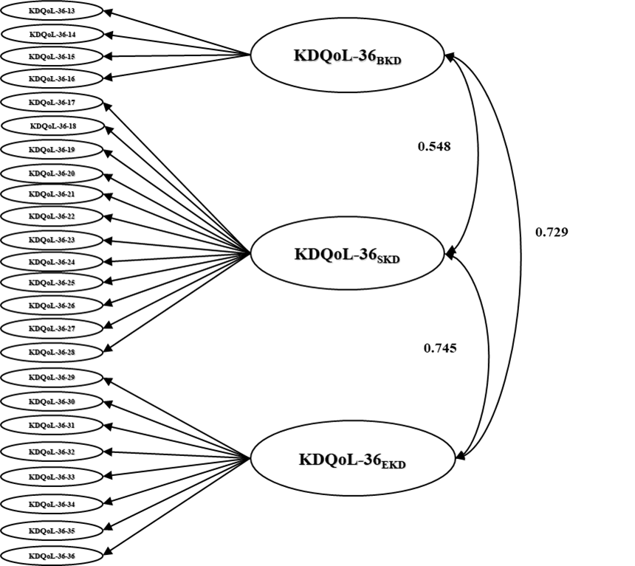
.

Table A1.7 Factor loadings, communalities (h²), variance explained, and factor correlations of the Model 1b- Correlated Two-Factor model of the KDQoL-36 disease specific scale questionnaire
 | Loadings |  |  |  |  |  | Variance
 | BKD | SKD | EKD | h2 |  |  | BKD | SKD | EKD
KDQoL-36-13 | 0.84 |  |  | 0.70 |  | SS loadings | 2.49 | 4.31 | 3.38
KDQoL-36-14 | 0.83 |  |  | 0.68 |  | Proportion variation | 0.10 | 0.18 | 0.14
KDQoL-36-15 | 0.84 |  |  | 0.71 |  | Factor correlations | BKD | SKD | EKD
KDQoL-36-16 | 0.63 |  |  | 0.40 |  | BKD | 1 | 0.548 | 0.729
KDQoL-36-17 |  | 0.62 |  | 0.38 |  | SKD | 0.548 | 1 | 0.745
KDQoL-36-18 |  | 0.62 |  | 0.38 |  | EKD | 0.729 | 0.745 | 1
KDQoL-36-19 |  | 0.53 |  | 0.28
KDQoL-36-20 |  | 0.52 |  | 0.28
KDQoL-36-21 |  | 0.56 |  | 0.31
KDQoL-36-22 |  | 0.65 |  | 0.42
KDQoL-36-23 |  | 0.65 |  | 0.43
KDQoL-36-24 |  | 0.56 |  | 0.32
KDQoL-36-25 |  | 0.75 |  | 0.56
KDQoL-36-26 |  | 0.61 |  | 0.37
KDQoL-36-27 |  | 0.66 |  | 0.43
KDQoL-36-28 |  | 0.40 |  | 0.16
KDQoL-36-29 |  |  | 0.54 | 0.29
KDQoL-36-30 |  |  | 0.56 | 0.32
KDQoL-36-31 |  |  | 0.70 | 0.49
KDQoL-36-32 |  |  | 0.65 | 0.42
KDQoL-36-33 |  |  | 0.68 | 0.46
KDQoL-36-34 |  |  | 0.79 | 0.62
KDQoL-36-35 |  |  | 0.55 | 0.30
KDQoL-36-36 |  |  | 0.70 | 0.49
BKD: KDQoL-36 Burden Kidney Disease, SKD: KDQoL-36 Symptom Kidney Disease, EKD: KDQoL-36 Effect Kidney Disease: h2: Communalities (Communalities of an item in IRT and factor analysis represents the proportion of variance in that item which is explained by the latent traits (factors or dimensions) estimated in the model).
Figure A1.6 Graphic representation of the Model 2b- UnCorrelated Two-Factor model of the KDQoL-36 disease specific scale questionnaire.
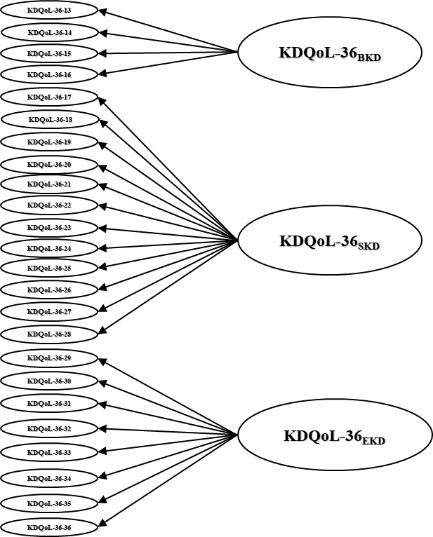
Model 2b Uncorrelated Two-Factor Model

Table A1.8 Factor loadings, communalities (h²), variance explained, and factor correlations of the Model 2b- UnCorrelated Two-Factor model of the KDQoL-36 disease specific scale questionnaire
 | Loadings |  |  |  |  |  | Variance
 | BKD | SKD | EKD | h2 |  |  | BKD | SKD | EKD
KDQoL-36-13 | 0.85 |  |  | 0.72 |  | SS loadings | 2.48 | 4.35 | 3.43
KDQoL-36-14 | 0.85 |  |  | 0.72 |  | Proportion variation | 0.10 | 0.18 | 0.14
KDQoL-36-15 | 0.83 |  |  | 0.69 |  | Factor correlations | BKD | SKD | EKD
KDQoL-36-16 | 0.59 |  |  | 0.35 |  | BKD | 1 | 0 | 0
KDQoL-36-17 |  | 0.62 |  | 0.38 |  | SKD | 0 | 1 | 0
KDQoL-36-18 |  | 0.63 |  | 0.40 |  | EKD | 0 | 0 | 1
KDQoL-36-19 |  | 0.54 |  | 0.30
KDQoL-36-20 |  | 0.54 |  | 0.29
KDQoL-36-21 |  | 0.558 |  | 0.31
KDQoL-36-22 |  | 0.66 |  | 0.44
KDQoL-23 |  | 0.66 |  | 0.43
KDQoL-36-24 |  | 0.56 |  | 0.31
KDQoL-36-25 |  | 0.72 |  | 0.52
KDQoL-36-26 |  | 0.63 |  | 0.40
KDQoL-36-27 |  | 0.66 |  | 0.43
KDQoL-36-28 |  | 0.39 |  | 0.15
KDQoL-36-29 |  |  | 0.56 | 0.32
KDQoL-36-30 |  |  | 0.60 | 0.36
KDQoL-36-31 |  |  | 0.67 | 0.45
KDQoL-36-32 |  |  | 0.66 | 0.43
KDQoL-36-33 |  |  | 0.687 | 0.47
KDQoL-36-34 |  |  | 0.764 | 0.58
KDQoL-36-35 |  |  | 0.566 | 0.32
KDQoL-36-36 |  |  | 0.709 | 0.50
BKD: KDQoL-36 Burden Kidney Disease, SKD: KDQoL-36 Symptom Kidney Disease, EKD: KDQoL-36 Effect Kidney Disease: h2: Communalities (Communalities of an item in IRT and factor analysis represents the proportion of variance in that item which is explained by the latent traits (factors or dimensions) estimated in the model).

Figure A1.7 Graphic representation of the Model 2c- Bi-Factor model of the KDQoL-36 disease specific scale questionnaire.
Model 2c Bi-Factor Model
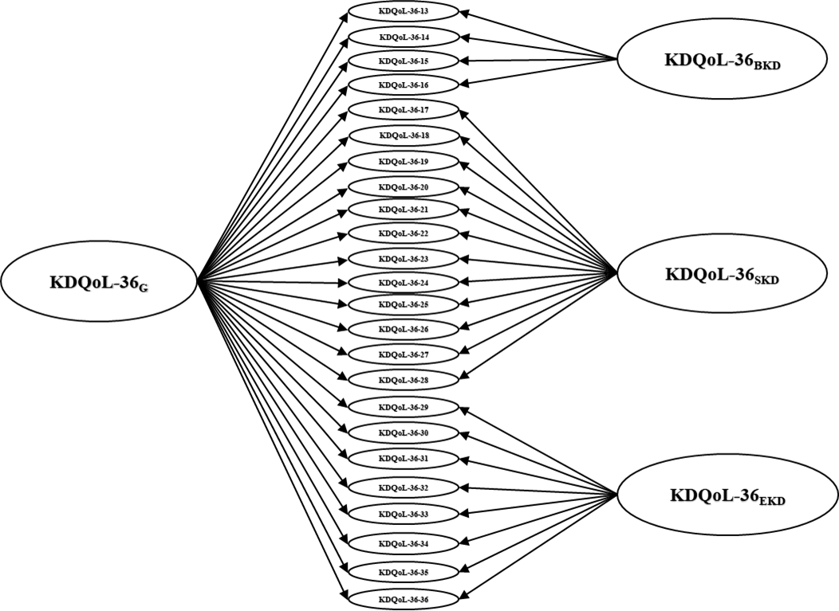

Table A1.9 Factor loadings, communalities (h²), variance explained, and factor correlations of the Model 2b- Bi-Factor model of the KDQoL-36 disease specific scale questionnaire
 |  | Loadings |  |  |  |  |  | Variance
 | KDQoL-36_{G} | BKD | SKD | EKD | h2 |  | KDQoL-36_{G} | BKD | SKD | EKD
KDQoL-36-13 | 0.60 | 0.61 |  |  | 0.72 | SS loadings | 7.14 | 1.12 | 1.96 | 0.88
KDQoL-36-14 | 0.56 | 0.66 |  |  | 0.72 | Proportion variation | 0.30 | 0.05 | 0.04 | 0.04
KDQoL-36-15 | 0.63 | 0.53 |  |  | 0.70 | Factor correlations | KDQoL-36_{G} | BKD | SKD | EKD
KDQoL-36-16 | 0.61 | 0.21 |  |  | 0.35 | KDQoL-36_{G} | 1 | 0 | 0 | 0
KDQoL-36-17 | 0.49 |  | 0.38 |  | 0.38 | BKD | 0 | 1 | 0 | 0
KDQoL-36-18 | 0.43 |  | 0.46 |  | 0.40 | SKD | 0 | 0 | 1 | 0
KDQoL-36-19 | 0.34 |  | 0.44 |  | 0.30 | EKD | 0 | 0 | 0 | 1
KDQoL-36-20 | 0.34 |  | 0.44 |  | 0.29
KDQoL-36-21 | 0.41 |  | 0.40 |  | 0.31
KDQoL-36-22 | 0.47 |  | 0.47 |  | 0.44
KDQoL-23 | 0.49 |  | 0.42 |  | 0.43
KDQoL-36-24 | 0.45 |  | 0.31 |  | 0.31
KDQoL-36-25 | 0.66 |  | 0.34 |  | 0.52
KDQoL-36-26 | 0.40 |  | 0.50 |  | 0.40
KDQoL-36-27 | 0.52 |  | 0.39 |  | 0.43
KDQoL-36-28 | 0.35 |  | 0.19 |  | 0.16
KDQoL-36-29 | 0.46 |  |  | 0.57 | 0.54
KDQoL-36-30 | 0.48 |  |  | 0.73 | 0.76
KDQoL-36-31 | 0.73 |  |  | -0.01 | 0.53
KDQoL-36-32 | 0.64 |  |  | 0.05 | 0.41
KDQoL-36-33 | 0.67 |  |  | 0.09 | 0.46
KDQoL-36-34 | 0.78 |  |  | 0.10 | 0.62
KDQoL-36-35 | 0.54 |  |  | 0.39 | 0.29
KDQoL-36-36 | 0.70 |  |  | 0.06 | 0.49
KDQoL-36_{G:} KDQoL-36 General Factor, BKD: KDQoL-36 Burden Kidney Disease, SKD: KDQoL-36 Symptom Kidney Disease, EKD: KDQoL-36 Effect Kidney Disease: h2: Communalities (Communalities of an item in IRT and factor analysis represents the proportion of variance in that item which is explained by the latent traits (factors or dimensions) estimated in the model).

1.3 Test Information Curves of the selected bifactor models
For completeness, we report in Figure A1.8 and A1.9 Test Information Curves (TICs) representations for SF-12 and kidney disease-specific domains selected models (bifactor models in both cases).

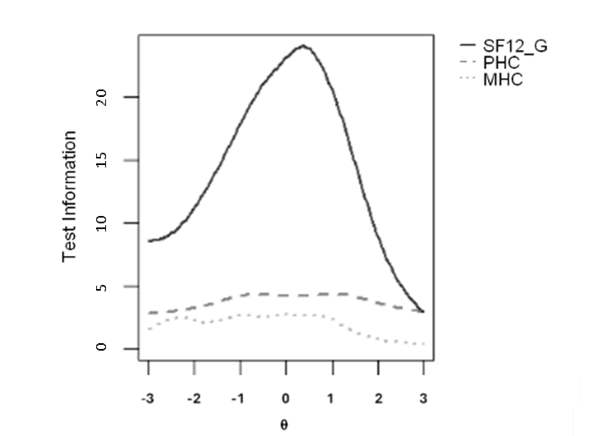
Figure A1.8 Test Information curves of the Bifactor-Model for the SF-12 questionnaire
The plot shows the test information curves across the latent trait (θ) for the general SF-12 factor (SF-12_{G}, solid line), Physical Health Composite factor (PHC, dashed line), and Mental Health Composite factor (MHC, dotted line). The SF-12_{G} provides the highest information, peaking around the mean trait level (-1<θ<1), whereas the domain-specific scales (PHC and MHC) contribute relatively lower test information across the continuum.

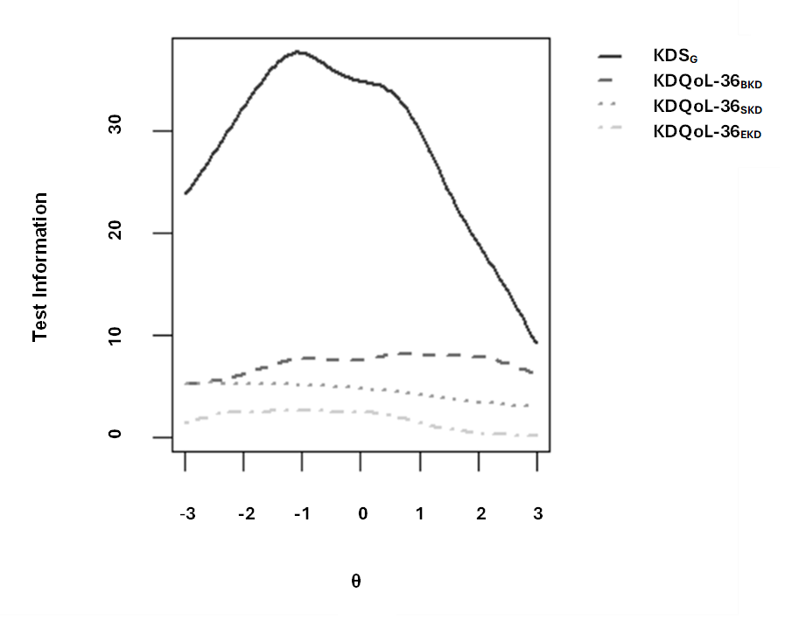
Figure A1.9 Test Information curves of the Bifactor-Model for the KDQoL-36 disease specific scale questionnaire
The plot shows the test information curves across the latent trait (θ) for the general Kidney Disease Scale (KDS_{G}, solid line), Burden kidney disease (BKD, dashed line), symptom kidney disease (SKD, dotted line), and effect kidney disease (EKD, dash-dotted line). The KDS_{G} provides the highest information, peaking around the mean trait level (-1<θ< 0), whereas the domain-specific scales (BKD, SKD, EKD) contribute relatively lower test information across the continuum.

Appendix 2
Computerized Adaptive Testing (CAT) technical details

CAT was applied to selected bifactor models to enhance the efficiency of questionnaire administration while maintaining score accuracy. CAT parameters were optimized by evaluating, for each factor of the models, the differences between scores obtained through full IRT and those generated via CAT using Bland-Altman plots as explained in the main text of the paper.
Here below the details on computed CAT are shown:
SF12:
Initial Item: Selected using the Expected Posterior (EP) Rule to maximize expected precision at baseline.
Subsequent Items: Chosen using the Expected Information (E) Rule to optimize information gain per response.
Stopping Criteria:
- Delta-theta thresholds: SF-12_{G} < 0.03; SF-12_{PHC} < 0.035; SF-12_{MHC} < 0.03
- Minimum Standard Error (min_SEM parameter): SF-12_{G} and SF-12_{PHC} < 0.65; SF-12_{MHC} < 0.70
KIDNEY DISEASE-SPECIFIC DOMAINS:
Initial Item: Selected using the Expected Posterior (EP) Rule to maximize expected precision at baseline.
Subsequent Items: Chosen using the Expected Information (E) Rule to optimize information gain per response.
Stopping Criteria:
- Delta-theta thresholds: KDS_{G} < 0.035; KDQoL-36_{BKD} < 0.035; KDQoL-36_{SKD} < 0.03; KDQoL-36_{EKD} < 0.03
- Minimum Standard Error (min_SEM): KDS_{G} and KDQoL-36_{BKD} < 0.1; KDQoL-36_{SKD} and KDQoL-36_{EKD} < 0.65
- Minimum number of items to be administered: 12 items
- Content Proportion: KDQoL-36_{BKD} = 15%; KDQoL-36_{SKD} = 50%; KDQoL-36_{EKD} = 35% (given the different number of items loading on each factor, to ensure adequate content coverage, the test aims to maintain the outlined proportions across the administered items: this helps maintain a balanced distribution of items across the different dimensions)
Latent traits were estimated via Maximum A Posteriori (MAP) estimation. All these thresholds were tuned to balance precision and response burden.

Appendix 3
T-score and Theta latent traits correspondence

The following table reports the correspondence between theta values obtained using selected bifactor IRT models and standardized T-scores (mean=50 and std=10).

SF-12_{PHC} |  | SF-12_{MHC} |  | KDQoL-36_{BKD} |  | KDQoL-36_{SKD} |  | KDQoL-36_{EKD}
θ | Tscore | θ | Tscore | θ | Tscore | θ | Tscore | θ | Tscore
-2.25 | 10 | -2.78 | 5 | -1.27 | 30 | -2.90 | 5 | -2.22 | 15
-1.97 | 15 | -2.47 | 10 | -0.96 | 35 | -2.58 | 10 | -1.91 | 20
-1.68 | 20 | -2.16 | 15 | -0.65 | 40 | -2.26 | 15 | -1.60 | 25
-1.40 | 25 | -1.85 | 20 | -0.34 | 45 | -1.94 | 20 | -1.29 | 30
-1.12 | 30 | -1.54 | 25 | -0.03 | 50 | -1.62 | 25 | -0.98 | 35
-0.84 | 35 | -1.23 | 30 | 0.28 | 55 | -1.31 | 30 | -0.68 | 40
-0.55 | 40 | -0.92 | 35 | 0.59 | 60 | -0.99 | 35 | -0.37 | 45
-0.27 | 45 | -0.62 | 40 | 0.90 | 65 | -0.67 | 40 | -0.06 | 50
-0.01 | 50 | -0.31 | 45 | 1.21 | 70 | -0.35 | 45 |  | 55
0.30 | 55 | 0.00 | 50 | 1.52 | 75 | -0.04 | 50 |  | 60
0.58 | 60 | 0.31 | 55 |  |  | 0.28 | 55 |  | 65
0.86 | 65 | 0.62 | 60 |  |  | 0.60 | 60
1.14 | 70 | 0.93 | 65 |  |  | 0.92 | 65
1.43 | 75 | 1.24 | 70
1.71 | 80 | 1.55 | 75
1.99 | 85 | 1.86 | 80
2.28 | 90 | 2.1 | 85
2.56 | 95 | 2.48 | 90
 |  | 2.79 | 95
Table A3.1 Score conversion tables for SF-12_{PHC}, SF-12_{MHC}, KDQoL-36_{BKD}, KDQoL-36_{SKD}, and KDQoL-36_{EKD} scales. Values provide reference conversions from θ to raw and T-score metrics for each domain (θ = latent trait estimate; T-score = standardized T-score (mean = 50, SD = 10); PHC = Physical Health Composite score; MHC = Mental Health Composite score; BKD = Burden of Kidney Disease; SKD = Symptoms/Problems of Kidney Disease; EKD = Effects of Kidney Disease).
Appendix 4
Validation Phase and Construct Validity Analysis technical details

To operationalize patients’ overall health status, we computed a Hospitalization Risk Score (HRS) using a multivariable logistic regression model predicting 1-year hospitalization as the dependent variable. Two models were built: the first one on Sf-12 dataset and the second one on kidney disease-specific domains dataset. The models included the following demographic and clinical predictors: age, Charlson comorbidity index, sex, BMI, albumin, phosphate, calcium, haemoglobin, KT/V, parathyroid hormone (Pth), calcium-phosphate product (CAP product), C-reactive protein (CRP), percentage of hemodiafiltration treatments over one year, vascular access type (venous central catheter or arterio-venous fistula), and comorbid conditions such as cancer, diabetes, cardiovascular disease, congestive heart failure, hypertension, hepatitis B, hepatitis C, Chronic Obstructive Pulmonary Disease (COPD), and liver disease. The model was estimated using a binomial family with a logit link function. Variables, coefficients’ estimates and p-values of the computed HRS models are shown in Table A4.1 and A4.2.
Predictive validity: To assess the predictive validity of the HRQoL scores, we conducted a series of logistic regression analyses using hospitalization within 12 months from the survey completion date as the clinically relevant endpoint. Each HRQoL score (derived from both IRT and CAT approaches) was added individually to a baseline model that included only the Hospitalization Risk Score. We then evaluated whether the inclusion of each HRQoL score resulted in a statistically significant improvement in the model’s predictive performance. This approach enabled us to assess the incremental prognostic value of patient-reported HRQoL in predicting clinically meaningful outcomes [Rincon Bello et al., 2024].

Table A4.1: Multivariable Logistic Regression predicting 1-year hospitalization after SF-12 questionnaire completion for the SF-12 dataset.
Variable | Coefficient Estimate | Standard Error | p-value
Intercept | 0.11 | 0.89 | 0.90
Age | 0.00 | 0.00 | 0.24
Charlson Index Score | 0.09 | 0.04 | 0.02 *
Male | -0.13 | 0.09 | 0.17
BMI >25 | -0.23 | 0.09 | 0.02 *
BMI - Missing | -1.11 | 0.96 | 0.24
Albumin >3.5 g/dL | -0.25 | 0.12 | 0.04 *
Albumin - Missing | -0.21 | 0.46 | 0.65
Phosphate >5.5 mg/dL | -0.01 | 0.33 | 0.99
Phosphate 2.5-5.5 mg/dL | -0.28 | 0.26 | 0.28
Phosphate - Missing | -2.06 | 1.23 | 0.09
Calcium >10 mg/dL | -0.40 | 0.29 | 0.17
Calcium 8.4-10 mg/dL | 0.06 | 0.14 | 0.66
Calcium - Missing | 2.10 | 1.49 | 0.16
Hemoglobin >12 g/dL | -0.25 | 0.17 | 0.14
Hemoglobin 10-12 g/dL | -0.37 | 0.15 | 0.01 *
Hemoglobin - Missing | -0.09 | 0.60 | 0.88
OCM_{KTV} >1.4 | -0.17 | 0.18 | 0.34
OCM_{KTV} 1.2-1.4 | 0.12 | 0.20 | 0.55
OCM_{KTV} - Missing | -1.71 | 0.96 | 0.07
Pth >575 pg/mL | -0.27 | 0.16 | 0.09
Pth 130-575 pg/mL | -0.20 | 0.11 | 0.08
Pth - Missing | -0.04 | 0.26 | 0.88
CAP product >55 | -0.08 | 0.24 | 0.76
CAP product 45-55 | -0.25 | 0.14 | 0.07
CAP product - Missing | 0.04 | 0.99 | 0.97
CRP >10 mg/L | -0.09 | 0.10 | 0.36
CRP 5-10 mg/L | -0.01 | 0.79 | 0.99
CRP (Missing) | -0.37 | 0.16 | 0.02 *
Percentage of HDF treatments (1 year) | 0.002 | 0.001 | 0.04 *
Fistula | -0.04 | 0.26 | 0.89
Catheter | 0.08 | 0.27 | 0.77
Cancer | -0.03 | 0.16 | 0.85
Diabetes | 0.19 | 0.12 | 0.11
Cardiovascular Disease | 0.35 | 0.16 | 0.03 *
Congestive Heart Failure | -0.04 | 0.12 | 0.75
Hypertension | -0.20 | 0.14 | 0.17
Hepatitis-B | -0.95 | 0.54 | 0.07
Hepatitis-C | -0.61 | 0.40 | 0.13
COPD | 0.41 | 0.21 | 0.05
Liver Disease | 0.33 | 0.21 | 0.12
Albumin – Serum Albumin; BMI – Body Mass Index;CAP product – Calcium–Phosphate Product; Calcium – Serum Calcium; Catheter – Central Venous Catheter; Charlson Index Score – Charlson Comorbidity Index Score; CHF – Congestive Heart Failure; COPD – Chronic Obstructive Pulmonary Disease; CRP – C-Reactive Protein; CVD – Cardiovascular Disease; Fistula – Arteriovenous Fistula; Hb – Hemoglobin concentration in blood; HDF – Hemodiafiltration; HBV – Hepatitis B Virus; HCV – Hepatitis C Virus; HTN – Hypertension; OCM_{KTV} – Online Clearance Monitoring Kt/V (dialysis adequacy); Phosphate – Serum Phosphate; PTH – Parathyroid Hormone

Estimates represent log-odds coefficients (β) for each predictor, with standard errors (SE), and p-values of Wald z statistics. Positive coefficients indicate higher odds of hospitalization; negative coefficients indicate lower odds. Significance codes: ***p < 0.001, **p < 0.01, *p < 0.05.

Table A4.2: Multivariable logistic regression predicting 1-year hospitalization after questionnaire completion for the disease specific KDQoL-36 scales dataset.
Variable | Coefficient Estimate | Standard Error | p-value
(Intercept) | 1.94 | 1.06 | 0.07
Age | 0.01 | 0.00 | 0.14
Charlson Index Score | 0.16 | 0.05 | 0.00 ***
Male | 0.28 | 0.12 | 0.02 *
BMI >25 | 0.02 | 0.11 | 0.86
BMI - Missing | -16.87 | 307.10 | 0.96
Albumin >3.5 g/dL | 0.07 | 0.15 | 0.66
Albumin - Missing | 0.98 | 0.50 | 0.05
Phosphate >5.5 mg/dL | -1.01 | 0.40 | 0.01 *
Phosphate 2.5-5.5 mg/dL | -0.87 | 0.32 | 0.01 *
Phosphate - Missing | 0.17 | 1.38 | 0.90
Calcium >10 mg/dL | -0.47 | 0.34 | 0.16
Calcium 8.4-10 mg/dL | -0.31 | 0.16 | 0.05
Calcium - Missing | -17.3 | 1691.0 | 0.99
Hemoglobin >12 g/dL | -0.57 | 0.20 | 0.00 **
Hemoglobin 10-12 g/dL | -0.52 | 0.17 | 0.00 **
Hemoglobin - Missing | -0.84 | 0.72 | 0.25
OCM_{KTV} >1.4 | -0.66 | 0.22 | 0.00 **
OCM_{KTV} 1.2-1.4 | -0.68 | 0.25 | 0.01 *
OCM_{KTV} - Missing | -1.51 | 1.19 | 0.20
Pth >575 pg/mL | -0.18 | 0.19 | 0.37
Pth 130-575 pg/mL | -0.36 | 0.14 | 0.01 *
Pth - Missing | -0.21 | 0.29 | 0.47
CAP product >55 | 0.50 | 0.29 | 0.09
CAP product 45-55 | -0.12 | 0.16 | 0.47
CAP product - Missing | 16.2 | 1691.0 | 0.99
CRP >10 mg/L | 0.24 | 0.13 | 0.06
CRP 5-10 mg/L | -0.07 | 1.05 | 0.95
CRP - Missing | -0.39 | 0.19 | 0.03 *
Percentage of HDF treatments (1 year) | 0.002 | 0.001 | 0.66
Fistula | -0.41 | 0.31 | 0.19
Catheter | -0.29 | 0.32 | 0.37
Cancer | -0.40 | 0.19 | 0.03 *
Diabetes | -0.09 | 0.14 | 0.51
Cardiovascular Disease | 0.03 | 0.19 | 0.88
Congestive Heart Failure | -0.04 | 0.14 | 0.79
Hypertension | 0.10 | 0.18 | 0.57
Hepatitis-B | -0.33 | 0.56 | 0.56
Hepatitis-C | 0.01 | 0.43 | 0.97
COPD | -0.23 | 0.24 | 0.35
Liver Disease | -0.67 | 0.27 | 0.01 *
Albumin – Serum Albumin; BMI – Body Mass Index;CAP product – Calcium–Phosphate Product; Calcium – Serum Calcium; Catheter – Central Venous Catheter; Charlson Index Score – Charlson Comorbidity Index Score; CHF – Congestive Heart Failure; COPD – Chronic Obstructive Pulmonary Disease; CRP – C-Reactive Protein; CVD – Cardiovascular Disease; Fistula – Arteriovenous Fistula; Hb – Hemoglobin concentration in blood; HDF – Hemodiafiltration; HBV – Hepatitis B Virus; HCV – Hepatitis C Virus; HTN – Hypertension; OCM_{KTV} – Online Clearance Monitoring Kt/V (dialysis adequacy); Phosphate – Serum Phosphate; PTH – Parathyroid Hormone
Estimates represent log-odds coefficients (β) for each predictor, with standard errors (SE), and p-values of Wald z statistics. Positive coefficients indicate higher odds of hospitalization; negative coefficients indicate lower odds. Significance codes: ***p < 0.001, **p < 0.01, *p < 0.0

Appendix 5
We provide here the calibration parameters of our item bank to enable and encourage replication studies by independent researchers.
Table A5.1 Multidimensional Item Response Theory parameters (slopes and thresholds) for SF12 questionnaire (Items 1-12 graded response model).
 | Slope |  |  | Thresholds
 | a1 | a2 | a3 | d1 | d2 | d3 | d4
SF12-1 | 1.1066 | 0.2253 | 0 | 2.0611 | -0.0191 | -2.2351 | -3.5664
SF12-2 | 2.1551 | 1.7749 | 0 | 1.4064 | -1.9296 | NA | NA
SF12-3 | 2.0763 | 1.7491 | 0 | 1.0733 | -2.0246 | NA | NA
SF12-4 | 2.8065 | -0.1416 | 0 | -0.7246 | NA | NA | NA
SF12-5 | 3.4355 | -0.1131 | 0 | -1.4826 | NA | NA | NA
SF12-6 | 2.0770 | 0 | 0.7479 | -0.0252 | NA | NA | NA
SF12-7 | 1.1640 | 0 | 0.0821 | 0.2323 | NA | NA | NA
SF12-8 | 1.5726 | 0.2568 | 0.0000 | 3.7164 | 1.8167 | -1.0584 | NA
SF12-9 | 1.0117 | 0 | 0.8340 | 4.1159 | 2.4686 | 0.9133 | -1.6190
SF12-10 | 1.2048 | 0 | 0.2699 | 2.6501 | 0.9337 | -0.5659 | -2.8256
SF12-11 | 1.8311 | 0 | 2.7156 | 6.5282 | 2.8359 | 0.2094 | -2.1463
SF12-12 | 1.3820 | 0 | 0.8963 | 3.4067 | 1.8445 | 0.0700 | -1.0919
Slopes (a1–a3) represent discrimination for General Factor (SF-12_{G}), a2=Physical health composite (PHC) factor, a3=Mental health composite (MHC) factors. Thresholds (d1–d4) denote step difficulties between adjacent response categories.
Notes
Slopes (a1, a2, a3) are item discrimination parameters on three latent factors: a1=SF-12_{G}, a2=PHC (physical health composite), a3=MHC (mental health composite). The number of “a” columns equals the number of factors (three here). Larger absolute values indicate stronger discrimination; values fixed at 0 denote no loading on that factor.
Thresholds (d1, d2, d3, d4 …) are step (category) difficulty parameters marking the transition between adjacent ordered response categories. The number of “d”s for a given item equals the “number of response categories−1” e.g., a yes/no item has only d1; items with 3, 4, or 5 categories have 2, 3, or 4 thresholds, respectively. NA = not applicable (the item has fewer categories than additional thresholds).
More positive threshold values indicate that a higher level of the latent trait (θ) is required to endorse the higher category; more negative thresholds indicate the opposite.
Parameter estimates are reported on a standardized latent‐trait metric (θ mean = 0, SD = 1). Signs reflect the coding of categories; cross-loadings (non-zero slopes on >1 factor) indicate multidimensional sensitivity of an item.

Table A5.2 Multidimensional Item Response Theory parameters for the KDQoL-36 Disease-specific scale (Items 13–36; graded response model).
 | Slope |  |  |  | Thresholds
 | a1 | a2 | a3 | a4 | d1 | d2 | d3 | d4
KDQoL-36-13 | 1.9305 | 1.9782 | 0 | 0 | 1.7141 | -1.6122 | -2.3016 | -4.5730
KDQoL-36-14 | 1.8877 | 2.2011 | 0 | 0 | 2.2742 | -1.0508 | -1.7854 | -4.4018
KDQoL-36-15 | 1.8713 | 1.5626 | 0 | 0 | 2.5442 | -0.2334 | -0.8198 | -2.8403
KDQoL-36-16 | 1.3706 | 0.4587 | 0 | 0 | 2.5563 | 0.8235 | 0.2622 | -0.8641
KDQoL-36-17 | 1.0524 | 0 | 0.8194 | 0 | 3.6225 | 2.2088 | 0.9583 | -0.6375
KDQoL-36-18 | 0.9488 | 0 | 1.0070 | 0 | 5.8836 | 4.5847 | 3.1136 | 1.7343
KDQoL-36-19 | 0.7005 | 0 | 0.9012 | 0 | 4.0462 | 2.6041 | 1.3758 | -0.2058
KDQoL-36-20 | 0.7013 | 0 | 0.9104 | 0 | 3.9771 | 2.6131 | 1.5401 | 0.0347
KDQoL-36-21 | 0.8483 | 0 | 0.8254 | 0 | 3.5326 | 2.1537 | 1.0733 | -0.5064
KDQoL-36-22 | 1.0552 | 0 | 1.0592 | 0 | 4.7147 | 3.1384 | 1.8687 | 0.3642
KDQoL-36-23 | 1.1059 | 0 | 0.9393 | 0 | 5.1577 | 3.4303 | 1.9525 | 0.1847
KDQoL-36-24 | 0.9261 | 0 | 0.6405 | 0 | 4.1576 | 2.9993 | 1.8892 | 0.5997
KDQoL-36-25 | 1.6906 | 0 | 0.8712 | 0 | 4.1672 | 2.3810 | 0.9412 | -1.0755
KDQoL-36-26 | 0.8881 | 0 | 1.1198 | 0 | 4.4604 | 2.8208 | 1.6297 | 0.0124
KDQoL-36-27 | 1.1739 | 0 | 0.8875 | 0 | 5.3486 | 3.6538 | 2.3997 | 0.9378
KDQoL-36-28 | 0.6582 | 0 | 0.3445 | 0 | 4.5272 | 3.2214 | 2.2784 | 1.0693
KDQoL-36-29 | 1.1429 | 0 | 0 | 1.4388 | 3.3943 | 1.9065 | 0.6721 | -1.0901
KDQoL-36-30 | 1.6343 | 0 | 0 | 2.4998 | 5.8441 | 3.6228 | 1.6627 | -0.7508
KDQoL-36-31 | 1.8085 | 0 | 0 | -0.0217 | 3.7934 | 2.1309 | 0.8434 | -0.8579
KDQoL-36-32 | 1.4148 | 0 | 0 | 0.1153 | 1.9703 | 0.7483 | -0.0435 | -1.1204
KDQoL-36-33 | 1.5490 | 0 | 0 | 0.2097 | 3.9893 | 2.5586 | 1.3714 | 0.1151
KDQoL-36-34 | 2.1534 | 0 | 0 | 0.2622 | 4.4785 | 2.8024 | 1.2382 | -0.8284
KDQoL-36-35 | 1.0929 | 0 | 0 | 0.0782 | 2.5239 | 1.6069 | 0.9006 | 0.1388
KDQoL-36-36 | 1.6626 | 0 | 0 | 0.1433 | 4.3328 | 2.8629 | 1.6743 | 0.3520
Slopes (a1–a4) represent discrimination for KDS_{G}, BKD, SKD, and EKD factors. Thresholds (d1–d4) denote step difficulties between adjacent response categories.
Notes
Slopes (a1–a4) are item discrimination parameters. The number of a columns equals the number of latent factors (here 4): a1 = KDS_{G} (kidney-disease–specific global factor) a2 = BKD (Burden of Kidney Disease) a3 = SKD (Symptoms/Problems of Kidney Disease) a4 = EKD (Effects of Kidney Disease). Larger absolute slope values indicate stronger ability of the item to differentiate respondents along that factor. Values fixed at 0 indicate no loading on that factor (constrained). Non-zero loadings on more than one a column indicate cross-factor sensitivity.
Thresholds (d1–d4) are category (step) difficulty parameters that mark the transition points between adjacent ordered response categories. The number of d columns per item equals (# response categories − 1). In this table all items have four thresholds (i.e., five ordered categories). More positive thresholds mean a higher level of the underlying trait (θ) is required to endorse the higher response category; more negative thresholds mean the opposite (direction depends on item coding).
Parameter estimates are reported on a standardized latent-trait metric (θ mean = 0, SD = 1).

