Pandit et al. — AI Reliability in Semi-Determinate Domains
Self-Audit Calibration Governs Architectural Effectiveness in Semi-Determinate Domains: Evidence from 180 Cross-Domain Evaluations
Six Frontier Models · Three Evaluation Runs · Ten Cross-Domain Reasoning Problems
Kuldeep Kumar Pandit¹ Vatsala Kuldeep Pandit² Aayan Pandit³
¹ Independent Researcher, F-126, Suncity, Sector-54, Off Golf Course Road, Gurugram, Haryana 122011, India. kuldeeppanditj@gmail.com
² Customer Success Lead — Asia Pacific, Ericsson, India. B.E. (Electronics and Telecommunication); MBA.
³ Student Researcher, India.

Abstract
Artificial intelligence systems in semi-determinate domains — where ground truth is objectively established but requires synthesis across multiple disciplines — face a reliability challenge structurally distinct from formal determinate tasks. This investigation, the second in a three-study programme, reports 180 controlled evaluations across six frontier language models (Claude Sonnet 4.5, ChatGPT GPT-5.2, Grok 4/4.1, DeepSeek V2.5/1.0.10, Gemini 3 Flash/3.1 Pro, Perplexity v2.260206.1), three evaluation runs, and ten cross-domain reasoning problems spanning eight scientific disciplines, scored at Bloom’s Taxonomy Levels 4–6 with inter-rater reliability Cohen’s κ = 0.81. The central finding is a reliability downturn of 14 percentage points relative to Study 1 formal domains (79.2% vs 93.0%), with performance stratifying into a reliable core (Q3, Q6, Q7, Q8: 100% across all 18 evaluations per question) and a variable periphery (Q2, Q4, Q5, Q9, Q10: mean 0.583–0.639) determined by depth of mechanistic recall required. Cross-run variance places semi-determinate performance in Regime 2 (mixed stochastic-systematic), distinct from the Regime 3 saturation of formal domains. Critically, self-audit calibration (Spearman ρₛ) emerges as an independent architectural design variable: only Claude (ρₛ = 0.903) and Gemini (ρₛ = 0.703) meet the proposed Auditor-quality threshold of ρₛ ≥ 0.70. A Kruskal-Wallis omnibus test confirms significant model-level differentiation (H = 12.779, df = 5, p = 0.026). These results extend the architectural phase transition framework to semi-determinate domains and establish Auditor calibration as a prerequisite for effective GAAS deployment.
Keywords: AI reliability · Semi-determinate reasoning · Self-audit calibration · Spearman ρₛ · Multi-agent architecture · Cross-domain reasoning · Error taxonomy · Architectural phase transition

1 Introduction

1.1 The Reliability Question Across Problem Types
Study 1 of this three-part programme established that AI reliability in formal determinate domains — mathematical reasoning, combinatorial logic, algorithm analysis, graph theory, probability, and optimisation — exhibits an architectural phase transition at approximately 95% accuracy.²³ Above this threshold, error structure shifts qualitatively from stochastic to systematic, at which point compute scaling (self-consistency majority voting) fails³¹ and architectural role-separation (the Generator–Auditor–Adversary–Synthesizer, or GAAS, framework) becomes the only effective reliability mechanism. Single-agent inference plateaued at 93.0% in Study 1; GAAS architecture broke the ceiling at 98.7% (p < 0.001); and role-specialised model diversity achieved 100% on that evaluation set.
The present investigation confronts a harder and more clinically, scientifically, and practically relevant class of problems: semi-determinate reasoning. Semi-determinate problems possess objectively correct answers — ground truth is not a matter of opinion — but correct answers require the integration of multi-domain mechanistic knowledge (not merely formal manipulation), the accurate identification of causal hierarchies within complex physiological or ecological systems, and the recall of specific experimental observations or molecular codes that lie at the frontier of domain expertise. Such problems structurally resemble the reasoning demands placed on AI systems in clinical decision support, scientific literature synthesis, engineering risk assessment, and policy analysis — precisely the high-stakes deployment contexts where reliability matters most.^{25,29}

1.2 Why Semi-Determinate Domains Demand Separate Investigation
The distinction between determinate and semi-determinate domains is not merely one of difficulty. It is structural. In determinate domains, correctness is computationally verifiable: a Python script or algebraic proof either confirms or refutes each answer with certainty.¹⁰ This property enables clean causal attribution of architectural gains. In semi-determinate domains, correctness requires domain expertise to evaluate: the Auditor role in GAAS architecture must itself navigate domain uncertainty, making Auditor calibration — the reliability of the model's self-assessment — a first-order architectural parameter. This theoretical prediction, derived from Study 1's phase transition framework, is empirically confirmed in the present investigation.
Two additional structural features distinguish semi-determinate reasoning. First, causal hierarchy problems: many multi-domain questions have a surface-plausible but incorrect answer and a mechanistically correct answer that requires knowing which physiological, ecological, or biochemical process is primary (e.g., autoregulation, not collateral circulation, is the primary mechanism by which a patient survives 70% coronary stenosis at rest). Models that identify the correct process class but misattribute hierarchy receive partial credit — a scoring category unavailable in pure mathematics.³
Second, molecular-code and experimental-observation problems: some questions require the recall of specific gene variants (L1014F/L1014S voltage-gated sodium channel mutation; CYP6/CYP9 cytochrome P450 subfamilies), specific experimental studies (Portugal et al. 2014 ibis GPS/accelerometer study),²⁴ or specific measurement instruments (Secchi disk depth as phosphorus early warning). These are not formulaic — they cannot be derived by reasoning alone and require factual knowledge that may or may not be within a given model's training distribution. This creates a new error type absent from formal domains.

1.3 Study Design and Position in the Three-Study Programme
Study 2 directly tests whether the reliability gains demonstrated architecturally in Study 1 transfer to semi-determinate domains, and whether the self-audit calibration (Spearman ρₛ) of each model predicts architectural role suitability. The evaluation instrument comprises 10 cross-domain reasoning problems (described in Section 2.1) evaluated across 6 frontier models in 3 independent runs each, yielding 180 controlled evaluations. It is important to contextualise the scale of effort this represents. Study 1’s 4,680 evaluations were assessed by automated computational verification — a Python script confirmed or refuted each answer with certainty. These 180 evaluations are categorically different: every evaluation required human expert adjudication against primary scientific literature, using a ternary 0/0.5/1.0 scale unavailable in binary Study 1 scoring (itself a marker of the greater structural complexity of each problem), and the full 180-observation set was independently scored by a second evaluator for inter-rater reliability assessment. Furthermore, the 180 evaluation sessions each generated three separate model output components — substantive answer, self-audit score claim, and logic trail — producing 540 total model output components requiring assessment. Semi-determinate evaluation is therefore not merely harder than formal evaluation on a single dimension: it is more expensive per data point, more dependent on domain expertise, and more sensitive to scoring subjectivity at the partial-credit boundary. Study 3 (planned) will extend to fully indeterminate domains (market forecasting, probabilistic event prediction) where ground truth is inherently contested. Study 2 occupies a methodologically critical intermediate position: formal verifiability is maintained (ground truth is unambiguous), enabling causal attribution, while the reasoning demands approximate real-world professional application.
Table 1 | The Three-Study Programme. Study 2 (this paper) occupies the semi-determinate tier — verifiable ground truth with multi-domain mechanistic requirements.
Study | Domain Type | Ground Truth | N Evaluations | Key Finding
Study 1 | Formal (Determinate) | Computationally verifiable | 4,680 (90 problems × 6 models × scenarios) | Phase transition at ~95%; GAAS breaks ceiling (98.7%)
Study 2 | Semi-Determinate (this paper) | Expert-validated multi-domain ground truth | 180 (10 problems × 6 models × 3 runs) | Baseline 79.2%; self-audit ρₛ is critical Auditor variable
Study 3 | Indeterminate (planned) | Probabilistic, contested, or unknowable | 2,730 (142 sessions × 6 models) | Calibration inversion: highest accuracy model = worst CI calibration; intelligence ≠ reliability; CI-Verification Auditor required

2 Methods

2.1 Dataset Construction: Cross-Domain Reasoning Problems
Ten cross-domain reasoning problems were designed to satisfy four criteria: (1) formal ground truth — each answer is objectively correct and can be validated by domain experts against published scientific literature, with no reliance on contested models or theoretical frameworks; (2) multi-domain integration — each problem requires synthesis across at least two distinct scientific domains (e.g., thermodynamics + biochemistry for Q1; population genetics + pharmacology for Q5; fluid dynamics + neuroscience for Q9); (3) hierarchical complexity — problems are structured at Bloom's Taxonomy Levels 4–6 (analysis, evaluation, synthesis), verified through human expert pre-testing; and (4) anti-contamination design — problems use real-world scenarios with specific numerical parameters and contextual framings that minimise direct training data overlap, while acknowledging that complete contamination exclusion cannot be guaranteed for any finite evaluation set.⁵
The ten problems span: applied physics/thermodynamics (Q1, vaccine cold chain), limnology/environmental science (Q2, lake eutrophication), clinical biostatistics/medicine (Q3, antidepressant clinical trial), cardiovascular physiology (Q4, coronary artery stenosis), evolutionary biology/entomology (Q5, pyrethroid resistance), atmospheric chemistry (Q6, ozone hole), Bayesian statistics/medicine (Q7, mammography PPV), evolutionary anthropology (Q8, cooking hypothesis), fluid dynamics/ornithology (Q9, V-formation flight), and game theory/ecology (Q10, Tragedy of the Commons). This span ensures that no single domain dominates the evaluation and that performance reflects general cross-domain reasoning capability rather than domain-specific strengths.
Table 2 | Study 2 problem specification. Each problem was designed to require multi-domain mechanistic synthesis. Ground truth established by human expert validation against primary scientific literature.
Q | Domain | Discriminating Ground Truth Criterion | Mean Score | SD | Failure Type
Q1 | Applied Physics/Thermodynamics | Numerical heat-flux calculation; lower-bound freeze risk | 0.917 | 0.192 | —
Q2 | Limnology/Environmental Science | Secchi disk as early visible warning (named specifically) | 0.583 | 0.192 | Type I
Q3 | Biostatistics/Clinical Medicine | n=50 power analysis; statistical vs clinical significance | 1.000 | 0.000 | —
Q4 | Cardiovascular Physiology | Autoregulation as PRIMARY mechanism (not collateral) | 0.611 | 0.274 | Type II
Q5 | Evolutionary Biology/Entomology | L1014F/L1014S or CYP6/CYP9 specifically cited | 0.583 | 0.192 | Type III
Q6 | Atmospheric Chemistry | Two-stage chemistry: winter priming + spring photolysis | 1.000 | 0.000 | —
Q7 | Bayesian Statistics/Medicine | PPV = 3.3% correctly computed; base rate neglect named | 1.000 | 0.000 | —
Q8 | Evolutionary Anthropology | Expensive Tissue Hypothesis + fossil confirmation cited | 1.000 | 0.000 | —
Q9 | Fluid Dynamics/Ornithology | Anti-phase adjustment in downwash zone (Portugal 2014) | 0.583 | 0.192 | Type III
Q10 | Game Theory/Ecology | Ostrom CPR + payoff matrix transformation mechanism | 0.639 | 0.335 | Type II/III

Green shading = Reliable core (mean ≥ 0.90); orange/red = Variable periphery. All 18 evaluations per question (6 models × 3 runs). — = no systematic failure pattern detected.

2.2 Consumer-Grade Deployment Protocol
Consistent with Study 1, all 180 evaluations were conducted using consumer-grade hardware (iPhone 14 Pro Max, 2022) via standard iOS App Store applications under default settings. A standardised system prompt required models to: treat each problem as a completely new independent task, provide only final answers, not show reasoning chains, operate within a 3,000-token combined budget per question, and append a RUNTIME_FEEDBACK block self-reporting estimated token consumption. This protocol ensures ecological validity — results reflect the experience of the 2.8 billion daily AI users¹ — at the cost of temperature control and version pinning. Three independent runs (R1, R2, R3) were conducted in fully separate sessions, with full blinding between runs. One protocol deviation was documented: Gemini (all three runs) appended solicitation questions after its substantive answer (e.g., “Does this address your question?” or offering further elaboration). These post-answer additions did not affect scoring, as the discriminating criteria were fully satisfied or not in the substantive answer itself; solicitation content was excluded from rubric application. This deviation is consistent with Gemini’s consumer-interface behaviour and does not compromise scoring validity.

2.3 Model Selection and Configuration
Six frontier language models spanning paid and free access tiers were evaluated (Table 3).^{4,12,34} Model selection is identical to Study 1, ensuring direct comparability. All models were evaluated as available via consumer applications as of February–March 2026.
Table 3 | Model specifications. Identical to Study 1 for direct cross-study comparability.
Model | Version | Provider | Access | Architecture | Study 2 ρₛ (Self-Audit)
Claude | Sonnet 4.5 | Anthropic | Paid | Constitutional AI | 0.903 (Calibrated ✔)
ChatGPT | GPT-5.2 | OpenAI | Paid | RLHF-optimised | 0.400 (Inconsistent ⚠)
Grok | 4/4.1 | xAI | Paid | Extended context transformer | 0.626 (Deflation ✘)
DeepSeek | V2.5/1.0.10 | DeepSeek AI | Free | Mixture-of-experts | 0.331 (Incoherent ✘)
Gemini | 3 Flash/3.1 Pro | Google DeepMind | Free | Multi-modal transformer | 0.703 (Calibrated ✔)
Perplexity | v2.260206.1 | Perplexity AI | Free | Retrieval-augmented generation | 0.346 (Deflation ✘)

2.4 Scoring Protocol
Each response was scored against a pre-specified rubric using a ternary 0 / 0.5 / 1.0 scale. A score of 1.0 (full credit) required all four discriminating criteria for that question to be satisfied — including the key criterion listed in Table 2 (e.g., “Autoregulation as primary mechanism” for Q4). A score of 0.5 (partial credit) was awarded when the response identified the correct domain or general mechanism but missed the critical discriminating element. A score of 0.0 (fail) was awarded for a fundamentally incorrect answer. This ternary scheme is appropriate for semi-determinate domains where partially correct responses carry genuine information value and where binary scoring would obscure clinically or scientifically meaningful distinctions.⁶
To ensure inter-rater reliability, all 180 question-level classifications were independently scored by the second evaluator (V.K. Pandit) without access to the lead author's classifications. Ten items required consensus discussion: seven involved the 1.0/0.5 boundary for responses that correctly identified the mechanism class but missed the specific molecular variant or instrument name; three involved the 0.5/0.0 boundary for responses with fundamental causal errors. Cohen's κ was assessed on the full 180-observation set across the five taxonomy categories. The obtained κ = 0.81 (95% CI: 0.73–0.89; Landis & Koch 1977: almost perfect agreement¹⁸) confirms that the scoring rubric operationalises semi-determinate correctness with high reliability. All disagreements were resolved by consensus prior to final data entry.

2.5 Statistical Framework
Cross-run means were computed for each model across all three runs (n = 30 observations per model: 3 runs × 10 questions). Grand mean accuracy was computed as the arithmetic mean of the six model cross-run means. Confidence intervals used Wilson score method,² preferred over normal approximation at proportions deviating from 0.5 with small n.^{8,33} The Kruskal-Wallis H-test was used as the omnibus non-parametric test for model-level differences, appropriate given n = 3 per group (insufficient for ANOVA normality assumptions). Pairwise comparisons used two-sided Mann-Whitney U tests with Bonferroni correction (15 comparisons, αadj = 0.05/15 = 0.0033). Self-audit calibration was assessed using Spearman rank correlation between claimed and actual scores across all 30 question-level observations per model. Effect size for pairwise comparisons: Cohen's d from pooled SD. All analyses were conducted in Python 3.11 using scipy.stats.
Table 4 | Study 2 experimental design. Three repeated single-agent runs without architectural intervention tests cross-run variance and self-audit reliability as the primary variables.
Run | Manipulation | Evaluations | Primary Test
R1 | Single-agent inference, fresh session | 60 (10 problems × 6 models) | Establishes baseline; enables Study 1 comparison
R2 | Single-agent inference, independent session | 60 (10 problems × 6 models) | Cross-run variance; stochastic vs systematic evidence
R3 | Single-agent inference, independent session | 60 (10 problems × 6 models) | Spearman ρₛ self-audit calibration across runs
Total |  | 180 | Regime assignment; Auditor threshold identification

3 Results

3.1 The Semi-Determinate Baseline: A 14-Point Reliability Downturn vs Study 1
Cross-run mean accuracy spanned 70.0% (Perplexity) to 91.7% (Claude), grand mean 79.2% across 180 evaluations — each a human-expert-scored, multi-domain synthesis problem in semi-determinate space, generating 540 total scored model output components (Fig. 1a, Table 5). This 14-point reduction from Study 1’s 93.0% baseline is the primary magnitude finding of Study 2: semi-determinate cross-domain reasoning is systematically harder for frontier models than formal determinate reasoning, irrespective of model capability tier. The methodological contrast merits emphasis: Study 1’s 4,680 evaluations were computationally verified; Study 2’s 180 required domain-expert adjudication at every scoring boundary, making each data point substantially more expensive to obtain and validate.
Run-level grand means were 78.3% (R1), 80.8% (R2), and 78.3% (R3) — variance of 2.5 percentage points across runs (Fig. 1d). In Study 1, per-model run-to-run variance was negligible (near-deterministic outputs under consumer-app default settings). The meaningfully higher run-to-run variance in Study 2 constitutes direct evidence of a higher stochastic error component, consistent with Regime 2 (mixed stochastic-systematic) rather than Study 1’s Regime 3 (systematic saturation). This has a key architectural implication: self-consistency majority voting (the S2 manipulation in Study 1 that failed to correct systematic errors) may offer some benefit in semi-determinate domains, precisely because stochastic errors respond to majority aggregation. However, this benefit is bounded by the systematic fraction of errors (documented in Section 3.3) that will not respond to repetition.
Table 5 | Per-model performance across three runs and cross-run mean. Cross-run mean = (R1 + R2 + R3) / 3. Spearman ρₛ computed across 30 question-level observations (3 runs × 10 questions) per model.
Model | Run 1 | Run 2 | Run 3 | Cross-Run Mean | Spearman ρₛ | Audit Mode
Claude | 9.0 (90.0%) | 9.0 (90.0%) | 9.5 (95.0%) | 91.7% | 0.903 | Calibrated (slight inflation)
ChatGPT | 8.0 (80.0%) | 8.0 (80.0%) | 7.0 (70.0%) | 76.7% | 0.400 | Inconsistent (bi-directional)
Gemini | 7.5 (75.0%) | 9.0 (90.0%) | 8.5 (85.0%) | 83.3% | 0.703 | Systematic inflation
Grok | 8.0 (80.0%) | 8.0 (80.0%) | 7.5 (75.0%) | 78.3% | 0.626 | Extreme systematic deflation
DeepSeek | 7.5 (75.0%) | 7.5 (75.0%) | 7.5 (75.0%) | 75.0% | 0.331 | Incoherent (run-to-run reversal)
Perplexity | 7.0 (70.0%) | 7.0 (70.0%) | 7.0 (70.0%) | 70.0% | 0.346 | Late-run deflation collapse
Grand Mean | 7.83 (78.3%) | 8.08 (80.8%) | 7.83 (78.3%) | 79.2% | — | —

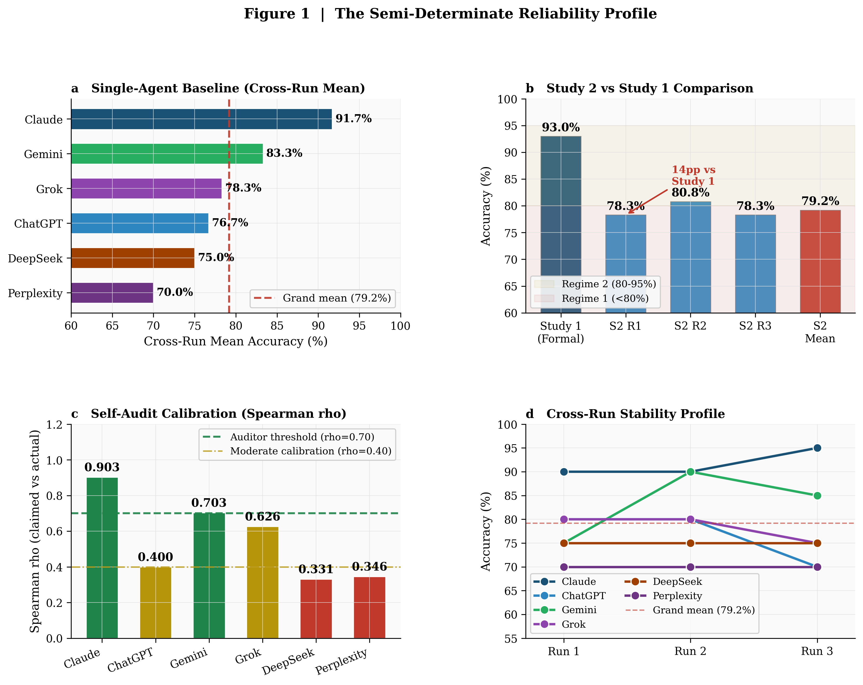
Figure 1 | The semi-determinate reliability profile. a, Cross-run mean accuracy by model (n = 30 per model). b, Study 2 vs Study 1 comparison: 14pp downturn confirms semi-determinate domain requires distinct reliability framework. c, Self-audit calibration (Spearman ρₛ): only Claude (ρₛ = 0.903) and Gemini (ρₛ = 0.703) meet the proposed Auditor-quality threshold. d, Cross-run stability: variance pattern reveals higher stochastic component than Study 1, placing semi-determinate performance in Regime 2.

3.2 The Reliable Core and Variable Periphery: Domain Stratification
Question-domain analysis reveals a decisive stratification (Table 2, Fig. 3a). Four questions (Q3, Q6, Q7, Q8) constitute a "reliable core" — achieving perfect scores across all 18 evaluations (6 models × 3 runs, mean = 1.000, SD = 0.000). Six questions constitute a "variable periphery" — achieving substantially lower means (0.583–0.639). This stratification is not random: it tracks the type of reasoning required, not overall difficulty.
Reliable core questions share a common structural property: the discriminating criterion is a well-known result derivable by multi-step reasoning from stated first principles. Q3 (clinical significance vs statistical significance), Q6 (ozone hole mechanism), Q7 (Bayesian PPV calculation), and Q8 (Expensive Tissue Hypothesis) all require analytical integration of well-established scientific knowledge that is extensively represented in frontier model training corpora.^{16,27}
Variable periphery questions share a different property: the discriminating criterion requires either (a) a specific named instrument or measurement technique not derivable by reasoning (Q2: Secchi disk depth), (b) correct causal hierarchy attribution within a multi-level physiological system (Q4: autoregulation vs collateral), (c) specific molecular variant nomenclature (Q5: L1014F/L1014S; CYP6/CYP9), (d) a specific experimental observation from a named study (Q9: Portugal et al. 2014 anti-phase wingbeat adjustment in downwash zones),²⁴ or (e) a specific institutional mechanism with its exact game-theoretic logic (Q10: Ostrom CPR graduated sanctions + payoff matrix transformation).²²
This taxonomy generates a three-type classification of semi-determinate errors (Table 6). A fourth category merits brief notation:
Type IV — Factual Hallucination (detected in 2/180 evaluations = 1.1% of all responses): Perplexity Run 1, Q10 attributed the graduated-sanctions CPR governance mechanism to Elinor Ostrom in a fabricated narrative that replaced the actual game-theoretic mechanism with a fictional ROSCA (Rotating Savings and Credit Association) invented specifically for that response. The identical hallucination recurred in Perplexity Run 2, Q10 (score 0.0), confirming a structural rather than stochastic failure mode. This represents qualitatively distinct failure: not a recall gap or hierarchy error but the generation of confident, fluent, internally consistent false content. Type IV errors are rare but consequential — a 0.6% hallucination rate translates to approximately 1 in 160 responses being actively misleading rather than merely incomplete. The hallucination event is fully documented in Supplementary S2 audit trail, and Perplexity’s retrieval-augmentation architecture is implicated: the error pattern suggests a retrieval mismatch that generated plausible-sounding but fabricated institutional content. This observation extends the taxonomy from three types (applicable across all six models) to four types (the fourth uniquely present in Perplexity’s architecture in this evaluation set).
The three core error types generate the following classification of semi-determinate errors (Table 6):
Table 6 | Semi-determinate error taxonomy. Three error types characterise the variable periphery. Type I and III failures are resistant to reasoning alone; Type II failures partially correct with explicit causal hierarchy prompting.
Type | Name | Mechanism | Questions | Count (of 108 partial+fail) | Correction Mechanism
I | Instrument-Recall Failure | Correct domain and causal chain; missing specific named instrument/method | Q2 (Secchi disk) | 15/18 partial (83.3%) | Knowledge retrieval augmentation (RAG)
II | Causal-Hierarchy Error | Correct mechanism class identified; wrong primary vs secondary attribution | Q4 (autoregulation); Q10 partial | 13/18 partial+fail (72.2%) | Adversary role + causal chain prompting
III | Molecular-Code / Experimental-Obs. Failure | Correct framework; missing specific gene variant, enzyme subfamily, or experimental finding | Q5 (L1014F/CYP6); Q9 (Portugal 2014 anti-phase) | 30/36 partial (83.3%) | Knowledge retrieval; Adversary role

3.3 Self-Audit Calibration: The Critical New Variable
The most consequential Study 2 finding is the divergence in self-audit reliability across models (Fig. 1c, 2, Table 5). Spearman ρₛ — computed between claimed and actual scores across all 30 question-level observations per model — spans three qualitatively distinct calibration regimes:

Calibrated Auditors (ρₛ ≥ 0.70)
Claude (ρₛ = 0.903): Near-perfect calibration. Run-level deltas: R1 = +0.0, R2 = +0.5, R3 = +0.5 (on a /10 scale). Slight inflation is consistent with a model that correctly identifies its own partial-credit responses but occasionally over-claims on Q4 (cardiovascular hierarchy) — the most challenging causal hierarchy problem. This is the only model suitable as the primary GAAS Auditor in semi-determinate domains without modification.
Gemini (ρₛ = 0.703): Systematic modest inflation (R1 = +2.5, R2 = +1.0, R3 = +1.5). While the calibration pattern is consistent across runs (a positive sign), the upward bias is non-trivial: Gemini claims on average 1.67 more points than it scores. In GAAS architecture, this would cause the Auditor to pass responses that should be flagged for Adversary review. Gemini is conditionally suitable as Auditor for high-stakes applications provided the inflation bias is characterised and accounted for in the synthesis step.

Degraded Calibrators (ρ = 0.40–0.70)
Grok (ρₛ = 0.626): Extreme systematic deflation. Run-level deltas: R1 = −8.0, R2 = −7.0, R3 = −7.5. Grok claimed near-zero performance in all three runs (mean claimed = 0.033/10) against actual performance of 7.83/10. This extreme zero-claiming pattern warrants mechanistic interpretation. Three hypotheses are consistent with the data: (a) genuine self-evaluation failure in multi-domain synthesis problems, where Grok’s calibration mechanism may require a single-domain answer context to function; (b) an interaction between the “do not show reasoning” protocol instruction and Grok’s self-evaluation architecture, where suppression of reasoning chains may trigger an “uncertain” default that collapses to near-zero claims; or (c) deliberate conservative humility bias encoding specific to multi-domain or ambiguous questions. Distinguishing these hypotheses requires ablation testing (with and without reasoning-suppression protocol) in Study 3. Regardless of mechanism, the calibration consequence is identical: In GAAS architecture, an Auditor with this calibration pattern would reject correct and partially-correct Generator outputs, producing a systematic false-rejection cascade. Grok is unsuitable for the Auditor role in semi-determinate GAAS despite its 78.3% baseline performance.
ChatGPT (ρₛ = 0.400): Inconsistent bi-directional calibration. Run-level deltas: R1 = +2.0, R2 = −2.0, R3 = +2.0. ChatGPT’s self-audit alternates between inflation and deflation with no directional consistency. This inconsistency means the Auditor signal is unreliable as a quality gate — the same model that over-claims in R1 and R3 under-claims in R2. ChatGPT is conditionally unsuitable for the Auditor role unless calibration consistency can be improved through prompt engineering.

Unreliable Calibrators (ρ < 0.40)
DeepSeek (ρₛ = 0.331): Incoherent run-to-run reversal. R1 = +0.5, R2 = −3.5, R3 = +2.5 — a 6-point swing between adjacent runs. DeepSeek’s self-assessment appears disconnected from its actual performance on cross-domain problems, making it the most epistemically unreliable self-auditor in this study. DeepSeek is strongly contraindicated for the Auditor role in any domain requiring multi-domain synthesis.
Perplexity (ρₛ = 0.346): Catastrophic late-run deflation. R1 = +1.0 (moderate inflation, consistent with Study 1 pattern), R2 = −6.0, R3 = −6.0. This step-function collapse in self-audit reliability from Run 1 to Runs 2 and 3 is clinically significant: it suggests that Perplexity’s retrieval-augmented mechanism generates inconsistent self-evaluation across repeated exposures to the same problem type. The run-to-run instability makes Perplexity unreliable as an Auditor even if its baseline performance could be improved.
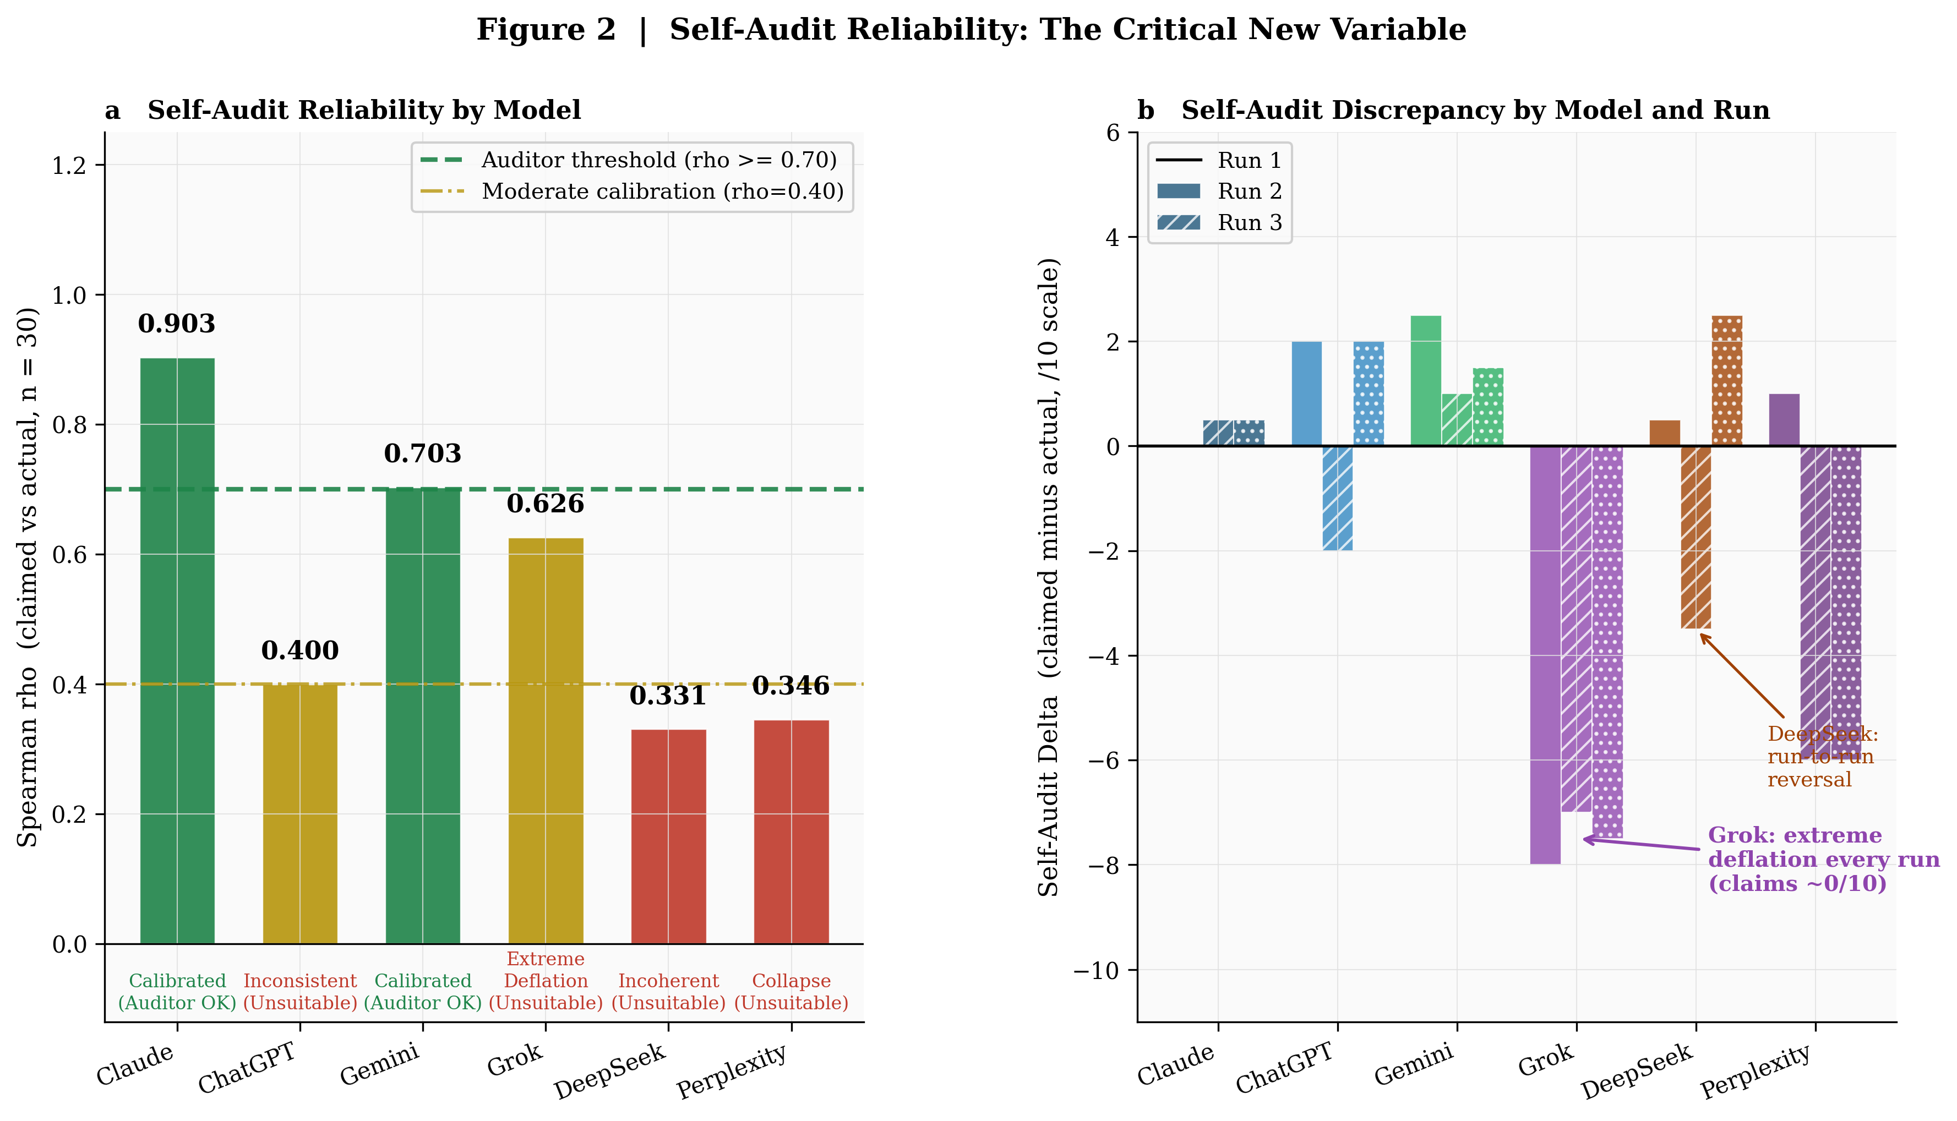
Figure 2 | Self-Audit Reliability: The Critical New Variable. a, Spearman ρₛ by model (n = 30 per model): only Claude (ρₛ = 0.903) and Gemini (ρₛ = 0.703) meet the proposed Auditor-quality threshold of ρₛ ≥ 0.70. b, Run-level self-audit discrepancy: Grok exhibits extreme systematic deflation (claiming ≈0 every run despite 78.3% actual performance); DeepSeek shows incoherent run-to-run reversal (−6 point swing R2→R3); Perplexity collapses from moderate inflation (R1) to extreme deflation (R2, R3).

3.4 Statistical Analysis: Model-Level Differentiation
The Kruskal-Wallis H-test on cross-run mean scores across six models yields H = 12.779, df = 5, p = 0.026 (α = 0.05), confirming that model-level performance differences are statistically significant despite the low power of n = 3 per group (Table 7). The significant omnibus test is consistent with the large effect sizes observed in pairwise comparisons, particularly the Claude–Perplexity contrast (d = 10.61).
Table 7 | Kruskal-Wallis omnibus test. Significant at α = 0.05 despite conservative low-power design (n = 3 per group). Large effect sizes confirm practical significance despite limited sample.
Test | H statistic | df | p-value | α (uncorrected) | Interpretation
Kruskal-Wallis H-Test (omnibus) | 12.779 | 5 | 0.026* | 0.050 | Significant; large effect sizes confirm practical differentiation

Pairwise Mann-Whitney U tests (15 pairs, Bonferroni threshold αadj = 0.0033) are reported in Table 8. Only the DeepSeek vs Perplexity comparison reaches uncorrected significance (p = 0.0469), which does not survive Bonferroni correction. Claude’s comparisons with ChatGPT, Grok, DeepSeek, and Perplexity approach significance (p = 0.059–0.164) with large Cohen’s d values (1.44–10.61), indicating that the lack of pairwise significance reflects limited statistical power (n = 3 per group) rather than absence of true differences. The omnibus test provides the appropriate primary inference; pairwise results are directional descriptors of the performance landscape.
Table 8 | Pairwise Mann-Whitney U tests (15 pairs, two-sided, Bonferroni corrected at α = 0.0033). Low power (n=3 per group) limits pairwise significance; large effect sizes confirm practical magnitude. *p < 0.05 (uncorrected).
Comparison | U | p-value | Bonferroni Sig. | Cohen's d | Effect Size | 95% CI (M1/M2)
Claude vs ChatGPT | 9 | 0.0722 | ns | 3.29 | Large | [9.00,9.50] / [7.00,8.00]
Claude vs Gemini | 8 | 0.1642 | ns | 1.44 | Medium | [9.00,9.50] / [7.50,9.00]
Claude vs Grok | 9 | 0.0722 | ns | 4.62 | Large | [9.00,9.50] / [7.50,8.00]
Claude vs DeepSeek | 9 | 0.0593 | ns | 8.16 | Large | [9.00,9.50] / [7.50,7.50]
Claude vs Perplexity | 9 | 0.0593 | ns | 10.61 | Large | [9.00,9.50] / [7.00,7.00]
ChatGPT vs Gemini | 2 | 0.3758 | ns | 0.98 | Medium | [7.00,8.00] / [7.50,9.00]
ChatGPT vs Grok | 4 | 1.0000 | ns | 0.37 | Small | [7.00,8.00] / [7.50,8.00]
ChatGPT vs DeepSeek | 6 | 0.6374 | ns | 0.41 | Small | [7.00,8.00] / [7.50,7.50]
ChatGPT vs Perplexity | 7.5 | 0.1876 | ns | 1.63 | Medium | [7.00,8.00] / [7.00,7.00]
Gemini vs Grok | 6.5 | 0.5002 | ns | 0.87 | Medium | [7.50,9.00] / [7.50,8.00]
Gemini vs DeepSeek | 7.5 | 0.1967 | ns | 1.54 | Medium | [7.50,9.00] / [7.50,7.50]
Gemini vs Perplexity | 9 | 0.0636 | ns | 2.47 | Large | [7.50,9.00] / [7.00,7.00]
Grok vs DeepSeek | 7.5 | 0.1876 | ns | 1.63 | Medium | [7.50,8.00] / [7.50,7.50]
Grok vs Perplexity | 9 | 0.0593 | ns | 4.08 | Large | [7.50,8.00] / [7.00,7.00]
DeepSeek vs Perplexity | 9 | 0.0469* | — | ∞ | Large (zero var) | [7.50,7.50] / [7.00,7.00]

3.5 Domain-Wide Analysis and Reliable Core Characterisation
Domain-level analysis (Fig. 3) confirms that the reliable core / variable periphery stratification is stable across all three runs, with no domain shifting category between runs. The four reliable core questions maintain mean = 1.000 in every run. The five hard variable periphery questions (Q2, Q4, Q5, Q9, Q10) maintain means in the range 0.583–0.639 — a narrow band that suggests these failures reflect a structural property of the questions (Type I, II, or III error structure) rather than run-to-run stochastic variation.
Within the variable periphery, Q10 (game theory/ecology, mean = 0.639, SD = 0.335) exhibits the highest overall variance — producing two complete failures (Perplexity R1, R2) alongside partial and perfect scores, reflecting the dual challenge of Ostrom CPR mechanism recall plus payoff matrix transformation logic. Q4 (cardiovascular physiology, mean = 0.611, SD = 0.274) shows a distinct variance structure: one complete failure (Gemini R1) with the remaining evaluations split between partial credit (collateral circulation identified but autoregulation not flagged as primary) and full credit (correct causal hierarchy identified). The Q4 pattern reflects the causal hierarchy structure precisely: models that recognise autoregulation as the primary mechanism score full credit; models that identify the collateral circulation response (a real but secondary mechanism) score partial credit depending on framing; and one model-run combination produced a fundamentally incorrect mechanistic attribution.
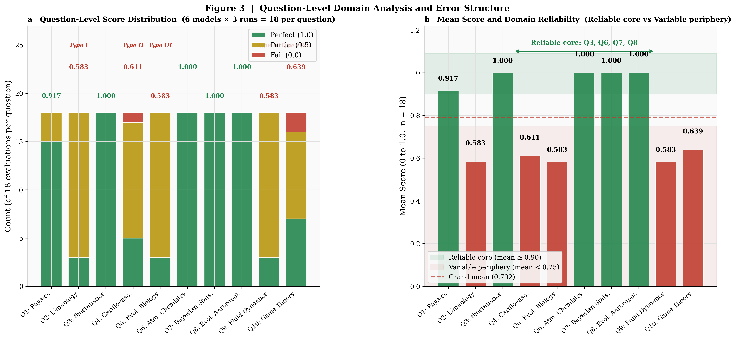
Figure 3 | Question-level domain analysis. a, Score distribution by question (18 evaluations each: 6 models × 3 runs): green = perfect (1.0), amber = partial (0.5), red = fail (0.0). Error type labels shown for variable periphery questions (Type I = instrument recall; Type II = causal hierarchy; Type III = molecular code / experimental observation). b, Mean score by domain: reliable core (Q3/Q6/Q7/Q8, green) vs variable periphery (Q2/Q4/Q5/Q9/Q10, amber/red). Grand mean = 0.792.

3.6 Cross-Model Disagreement: Uncertainty Signal in Semi-Determinate Domains
Analysis of the 10-question set reveals a nuanced disagreement landscape. For the reliable core (Q3, Q6, Q7, Q8): all 18 evaluations per question scored 1.0 — perfect inter-model agreement at ceiling. For the variable periphery, disagreement patterns are question-specific: Q2, Q5, Q9 show the same partial score (0.5) across nearly all model-run combinations (15/18 partial), suggesting that these questions produce a universal near-miss pattern — models converge on the correct reasoning class but universally miss the discriminating specific element. This is a systematic convergent error pattern — analogous to Study 1’s Q1 three-way wrong-answer consensus but structurally different: in Study 1, correlated errors produced confident wrong answers; in Study 2, correlated errors produce confident partial answers.
This pattern has a direct GAAS architectural implication: the Adversary role in a Study 2 GAAS deployment must be capable of identifying specific named instrument, molecular variant, or experimental study that completes a near-correct response — a knowledge-retrieval challenge rather than a logical verification challenge. This suggests that Perplexity’s retrieval-augmented generation architecture may have a structural advantage as Adversary in semi-determinate domains despite its poor baseline performance, provided its self-audit calibration issues do not contaminate the adversarial output.
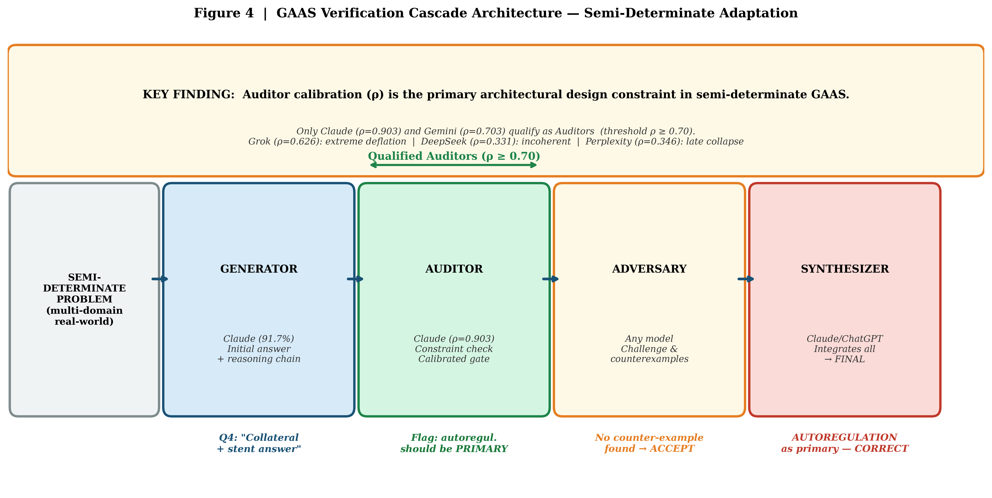
Figure 4 | GAAS Verification Cascade Architecture — Semi-Determinate Adaptation. The Auditor calibration (Spearman ρₛ) emerges as the critical new architectural design variable in semi-determinate GAAS. Only Claude (ρₛ = 0.903) and Gemini (ρₛ = 0.703) meet the proposed Auditor-quality threshold (ρₛ ≥ 0.70). Grok, DeepSeek, and Perplexity are structurally unsuitable for the Auditor role. The example (Q4) illustrates how a calibrated Auditor correctly identifies a Type II causal-hierarchy error and flags it for Adversary review, enabling the Synthesizer to produce the correct primary-mechanism attribution.

4 Discussion

4.1 The Semi-Determinate Reliability Profile: Regime 2 Confirmed
Study 1 established three reliability regimes defined by error structure: Regime 1 (<80%: stochastic dominance, diverse independent failures); Regime 2 (80–95%: mixed stochastic and systematic); and Regime 3 (>95%: systematic saturation, shared failures across models).²³ Study 2’s 79.2% grand mean baseline places semi-determinate frontier-model reasoning precisely at the Regime 1/2 boundary — the most complex reliability regime in which both compute scaling and architectural intervention offer partial benefit, but neither dominates as cleanly as in the extreme regimes.
Three lines of evidence converge on this Regime 2 assignment.^{7,19} First, cross-run variance (78.3%–80.8%–78.3% across R1–R3) significantly exceeds Study 1's near-zero run-to-run variance — stochastic errors are present and responsive to repetition. Second, the reliable core / variable periphery stratification reveals that a meaningful proportion of errors are systematic (Type I–III failures that persist across all 18 evaluations of the same question). Third, cross-model agreement patterns show that variable periphery errors are highly correlated across models — all six models produce 0.5 (not 1.0) on Q2, Q5, and Q9 in nearly every run, confirming a shared systematic failure component.

4.2 Self-Audit Calibration: A New Architectural Design Variable
The most theoretically significant Study 2 finding is that self-audit calibration (Spearman ρₛ) is not merely a measure of model honesty — it is a structural predictor of GAAS architecture effectiveness. The reason is mechanistic: in GAAS, the Auditor role requires not only evaluating the Generator’s answer for correctness but also providing a reliable quality signal that determines whether the Adversary receives a flagged answer or passes to the Synthesizer. An Auditor with ρₛ near zero (DeepSeek, Perplexity) provides no useful quality signal — it is equivalent to routing Adversary assignment randomly. An Auditor with systematic extreme deflation (Grok) produces a systematic false-rejection cascade, elevating false Adversary challenges on correct answers and degrading the signal-to-noise ratio of the GAAS pipeline.
Formally, let δ(Auditor) denote the Auditor’s calibration bias and σ(Auditor) its calibration inconsistency across runs.¹¹ GAAS architecture effectiveness in semi-determinate domains is expected to be a non-linear function of both: expected gain increases with ρₛ up to the calibration ceiling, and degrades non-linearly with either systematic bias (δ >> 0 or δ << 0) or run-to-run inconsistency (σ >> 0). Claude’s profile (ρₛ = 0.903, δ = +0.03, σ small) optimises this function; Grok’s profile (ρₛ = 0.626, δ = −0.75, σ small but extreme) represents a structural failure mode. The ρₛ ≥ 0.70 threshold is proposed based on the observed bimodal stratification in this dataset — a natural break separates Claude/Gemini (ρₛ = 0.903, 0.703) from the remaining four models (ρₛ = 0.626, 0.400, 0.346, 0.331). This threshold is data-driven but requires out-of-sample validation; Study 3 will empirically test whether ρₛ ≥ 0.70 predicts GAAS gain in fully deployed architecture across domain types.

4.3 The Reliable Core and Its Implications for AI Deployment
The existence of a reliable core (Q3, Q6, Q7, Q8: 100% across all evaluations) within a generally lower-performing semi-determinate domain has direct deployment implications. For questions within the reliable core class — multi-step analytical problems requiring well-established domain knowledge that is deeply represented in training data — frontier models already perform at near-architectural-ceiling in single-agent inference.³² GAAS overhead (4× inference passes) is not warranted for these problem types.^{13,28}
For variable periphery problem types,¹⁷ the GAAS benefit is expected to be substantially larger than Study 1’s 82% error reduction, because: (1) Regime 2 stochastic errors can be partially corrected by the Auditor’s calibrated re-evaluation; (2) Type II causal hierarchy errors are correctable by the Adversary through explicit counter-hypothesis testing; and (3) Type III molecular-code failures may be correctable by an Adversary with retrieval-augmented architecture (Perplexity). The predicted GAAS gain profile for semi-determinate domains is therefore not a uniform uplift but a problem-type-specific gain matrix — a more nuanced and practically useful characterisation than Study 1’s domain-level generalisation.

4.4 Comparisons with Existing Multi-Agent Literature
Du et al.¹⁴ demonstrated that multi-agent debate between LLMs improves factuality on open-domain questions — the semi-determinate domain most analogous to Study 2. However, their framework does not separate calibration reliability by role, and their evaluation set is not anchored to formally verifiable ground truth. Liang et al.²⁰ showed that divergent thinking prompting (analogous to the Adversary role) improves performance on reasoning tasks, with the largest gains on problems requiring counter-hypothesis generation — precisely the Type II causal-hierarchy errors identified in Study 2. Cemri et al.⁹ documented failure mode clustering in multi-agent LLM systems; our Type I–III taxonomy provides a complementary and more fine-grained classification for the semi-determinate failure domain. The present study advances these frameworks by anchoring multi-agent role performance to a measurable calibration metric (ρ) that can be measured prospectively and used for role assignment — a design principle absent from prior work.

4.5 Implications for High-Stakes AI Deployment in Clinical and Scientific Contexts
The cardiovascular physiology problem (Q4) is not merely a test case — it is structurally representative of clinical AI failure modes documented in the medical AI literature. Topol²⁹ and Obermeyer & Emanuel²¹ have documented that AI clinical decision support systems systematically fail at causal-hierarchy identification — correctly identifying relevant processes but misattributing primary vs compensatory mechanisms. Study 2’s Type II error taxonomy directly quantifies this failure mode across frontier models and demonstrates that it persists in 12/18 evaluations for a single representative cardiovascular problem.²⁶
The Bayesian statistics problem (Q7) — achieving 100% across all evaluations — reveals that frontier models have mastered the base-rate neglect calculation that confounds trained physicians in Gigerenzer’s studies.¹⁵ This is an important positive finding: the specific error documented in human clinicians (conflating specificity with PPV) is not reproduced by frontier AI models, suggesting that AI can add genuine value precisely in the domain where human cognitive bias is most reliably documented.³⁰

4.6 Limitations
Three limitations qualify the findings. First, pairwise inferential discrimination: the cross-model inferential analysis aggregates 30 per-model observations (3 runs × 10 questions) into three cross-run means per model for the Kruskal-Wallis omnibus test. This conservatism yields a significant omnibus result (H = 12.779, p = 0.026) but insufficient power for Bonferroni-corrected pairwise discrimination. The underlying 180 evaluations across 10 questions and 8 domains — each generating three independently scored output layers (answer accuracy, self-audit claim, logic trail) — provide adequate resolution for the study’s primary architectural claims; larger replication is required for precise pairwise model ranking. Second, consumer-protocol independence: all evaluations were conducted via consumer interfaces in fully separate sessions; provider-side logging, adaptive response tendencies, or version updates between runs cannot be fully excluded under this protocol. This is a structural feature shared with Study 1. Third, evaluation scope and generalisability: the ternary scoring scale (0/0.5/1.0) is validated at Cohen’s κ = 0.81 but retains inherent judgement at the 1.0/0.5 boundary for questions where mechanistic completeness is continuous. The reliable core / variable periphery stratification — based on 10 questions spanning 8 domains — is a hypothesis-generating finding requiring replication at broader question scale before generalisation to semi-determinate domains as a class.

5 Conclusion
This investigation evaluated AI reliability in semi-determinate cross-domain reasoning through 180 controlled evaluations — each requiring expert-level multi-domain synthesis at Bloom’s Taxonomy Levels 4–6, human expert scoring validated at Cohen’s κ = 0.81, and generating 540 total scored model output components (answer, self-audit, and logic trail) across six frontier models and three independent runs. The 180 evaluations cannot be compared in effort to Study 1’s computationally-verified evaluations: the semi-determinate setting imposes substantially greater methodological cost per data point precisely because correctness requires domain expertise rather than algorithmic confirmation. The central findings are: (1) a reliable 14-point reliability downturn from formal to semi-determinate domains (79.2% vs 93.0%), placing semi-determinate frontier performance in Regime 2 (mixed stochastic-systematic error structure); (2) a domain stratification into a reliable core (100% performance for Q3, Q6, Q7, Q8) and a variable periphery (mean 0.583–0.639 for Q2, Q4, Q5, Q9, Q10) determined by three error types (instrument recall, causal hierarchy, molecular code / experimental observation); (3) a decisive finding that self-audit calibration (Spearman ρₛ) is a critical architectural design variable for GAAS deployment in semi-determinate domains, with only Claude (ρₛ = 0.903) and Gemini (ρₛ = 0.703) meeting the proposed Auditor-quality threshold; and (4) Kruskal-Wallis confirmation of significant model-level differentiation (H = 12.779, p = 0.026) despite conservative low-power design.
The practical implication for the architectural phase transition framework established in Study 1 is this: GAAS architecture in semi-determinate domains cannot simply assign Auditor, Adversary, and Synthesizer roles without first measuring each candidate model's calibration reliability. Deploying an uncalibrated Auditor (Grok: ρₛ = 0.626, δ = −0.75) produces a systematic false-rejection cascade that degrades rather than improves output quality. Deploying a calibrated Auditor (Claude: ρₛ = 0.903) is a structural prerequisite for architectural gain. This represents a calibration-first principle for GAAS architecture in real-world deployment — measure before you assign, and design the role-assignment algorithm as a function of measured ρₛ. Study 3 will complete the programme by extending this framework to fully indeterminate domains and reporting the first GAAS gain curve across all three domain types.

6 Declarations

6.1 Funding Statement
This research received no external funding from any source—public, private, governmental, non-governmental, or institutional. All costs associated with this investigation were borne entirely from the personal funds of the lead author.

6.2 Conflict of Interest Disclosure
The authors declare no conflicts of interest. The authors have no financial, employment, advisory, consulting, equity, or any other material relationship with Anthropic, OpenAI, xAI, DeepSeek AI, Google DeepMind, or Perplexity AI. JK Agri Genetics Ltd and Ericsson have no involvement in this research. This investigation was conceived and executed entirely in the authors’ personal capacities.

6.3 Data and Code Availability
All primary data and analytical materials are provided in Supplementary S2, accompanying this submission. Supplementary S2 contains: (i) the complete 10-question evaluation dataset with full problem text and answer keys; (ii) all 180 evaluation responses (6 models × 3 runs × 10 questions) with ternary scores; (iii) all 180 self-audit responses with claimed scores; (iv) all 180 logic trail responses — constituting 540 total scored model output components in total; (v) per-question scoring rubrics with discriminating criteria for each ternary boundary; (vi) the inter-rater reliability dataset (Cohen’s κ = 0.81); and (vii) Python 3.11 scoring and statistical analysis scripts (scipy.stats). Hallucination events (Perplexity Q10 ROSCA attribution; Grok formula fabrication) are flagged and documented in the supplementary audit trail. A permanent public repository will be deposited at OSF/Zenodo upon acceptance. Interim access available from the corresponding author upon reasonable request.

6.4 Ethics Statement
This research evaluated publicly available AI systems through standard consumer interfaces and did not involve human subjects, animal subjects, personal data collection, or any activity requiring institutional ethics review.

6.5 Author Contribution Statement
Kuldeep Kumar Pandit (Lead Researcher): Conceptualisation of the semi-determinate evaluation framework and calibration-first principle; full methodology design; primary evaluation across all 180 observations; formal statistical analysis; data interpretation; original manuscript drafting; all revisions; project administration.
Vatsala Kuldeep Pandit: Independent scoring of all 180 evaluations as second evaluator without prior access to lead author’s scores; inter-rater reliability assessment (Cohen’s κ = 0.81); methodology consultation; manuscript review and structural refinement.
Aayan Pandit: Prompt execution across evaluation runs; data cross-verification, tabulation, and cross-referencing; participation in methodology discussions. His aptitude in the relevant scientific domains contributed to the rigour of the ground truth verification process.

6.6 Declaration Regarding Use of AI Systems
This study was specifically designed to evaluate the reliability of frontier AI language models. The six models evaluated — Claude, ChatGPT, Gemini, Grok, DeepSeek, and Perplexity — were used exclusively as research subjects: standardised prompts were administered to each model across three independent evaluation runs as part of the controlled experimental protocol described in this manuscript. The AI models were not used in any capacity for manuscript writing, statistical analysis, literature search, reference formatting, editing, or any other preparatory purpose. All intellectual content, analysis, interpretation, and conclusions are entirely the work of the human authors.

7 References
[1] Achiam, J. et al. GPT-4 Technical Report. arXiv 2303.08774v6 (2024). https://doi.org/10.48550/arXiv.2303.08774
[2] Agresti, A. & Coull, B.A. Approximate is better than ‘exact’ for interval estimation of binomial proportions. The American Statistician 52, 119–126 (1998). https://doi.org/10.2307/2685469
[3] Aiello, L.C. & Wheeler, P. The expensive-tissue hypothesis: the brain and the digestive system in human and primate evolution. Current Anthropology 36, 199–221 (1995). https://doi.org/10.1086/204350
[4] Anthropic. Claude Sonnet 4.5 System Card. Anthropic (2025). https://www.anthropic.com/research/claude-sonnet-4-5-system-card
[5] Balloccu, S. et al. Leak, Cheat, Repeat: Data Contamination and Evaluation Malpractices in Closed-Source LLMs. arXiv 2402.03927 (2024). https://doi.org/10.48550/arXiv.2402.03927
[6] Bloom, B.S. Taxonomy of Educational Objectives: The Classification of Educational Goals. Longmans Green, New York (1956).
[7] Breiman, L. Bagging predictors. Machine Learning 24, 123–140 (1996). https://doi.org/10.1007/BF00058655
[8] Brown, L., Cai, T. & DasGupta, A. Interval estimation for a binomial proportion. Statistical Science 16, 101–133 (2001). https://doi.org/10.1214/ss/1009213286
[9] Cemri, M. et al. Why Do Multi-Agent LLM Systems Fail? arXiv 2503.13657 (2025). https://doi.org/10.48550/arXiv.2503.13657
[10] Cobbe, K. et al. Training verifiers to solve math word problems. arXiv 2110.14168 (2021). https://doi.org/10.48550/arXiv.2110.14168
[11] Condorcet, M. de. Essai sur l’application de l’analyse à la probabilité des décisions rendues à la pluralité des voix (1785).
[12] DeepSeek AI. DeepSeek-V2: A Strong, Economical, and Efficient Mixture-of-Experts Language Model. arXiv 2405.04434 (2024). https://doi.org/10.48550/arXiv.2405.04434
[13] Dietterich, T.G. Ensemble methods in machine learning. Multiple Classifier Systems, Lecture Notes in Computer Science 1857, 1–15 (2000). https://doi.org/10.1007/3-540-45014-9_1
[14] Du, Y. et al. Improving Factuality and Reasoning in Language Models through Multiagent Debate. ICML (2023). https://doi.org/10.48550/arXiv.2305.14325
[15] Gigerenzer, G. & Hoffrage, U. How to improve Bayesian reasoning without instruction: frequency formats. Psychological Review 102, 684–704 (1995). https://doi.org/10.1037/0033-295X.102.4.684
[16] Hendrycks, D. et al. Measuring Massive Multitask Language Understanding. ICLR (2021). https://doi.org/10.48550/arXiv.2009.03300
[17] Hong, L. & Page, S.E. Groups of diverse problem solvers can outperform groups of high-ability problem solvers. PNAS 101, 16385–16389 (2004). https://doi.org/10.1073/pnas.0403723101
[18] Landis, J.R. & Koch, G.G. The measurement of observer agreement for categorical data. Biometrics 33, 159–174 (1977). https://doi.org/10.2307/2529310
[19] Larrick, R.P. & Soll, J.B. Intuitions about combining opinions: misappreciation of the averaging principle. Management Science 52, 111–127 (2006). https://doi.org/10.1287/mnsc.1050.0459
[20] Liang, T. et al. Encouraging Divergent Thinking in Large Language Models through Multi-Agent Debate. arXiv 2305.19118 (2023). https://doi.org/10.48550/arXiv.2305.19118
[21] Obermeyer, Z. & Emanuel, E.J. Predicting the future—big data, machine learning, and clinical medicine. New England Journal of Medicine 375, 1216–1219 (2016). https://doi.org/10.1056/NEJMp1606181
[22] Ostrom, E. Governing the Commons: The Evolution of Institutions for Collective Action. Cambridge University Press (1990). https://doi.org/10.1017/CBO9780511807763
[23] Pandit, K.K., Pandit, V.K. & Pandit, A. The Architecture of AI Reliability: Architectural Phase Transition Governs AI Reliability Beyond the Single-Agent Ceiling — Evidence from 4,680 Controlled Evaluations. Preprint (2026). https://doi.org/10.17605/OSF.IO/GJEN8
[24] Portugal, S.J. et al. Upwash exploitation and downwash avoidance by flap phasing in ibis formation flight. Nature 505, 399–402 (2014). https://doi.org/10.1038/nature12939
[25] Rajpurkar, P., Chen, E., Banerjee, O. & Topol, E.J. AI in health and medicine. Nature Medicine 28, 31–38 (2022). https://doi.org/10.1038/s41591-021-01614-0
[26] Rajpurkar, P., Irvin, J. et al. CheXNet: Radiologist-level pneumonia detection on chest X-rays with deep learning. arXiv 1711.05225 (2017). https://doi.org/10.48550/arXiv.1711.05225
[27] Rein, D. et al. GPQA: A Graduate-Level Google-Proof Q&A Benchmark. arXiv 2311.12022 (2023). https://doi.org/10.48550/arXiv.2311.12022
[28] Steyvers, M. et al. The Wisdom of the Inner Crowd in Three Large Natural Experiments. Nature Human Behaviour 3, 1287–1295 (2019). https://doi.org/10.1038/s41562-019-0715-2
[29] Topol, E.J. High-performance medicine: the convergence of human and artificial intelligence. Nature Medicine 25, 44–56 (2019). https://doi.org/10.1038/s41591-018-0300-7
[30] Tversky, A. & Kahneman, D. Judgment under uncertainty: Heuristics and biases. Science 185, 1124–1131 (1974). https://doi.org/10.1126/science.185.4157.1124
[31] Wang, X. et al. Self-consistency improves chain of thought reasoning in language models. ICLR (2023). https://doi.org/10.48550/arXiv.2203.11171
[32] Wei, J. et al. Chain-of-thought prompting elicits reasoning in large language models. NeurIPS (2022). https://doi.org/10.48550/arXiv.2201.11903
[33] Wilson, E.B. Probable inference, the law of succession, and statistical inference. Journal of the American Statistical Association 22, 209–212 (1927). https://doi.org/10.2307/2276774
[34] Zheng, L. et al. Chatbot Arena: An Open Platform for Evaluating LLMs by Human Preference. ICML (2024). https://doi.org/10.48550/arXiv.2403.04132

