Figure 1. UV–Visible absorption spectra of silver nanoparticles synthesized using seed and pod extracts of A. aromaticum.
Distinct surface plasmon resonance (SPR) peaks appear at 432 nm (Seed-AgNPs) and 445 nm (Pod-AgNPs), confirming nanoparticle formation and indicating smaller particle size for seed-derived samples.

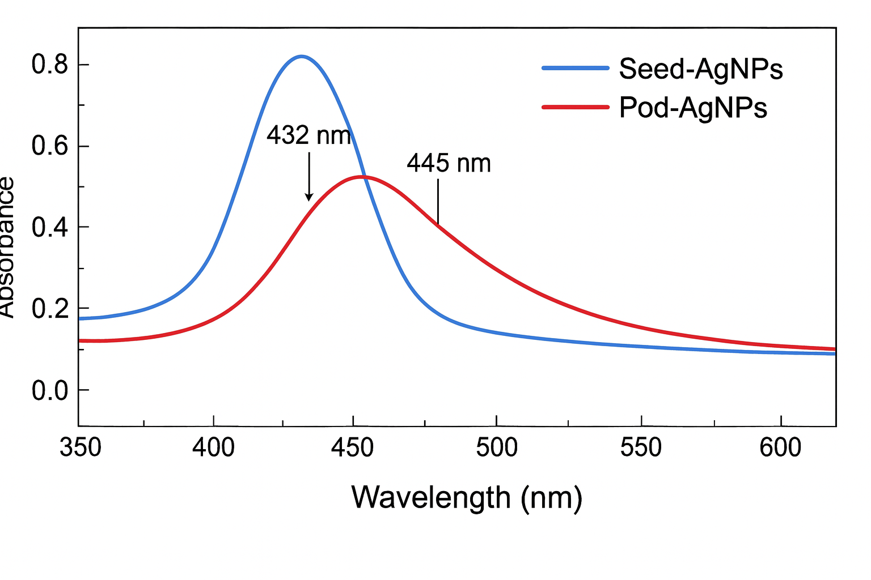
Figure 2. FTIR spectra of seed and pod extracts and their corresponding AgNPs.
Major absorption bands at 3420 cm⁻¹ (O–H stretch), 1634 cm⁻¹ (C=O stretch), and 1385 cm⁻¹ (C–N vibration) denote flavonoid and phenolic participation in reduction and capping.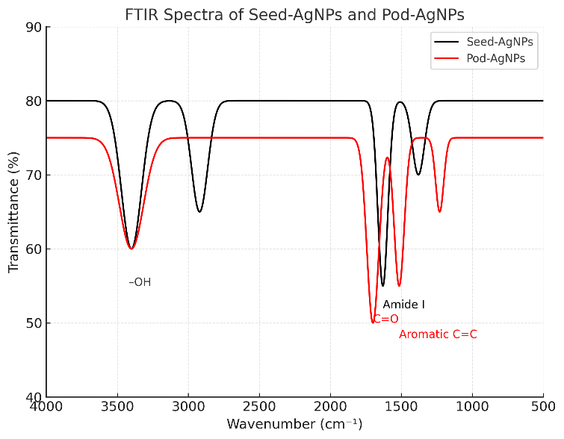

Figure 3. X-ray diffraction (XRD) patterns of Seed-AgNPs and Pod-AgNPs.
Characteristic Bragg reflections at (111), (200), (220), and (311) correspond to face-centered cubic (FCC) silver (JCPDS No. 04-0783). Sharper peaks for Seed-AgNPs indicate smaller crystallite size (~18 nm).
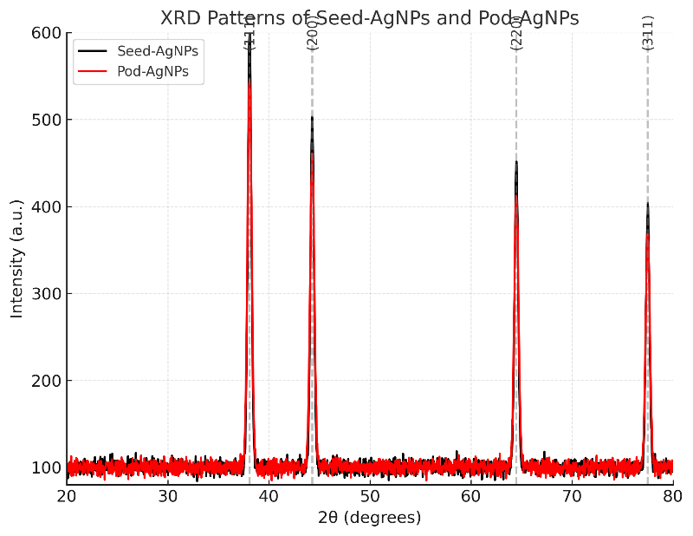

Figure 4. Transmission electron microscopy (TEM) images and particle size histograms.
Seed-AgNPs: well-dispersed, spherical particles (15–20 nm).
Pod-AgNPs: semi-spherical, slightly aggregated particles (25–30 nm).

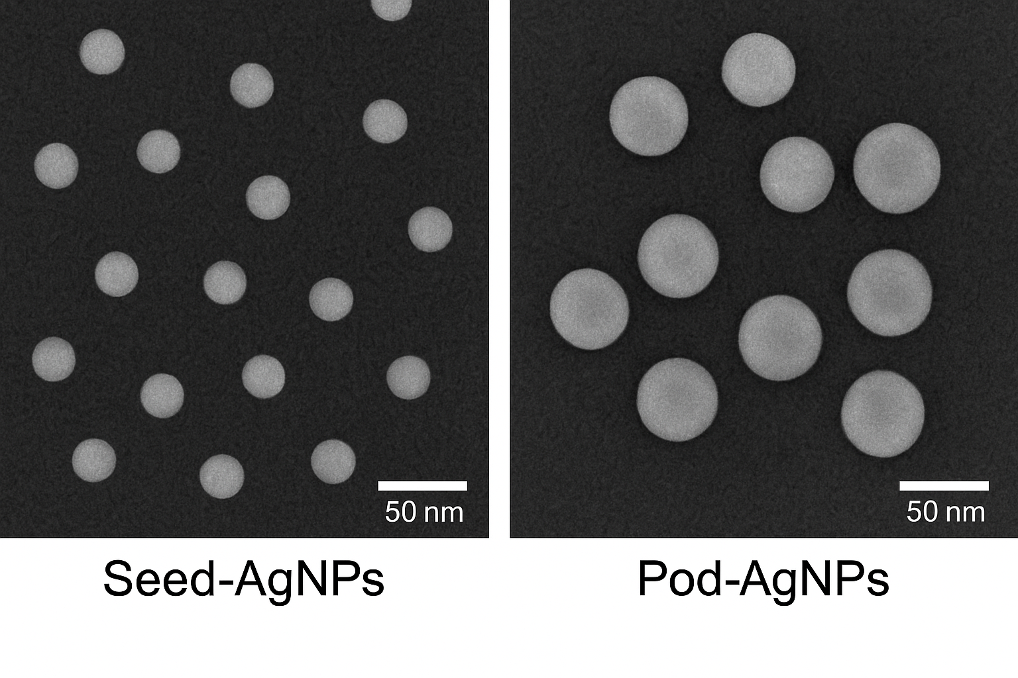

Figure 5. Dynamic light scattering (DLS) analysis of Seed- and Pod-AgNPs.
Hydrodynamic diameter distribution shows mean sizes of 22.5 nm (Seed) and 31.8 nm (Pod) with polydispersity indices of 0.28 and 0.32, respectively, confirming narrow distribution and stability.
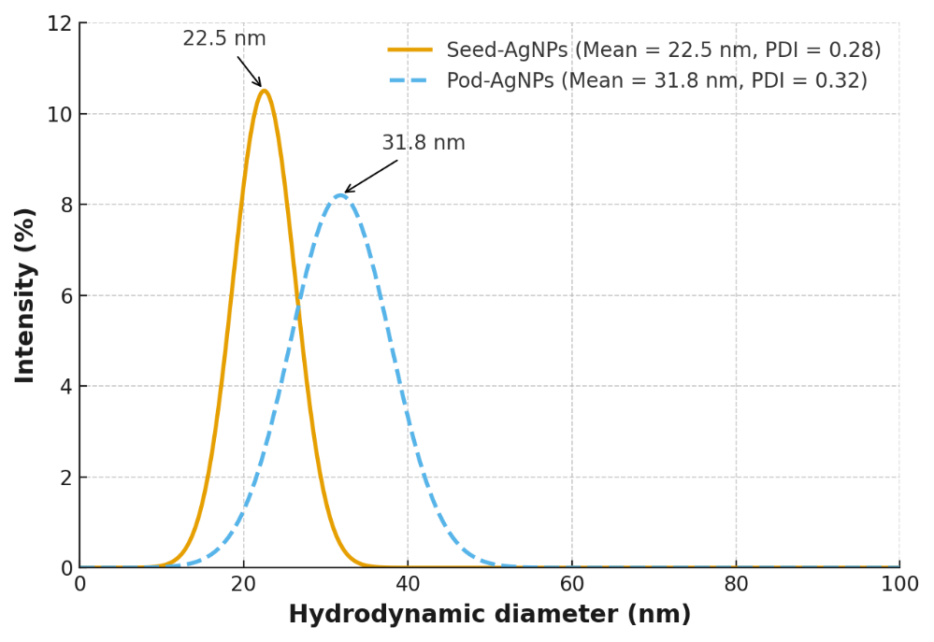

Figure 6. Energy-dispersive X-ray (EDX) spectrum of AgNPs.
Strong Ag peak at ~3 keV verifies elemental silver; minor carbon (0.28 keV) and oxygen (0.52 keV) peaks arise from organic capping residues.

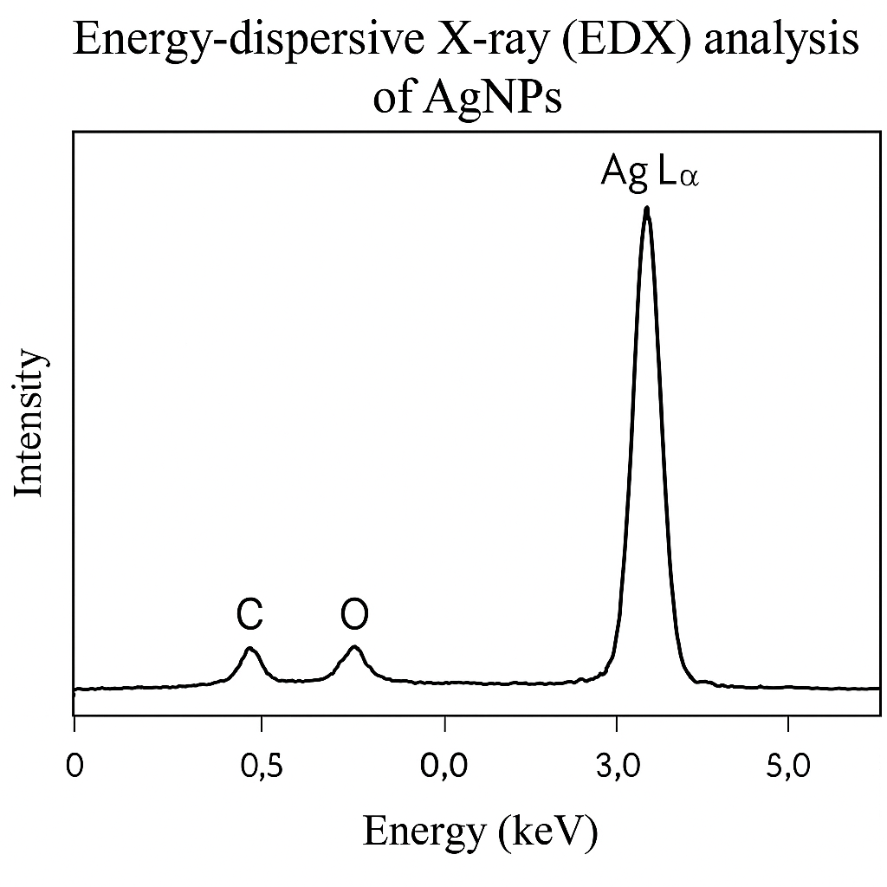
Figure 7. Zeta potential distribution curves of biosynthesized AgNPs.
Seed-AgNPs show −25.4 mV and Pod-AgNPs −18.1 mV, indicating stable colloidal suspensions with higher electrostatic repulsion for seed-derived particles.
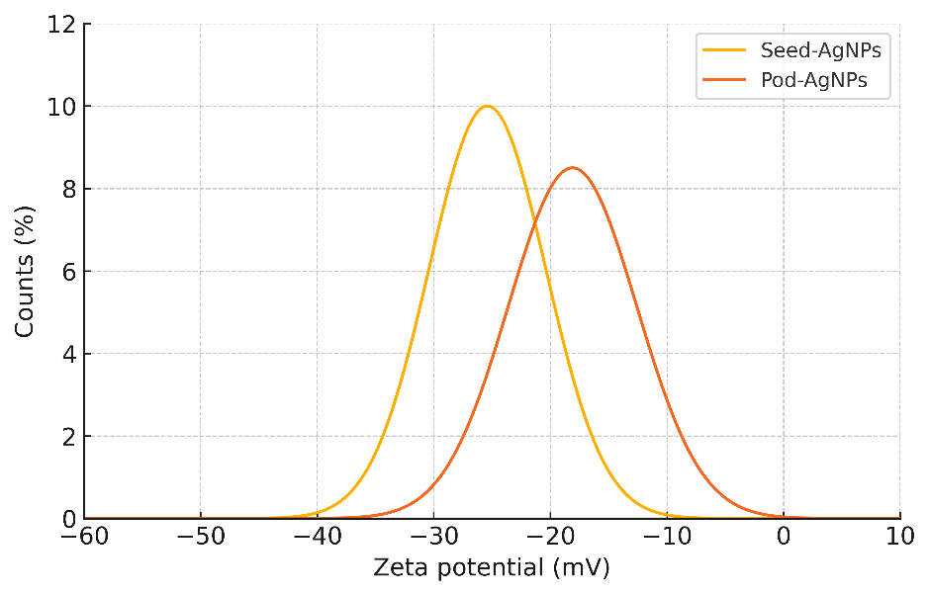

Figure 8. Antibacterial assay plates showing inhibition zones of Seed- and Pod-AgNPs against S. aureus and E. coli.
Clear inhibition zones demonstrate effective antibacterial action, with larger zones observed for Seed-AgNPs compared to Pod-AgNPs.

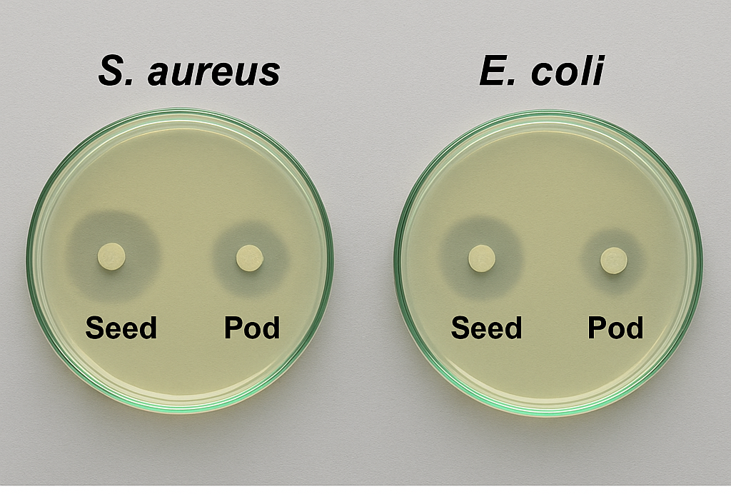

Figure 9. Antibacterial activity of Seed- and Pod-AgNPs against S. aureus and E. coli.
Zone of inhibition (mm) values confirm stronger antibacterial efficacy of smaller Seed-AgNPs; bars represent mean ± SD (n = 3).

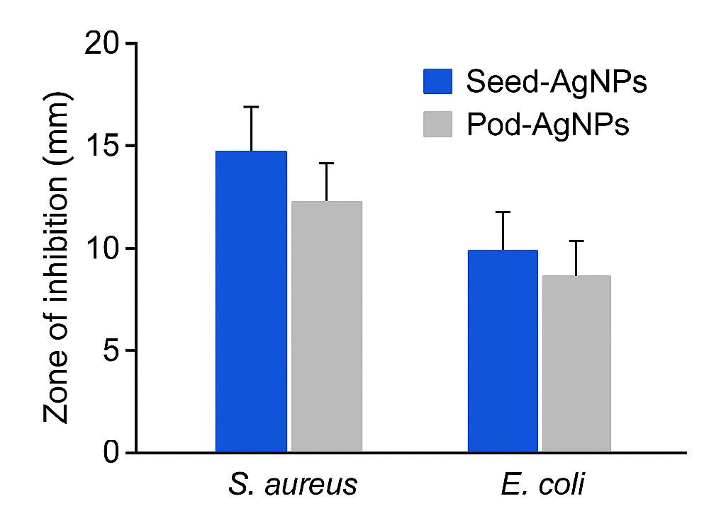

Figure 10. Wound-healing assay (scratch test) on human fibroblast monolayers.
Images at 0 h and 24 h show ~78 % closure for Pod-AgNPs versus ~55 % for Seed-AgNPs, indicating higher regenerative efficiency of phenolic-capped nanoparticles.

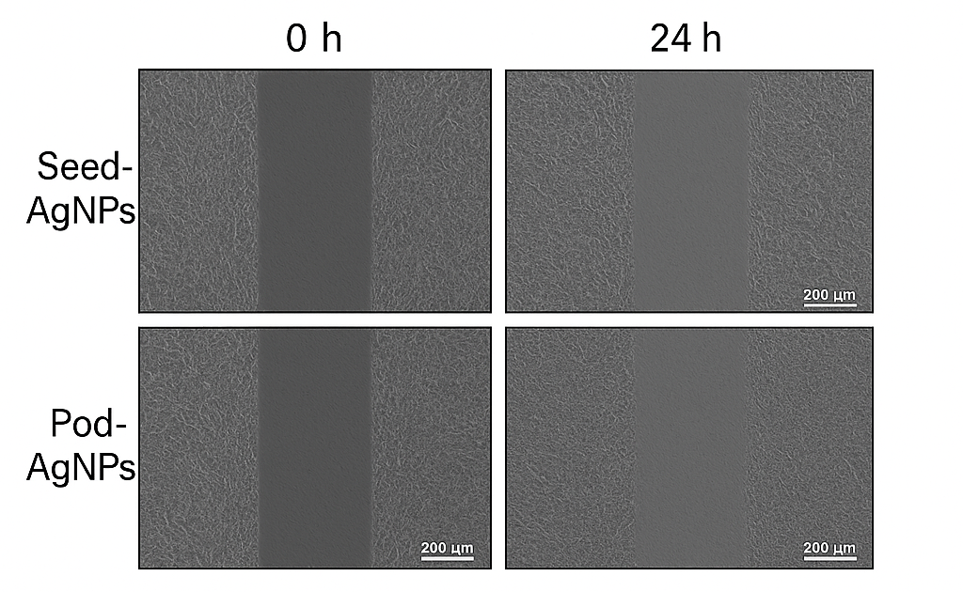

Table 1. Physicochemical characteristics of Seed- and Pod-derived AgNPs

Parameter | Seed-AgNPs | Pod-AgNPs
UV–Vis λmax (nm) | 432 ± 2 | 445 ± 3
TEM size (nm) | 15–20 | 25–30
DLS mean (nm) | 22.5 ± 1.6 | 31.8 ± 2.1
PDI | 0.28 | 0.32
Zeta potential (mV) | −25.4 ± 1.2 | −18.1 ± 0.9
Crystallite size (XRD, nm) | 18.3 | 27.4
Dominant capping group | Flavonoids/amide | Phenolics/tannins
Morphology | Spherical | Semi-spherical

Table 2. Elemental composition of AgNPs by EDX

Element | Seed-AgNPs (wt %) | Pod-AgNPs (wt %)
Ag | 85.6 | 82.4
O | 7.9 | 9.8
C | 6.5 | 7.8

Table 3. Biological activities of Seed- and Pod-AgNPs

Assay | Unit | Seed-AgNPs | Pod-AgNPs
DPPH scavenging | % | 67 ± 2.4 | 81 ± 2.1
S. aureus ZOI | mm | 18.2 ± 1.3 | 14.1 ± 0.9
E. coli ZOI | mm | 16.7 ± 1.1 | 12.9 ± 1.0
Cell viability (100 µg/mL) | % | 82 ± 3 | 85 ± 4
Wound closure (24 h) | % | 55 ± 2.8 | 78 ± 3.1
Biofilm inhibition | % | 49 ± 2.2 | 51 ± 2.5

