Supplementary Appendix

Table of Contents

Supplementary Results – pages 2-3

Supplementary Figures – pages 4-10
- Supplementary Figure S1: Annual publication trends for included systematic reviews (2008–2024), categorized by screening pathway phase – page 4
- Supplementary Figure S2: Distribution of included systematic reviews by screening pathway phase – page 4
- Supplementary Figure S3: Pooled estimates of sensitivity, specificity, accuracy, and AUC from reviews reporting meta-analytic results – page 5
- Supplementary Figure S4: Ranges of sensitivity, specificity, accuracy, and AUC reported for primary studies within included reviews – page 6
- Supplementary Figure S5: Number of included reviews that addressed ethnicity or skin tone representation, and the methods used to estimate or report it – page 7
- Supplementary Figure S6: Sizes of publicly available and named or available-upon-request dermatology datasets cited across included reviews – page 8
- Supplementary Figure S7: Overlap in cancer types targeted across included systematic reviews – page 9
- Supplementary Figure S8: Diagnostic label categories present in publicly available skin cancer datasets cited across reviews – page 9
- Supplementary Figure S9: AI model architecture categories targeted for evaluation across included systematic reviews – page 10
- Supplementary Figure S10: Diagnostic performance evaluation metrics reported across included reviews – page 11
Supplementary Tables – pages 12-29
- Supplementary Table S1: Overview of relevance assessment and risk of bias ratings for included systematic reviews – pages 12-13
- Supplementary Table S2: Boolean search strings used for database searches of PubMed, Web of Science, and CINAHL – page 13
- Supplementary Table S3: Studies excluded at full-text review with reasons for exclusion – pages 13-16
- Supplementary Table S4: Methodological characteristics of included systematic reviews – pages 17-29

Supplementary Results: Risk of Bias Assessment
Relevance Assessment
The relevance of the included systematic reviews to the target research question was evaluated using ROBIS Phase 1 criteria. The target question addressed the performance and implementation of artificial intelligence (AI) and machine learning (ML) tools for skin cancer detection across the full screening continuum, from self-assessment to histopathological confirmation, with outcomes including diagnostic accuracy, clinical utility, and implementation feasibility.

Of the 37 systematic reviews analyzed, 29 (78.4%) were deemed fully relevant to this research question and directly aligned with all components of the target PICO framework. Relevance varied by screening phase. Both reviews addressing primary care evaluation comprehensively examined AI use in frontline clinical contexts and were classified as fully relevant. Similarly, reviews focused on specialist evaluation and multiple screening phases demonstrated high alignment, with 7 of 9 (77.8%) in each category meeting all inclusion criteria.

Eight reviews (21.6%) were assessed as partially relevant due to scope or methodological limitations. Both self-screening reviews were rated as partially relevant because they evaluated consumer applications that did not consistently employ AI or lacked adequate description of algorithmic methods. Additional reviews were categorized as partially relevant when AI interventions combined imaging and non-imaging data sources, extended outcomes beyond diagnostic screening to include genomic prediction or treatment response, evaluated AI alongside traditional diagnostic approaches, or focused on representational issues or methodological weaknesses that limited applicability

Risk of Bias by Screening Phase
The two reviews evaluating self-screening applications (Chuchu 2018; Freeman 2020) achieved low risk of bias overall, showing consistent methodological rigor across most ROBIS domains, with only minor concerns related to synthesis procedures. Reviews focused on primary care evaluation (Abdalla 2024; Jones 2022) also achieved low overall risk ratings, though isolated concerns were noted in study selection and data collection processes.

Within specialist evaluation settings (n = 9), methodological quality was more variable. Three reviews (33.3%) were rated low risk, four (44.4%) high risk, and two (22.2%) unclear. The most common limitation involved inadequate documentation of study identification and selection, with seven of nine specialist reviews showing high concern in this domain.

The two reviews examining histopathological analysis demonstrated mixed methodological quality, with one rated low risk and one unclear risk. Both provided clear eligibility criteria but presented concerns in data collection and synthesis procedures.

Among the multiple screening-phase reviews (n = 9), two (22.2%) were rated low risk, 5 (55.6%) high risk, and two (22.2 %) unclear. High concern was most frequent in the synthesis domain, where eight of nine reviews encountered difficulties in combining heterogeneous clinical and imaging data.

Finally, methodological or technical reviews (n = 12) showed the poorest performance overall, with only one (8.3%) rated low risk and 11 (91.7%) rated high risk. Every review in this group exhibited high concern in the synthesis domain (100%), and most also showed high concern in study eligibility, selection, and data collection, reflecting widespread methodological deficiencies within this subgroup.

Domain-Specific Analysis
Across ROBIS domains, quality varied substantially. For Domain 1 (Study Eligibility Criteria), methodological/technical reviews exhibited the highest rate of concerns (91.7%), while self-screening, primary care, and histopathology reviews consistently demonstrated low concerns (100%). In Domain 2 (Identification and Selection of Studies), widespread deficiencies were noted, with methodological/technical (91.7%) and multiple-phase (77.8%) reviews showing the greatest challenges in documenting search and selection methods.

In Domain 3 (Data Collection and Study Appraisal), patterns were similar: methodological/technical reviews again displayed the highest proportion of high concerns (83.3%), whereas self-screening and primary care reviews performed best, showing clear reporting of data extraction and appraisal methods. Finally, Domain 4 (Synthesis and Findings) exhibited the most persistent issues. High concerns were universal among methodological/technical reviews (100%) and frequent among multiple-phase reviews (88.9%), while self-screening reviews showed comparatively stronger synthesis procedures.

Supplementary Figures

Supplementary Figures 1 to 4 are referenced in the main text. Figures 5 to 19 present additional analyses that are not included in the paper but are provided for reference.

Supplementary Figure S1: Annual publication trends for included systematic reviews (2008–2024), categorized by screening pathway phase.

Supplementary Figure S2: Distribution of included systematic reviews by screening pathway phase.

Supplementary Figure S3: Pooled estimates of sensitivity, specificity, accuracy, and AUC from reviews reporting meta-analytic results.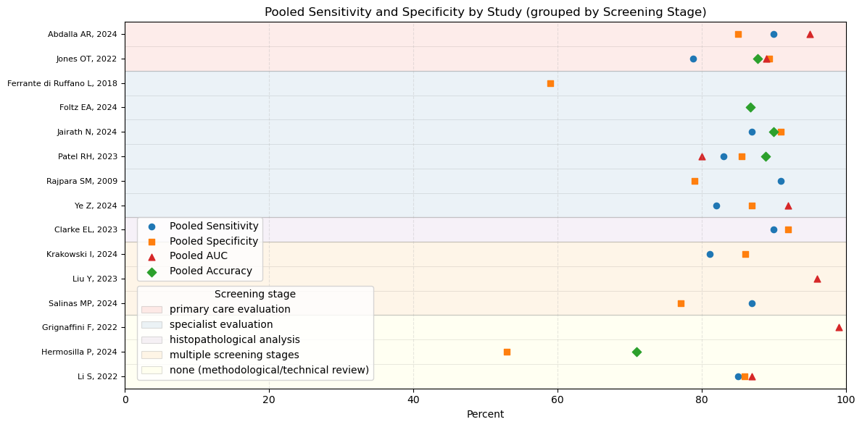

Supplementary Figure S4: Ranges of sensitivity, specificity, accuracy, and AUC reported for primary studies within included reviews.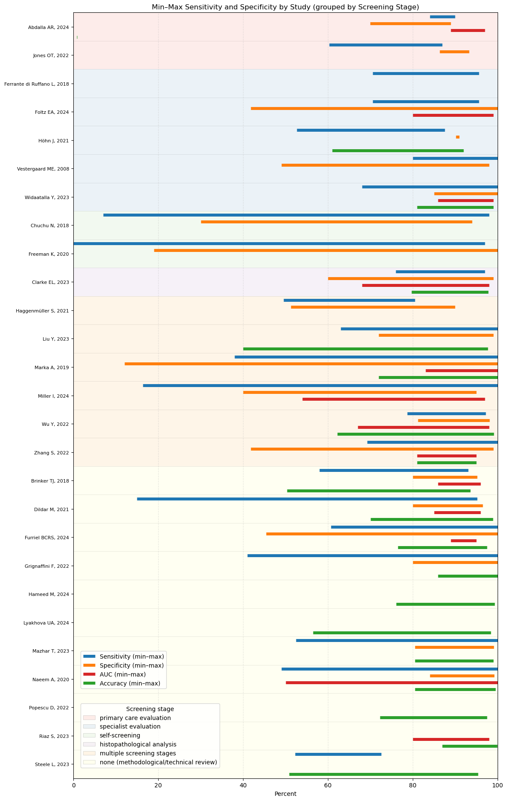

Supplementary Figure S5: Number of included reviews that addressed ethnicity or skin tone representation, and the methods used to estimate or report it.

Supplementary Figure S6: Sizes of publicly available and named or available-upon-request dermatology datasets cited across included reviews.

Supplementary Figure S7: Overlap in cancer types targeted across included systematic reviews.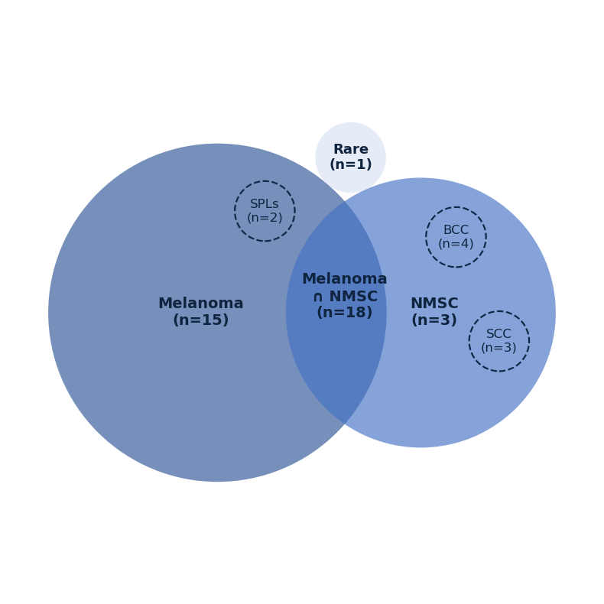

Supplementary Figure S8: Diagnostic label categories present in publicly available skin cancer datasets cited across reviews.

Supplementary Figure S9: AI model architecture categories targeted for evaluation across included systematic reviews.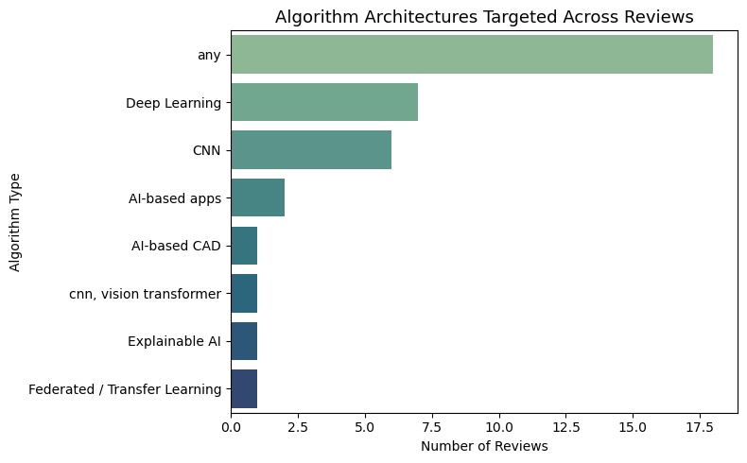

Supplementary Figure S10: Diagnostic performance evaluation metrics reported across included reviews.

Supplementary Tables
Supplementary Table S1: Overview of relevance assessment and risk of bias ratings for included systematic reviews.
Reference | Relevance | Review Process |  |  |  | Risk of Bias
Reference | Is the research question relevant to this review (yes/partial/no)? | Eligibility Criteria | Study Selection | Data Collection | Synthesis & Findings | Risk of bias introduced by methods used to id/select studies:
Self-Screening
Chuchu, 2018 | Partial | Low | Low | Low | Low | Low
Freeman, 2020 | Partial | Low | Low | Low | High | Low
Primary Care Evaluation
Abdalla, 2024 | Yes | Low | High | Unclear | High | Low
Jones, 2022 | Yes | Low | Low | Low | Low | Low
Specialist Evaluation
Ferrante di Ruffano L, 2018 | Yes | Low | Low | Low | Low | Low
Foltz, 2024 | Yes | High | High | High | High | High
Höhn, 2021 | Partial | Low | High | High | High | Unclear
Jairath, 2024 | Yes | Low | High | High | High | High
Patel, 2023 | Yes | Low | High | High | High | High
Rajpara, 2009 | Yes | Low | Low | Low | Low | Low
Vestergaard, 2008 | Partial | Low | High | High | High | Unclear
Widaatalla, 2023 | Yes | High | High | High | High | Low
Ye, 2024 | Yes | High | High | Low | Low | High
Histopathological Analysis
Clarke, 2023 | Partial | Low | Low | Unclear | Low | Unclear
Mosquera-Zamudio, 2022 | Yes | Low | High | High | High | High
Multiple Screening Stages
Haggenmüller, 2021 | Yes | Low | High | High | High | High
Hauser, 2022 | Yes | High | High | High | High | High
Krakowski, 2024 | Yes | Low | Low | Low | Low | Low
Liu, 2023 | Yes | Low | High | Low | High | Unclear
Marka, 2019 | Yes | Low | Low | High | High | Low
Miller, 2024 | Yes | High | High | High | High | High
Salinas, 2024 | Yes | High | High | Low | High | Unclear
Wu, 2022 | Partial | High | High | High | High | High
Zhang, 2022 | Partial | High | High | High | High | High
No Screening Stage Specified (methodological/technical reviews)
Brinker, 2018 | Yes | High | High | High | High | High
Dildar, 2021 | Yes | High | High | High | High | High
Furriel, 2024 | Yes | High | High | Unclear | High | High
Grignaffini, 2022 | Yes | High | High | High | High | High
Hameed, 2024 | Yes | High | High | High | High | High
Hermosilla, 2024 | Yes | High | High | High | High | High
Li, 2022 | Yes | High | High | Low | High | High
Lyakhova, 2024 | Yes | High | High | High | High | High
Mazhar, 2023 | Yes | High | High | High | High | High
Naeem, 2020 | Yes | High | High | High | High | High
Popescu, 2022 | Yes | High | High | High | High | High
Riaz, 2023 | Yes | High | High | High | High | High
Steele, 2023 | Partial | Low | Low | High | High | Low

Supplementary Table S2: Boolean search strings used for database searches of PubMed, Web of Science, and CINAHL.
Database | Boolean Search String
PubMed | ("Artificial Intelligence"[Mesh] OR "Machine Learning"[Mesh] OR Artificial Intelligence OR AI OR Machine Learning OR ML OR Deep Learning OR Neural Networks OR Computer-Aided Diagnosis OR Automated Detection OR Algorithm) AND ("Skin Neoplasms"[Mesh] OR "Melanoma"[Mesh] OR Skin Cancer OR Melanoma OR Skin Neoplasms OR Cutaneous Malignancy OR Non-Melanoma Skin Cancer OR Basal Cell Carcinoma OR Squamous Cell Carcinoma OR Skin Tumor) AND ("Diagnosis"[Mesh] OR Detection OR Diagnosis) AND "Systematic Review"
Web of Science and CINAHL | (Artificial Intelligence OR Machine Learning OR Deep Learning OR Neural Networks OR Computer-Aided Diagnosis OR Automated Detection OR Algorithm) AND (Skin Cancer OR Melanoma OR Skin Neoplasms OR Cutaneous Malignancy OR Basal Cell Carcinoma OR Squamous Cell Carcinoma OR Skin Tumor) AND (Detection OR Diagnosis) AND "Systematic Review"

Supplementary Table S3. Studies excluded at full-text review with reasons for exclusion.
No. | Author, Year | Title | Journal | Reason for Exclusion
1 | Bassani et al., 2022 | Artificial intelligence in head and neck cancer diagnosis. | Journal of Pathology Informatics | Did not focus exclusively on skin cancer; skin cancer data could not be separated
2 | Brown et al., 2000 | Exploration of diagnostic techniques for malignant melanoma: an integrative review. | Clinical Excellence for Nurse Practitioners | Not a systematic review or meta-analysis (integrative review)
3 | Debelee et al., 2023 | Skin Lesion Classification and Detection Using Machine Learning Techniques: A Systematic Review. | Diagnostics (Basel) | Did not focus exclusively on skin cancer; skin cancer data could not be separated
4 | Escalé-Besa et al., 2024 | The Use of Artificial Intelligence for Skin Disease Diagnosis in Primary Care Settings: A Systematic Review. | Healthcare | Did not focus exclusively on skin cancer; skin cancer data could not be separated
5 | Gorman et al., 2023 | Artificial intelligence and frozen section histopathology: A systematic review. | Journal of Cutaneous Pathology | Did not focus exclusively on skin cancer; skin cancer data could not be separated
6 | Grant et al., 2022 | Diagnostic and Prognostic Deep Learning Applications for Histological Assessment of Cutaneous Melanoma. | Cancers | Not a systematic review or meta-analysis
7 | Guerrisi et al., 2020 | Novel cancer therapies for advanced cutaneous melanoma: The added value of radiomics in the decision making process — A systematic review. | Cancer Medicine | Outcomes not related to screening (e.g., prognosis, treatment response)
8 | Kassem et al., 2021 | Machine Learning and Deep Learning Methods for Skin Lesion Classification and Diagnosis: A Systematic Review. | Diagnostics | Did not focus exclusively on skin cancer; skin cancer data could not be separated
9 | Lalmalani et al., 2024 | Artificial Intelligence in Dermatopathology: a systematic review. | Clinical and Experimental Dermatology | Did not focus exclusively on skin cancer; skin cancer data could not be separated
10 | Li et al., 2024 | Machine learning in the prediction of immunotherapy response and prognosis of melanoma: a systematic review and meta-analysis. | Frontiers in Immunology | Outcomes not related to screening (e.g., prognosis, treatment response)
11 | Liu et al., 2023 | Mapping the landscape of artificial intelligence in skin cancer research: a bibliometric analysis. | Frontiers in Oncology | Not a systematic review or meta-analysis
12 | Magalhaes et al., 2019 | The role of AI classifiers in skin cancer images. | Skin Research and Technology | Not a systematic review or meta-analysis
13 | Mahmood et al., 2020 | Use of artificial intelligence in diagnosis of head and neck precancerous and cancerous lesions: A systematic review. | Oral Oncology | Did not focus exclusively on skin cancer; skin cancer data could not be separated
14 | Mcgenity et al., 2024 | Artificial intelligence in digital pathology: a systematic review and meta-analysis of diagnostic test accuracy. | NPJ Digital Medicine | Did not focus exclusively on skin cancer; skin cancer data could not be separated
15 | Muir et al., 2020 | The potential for malignancy from atopic disorders and allergic inflammation: A systematic review and meta-analysis. | Clinical and Experimental Allergy | Did not focus exclusively on skin cancer; skin cancer data could not be separated
16 | Nasreen et al., 2023 | Review: a comparative study of state-of-the-art skin image segmentation techniques with CNN. | Multimedia Tools and Applications | Outcomes not related to screening (e.g., prognosis, treatment response)
17 | Noronha et al., 2023 | Deep Learning-Based Dermatological Condition Detection: A Systematic Review With Recent Methods, Datasets, Challenges, and Future Directions. | IEEE Access | Did not focus exclusively on skin cancer; skin cancer data could not be separated
18 | Paganelli et al., 2024 | Natural language processing in dermatology: A systematic literature review and state of the art. | Journal of the European Academy of Dermatology and Venereology | Outcomes not related to screening (e.g., prognosis, treatment response)
19 | Prabhu et al., 2022 | AI-based carcinoma detection and classification using histopathological images: A systematic review. | Computers in Biology and Medicine | Did not focus exclusively on skin cancer; skin cancer data could not be separated
20 | Ravikumar et al., 2024 | Alleviation of Health Data Poverty for Skin Lesions Using ACGAN: Systematic Review. | IEEE Access | Outcomes not related to screening (e.g., prognosis, treatment response)
21 | Ray et al., 2017 | A Systematic Review of Wearable Systems for Cancer Detection: Current State and Challenges. | Journal of Medical Systems | Did not focus exclusively on skin cancer; skin cancer data could not be separated
22 | Saba et al., 2020 | Recent advancement in cancer detection using machine learning: Systematic survey of decades, comparisons and challenges. | Journal of Infection and Public Health | Did not focus exclusively on skin cancer; skin cancer data could not be separated
23 | Thomsen et al., 2020 | Systematic review of machine learning for diagnosis and prognosis in dermatology. | Journal of Dermatological Treatment | Did not focus exclusively on skin cancer; skin cancer data could not be separated
24 | Van Dieren et al., 2023 | Unveiling the power of convolutional neural networks in melanoma diagnosis. | European Journal of Dermatology | Not a systematic review or meta-analysis
25 | Vidal et al., 2024 | Commentary on 'Artificial Intelligence in Dermatology: A Systematic Review of Its Applications in Melanoma and Keratinocyte Carcinoma Diagnosis' and 'Artificial Intelligence for Mohs and Dermatologic Surgery: A Systematic Review and Meta-Analysis'. | Dermatologic Surgery | Not a systematic review or meta-analysis

Supplementary Table S4: Methodological characteristics of included systematic reviews.
Reference | Protocol Registration | Journal | Quality Assessment Tool (primary studies) | Performance Metrics Reported | Synthesis Method | Public Datasets Used | Architectures Targeted | Architectures Utilized by Primary Studies | Min Dataset Size | Max Dataset Size | Number of Primary Studies | Author Countries of Origin
Abdalla, 2024 | no | Cureus | QUADAS-2/modified QUADAS-2 | sensitivity, specificity, PPV, NPV, accuracy, DOR, PLR, NLR, AUC | Bivariate Meta-analysis | data source(s) not discussed | Deep Learning | CNN (RD-174), LR + PCA, DCNN | 785 | 33980 | 3 | Egypt
Brinker, 2018 | no | J Med Internet Res | Not formally assessed | AUC, senstivity, specificity, accuracy | Descriptive Synthesis | DermIS, ISIC archive/unspecified ISIC dataset, Edinburgh Dermofit Library, private dataset; Asan & Hallym, Atlas Dermatologico, DanDerm, DermAtlas, Dermatoweb, Hellenic Derm Atlas, MED-NODE, Meddean, SD-198 | CNN | Inception, ResNet, AlexNet, AlexNet + U-Net + SVM, AlexNet, ResNet ensemble, CaffeNet, VGGNet, CNN, ensemble | 399 | 129450 | 13 | Germany
Chuchu, 2018 | CDSR | Cochrane Database Syst Rev | QUADAS-2/modified QUADAS-2 | sensitivity, specificity, 2x2 diagnostic table metrics | Forest plots | private/institutional dataset(s) | AI-based smartphone applications | commercial algorithms - not disclosed | 175 | 188 | 2 | UK, USA, Germany
Clarke, 2023 | PROSPERO | Sci Rep | QUADAS-2/modified QUADAS-2 | sensitivity, specificity | Bivariate Meta-analysis | private/institutional dataset(s) | any | CNN, SVM, CNN + SVM | not given | not given | 16 | UK
Dildar, 2021 | no | Int J Environ Res Public Health | Custom quality scoring method | accuracy, reliability, senstivity, specificity | Descriptive Synthesis | HAM10000, PH2, ISIC archive/unspecified ISIC dataset, DermQuest, DermIS, Atlas Dermatologico, Dermnet | Deep Learning | ANN, KNN, CNN, GAN | 31 | 448 | 51 | Pakistan
Ferrante di Ruffano, 2018 | CDSR | Cochrane Database Syst Rev | QUADAS-2/modified QUADAS-2 | sensitivity, specificity | Bivariate Meta-analysis | data source(s) not discussed | AI-based CAD devices | commercial algorithm - not disclosed | 12 | 3021 | 42 | UK
Foltz, 2024 | no | Cancers (Basel) | QUADAS-2/modified QUADAS-2 | accuracy, sensitivity, specificity, PPV, NPV, AUC, F1-score | Descriptive Synthesis | HAM10000, Derm7pt, ISIC archive/unspecified ISIC dataset, DermIS, Dermquest, PH2, ISIC 2016, ISIC 2017, ISIC 2017, ISIC 2018, ISIC 2019, ISIC 2020 | any | CNN, DNN, DCNN, transformer, GAN, fuzzy ensemble, CNN with attention mechanism | 200 | 33126 | 44 | USA
Freeman, 2020 | PROSPERO | BMJ | QUADAS-2/modified QUADAS-2 | sensitivity, specificity | Forest plots | private/institutional dataset(s) | AI-based smartphone applications | commercial algorithm - not disclosed | 15 | 341 | 9 | UK
Furriel, 2024 | PROSPERO | Front Med (Lausanne) | Not formally assessed | sensitivity, specificity, accuracy, PPV, AUC, NPV | Descriptive Synthesis | PH2, ISIC archive/unspecified ISIC dataset, DermNet, EDRA-CDROM, Hellenic Derm Atlas, DanDerm | any | CNN, DNN | 83 | 131873 | 18 | Brazil
Grignaffini, 2022 | no | Algorithms | Not formally assessed | accuracy, sensitivity, specificity, AUC, PPV, F1-score, AUC | Qualitative Comparison | ISIC 2016, ISIC 2017, ISIC 2019, ISIC 2020, PH2 | any | Bagged Tree, KNN, SVM, RBF-SVM, OPF, LDA, LR, MPL, NB, EfficientNet, DenseNet, Inception, VGGNet, ResNet, Inception, ResNeXt, AlexNet, MobileNet, EfficientNet, CNN, DCNN, SENet, xception, PNASNet, Mask R-CNN, DeepLab, LSTM, CycleGAN, STCN | 170 | 33126 | 68 | Italy
Haggenmüller, 2021 | no | Eur J Cancer | Not formally assessed | sensitivity, specificity, accuracy | Qualitative Comparison | ISIC archive/unspecified ISIC dataset, ISIC 2016, HAM10000, Asan & Hallym, SNU, Edinburgh Dermofit Library, MED-NODE | CNN | CNN (architecture details not specified) | 100 | 2072 | 19 | Germany, Portugal, Switzerland, Australia, UK, Spain, Italy, France, Greece, USA, Chile, Austria
Hameed, 2024 | no | Comput Model Eng Sci | Not formally assessed | accuracy, F1-score | Descriptive synthesis | HAM10000, ISIC archive/unspecified ISIC dataset, ISIC 2020, ISIC 2017, ISIC 2018, PH2, Dermofit, ISIC 2019, ISIC 2016, Atlas Dermatologico | CNN, vision transformer | AlexNet, VGGNet, Squeeze-Mnet, Deep Residual Network, ResNet, SVM, CNN, Xception, DenseNet, EfficientNet, MobileNet, Inception | 804 | 35348 | 381 | Pakistan
Hauser, 2022 | no | Eur J Cancer | Not formally assessed | sensitivity, specificity | Qualitative Comparison | ISIC 2016, ISIC 2017 ISIC 2018, ISIC 2019, HAM10000, PH2, Derm7pt, EDRA-CDROM, BCN20000 | DNNs using XAI | Inception, DRANet, U-Net, ResNet, DenseNet, LSTM, VGGNet, CNN with attention mechanism, AlexNet, Inception, PNASNet, SENet, EfficientNet, Xception, CNN, MobileNet | 290 | 44732 | 37 | Germany
Hermosilla, 2024 | PROSPERO | Diagnostics (Basel) | Not formally assessed | accuracy, sensitivity, specificity | Descriptive Synthesis | HAM10000, ISIC archive/unspecified ISIC dataset, PH2 | Deep Learning | CNN, SVM, Inception, SqueezeNet, ResNet, FCN, DenseNet, Xception, SEResNeXt, DT | not given | not given | 45 | Chile
Höhn, 2021 | no | J Med Internet Res | Not formally assessed | accuracy, senstivity, specificity, MAP | Qualitative Comparison | ISIC 2017, ISIC archive/unspecified ISIC dataset, EDRA-CDROM, BCN20000, MSK, Derm7pt, HAM10000, ILSVRC 2015 | CNN | ResNet, DenseNet, SVM, EfficientNet, CNN, SENet, AlexNet | 300 | 27665 | 11 | Germany
Jairath, 2024 | PROSPERO | Dermatol Surg | Not formally assessed | Fitzpatrick skin type | Descriptive Synthesis | ISIC archive/unspecified ISIC dataset | any | DenseNet, ResNet, Inception, EfficientNet, AlexNet, SVM | not given | not given | 232 | USA
Jones, 2022 | PROSPERO | Lancet Digit Health | QUADAS-2/modified QUADAS-2 | sensitivity, specificity, PPV, NPV, AUC, accuracy, F1-score | Descriptive Synthesis | ISIC archive/unspecified ISIC dataset, DermIS, DermQuest, PH2, DermNet, DermAtlas, MED-NODE, DanDerm, Skin-EDRA | any | DNN, CNN | not given | not given | 272 | UK, Australia
Krakowski, 2024 | PROSPERO | NPJ Digit Med | Not formally assessed | sensitivity, specificity | Bivariate Meta-analysis | ISIC archive/unspecified ISIC dataset, HAM10000, SNU | any | ResNet, CNN | 872 | 4204323 | 12 | USA, Sweden, Cyprus
Li, 2022 | PROSPERO | Mediators Inflamm | QUADAS-2/modified QUADAS-2 | sensitivity, specificity, AUC | Meta-analysis (Random-effects) | data source(s) not discussed | any | DCNN, DL, ensemble, traditional ML, CNN, convolutional spiking neural network (CSNN), iterative deep vector network (IDVN) | not given | not given | 30 | China
Liu, 2023 | PROSPERO | Dermatology | CLEAR Derm | accuracy, sensitivity, specificity, AUC | Narrative Synthesis | DermNet NZ, MedNode, Atlas Dermatologico, Edinburgh Dermofit Library, Dermofit, SNU, HAM10000, ISIC archive/unspecified ISIC dataset, KCGMH, Shinshu | any | DL | 297 | 224181 | 22 | Australia
Lyakhova, 2024 | no | Comput Biol Med | QUADAS-2/modified QUADAS-2 | accuracy, AUC, sensitivity, specificity | Qualitative comparison, Meta-analysis (Random-effects) | ISIC archive/unspecified ISIC dataset, Asan & Hallym, HAM10000, BCN20000, PAD-UFES-20, PH2, MED-NODE, Derm7pt | any | SVM, KNN, RF, NB, RFE-SVM, CNN, ResNet, AlexNet, Inception, EfficientNet, hybrid, MobileNet, Residual block + attention, RDCNN, Xception, InceptionResNet, ResNeXt, VGGNet, DeepLab, LSTM, ResNeXt, SEResNeXt, Xception, DenseNet, MLP | 431 | 52009 | 171 | Russia
Marka, 2019 | PROSPERO | BMC Med Imaging | QUADAS-2/modified QUADAS-2 | accuracy, sensitivity, specificity, AUC, F1-score | Narrative Synthesis | data source(s) not discussed | any | ANN, KNN, SVM, LR, RF, CNN | 56 | 128170 | 39 | USA
Mazhar, 2023 | no | Healthcare (2227-9032) | Custom quality scoring method | sensitivity, specificity, PPV, accuracy | Qualitative Comparison | PH2, ISIC 2016, ISIC 2017, ISIC 2018, ISIC archive/unspecified ISIC dataset, Dermis, DermQuest | Deep Learning | AlexNet, DCNN, CNN, FCNN, Inception, LDA, VGGNet, DRCN | 240 | 45565 | 60 | Pakistan, Malaysia, China
Miller, 2024 | PROSPERO | Cancers (Basel) | AXIS tool | sensitivity, specificity, accuracy, AUC | Qualitative Comparison | HAM10000, ISIC 2017 | CNN | commercial CNN-based diagnostic platforms | 61 | 6138 | 16 | Australia
Mosquera-Zamudio, 2022 | no | Cancers (Basel) | CLAIM checklist | accuracy, sensitivity, specificity, AUC | Qualitative Comparison | data source(s) not discussed | Deep Learning | CNN, RF, ResNet, FCN, VGGNet, Inception, ResNeXt, U-Net, MobileNet, ensemble, InceptionResNet, Mask R-CNN, ESPNet, ShuffleNet, QuIP TIL CNN | 43 | 981 | 28 | Spain, Colombia, Norway
Naeem, 2020 | no | IEEE Access | Custom quality scoring method | sensitivity, specificity, PPV, accuracy, AUC | Qualitative Comparison, Performance Comparison | ISIC 2016, ISIC 2017, ISIC 2018, PH2, ISIC archive/unspecified ISIC dataset, Dermofit, Dermis, MED-NODE | CNN | CNN, LDA, DNN, KcPCA, FCN, VGGNet, Inception, DRN, ensemble, AlexNet, DBA, DCNN, ResNet, SVM, DenseNet, SEResNeXt, NASNet, Fuzzy C-Mean clustering, SCIDOG, PECK | 170 | 10000 | 55 | Pakistan, UAE
Patel, 2023 | OSF | Cancers (Basel) | Not formally assessed | accuracy, sensitivity, specificity, F1-Score, BA, AUC, PPV, NPV | Descriptive Synthesis | ISIC 2016, ISIC 2017, ISIC 2018, ISIC 2019, ISIC 2020, HAM10000, PH2, ISIC archive/unspecified ISIC dataset, Shinshu, ISIC Archive | any | DL, ensemble, ViT, CNN, DCNN, transparent learning machine, DERM | 80 | 44108 | 40 | USA
Popescu, 2022 | no | Sensors (Basel) | Not formally assessed | accuracy, PPV, sensitivity, specificity, F1-score, Jaccard index | Descriptive Synthesis | PH2, ISIC 2016, ISIC 2017, ISIC 2018, ISIC 2019, ISIC 2020, HAM10000, DERMQUEST, MED-NODE, Dermnet, Dermis, Dermofit | Deep Learning | ResNet, SEResNet, FCRN, Inception, InceptionResNet, Inception, U-Net, GAN, SPGGAN, DCGAN, DDGAN, LAPGAN, PGAN, DenseNet, AlexNet, Xception, EfficientNet, VGGNet, NASNet, MobileNet, YOLO, FrNet, Mask R-CNN | not given | not given | 134 | Romania
Rajpara, 2009 | no | Br J Dermatol | Custom quality scoring method | sensitivity, specificity, DOR | Bivariate Meta-analysis | data source(s) not discussed | any | ANN, linear classifier, discriminant analysis, LR | 29 | 2731 | 30 | UK
Riaz, 2023 | no | Sensors (Basel) | Not formally assessed | sensitivity, specificity, AUC, accuracy, PPV | Narrative Synthesis | ISIC 2016, ISIC 2017, ISIC 2018, ISIC 2019, ISIC archive/unspecified ISIC dataset, HAM10000, PH2, dermofit, MED-NODE, EDRA-CDROM | federated learning/transfer learning | CNN, Inception, ResNet, AlexNet, VGGNet, ResNeXt, NASNet, InceptionResNet, Inception, Xception, FedPerl, DSNet, MobileNet, SqueezeNet, DRCNN, DenseNet, SVM, hybrid, ensemble, EfficientNet, ViT, CAN, NASNetMobile, DCNN, SLDCNet | not given | not given | 86 | Pakistan, South Korea
Salinas, 2024 | PROSPERO | NPJ Digit Med | QUADAS-2/modified QUADAS-2 | sensitivity, specificity, AUC, PPV, NPV, accuracy | Bivariate Meta-analysis | ISIC 2018, ISIC archive/unspecified ISIC dataset, HAM10000, Shinshu, SNU, BCN20000, Asan & Hallym, MED-NODE, Derm7pt, Edinburgh Dermofit Library, Hellenic Derm Atlas, DanDerm, CSID, MSK, PH2, DermNet | any | Inception, VGGNet, ensemble, ResNet, CNN, SEResNet, EfficientNet, MobileNet, InceptionResNet, RCNN, Xception, SENet, SEResNeXt | 30 | 1110055 | 53 | Chile, USA
Steele, 2023 | PROSPERO | J Eur Acad Dermatol Venereol | Not formally assessed | accuracy, sensitivity | Descriptive Synthesis | ISIC archive/unspecified ISIC dataset, Asan & Hallym, DermNet NZ, PH2, Interactive Atlas of Dermoscopy, Hellenic Derm Atlas, MED-NODE, CSID, NSDD, XiangyaDerm, PLA | any | CNN | not given | not given | 114 | UK
Vestergaard, 2008 | no | Semin Cutan Med Surg | Not formally assessed | sensitivity, specificity | Descriptive Synthesis | data source(s) not discussed | any | ANN | 78 | 1198 | 9 | Australia
Widaatalla, 2023 | no | J Eur Acad Dermatol Venereol | Not formally assessed | sensitivity, specificity, AUC, accuracy | Descriptive Synthesis | ISIC 2018, ISIC 2019, HAM10000 | any | ResNet, FrCN, DCNN, LR, DenseNet, MobileNet, ScMFO, XLM, K-means clustering, RF, Autoencoder, U-Net, KNN, SVM, Linear Gaussian Kernels, Linear Classifier, Inception, EfficientNet, LDA, SVM | 42 | 45361 | 15 | Netherlands, USA
Wu, 2022 | no | Front Oncol | Not formally assessed | accuracy, PPV, NPV, sensitivity, specificity, F1-score, PPV | Descriptive Synthesis | PH2, MED-NODE, HAM10000, BCN20000, ISIC archive/unspecified ISIC dataset | CNN | DenseNet, Inception, InceptionResNet, MobileNet, PNASNet, ResNet, SENet, Xception, DCNN, CNN, ensemble, bayesian generative model, EfficientNet, MT-TransUNet, Squeezenet | not given | not given | 52 | China
Ye, 2024 | PROSPERO | Artif Intell Med | QUADAS-2, QUADAS-C, & QUADAS-AI | sensitivity, specificity, AUC | Bivariate Meta-analysis | HAM10000, ISIC 2016, ISIC 2017, ISIC 2018, ISIC archive/unspecified ISIC dataset, Edinburgh Dermofit Library, MED-NODE, DermIS, DermQuest, PH2, HIAE, MoleMap, EDRA-CDROM, BCN20000, Shinshu, KCGMH, EDRA-CDROM | Deep Learning | VGGNet, MobileNet, Xception, DNN, Inception, ResNet, EfficientNet, SCNN, RDCNN, DCNN, CNN, Inception, AlexNet | 200 | 129405 | 37 | China, UK
Zhang, 2022 | no | J Cosmet Dermatol | Not formally assessed | sensitivity, specficity, AUC, PPV, NPV, accuracy | Descriptive Synthesis | data source(s) not discussed | any | DT, SVM, NN, K-means clustering, LR, CNN, DL, KNN, ANN, Bayesian network | 8 | 12378 | 51 | China

