Supporting Information
Hong-Yi Lin¹†, Kai-Chi Hsiao¹† , Ting-Han Lin², Jia-Mao Chang¹, Wei-Chen Chu¹, Wei-Hao Chiu², Kun-Mu Lee^{1,2,3}, Ming-Chung Wu^{1,2,3*}
- Department of Chemical and Materials Engineering, Chang Gung University, Taiwan.
- Center for Sustainability and Energy Technologies, Chang Gung University, Taiwan.
- Division of Neonatology Department of Pediatrics, Chang Gung Memorial Hospital at Linkou Taoyuan, Taiwan.

† These authors contributed equally to this work.
Correspondence to: Ming-Chung Wu (Email:mingchungwu@cgu.edu.tw)

Materials
Here the chemicals in this study such as formamidinium (FAI, 99.9 %, FrontMaterials Co. Ltd.), methylammonium iodide (MAI, 99.9%, FrontMaterials Co. Ltd.), methylammonium bromide (MABr, 99.9 %, FrontMaterials Co. Ltd.), and phenethylammonium iodide (PEAI, 99.9%, FrontMaterials Co. Ltd.), lead iodide (PbI₂ 99.9%, Tokyo Chemical Industry Co., Ltd.), cesium iodide (CsI, 99.9%, Sigma-Aldrich), 6-mercaptopyridine-3 carboxylic acid (MPCA, 90.0%, Sigma-Aldrich), 2-aminoethylphosphonic acid (APA, 99.0%, Sigma-Aldrich), bis(trifluoromethane) sulfonimide lithium salt (TFSI, 99.9%, Sigma-Aldrich), thioglycolic acid (TGA, 99.0%, Sigma-Aldrich), 4-tertbutylpyridine (tbp, 96%, Sigma-Aldrich), and tin chloride dihyrdate (SnCl₄, 98.0%, Sigma-Aldrich), 3-mercaptopropionic acid (3-MPA, 99.3%, Chem Service Inc), chlorobenzene (99.9%, Tedia), dimethylformamide (DMF, 99.5%, Fisher), urea (99.9%, J.T. Baker), hydrochloride acid (HCl, 99.9%, Honeywell), toluene (99.0%, ECOH CHEMICAL Co. Ltd.), dimethyl sulfoxide (DMSO, 99.9%, ECOH CHEMICAL Co. Ltd.), acetonitrile (ACN, 99.9%, ECOH CHEMICAL Co. Ltd.) were purchased and used without any purification process.

Experimental
Computational Details
Density functional theory (DFT) calculations were performed using the CASTEP module in BIOVIA Materials Studio 2024. A tetragonal CH₃NH₃PbI₃ perovskite structure was adopted as the substrate model. Convergence tests were first conducted to determine appropriate plane-wave cutoff energy and k-point sampling Geometry optimization was carried out using the LBFGS algorithm with the exchange-correlation functional of Generalized Gradient Approximation (GGA) using the Perdew-Burke-Ernzerhof (PBE) functional. On-the-fly generated (OTFG) ultrasoft pseudopotentials were employed to describe electron-ion interactions. Long-range dispersion interactions were included using the Tkatchenko–Scheffler (TS) scheme. A plane-wave cutoff energy of 650.0 eV and a Monkhorst-Pack k-point mesh of 2 × 2 × 1 were used during optimization for surface slab geometry. The geometry optimization convergence criteria were set to 1.0 × 10⁻⁵ eV/atom for total energy, 0.03 eV⸳Å⁻¹ for maximum force, and 0.001 Å for maximum atomic displacement. The self-consistent field (SCF) tolerance was set to 1 × 10⁻⁶ eV with a maximum of 500 SCF cycles. A (010) surface slab was constructed from 3×3×1 supercell, comprising two atomic layers and a 20.0 Å vacuum layer along the z-direction to eliminate periodic interactions and to provide sufficient space for single molecule adsorbed on the perovskite slab. During slab optimization, the bottom layer of the perovskite slab was constrained to simulate a supported surface. After optimizing the clean slab, the target molecule was introduced onto the surface, followed by full geometry optimization of the adsorbed configuration. The adsorption energy (∆${\text{E}}_{\text{abs}}$) was evaluated using the equation:

∆$E_{abs}{=E}_{Combined}-E_{slab}- E_{molecule}$

where $E_{combined}$, $E_{slab}$, and $E_{molecule}$represent the total energies of the adsorbed system, the clean slab, and the isolated molecule, respectively.
To evaluate the intrinsic electrostatic characteristics of the isolated chelating molecules (AEP, MPA, and MCPA), geometry optimizations and electrostatic potential (ESP) calculations were carried out using the DMol3 module in Materials Studio. All-electron calculations were performed with a double numerical plus polarization (DNP) basis set using the GGA-PBE functional. Dispersion interactions were included using the TS scheme. The SCF convergence criterion was set to 1 × 10⁻⁶ Hartree with a maximum of 100 SCF cycles.
Preparation of precursor solution
For preparation of electron transport layer (ETL) precursor solution, a xxxx-M SnO₂ solution was prepared by dissolving 1565.0 mg of urea, 1565.0 μL of HCl, 31.5 μL of thioglycolic acid, and 383.4 mg of SnCl₂·2H₂O into deionized water. The as-prepared solution was placed into a fridge before used to keep the precursor without aggregation and precipitation. Perovskite precursor solutions with a concentration of 1.4 M were prepared by weighing of CsI, of MABr, of MAI, of FAI, and of PbI₂ and dissolved into a mixed solution of DMF and DMSO with a volume ratio of 4:1. In terms of multidentate solution, a series of multidentate linker molecules, including 3-mercaptopropionic acid (MPA), 6-mercaptopyridine-3-carboxylic acid (MPCA), and 2-aminoethylphosphonic acid (APA), were prepared as aqueous solutions with concentrations ranging from 1.0 to 10.0 mM. For the hole-transporting layer (HTL) precursor solution, it was prepared by dissolving 80.0 mg of Spiro-OMeTAD in 1.0 mL of chlorobenzene (CB). Subsequently, 25.8 μL of 4-tert-butylpyridine (tBP) was added, followed by 30 minutes of stirring. To increase the hole mobility and its conductivity, 17.5 μL of Li-TFSI solution (520 mg/mL in acetonitrile) was also incorporated, and the mixture was stirred for an additional 30 minutes prior. In terms of PEAI passivation solution, 5.0 mg of PEAI was dissolved into 1.0 mL of isopropanol. The precursor solutions were all prepared and stored in N₂-filled glove box.
Fabrication of perovskite solar cells
First, the FTO glass substrates (7Ω, Ruilong) were sequentially cleaned with deionized water, acetone, and isopropanol. Subsequently, the cleaned FTO substrates were immersed in SnO₂ precursor solution and heated at 110 °C for 3 hours. This process was repeated for two cycles to ensure uniform SnO₂ deposition and completed the preparation of ETL onto substrates. For MIL molecules deposition, 100 μL of each precursor solutions was spin-coated onto as-prepared ETL/FTO substrates at 3000 rpm for 30 s. The MIL molecules deposited substrates were then annealed on a hot plate at 105 °C for 10 minutes to complete the preparation. For perovskite layer deposition, 70 μL of perovskite precursor solution was spin-coated onto the as-prepared substrate with two-step spin-coated procedure. The first step was set at 1000 rpm for 20 s, and the second step was at 5000 rpm for 10 s. During the final 3 seconds of the second step, 100.0-μL of toluene serving as an antisolvent was dripped onto the substates. The as-deposited perovskite film was subsequently annealed at 70 °C for 10 minutes, followed by a second annealing step at 135 °C for 60 minutes to obtain crsytallized perovskite films. The PEAI passivation layer was thereafter deposited onto a perovskite layer by spin-coating method at 3000 rpm for 20 s. Subsequently, a hole transport layer was spin-coated at 2000 rpm for 30 s. Finally, a 100 nm silver electrode was thermally evaporated to complete the device fabrication.

Characterization
Ultraviolet–visible (UV–Vis) absorption spectra of perovskite films were measured using a UV–Vis spectrometer (Jasco, V-730). The morphologies of perovskite films were characterized by field-emission scanning electron microscopy (FE-SEM, Hitachi, SU-8010) operated at an accelerating voltage of 10 kV. Surface roughness and contact potential differences of the perovskite films was analysed by atomic force microscopy (AFM, Bruker Multimode-8J) operating in tapping mode and scanning Kelvin probe system (SKP5050, KP Technology, UK). Current density–voltage (J–V) curves of devices were measured using a digital source meter (Keithley 2400) under simulated AM 1.5G solar illumination at 100 mW cm⁻², calibrated with a Si reference cell (Bunkokeiki BS-520BK) equipped with a KG-5 filter. External quantum efficiency (EQE) spectra were recorded using an IPCE spectrometer (EQE-R-3011, Enli Technology Co., Ltd.). Crystallographic structure analysis was performed by using an X-ray diffractometer (Rigaku SmartLab, 220C212). Chemical states and oxidation states were investigated by X-ray photoelectron spectroscopy (XPS, Thermo VG-Scientific Sigma Probe) using a monochromatic Al K-alpha source. Steady-state photoluminescence (PL) spectra were acquired by using a diode laser (LDH-PC-405, PicoQuant) with excitation at 532 nm. Time-resolved photoluminescence (TRPL) decay curves were recorded using a time-correlated single-photon counting system (UniDRON-plus, UniNano Tech). Synchrotron-based grazing-incidence wide-angle X-ray scattering (GIWAXS) measurements were conducted by using synchrotron radiation (λ ≈ 1.02718 Å) at beamline 23A1 of the National Synchrotron Radiation Research Center (NSRRC) in Hsinchu, Taiwan. The hydrophobicity of the films was evaluated by measuring water contact angles using a contact angle goniometer (100SB, Sindatek Instruments Co., Ltd.).
Calculation of residual stress from GIWAX analysis
For residual stress analysis using GIWAXS data, the characteristic peak at 2$θ$equal to 31.6° in the XRD pattern was defined as the stress-free reference for the perovskite. In this measurement, the 2$θ$angle was fixed while various tilt angles ($φ$) were employed to probe different perovskite crystallites at varying X-ray penetration depths. The tilt angles were set at 2.5°, 3.0°, 3.5°, 4.0°, 4.5°, and 5.0°, respectively. According to Bragg's Law and the generalized Hooke's Law, the relationship between 2$θ$ and sin²$φ$can be expressed by the following equation S1¹:
$σ=\frac{-E}{2(1+v)}\frac{π}{{180}^{o}}cot⁡θ_{0}\frac{∂(2θ)}{∂\sin^{2}φ}$ (S1)
Where E is the perovskite modulus (10 GPa) ², $v$is Poisson ratio of perovskite (0.3) ³, $θ_{0}$ is half of the characteristic peak at 2$θ$ for stress-free perovskite crystal (which mean $θ_{0}=$31.6º/2). The residual stress can be calculated from equation S1 by fitting 2$θ$ as a function of sin²$φ$, where the slope of the fitted line represents the magnitude of the residual strain. A negative slope indicates that the films are under tensile stress, whereas a positive slope indicates that the films are under compressive stress.
Calculation of average carrier lifetime from TRPL analysis
To evaluate the charge transfer dynamics in perovskite devices, TRPL measurements were performed. All TRPL profiles were fitted using a biexponential decay model, as show in equation S2. The biexponential decay function describes two distinct charge carrier decay mechanisms: a fast decay process and a slow decay process. For PL lifetime analysis, all samples were prepared as FTO glass/ control or target ETL/perovskite layer. The fast decay component can be attributed to the quenching of from charge transferring process, whereas the slow decay process corresponds to radiative recombination within the perovskite bulk. Consequently, the fast decay time ($τ_{1}$) and its proportional coefficient ($A_{1}$) represent the charge transfer efficiency from perovskite to SnO₂, while the slow decay time ($τ_{1}$) and its proportional coefficient ($A_{2}$) reflect the radiative recombination dynamics within a perovskite film. The average carrier lifetime ($τ_{ave}$) was calculated using equation S3.
$I(t)= A_{1}e^{-\frac{t}{τ_{1}}}+A_{2}e^{-\frac{t}{τ_{2}}}$ (S2)
$τ_{ave}= \frac{A_{1}τ_{1}+A_{2}τ_{2}}{A_{1}+A_{2}}$ (S3)

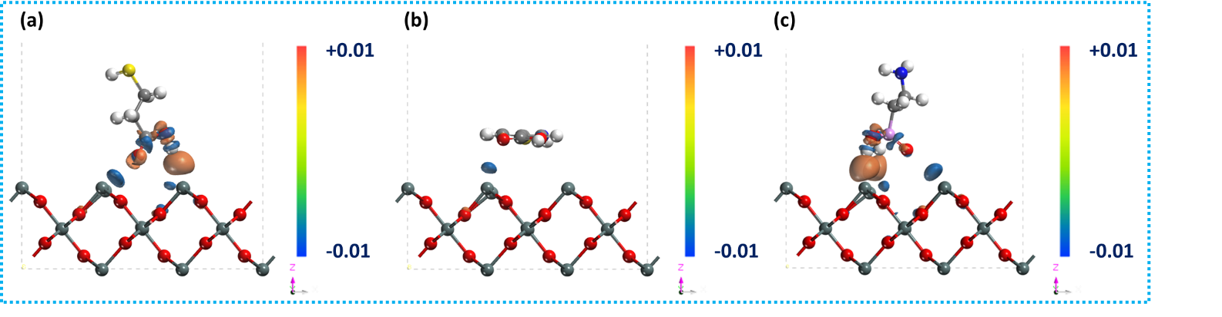
Figure S1. DFT simulation between defectives SnO₂ and (a) MPA, (b) MPCA, and (c) APA.

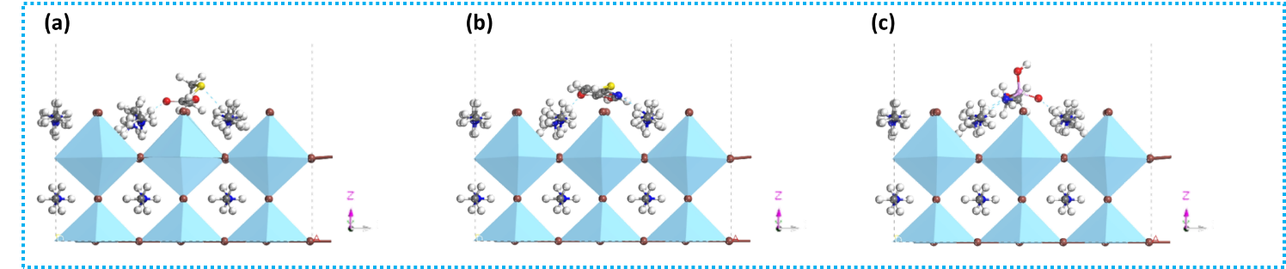
Figure S2. DFT simulation between defectives perovskite and (a) MPA, (b) MPCA, and (c) APA.
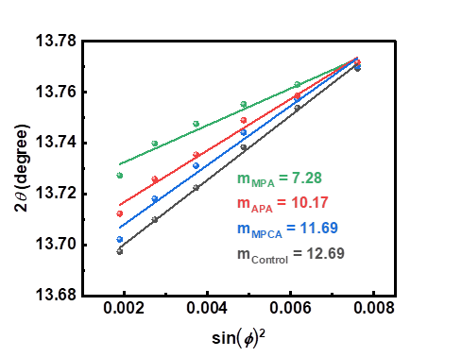
Figure S3. Overall residual strain in perovskite calculated from 2θ–sinψ² plots.
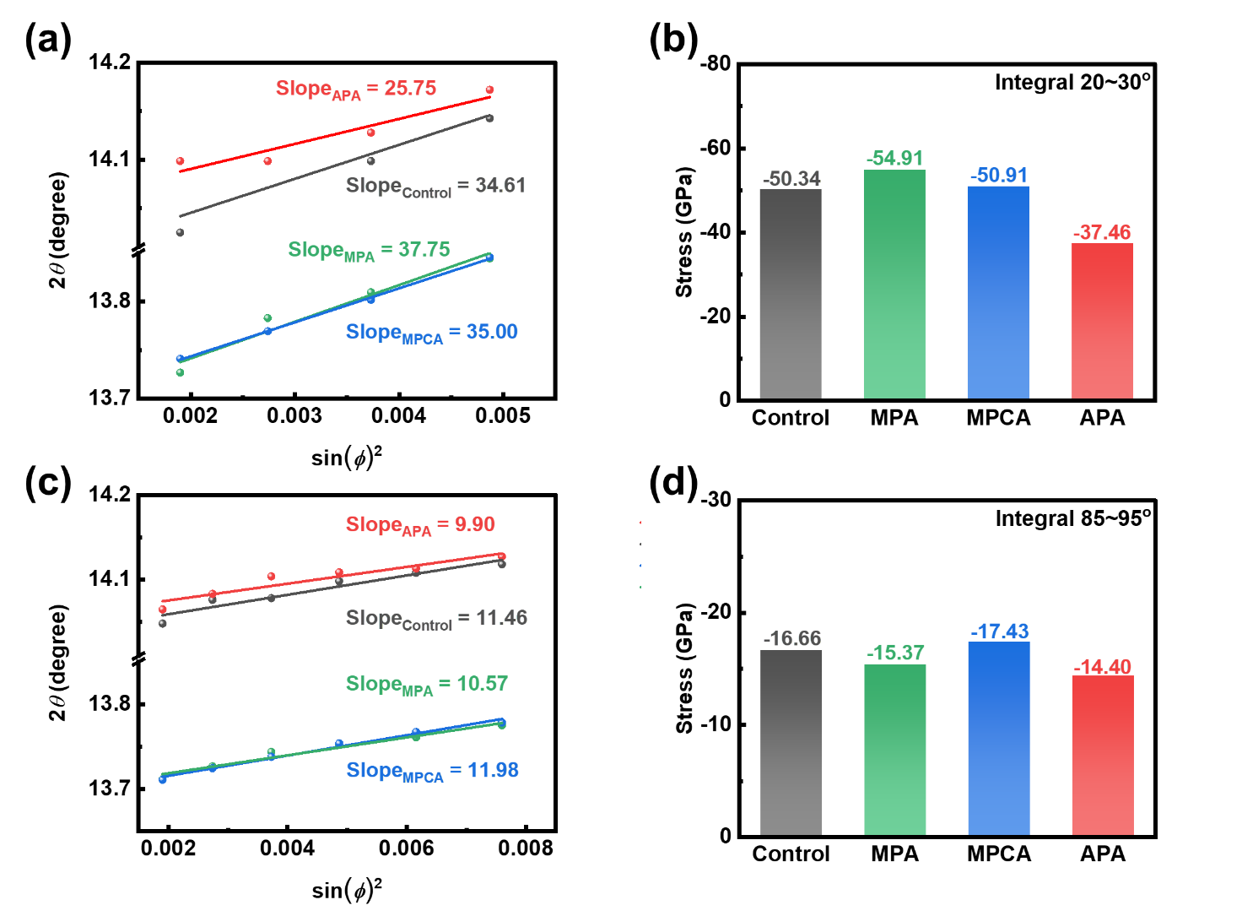
Figure S4. Azimuth stress discussion in perovskite layers: (a) in-plane residual strain, and (b) compressed stress; (c) out-off-plane residual strain and (d) compress stress.
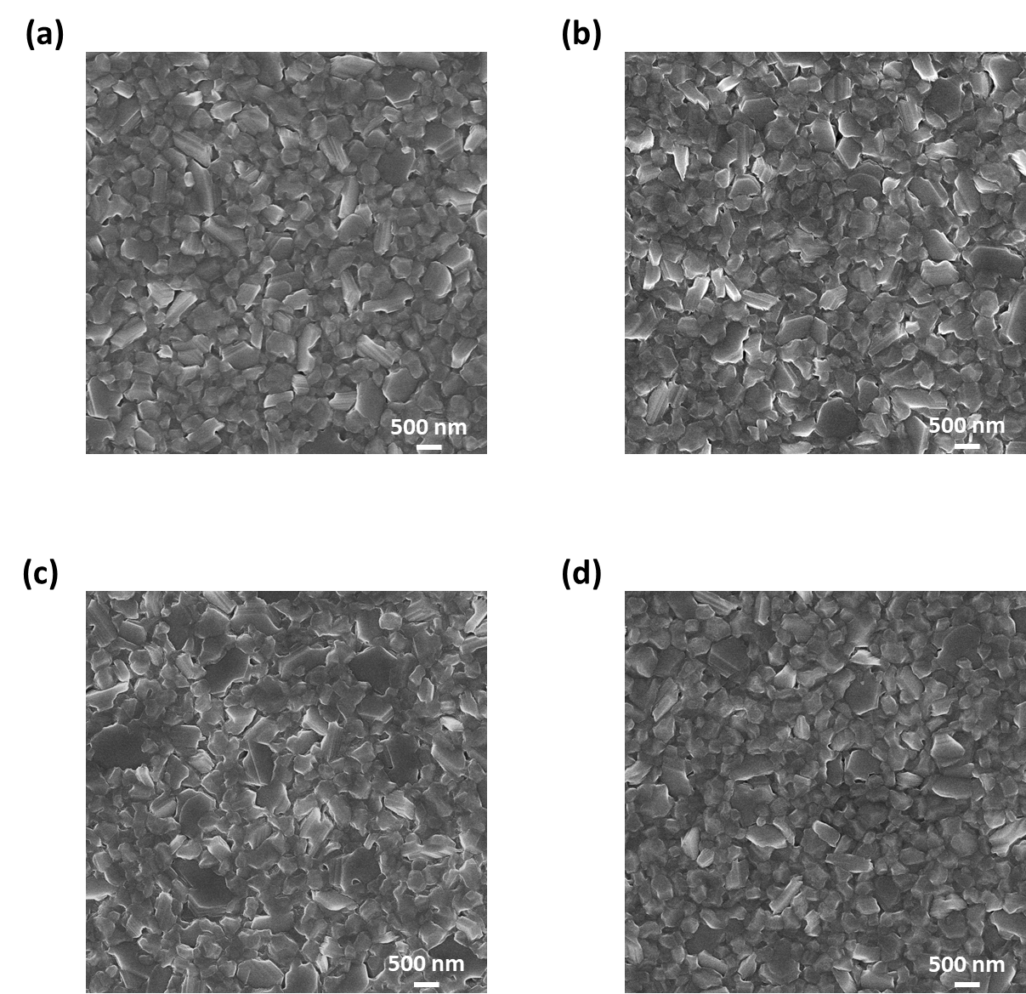
Figure S5. Top view imagines of perovskite film modify with (a) control, (b) MPA, (c) MPCA, and (d) APA.

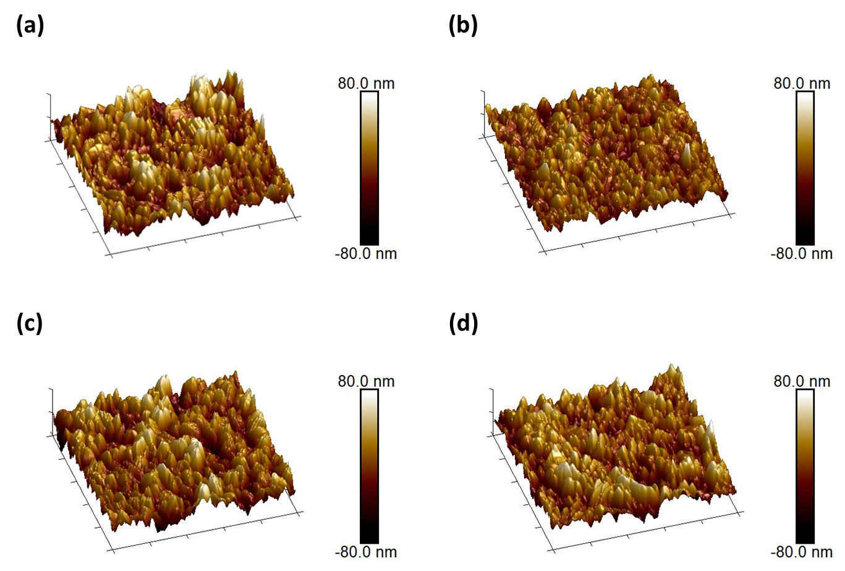
Figure S6. Surface roughness of perovskite film modifies with (a) control, (b) MPA, (c) MPCA, and (d) APA.

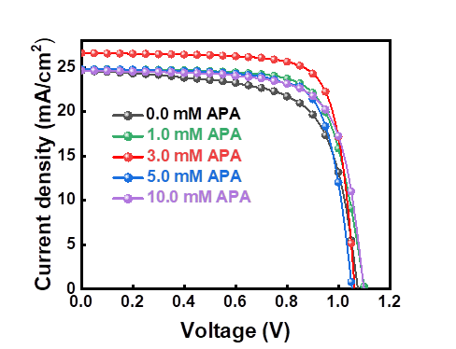
Figure S7. J-V curves of optimal device.

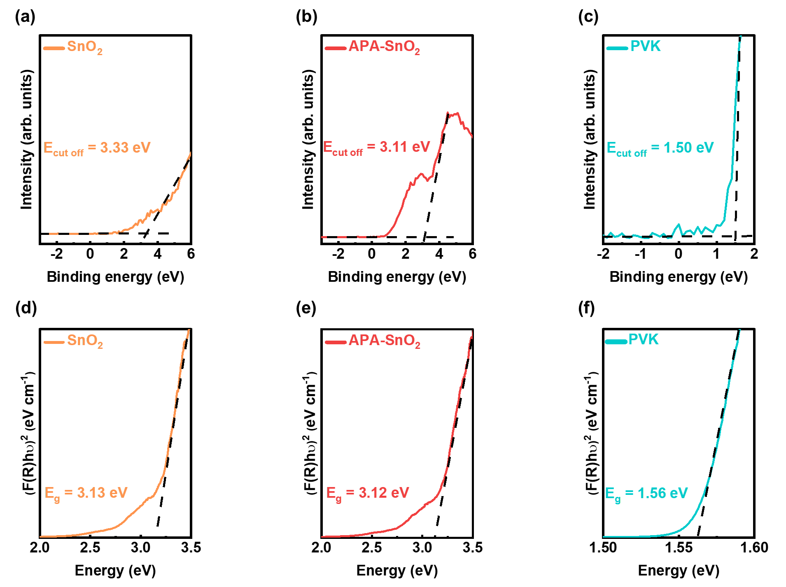
Figure S8. Band structure characterization: Valance XPS spectrum for (a) SnO₂, (b) APA modified SnO₂, and (c) perovskite film, Bandgap of (d) SnO₂, (e) APA modified SnO₂, and (f) perovskite film.

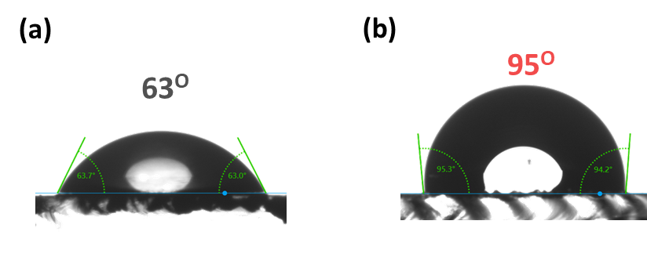
Figure S9. Water contact angle of perovskite film modified (a) without, (b) with APA.

Table S1. Photovoltaic performance of perovskite solar cell modified by different chelating molecules.
Interlayer | V_{OC} (V) | J_{SC} (mA/cm²) | FF (%) | PCE (%)
Control | 1.06 ± 0.01  (1.08) | 24.06 ± 0.51  (24.66) | 70.59 ± 1.75  (74.05) | 17.99 ± 0.53  (18.85)
MPA | 1.10 ± 0.01  (1.12) | 22.34 ± 0.45  (22.99) | 72.68 ± 1.56  (75.41) | 17.85 ± 0.49  (19.35)
MPCA | 1.09 ± 0.02  (1.11) | 22.44 ± 0.30  (22.68) | 72.50 ± 1.48  (73.22) | 17.79 ± 0.49  (18.74)
APA | 1.09 ± 0.02  (1.11) | 24.09 ± 0.52  (24.64) | 69.25 ± 2.50  (72.94) | 18.14 ± 1.00  (19.59)

Table S2. Photovoltaic performance of perovskite solar cell modified with optimal APA concentration.
Con. of APA (mM) | V_{OC} (V) | J_{SC} (mA/cm²) | FF (%) | PCE (%)
0.0 | 1.07 ± 0.03 | 24.26 ± 0.52 | 65.52 ± 2.16 | 17.08 ± 0.47
1.0 | 1.08 ± 0.02 | 24.92 ± 0.57 | 67.40 ± 4.16 | 18.15 ± 1.29
3.0 | 1.10 ± 0.00 | 25.30 ± 0.96 | 72.38 ± 0.64 | 19.23 ± 0.20
5.0 | 1.02 ± 0.02 | 24.87 ± 0.43 | 72.37 ± 1.67 | 18.40 ± 0.45
10.0 | 1.09 ± 0.02 | 24.09 ± 0.5 | 69.25 ± 2.50 | 18.14 ± 1.00

Table S3. Fitting parameter from TRPL analysis
Interlayer | τ₁ (ns) | A₁ (%) | τ₂ (ns) | A₂ (%) | τ_{ave} (ns)
Control | 4.28 | 62.7 | 44.6 | 37.3 | 19.3
APA | 2.78 | 63.3 | 31.9 | 36.6 | 13.4

Reference
(1) Liu, S.; Li, J.; Xiao, W.; Chen, R.; Sun, Z.; Zhang, Y.; Lei, X.; Hu, S.; Kober-Czerny, M.; Wang, J.; et al. Buried interface molecular hybrid for inverted perovskite solar cells. Nature 2024, 632 (8025), 536-542. DOI: 10.1038/s41586-024-07723-3.
(2) Li, F.; Deng, X.; Qi, F.; Li, Z.; Liu, D.; Shen, D.; Qin, M.; Wu, S.; Lin, F.; Jang, S.-H.; et al. Regulating Surface Termination for Efficient Inverted Perovskite Solar Cells with Greater Than 23% Efficiency. Journal of the American Chemical Society 2020, 142 (47), 20134-20142. DOI: 10.1021/jacs.0c09845.
(3) Luo, C.; Zheng, G.; Gao, F.; Wang, X.; Zhan, C.; Gao, X.; Zhao, Q. Engineering the buried interface in perovskite solar cells via lattice-matched electron transport layer. Nature Photonics 2023, 17 (10), 856-864. DOI: 10.1038/s41566-023-01247-4.

