Disparities in Bowel Preparation Quality for Colonoscopy in Central Australia: A Retrospective Cohort Study at Alice Springs Hospital
A total of 125 colonoscopies were analyzed (First Nations 35, non‑First Nations 90). Mean BBPS was 6.0±1.8 for First Nations vs 7.8±1.6 for non‑First Nations patients (p<0.001). Inadequate bowel preparation (BBPS <6) occurred in 28.6% vs 7.8% (p=0.002).

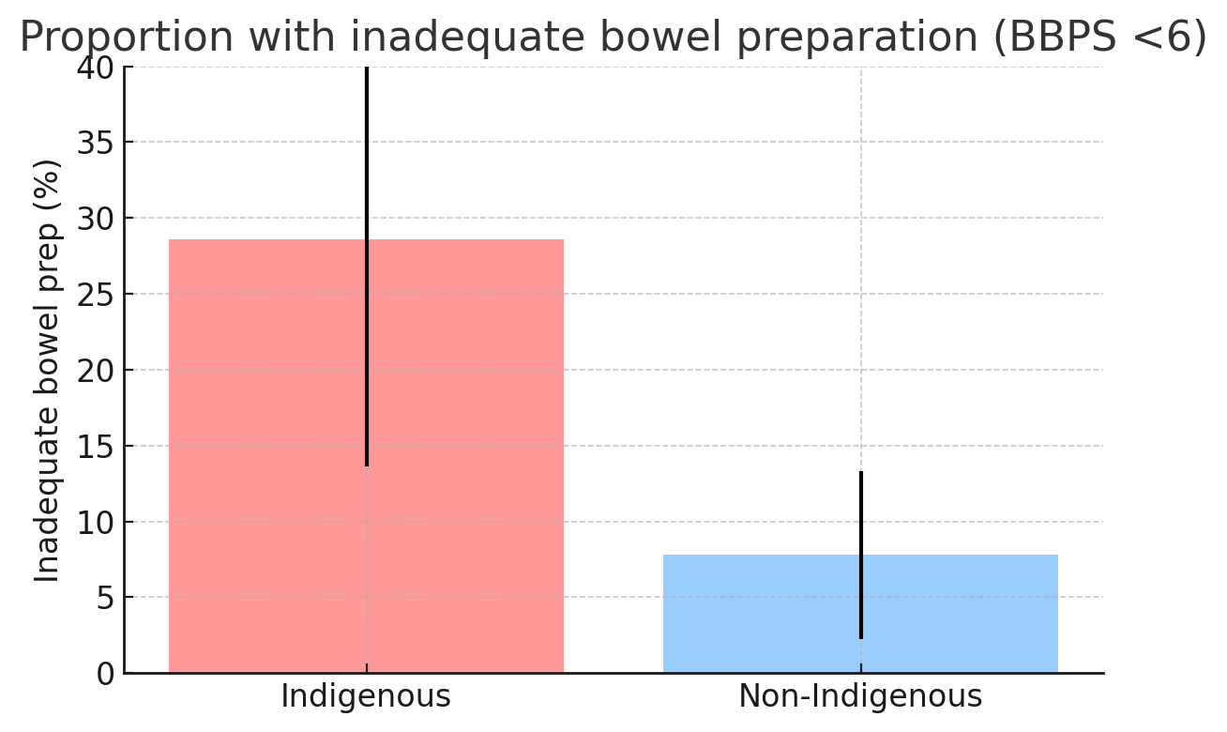

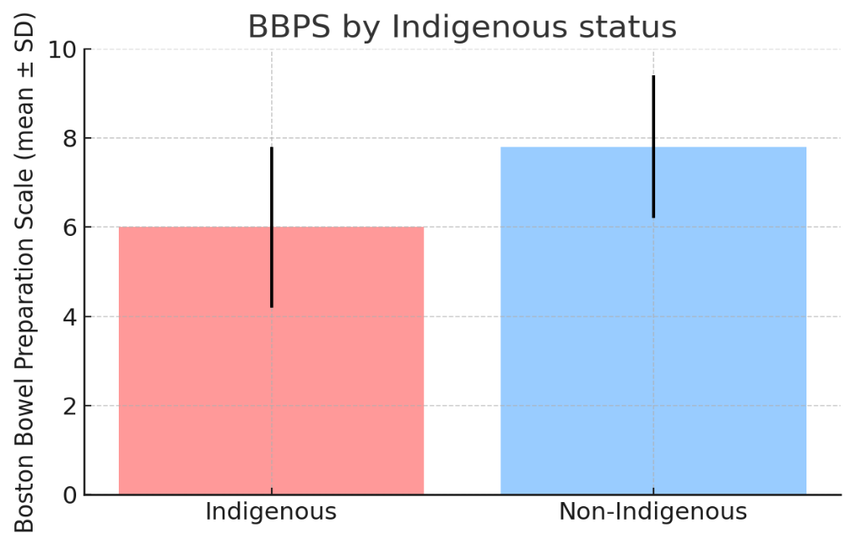

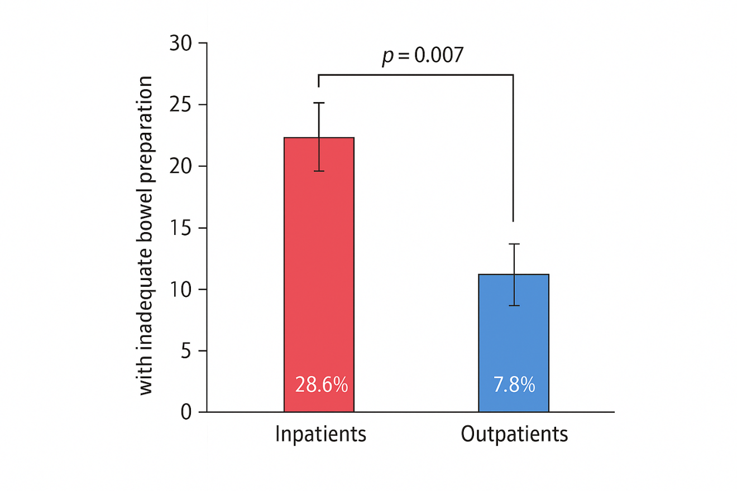

Results

Table 1. Baseline Characteristics

Characteristic | First Nations (n=35) | Non‑First Nations (n=90)
Mean age (years) | 59.2 | 57.8
Female sex, n (%) | 20 (57%) | 51 (57%)
Inpatient status, n (%) | 10 (29%) | 9 (10%)
Diabetes, n (%) | 24 (68%) | 29 (32%)
CKD, n (%) | 10 (29%) | 8 (9%)
Mean BBPS (SD) | 6.0 (1.8) | 7.8 (1.6)
Inadequate BBPS (<6), n (%) | 10 (28.6%) | 7 (7.8%)

Table 2. Logistic Regression Predictors of Inadequate Bowel Preparation

Predictor | Adjusted OR (95% CI) | p Value
First Nations status | 4.8 (1.8–12.7) | 0.001
Inpatient status | 3.9 (1.4–10.6) | 0.007
CKD (≥ Stage 3) | 3.2 (1.1–9.3) | 0.035
Distance >200 km | 2.7 (1.0–7.4) | 0.049
Hospital-based preparation | 2.9 (1.0–8.3) | 0.046

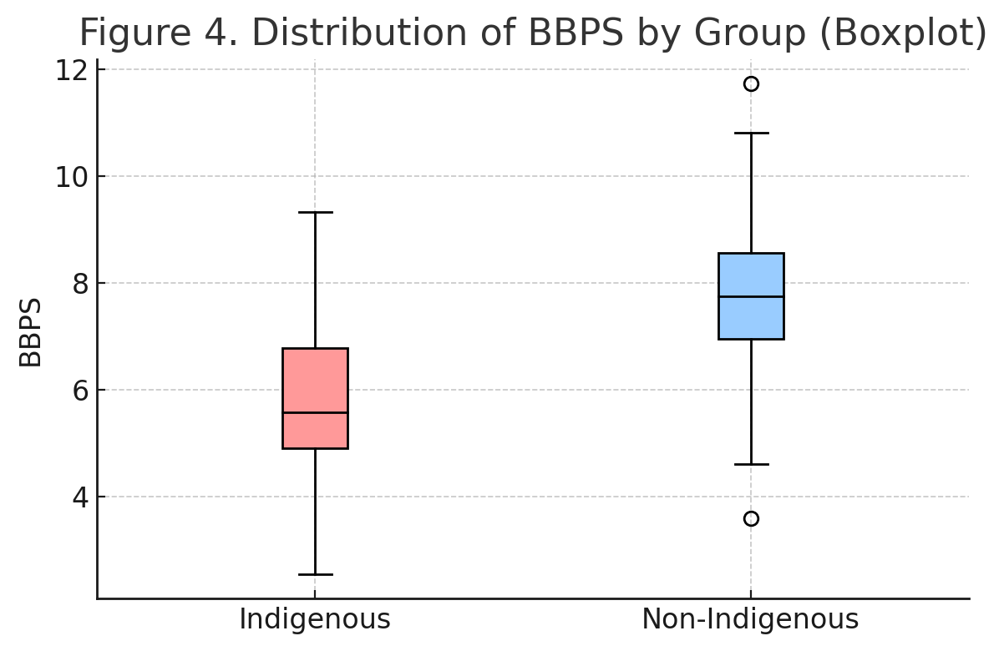
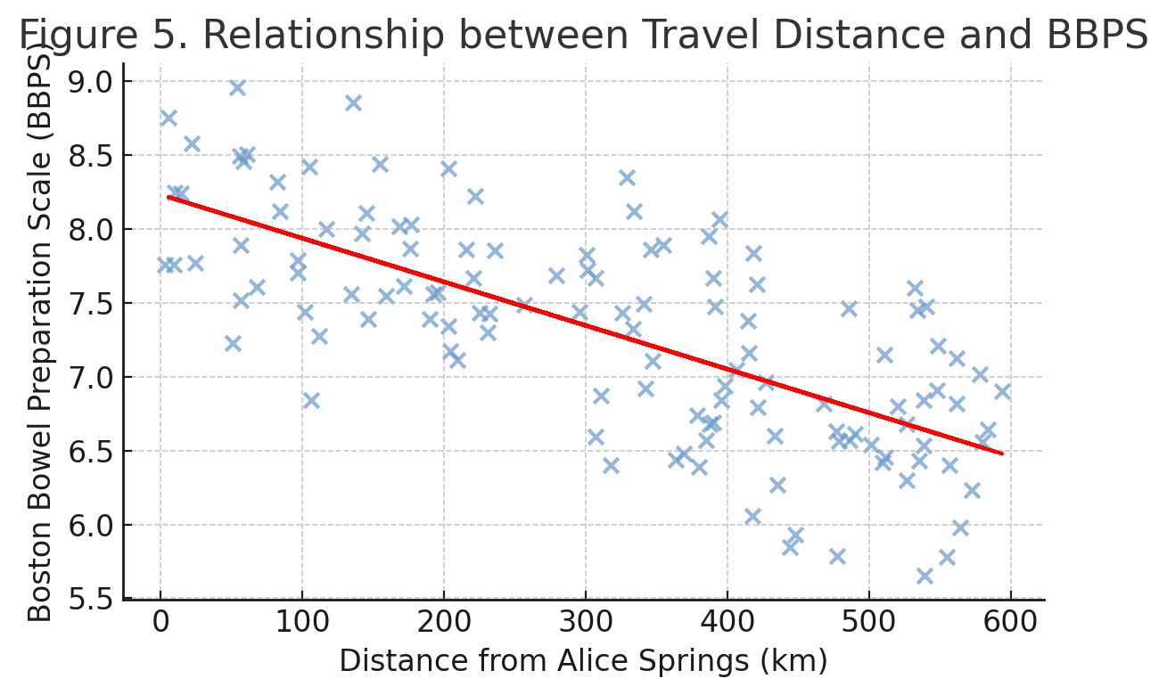

Table3: Association between comorbidities and Inadequate bowel preparation

Comorbidity | % Inadequate Prep (BBPS <6) | Odds Ratio (95% CI) | p-value | Interpretation
Diabetes Mellitus | 22.0% vs 10.5% (No DM) | 2.3 (0.9–5.9) | 0.08 | Trend towards higher inadequate prep
Chronic Kidney Disease (CKD ≥ Stage 3) | 28.6% vs 9.5% | 3.2 (1.1–9.3) | 0.035 | Significant association
Hypertension | 18.0% vs 12.5% | 1.5 (0.6–3.8) | 0.32 | Not significant
Cardiovascular Disease (IHD) | 20.0% vs 12.3% | 1.8 (0.7–4.9) | 0.21 | Not significant
≥2 Comorbidities | 26.3% vs 9.8% | 2.9 (1.0–8.1) | 0.048 | Significant predictor

