Appendix A: Figure 1. Pedagogical Class Scenario Inventory
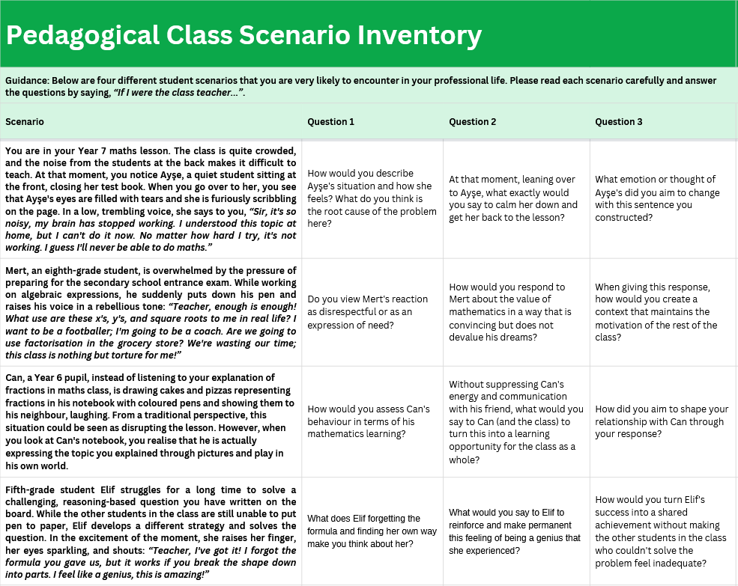

Appendix-B: Table 4. MWB x WBL Integration Matrix (MWBL Matrix)
MWB dimension | WBL component
 | Vocabulary and knowledge about WB | Comprehension | Composition | Context awareness | Intentionality
Positive emotions | Anxiety, panic, cognitive load, and learned helplessness terms | Understanding the root cause of the crisis as emotional turbulence rather than a lack of talent | Normalisation: “What you are feeling is perfectly normal; everyone experiences it.” | Physical environment: Being aware of the oppressive effects of noise and crowds. | Emotion regulation: Reducing and calming the student's current high anxiety
Relationship | Teacher-student bond, trust, sense of belonging | Distinguishing rebellion from a call for help as disrespectful | Inclusivity: “I am here.” “My only daughter.”, “We will manage together.” | Power balance: Positioning teacher authority as protective rather than punitive | Building trust: Ensuring that the student does not feel alone and trusts the teacher
Engagement | Active participation, visual/auditory learning styles | Drawing is not a distraction from the lesson, but an active form of participation in reading | Invitation: “Tell us too”, “Come to the board and show us.” | Educational flexibility: Converting an individual method (drawing) into an activity for the whole class | Retention in the system: Keeping the student in the lesson without excluding them
Perseverance | Perseverance, perseverance, effort, process | Identifying Ayşe's renunciation not as an end, but as a turning point | Encouragement: “If not now, you can do it at home”, “Let us try again.” | Timing: Taking a break and trying again later rather than persisting during a crisis | Attribution change: Increasing resilience by attributing failure to circumstances rather than intelligence
Learning environment | Noise pollution, classroom management, and peer pressure | Viewing the environment not only as a physical barrier but also as a psychological one | Moral language: “Do not infringe on your friend's rights”, “Let us be quiet.” | System responsibility: Seeing the source of the problem not in the student, but in the unmanageable environment | Ensuring justice: Protecting the rights of students working within the class and maintaining order
Cognition | Metacognition, cognitive schema, and reasoning | Viewing Elif's success as conceptual understanding rather than rote memorisation | Thinking language: “You thought like a mathematician”, “You grasped the logic.” | Cognitive level: Distinguishing between formula (operational) and logic (conceptual) | Mindset shift: Changing the perception of success from being results-oriented to process-oriented
Passion for learning | Inner motivation, curiosity, the joy of discovery | Noticing Mert's weariness or Elif's excitement at discovery | Inspiration: “The greatest discoveries begin with curiosity”, “I found it moment.” | Academic burnout: Accepting exam year fatigue | Stimulating curiosity: Maintaining the student's interest in the lesson without turning it into aversion.
Supportive actions | Gamification, concretization, and visualization | Accepting Can's pizzas not as mischief but as supportive material | Approval: “A splendid feast”, “Creative models.” | Instrumentality: Instrumentalising non-standard actions (art/drawing) for mathematics learning | Legitimisation: Allowing and valuing the student's own method
Accomplishment | Self-efficacy, sense of achievement, collective success | Viewing success not as individual stardom but as the collective capital of the class | Sharing: “We solved it as a class”, “We can all do it.” | Competition management: Preventing one person's success from creating a feeling of inadequacy in others | Collective competence: We are a successful class in identity building
Connection | Interdisciplinary connection, career, and real life | Coding mathematics as an exam obstacle (negative) or a tool for life (positive) | Metaphor: “Mental muscle”, “Coordinate field”, “Key.” | Sociological reality: Considering the reality of the secondary school entrance exam or the student's career aspirations | Meaning making: Providing a satisfactory answer to the student's question, “Why am I learning this?”

