LM STATISTICAL CONSULTING
REPORT
Client: Vitória Bernal
contato@lmestatistica.com.br
WhatsApp: +55 (11) 95619-0790
September 9, 2025
Table of Contents
1 Introduction .................................................. 3
2 Profile Variables Analysis .................................... 4
3 Seizure Charts ................................................ 7
4 Effect of Surgery ............................................. 12
4.1 Posterior ............................................... 13
4.2 Total ................................................... 14
5 Comparison Between Surgeries .................................. 16

1 INTRODUCTION
This report presents the statistical analysis of a dataset containing the time and degree of seizures observed in rats after epilepsy induction through injections, before and after surgical procedures. The analyses were performed with the objective of studying the effect of surgery on seizure time and degree.
All analyses were conducted using the statistical software R [3].
Note: Data from sessions that were not completed were excluded from the analysis. That is, when an "x" was marked in the data spreadsheet for a rat, all data from the respective injection of that rat were excluded from the analysis.

2 PROFILE VARIABLES ANALYSIS
In this section, we compare the rats submitted to each surgery with respect to weight and surgery time. First, we present descriptive statistics of each variable in each surgery group. The descriptive statistics presented are, in addition to the mean:
- Sample Size (N): number of observations in the sample.
- Standard Deviation (SD): measure of data variation. The larger the standard deviation, the greater the variation of observations in the sample.
- LCI: Lower bound of the 95% confidence interval for the mean.
- UCI: Upper bound of the 95% confidence interval for the mean.
- Minimum: smallest value observed in the sample.
- 1st Quartile: value such that 25% of observations have a value below it.
- Median: value such that 50% of observations have a value of the variable below it.
- 3rd Quartile: value such that 75% of observations have a value below it.
- Maximum: largest value observed in the sample.
Next, we present the box-plot of the variable in each surgery group. A box-plot is formed by three horizontal line segments and two vertical ones (forming a box shape), plus two vertical whiskers, one above and one below the box. Points above or below the whiskers are called outliers — observations too high or too low for the pattern observed in the data. The diamond represents the mean and the central horizontal line inside the box represents the median. Analyzing the box from bottom to top: the base of the box represents the first quartile (25% of observations fall below it), and the top of the box represents the third quartile (75% of observations fall below it).
For interpretation, we suggest evaluating two important points in the graph: the interquartile range (distance between the third and first quartile lines) and the height of the box. A larger interquartile range indicates greater variability. When the box of one group is higher than another, individuals in that group tend to have higher values in the variable.
More information about box-plots can be found at: http://assessoriaestatistica.com.br/blog/boxplot
To determine whether there is a statistically significant difference between groups, we first performed the Shapiro-Wilk Normality Test [1] at a 5% significance level. If the variable has a Normal distribution (p > 0.05), we apply a Parametric Test; otherwise (p < 0.05), we apply a Non-Parametric Test:
- If the variable does not follow a Normal distribution, we use the Wilcoxon Test [1] (Mann-Whitney Test) — a non-parametric alternative to the t-test. If p < 0.05, the distribution of the variable differs between surgery groups at 5% significance. If p > 0.05, no significant difference exists.
- If the variable follows a Normal distribution, we use Student's t-test [2]. If p < 0.05, the mean of the variable differs between surgery groups at 5% significance. If p > 0.05, no significant difference exists.
We observe that both rat weight and surgery time tend to be higher in the Total surgery group, as visible in the box-plots. However, this observed difference is not statistically significant — for rat weight according to the t-test (p = 0.161) and for surgery time according to the Wilcoxon test (p = 0.806).
Table 1: Descriptive statistics of the variable Rat weight by the variable Surgery in the sample (p = 0.161, t-test).
 | N | Mean | SD | LCI | UCI | Min | Q1 | Median | Q3 | Max
Posterior | 5 | 585 | 55.3 | 536.6 | 633.4 | 515 | 564 | 582 | 597 | 667
Total | 6 | 660.7 | 103.2 | 578.1 | 743.2 | 556 | 574.8 | 642.5 | 757.5 | 775

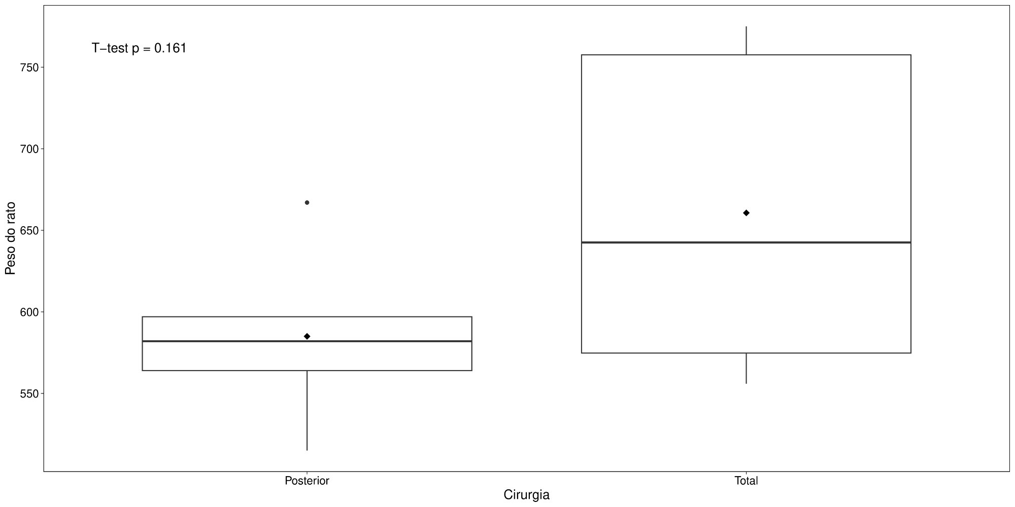
Figure 1: Box-plot of the variable Rat weight by the variable Surgery.
Table 2: Descriptive statistics of the variable Surgery time (min) by the variable Surgery in the sample (p = 0.806, Wilcoxon).
 | N | Mean | SD | LCI | UCI | Min | Q1 | Median | Q3 | Max
Posterior | 5 | 45.4 | 27.7 | 21.2 | 69.6 | 25 | 27 | 40 | 42 | 93
Total | 4 | 40.8 | 12.3 | 28.7 | 52.8 | 25 | 37 | 41.5 | 45.3 | 55

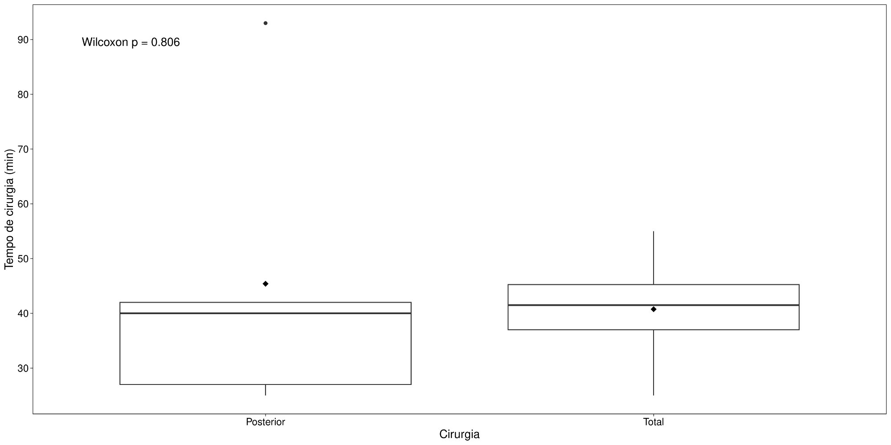
Figure 2: Box-plot of the variable Surgery time (min) by the variable Surgery.

3 SEIZURE CHARTS
In this section, we present, for each rat and injection, the graph showing the evolution of the seizure degree over time. Graph colors correspond to surgery type.
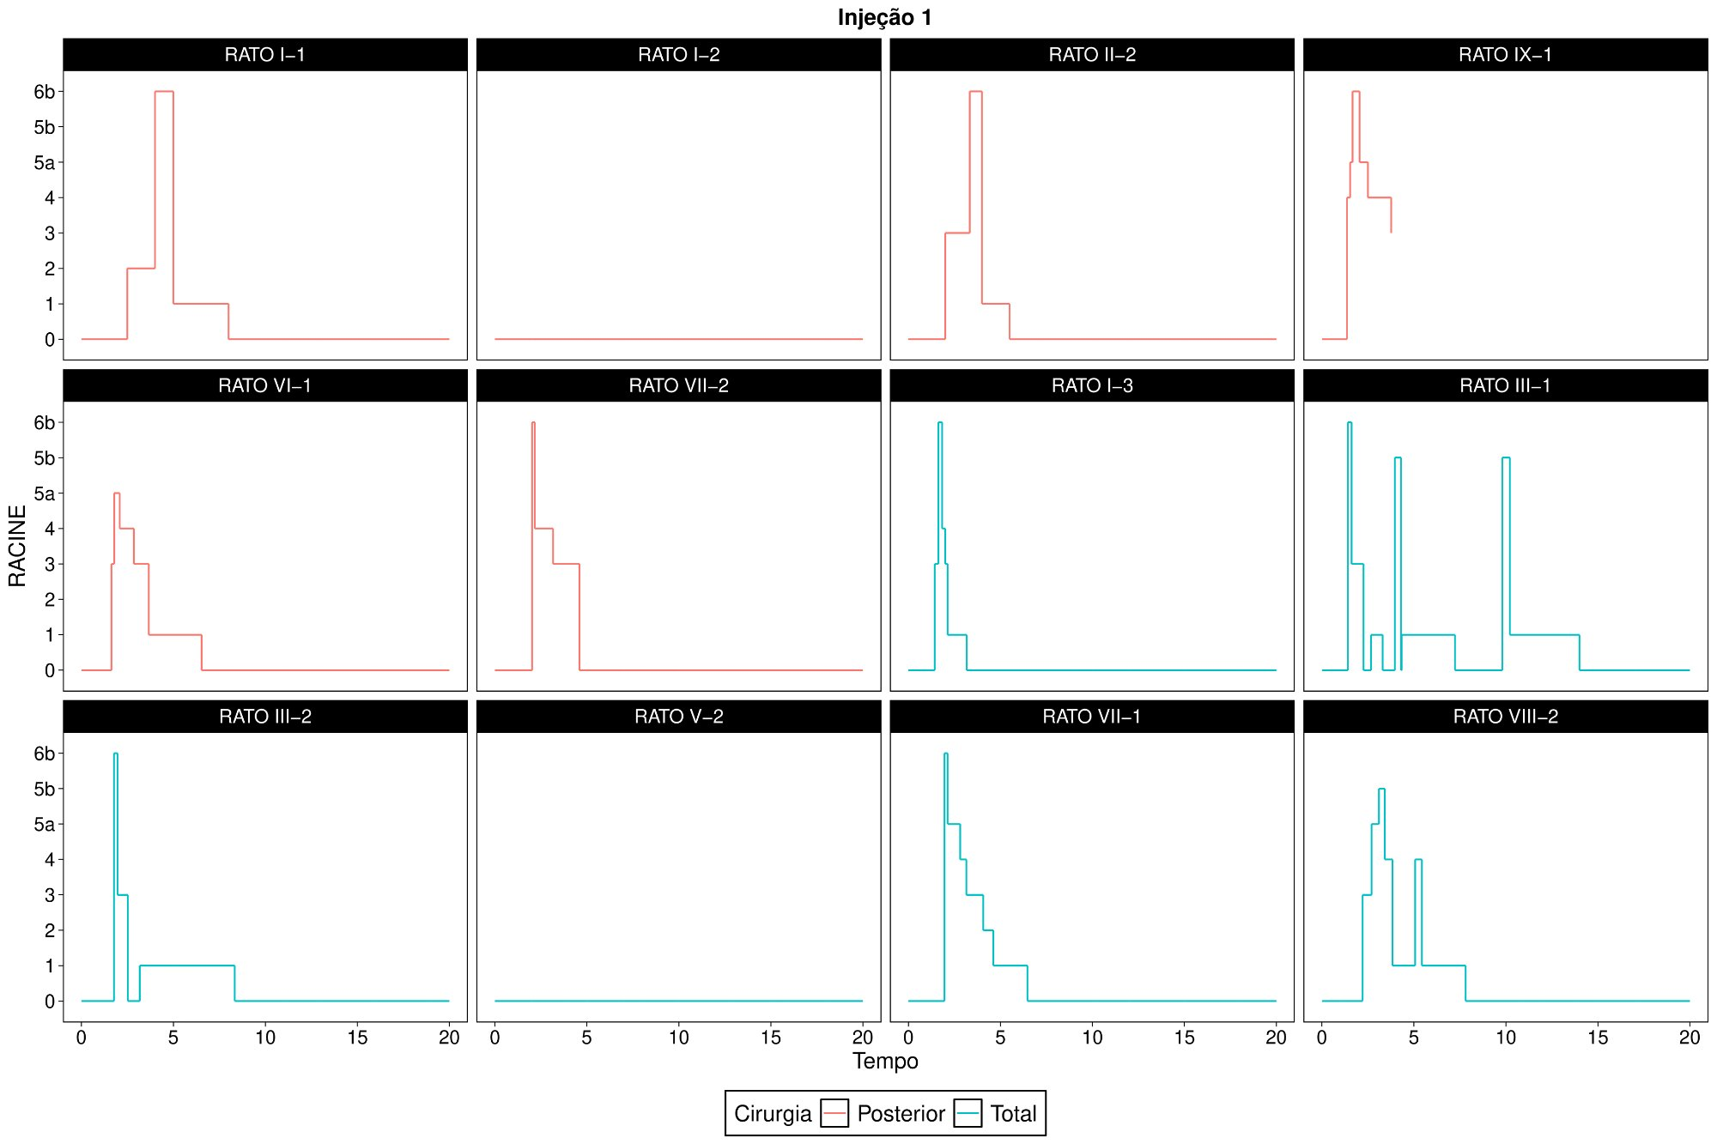
Figure 3: Seizures over time for each rat in Injection 1.
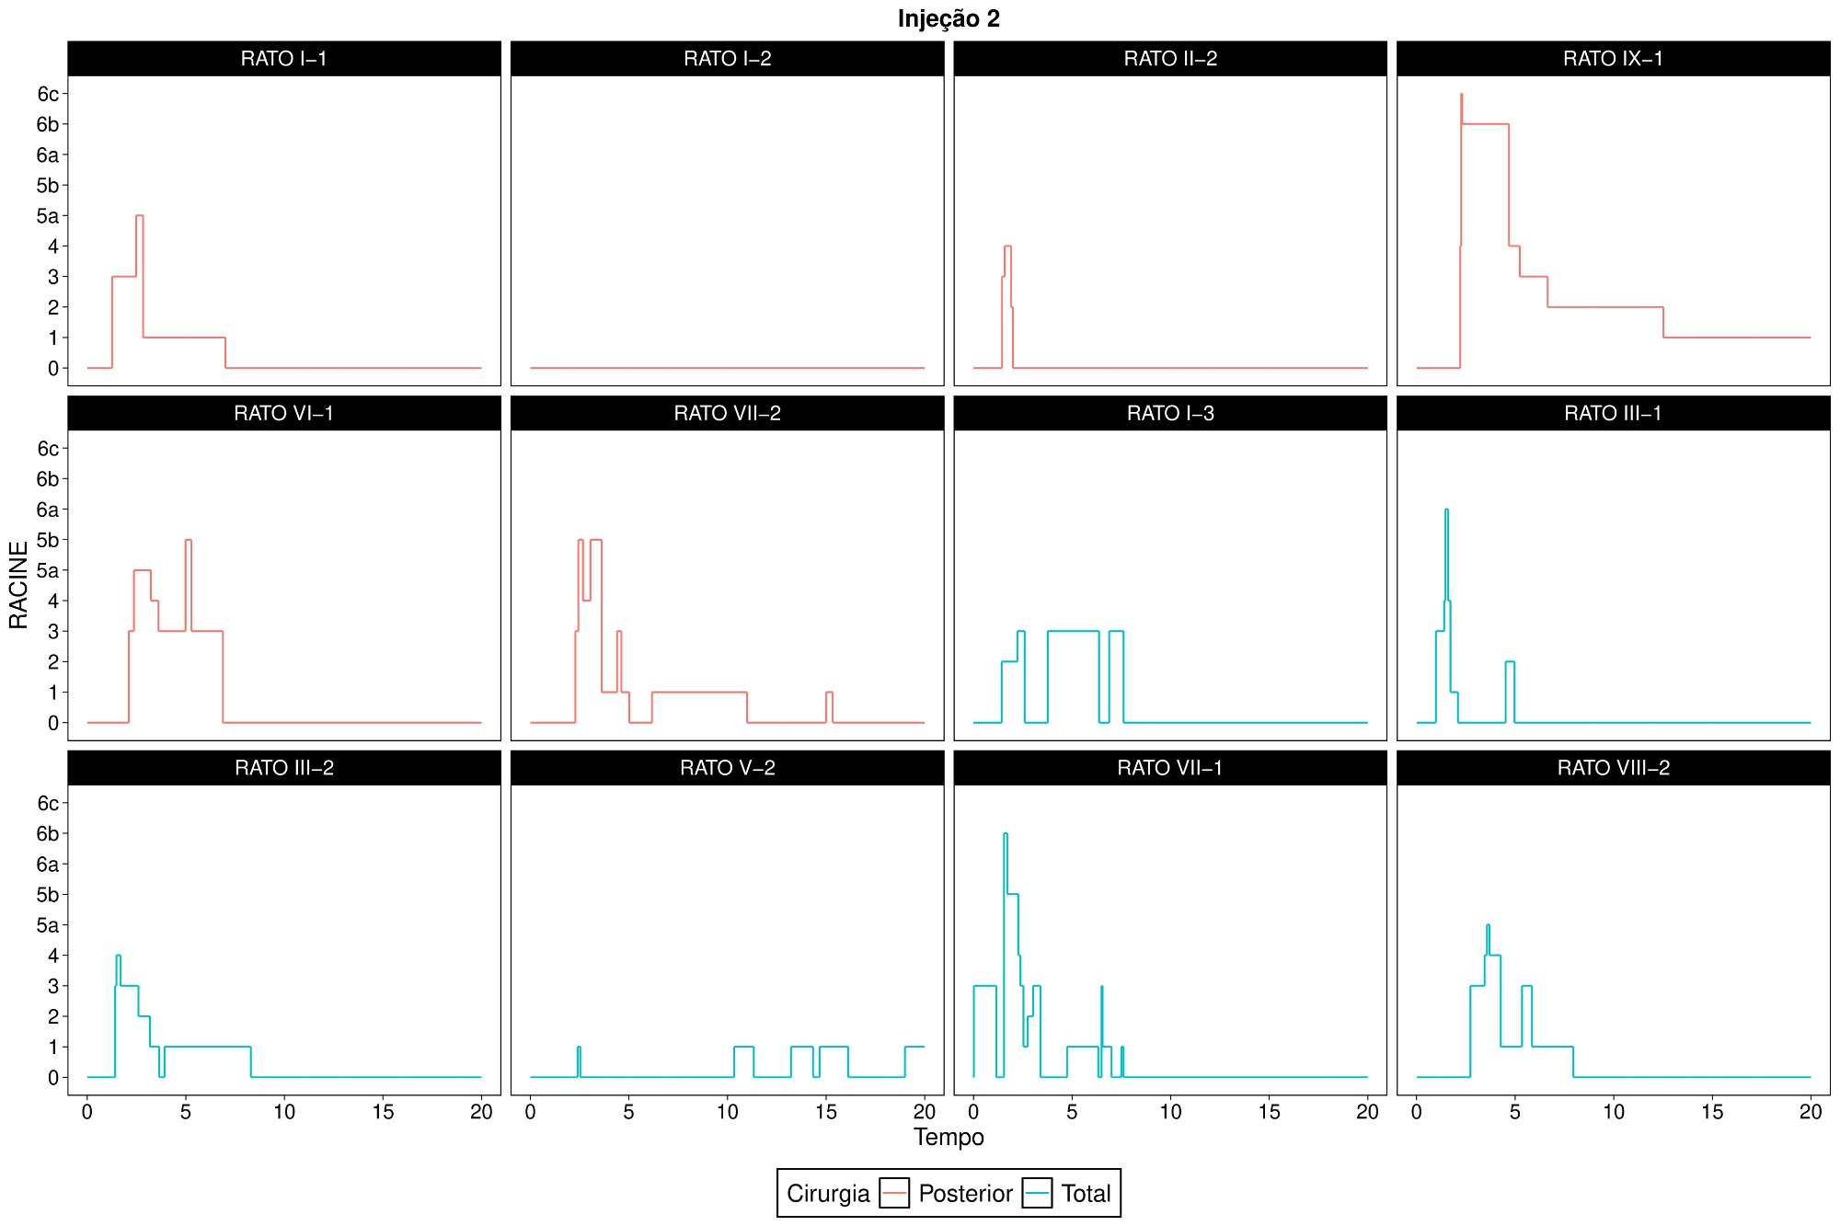
Figure 4: Seizures over time for each rat in Injection 2.
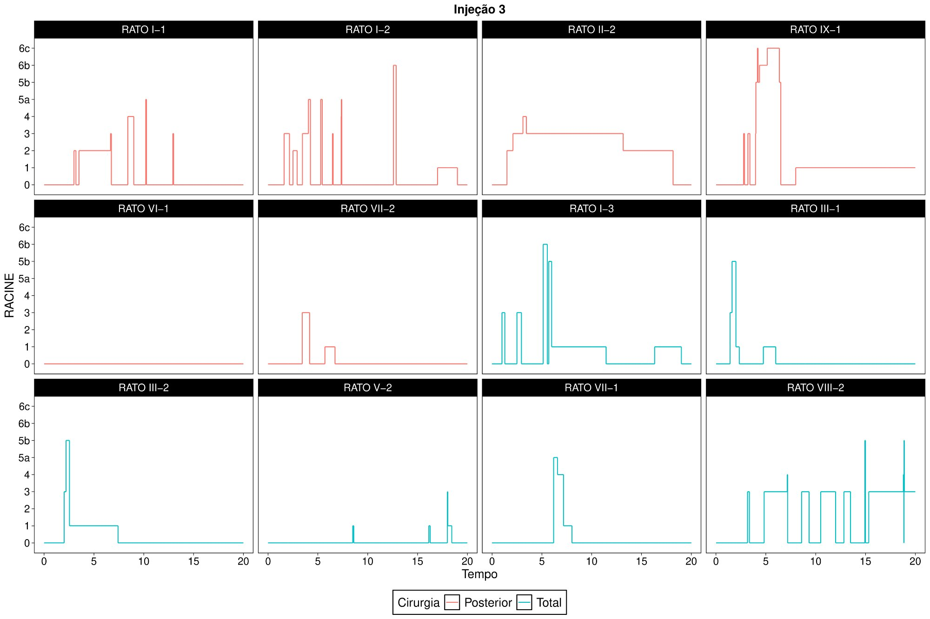
Figure 5: Seizures over time for each rat in Injection 3.
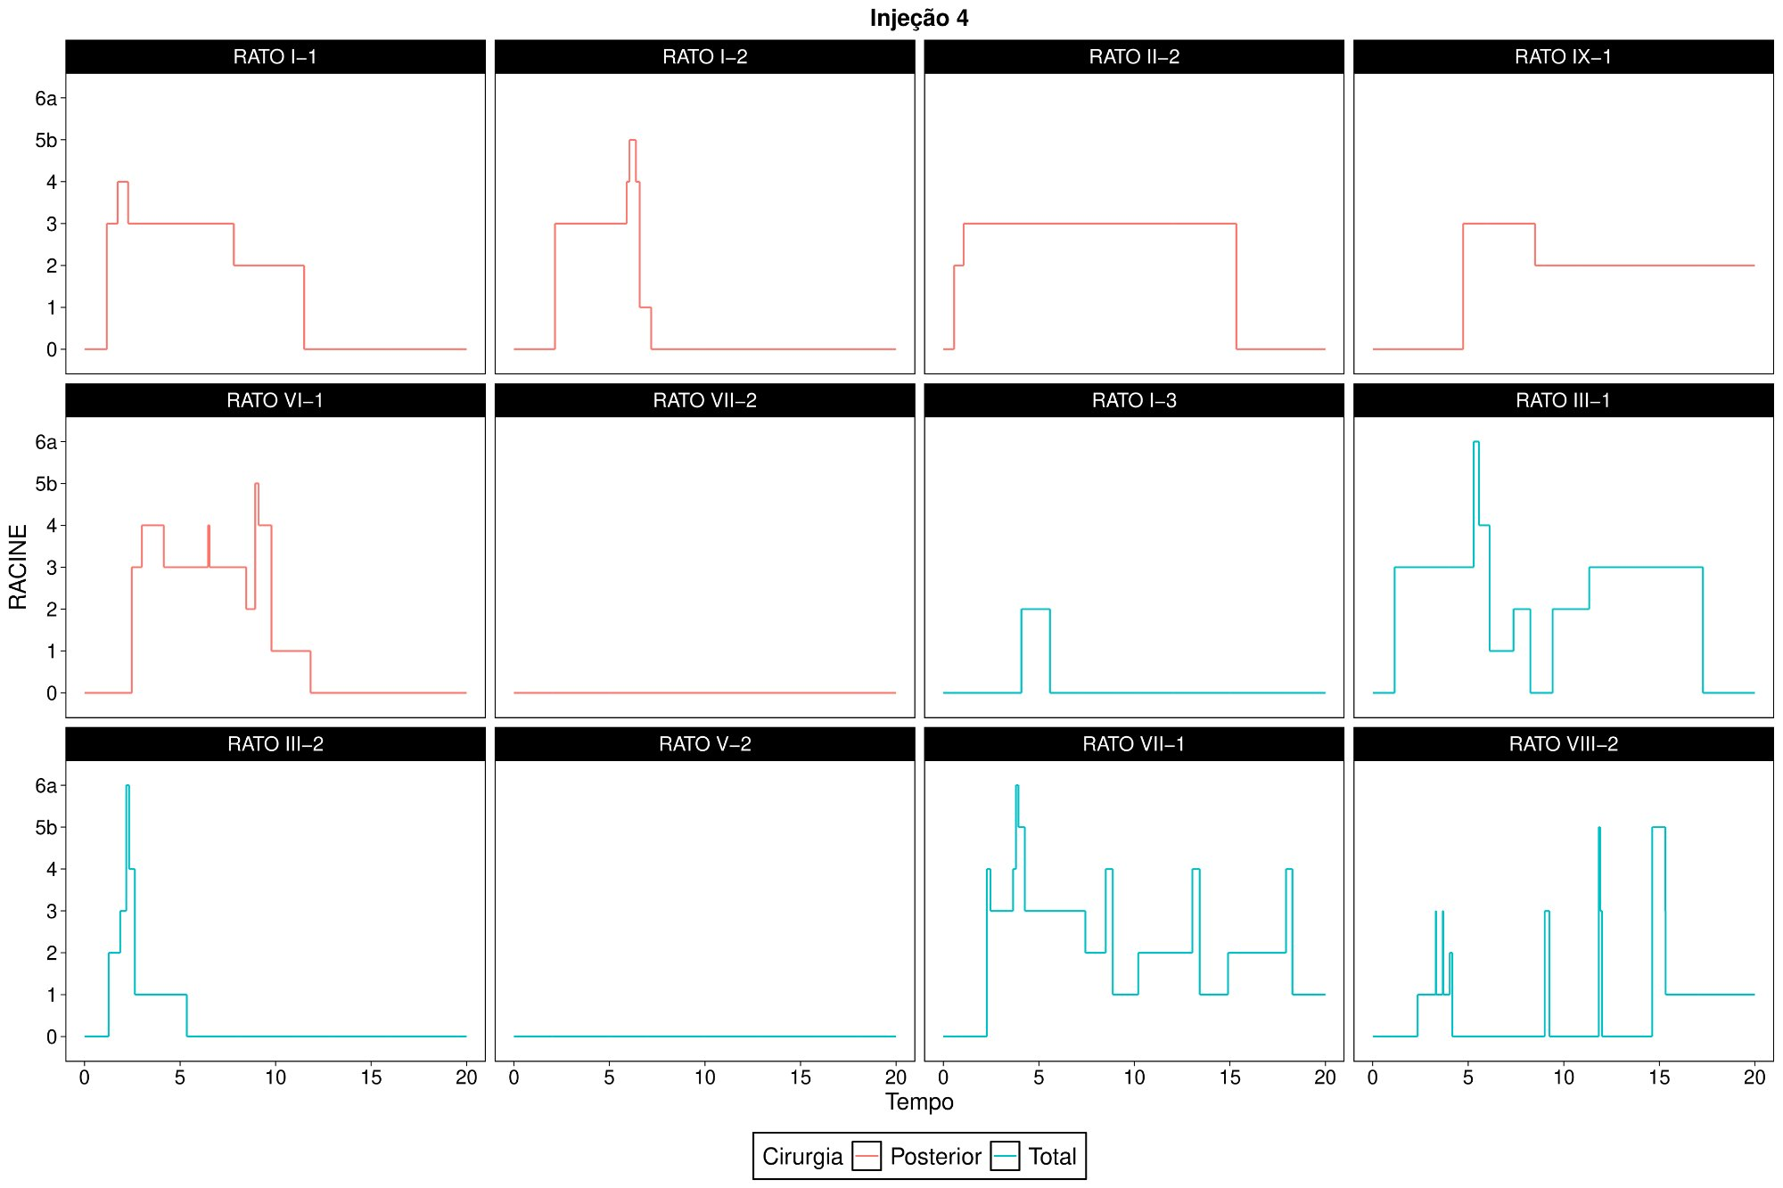
Figure 6: Seizures over time for each rat in Injection 4.
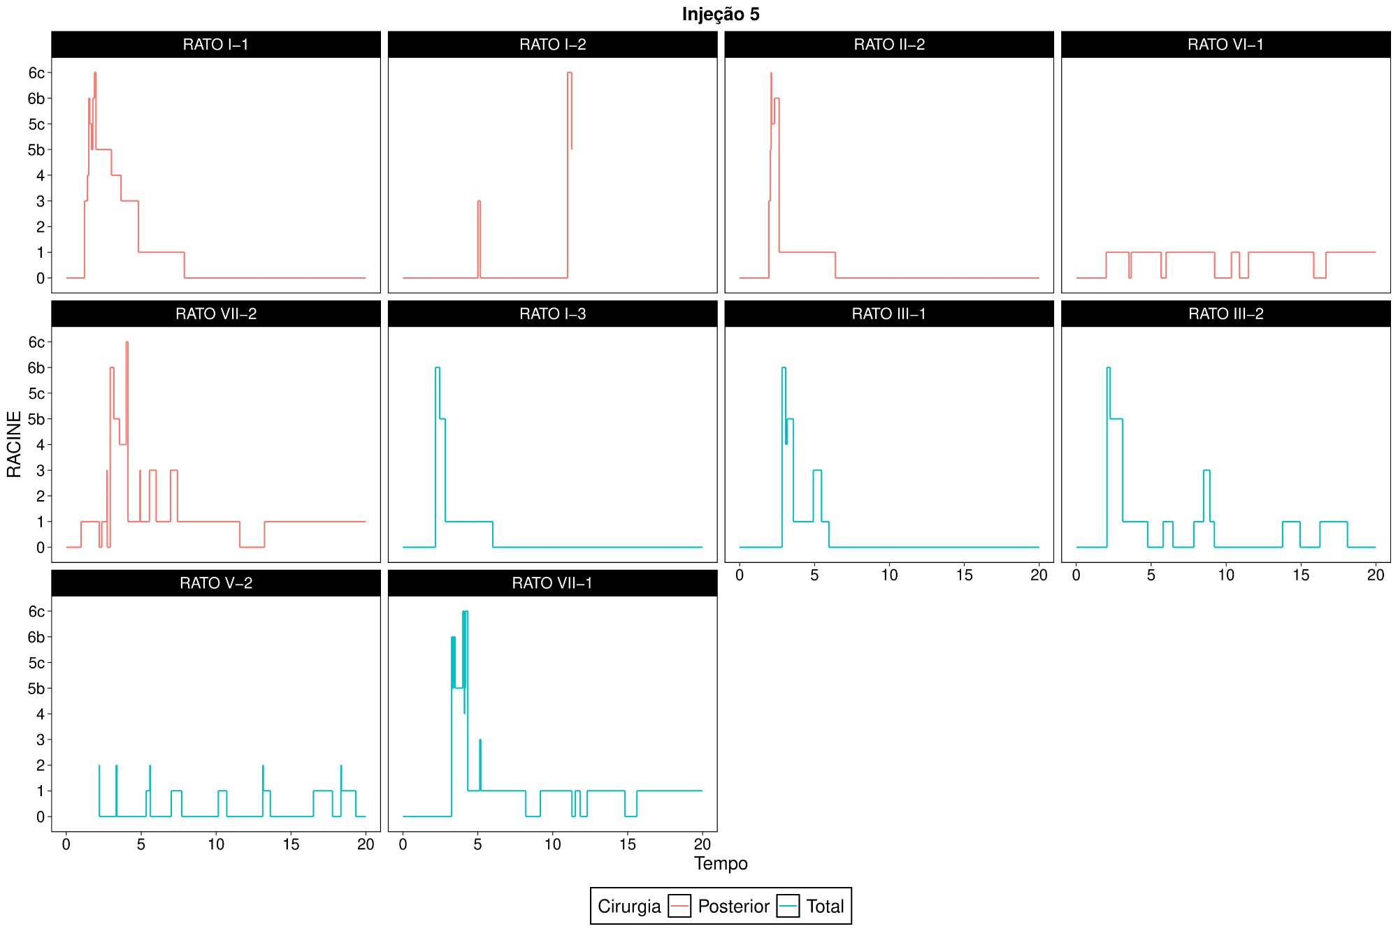
Figure 7: Seizures over time for each rat in Injection 5.
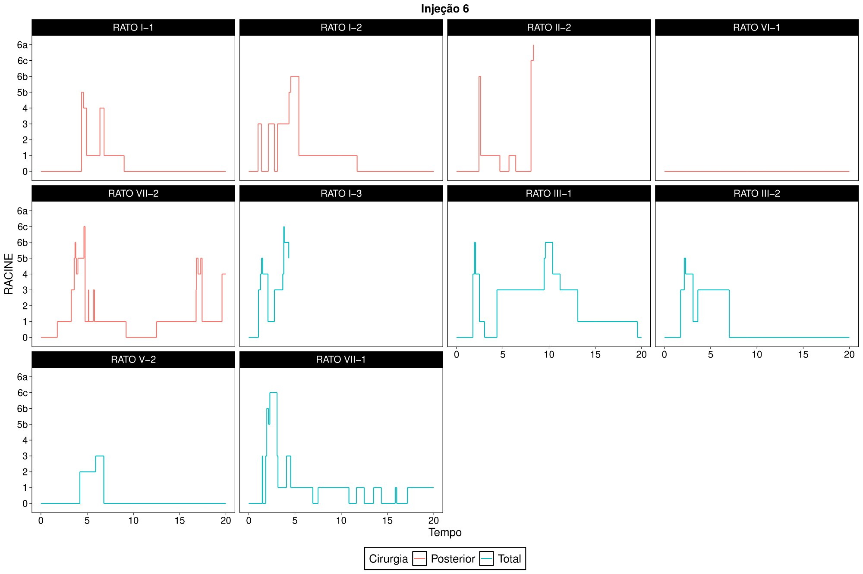
Figure 8: Seizures over time for each rat in Injection 6.
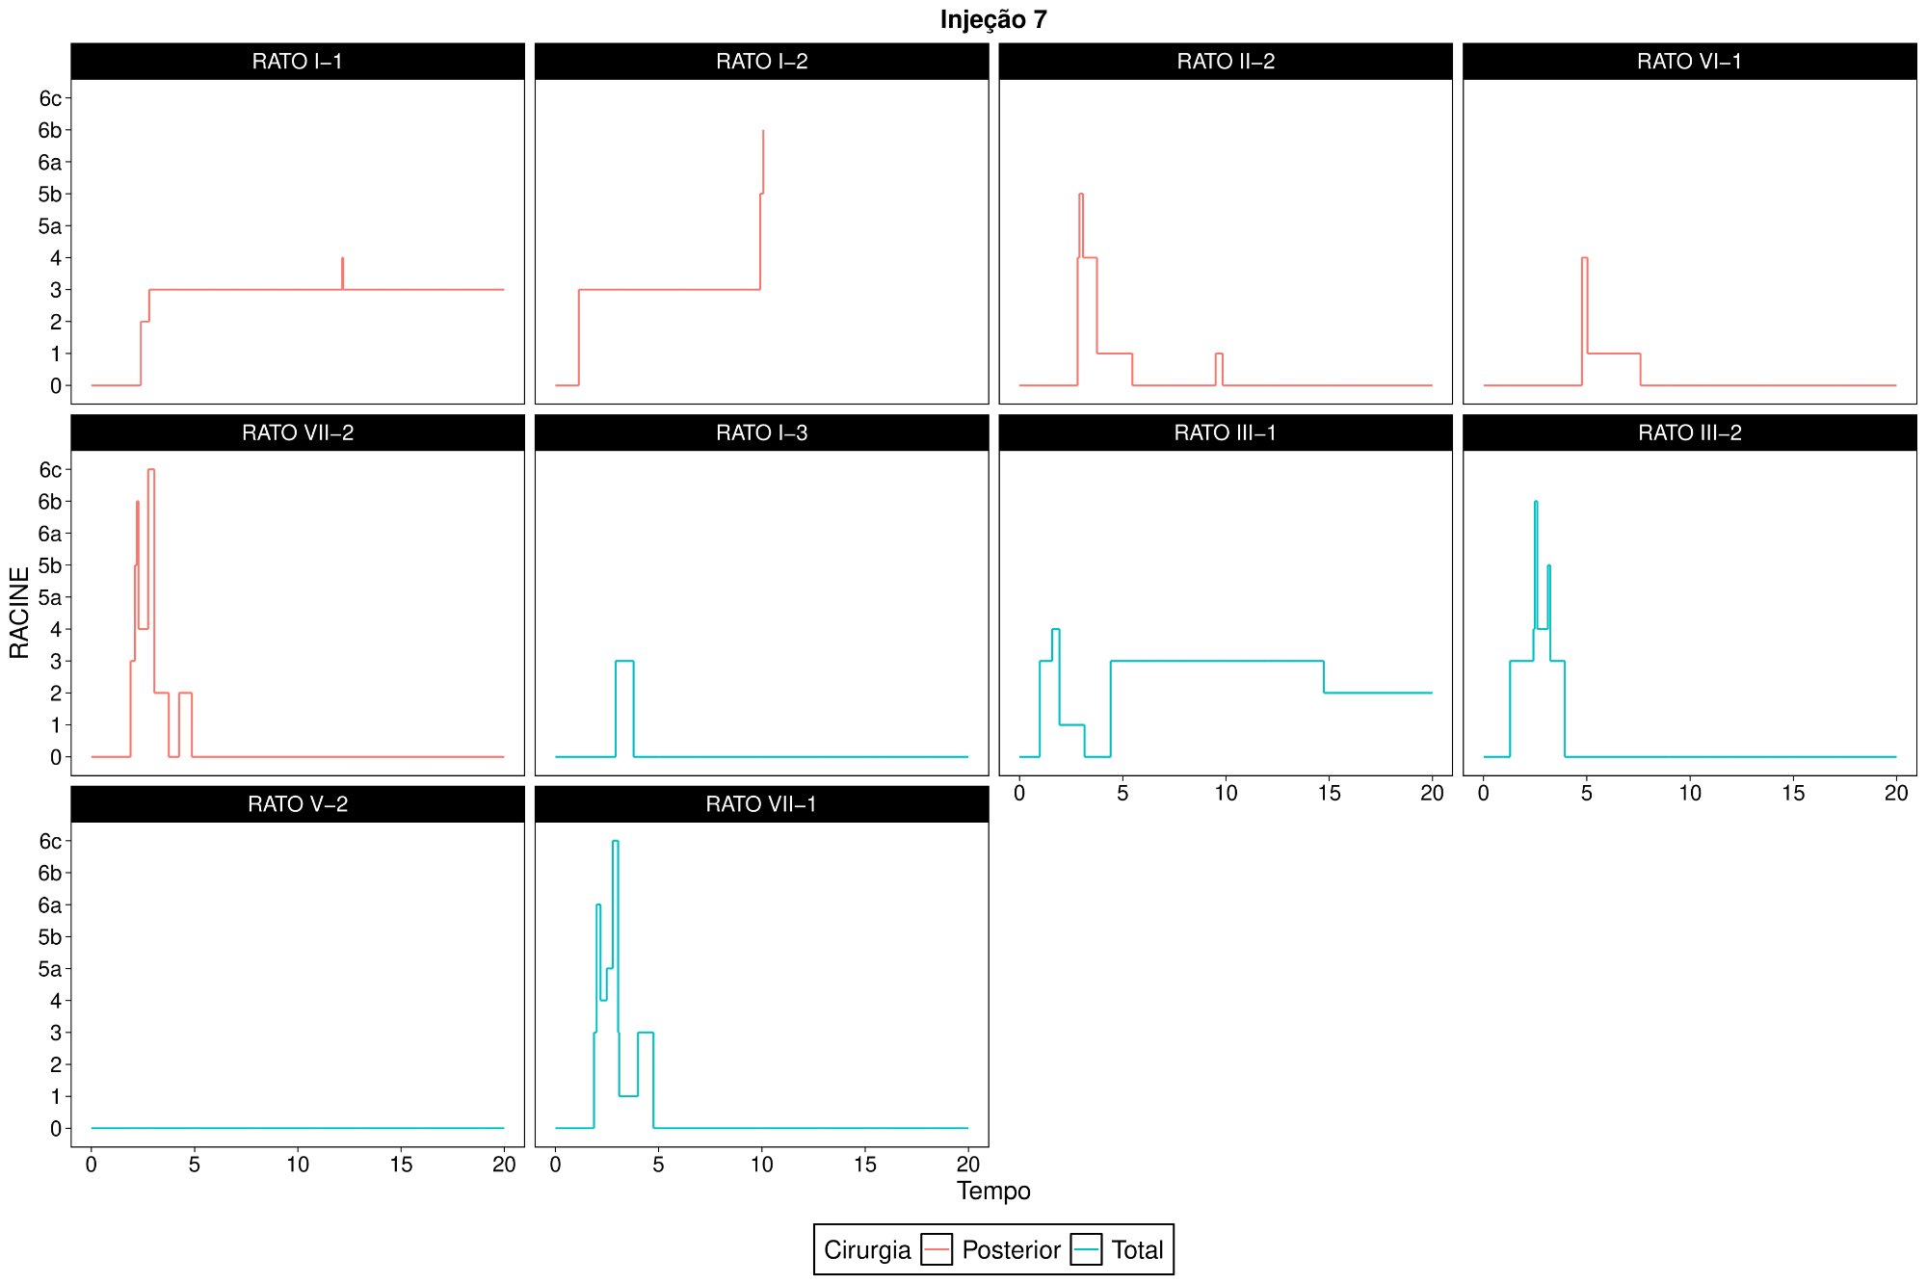
Figure 9: Seizures over time for each rat in Injection 7.
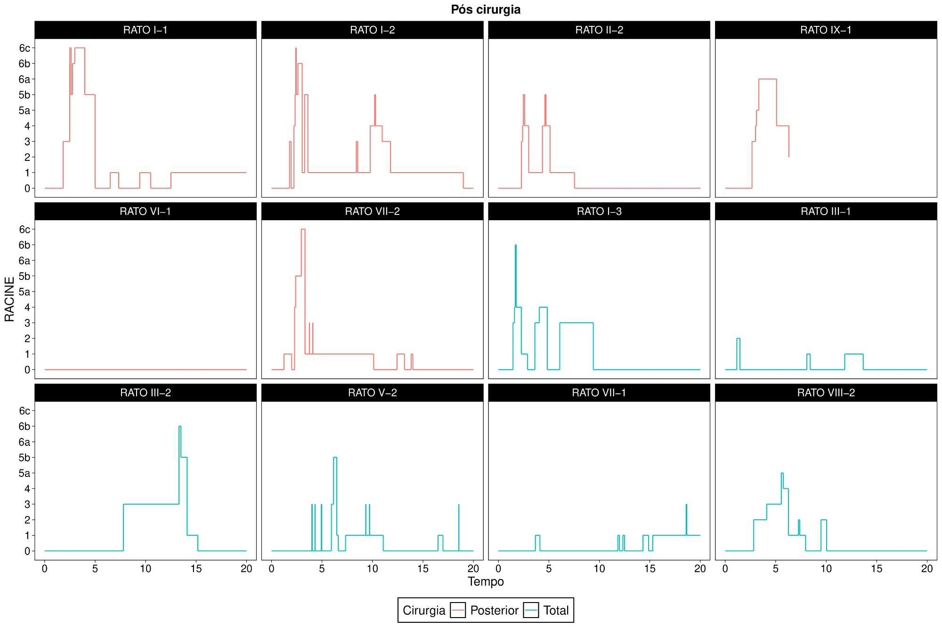
Figure 10: Seizures over time for each rat in the Post-surgery session.

4 EFFECT OF SURGERY
In this section, we study the effect of surgery on seizure time at each seizure degree. For each rat, we calculated the mean time at each seizure degree across the 7 pre-operative injections and compared this mean with the time at the respective degree in the post-operative injection.
For each surgery, we first present a profile graph for each seizure degree showing each rat's mean pre-surgery time and its post-surgery value (dashed lines), together with the overall mean time across all rats undergoing that surgery (solid line). We then present descriptive statistics and a box-plot of the Post - Pre Difference in Seizure Time for each seizure degree, where pre-surgery time is the mean across the seven pre-surgery injections.
Finally, we present the p-value of the paired t-test, which tests whether the mean seizure time is the same in the pre- and post-operative periods. If p < 0.05, the mean seizure time differs significantly between pre- and post-surgery at the 5% significance level. Otherwise (p > 0.05), there is no statistically significant difference.
We do not observe statistically significant differences between pre- and post-surgery mean times for any seizure degree in either surgery.

4.1 POSTERIOR
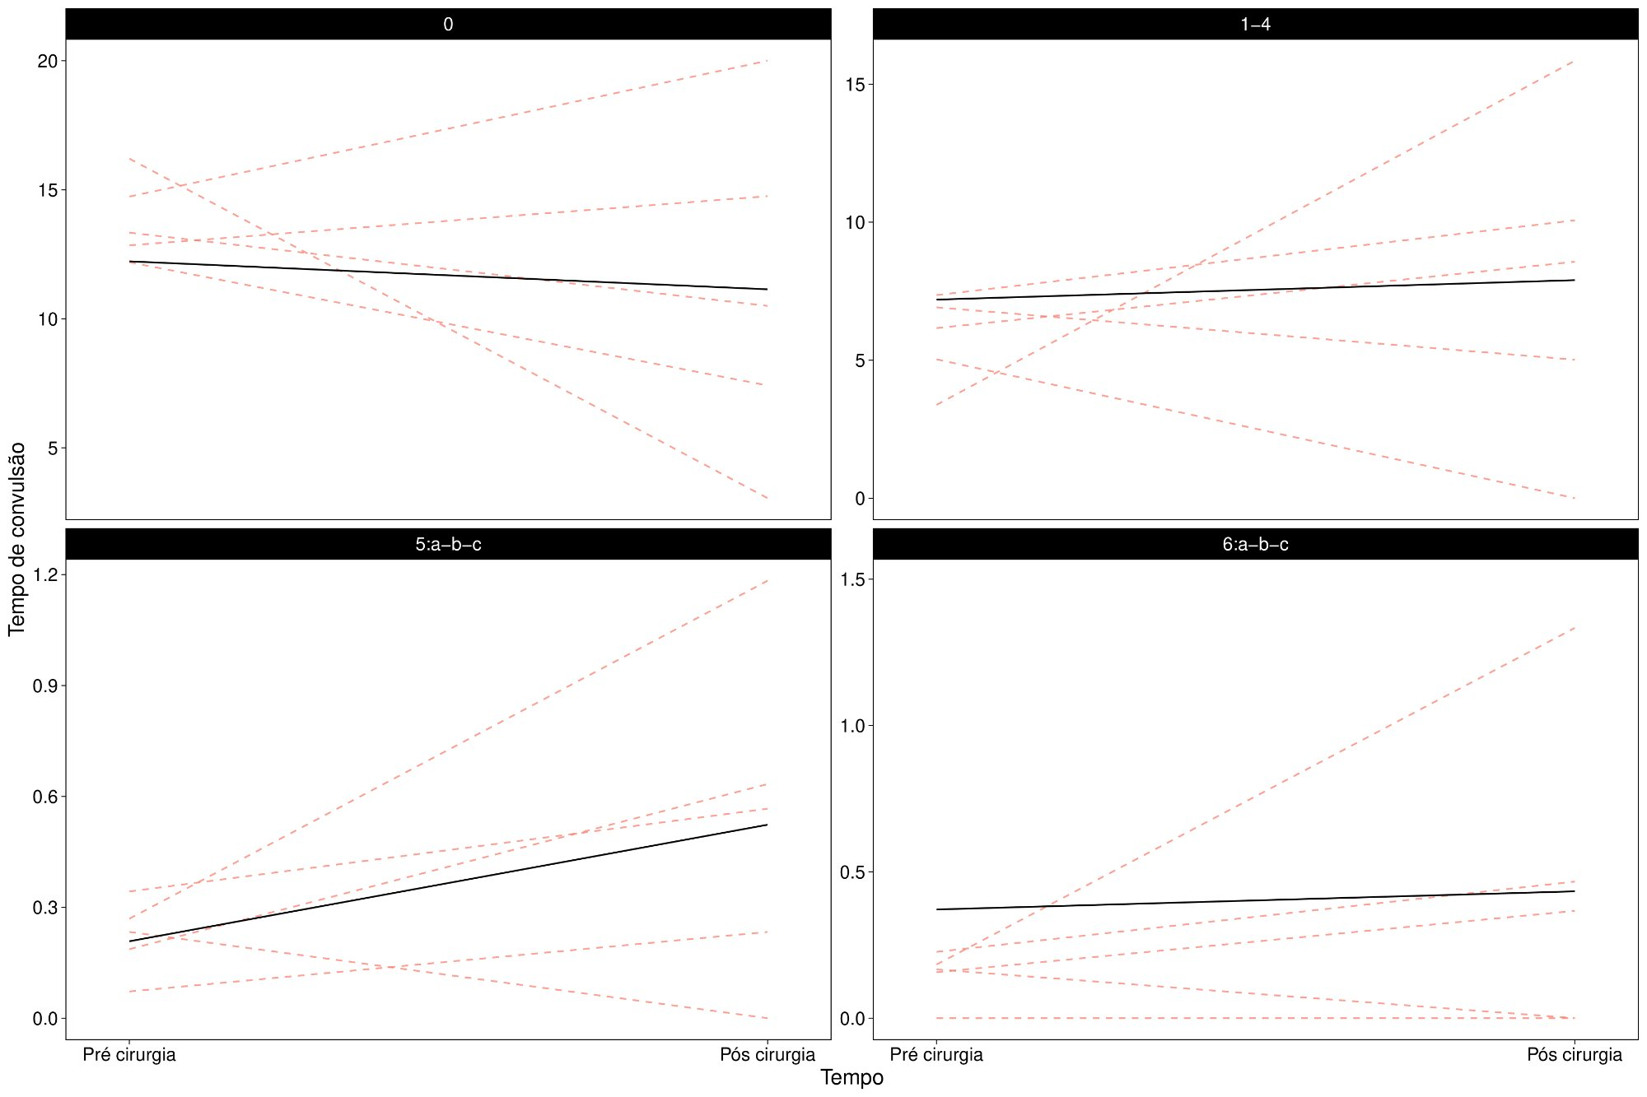
Figure 11: Seizure time at each degree before and after surgery (Posterior).
Table 3: Descriptive statistics of the variable Post - Pre Difference in Seizure Time by the variable Seizure Degree in the sample (Posterior surgery).
 | N | Mean | SD | LCI | UCI | Min | Q1 | Median | Q3 | Max | p
0 | 5 | -2.72 | 7.04 | -8.89 | 3.45 | -13.16 | -4.77 | -2.84 | 1.90 | 5.26 | 0.44
1-4 | 5 | 2.13 | 6.61 | -3.66 | 7.93 | -5.03 | -1.90 | 2.40 | 2.71 | 12.47 | 0.51
5:a-b-c | 5 | 0.30 | 0.42 | -0.07 | 0.67 | -0.23 | 0.16 | 0.22 | 0.45 | 0.91 | 0.18
6:a-b-c | 5 | 0.29 | 0.51 | -0.16 | 0.73 | -0.17 | 0 | 0.21 | 0.24 | 1.15 | 0.28

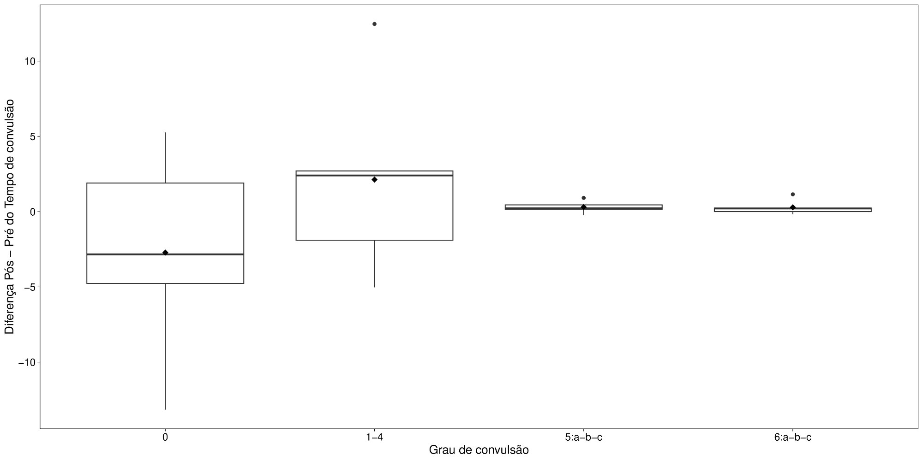
Figure 12: Box-plot of the variable Post - Pre Difference in Seizure Time by Seizure Degree (Posterior surgery).

4.2 TOTAL
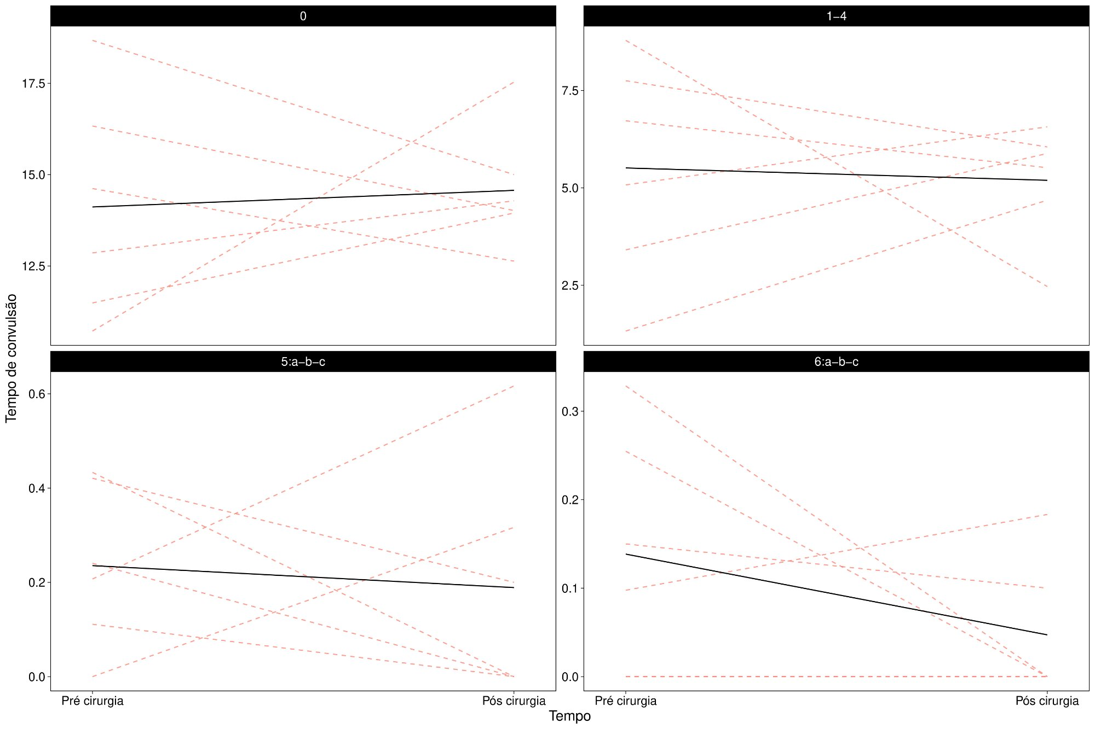
Figure 13: Seizure time at each degree before and after surgery (Total).
Table 4: Descriptive statistics of the variable Post - Pre Difference in Seizure Time by the variable Seizure Degree in the sample (Total surgery).
 | N | Mean | SD | LCI | UCI | Min | Q1 | Median | Q3 | Max | p
0 | 6 | 0.45 | 3.90 | -2.67 | 3.58 | -3.68 | -2.23 | -0.28 | 2.20 | 6.81 | 0.79
1-4 | 6 | -0.32 | 3.56 | -3.16 | 2.53 | -6.32 | -1.58 | 0.14 | 2.23 | 3.36 | 0.84
5:a-b-c | 6 | -0.05 | 0.34 | -0.31 | 0.22 | -0.43 | -0.24 | -0.17 | 0.21 | 0.41 | 0.75
6:a-b-c | 6 | -0.09 | 0.16 | -0.22 | 0.04 | -0.33 | -0.20 | -0.03 | 0 | 0.09 | 0.23

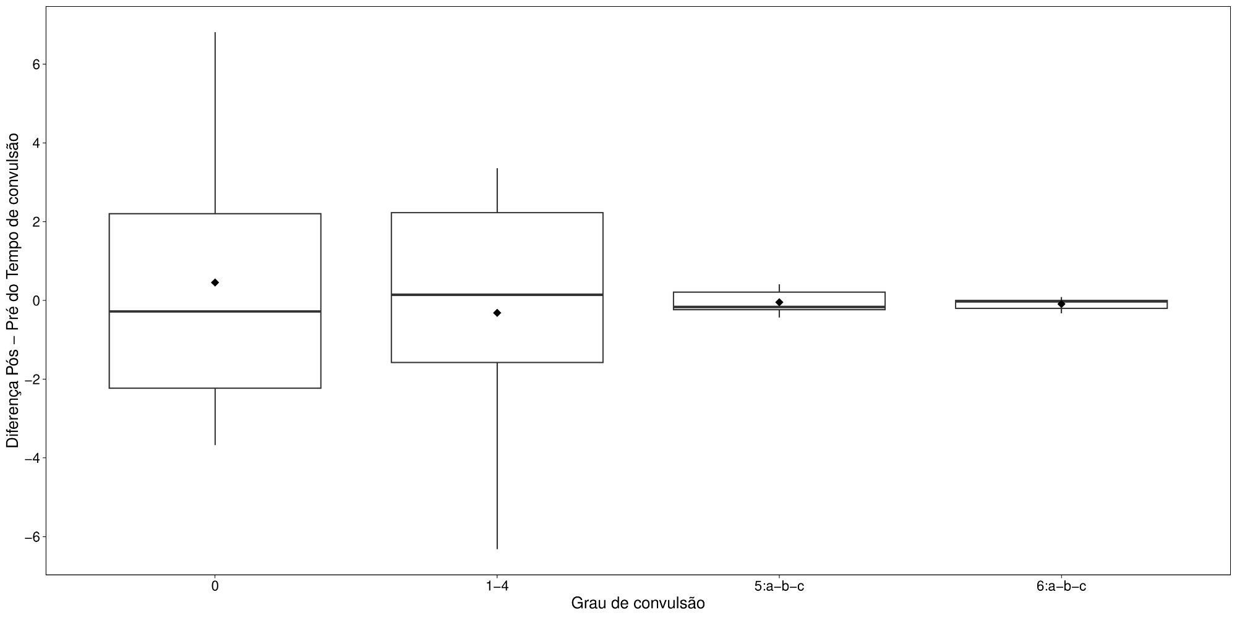
Figure 14: Box-plot of the variable Post - Pre Difference in Seizure Time by Seizure Degree (Total surgery).

5 COMPARISON BETWEEN SURGERIES
In this section, we compare the surgeries with respect to the Post - Pre Difference in Seizure Time at each degree. Again, the pre-operative seizure time is the mean across the first seven injections. This difference measures the surgical effect on seizure time at each degree.
We applied the same methodology as Section 2: descriptive statistics and box-plots of the Post - Pre Difference in Seizure Time at each degree, with Student's t-test to determine whether there is a statistically significant difference between surgeries.
We observe no statistically significant difference between the surgeries regarding the change in seizure time from pre- to post-surgery at any degree.
Table 5: Descriptive statistics of the variable Post - Pre Difference in Seizure Time at degree 0 by Surgery (p = 0.403, t-test).
 | N | Mean | SD | LCI | UCI | Min | Q1 | Median | Q3 | Max
Posterior | 5 | -2.72 | 7.04 | -8.89 | 3.45 | -13.16 | -4.77 | -2.84 | 1.90 | 5.26
Total | 6 | 0.45 | 3.90 | -2.67 | 3.58 | -3.68 | -2.23 | -0.28 | 2.20 | 6.81

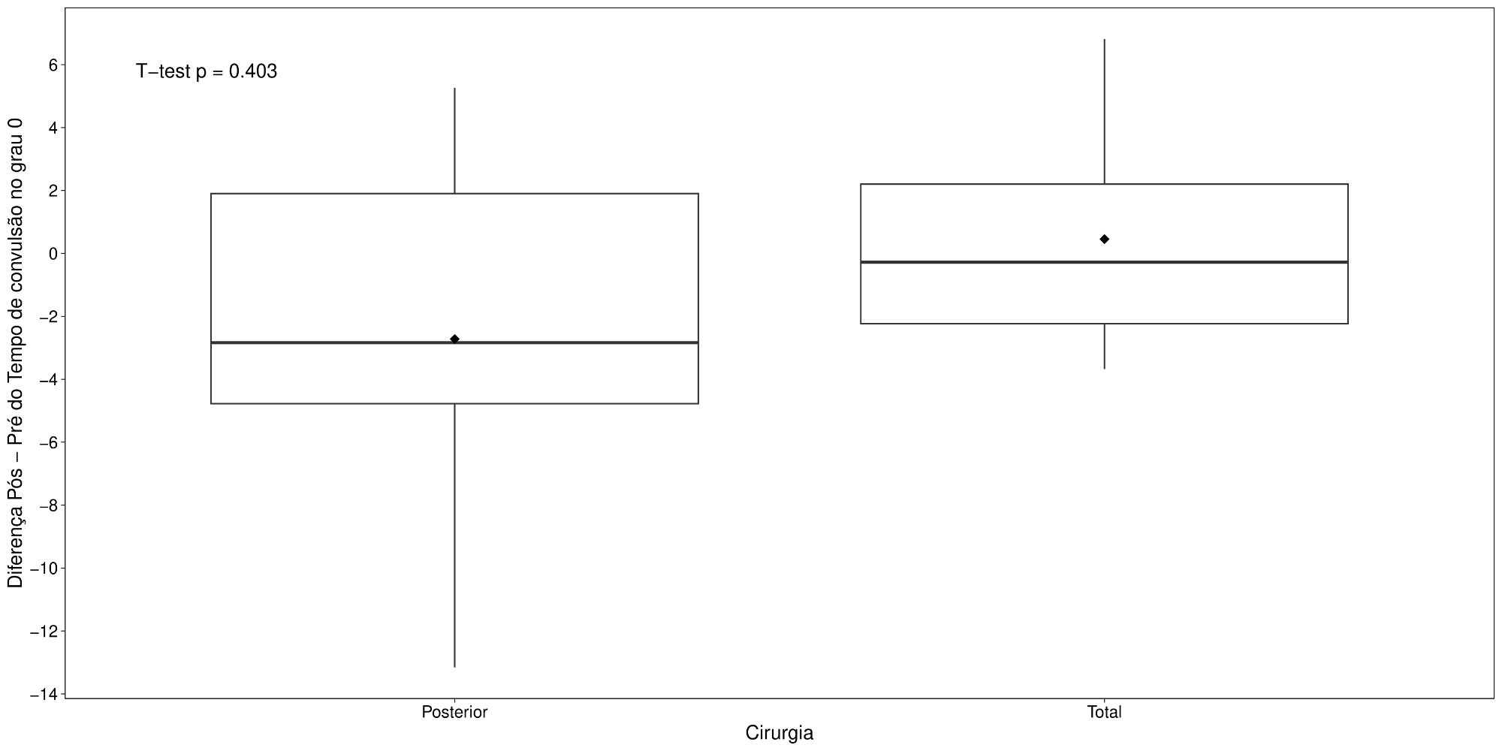
Figure 15: Box-plot of the Post - Pre Difference in Seizure Time at degree 0 by Surgery.
Table 6: Descriptive statistics of the variable Post - Pre Difference in Seizure Time at degree 1-4 by Surgery (p = 0.486, t-test).
 | N | Mean | SD | LCI | UCI | Min | Q1 | Median | Q3 | Max
Posterior | 5 | 2.13 | 6.61 | -3.66 | 7.93 | -5.03 | -1.90 | 2.40 | 2.71 | 12.47
Total | 6 | -0.32 | 3.56 | -3.16 | 2.53 | -6.32 | -1.58 | 0.14 | 2.23 | 3.36

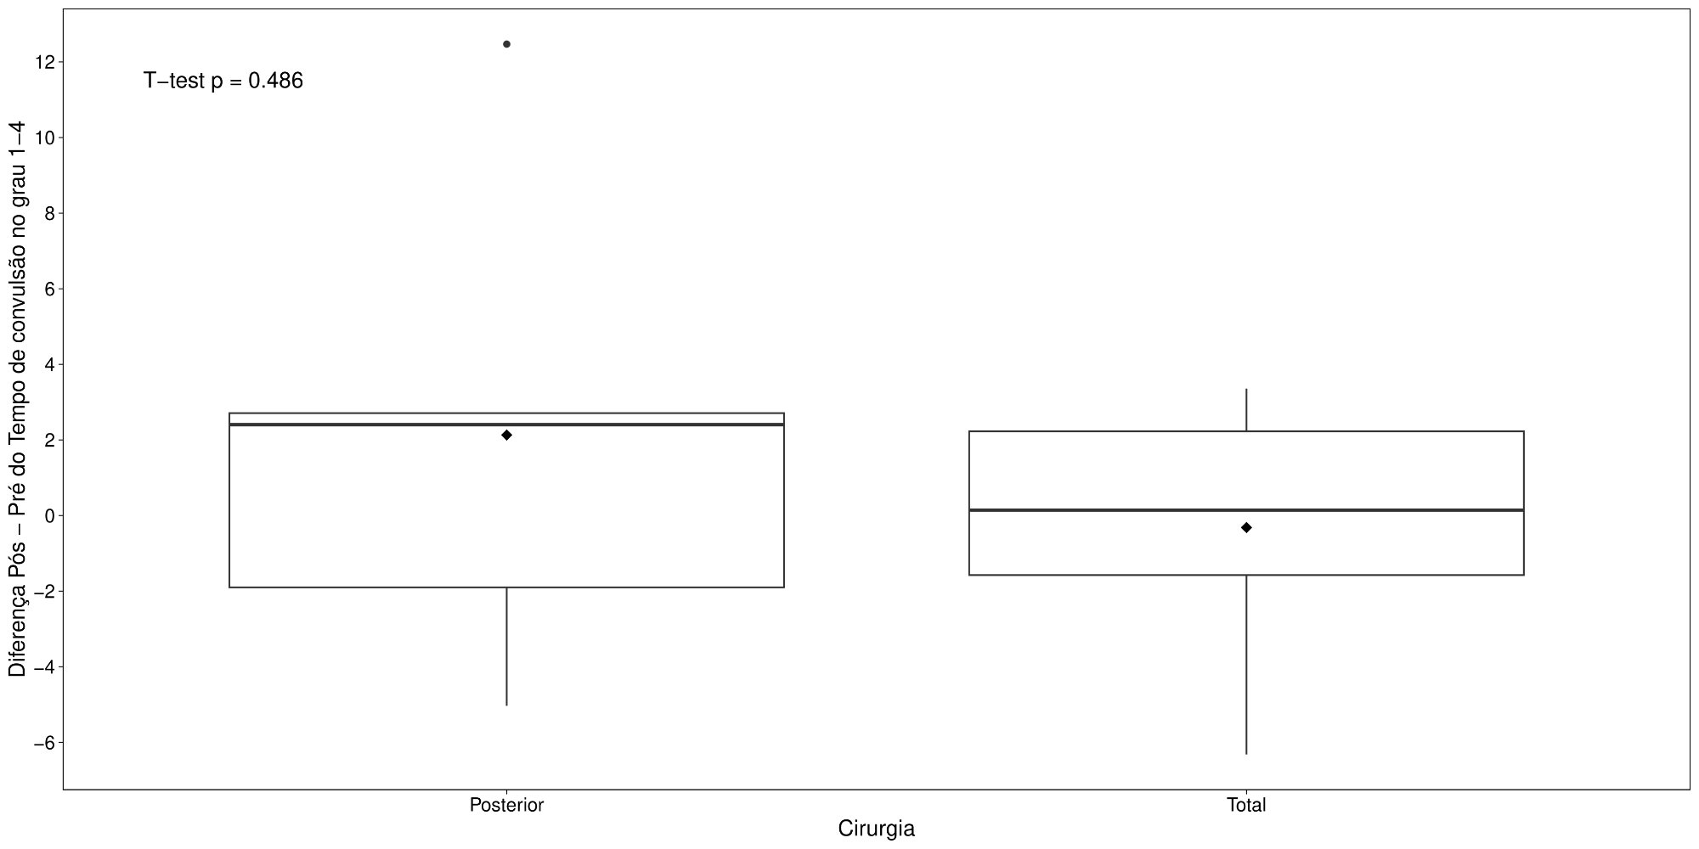
Figure 16: Box-plot of the Post - Pre Difference in Seizure Time at degree 1-4 by Surgery.
Table 7: Descriptive statistics of the variable Post - Pre Difference in Seizure Time at degree 5:a-b-c by Surgery (p = 0.174, t-test).
 | N | Mean | SD | LCI | UCI | Min | Q1 | Median | Q3 | Max
Posterior | 5 | 0.30 | 0.42 | -0.07 | 0.67 | -0.23 | 0.16 | 0.22 | 0.45 | 0.91
Total | 6 | -0.05 | 0.34 | -0.31 | 0.22 | -0.43 | -0.24 | -0.17 | 0.21 | 0.41

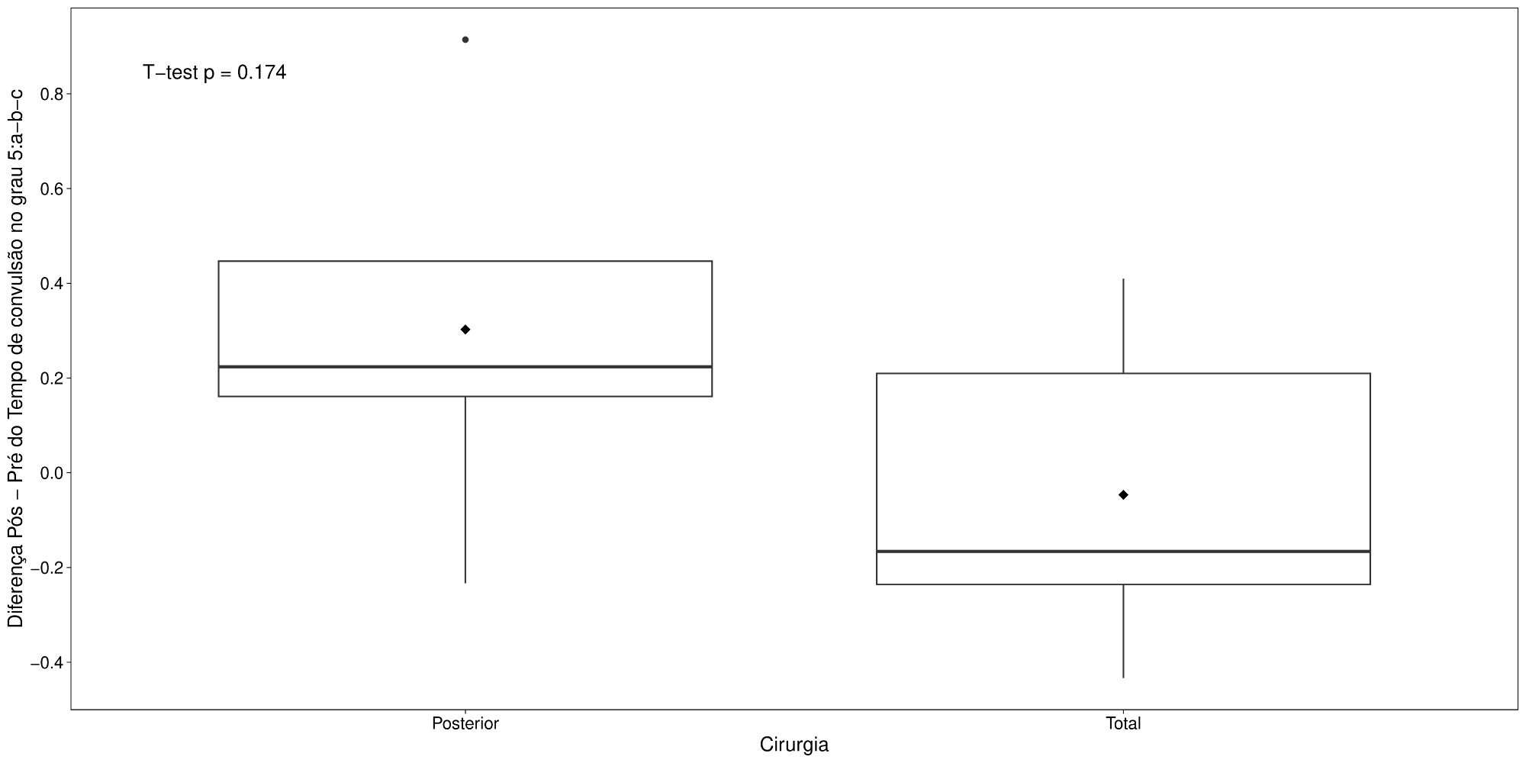
Figure 17: Box-plot of the Post - Pre Difference in Seizure Time at degree 5:a-b-c by Surgery.
Table 8: Descriptive statistics of the variable Post - Pre Difference in Seizure Time at degree 6:a-b-c by Surgery (p = 0.177, t-test).
 | N | Mean | SD | LCI | UCI | Min | Q1 | Median | Q3 | Max
Posterior | 5 | 0.29 | 0.51 | -0.16 | 0.73 | -0.17 | 0 | 0.21 | 0.24 | 1.15
Total | 6 | -0.09 | 0.16 | -0.22 | 0.04 | -0.33 | -0.20 | -0.03 | 0 | 0.09

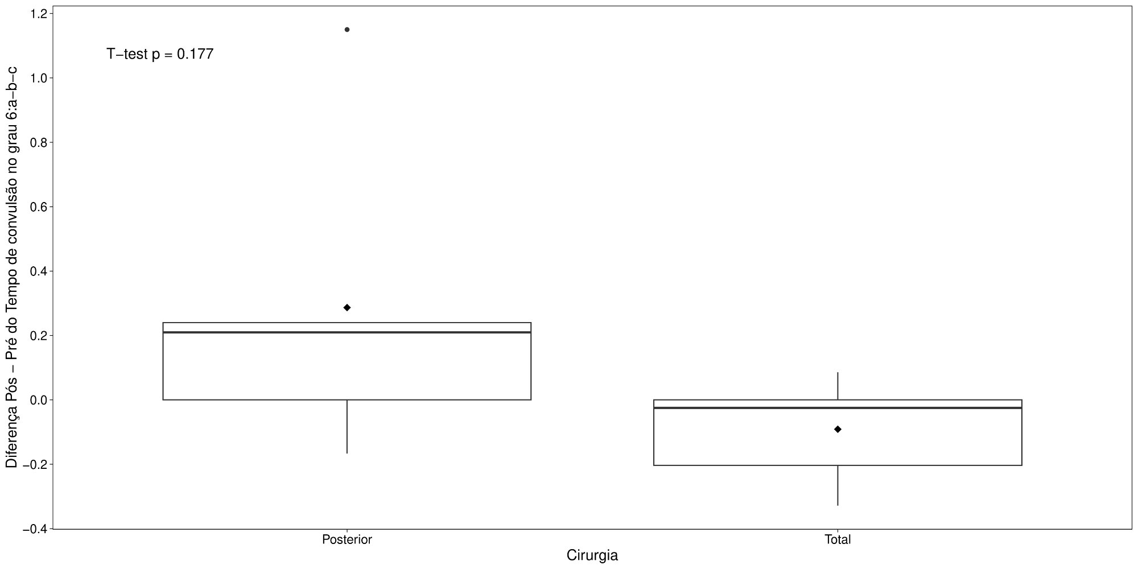
Figure 18: Box-plot of the Post - Pre Difference in Seizure Time at degree 6:a-b-c by Surgery.

References
[1] William Jay Conover. Practical Nonparametric Statistics. 1971.
[2] Pedro Alberto Morettin and Wilton O Bussab. Estatística Básica. Editora Saraiva, 8th edition, 2013.
[3] R Core Team. R: A Language and Environment for Statistical Computing. R Foundation for Statistical Computing, Vienna, Austria, 2018.

