Extended Data
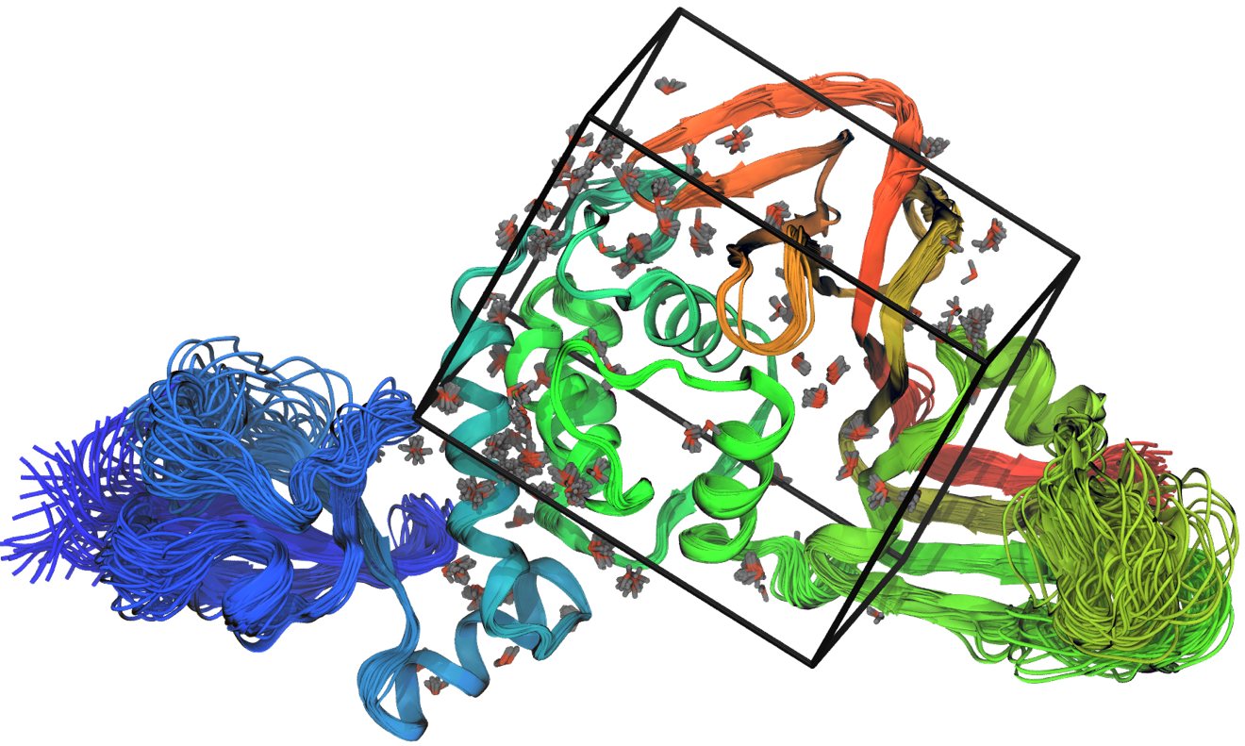
Extended Data Fig. S1. Superposition of 50 ensemble models and docking box used for docking. Conserved water molecules are shown in stick representation.

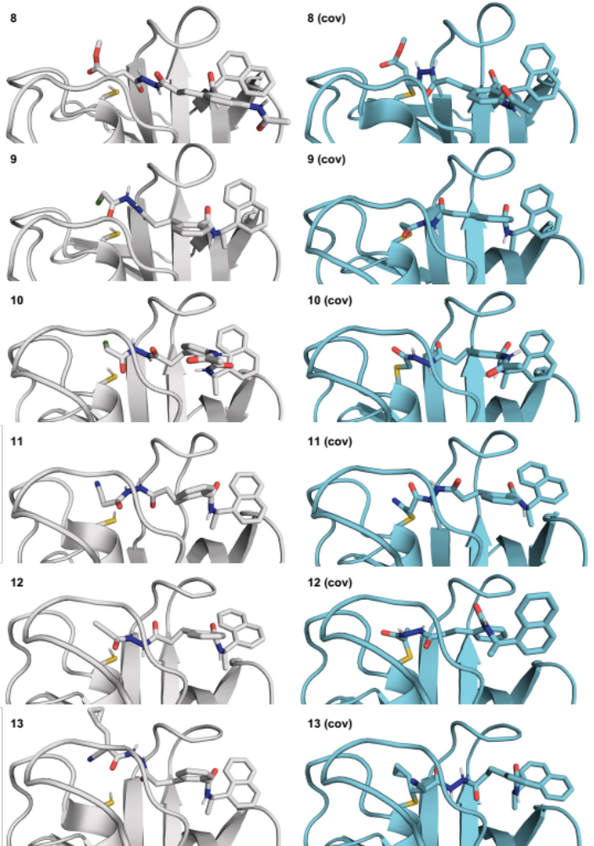
Extended Data Fig. S2. Docked poses of compounds 8-13. Left: noncovalent, right: covalent.

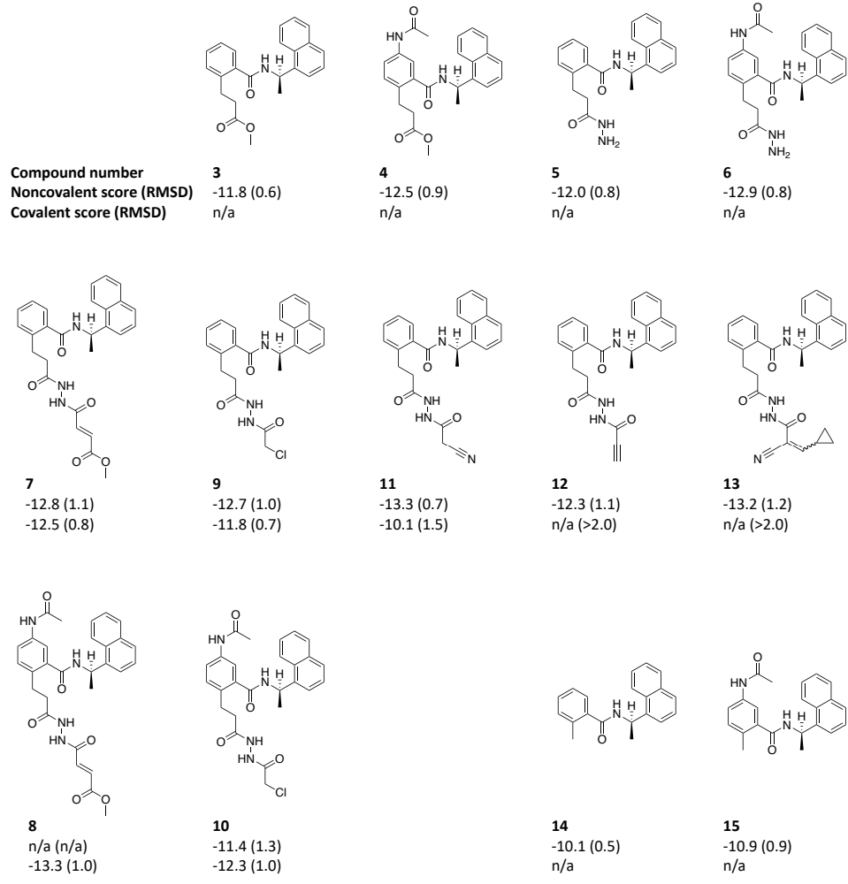
Extended Data Fig. S3. Summary of docking results for experimentally tested compounds. Docking scores are in kcal/mol and MCS-RMSDs are in Å. Additional docking data for all candidate inhibitors are provided in Extended Data File 1.

Extended Data Fig. S4. Michaelis-Menten kinetics data for Z-RLRGG-AMC and Z-LRGG-AMC substrates. Data points represent the average initial rate for n = 2 independent experiments performed with n = 3 replicates, ± s.d.

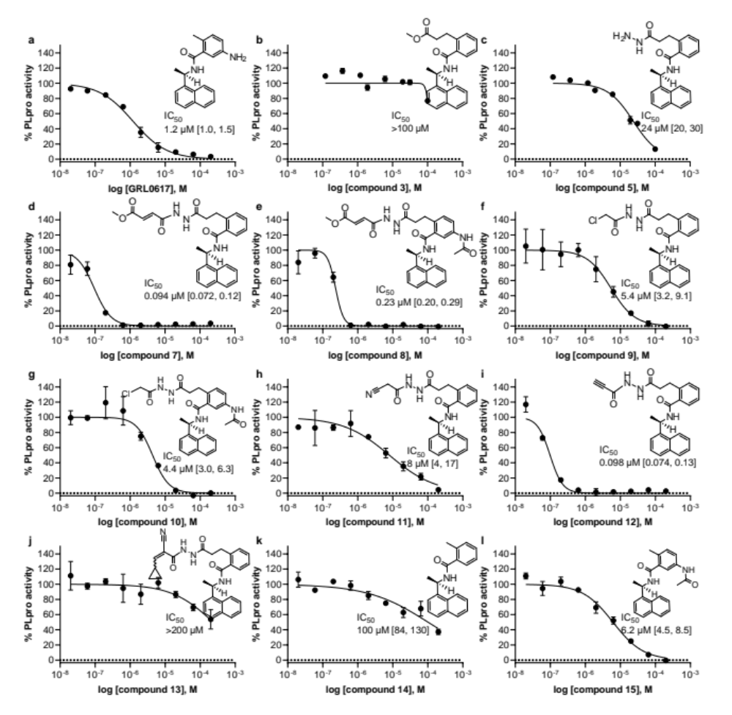
Extended Data Fig. S5. Fluorogenic peptide activity assay after 30 min preincubation with inhibitor candidates. Data points are the average of n = 2 independent samples ± range and are representative of n ≥ 1 independent experiments. IC₅₀ is the concentration at which 50% inhibition was observed, and bracketed values are the 95% confidence interval. Curve is the nonlinear regression to the normalized inhibitor dose response equation.

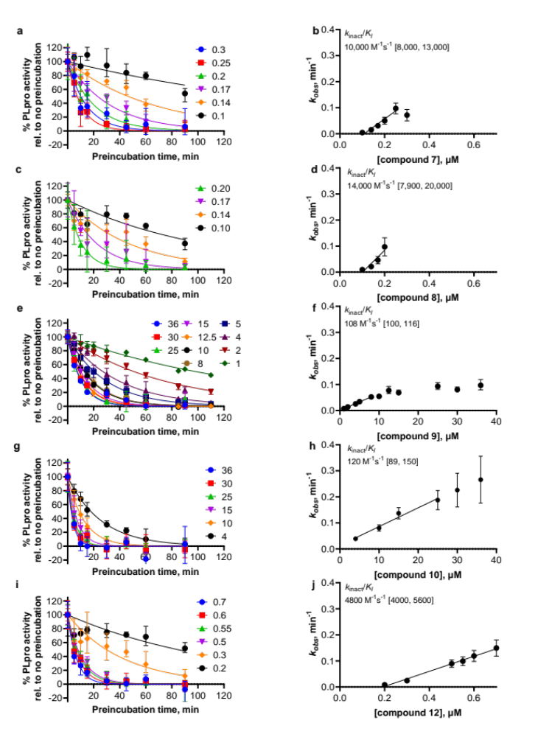
Extended Data Fig. S6. Time-dependent characterization with fluorogenic peptide assay. a, c, e, g, and i are initial rates determined at various inhibitor concentrations (concentrations in μM, inhibitor in x-axis of right panels) and preincubation times, normalized to no preincubation. Data points are from n ≥ 2 independent experiments with n = 2 independent samples each, ± range. Curves are nonlinear regressions of the exponential decay equation to the data. b, d, f, h, and j, Data points are the k_{obs} values determined from a, c, e, g, and i ± 95% confidence interval of the nonlinear regression. Line represents the linear regression yielding as its slope the second-order rate constant (k_{inact}/K_{I}), with bracketed values representing 95% confidence interval of the slope.

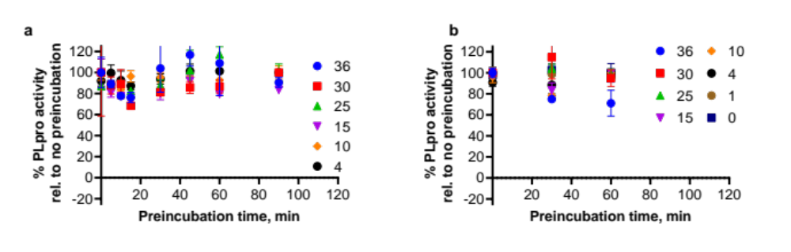
Extended Data Fig. S7. Time-dependent characterization with fluorogenic peptide assay. a, compound 11; b, compound 13. Data points are from an experiment with n = 2 independent samples, ± range.
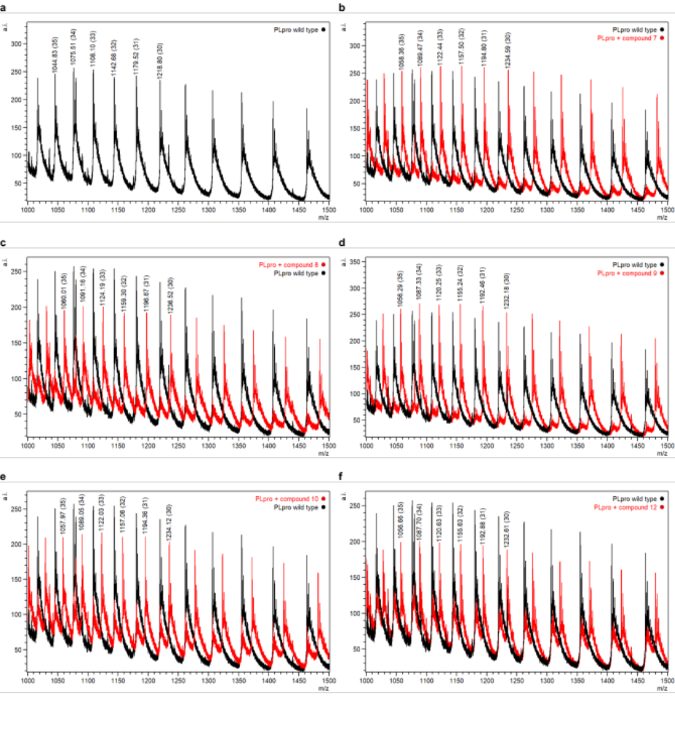
Extended Data Fig. S8. Intact protein ESI-MS spectra of PLpro (black) and PLpro incubated with compounds indicated in figure legend (red). a.i., arbitrary intensity; m/z, mass-to-charge ratio. Spectral peaks used for protein monoisotopic mass deconvolution are annotated with their monoisotopic masses and, in parentheses, charge states.
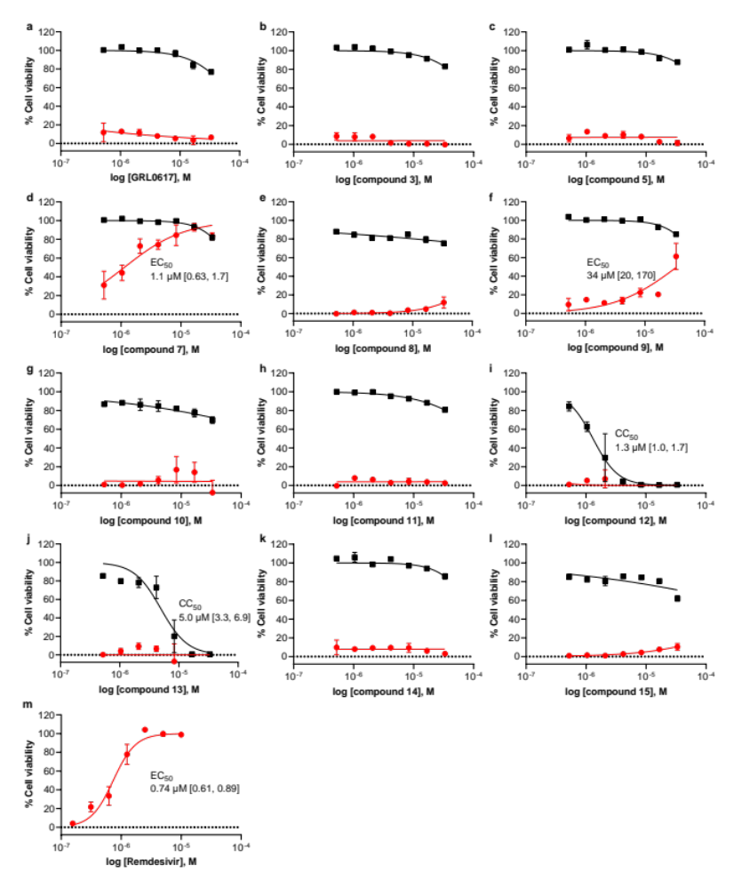
Extended Data Fig. S9. Cell viability in Vero E6 cells for uninfected cells pretreated with indicated compound (black) and SARS-CoV-2-infected cells pretreated with indicated compound (red). Data points are the average of n = 2 independent samples ± range and are representative of n ≥ 1 independent experiments. EC₅₀ is the concentration at which 50% effect was observed, CC₅₀ is the concentration at which 50% cytotoxicity was observed, and bracketed values are the 95% confidence intervals. Curves are nonlinear regression to the normalized dose response equation.

Extended Data Table S1. PLpro intact protein ESI-MS analysis.
Compound | Deconvoluted monoisotopic PLpro+compound mass | Measured  adduct  mass | Predicted  adduct  mass
- (wild-type PLpro) | 36535 (FWHM 16) | - | -
7 | 37009 (FWHM 16) | 474 | 473
8 | 37066 (FWHM 16) | 531 | 530
9 | 36936 (FWHM 15) | 401 | 401
10 | 36995 (FWHM 15) | 460 | 458
FWHM, full-width half maximum

Extended Data Table S2. Summary of X-ray crystallography data collection and refinement
 | PLpro-compound 7
Crystallographic parameters  Space group  Unit-cell dimensions | I4₁22  112.33 Å, 112.33 Å, 217.33 Å  90.0˚, 90.0˚, 90.0˚
Data collection statistics  Resolution limits (Å)  No. of observed reflections  No. of unique reflections  Completeness  overall/outer shell  CC1/2 (overall/outer shell)  R_{sym}ª (%)  overall/outer shell & os I/σ | 39.1 – 3.10  333876  13010  99.8/99.8  99.8/75.2  44.5/720.0 & 1.3
Refinement statistics  Resolution limits (Å)  Number of reflections/%  (|F| > 2σ|F|)  Reflections used for R_{free}  R_{factor}^{b} (%)  R_{free} (%)  Model contents/average B (Å²)  Protein atoms  Ligand  Ions  Water molecules  RMS deviations  Bond length (Å)  Bond angle (°)  Ramachandran (analyzed/outliers) | 39.1-3.10  12359/99.8  651  19.1  25.3  2468/97.4  35/81.7  8/101.9  42/71.6  0.008  1.79  311/5

Extended Data Table S3. Metabolic stability in liver microsomes
 | human |  | rat |  | mouse
 | half-life  (min)ª | Cl_{int}  (μL/min/mg) | half-life  (min)ª | Cl_{int}  (μL/min/mg) | half-life  (min)ª | Cl_{int}  (μL/min/mg)
7 | 50 | 138.8 | 46 | 151.2 | 13 | 539.7
9 | 7 | 974.9 | 13 | 514.7 | 5 | 1333.3
14 | 41 | 171.0 | 21 | 329.7 | 16 | 434.6
imipramine | >60 | <115.5 | 5 | 1420.5 | 16 | 435.5
propranolol | >60 | <115.5 | 3 | 2387.8 | 20 | 373.2
terfenadine | 11 | 615.1 | 7 | 1053.6 | 8 | 851.4
verapamil | 38 | 183.0 | 35 | 195.7 | 18 | 374.8
ª mean of two replicates

Extended Data Table S4. Metabolic stability in liver S9 fractions
 | human |  | rat |  | mouse
 | half-life  (min)ª | Cl_{int}  (μL/min/mg) | half-life  (min)ª | Cl_{int}  (μL/min/mg) | half-life  (min)ª | Cl_{int}  (μL/min/mg)
7 | 60 | 38.9 | 31 | 75.5 | 9 | 266.4
9 | 3 | 689.4 | 16 | 140.4 | 4 | 544.0
14 | >60 | <38.5 | 17 | 137.5 | 18 | 128.4
imipramine | >60 | <38.5 | 3 | 886.4 | 15 | 153.3
propranolol | >60 | <38.5 | 3 | 765.7 | 6 | 356.6
terfenadine | 16.0 | 144.5 | 8 | 290.8 | 14 | 160.1
verapamil | >60 | <38.5 | 31 | 76.1 | 18 | 127.0
ª mean of two replicates

Extended Data Figure S10. MetaSite site-of-metabolism prediction for compound 7. The shade of the red circles indicates relative liability (darker = greater liability).

