SUPPLEMENTARY INFORMATION

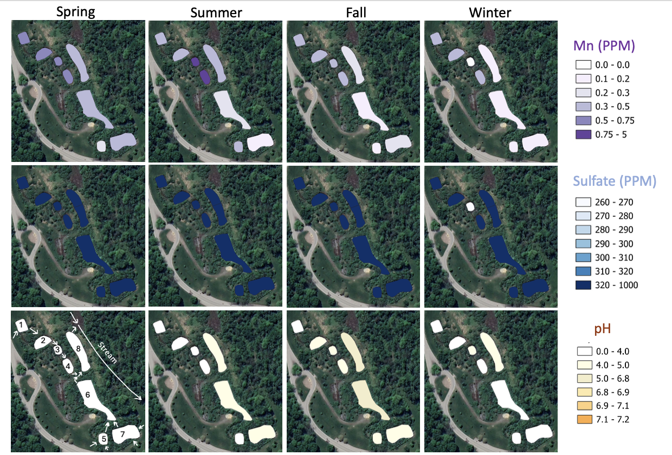
SI Fig. 1. GIS images of Boyce Park PRS for seasonal levels of Mn, sulfate, and pH. The Mn and sulfate are reported in parts per millions (PPM). The Mn levels on average are above recommended standards of 0.05 PPM. The sulfate levels on average are above recommended standards of 250 PPM. The pH seasonally is below 6.0 with the highest pH for all seasons reaching 5.4 in pond 6 of Fall and the average pH for all seasons with all components is 3.8. Flow through the system is indicated by arrows. Each component of the system is numbered in the lower left image. Key for each respective geochemical concentration is on the right.
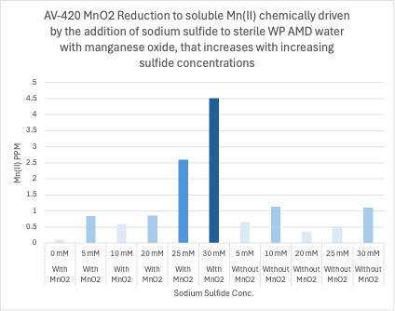
SI Fig. 2. The addition of increasing sterile sodium sulfide concentrations to sterile 50 mM MnO₂ results in increased concentrations of soluble Mn(II) detected by the FAD assay. Negative controls show that the addition of increasing sulfide concentrations without MnO₂ added does not result in soluble Mn(II) with the FAD assay, n = 1.

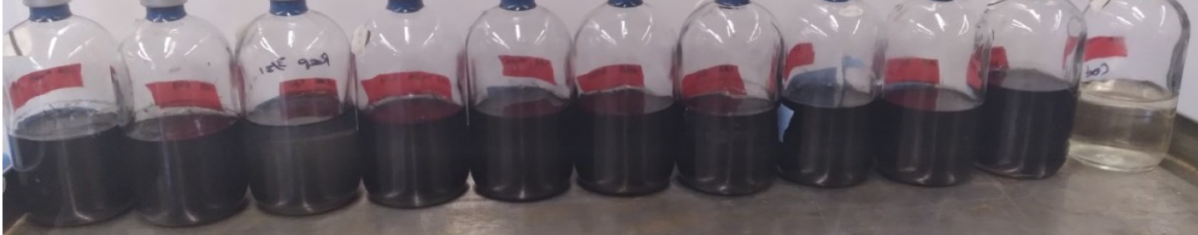
SI Fig. 3. All ten sulfidogenic isolates tested in the modified Postgate media turned black in color within 14 days of growth indicating sulfidogenesis. From left to right sterile control, NML8, NML9, NML10, NML11, NML14, NML16, NML34, NML35, NML36, NML37.

SI Table 1. Genus level of bacteria known to produce acid.
Acidogenic Bacteria | Total | WP1 | WP3 | WP4 | WP5 | WP6 | WP7 | Reference
Bacillus sp. | 275 | 7 | 58 | 58 | 113 | 26 | 13 | This study, (Kim, Hwang et al. 2010, Liu, Wang et al. 2012)
Bacteroides sp. | 279 | 18 | 51 | 21 | 21 | 92 | 76 | (Zhao, Ren et al. 2008)
Clostridium sp. | 2,208 | 25 | 115 | 640 | 295 | 439 | 694 | (Grupe and Gottschalk 1992, Zhao, Ren et al. 2008, Liu, Wang et al. 2012, Tahir, Miran et al. 2020)
Corynebacterium sp. | 12 | 8 | 0 | 1 | 3 | 0 | 0 | This study
Lactobacillus sp. | 216 | 26 | 71 | 5 | 49 | 36 | 29 | (Zhang, Loh et al. 2020)
Paenibacillus sp. | 33 | 8 | 6 | 11 | 4 | 2 | 2 | (Grady, MacDonald et al. 2016)
Propionibacterium sp. | 9 | 0 | 0 | 9 | 0 | 0 | 0 | (Duan, Wang et al. 2018)
Pseudomonas sp. | 1,941 | 971 | 101 | 96 | 481 | 273 | 19 | (Kim, Hwang et al. 2010, Liu, Wang et al. 2012)
Ruminococcus sp. | 446 | 7 | 2 | 6 | 329 | 66 | 36 | (Zhao, Ren et al. 2008)
Thiobacillus sp. | 18,643 | 136 | 262 | 157 | 676 | 9314 | 8098 | (Crescenzi, Crisari et al. 2006)
Veillonella sp. | 44 | 13 | 3 | 6 | 2 | 2 | 18 | (Liu, Wang et al. 2012)

SI Table 2. Genus level of bacteria known to produce sulfide.
Sulfide Production | Total | WP1 | WP3 | WP4 | WP5 | WP6 | WP7 | Reference
Alteromonas sp. | 25 | 25 | 0 | 0 | 0 | 0 | 0 | (Myers and Nealson 1988)
Desulfacinum sp. | 372 | 0 | 11 | 20 | 25 | 11 | 305 | (Valkanas 2020)
Desulfarculus sp. | 60 | 0 | 8 | 15 | 3 | 5 | 29 | (Valkanas 2020)
Desulfobacca sp. | 1,407 | 64 | 282 | 40 | 196 | 372 | 453 | (Valkanas 2020)
Desulfobulbus sp. | 14,395 | 36 | 1,787 | 1,875 | 8,119 | 1,571 | 1,007 | (Lovley and Phillips 1994, Zhao, Ren et al. 2008, Valkanas 2020, Valkanas, Rosso et al. 2021)
Desulfococcus sp. | 10,485 | 125 | 622 | 1,016 | 1,108 | 4,114 | 3,500 | (Valkanas 2020)
Desulfofrigus sp. | 15 | 9 | 1 | 4 | 1 | 0 | 0 | (Valkanas 2020)
Desulfomicrobium sp. | 417 | 3 | 237 | 21 | 11 | 101 | 44 | (Kushkevych 2014, Valkanas 2020)
Desulfomonile sp. | 1,174 | 89 | 151 | 304 | 145 | 154 | 331 | (Tahir, Miran et al. 2020, Valkanas 2020)
Desulfotalea sp. | 17 | 0 | 0 | 3 | 0 | 14 | 0 | (Valkanas 2020)
Desulfovibrio sp. | 535 | 5 | 191 | 60 | 20 | 90 | 169 | (Burdige and Nealson 1986, Lovley and Phillips 1994, Zhao, Ren et al. 2008, Valkanas 2020, Valkanas, Rosso et al. 2021)
Desulfuromonas sp. | 87 | 0 | 1 | 0 | 1 | 56 | 29 | (Lovley and Phillips 1994, Zhao, Ren et al. 2008, Valkanas, Rosso et al. 2021)
Pelobacter sp. | 3 | 0 | 0 | 0 | 3 | 0 | 0 | (Valkanas 2020)
Shewanella sp. | 5 | 0 | 0 | 0 | 2 | 3 | 0 | This study, (Lee, Kennedy et al. 2011, Wu, Li et al. 2015, Wu 2020)
Sulfuricurvum sp. | 40,654 | 176 | 1,669 | 669 | 1,067 | 30,541 | 6,532 | (Zhao, Ren et al. 2008)
Sulfurimonas sp. | 1,481 | 21 | 135 | 86 | 939 | 92 | 208 | (Henkel, Dellwig et al. 2019)
Syntrophobacter sp. | 501 | 3 | 59 | 30 | 101 | 146 | 162 | (Valkanas 2020)

