Supplementary Materials for

AI-driven Large-scale Electron Microscopy enables Whole-tissue Subcellular Digitization
Li Xiao, Liqing Liu, Hongjun Wu, Jiayi Zhong, Yan Zhang, Junjie Hu, Fei Sun, Ge Yang, Tao Xu
Corresponding author: Li Xiao, andrewxiao@bupt.edu.cn; Liqing Liu, liuliqing@ibp.ac.cn; Junjie Hu, huj@ibp.ac.cn; Fei Sun, feisun@ibp.ac.cn； Ge Yang, yangge@ucas.edu.cn; Tao Xu, xutao@ibp.ac.cn

The supplementary materials includes:

Materials and Methods
Supplementary Text
Extended Data Figs. 1
Supplementary Tables 1 to 2
References

MATERIALS AND METHODS
Animals

Eight to 10-week-old male C57B/L6J mice were housed in groups of three to five at 22–24℃ with a 12-h light/dark cycle. Animals had access to water and food ad libitum. All experiments were approved by the Animal Care Committee at the Institute of Biophysics (license no. SYXK2016-19).
Resin Sample Preparation

The testes were exposed in the lower abdomen after anesthetizing the mouse via isoflurane inhalation. The pair of testes were transpierced with a 26-gauge needle in the middle shaft of the short axis and injected slowly with 0.2 ml first fixative (2% PFA + 2.5% glutaraldehyde in PBS) from one end of the long axis for brief fixation of the seminiferous tissues under physiological conditions. The testes were then dissected out and immersed into fresh first fixative. The tunica albuginea was carefully removed using ophthalmic scissors, and bundles of seminiferous tissue with approximately 20 seminiferous tubules were gently dissected using the ophthalmic scalpel and further fixed in first fixative for more than 12 h in a 4°C refrigerator. Reduced osmium-thiocarbohydrazide-osmium (ROTO) ⁵³ procedures were adapted for preparation of the seminiferous tissue sample. Dissected tissue was immersed in 2% (wt/vol) OsO₄ in water at 4°C for 90 min, followed by a wash with 1.5% potassium ferrocyanide (wt/vol) at 4°C for 90 min. Tissues were incubated in filtered 1% thiocarbohydrazide at room temperature for 30 min, 2% unbuffered OsO₄ aqueous solution at 4°C for 90 min, and 2% uranyl acetate aqueous solution at 4°C overnight followed by heating at 50℃ for 60 min. Triple rinses were performed in ddH₂O for 30 min between steps. After washing, the tissues were dehydrated through a graded ethanol series (30%, 50%, 70%, 80%, 90%, 100%, 10 min each) at 4℃ three times, followed by two exchanges of 100% acetone. Dehydrated samples were infiltrated in graded mixtures (3:1, 1:1, and 1:3) of acetone with SPI-PON812 resin, then pure resin for 2 days with exchange every 12 h. Tissues were embedded in pure resin with 1.5% BDMA accelerator and aligned longitudinally with the wells of an embedding mold and polymerized in an oven at 45°C for 24 h and 60°C for 48 h.

Ultra-thin Sectioning

Resin samples were cut into ultra-thin sections 70-nm-thick using a microtome (EM UC7; Leica) and collected with silicon substrates to enhance the transductivity during scanning electron microscopy.
Scanning Field Emission Electron Microscopy Data

For large-scale tissue electron microcopy, tile sets covering one intact seminiferous tubule at 10-nm pixel resolution were acquired and stitched with Maps software using Helios 5 Hydra CX scanning microscopy (Thermo Fisher) with Circular Backscattered Detector under immersion high-magnification mode (4 mm working distance, 2 kV accelerating voltage, 40 nA beam current, 2 μs dwell time).
FIB-SEM data collection

3 dimentional Volume Electron Microscopic data were acquired on the Helios 5 Hydra CX system (Thermo Fisher) using Auto Slice and View acquisition software with O as plasma FIB ion source at 30kV, 5.6nA beam currrent, and with TLD detector using back-scattered electron signal under immersion high-magnification mode (4 mm working distance, 10 nm pixel resolution, 2kV accelerating voltage, 0.8 nA beam current, 2 μs dwell time).
Training Data

The dataset used in this study (Extended Data Fig. 1a) comprised histological annotations of murine seminiferous tubules covering the full spermatogenic lineage and supporting somatic structures. A total of 23 cellular and tissue categories were annotated, including germ cells at multiple differentiation stages, as well as Sertoli cells and other structural components. During training, we incorporated an active learning framework to reduce the annotation effort ²⁵. Both the number of annotated images and the total annotated area were summarized for each category.

Among germ cells, spermatogonial populations (SC/SPG), meiotic spermatocytes (preleptotene, leptotene, zygotene, pachytene, and diplotene), and post-meiotic spermatids (steps 1–16) were comprehensively represented (Extended Data Fig. 1a). Post-meiotic spermatids constituted a major fraction of the annotations, with individual steps typically represented by 8–25 annotated images and annotated areas ranging from approximately 9.9 × 10³ to 3.2 × 10⁴ µm². Sertoli cells formed the largest continuous tissue component, with 120 annotated images and a total annotated area of approximately 9.5 × 10⁴ µm², reflecting their extensive, non-discrete morphology. Due to this structural continuity, Sertoli cells were annotated using non-instance-based “stuff” labels.

Extended Data Fig. 1b summarizes the distribution of annotations across 12 developmental stages (stage I to stage XII). Each stage was supported by 9–17 tissue samples, with the total annotated area ranging from 0.15 to 7.2 mm². The relative annotation ratios indicated that later and mid-cycle stages (e.g., stages V, VI, X, and XII) contributed a larger proportion of annotated area, highlighting stage-dependent differences in tissue representation.

In addition to cell-level annotations, the dataset included extensive subcellular and structural annotations (Extended Data Fig. 1c). Major organelles, such as mitochondria (228 images; ~3.9 × 10³ µm²), endoplasmic reticulum (235 images; ~6.0 × 10³ µm²), nucleus (182 images; ~1.2 × 10⁴ µm²), Golgi apparatus (153 images; 9.4 × 10² µm²), lipid droplets (111 images; ~5.2 × 10² µm²), primary lysosome (224 images; ~3.9 × 10² µm²), secondary lysosome (157 images, ; ~7.7 × 10² µm²) and residual bodies (19 images; ~1.8 × 10³ µm²), were systematically labeled. Furthermore, specialized tissue structures, including the blood–testis barrier (BTB; 57 images; ~3.1 × 10² µm²), were explicitly annotated. These organelle- and structure-level labels substantially extended the dataset beyond cell identification, enabling quantitative analysis of the subcellular organization and tissue architecture during spermatogenesis.
Panoptic Segmentor

DeepOrganelle was engineered to resolve a fundamental conflict between dense subcellular packing and boundary-accurate contact quantification in ultrastructural images. Given that membrane contact sites (MCSs) typically occur within a narrow spatial range (2–3 pixels), such overlaps introduce substantial bias during quantification. To resolve this, DeepOrganelle adopts a panoptic segmentation framework that integrates semantic and instance segmentation, thereby preserving structural boundaries while avoiding ambiguity.

To enable comprehensive panoptic segmentation of both cells and organelles within this dataset, a Mask2Former ³⁸ neural network with multi-scale deformable attention was trained and applied. Considering the distinct scale differences between cells and organelles, two separate models were utilized: one trained on 10-nm-resolution images for organelle segmentation and another on 40-nm-resolution images for cell segmentation. Both models adopted a panoptic segmentation framework, jointly predicting instance-level (things) and region-level (stuff) categories. All annotated cell types and organelles were integrated into a unified training process to facilitate consistent segmentation across biological scales.
The performance of the trained models was systematically evaluated against several existing segmentation methods, including the common segmentor (nnU-Net ⁵⁴ and Mask R-CNN ⁵⁵), as well as methods focusing on microscopic images, such as Cellpose3 ³⁰ combined with CellSighter ⁵⁶, Cellpose-SAM ³¹ combined with CellSighter ⁵⁶, and Cellotype ³². Methods based on Cellpose3³⁰ or Cellpose-SAM ³¹ are restricted to instance segmentation and cannot perform unified panoptic segmentation of cells and organelles. A comparative analysis for subcellular segmentation (Supplementary Table 1) and cellular segmentation (Supplementary Table 2) showed that DeepOrganelle achieves superior segmentation performance over these fine-tuned baselines, particularly in handling heterogeneous cellular structures and densely packed regions. This highlights the effectiveness of the proposed multi-scale panoptic segmentation approach for complex histological data.
Extended Description for EM segmentation and MCS Analysis

A dual-stage pipeline supports cross-scale analysis. In the first stage, cells are segmented and classified at the instance level. Unique IDs are assigned based on cell boundaries, and all instances of a given cell type are included to enable statistically robust comparisons. In the second stage, these boundaries define regions of interest (ROIs) for organelle segmentation, supporting precise MCS quantification at the single-cell level.

For three-dimensional (3D) volume EM (vEM) data, two-dimensional (2D) segmentation results are extended into volumetric instances across the Z-axis. Initial slice-wise panoptic segmentation is performed using the Mask2Former framework. To reconstruct 3D instances, a weighted bipartite graph-matching algorithm is applied across adjacent slices, with nodes representing individual segmented objects and edge weights defined by pairwise intersection over union (IoU). Weak matches (below a defined threshold) are suppressed, and the Hungarian algorithm is used to solve for optimal assignments by maximizing total IoU. New 3D instances are initialized when no suitable match is found in the previous n slices. Within each reconstructed cell, we cropped the corresponding subvolume of cell instances and organelle labels, masking out voxels outside the cell.

For contact analysis, we provide both 3D and 2D methods to address general research needs. The 3D method is applied to volume EM data using a defined 3D distance threshold, and the contact ratio is calculated as the proportion of the contact surface area to the total surface area. The 2D method is applied to each 2D EM image based on a specified 2D distance threshold, with the contact ratio defined as the ratio of the contact length to the total edge length.

3D contact ratio: For each reconstructed organelle in volume EM, a 1-voxel 3D surface mask was obtained by binary erosion, and a Euclidean distance transform was computed from the complement of the target organelle’s surface. Let A and B represent 2 different types of organelles. To compute the contact ratio of organelle A with respect to organelle B, we sampled distances from A-surface voxels ∂A to the nearest B-surface voxel ∂B, and the 3D contact ratio within a threshold distance d is defined as equation (1),
ratio_{3D}(d) =$\frac{\sum_{p∈∂A}{1(dist\left(p, ∂B\right)≤d)}}{\sum_{p∈∂A}{1}}{ }$. (1)

2D contact ratio: For each organelle pair A–B in every 2D EM slice, the 2D MCS ratio was then calculated according to equation (2),
ratio_{2D}(d) =$\frac{\sum_{p∈C(A)}{1(dist\left(p, C(B)\right)≤d)}}{\sum_{p∈C(A)}{1}}{ }$, (2)

where $C(⋅)$ denotes the Canny edge detector operator, which extracts the 2D boundary from the input mask.

Layerwise contact ratio: To address contact analysis for general anisotropic volume EM data, we additionally offer a layerwise analysis approach. This method involves sampling cross-sectional slices at 500 nm intervals along the z-axis and performing 2D contact measurements on each slice.
Fine Quantification of Organelle

To enable high-resolution characterization of MCSs and organelle morphology, a comprehensive quantification protocol was developed for both 2D and 3D analyses. The pipeline integrates geometric feature extraction with contact-specific metrics, supporting detailed structural and spatial analysis of organelles and their interactions. The quantification includes organelle morphology, spatial organization, and inter-organelle contact within reconstructed testicular cells.
Morphological Metrics for Organelle Geometry

For each type of organelle (e.g., mitochondria, lipid droplets, primary lysosome), several shape descriptors were computed from binary masks, M(x,y): area [A = ∑M(x,y)], perimeter [P = ∑Canny(M)], circularity (C = $\frac{4πA}{P^{2}}$), shape factor (S = $\frac{\sqrt{A}}{P}$), and the aspect ratio (R_{AR} = $\frac{w}{h}$) based on the bounding box dimensions (h,w). All quantities were recorded as histograms and summarized by their means for stage-level comparison. These descriptors were selected to capture complementary aspects of organelle geometry relevant to spatial packing and interaction potential.
Distance Metrics for Subcellular Spatial Organization
Distance metrics were designed to characterize the spatial organization of organelles relative to functional cellular boundaries. In this study, boundary-based distance metric was designed to quantify the distribution of organelle boundaries with respect to the cell membrane. Specifically, for each cell, distances were computed from organelle boundary pixels to the corresponding cell boundary.
For each pixel (x,y), the boundary-based distance metric was defined as equation (3),
d_{boundary}(x,y) =$\min_{p∈∂C}{ }$║(x,y) − p║, (x,y)$∈$∂𝑂 (3)
where ∂𝑂 denotes the set of boundary pixels of a given organelle and ∂𝐶 denotes the boundary of the corresponding cell membrane. Because membrane contact sites (MCSs) are defined at organellar boundaries, the same boundary-based distance metric was also applied to characterize the spatial distribution of MCSs. To enable comparisons across cells of different sizes, distances were normalized on a per-cell basis by the maximum distance observed within each cell as equation (4),
d_{norm}=$\frac{d_{\text{boundary}}}{max⁡(d_{\text{boundary}})}$ (4)
For each cell, normalized distances were summarized as histograms, capturing the distribution of organelle boundary positions relative to the cell membrane. These per-cell histograms were then averaged across cells of the same developmental stage or cell type, producing characteristic distance profiles that reflect organelle spatial organization at the population level.
Radial Distance Metrics for Tissue-Level Organelle Organization
To characterize the tissue-level organization of organelles within Sertoli cells, we leveraged the approximately elliptical or circular cross-sectional geometry of seminiferous tubules. An orientation-normalized radial coordinate system was established with respect to the tissue boundary, partitioning the Sertoli cell region into concentric annular compartments. Within this framework, organelle spatial distributions were quantified by computing area densities within each annulus, enabling systematic assessment of radial organization patterns. This metric supports comparative analysis of subcellular spatial reorganization across developmental and pathological stages.
Denoting the image domain representing tissue cross-section as Ω$⊂R^{2}$, the Sertoli region as Ω_{S}$⊂$Ω, and the organelle region as Ω_{O}$⊂$Ω_{S}, the tissue outer boundary is ∂Ω, and the geometric center of the tissue is c = (x_{c},y_{c}).
For any point, p = (x,y)$ϵ$ Ω, the orientation-normalized radial coordinate system is defined as follows. The distance to the tissue boundary is given by d(p) = dist(p,∂Ω), and the angular orientation relative to the tissue center is defined by equation (5),
θ(p) = arctan2(y−y_{c}, x−x_{c}). (5)
The maximum radial extent in direction $α$is defined as in equation (6),
R($α$)=$\max_{q∈Ω,θ\left(q\right)=α}$‖q-c‖₂. (6)
The orientation-normalized radial coordinate is then defined as in equation (7),
𝜌=$\frac{d\left(p\right)}{R\left(θ\left(p\right)\right)}$ ∈ [0,1]. (7)
This normalization accounts for tissue anisotropy by scaling the local boundary distance with respect to the maximum possible radius in the same angular direction, thereby enabling cross-sample comparability.
To analyze spatial distribution, the unit interval [0,1] is partitioned into K equally spaced bins, with boundaries defined as e_{i} = $\frac{i}{K}$ for i = 1,2,…,K. The i-th annular region is defined by equation (8).
$A_{i}=\{p∈Ω∣e_{i}≤ρ<e_{i+1}\}$. (8)
The area density (projected area fraction) of the organelle within A_{i} as given by equation (9).
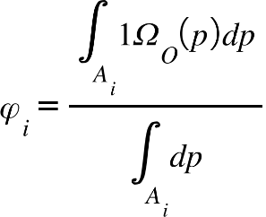, (9)
where 1Ω_{O}(p) denotes the indicator function that is 1 if p $ϵ$ Ω_{O} and 0 otherwise.
In practice, the integrals are approximated using pixel-wise summation over a digital image as given in equation (10).
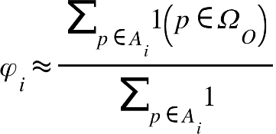. (10)
However, to improve computational efficiency and reduce sensitivity to segmentation noise, the denominator is approximated by the theoretical area of the annular sector as in equation (11),
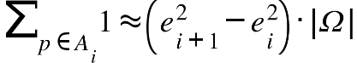. (11)
Thus, the final computation becomes equation (12), which assumes uniform tissue coverage and effectively normalizes by the expected bin area under isotropy.
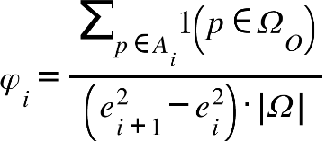, (12)
where ($e_{i+1}^{2}$−$e_{i}^{2}$)·|Ω| denotes the theoretical pixel area assigned to the 𝑖-th radial bin under an idealized perfectly circular organization. In the radial coordinate system, bins located farther from the center inherently cover larger physical areas than inner bins. Normalizing by this theoretical area therefore corrects for geometric scaling, ensuring that $φ_{i}$ reflects the spatial distribution of organelles rather than trivial differences in bin size.

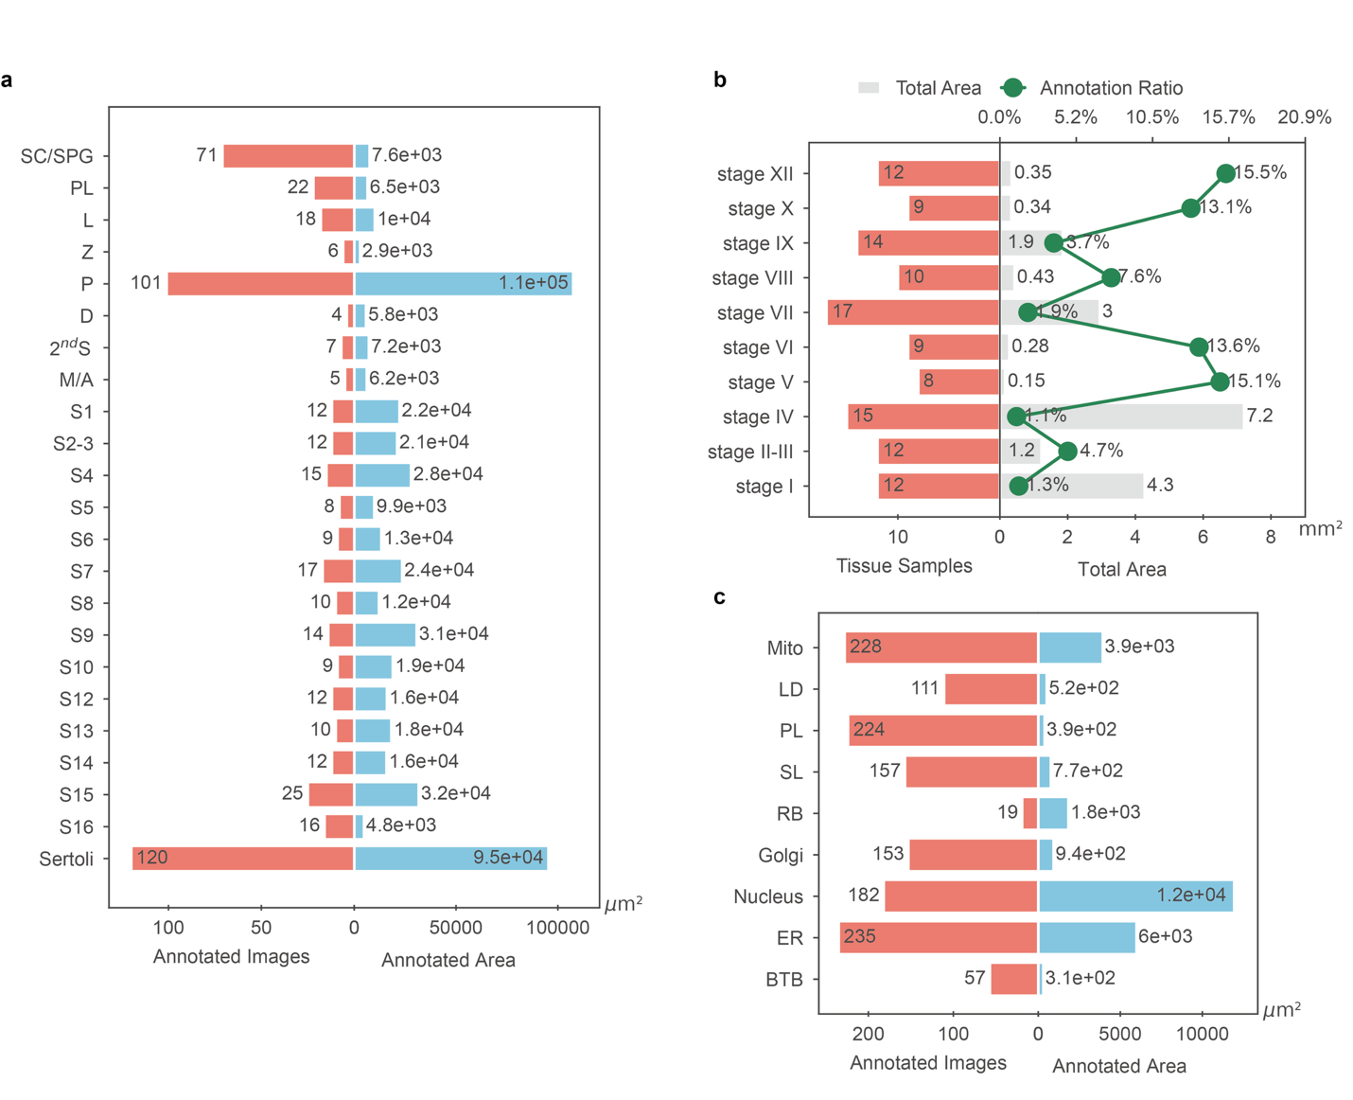

Extended data Fig 1.

Summary of samples and annotations for the analysis of spermatogenesis. (a) Overview of annotated cell and tissue categories in murine seminiferous tubules. For each category, the number of annotated images (left, red bars) and the corresponding total annotated area (right, blue bars) are shown, covering germ cells at multiple differentiation stages, as well as Sertoli cells and other supporting structures. (b) Distribution of annotated samples across seminiferous epithelial cycle stages (stage I–XII). Red bars indicate the number of tissue samples per stage, gray bars denote the total annotated tissue area, and green markers represent the relative annotation ratio for each stage. (c) Summary of subcellular and structural annotations, including major organelles and specialized structures. Mito, mitochondria; LD, lipid droplets; PL, primary lysosome; SL, secondary lysosome; RB, residual body; ER, endoplasmic reticulum; BTB, blood–testis barrier. For each category, the number of annotated images and the total annotated area are reported.

Supplementary Table 1.

The performance of methods for subcellular segmentation. PQ, panoptic quality; SQ, segmentation quality; RQ, recognition quality; PQ_th, panoptic quality for things; PQ_st, panoptic quality for stuff; bbox_mAP, mean Average Precision for bbox; bbox_mAP50, mean Average Precision at IoU=0.5 for bbox; segm_mAP, mean Average Precision for segmentation; segm_mAP50, mean Average Precision at IoU=0.5 for segmentation; mIoU, mean IoU; mDice, mean Dice coefficient; mAcc, mean Accuracy.
model | PQ | SQ | RQ | PQ_th | PQ_st | bbox_mAP | bbox_mAP50 | segm_mAP | segm_mAP50 | mIoU | mDice | mAcc
DeepOrganelle  (swin-base) | 81.9 | 91.3 | 89.9 | 81.7 | 82.3 | 68.0 | 84.8 | 67.0 | 85.5 | 87.3 | 92.6 | 91.5
DeepOrganelle  (r50) | 80.5 | 90.6 | 88.9 | 80.6 | 80.4 | 65.8 | 83.5 | 65.6 | 84.7 | 88.5 | 93.6 | 92.5
Cellotype  (r50) | 80.3 | 90.2 | 89.0 | 81.0 | 79.0 | 65.0 | 84.8 | 66.0 | 86.0 | 83.4 | 90.3 | 89.4
Cellpose3+  Cellsighter | — | — | — | 42.7 | — | 13.4 | 20.6 | 13.3 | 20.6 | 47.6 | 57.5 | 66.0
Cellpose-sam+  Cellsighter | — | — | — | 49.4 | — | 10.5 | 23.2 | 10.7 | 23.6 | 65.4 | 75.8 | 85.6
nnUnet | — | — | — | — | — | — | — | — | — | 43.2 | 46.8 | 57.9
MaskRCNN | — | — | — | — | — | 60.2 | 78.9 | 59.6 | 78.2 | — | — | —

Supplementary Table 2.
The performance of methods for cellular segmentation. PQ, panoptic quality; SQ, segmentation quality; RQ, recognition quality; PQ_th, panoptic quality for things; PQ_st, panoptic quality for stuff; bbox_mAP, mean Average Precision for bbox; bbox_mAP50, mean Average Precision at IoU=0.5 for bbox; segm_mAP, mean Average Precision for segmentation; segm_mAP50, mean Average Precision at IoU=0.5 for segmentation; mIoU, mean IoU; mDice, mean Dice coefficient; mAcc, mean Accuracy.
model | PQ | SQ | RQ | PQ_th | PQ_st | bbox_mAP | bbox_mAP50 | segm_mAP | segm_mAP50 | mIoU | mDice | mAcc
DeepOrganelle  (swin-base) | 84.5 | 95.3 | 88.9 | 84.6 | 84.3 | 77.0 | 85.9 | 79.1 | 87.2 | 89.7 | 94.5 | 96.2
DeepOrganelle  (r50) | 84.2 | 95.1 | 88.6 | 84.3 | 84.1 | 76.8 | 85.7 | 78.6 | 87 | 89.1 | 94.1 | 95.6
Cellotype  (r50) | 80.3 | 94.4 | 85.1 | 80.1 | 82.8 | 70.9 | 83.1 | 74.9 | 84.2 | 83.3 | 90.3 | 92.6
Cellpose3+  Cellsighter | — | — | — | 41.2 | — | 24.7 | 34.3 | 26.2 | 35.4 | 62.4 | 75.3 | 77.2
Cellpose-sam+  Cellsighter | — | — | — | 59.0 | — | 42.0 | 55.1 | 42.9 | 55.5 | 66.2 | 79.1 | 82.1
nnUnet | — | — | — | — | — | — | — | — | — | 64.2 | 68.4 | 66.7
MaskRCNN | — | — | — | — | — | 34.9 | 46.4 | 34.9 | 45.2 | — | — | —

RERFERENCES
25 Liu, L. et al. DeepContact: High-throughput quantification of membrane contact sites based on electron microscopy imaging. Journal of Cell Biology 221, e202106190 (2022).
30 Stringer, C. & Pachitariu, M. Cellpose3: one-click image restoration for improved cellular segmentation. Nature Methods (2025).
31 Pachitariu, M., Rariden, M. & Stringer, C. Cellpose-SAM: superhuman generalization for cellular segmentation. bioRxiv, 2025.2004.2028.651001 (2025).
32 Pang, M.X., Roy, T.K., Wu, X.D. & Tan, K. CelloType: a unified model for segmentation and classification of tissue images. Nature Methods 22 (2025).
38 Cheng, B., Misra, I., Schwing, A.G., Kirillov, A. & Girdhar, R. in Proceedings of the IEEE/CVF Conference on Computer Vision and Pattern Recognition 1290-1299 (2022).
53 Hua, Y., Laserstein, P. & Helmstaedter, M. Large-volume en-bloc staining for electron microscopy-based connectomics. Nat Commun 6, 7923 (2015).
54 Isensee, F., Jaeger, P.F., Kohl, S.A.A., Petersen, J. & Maier-Hein, K.H. nnU-Net: a self-configuring method for deep learning-based biomedical image segmentation. Nat Methods 18, 203-211 (2021).
55 He, K., Gkioxari, G., Dollár, P. & Girshick, R. Mask R-CNN. IEEE Transactions on Pattern Analysis and Machine Intelligence 42, 386-397 (2020).
56 Amitay, Y. et al. CellSighter: a neural network to classify cells in highly multiplexed images. Nat Commun 14 (2023).

