Supplemental Information
SI 1: Material Properties of the spray dried product
Effect of emulsifier soy lecithin (SL) and quillaja extract (QE) on spray drying related metrics: overall yield of product (A) and total crude lipid yield (B). The effect of emulsifier was significant on overall yield. Particle size distribution of the spray dried powder form of the liquid biopolymer composite coating ingredient (C).
A)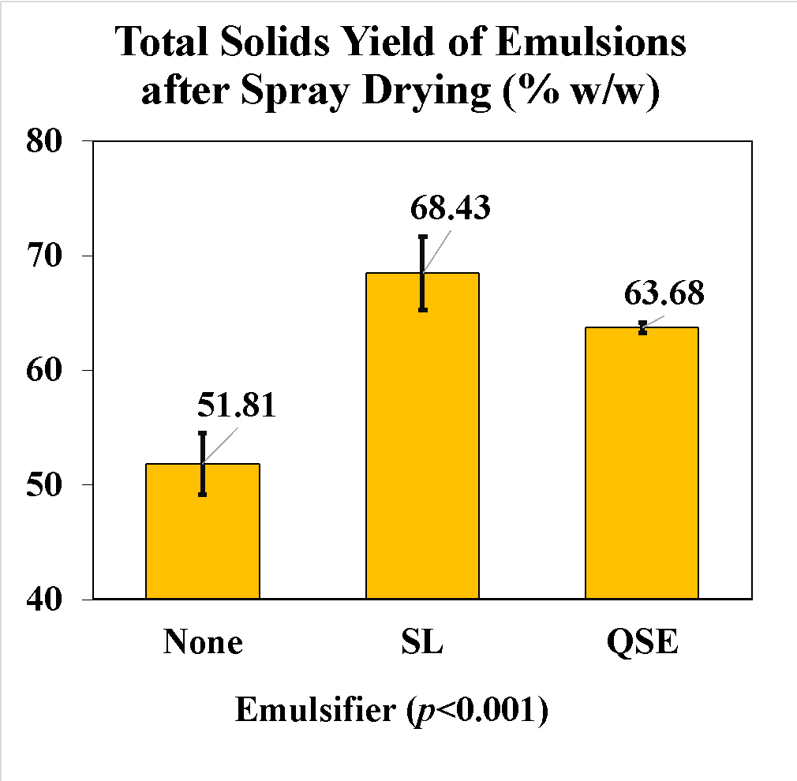 B) 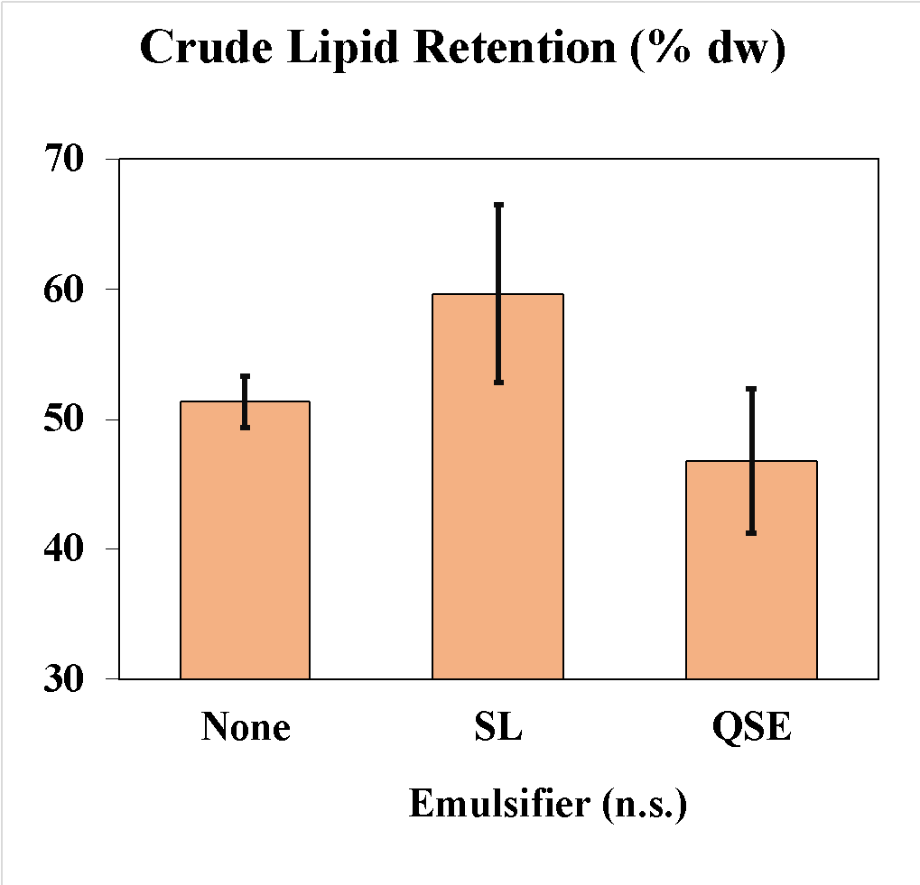

SI 2: Electrosprayer setup
Actual set up of the electrospray unit (A) with schematic (B) and a zoomed in view of the needle spraying in real time (C). The parts of the schematic are as follows: 1. positive displacement pump; 2. syringe with liquid; 3. polymer tubing; 4. a bent needle as the nozzle; 5. high voltage source; 6. grounding 7. grounding; 8. stainless steel deposition plate; 9. liquid plume from electrosprayer
A) 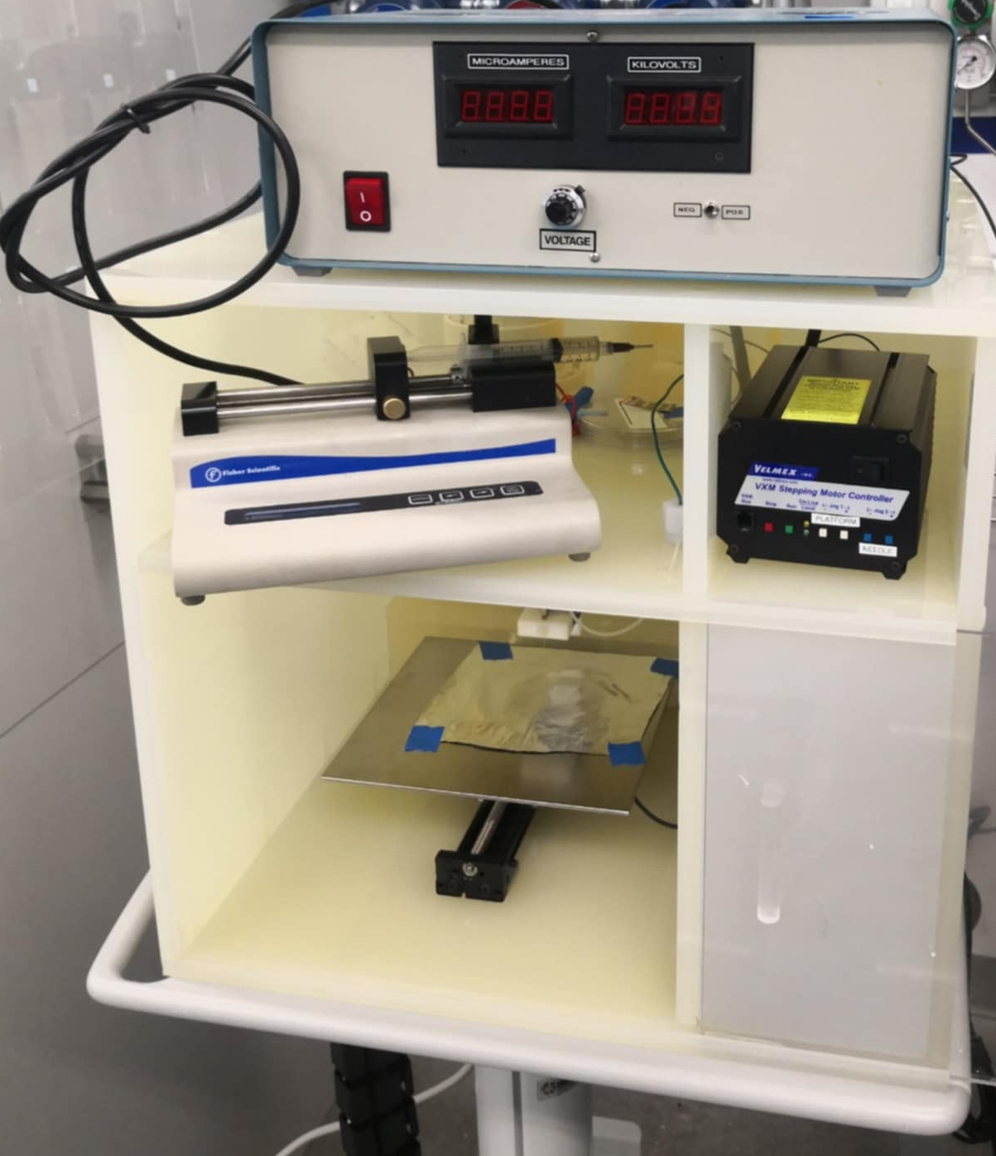 B) 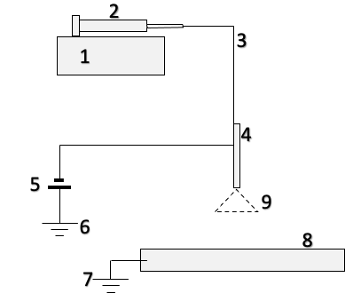
C) 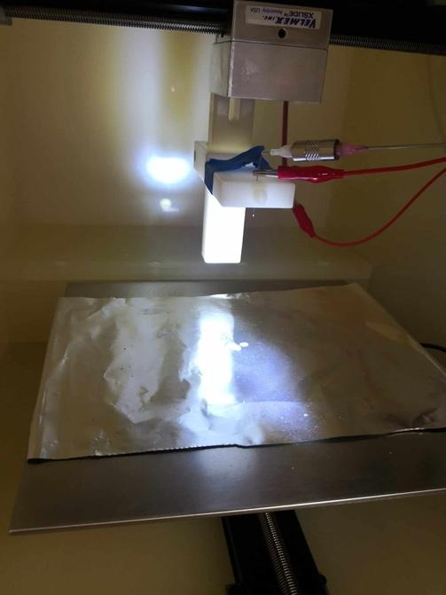

SI 3: Time, temperature, and humidity profile for real-time shelf-life testing
Temperature (°C) shown in blue graph and relative humidity (%) in orange graph.
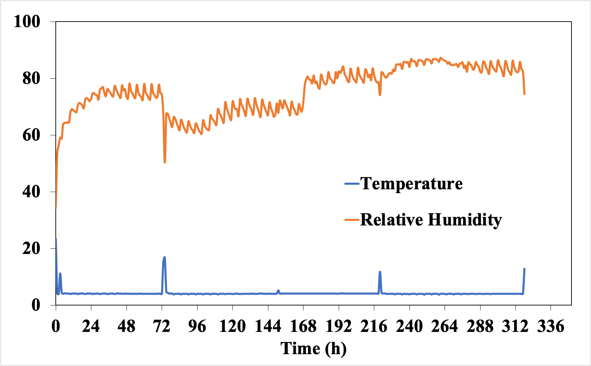

SI 4: Technoeconomic analysis related inputs and outputs
Process Flow Diagram

Milling

Ensilage

Acid extraction

Separation

Alkali extraction

Separation

Mixing

Spray drying
Table SI4.1. Total capital investment for industrial production of edible coating powder.

Category | Cost (USD) | % of Total Capital Cost
Direct Costs
Purchased equipment | 1,304,957 | 20.9%
Purchased-equipment installation | 508,933 | 8.2%
Instrument & controls | 339,289 | 5.4%
Piping | 404,537 | 6.5%
Electrical systems | 130,496 | 2.1%
Buildings (including services) | 378,437 | 6.1%
Yard improvements | 156,595 | 2.5%
Service facilities | 717,726 | 11.5%
Subtotal direct plant cost | 3,940,969 | 63.2%
Indirect Costs
Engineering & supervision | 430,636 | 6.9%
Construction expenses | 508,933 | 8.2%
Legal expenses | 52,198 | 0.8%
Contractor’s fee | 221,843 | 3.6%
Contingency | 456,735 | 7.3%
Subtotal indirect cost | 1,670,344 | 26.8%
Fixed capital investment (FCI) | 5,611,313 | 90%
Working capital (10% of FCI) | 622,856 | 10%
Total Capital Investment (TCI) | 6,234,169 | 100%

Table SI4.2. Annual operating cost for edible coating powder production.

Category | Annual Use (kg) | Unit Cost ($/kg, Base) | Annual Cost (USD) | % of Total Operating Cost
Raw Materials |  |  | 8,837,452 | 75.2%
Sugar kelp | 7,920,000 | 0.6 | 4,752,000 | 40.4%
Citric acid | 1,584 | 10 | 15,840 | 0.13%
Coconut oil | 82,210 | 3.56 | 292,668 | 2.49%
Essential oil | 24,631 | 122 | 3,004,982 | 25.57%
Na₂CO₃ | 198,000 | 1.5 | 297,000 | 2.53%
Soy lecithin | 8,712 | 2.7 | 23,522 | 0.20%
Water | 4,514,400 | 0.10 | 451,440 | 3.84%
Utilities | — | — | 2,084,091 | 17.7%
Labor (salary + 90% burden) | — | — | 475,000 | 4.0%
Other overhead (maintenance + insurance) | — | — | 78,428 | 0.7%
Depreciation (5% of capital/year) | — | — | 280,566 | 2.4%
Total Operating Cost |  |  | 11,755,537 | 100%

SI 5 Life Cycle Assessment Related Information
Table SI5.1. Life cycle inventory of the uncoated system
Uncoated System
No. | Material | Input / Output / Emissions | Amount | Unit
Strawberry cultivation
1 | Land Use | Input | 0.2384 | m2a
2 | Water use | Input | 0.0934 | m3
3 | Electricity (Irrigation) | Input | 0.0442 | kWh
4 | Nitrogen | Input | 0.00554 | kg
5 | P2O5 | Input | 0.0048 | kg
6 | K2O | Input | 0.0059 | kg
7 | Sulfur | Input | 0.0010 | kg
8 | Zinc | Input | 0.0001 | kg
9 | Gypsum | Input | 0.0006 | kg
10 | Soluble Potash | Input | 0.0001 | kg
11 | Total pesticides | Input | 0.0031 | kg
12 | Diesel | Input | 0.7580 | MJ
13 | Gasoline | Input | 0.0038 | l
14 | Drip tapes | Input | 0.0025 | kg
15 | Product Transport | Input | 0.0129 | t*km
16 | Worker Transport | Input | 0.1580 | km
17 | Ammonia | Emission to air | 0.0000 | kg
18 | Nitrogen oxides | Emission to air | 0.0001 | kg
19 | Dinitrogen monoxide | Emission to air | 0.0001 | kg
20 | Nitrate | Emission to water | 0.0034 | kg
21 | Unharvested strawberries (Food loss) | Output | 0.3230 | kg
22 | Strawberry at the farm | Output | 1.5500 | kg
Strawberry packaging
1 | Strawberry at the farm | Input | 1.55 | kg
2 | PET | Input | 0.0952 | kg
3 | Label | Input | 0.0015 | kg
4 | Diesel | Input | 0.00106 | MJ
5 | Refrigerant gas | Input | 0.0000153 | kg
6 | Electricity | Input | 0.0628 | kWh
7 | Refrigerant | Emission to air | 0.00000306 | kg
8 | Organic waste (Food loss) | Output | 0.03000 | kWh
9 | Strawberry packed at the farm | Output | 1.52 | kg
Strawberry packed at retail
1 | Strawberry packed at the farm | Input | 1.52 | kg
2 | Transport, refrigerated | Input | 3.28 | t*km
3 | Natural gas | Input | 2.15 | MJ
4 | Refrigerant | Input | 0.0000693 | kg
5 | Electricity | Input | 0.0370 | kWh
6 | Refrigerant leakage | Emission to air | 0.0000173 | kg
7 | Organic waste | Output | 0.19 | kg
8 | Strawberry packed at retail | Output | 1.33 | kg
Strawberry packed at consumer
1 | Strawberry packed at retail | Input | 1.33 | kg
2 | Plastic bag | Input | 0.00052 | kg
3 | Water for dishwasher | Input | 0.0202 | kg
4 | Transport | Input | 0.0333 | km
5 | Electricity | Input | 0.3870 | kWh
6 | Organic Waste | Output | 0.33 | kg
7 | PET waste | Output | 0.0952 | kg
8 | PE waste (Bag + Label) | Output | 0.00202 | kg
9 | Strawberry packed at consumer | Output | 1 | kg

Table S5I.2. Life cycle inventory of the coated system
Coated system
No. | Material | Input / Output / Emissions | Amount | Unit
Strawberry cultivation
1 | Land Use | Input | 0.1913 | m2a
2 | Water use | Input | 0.0749 | m3
3 | Electricity (Irrigation) | Input | 0.0355 | kWh
4 | Nitrogen | Input | 0.00445 | kg
5 | P₂O₅ | Input | 0.0039 | kg
6 | K₂O | Input | 0.0047 | kg
7 | Sulfur | Input | 0.0008 | kg
8 | Zinc | Input | 0.0000 | kg
9 | Gypsum | Input | 0.0005 | kg
10 | Soluble Potash | Input | 0.0001 | kg
11 | Total pesticides | Input | 0.0025 | kg
12 | Diesel | Input | 0.6082 | MJ
13 | Gasoline | Input | 0.0031 | l
14 | Drip tapes | Input | 0.0020 | kg
15 | Product Transport | Input | 0.0104 | t*km
16 | Worker Transport | Input | 0.1268 | km
17 | Ammonia | Emission to air | 0.0000 | kg
18 | Nitrogen oxides | Emission to air | 0.0001 | kg
19 | Dinitrogen monoxide | Emission to air | 0.0001 | kg
20 | Nitrate | Emission to water | 0.0027 | kg
21 | Unharvested strawberry or Farm waste | Output | 0.2592 | kg
22 | Strawberry at the farm | Output | 1.2438 | kg
Strawberry coated and packed
1 | Strawberry at the farm | Input | 1.244 | kg
 | Powder coating | Input | 0.001 | kg
2 | PET | Input | 0.076 | kg
3 | Label | Input | 0.001 | kg
4 | Diesel | Input | 0.001 | MJ
5 | Refrigerant gas | Input | 0.000 | kg
6 | Electricity | Input | 0.050 | kWh
7 | Electricity | Input (coating) | 0.00000002 | kWh
8 | Refrigerant | Emission to air | 0.00000246 | kg
9 | Organic waste | Output | 0.028 | kg
10 | Strawberry packed at the farm | Output | 1.22 | kg
Strawberry coated and packed at retail
1 | Strawberry packed at the farm | Input | 1.216 | kg
2 | Transport, refrigerated | Input | 2.811 | t*km
3 | Natural gas | Input | 1.843 | MJ
4 | Refrigerant | Input | 0.000059 | kg
5 | Electricity | Input | 0.032 | kWh
6 | Refrigerant leakage | Emission to air | 0.0000148 | kg
7 | Organic waste | Output | 0.07 | kg
8 | Strawberry packed at retail | Output | 1.14 | kg
Strawberry coated packed at consumer
1 | Strawberry packed at retail | Input | 1.143 | kg
2 | Plastic bag | Input | 0.00039 | kg
3 | Water for dishwasher | Input | 0.015 | kg
4 | Transport | Input | 0.025 | km
5 | Electricity | Input | 0.290 | KWh
6 | Organic waste | Output | 0.143 | kg
7 | PET waste | Output | 0.076 | kg
8 | PE waste (Bag + Label) | Output | 0.002 | kg
9 | Strawberry packed at consumer | Output | 1 | kg

Table SI5.3. Life cycle inventory of seaweed.
Seaweed
No. | Material | Input / Output / Emissions | Amount | Unit
Collection of fertile algae
1 | Plastic bag | Input | 0.1 | kg
2 | Fabric cloths | Input | 0.1 | kg
3 | Transportation to the hatchery | Input | 0.1 | t*km
Spore preparation and seedling
1 | Energy for aeration, lights, seawater sourcing, and filtering | Input | 656 | MJ
2 | Bucket | Input | 0.17 | kg
3 | Seawater filters, plastic part | Input | 0.45 | kg
4 | Seawater filters, metal part | Input | 0.32 | kg
5 | Nutrients, 25% Phosphate | Input | 0.0475 | kg
6 | Nutrients, 75% ammonium nitrate | Input | 0.1425 | kg
7 | Aquaria | Input | 2.91 | kg
8 | Collectors | Input | 2.75 | kg
9 | Thin cultivation line | Input | 3.8 | kg
10 | Transportation to the farm | Input | 1.6 | t*km
11 | Plastic container for storage at farm prior deployment | Input | 0.03 | kg
Deploying, on-growth, and maintenance
1 | Anchors and a mooring block & Base shackles and hooks | Input | 547 | kg
2 | Metal chains | Input | 4.9 | kg
3 | Unalloyed steel | Input | 0.6 | kg
4 | Ropes | Input | 1.4 | kg
5 | Buoys | Input | 8.1 | kg
6 | Main long line | Input | 3.3 | kg
7 | Boat operation for setting | Input | 26 | kg
8 | Boat operation for seedlings | Input | 66 | kg
9 | Boat operation for maintenance | Input | 244 | kg
Harvesting
1 | Boat operation | Input | 69.3 | kg
2 | Big bags | Input | 3.1 | kg
3 | Transportation | Input | 1000 | t*km
4 | Sugar kelp | Output | 10,000 | kg

Table SI5.4. Life cycle inventory of coating.
Coating
No. | Material | Input / Output / Emissions | Amount | Unit
Coating Production
1 | Sugar kelp | Input | 7,920,000 | kg
2 | Citric acid | Input | 1,584 | kg
3 | Coconut oil | Input | 82,210 | kg
4 | Na₂CO₃ | Input | 198,000 | kg
5 | Soybean lecithin | Input | 8,712 | kg
6 | Water | Input | 45,144,000 | kg
7 | Steam | Input | 11,489,000 | kg
8 | Essential oil | Input | 24,63 | kg
9 | Electricity | Input | 498,792 | kWh
10 | Cooling water | Input | 2,219,000 | kg
11 | Energy for cooling water | Input | 348.33 | kWh
12 | Chilled water | Input | 34,008,000 | kg
13 | Energy for chilling water | Input | 44936.08 | kWh
14 | Powder coating | Output | 481,138 | kg

