Figure S1: Optimization of Cluster Number Using the Elbow Method and Silhouette Method
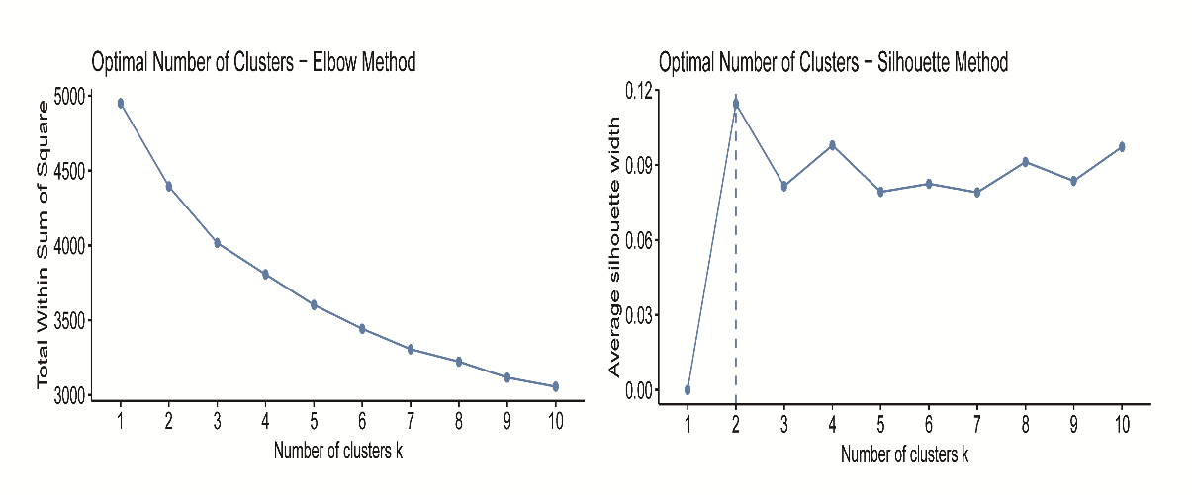
Both the Elbow Method and the Silhouette Method consistently suggest that k=2 is the optimal number of clusters for this dataset.

Figure S2: Radar Chart of Standardized Clinical Profiles Across Clusters
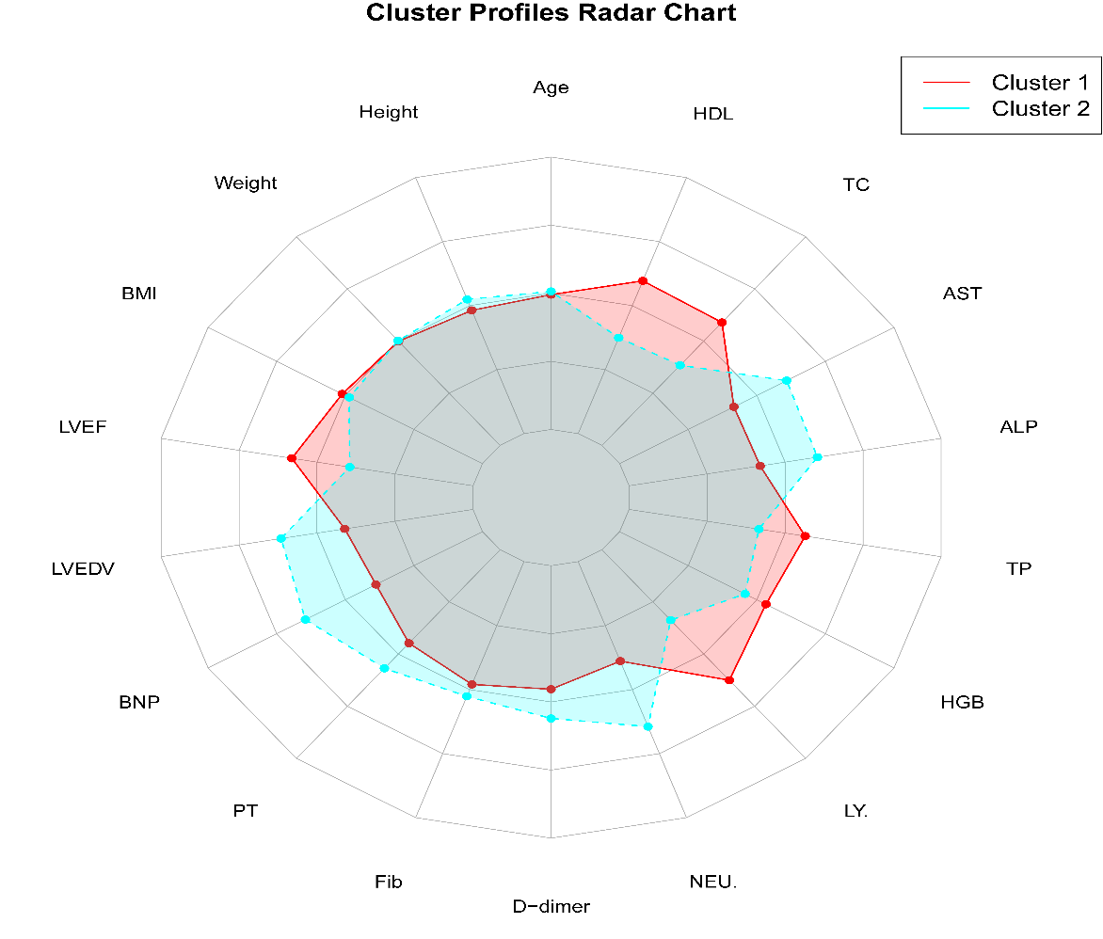
The radar chart visually reinforces the two phenotypically distinct patient subgroups identified in the analysis.

Figure S3: Parallel Coordinate Plot of Clinical Variables Across Clusters
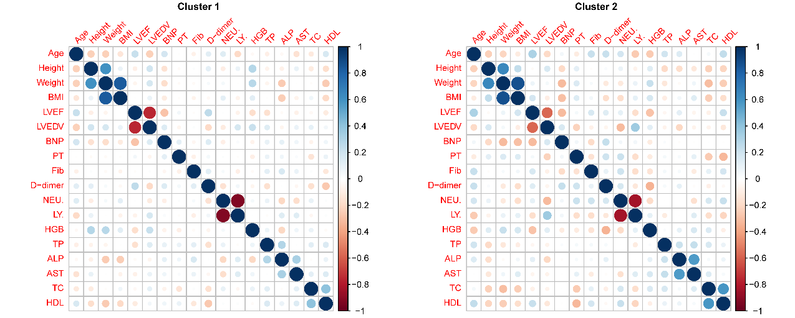
The parallel coordinate plot reinforces the presence of two distinct patient subgroups with coherent and internally consistent clinical signatures.

FigureS4: Receiver Operating Characteristic Curves Comparing Venous Thromboembolism Prediction Models
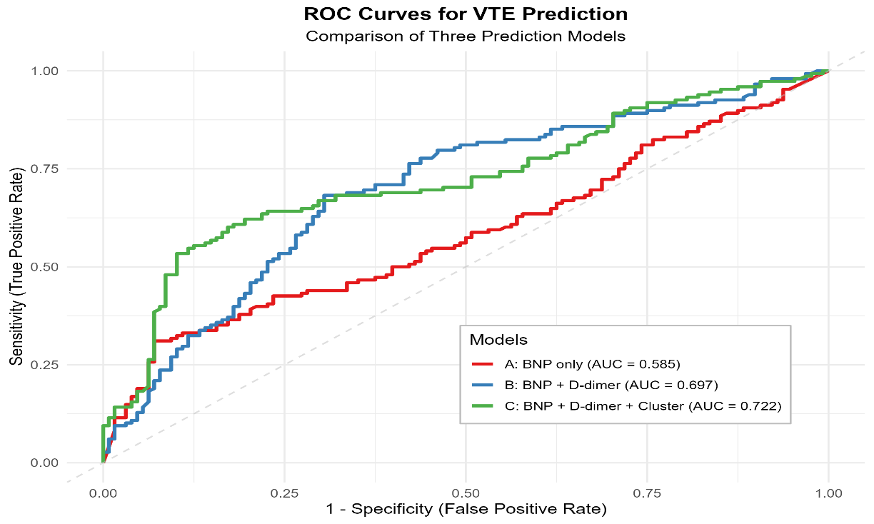
This supports the utility of cluster-based phenotyping as a complementary stratifier in Venous thromboembolism risk assessment among the studied population.

