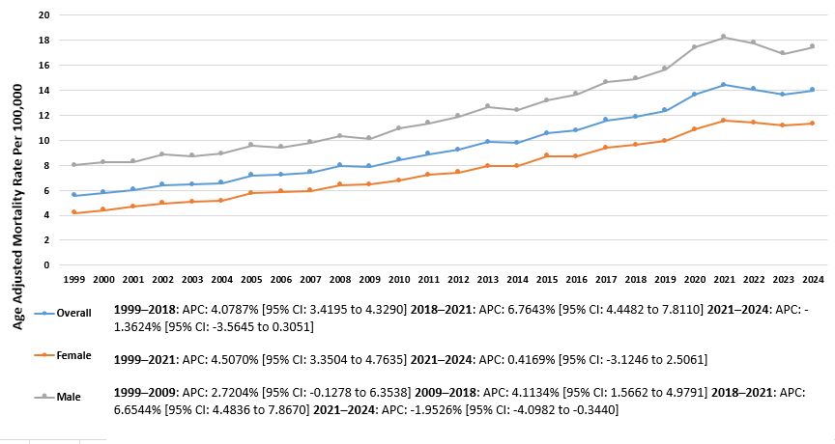
Supplementary Figure 1. Trends in Atrial Fibrillation and COPD-related AAMR per 100,000, stratified by overall and sex, in the United States from 1999–2024

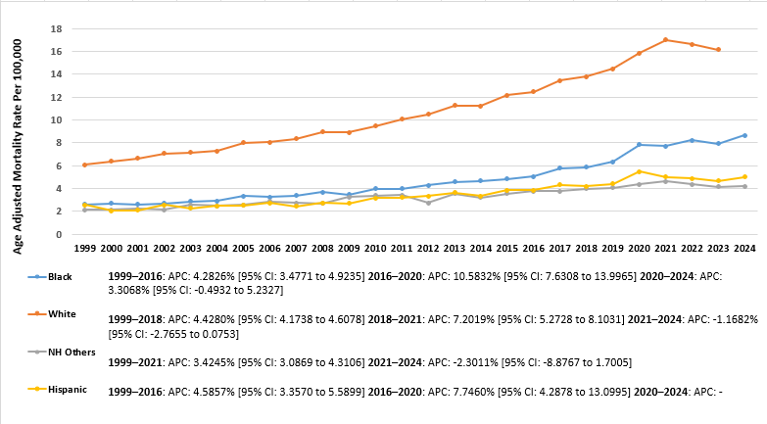
Supplementary Figure 2. Trends in Atrial Fibrillation and COPD-related AAMR per 100,000, stratified by race, in the United States from 1999–2024

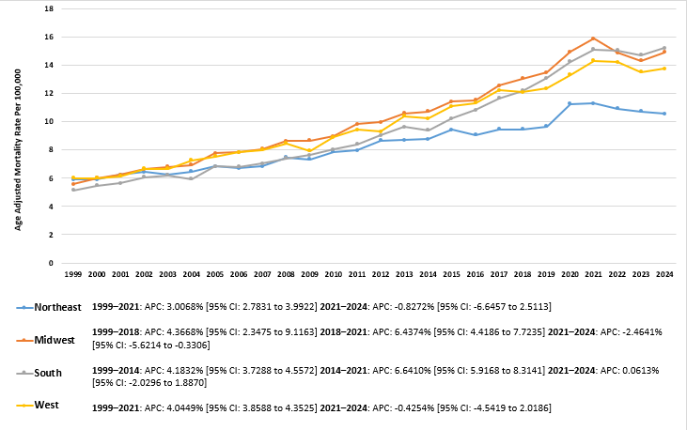
Supplementary Figure 3. Trends in Atrial Fibrillation and COPD-related AAMR per 100,000, stratified by census region, in the United States from 1999–2024

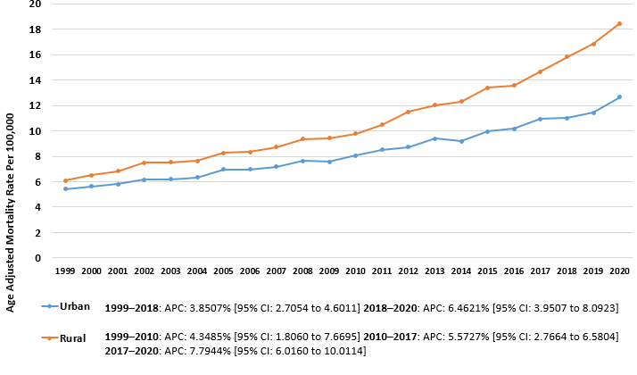
Supplementary Figure 4. Trends in Atrial Fibrillation and COPD-related AAMR per 100,000, stratified by urbanization, in the United States from 1999–2024
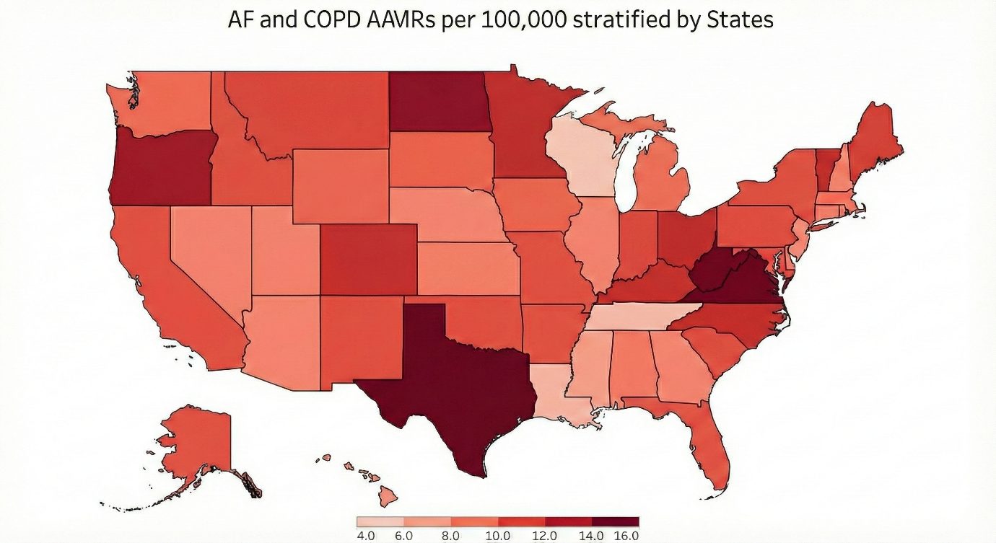
Supplementary Figure 5. Trends in Atrial Fibrillation and COPD-related AAMR per 100,000, stratified by states, in the United States from 1999–2024

