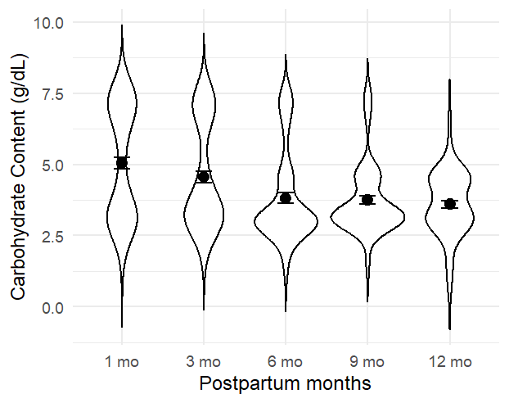
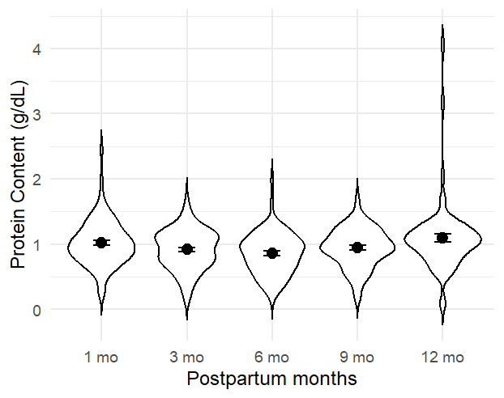
B. Carbohydrate
A. Protein

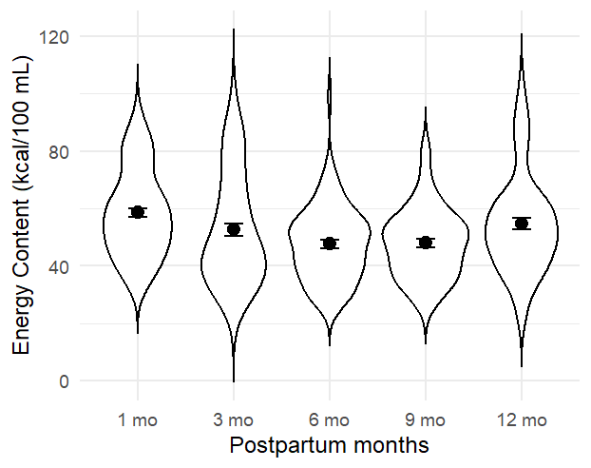
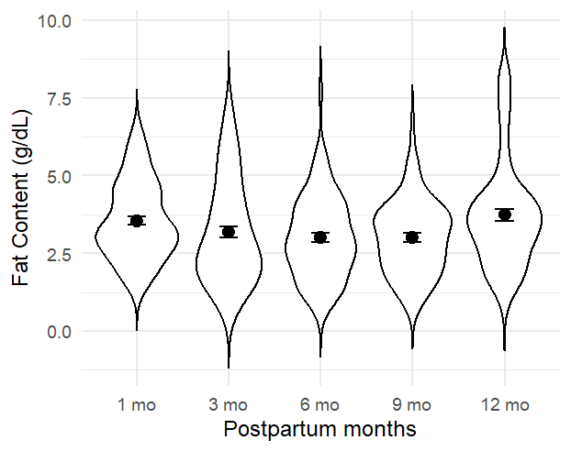
C. Fat
D. Energy

Supplementary Figure 1: Distribution of human milk macronutrient concentrations at 1, 3, 6, 9, and 12 months postpartum.
Note: Each panel displays the distribution of protein (A), carbohydrate (B), fat (C), and energy (D) concentrations at five postpartum visits. Violin shapes represent kernel density distributions; wider sections indicate greater data density. Black dots represent mean values, and horizontal bars indicate standard errors.

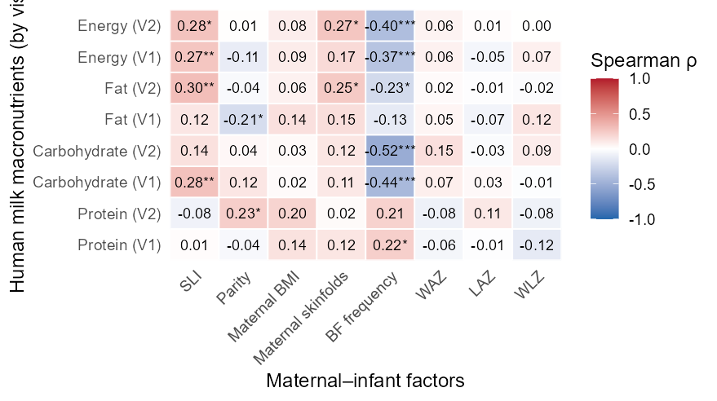
(A)

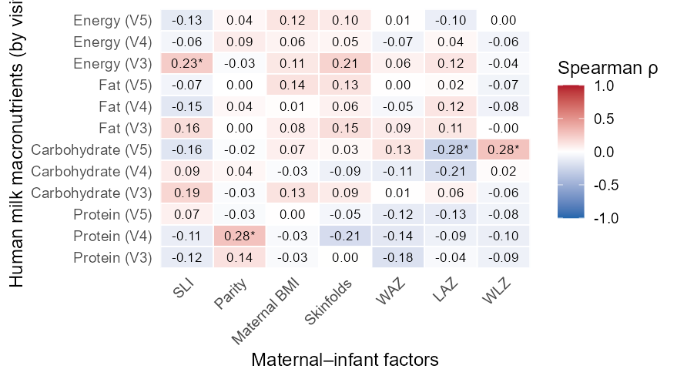
(B)

Supplementary Figure 2: Spearman correlation heatmaps between human milk macronutrients and maternal-infant characteristics across five postpartum visits.

Note: 2A: 1 (V1), 3 (V2) months, 2B: 6 (V3), 9 (V4), and 12 (V5) months. Factors include socioeconomic status (SLI: standard-of-living index score), parity, maternal BMI, maternal sum of four skinfolds (Skinfolds), WAZ (infant’s weight-for-age), LAZ (length-for-age), and WLZ (weight-for-length) z scores, and breastfeeding frequency (BF Frequency; available only at visits 1 and 2). Statistically significant correlations (p < 0.05) are marked with an asterisk. Significance levels: *p < 0.05, **p < 0.01, ***p < 0.001. Blue indicates negative correlations and red indicates positive correlations, with intensity scaled to the magnitude of Spearman’s rho (ρ).
Supplementary Table 1: Linear mixed-effects model estimates for human milk macronutrient concentrations across 1-12 months postpartum.

Model | Intercept | Postpartum days (linear term) | Postpartum days (quadratic term) | Standard of living | Parity | Maternal skinfolds, mm | Sex  (Male)
Protein, gm/dL
Estimate | 0.920 | 0.426 x 10⁻⁴ | 0.613 x 10⁻⁵ | -0.002 | 0.075 | -0.001 | -0.065
Standard Error | 0.162 | 0.0002 | 0.134 x 10⁻⁵ | 0.004 | 0.054 | 0.001 | 0.054
p-value | <0.001 | 0.815 | <0.001 | 0.715 | 0.167 | 0.320 | 0.236
Carbohydrate
Estimate | 3.362 | -0.005 | 0165 x 10⁻⁴ | 0.013 | 0.011 | 0.001 | 0.047
Standard Error | 0.656 | 0.001 | 0.404 x 10⁻⁵ | 0.016 | 0.223 | 0.004 | 0.223
p-value | <0.001 | <0.001 | <0.001 | 0.427 | 0.960 | 0.747 | 0.833
Fat
Estimate | 1.743 | -0.0004 | 0.213 x 10⁻³ | 0.028 | -0.244 | 0.010 | 0.146
Standard Error | 0.470 | 0.001 | 0.568 x 10⁻⁵ | 0.011 | 0.153 | 0.004 | 0.153
p-value | <0.001 | 0.582 | <0.001 | 0.013 | 0.114 | 0.014 | 0.344
Energy
Estimate | 31.180 | -0.023 | 0.296 x 10⁻³ | 0.333 | -1.109 | 0.118 | 0.945
Standard Error | 5.784 | 0.008 | 0.564 x 10⁻⁴ | 0.139 | 1.904 | 0.047 | 1.908
p-value | <0.001 | 0.005 | <0.001 | 0.019 | 0.562 | 0.014 | 0.622

Note: Models were fitted using linear mixed-effects regression with participant-specific random intercepts. Postpartum time was modelled as a continuous variable (days since delivery), including linear and quadratic terms. Estimates represent fixed-effects coefficients. Maternal skinfolds represent the sum of four skinfold thicknesses (mm). Statistical significance was set at p<0.05.

