Supplementary Method
Acute toxicity evaluation
To assess the in vivo biosafety of the BED probe at a supra-diagnostic dose, healthy BALB/c mice (n = 3) received a single intravenous injection of [⁶⁸Ga]Ga-NOTA-BED (37 MBq, 1 mCi). Animals were observed daily for 7 days for clinical signs of toxicity, including general condition, locomotor activity, and food and water intake. At day 7, mice were euthanized by cervical dislocation, and major organs (heart, liver, spleen, lung, and kidney) were collected for histological analysis. Tissues were fixed in 4% paraformaldehyde, embedded in paraffin, sectioned, and stained with hematoxylin and eosin (H&E). Histopathological evaluation was performed under light microscopy to identify evidence of acute tissue injury.
Human radiation dosimetry estimation
To evaluate the potential clinical safety of the [⁶⁸Ga]Ga-NOTA-BED probe, human radiation doses were estimated from murine biodistribution data using the Medical Internal Radiation Dose (MIRD) schema. Organ uptake values in mice (%ID/g) were extrapolated to a reference adult male phantom (ICRP Publication 89) via relative organ mass scaling. Time–activity curves (TACs) were generated for each organ, and residence times were calculated by integrating the TACs using the trapezoidal method for measured time points and an exponential decay model for the terminal phase. These residence times were then input into OLINDA/EXM software (version 2.1) to calculate organ-specific absorbed doses (mSv/MBq) based on internal [⁶⁸Ga] S-values. The total-body effective dose (mSv/MBq) was derived using tissue weighting factors recommended in ICRP Publication 103.
Sequence of the BCMA ectodomain-based truncated probe (BED)
Sequence of the BCMA ectodomain-based truncated probe (BED) used for imaging, as reported in reference^{[1]}. This construct comprises the core extracellular domain of human BCMA (residues A5 to A54). To facilitate recombinant expression and high-purity isolation, a 6xHis-SUMO dual tag was incorporated at the N-terminus of the protein. The final, tag-free BED protein was obtained following site-specific proteolytic cleavage with Ulp1 protease.
6xHis-SUMO-BED sequence:
MGSSHHHHHHSSGMSDSEVNQEAKPEVKPEVKPETHINLKVSDGSSEIFFKIKKTTPLRRLMEAFAKRQGKEMDSLRFLYDGIRIQADQTPEDLDMEDNDIIEAHREQIGGAGQCSQNEYFDSLLHACIPCQLRCSSNTPPLTCQRYCNASVTNSVKGTNA
Tag-free BED sequence:
AGQCSQNEYFDSLLHACIPCQLRCSSNTPPLTCQRYCNASVTNSVKGTNA
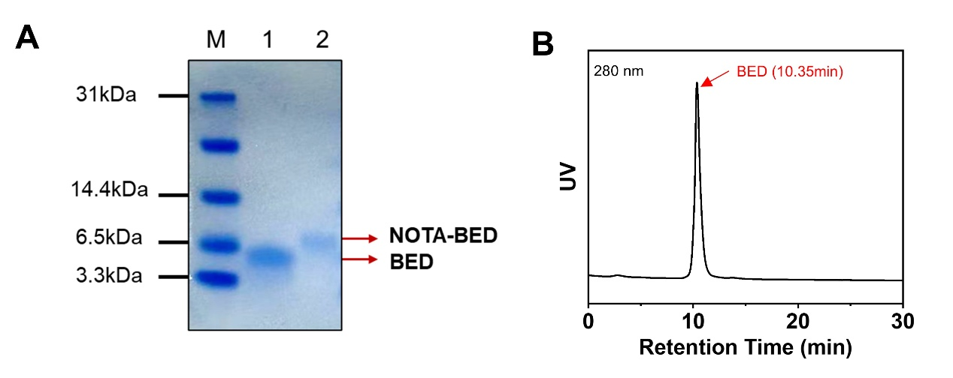
Figure S1. Characterization of the BED and NOTA-BED probes. (A) Characterization of BED and NOTA-BED via SDS-PAGE analysis. Coomassie staining of the gels for BED (Lane 1) and NOTA-BED (Lane 2) is presented. Lane M represents the molecular weight marker. (B) SEC-HPLC profile of the BED probe. Ultraviolet (UV) absorbance at 280 nm is recorded against retention time.

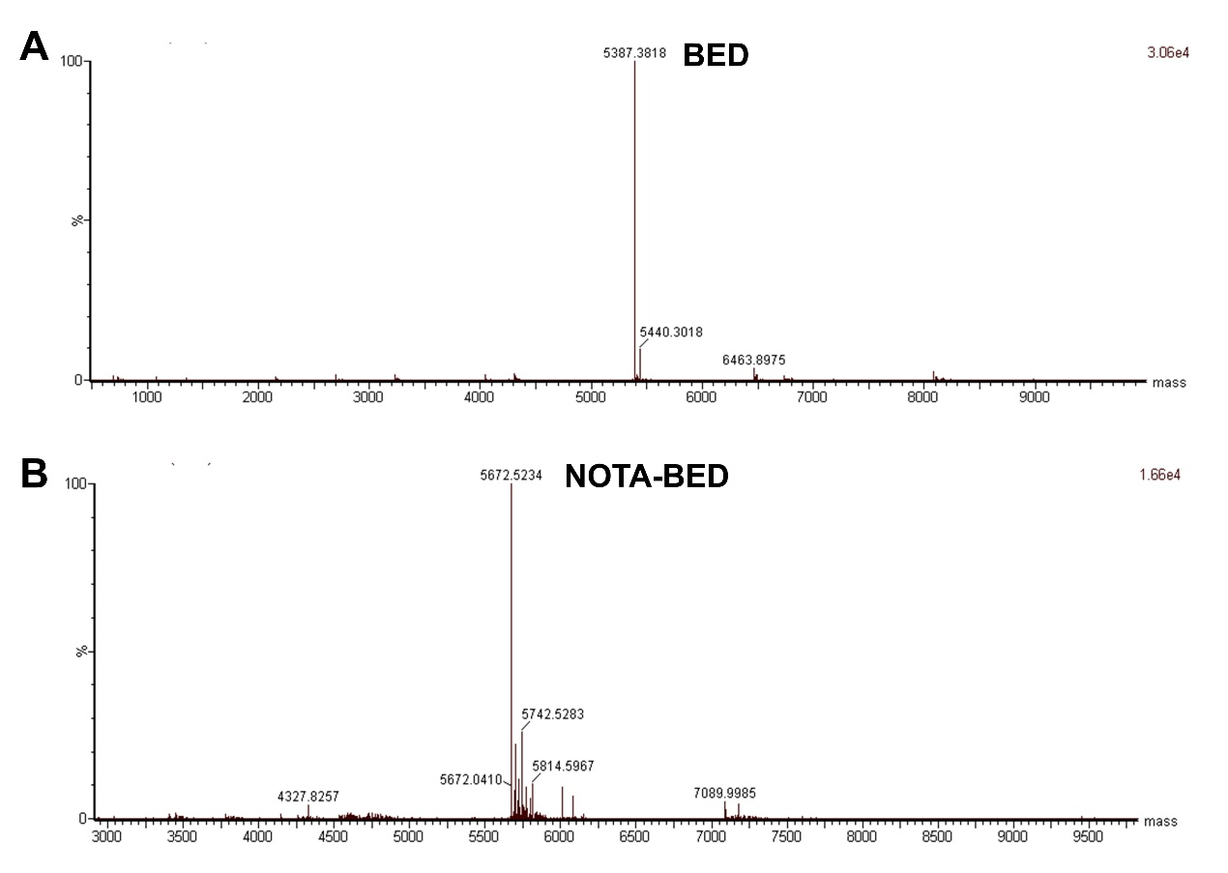
Figure S2. Characterization of BED (A) and NOTA-BED (B) via TOF-MS. TOF-MS confirmed the molecular mass and integrity of BED (A) and the successful conjugation of NOTA to BED (B).

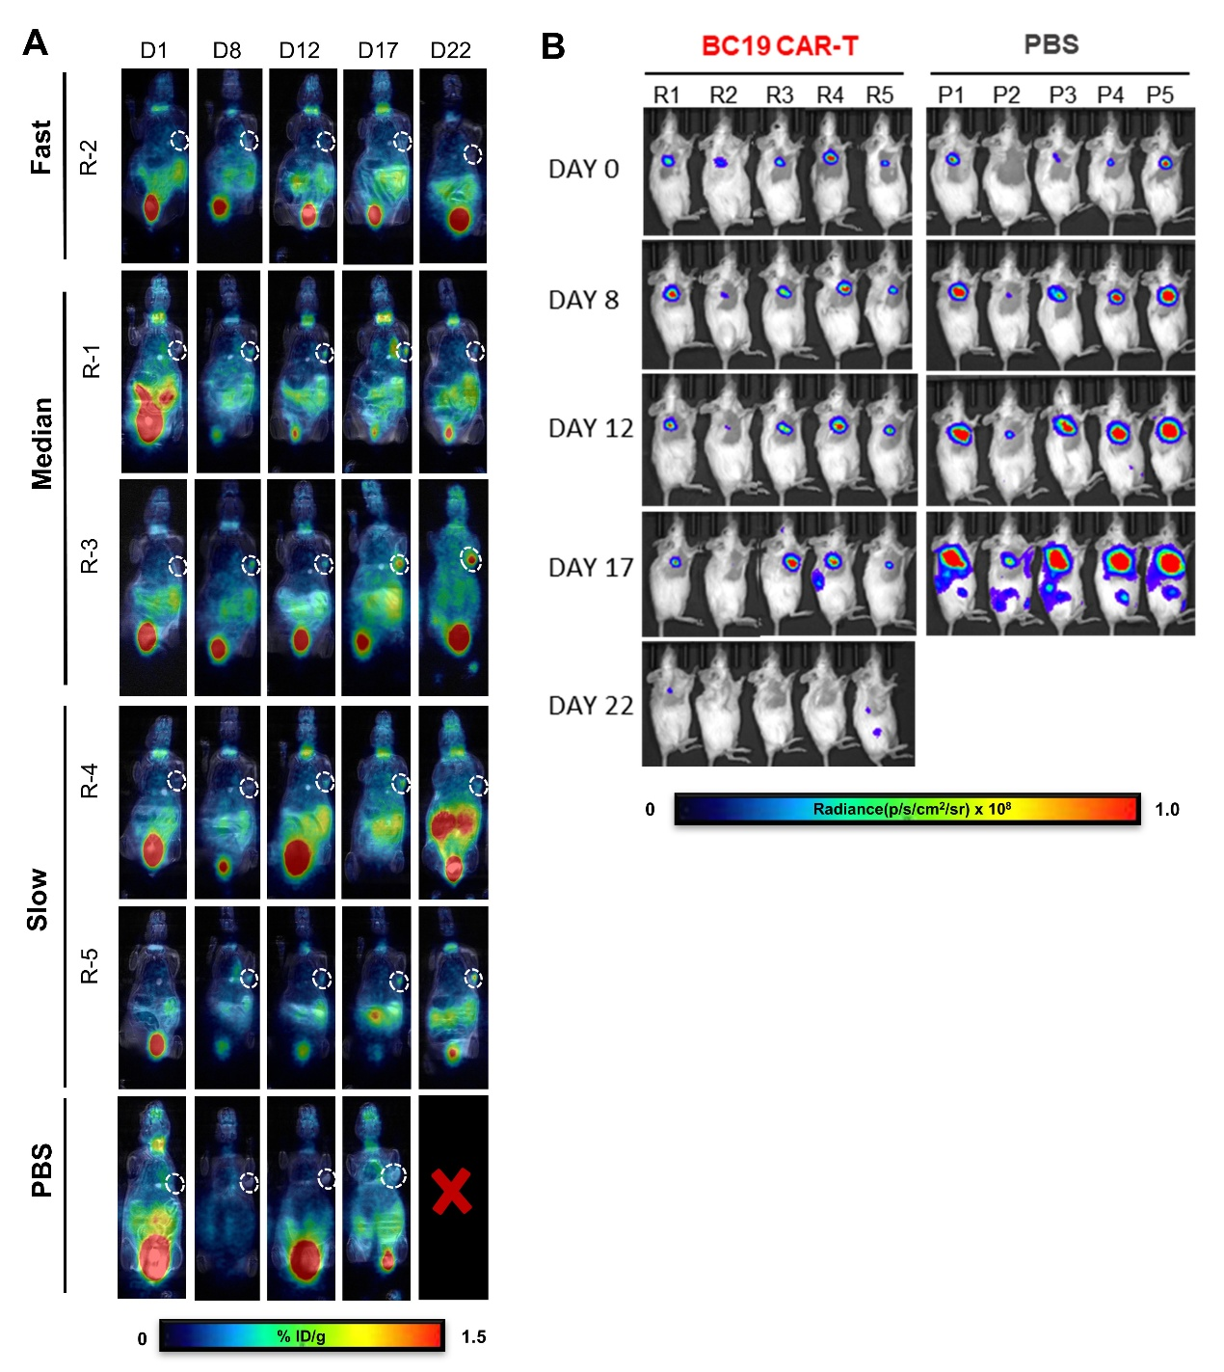
Figure S3. Longitudinal PET/MR and bioluminescence imaging monitoring of BC19 CAR-T and PBS cohorts in the Raji lymphoma model. Ten female NCG mice (4–6 weeks old) were inoculated with Raji-Luc cells subcutaneously (day −10) and intravenously (day −2). On day 0, mice were randomized to receive 5 × 10⁶ BC19 CAR-T cells (n = 5) or PBS (n = 5). (A) Serial [⁶⁸Ga]Ga-NOTA-BED PET/MR imaging on days 1, 8, 12, 17, and 22. The CAR-T cohort includes all mice (R1–R5), whereas representative images are shown for the PBS group. Animals in the CAR-T cohort are categorized into "Fast", "Median", and "Slow" groups based on the kinetics of T cell expansion and tumor clearance. Red crosses indicate missing scans due to death or excessive tumor burden. White dashed circles outline subcutaneous tumors. Radioactivity uptake is expressed as %ID/g (scale, 0–1.5). (B) Corresponding longitudinal BLI of the same mice to assess therapeutic response. Bioluminescence intensity is expressed as radiance (p/s/cm²/sr), with the color scale ranging from 0 to 1.0 × 10⁸ p/s/cm²/sr.
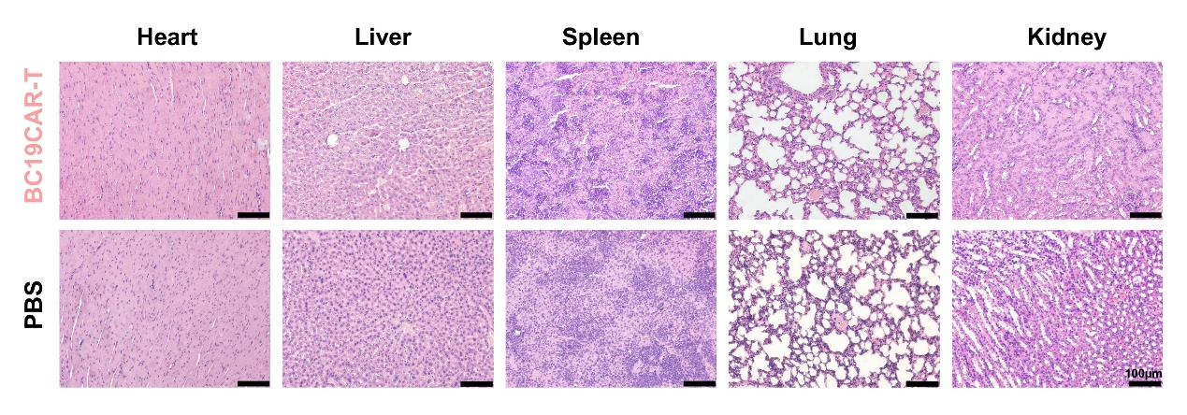
Figure S4. Histopathological analysis of major organs in the Raji lymphoma model at the experimental endpoint. Representative H&E-stained sections from BC19 CAR-T and PBS-treated groups are presented. Scale bars, 100 μm.

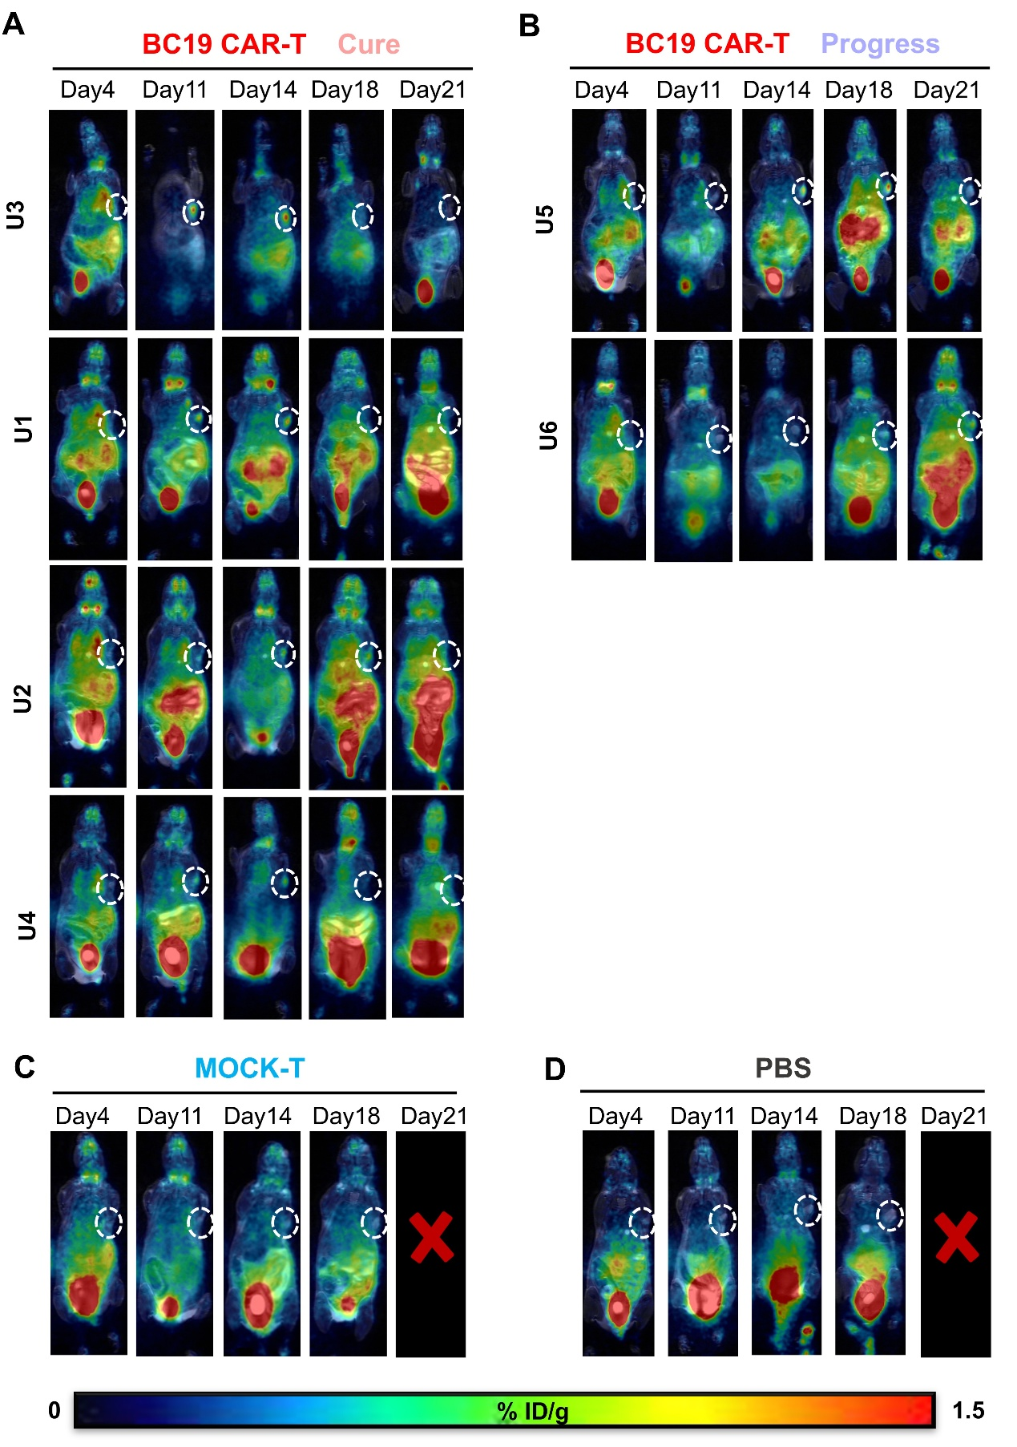
Figure S5. Longitudinal PET/MR monitoring of BC19 CAR-T, MOCK-T, and PBS cohorts in the U266 myeloma model. Twelve female NCG mice (4–6 weeks old) were inoculated with U266-Luc cells subcutaneously (day −7) and intravenously (day −2). On day 0, mice were randomized to receive 5 × 10⁶ BC19 CAR-T cells (n = 6), MOCK-T cells (n = 3), or PBS (n = 3). (A–B) Serial [⁶⁸Ga]Ga-NOTA-BED PET/MR imaging of the BC19 CAR-T cohort on days 4, 11, 14, 18, and 21, stratified into (A) “Cure” and (B) “Progress” phenotypes according to the kinetics of T cell expansion and tumor regression. (C–D) Representative longitudinal PET/MR images from mice in the (C) MOCK-T–treated and (D) PBS-treated groups. White dashed circles delineate subcutaneous tumor regions. Red crosses indicate missing scans due to death or excessive tumor burden. Radioactivity uptake is expressed as %ID/g (scale, 0–1.5).

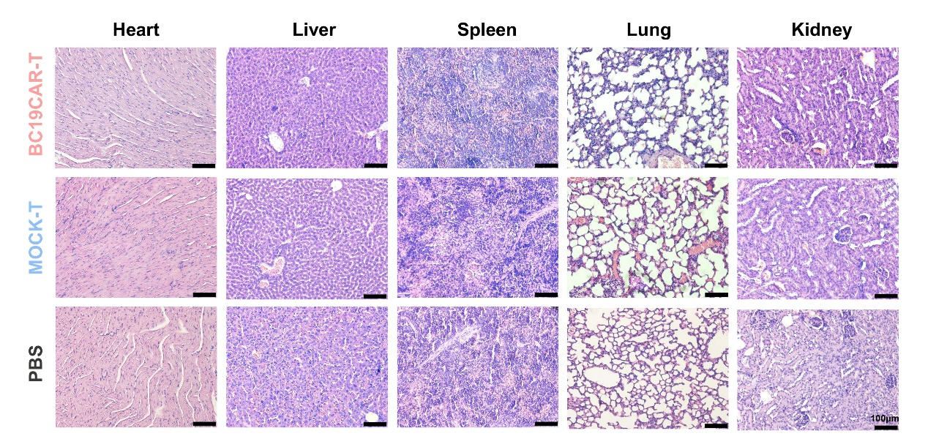
Figure S6. Histopathological analysis of major organs in the U266 myeloma model at the experimental endpoint. Representative H&E-stained sections from BC19 CAR-T, MOCK-T, and PBS-treated groups are shown.Scale bars, 100 μm.

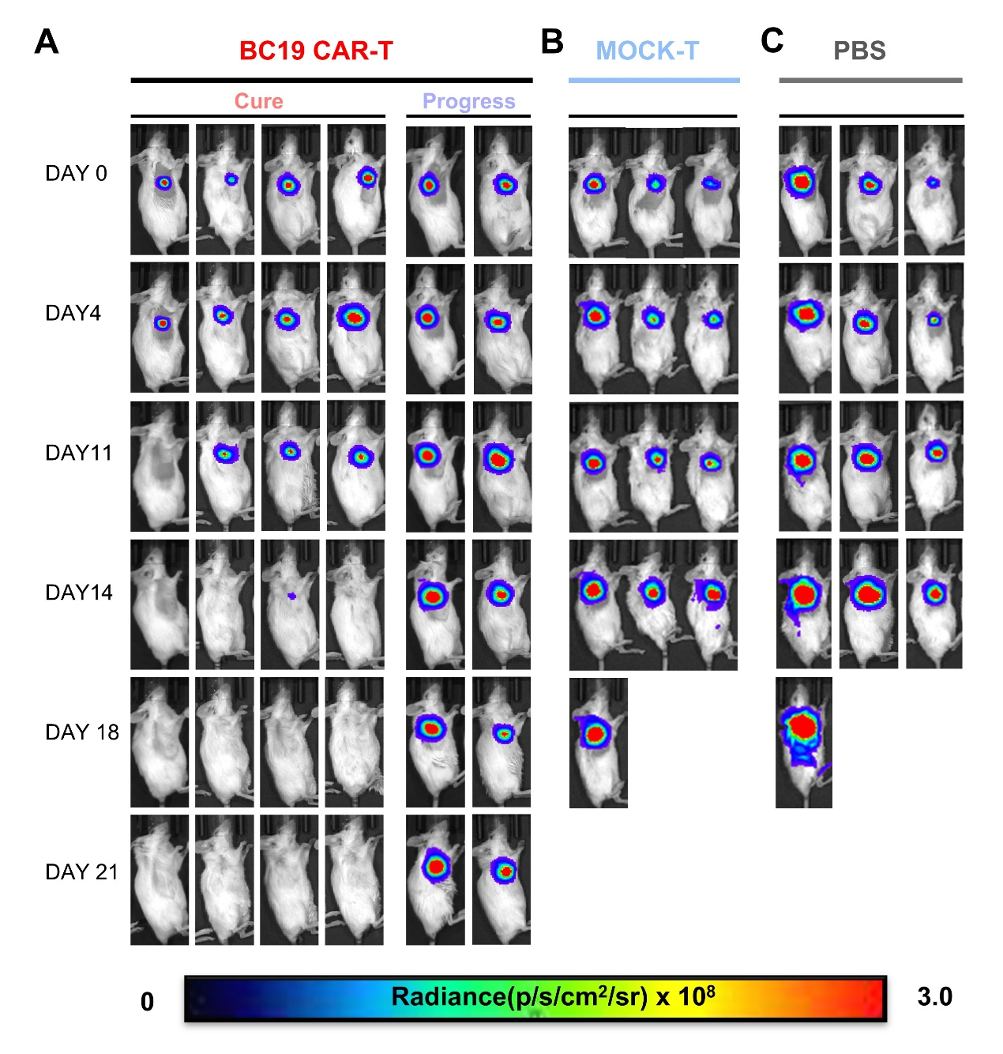
Figure S7. Therapeutic efficacy of BC19 CAR-T cells in the U266 xenograft model. (A–C) Representative longitudinal bioluminescence imaging (BLI) of mice in the (A) BC19 CAR-T–treated, (B) MOCK-T–treated, and (C) PBS-treated groups from day 0 to day 21. In the BC19 CAR-T cohort, representative images from mice exhibiting “Cure” and “Progress” phenotypes are shown separately. All images were acquired and displayed using an identical pseudocolor scale. Bioluminescence intensity is expressed as radiance (p/s/cm²/sr), with the color scale ranging from 0 to 3.0 × 10⁸ p/s/cm²/sr.

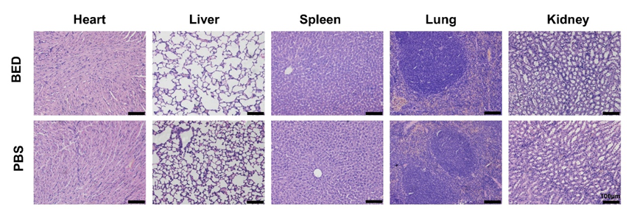
Figure S8. H&E staining of major organs in the acute toxicity study. Representative sections of heart, liver, spleen, lung, and kidney from mice receiving BED probe or PBS control are shown. Scale bars, 100 μm.

Table 1. Kinetic constants for the binding of BED and NOTA-BED to His-tagged CAR proteins
 | ka (× 10⁵ M⁻¹ s⁻¹) | kd (× 10⁻⁴ s) | K_{D} (nM)
BED | 2.73 | 2.43 | 0.89
NOTA-BED | 2.21 | 2.45 | 1.11

Organ | Equivalent dose (mSv/MBq)
Adrenals | 7.55E-02
Brain | 4.54E-04
Esophagus | 2.42E-03
Eyes | 1.72E-04
Gallbladder Wall | 5.06E-03
Left colon | 6.47E-03
Small Intestine | 5.31E-03
Stomach Wall | 5.08E-03
Right colon | 4.34E-03
Rectum | 1.45E-03
Heart | 3.45E-03
Kidneys | 8.71E-01
Liver | 9.54E-03
Lungs | 1.11E-02
Pancreas | 6.09E-03
Prostate | 1.92E-03
Salivary Glands | 2.08E-04
Red Marrow | 2.43E-03
Skeleton | 5.23E-03
Spleen | 1.78E-02
Testes | 3.90E-03
Thymus | 1.07E-03
Thyroid | 4.74E-03
Urin Blad | 8.19E-04
Total Body | 5.46E-03
Effective Dose | 1.28E-02
Mean absorbed doses after injection of [⁶⁸Ga]Ga- NOTA-BED mice, extrapolated to adult human male model.

Table 2. Extrapolated Human Radiation Dose Estimates for [⁶⁸Ga]Ga- NOTA-BED

References:
[1] YANG M, HASE H, LEGARDA-ADDISON D, et al. B cell maturation antigen, the receptor for a proliferation-inducing ligand and B cell-activating factor of the TNF family, induces antigen presentation in B cells. J Immunol., 175, 2814-24 (2005).

