Supplementary Figures
This document contains the supplementary material referenced in the main text (Figures S1–S6).
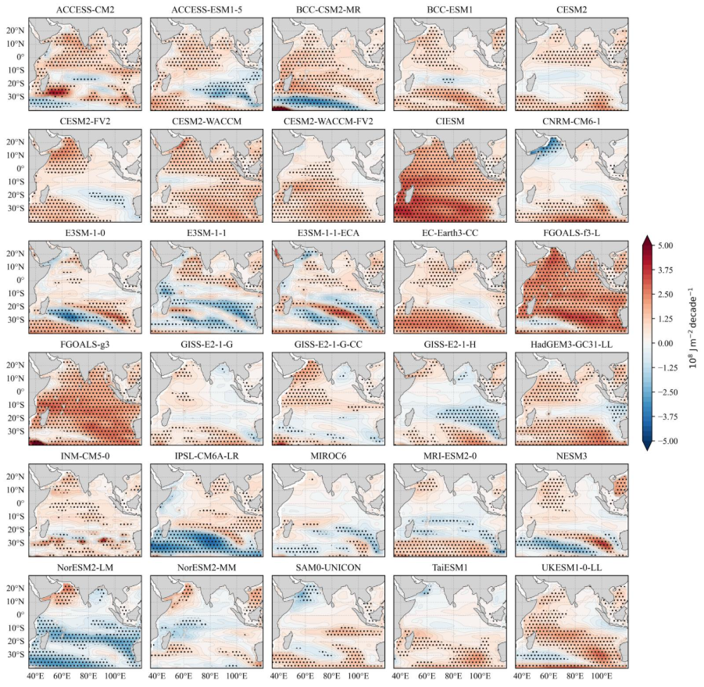
Figure S1: Trend of h700 for the MMM of the model ensemble over 1960-2014. Stippling indicates trends significant at 95% confidence interval.
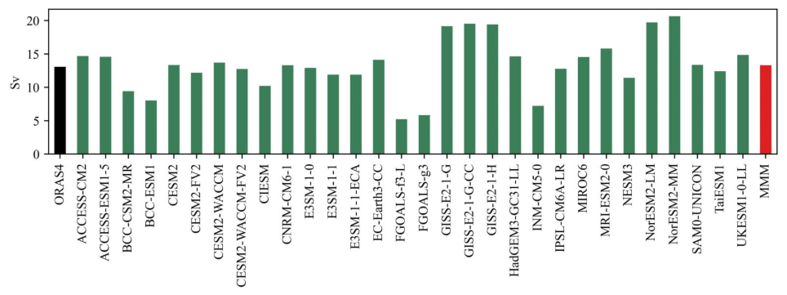Figure S2: Mean ITF transport across the models.

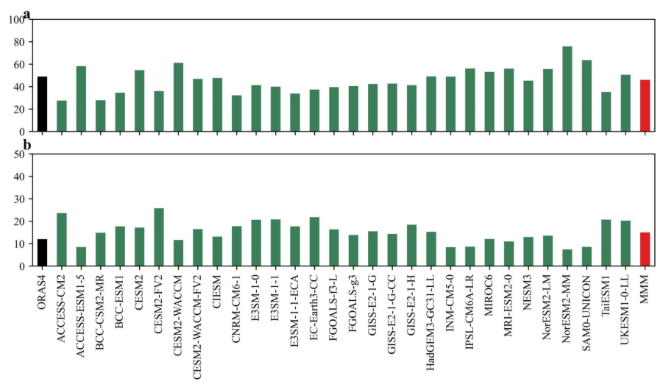Figure S3: (a) Explained Variance for the first mode of decadal pacific EOF. (b) same as (a) but for the second mode.

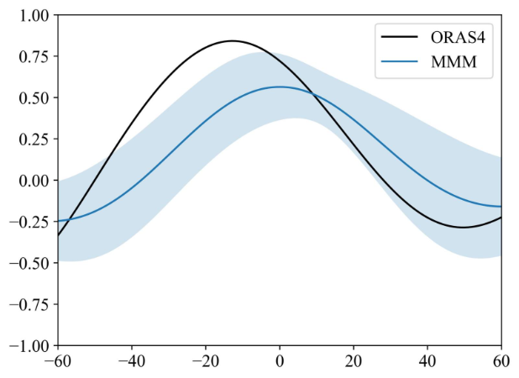
Figure S4: lead lag regression of ITF-PAC with ITF for ORAS4 and MMM, the shading represents the intermodel spread (1 standard deviation).
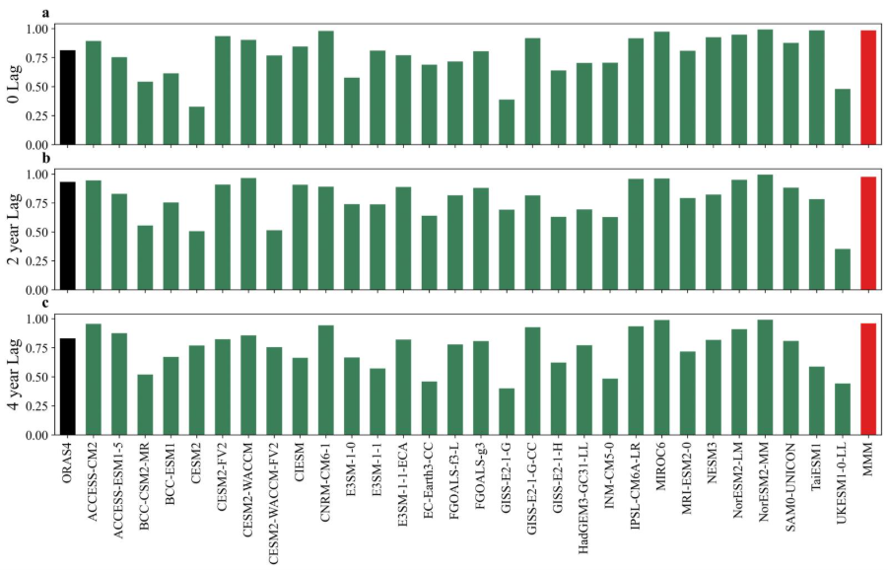
Figure S5: (a)-(c) skill score between regression coefficients of ITF and h700 vs regression coefficients of ITF-PAC and h700 at 0, 2 year and 4-year lag.

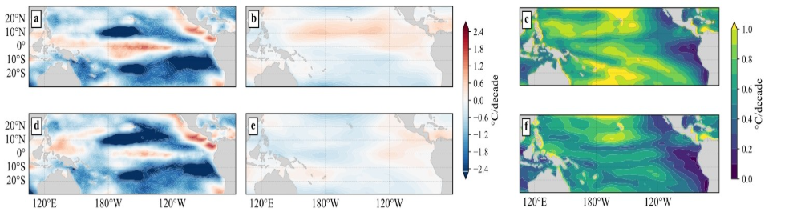
Figure S6: (a) Trend of zonal wind stress for the period 1960-2014 for observation . (b) same as (a) but for the MMM. (c) Intermodel spread of the h700 trends within the ensemble. (d)-(f) same as (a)-(c) but after removing internal variability at decadal scales (forced signal).

