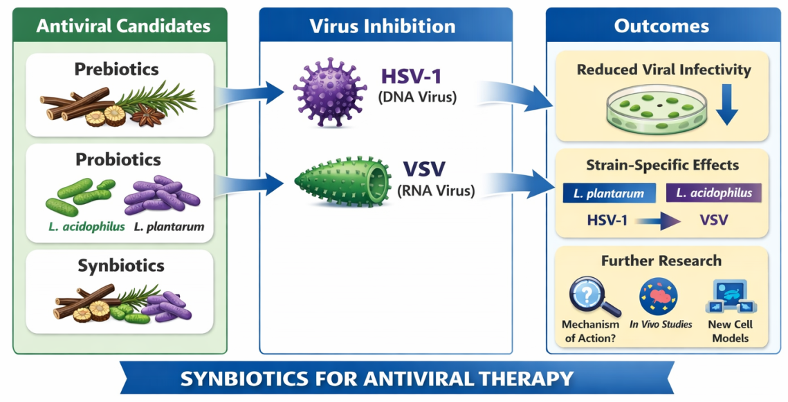
Scheme 1. Summary of the study conclusions on synbiotics as antiviral candidates. Plant-derived prebiotics, probiotic preparations (notably Lactobacillus plantarum and L. acidophilus), and synbiotic combinations reduced viral infectivity of HSV-1 (DNA virus) and VSV (RNA virus) in Vero cell assays. The scheme highlights strain-/preparation-dependent effects and outlines key next steps, including mechanistic characterization, validation in additional cell models, and in vivo evaluation.

