Supplementary material

Systemic neuroimmune reconfiguration and synaptic restoration in Alzheimer’s disease by young xenogeneic extracellular vesicles
Xiaoyang Lu¹, Yiling Jiang¹, Xiuqing Lin¹, Yuanxing Zhang¹, Qin Liu^{1,}*, and Shouwen Chen^{1,}*
¹State Key Laboratory of Bioreactor Engineering, Shanghai Frontiers Science Center of Optogenetic Techniques for Cell Metabolism, East China University of Science and Technology, Shanghai, 200237
* Correspondence:
Qin Liu: qinliu@ecust.edu.cn; Shouwen Chen: swchen@ecust.edu.cn

Supplementary Figure 1. ELISA analysis of IL-6 protein in mouse plasma.
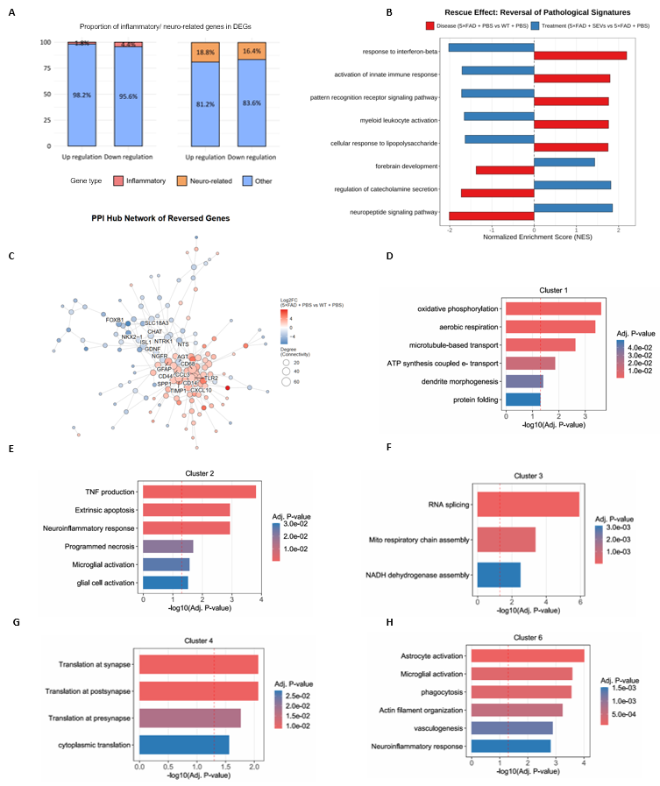
Supplementary Figure 2. PpSEVs normalize transcriptomic profiles toward wild-type levels in 5×FAD mice. (A) Functional categorization of upregulated and downregulated genes in PpSEV-treated 5×FAD mice. (B) Gene Set Enrichment Analysis (GSEA) reveals rescue of key biological pathways. (C) Protein-Protein Interaction (PPI) network of rescued genes. (D-H) GO Biological Process enrichment analysis of gene clusters 1-6 from Fig. 4F. Cluster 5 showed no significant enrichment.
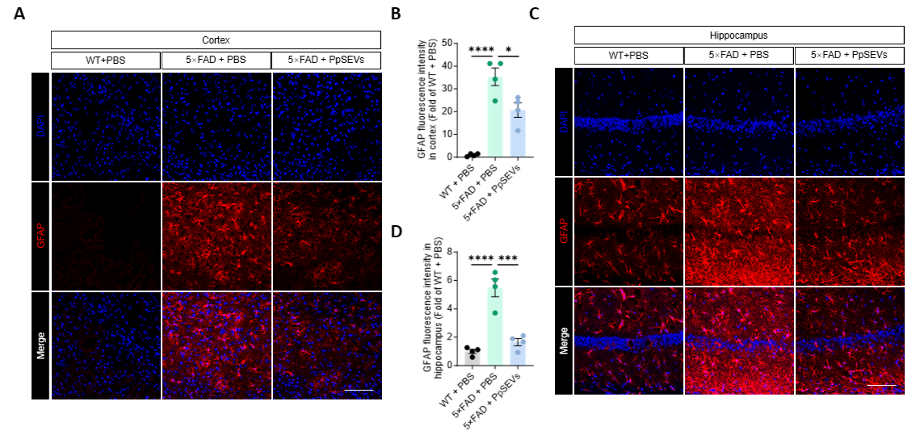
Supplementary Figure 3. PpSEVs attenuate astrocyte reactivity. (A and B) Representative IF images of cortex sections collected from treated mice co-stained with anti-GFAP antibody (A), and quantification of GFAP fluorescence intensity measured by ImageJ (B). Scale bars, 100 μm (n = 4 replicates per group). (C and D) Representative IF images of hippocampus sections co-stained with anti-GFAP antibody (C), and quantification of GFAP fluorescence intensity (D) (n = 4 replicates per group).

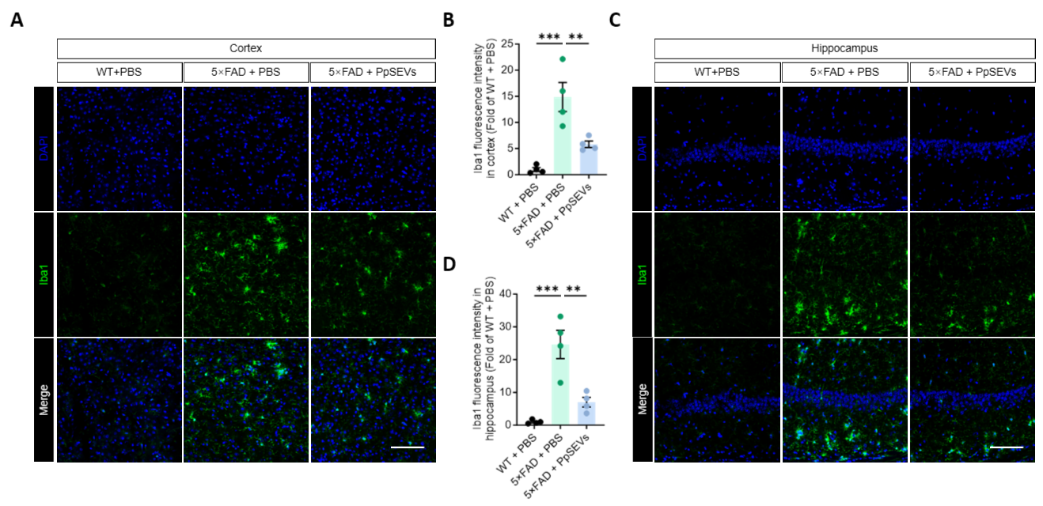
Supplementary Figure 4. PpSEVs attenuate microglial activation. (A and B) Representative IF images of cortex sections stained with anti-Iba1 antibody (A), and quantification of Iba1 fluorescence intensity measured by ImageJ (B). Scale bars, 100 μm (n = 4 replicates per group). (C and D) Representative IF images of hippocampus sections stained with anti-Iba1 antibody (C), and quantification of Iba1 fluorescence intensity (D) (n = 4 replicates per group).
Supplementary Figure 5. Mechanistic overview of PpSEV therapy in 5×FAD mice. PpSEVs cross the BBB to target glial and neuronal populations, exerting tripartite effects: (1) dual modulation of microglia via pyroptosis inhibition and enhanced Aβ clearance; (2) astrocyte reprogramming switching from neurotoxic (C3-positive) to neuroprotective (S100A10-positive) states; (3) BDNF-mediated restoration of synaptic function. This multi-target strategy coordinately ameliorates AD pathology and cognitive impairment.
Supplementary Table 1. Primers used in this study.
Genes | Oligonucleotides (5’-3’)
Genes | Forward |  | Reverse
GAPDH | CATCACTGCCACCCAGAAGACTG | ATGCCAGTGAGCTTCCCGTTCAG
IL-1α | CGAAGACTACAGTTCTGCCATT | ATGCCAGTGAGCTTCCCGTTCAG
IL-6 | TAGTCCTTCCTACCCCAATTTCC | TTGGTCCTTAGCCACTCCTTC
IL-1β | GCAACTGTTCCTGAACTCAACT | ATCTTTTGGGGTCCGTCAACT
tnf-α | CCCTCACACTCAGATCATCTTCT | GCTACGACGTGGGCTACAG
IFN-γ | ATGAACGCTACACACTGCATC | CCATCCTTTTGCCAGTTCCTC
HMGB1 | GGCGAGCATCCTGGCTTATC | GGCTGCTTGTCATCTGCTG
CCL2 | TTAAAAACCTGGATCGGAACCAA | GCATTAGCTTCAGATTTACGGGT
iNOS | GTTCTCAGCCCAACAATACAAGA | GTGGACGGGTCGATGTCAC
Ptgs2 | TGAGCAACTATTCCAAACCAGC | GCACGTAGTCTTCGATCACTATC
NF-κB | AGGCTTCTGGGCCTTATGTG | TGCTTCTCTCGCCAGGAATAC
BDNF | TCATACTTCGGTTGCATGAAGG | AGACCTCTCGAACCTGCCC
NGF | CCAGTGAAATTAGGCTCCCTG | CCTTGGCAAAACCTTTATTGGG
IGF-1 | GTGAGCCAAAGACACACCCA | ACCTCTGATTTTCCGAGTTGC
FGF2 | GCGACCCACACGTCAAACTA | TCCCTTGATAGACACAACTCCTC
VEGF | GCACATAGAGAGAATGAGCTTCC | CTCCGCTCTGAACAAGGCT
TrkB | CTGGGGCTTATGCCTGCTG | AGGCTCAGTACACCAAATCCTA
ADNP | GACTCCCACCACGAATCAGC | CCCGTTGAATTTAAGTTGGGCT
GDNF | TCCAACTGGGGGTCTACGG | GCCACGACATCCCATAACTTCAT
NT-3 | GGAGTTTGCCGGAAGACTCTC | GGGTGCTCTGGTAATTTTCCTTA
Amigo2 | CTGTGTCTGTTGGTGATCGCA | CGGGCACCTTAGATAGGTTTTTG
Cxcl10 | CCAAGTGCTGCCGTCATTTTC | GGCTCGCAGGGATGATTTCAA
GBP2 | CTGCACTATGTGACGGAGCTA | GAGTCCACACAAAGGTTGGAAA
Serping1 | TAGAGCCTTCTCAGATCCCGA | ACTCGTTGGCTACTTTACCCA
Iigp1 | CAGGACATCCGCCTTAACTGT | AGGAAGTAAGTACCCATTAGCCA
Lcn2 | TGGCCCTGAGTGTCATGTG | CTCTTGTAGCTCATAGATGGTGC
Ggta1 | GGTGGTTCCCAAGCTGGTTTA | CGGGCGGTTCTTTGGATTGA
Ugt1a1 | GCTTCTTCCGTACCTTCTGTTG | GCTGCTGAATAACTCCAAGCAT
Fbln5 | GCTTGTCGTGGGGACATGAT | TGGGGTAGTTGGAAGCTGGTA
Fkbp5 | TGAGGGCACCAGTAACAATGG | CAACATCCCTTTGTAGTGGACAT

