Vaccine Induced Thrombotic Thrombocytopenia (VITT) : First report from India and 6T score for diagnosis in resource limited settings.
Authors
- Christy V John
- Rajesh Kumar
- Anil Kumar Sivan
- Sangeetha Jithin
- Rojin Abraham
- Chepsy C Philip
Author: Institution: Believers Church Medical College Hospital
Research Support: None
Corresponding Author: Chepsy C Philip
Clinical Hematology & Bone Marrow Transplantation
Believers Church Medical College Hospital
Thiruvalla
Kerala, India -689103
chepsyphilip@bcmch.edu.in
Running Head: Thrombosis and thrombocytopenia following COVID vaccination: Diagnosing in a resource limited setting

Disclaimers: None

Author Contribution & COI disclosure section

The authors confirm contribution to the paper as follows
- Christy V John -: draft manuscript preparation, data collection, Analysis & interpretation
- Rajesh Kumar : draft manuscript preparation ,data collection, Analysis
- Anil Kumar Sivan : data collection, Analysis & interpretation
- Sangeetha Jithin : data collection, Analysis & interpretation
- Rojin Abraham : data collection, Analysis & interpretation
- Chepsy C Philip : study conception and design, draft manuscript preparation, data collection , analysis & interpretation

All authors reviewed the results and approved the final version of the manuscript.
- Christy V John -: no conflict of interest
- Rajesh Kumar : no conflict of interest
- Anil Kumar Sivan : no conflict of interest
- Sangeetha Jithin: no conflict of interest
- Rojin Abraham : no conflict of interest
- Chepsy C Philip : no conflict of interest
All authors declare no conflict of interest

Essentials section

- VITT can be fatal and reporting needs to be encouraged to understand the magnitude, given the rapidity of production and emergency use authorization of COVID vaccines.
- Current guidance from societies emphasize on specialized tests for confirmation of VITT which are unavailable in resource limited settings and can lead to under reporting.
- We describe the first two cases of VITT from India ,based on a 4T inspired risk which can be used to report and treat patients in the absence of such specialized tests
- Clinical based scores can encourage rapid diagnosis enabling treatment and adequate reporting necessary for post authorization surveillance.

Abstract
Vaccine induced thrombotic thrombocytopenia (VITT) is a rare but devastating adverse event following adenoviral vector based vaccinations for COVID-19. Guidance statements and available reports lack clarity on the choice of imaging modalities and emphasize on the need for specialized tests as a requisite criterion. Such tests have practical limitations of availability likely to restrict the treatment and reporting of such catastrophic events and need reconsideration. We describe two young men with VITT who had no other contributory cause besides a recent ChAdOx1 nCoV-19 vaccination. They were treated with IVIG and full dose anticoagulation. In both our cases the primary neuroimaging was normal and the recommended PF-4 testing was not reported due to technical limitations. Diagnosis was based on a 4T inspired score. Clinicians should report and though counter intuitive; not delay the institution of full dose anticoagulation, IVIG and limit platelet transfusion in the appropriate setting.

Keywords: VITT, ChAdOx1, Thrombosis, Thrombocytopenia, COVID-19

Figures
Fig. 1
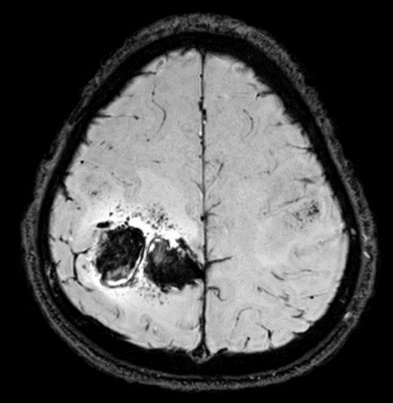
MRI brain: Right high fronto-paretial hematoma with perilesional edema.
Fig 2
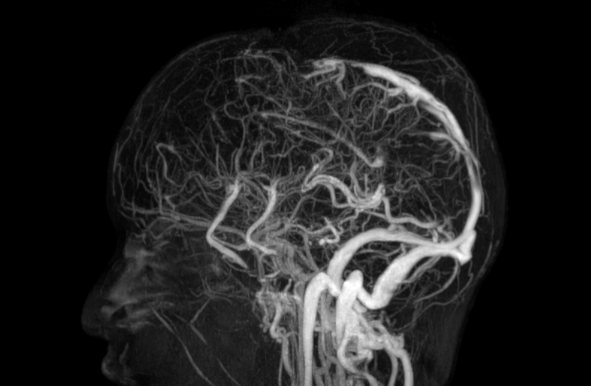
MR Venogram: Non Visualized Anterior Superior Sagittal Sinus

Table 1: 6T score sheet for VITT
Category
Thrombocytopenia | >50% fall or nadir < 75000/mm³
Test for PF4 antibody | Positive by ELISA
Timing | Within 30 days of the first dose of vaccination
Time/Age | Less than 30 years
Thrombosis | Documented thrombus ( if suspecting CVT a venogram is needed)
Trephine/Other causes for Thrombocytopenia | Normal/ No alternate likley etiology
Treatment/high likelihood of VITT | Alteast 5 out of the 6 Ts

